Data 621 Homework 3: Boston Crime Rates

Tommy Jenkins, Violeta Stoyanova, Todd Weigel, Peter Kowalchuk, Eleanor R-Secoquian

October, 2019

Table of Contents

# OVERVIEW

In this homework assignment, we will explore, analyze and model a data set containing information on crime for various neighborhoods of a major city. Each record has a response variable indicating whether or not the crime rate is above the median crime rate (1) or not (0).

## Objective:

The objective is to build a binary logistic regression model on the training data set to predict whether the neighborhood will be at risk for high crime levels.

# DATA EXPLORATION

## Data Summary

The dataset consists of two data files: training and evaluation. The training dataset contains 13 columns, while the evaluation dataset contains 12. The evaluation dataset is missing column target which represend our responce variable and defines whether the crime rate is above the median crime rate (1) or not (0). We will start by exploring the training data set since it will be the one used to generate the regression model.

First we see that all data is numeric. The dataset does contain one dummy variable to identify if the property borders the Charles River (1) or not (0).

An important aspect of any dataset is to determine how much, if any, data is missing. We look at all the variables to see which if any have missing data. We look at the basic descriptive statistics as well as the missing data and their percentages:

vars

n

mean

sd

median

trimmed

mad

min

max

range

skew

kurtosis

se

na_count

na_count_perc

zn

1

466

11.5772532

23.3646511

0.00000

5.3542781

0.0000000

0.0000

100.0000

100.0000

2.1768152

3.8135765

1.0823466

0

0

indus

2

466

11.1050215

6.8458549

9.69000

10.9082353

9.3403800

0.4600

27.7400

27.2800

0.2885450

-1.2432132

0.3171281

0

0

chas

3

466

0.0708155

0.2567920

0.00000

0.0000000

0.0000000

0.0000

1.0000

1.0000

3.3354899

9.1451313

0.0118957

0

0

nox

4

466

0.5543105

0.1166667

0.53800

0.5442684

0.1334340

0.3890

0.8710

0.4820

0.7463281

-0.0357736

0.0054045

0

0

rm

5

466

6.2906738

0.7048513

6.21000

6.2570615

0.5166861

3.8630

8.7800

4.9170

0.4793202

1.5424378

0.0326516

0

0

age

6

466

68.3675966

28.3213784

77.15000

70.9553476

30.0226500

2.9000

100.0000

97.1000

-0.5777075

-1.0098814

1.3119625

0

0

dis

7

466

3.7956929

2.1069496

3.19095

3.5443647

1.9144814

1.1296

12.1265

10.9969

0.9988926

0.4719679

0.0976026

0

0

rad

8

466

9.5300429

8.6859272

5.00000

8.6978610

1.4826000

1.0000

24.0000

23.0000

1.0102788

-0.8619110

0.4023678

0

0

tax

9

466

409.5021459

167.9000887

334.50000

401.5080214

104.5233000

187.0000

711.0000

524.0000

0.6593136

-1.1480456

7.7778214

0

0

ptratio

10

466

18.3984979

2.1968447

18.90000

18.5970588

1.9273800

12.6000

22.0000

9.4000

-0.7542681

-0.4003627

0.1017669

0

0

lstat

11

466

12.6314592

7.1018907

11.35000

11.8809626

7.0720020

1.7300

37.9700

36.2400

0.9055864

0.5033688

0.3289887

0

0

medv

12

466

22.5892704

9.2396814

21.20000

21.6304813

6.0045300

5.0000

50.0000

45.0000

1.0766920

1.3737825

0.4280200

0

0

target

13

466

0.4914163

0.5004636

0.00000

0.4893048

0.0000000

0.0000

1.0000

1.0000

0.0342293

-2.0031131

0.0231835

0

0

zn indus chas nox rm age dis rad tax 0 0 0 0 0 0 0 0 0 ptratio lstat medv target 0 0 0 0 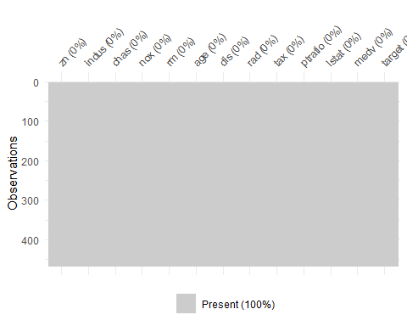 zn indus chas nox rm age dis rad tax ptratio lstat medv target 1 0 19.58 0 0.605 7.929 96.2 2.0459 5 403 14.7 3.70 50.0 1 2 0 19.58 1 0.871 5.403 100.0 1.3216 5 403 14.7 26.82 13.4 1 3 0 18.10 0 0.740 6.485 100.0 1.9784 24 666 20.2 18.85 15.4 1 4 30 4.93 0 0.428 6.393 7.8 7.0355 6 300 16.6 5.19 23.7 0 5 0 2.46 0 0.488 7.155 92.2 2.7006 3 193 17.8 4.82 37.9 0 6 0 8.56 0 0.520 6.781 71.3 2.8561 5 384 20.9 7.67 26.5 0

## Missing and Invalid Data

No missing data was found in the dataset.

With missing data assessed, we can look into the data in more detail. To visualize this we plot histograms for each data. Several predictors like dist, chas, rad, zn and tax are not normally distributed and noticable outliers.

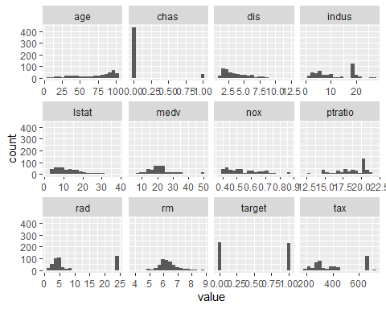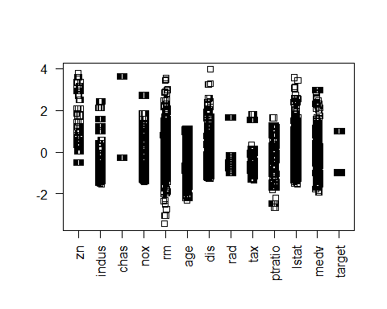

# DATA PREPARATION

## Fix missing values

No data was found missing.

## Mathematical transformations.

**Box Cox** The Box Cox transformation tries to transform non-normal data into a normal distribution. This transformation attemps to estimate the for Y. With the exception of tax, all predictors have either no transformation extimate or were given a fudge value of 0.

$zn Box-Cox Transformation

466 data points used to estimate Lambda

Input data summary: Min. 1st Qu. Median Mean 3rd Qu. Max. 0.00 0.00 0.00 11.58 16.25 100.00

Lambda could not be estimated; no transformation is applied

$indus Box-Cox Transformation

466 data points used to estimate Lambda

Input data summary: Min. 1st Qu. Median Mean 3rd Qu. Max. 0.460 5.145 9.690 11.105 18.100 27.740

Largest/Smallest: 60.3 Sample Skewness: 0.289

Estimated Lambda: 0.4

$chas Box-Cox Transformation

466 data points used to estimate Lambda

Input data summary: Min. 1st Qu. Median Mean 3rd Qu. Max. 0.00000 0.00000 0.00000 0.07082 0.00000 1.00000

Lambda could not be estimated; no transformation is applied

$nox Box-Cox Transformation

466 data points used to estimate Lambda

Input data summary: Min. 1st Qu. Median Mean 3rd Qu. Max. 0.3890 0.4480 0.5380 0.5543 0.6240 0.8710

Largest/Smallest: 2.24 Sample Skewness: 0.746

Estimated Lambda: -0.9

$rm Box-Cox Transformation

466 data points used to estimate Lambda

Input data summary: Min. 1st Qu. Median Mean 3rd Qu. Max. 3.863 5.887 6.210 6.291 6.630 8.780

Largest/Smallest: 2.27 Sample Skewness: 0.479

Estimated Lambda: 0.2

$age Box-Cox Transformation

466 data points used to estimate Lambda

Input data summary: Min. 1st Qu. Median Mean 3rd Qu. Max. 2.90 43.88 77.15 68.37 94.10 100.00

Largest/Smallest: 34.5 Sample Skewness: -0.578

Estimated Lambda: 1.3

$dis Box-Cox Transformation

466 data points used to estimate Lambda

Input data summary: Min. 1st Qu. Median Mean 3rd Qu. Max. 1.130 2.101 3.191 3.796 5.215 12.127

Largest/Smallest: 10.7 Sample Skewness: 0.999

Estimated Lambda: -0.1 With fudge factor, Lambda = 0 will be used for transformations

$rad Box-Cox Transformation

466 data points used to estimate Lambda

Input data summary: Min. 1st Qu. Median Mean 3rd Qu. Max. 1.00 4.00 5.00 9.53 24.00 24.00

Largest/Smallest: 24 Sample Skewness: 1.01

Estimated Lambda: -0.2 With fudge factor, Lambda = 0 will be used for transformations

$tax Box-Cox Transformation

466 data points used to estimate Lambda

Input data summary: Min. 1st Qu. Median Mean 3rd Qu. Max. 187.0 281.0 334.5 409.5 666.0 711.0

Largest/Smallest: 3.8 Sample Skewness: 0.659

Estimated Lambda: -0.5

$ptratio Box-Cox Transformation

466 data points used to estimate Lambda

Input data summary: Min. 1st Qu. Median Mean 3rd Qu. Max. 12.6 16.9 18.9 18.4 20.2 22.0

Largest/Smallest: 1.75 Sample Skewness: -0.754

Estimated Lambda: 2

$lstat Box-Cox Transformation

466 data points used to estimate Lambda

Input data summary: Min. 1st Qu. Median Mean 3rd Qu. Max. 1.730 7.043 11.350 12.631 16.930 37.970

Largest/Smallest: 21.9 Sample Skewness: 0.906

Estimated Lambda: 0.2

$medv Box-Cox Transformation

466 data points used to estimate Lambda

Input data summary: Min. 1st Qu. Median Mean 3rd Qu. Max. 5.00 17.02 21.20 22.59 25.00 50.00

Largest/Smallest: 10 Sample Skewness: 1.08

Estimated Lambda: 0.2

$target Box-Cox Transformation

466 data points used to estimate Lambda

Input data summary: Min. 1st Qu. Median Mean 3rd Qu. Max. 0.0000 0.0000 0.0000 0.4914 1.0000 1.0000

Lambda could not be estimated; no transformation is applied

## Variable Creation / Removal

To determine how we can combine variables to create new one we start by looking at a correlation plot. The plot and cor funtion lists nox, age, rad,tax and indus as the strongest postively correlated predictors, while rad and distance are the strongest negatively correlated predictors.

indus chas nox rm age dis

[1,] 0.6048507 0.08004187 0.7261062 -0.1525533 0.6301062 -0.6186731 rad tax ptratio lstat medv target [1,] 0.6281049 0.6111133 0.2508489 0.469127 -0.2705507 1 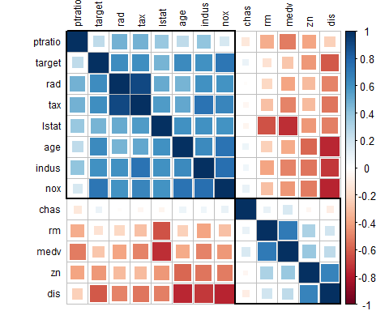

# BUILD MODELS

### General regression

We start by building a model with all the predictors in the dataset.

Call: glm(formula = target ~ ., family = binomial(link = “logit”), data = crimeTrain)

Deviance Residuals: Min 1Q Median 3Q Max  
-1.8464 -0.1445 -0.0017 0.0029 3.4665

Coefficients: Estimate Std. Error z value Pr(>|z|)  
(Intercept) -40.822934 6.632913 -6.155 7.53e-10  ***zn -0.065946 0.034656 -1.903 0.05706 .***  
***indus -0.064614 0.047622 -1.357 0.17485***  
***chas 0.910765 0.755546 1.205 0.22803***  
***nox 49.122297 7.931706 6.193 5.90e-10***  rm -0.587488 0.722847 -0.813 0.41637  
age 0.034189 0.013814 2.475 0.01333 *  
dis 0.738660 0.230275 3.208 0.00134 ** rad 0.666366 0.163152 4.084 4.42e-05  ***tax -0.006171 0.002955 -2.089 0.03674***   
**ptratio 0.402566 0.126627 3.179 0.00148**  lstat 0.045869 0.054049 0.849 0.39608  
medv 0.180824 0.068294 2.648 0.00810 ** — Signif. codes: 0 ‘***’ 0.001 ’****’ 0.01 ’*’ 0.05 ‘.’ 0.1 ’ ’ 1

(Dispersion parameter for binomial family taken to be 1)

Null deviance: 645.88 on 465 degrees of freedom Residual deviance: 192.05 on 453 degrees of freedom AIC: 218.05

Number of Fisher Scoring iterations: 9

The Summary of this model shows several predictor are not relevant. We build a second model without these predictors.

Call: glm(formula = target ~ nox + age + dis + rad + tax + ptratio + medv, family = binomial(link = “logit”), data = crimeTrain)

Deviance Residuals: Min 1Q Median 3Q Max  
-2.01059 -0.19744 -0.01371 0.00402 3.06424

Coefficients: Estimate Std. Error z value Pr(>|z|)  
(Intercept) -36.824228 5.858405 -6.286 3.26e-10  ***nox 42.338378 6.639207 6.377 1.81e-10***  age 0.031882 0.010693 2.982 0.002867 ** dis 0.429555 0.171849 2.500 0.012433 *  
rad 0.701767 0.139426 5.033 4.82e-07  ***tax -0.008237 0.002534 -3.250 0.001153***  *ptratio 0.376575 0.108912 3.458 0.000545*  **medv 0.093653 0.033556 2.791 0.005255**  — Signif. codes: 0 ‘***’ 0.001 ’****’ 0.01 ’*’ 0.05 ‘.’ 0.1 ’ ’ 1

(Dispersion parameter for binomial family taken to be 1)

Null deviance: 645.88 on 465 degrees of freedom Residual deviance: 203.45 on 458 degrees of freedom AIC: 219.45

Number of Fisher Scoring iterations: 9

[1] 1 [1] 1

The new model has a slightly higher AIC which would tells us the first model is slightly less complex. For the 2 data sets p-value = 1 - pchisq(deviance, degrees of freedom) are 1. The Null hypothesis is still supported.

### AIC Step Method

Another way of selecting which predictors to use in the model is by calculating the AIC of the model. This metric is similar to the adjusted R-square of a model in that it penalizes models with more predictors over simpler model with few predictors. We use Stepwise function in r to find the lowest AIC with different predictors.

Start: AIC=218.05 target ~ zn + indus + chas + nox + rm + age + dis + rad + tax + ptratio + lstat + medv

Df Deviance AIC

* rm 1 192.71 216.71
* lstat 1 192.77 216.77
* chas 1 193.53 217.53
* indus 1 193.99 217.99 192.05 218.05
* tax 1 196.59 220.59
* zn 1 196.89 220.89
* age 1 198.73 222.73
* medv 1 199.95 223.95
* ptratio 1 203.32 227.32
* dis 1 203.84 227.84
* rad 1 233.74 257.74
* nox 1 265.05 289.05

Step: AIC=216.71 target ~ zn + indus + chas + nox + age + dis + rad + tax + ptratio + lstat + medv

Df Deviance AIC

* chas 1 194.24 216.24
* lstat 1 194.32 216.32
* indus 1 194.58 216.58 192.71 216.71
* tax 1 197.59 219.59
* zn 1 198.07 220.07
* age 1 199.11 221.11
* ptratio 1 203.53 225.53
* dis 1 203.85 225.85
* medv 1 205.35 227.35
* rad 1 233.81 255.81
* nox 1 265.14 287.14

Step: AIC=216.24 target ~ zn + indus + nox + age + dis + rad + tax + ptratio + lstat + medv

Df Deviance AIC

* indus 1 195.51 215.51 194.24 216.24
* lstat 1 196.33 216.33
* zn 1 200.59 220.59
* tax 1 200.75 220.75
* age 1 201.00 221.00
* ptratio 1 203.94 223.94
* dis 1 204.83 224.83
* medv 1 207.12 227.12
* rad 1 241.41 261.41
* nox 1 265.19 285.19

Step: AIC=215.51 target ~ zn + nox + age + dis + rad + tax + ptratio + lstat + medv

Df Deviance AIC

* lstat 1 197.32 215.32 195.51 215.51
* zn 1 202.05 220.05
* age 1 202.23 220.23
* ptratio 1 205.01 223.01
* dis 1 205.96 223.96
* tax 1 206.60 224.60
* medv 1 208.13 226.13
* rad 1 249.55 267.55
* nox 1 270.59 288.59

Step: AIC=215.32 target ~ zn + nox + age + dis + rad + tax + ptratio + medv

Df Deviance AIC

197.32 215.32 - zn 1 203.45 219.45 - ptratio 1 206.27 222.27 - age 1 207.13 223.13 - tax 1 207.62 223.62 - dis 1 207.64 223.64 - medv 1 208.65 224.65 - rad 1 250.98 266.98 - nox 1 273.18 289.18

Call: glm(formula = target ~ zn + nox + age + dis + rad + tax + ptratio + medv, family = binomial(link = “logit”), data = crimeTrain)

Deviance Residuals: Min 1Q Median 3Q Max  
-1.8295 -0.1752 -0.0021 0.0032 3.4191

Coefficients: Estimate Std. Error z value Pr(>|z|)  
(Intercept) -37.415922 6.035013 -6.200 5.65e-10  ***zn -0.068648 0.032019 -2.144 0.03203***   
**nox 42.807768 6.678692 6.410 1.46e-10**  *age 0.032950 0.010951 3.009 0.00262*  ***dis 0.654896 0.214050 3.060 0.00222***  *rad 0.725109 0.149788 4.841 1.29e-06*  **tax -0.007756 0.002653 -2.924 0.00346**  ptratio 0.323628 0.111390 2.905 0.00367 ** medv 0.110472 0.035445 3.117 0.00183 ** — Signif. codes: 0 ‘***’ 0.001 ’****’ 0.01 ’*’ 0.05 ‘.’ 0.1 ’ ’ 1

(Dispersion parameter for binomial family taken to be 1)

Null deviance: 645.88 on 465 degrees of freedom Residual deviance: 197.32 on 457 degrees of freedom AIC: 215.32

Number of Fisher Scoring iterations: 9

This reduces the predictors used in the model to these: zn nox age dis rad tax ptRation medv

It Removes these predictors: indus chas rm#

The AIC improves marginally from 218.05 (our original general model) to 215.32, but we also benefit by having a simpler model less prone to overfitting.

Also, the predictors in the model now are all signficant (under 0.05 pr level) and all but one under .01 or very significant. Which is much improved over the prior model

### BIC Method

To determine the number of predictors and which predictors to be used we will use the Bayesian Information Criterion (BIC).

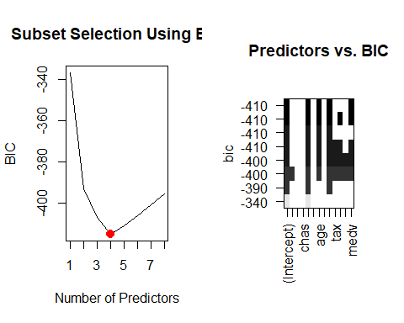

The plot on the right shows that the number of predictors with the lowest BIC are nox , age, rad, and medv. We will use those predictors to build the next model

|  |  |  |  |  |
| --- | --- | --- | --- | --- |
|  | Estimate | Std. Error | z value | Pr(>|z|) |
| **(Intercept)** | -17.63 | 2.168 | -8.131 | 4.246e-16 |
| **nox** | 23.62 | 3.936 | 6.003 | 1.942e-09 |
| **age** | 0.01824 | 0.009172 | 1.989 | 0.04673 |
| **rad** | 0.4528 | 0.1093 | 4.144 | 3.413e-05 |
| **medv** | 0.04481 | 0.02319 | 1.932 | 0.05338 |

(Dispersion parameter for binomial family taken to be 1 )

|  |  |
| --- | --- |
| Null deviance: | 645.9 on 465 degrees of freedom |
| Residual deviance: | 232.8 on 461 degrees of freedom |

### Forward Selection Method using some BoxCox transformed independent variables:

Start: AIC=680.3 target ~ 1

Df Deviance AIC

* I(nox^-1) 1 50.349 291.51
* I(age^2) 1 66.713 422.64
* I(dis^-0.5) 1 66.801 423.26
* rad 1 70.518 448.50
* I(log(indus)) 1 74.068 471.38
* I(tax^-1) 1 74.547 474.39
* lstat 1 90.834 566.47
* zn 1 94.762 586.20
* I(ptratio^2) 1 107.479 644.88
* medv 1 107.941 646.88
* I(log(rm)) 1 112.912 667.86
* I(sqrt(chas)) 1 115.720 679.31 116.466 680.30

Step: AIC=291.51 target ~ I(nox^-1)

Df Deviance AIC

* rad 1 45.272 243.97
* I(tax^-1) 1 46.956 260.99
* I(age^2) 1 49.650 286.99
* I(ptratio^2) 1 49.778 288.19
* I(log(rm)) 1 49.876 289.10
* medv 1 49.907 289.40
* I(log(indus)) 1 50.043 290.66 50.349 291.51
* zn 1 50.147 291.63
* I(sqrt(chas)) 1 50.305 293.10
* lstat 1 50.336 293.38
* I(dis^-0.5) 1 50.345 293.46

Step: AIC=243.97 target ~ I(nox^-1) + rad

Df Deviance AIC

* medv 1 44.061 233.33
* I(age^2) 1 44.442 237.35
* I(log(rm)) 1 44.674 239.77
* I(tax^-1) 1 45.017 243.34 45.272 243.97
* I(sqrt(chas)) 1 45.113 244.33
* lstat 1 45.149 244.71
* I(dis^-0.5) 1 45.180 245.03
* zn 1 45.223 245.47
* I(ptratio^2) 1 45.240 245.64
* I(log(indus)) 1 45.267 245.92

Step: AIC=233.33 target ~ I(nox^-1) + rad + medv

Df Deviance AIC

* I(age^2) 1 43.027 224.27
* I(tax^-1) 1 43.368 227.96
* I(dis^-0.5) 1 43.827 232.86
* lstat 1 43.834 232.93
* I(log(indus)) 1 43.856 233.17 44.061 233.33
* I(ptratio^2) 1 43.956 234.23
* I(sqrt(chas)) 1 44.030 235.01
* I(log(rm)) 1 44.052 235.24
* zn 1 44.060 235.33

Step: AIC=224.27 target ~ I(nox^-1) + rad + medv + I(age^2)

Df Deviance AIC

* I(dis^-0.5) 1 42.184 217.05
* I(tax^-1) 1 42.397 219.40 43.027 224.27
* I(log(indus)) 1 42.888 224.77
* I(ptratio^2) 1 42.975 225.71
* I(sqrt(chas)) 1 43.004 226.02
* lstat 1 43.006 226.05
* zn 1 43.013 226.12
* I(log(rm)) 1 43.024 226.24

Step: AIC=217.05 target ~ I(nox^-1) + rad + medv + I(age^2) + I(dis^-0.5)

Df Deviance AIC

* I(tax^-1) 1 41.399 210.29
* I(log(indus)) 1 41.866 215.53 42.184 217.05
* lstat 1 42.036 217.41
* I(ptratio^2) 1 42.124 218.39
* I(log(rm)) 1 42.150 218.67
* I(sqrt(chas)) 1 42.169 218.89
* zn 1 42.173 218.93

Step: AIC=210.29 target ~ I(nox^-1) + rad + medv + I(age^2) + I(dis^-0.5) + I(tax^-1)

Df Deviance AIC

* lstat 1 41.180 209.83 41.399 210.29
* I(log(indus)) 1 41.232 210.42
* I(ptratio^2) 1 41.318 211.38
* I(log(rm)) 1 41.360 211.86
* I(sqrt(chas)) 1 41.374 212.02
* zn 1 41.396 212.27

Step: AIC=209.83 target ~ I(nox^-1) + rad + medv + I(age^2) + I(dis^-0.5) + I(tax^-1) + lstat

Df Deviance AIC

41.180 209.83 + I(log(indus)) 1 41.012 209.92 + I(ptratio^2) 1 41.062 210.49 + I(sqrt(chas)) 1 41.159 211.59 + zn 1 41.174 211.76 + I(log(rm)) 1 41.178 211.80

Call: glm(formula = target ~ I(nox^-1) + rad + medv + I(age^2) + I(dis^-0.5) + I(tax^-1) + lstat, data = crimeTrain)

Deviance Residuals: Min 1Q Median 3Q Max  
-0.70627 -0.18647 -0.02143 0.13160 0.98687

Coefficients: Estimate Std. Error t value Pr(>|t|)  
(Intercept) 2.099e+00 2.682e-01 7.826 3.52e-14  ***I(nox^-1) -8.407e-01 8.932e-02 -9.413 < 2e-16***  rad 1.258e-02 2.698e-03 4.661 4.13e-06  ***medv 1.195e-02 2.464e-03 4.850 1.69e-06***  I(age^2) 2.846e-05 7.544e-06 3.772 0.000183  ***I(dis^-0.5) -7.689e-01 2.123e-01 -3.621 0.000326***  I(tax^-1) -7.196e+01 2.332e+01 -3.086 0.002155 ** lstat 5.686e-03 3.647e-03 1.559 0.119675  
— Signif. codes: 0 ‘***’ 0.001 ’****’ 0.01 ’*’ 0.05 ‘.’ 0.1 ’ ’ 1

(Dispersion parameter for gaussian family taken to be 0.08991273)

Null deviance: 116.47 on 465 degrees of freedom Residual deviance: 41.18 on 458 degrees of freedom AIC: 209.83

Number of Fisher Scoring iterations: 2

# SELECT MODELS

## Compare Model Statistics

### Model 1 - General Model

#### Complete general model

**ROC Curve**

The ROC Curve helps measure true positives and true negative. A high AUC or area under the curve tells us the model is predicting well.

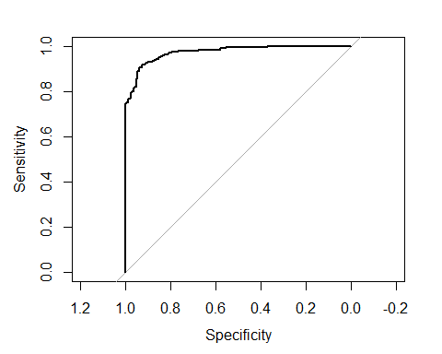

The AUC value of 0.97, tells us this model predicted values are acurate.

**Confusion Matrix**

targethat 0 1 0 220 22 1 17 207

**Create a binned diagnostic plot of residuals vs prediction** There are definite patterns here, which bear investigating.

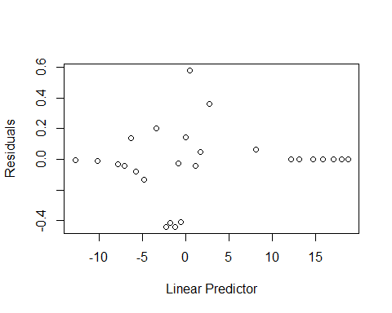

**Plot leverages.**

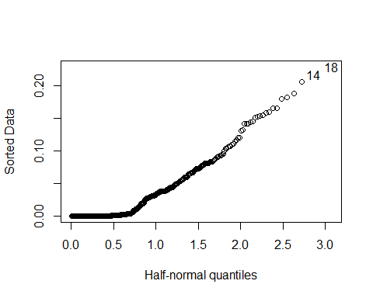

We don’t see any strong outliers with the leverage plot. The points identified (14,18) are essentially in the plot of the line formed, so they are not likely pulling our model in any direction.

**Plot Goodness of fit** 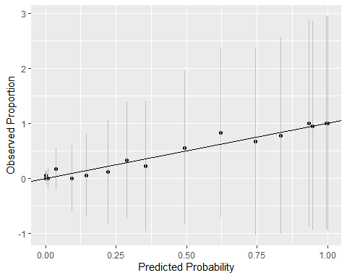

We see that our predictors fall close to the line. (Note to group, need do adjust the min max line)

#### Reduced general model

**ROC Curve** 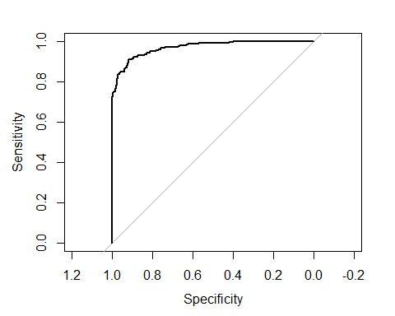

This model also show a high AUC value of 0.97. This tells us predicted values are acurate, although slightly lower.

**Confusion Matrix**

targethat 0 1 0 218 22 1 19 207

**Create a binned diagnostic plot of residuals vs prediction** There are definite patterns here, which bear investigating.

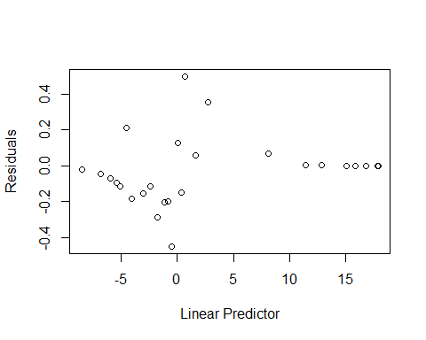

**Plot leverages.**

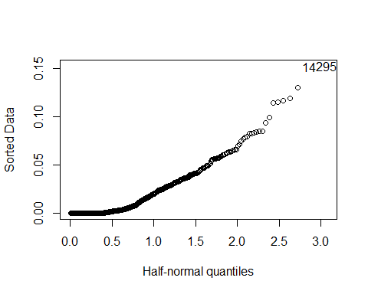

We don’t see any strong outliers with the leverage plot. The points identified (14,18) are essentially in the plot of the line formed, so they are not likely pulling our model in any direction.

**Plot Goodness of fit** 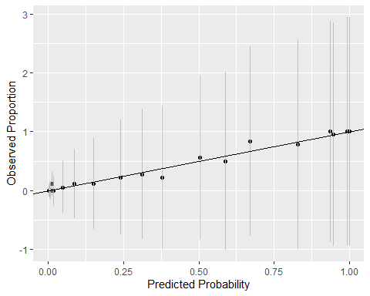

We see that our predictors fall close to the line. (Note to group, need do adjust the min max line)

### Model 2 - AIC Model

**ROC Curve** 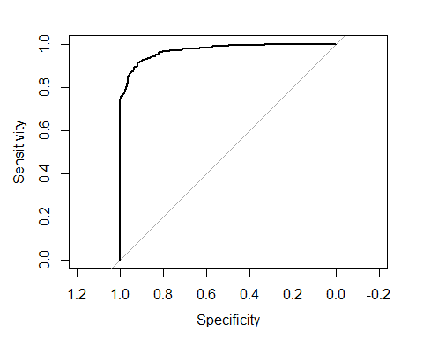

The AUC value of 0.97, tells us this model predicted values are acurate.

**Confusion Matrix**

targethat 0 1 0 218 22 1 19 207

**Create a binned diagnostic plot of residuals vs prediction**

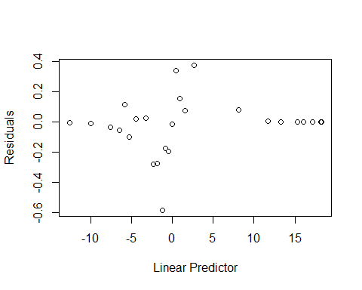

**Plot leverages.**

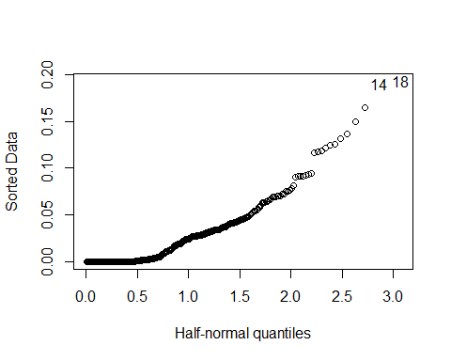

We don’t see any strong outliers with the leverage plot. The points identified (14,18) are essentially in the plot of the line formed, so they are not likely pulling our model in any direction.

**Plot Goodness of fit**

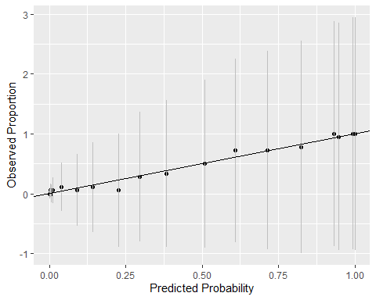

We see that our predictors fall close to the line. (Note to group, need do adjust the min max line)

### Model 3 - BIC Model

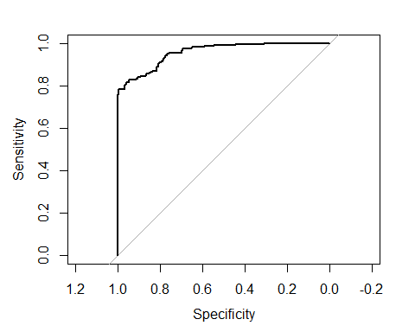  
targethat 0 1 0 214 37 1 23 192

The AUC value of 0.96, although high for this model it has the lowest AUC score.

**Create a binned diagnostic plot of residuals vs prediction**

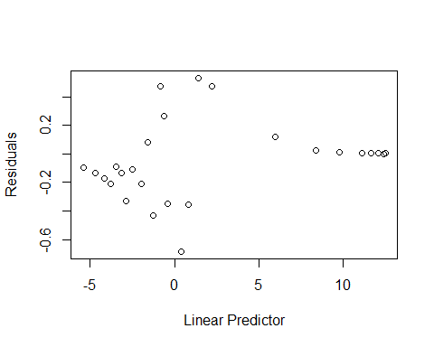

**Plot leverages.**

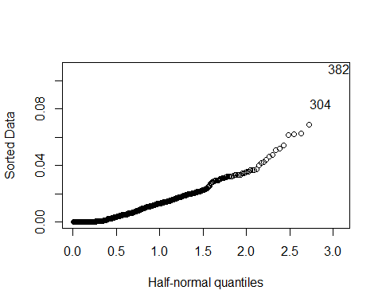

We don’t see any strong outliers with the leverage plot. The points identified (14,18) are essentially in the plot of the line formed, so they are not likely pulling our model in any direction.

**Plot Goodness of fit**

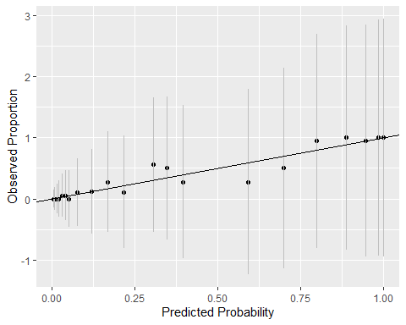

We see that our predictors fall close to the line.

## Pick the best regression model

Call: glm(formula = target ~ ., family = binomial(link = “logit”), data = crimeTrain)

Deviance Residuals: Min 1Q Median 3Q Max  
-1.8464 -0.1445 -0.0017 0.0029 3.4665

Coefficients: Estimate Std. Error z value Pr(>|z|)  
(Intercept) -40.822934 6.632913 -6.155 7.53e-10  ***zn -0.065946 0.034656 -1.903 0.05706 .***  
***indus -0.064614 0.047622 -1.357 0.17485***  
***chas 0.910765 0.755546 1.205 0.22803***  
***nox 49.122297 7.931706 6.193 5.90e-10***  rm -0.587488 0.722847 -0.813 0.41637  
age 0.034189 0.013814 2.475 0.01333 *  
dis 0.738660 0.230275 3.208 0.00134 ** rad 0.666366 0.163152 4.084 4.42e-05  ***tax -0.006171 0.002955 -2.089 0.03674***   
**ptratio 0.402566 0.126627 3.179 0.00148**  lstat 0.045869 0.054049 0.849 0.39608  
medv 0.180824 0.068294 2.648 0.00810 ** — Signif. codes: 0 ‘***’ 0.001 ’****’ 0.01 ’*’ 0.05 ‘.’ 0.1 ’ ’ 1

(Dispersion parameter for binomial family taken to be 1)

Null deviance: 645.88 on 465 degrees of freedom Residual deviance: 192.05 on 453 degrees of freedom AIC: 218.05

Number of Fisher Scoring iterations: 9 | Metric | Model 1 | Model 2 | Model 3 | Model 4 | | ——— | ———– | ———– | ———- | ———- | | AIC | 218.0469179 | 215.3228528 | 242.7968243 | 209.8265226 | | BIC | 271.9213312 | 252.6205235 | 263.5177525 | 247.1241933 |

From the above we see that Model 4, found by using the step forward selection method to do stepwise reduction of models achieves both the lowest AIC and the lowest BIC. Considering that it returns the best by both of those measures, this is the model we will use against future data (e.g., an evaulation dataset.)

## Conclusion

# APPENDIX

**Code used in analysis**

library(ggplot2) library(tidyr) library(MASS) library(psych) library(kableExtra) library(dplyr) library(faraway) library(gridExtra) library(reshape2) library(leaps) library(pROC) library(caret) library(naniar) library(pander) library(pROC) crimeTrain <- read.csv(“crime-training-data_modified.csv”) crimeEval <- read.csv(“crime-evaluation-data_modified.csv”)

## OVERVIEW

In this homework assignment, we will explore, analyze and model a data set containing information on crime for various neighborhoods of a major city. Each record has a response variable indicating whether or not the crime rate is above the median crime rate (1) or not (0).

### Objective:

The objective is to build a binary logistic regression model on the training data set to predict whether the neighborhood will be at risk for high crime levels.

## DATA EXPLORATION

### Data Summary

crimed1 <- describe(crimeTrain, na.rm = F) crimed1 $na_{c}ount<−sapply(crimeTrain,function(y)sum(length(which(is.na(y)))))crimed1$ na_count_perc <- sapply(crimeTrain, function(x) round(sum(is.na(x))/nrow(crimeTrain)*100,1))

colsTrain<-ncol(crimeTrain) colsEval<-ncol(crimeEval) missingCol<-colnames(crimeTrain)[!(colnames(crimeTrain) %in% colnames(crimeEval))]

The dataset consists of two data files: training and evaluation. The training dataset contains 13 columns, while the evaluation dataset contains 12. The evaluation dataset is missing column target which represend our responce variable and defines whether the crime rate is above the median crime rate (1) or not (0). We will start by exploring the training data set since it will be the one used to generate the regression model.

text<-“a test” if(all(apply(crimeTrain,2,function(x) is.numeric(x)))==TRUE) { text<-“all data is numeric” } else { text<-“not all data is numeric” } maxMeanMedianDiff<-round(max(abs(sapply(crimeTrain, median, na.rm = T) - sapply(crimeTrain, mean, na.rm = T))*100/(sapply(crimeTrain, max, na.rm = T)-sapply(crimeTrain, min, na.rm = T))),2)

First we see that all data is numeric. The dataset does contain one dummy variable to identify if the property borders the Charles River (1) or not (0).

nas<-as.data.frame(sapply(crimeTrain, function(x) sum(is.na(x)))) nasp<-as.data.frame(sapply(crimeTrain, function(x) round(sum(is.na(x))/nrow(crimeTrain)*100,1))) colnames(nas)<-c(“name”) maxna<-max(nas) maxnaname<-rownames(nas)[nas$name==maxna] percent<-round(maxna/nrow(crimeTrain)*100,1)

An important aspect of any dataset is to determine how much, if any, data is missing. We look at all the variables to see which if any have missing data. We look at the basic descriptive statistics as well as the missing data and their percentages:

kable(crimed1, “html”, escape = F) %>% kable_styling(bootstrap_options = c(“striped”, “hover”, “condensed”), full_width = T) %>% column_spec(1, bold = T) %>% scroll_box(width = “100%”, height = “500px”) sapply(crimeTrain, function(x) round(sum(is.na(x))/nrow(crimeTrain)*100,1)) vis_miss(crimeTrain) head(crimeTrain)

### Missing and Invalid Data

No missing data was found in the dataset.

With missing data assessed, we can look into the data in more detail. To visualize this we plot histograms for each data. Several predictors like dist, chas, rad, zn and tax are not normally distributed and noticable outliers.

attach(crimeTrain[,-1]) ggplot(gather(crimeTrain[,-1]), aes(value)) + geom_histogram(bins = 20) + facet_wrap(~key, scales = “free_x”) stripchart(data.frame(scale(crimeTrain)), method =“jitter”, las=2, vertical=TRUE)

### Mathematical transformations.

**Box Cox** The Box Cox transformation tries to transform non-normal data into a normal distribution. This transformation attemps to estimate the for Y. With the exception of tax, all predictors have either no transformation extimate or were given a fudge value of 0.

crimeTrain_bct <- apply(crimeTrain, 2, BoxCoxTrans) crimeTrain_bct

### Variable Creation / Removal

To determine how we can combine variables to create new one we start by looking at a correlation plot. The plot and cor funtion lists nox, age, rad,tax and indus as the strongest postively correlated predictors, while rad and distance are the strongest negatively correlated predictors. cor(crimeTrain$target, crimeTrain[-c(1)], use=“na.or.complete”)

corrplot::corrplot(cor(crimeTrain[,1:13]), order = “hclust”, method=‘square’, addrect = 2, tl.col = “black”, tl.cex = .75, na.label = " ")

## BUILD MODELS

### General regression

We start by building a model with all the predictors in the dataset.

m1<-glm(target~.,data=crimeTrain,family=“binomial”(link=“logit”)) summary(m1)

The Summary of this model shows several predictor are not relevant. We build a second model without these predictors.

m1.1<-glm(target~nox+age+dis+rad+tax+ptratio+medv,data=crimeTrain,family=“binomial”(link=“logit”)) summary(m1.1)

1-pchisq(m1.1 $deviance,m1.1$ df.residual) 1-pchisq(m1 $deviance,m1$ df.residual)

The new model has a slightly higher AIC which would tells us the first model is slightly less complex. For the 2 data sets p-value = 1 - pchisq(deviance, degrees of freedom) are 1. The Null hypothesis is still supported.

### AIC Step Method

Another way of selecting which predictors to use in the model is by calculating the AIC of the model. This metric is similar to the adjusted R-square of a model in that it penalizes models with more predictors over simpler model with few predictors. We use Stepwise function in r to find the lowest AIC with different predictors.

m2 <- step(m1) summary(m2)

This reduces the predictors used in the model to these: zn nox age dis rad tax ptRation medv

It Removes these predictors: indus chas rm#

The AIC improves marginally from 218.05 (our original general model) to 215.32, but we also benefit by having a simpler model less prone to overfitting.

Also, the predictors in the model now are all signficant (under 0.05 pr level) and all but one under .01 or very significant. Which is much improved over the prior model

### BIC Method

To determine the number of predictors and which predictors to be used we will use the Bayesian Information Criterion (BIC).

regfit.full <- regsubsets(factor(target) ~ ., data=crimeTrain) par(mfrow = c(1,2)) reg.summary <- summary(regfit.full) plot(reg.summary$bic, xlab="Number of Predictors", ylab="BIC", type="l", main="Subset Selection Using BIC") BIC_num <- which.min(reg.summary$bic) points(BIC_num, reg.summary$bic[BIC_num], col=“red”, cex=2, pch=20) plot(regfit.full, scale=“bic”, main=“Predictors vs. BIC”) par(mfrow = c(1,1))

The plot on the right shows that the number of predictors with the lowest BIC are nox , age, rad, and medv. We will use those predictors to build the next model

m3 <- glm(target ~ nox + age + rad + medv, family=binomial, data = crimeTrain) crimeTrain $predicted_{m}3<−predict(m3,crimeTrain,type=′response′)crimeTrain$ target_m3 $target<−ifelse(crimeTrain$ predicted_m3>0.5, 1, 0) pander::pander(summary(m3))

Forward Selection Method using some BoxCox transformed independent variables:

{r echo=FALSE, warning=FALSE, message=FALSE, results=“asis”} m4 <- step(glm(target~1, data=crimeTrain), direction = “forward”, scope = ~zn + I(log(indus)) + I(sqrt(chas)) + I(nox^-1) + I(log(rm)) + I(age^2) + I(dis^-.5) + rad + I(tax^-1) + I(ptratio^2) + lstat + medv) summary(m4)

## SELECT MODELS

Compare Model Statistics

### Model 1 - General Model

Complete general model

#### **ROC Curve**

The ROC Curve helps measure true positives and true negative. A high AUC or area under the curve tells us the model is predicting well.

targethat<-predict(m1,type=“response”) g<-roc(target~targethat,data=crimeTrain) plot(g)

The AUC value of 0.96, tells us this model predicted values are acurate.

#### **Confusion Matrix**

targethat[targethat<0.5]<-0 targethat[targethat>=0.5]<-1 table(targethat,crimeTrain$target)

#### **Create a binned diagnostic plot of residuals vs prediction**

There are definite patterns here, which bear investigating.

crimeMut <- mutate(crimeTrain, Residuals = residuals(m1), linPred = predict(m1)) grpCrime <- group_by(crimeMut, cut(linPred, breaks=unique(quantile(linPred, (0:25/26))))) diagCrime <- summarise(grpCrime, Residuals = mean(Residuals), linPred = mean(linPred)) plot(Residuals ~ linPred, data = diagCrime, xlab=“Linear Predictor”)

#### **Plot leverages.**

halfnorm(hatvalues(m1))

We don’t see any strong outliers with the leverage plot. The points identified (14,18) are essentially in the plot of the line formed, so they are not likely pulling our model in any direction.

#### **Plot Goodness of fit**

linPred <- predict(m1) crimeMut <- mutate(crimeTrain, predProb = predict(m1, type = “response”)) grpCrime <- group_by(crimeMut, cut(linPred, breaks = unique(quantile(linPred, (0:25)/26))))

hlDf <- summarise(grpCrime, y= sum(target), pPred=mean(predProb), count = n()) hlDf <- mutate(hlDf, se.fit=sqrt(pPred * (1-(pPred)/count))) ggplot(hlDf,aes(x=pPred,y=y/count,ymin=y/count-2*se.fit,ymax=y/count+2*se.fit)) + geom_point()+geom_linerange(color=grey(0.75))+geom_abline(intercept=0,slope=1) + xlab(“Predicted Probability”) + ylab(“Observed Proportion”)

We see that our predictors fall close to the line. (Note to group, need do adjust the min max line)

### Reduced general model

#### **ROC Curve**

targethat<-predict(m1.1,type=“response”) g<-roc(target~targethat,data=crimeTrain) plot(g)

This model also show a high AUC value of 0.96. This tells us predicted values are acurate, although slightly lower.

#### **Confusion Matrix**

targethat[targethat<0.5]<-0 targethat[targethat>=0.5]<-1 table(targethat,crimeTrain$target)

#### **Create a binned diagnostic plot of residuals vs prediction**

There are definite patterns here, which bear investigating.

crimeMut <- mutate(crimeTrain, Residuals = residuals(m1.1), linPred = predict(m1.1)) grpCrime <- group_by(crimeMut, cut(linPred, breaks=unique(quantile(linPred, (0:25/26))))) diagCrime <- summarise(grpCrime, Residuals = mean(Residuals), linPred = mean(linPred)) plot(Residuals ~ linPred, data = diagCrime, xlab=“Linear Predictor”)

#### **Plot leverages.**

halfnorm(hatvalues(m1.1))

We don’t see any strong outliers with the leverage plot. The points identified (14,18) are essentially in the plot of the line formed, so they are not likely pulling our model in any direction.

#### **Plot Goodness of fit**

linPred <- predict(m1.1) crimeMut <- mutate(crimeTrain, predProb = predict(m1.1, type = “response”)) grpCrime <- group_by(crimeMut, cut(linPred, breaks = unique(quantile(linPred, (0:25)/26))))

hlDf <- summarise(grpCrime, y= sum(target), pPred=mean(predProb), count = n()) hlDf <- mutate(hlDf, se.fit=sqrt(pPred * (1-(pPred)/count))) ggplot(hlDf,aes(x=pPred,y=y/count,ymin=y/count-2*se.fit,ymax=y/count+2*se.fit)) + geom_point()+geom_linerange(color=grey(0.75))+geom_abline(intercept=0,slope=1) + xlab(“Predicted Probability”) + ylab(“Observed Proportion”)

We see that our predictors fall close to the line. (Note to group, need do adjust the min max line)

### Model 2 - AIC Model

#### **ROC Curve**

targethat<-predict(m2,type=“response”) g<-roc(target~targethat,data=crimeTrain) plot(g)

The AUC value of 0.96, tells us this model predicted values are acurate.

#### **Confusion Matrix**

targethat[targethat<0.5]<-0 targethat[targethat>=0.5]<-1 table(targethat,crimeTrain$target)

#### **Create a binned diagnostic plot of residuals vs prediction**

crimeMut <- mutate(crimeTrain, Residuals = residuals(m2), linPred = predict(m2)) grpCrime <- group_by(crimeMut, cut(linPred, breaks=unique(quantile(linPred, (0:25/26))))) diagCrime <- summarise(grpCrime, Residuals = mean(Residuals), linPred = mean(linPred)) plot(Residuals ~ linPred, data = diagCrime, xlab=“Linear Predictor”)

#### **Plot leverages.**

halfnorm(hatvalues(m2))

We don’t see any strong outliers with the leverage plot. The points identified (14,18) are essentially in the plot of the line formed, so they are not likely pulling our model in any direction.

#### **Plot Goodness of fit**

linPred <- predict(m2) crimeMut <- mutate(crimeTrain, predProb = predict(m2, type = “response”)) grpCrime <- group_by(crimeMut, cut(linPred, breaks = unique(quantile(linPred, (0:25)/26))))

hlDf <- summarise(grpCrime, y= sum(target), pPred=mean(predProb), count = n()) hlDf <- mutate(hlDf, se.fit=sqrt(pPred * (1-(pPred)/count))) ggplot(hlDf,aes(x=pPred,y=y/count,ymin=y/count-2*se.fit,ymax=y/count+2*se.fit)) + geom_point()+geom_linerange(color=grey(0.75))+geom_abline(intercept=0,slope=1) + xlab(“Predicted Probability”) + ylab(“Observed Proportion”)

We see that our predictors fall close to the line. (Note to group, need do adjust the min max line)

### Model 3 - BIC Model

targethat<-predict(m3,type=“response”) g<-roc(target~targethat,data=crimeTrain) plot(g) targethat[targethat<0.5]<-0 targethat[targethat>=0.5]<-1 table(targethat,crimeTrain$target)

The AUC value of 0.96, although high for this model it has the lowest AUC score.

#### **Create a binned diagnostic plot of residuals vs prediction**

crimeMut <- mutate(crimeTrain, Residuals = residuals(m3), linPred = predict(m3)) grpCrime <- group_by(crimeMut, cut(linPred, breaks=unique(quantile(linPred, (0:25/26))))) diagCrime <- summarise(grpCrime, Residuals = mean(Residuals), linPred = mean(linPred)) plot(Residuals ~ linPred, data = diagCrime, xlab=“Linear Predictor”)

#### **Plot leverages.**

halfnorm(hatvalues(m3))

We don’t see any strong outliers with the leverage plot. The points identified (14,18) are essentially in the plot of the line formed, so they are not likely pulling our model in any direction.

#### **Plot Goodness of fit**

linPred <- predict(m3) crimeMut <- mutate(crimeTrain, predProb = predict(m3, type = “response”)) grpCrime <- group_by(crimeMut, cut(linPred, breaks = unique(quantile(linPred, (0:25)/26))))

hlDf <- summarise(grpCrime, y= sum(target), pPred=mean(predProb), count = n()) hlDf <- mutate(hlDf, se.fit=sqrt(pPred * (1-(pPred)/count))) ggplot(hlDf,aes(x=pPred,y=y/count,ymin=y/count-2*se.fit,ymax=y/count+2*se.fit)) + geom_point()+geom_linerange(color=grey(0.75))+geom_abline(intercept=0,slope=1) + xlab(“Predicted Probability”) + ylab(“Observed Proportion”)

We see that our predictors fall close to the line.

Pick the best regression model

m1AIC <- AIC(m1) m1BIC <- BIC(m1) m2AIC <- AIC(m2) m2BIC <- BIC(m2) m3AIC <- AIC(m3) m3BIC <- BIC(m3) m4AIC <- AIC(m4) m4BIC <- BIC(m4) summary(m1)