Data 621 Homework 4: Car Insurance

Tommy Jenkins, Violeta Stoyanova, Todd Weigel, Peter Kowalchuk, Eleanor R-Secoquian, Anthony Pagan

November 15, 2019

# OVERVIEW

In this homework assignment, we will explore, analyze and model a data set containing approximately 8000 records representing a customer at an auto insurance company. Each record has two response variables. The first response variable, TARGET_FLAG, is a 1 or a 0. A “1” means that the person was in a car crash. A zero means that the person was not in a car crash. The second response variable is TARGET_AMT. This value is zero if the person did not crash their car. But if they did crash their car, this number will be a value greater than zero representing the cost of the crash.

## Objective:

Our objective is to build multiple linear regression and binary logistic regression models on the training data to predict the probability that a person will crash their car and also the amount of money it will cost if the person does crash their car.

# DATA EXPLORATION

## Data Summary

The dataset consists of two data files: training and evaluation. The training dataset contains 26 columns, while the evaluation dataset contains 26. The evaluation dataset is missing columns which represent our response variables, respectively whether the person was in a car crash and the cost of the car crash if the person was in an accident. We will start by exploring the training data set since it will be the one used to generate the models.

The columns in the data set are:

## Missing Data

An important aspect of any dataset is to determine how much, if any, data is missing. We look at all the variables to see which if any have missing data. We look at the basic descriptive statistics as well as the missing data and percentages.

We start by looking at the dataset as a whole and determine how many complete rows, that is rows with data for all predictors, do we have.

## Mode FALSE TRUE   
## logical 2116 6045

With these results, if we remove all rows with incomplete rows, there will be a total of 6045 rows out of 8161 .If we eliminate all non-complete rows and keep only rows with data for all the predictors in the dataset, our new dataset will results in 74% of the total dataset. We create a subset of data with complete cases only to use later in our analysis.

## Observations: 6,045  
## Variables: 26  
## $ INDEX <int> 1, 2, 4, 7, 12, 13, 14, 15, 16, 19, 20, 22, 23, 24...  
## $ TARGET_FLAG <int> 0, 0, 0, 1, 1, 0, 1, 0, 0, 1, 0, 0, 0, 0, 1, 0, 0,...  
## $ TARGET_AMT <dbl> 0.000, 0.000, 0.000, 2946.000, 2501.000, 0.000, 60...  
## $ KIDSDRIV <int> 0, 0, 0, 0, 0, 0, 0, 0, 0, 0, 0, 0, 0, 0, 0, 0, 0,...  
## $ AGE <int> 60, 43, 35, 34, 34, 50, 53, 43, 55, 45, 39, 42, 34...  
## $ HOMEKIDS <int> 0, 0, 1, 1, 0, 0, 0, 0, 0, 0, 3, 0, 3, 2, 1, 0, 0,...  
## $ YOJ <int> 11, 11, 10, 12, 10, 7, 14, 5, 11, 0, 12, 11, 13, 1...  
## $ INCOME <fct> "$67,349", "$91,449", "$16,039", "$125,301", "$62,...  
## $ PARENT1 <fct> No, No, No, Yes, No, No, No, No, No, No, Yes, No, ...  
## $ HOME_VAL <fct> "$0", "$257,252", "$124,191", "$0", "$0", "$0", "$...  
## $ MSTATUS <fct> z_No, z_No, Yes, z_No, z_No, z_No, z_No, Yes, Yes,...  
## $ SEX <fct> M, M, z_F, z_F, z_F, M, z_F, z_F, M, z_F, z_F, M, ...  
## $ EDUCATION <fct> PhD, z_High School, z_High School, Bachelors, Bach...  
## $ JOB <fct> Professional, z_Blue Collar, Clerical, z_Blue Coll...  
## $ TRAVTIME <int> 14, 22, 5, 46, 34, 48, 15, 36, 25, 48, 43, 42, 27,...  
## $ CAR_USE <fct> Private, Commercial, Private, Commercial, Private,...  
## $ BLUEBOOK <fct> "$14,230", "$14,940", "$4,010", "$17,430", "$11,20...  
## $ TIF <int> 11, 1, 4, 1, 1, 7, 1, 7, 7, 1, 6, 6, 7, 4, 6, 6, 1...  
## $ CAR_TYPE <fct> Minivan, Minivan, z_SUV, Sports Car, z_SUV, Van, S...  
## $ RED_CAR <fct> yes, yes, no, no, no, no, no, no, yes, no, no, no,...  
## $ OLDCLAIM <fct> "$4,461", "$0", "$38,690", "$0", "$0", "$0", "$0",...  
## $ CLM_FREQ <int> 2, 0, 2, 0, 0, 0, 0, 0, 2, 0, 0, 0, 0, 0, 2, 1, 0,...  
## $ REVOKED <fct> No, No, No, No, No, No, No, No, Yes, No, No, No, N...  
## $ MVR_PTS <int> 3, 0, 3, 0, 0, 1, 0, 0, 3, 3, 0, 0, 0, 0, 0, 5, 1,...  
## $ CAR_AGE <int> 18, 1, 10, 7, 1, 17, 11, 1, 9, 5, 13, 16, 20, 7, 1...  
## $ URBANICITY <fct> Highly Urban/ Urban, Highly Urban/ Urban, Highly U...

But we can also look at what specific predictors are missing in our dataset. If we do this we can see how there is much more data available, as we find only 5 predictors with missing data. Data missing for these predictors also only accounts for less than 7% of the respective predictors total.

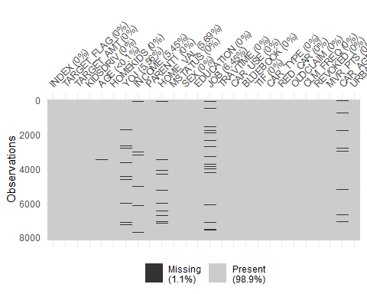

We look closer at the missing data and look at the intersection of predictors with missing data. We find that the bulk of the missing data is for predictors with no intersection with other missing predictor data.

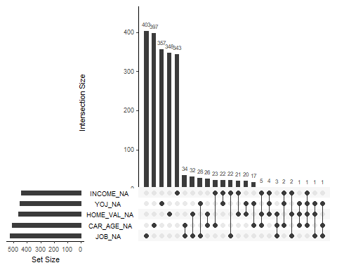

Having this detail in missing data might be of importance when looking at models. In the next Data Preparation section we will handle these missing cases and build a data set with data for all predictors in all rows.

## Data Exploration

Using TARGET_FLAG as response variables we confirm when TARGET_FLAG is 1 TARGET_AMOUNT >0 and when TARGET_FLAG is 0 when TARGET_AMOUNT = 0

nrow(subset(InsTrain,TARGET_FLAG == 0))

## [1] 6008

nrow(subset(InsTrain,TARGET_AMT == 0))

## [1] 6008

nrow(subset(InsTrain,TARGET_FLAG > 0))

## [1] 2153

nrow(subset(InsTrain,TARGET_AMT > 0))

## [1] 2153

A glimpse of the data shows that the following columns should be integers and not Factors:

* INCOME
* HOME_VAL
* BLUEBOOK
* OLDCLAIM

We display and view data with all cases and only complete cases

## INCOME PARENT1 HOME_VAL MSTATUS SEX EDUCATION JOB CAR_USE BLUEBOOK CAR_TYPE RED_CAR OLDCLAIM REVOKED URBANICITY

## Observations: 8,161  
## Variables: 26  
## $ INDEX <int> 1, 2, 4, 5, 6, 7, 8, 11, 12, 13, 14, 15, 16, 17, 1...  
## $ TARGET_FLAG <int> 0, 0, 0, 0, 0, 1, 0, 1, 1, 0, 1, 0, 0, 1, 1, 0, 0,...  
## $ TARGET_AMT <dbl> 0.000, 0.000, 0.000, 0.000, 0.000, 2946.000, 0.000...  
## $ KIDSDRIV <int> 0, 0, 0, 0, 0, 0, 0, 1, 0, 0, 0, 0, 0, 0, 0, 0, 0,...  
## $ AGE <int> 60, 43, 35, 51, 50, 34, 54, 37, 34, 50, 53, 43, 55...  
## $ HOMEKIDS <int> 0, 0, 1, 0, 0, 1, 0, 2, 0, 0, 0, 0, 0, 0, 0, 3, 0,...  
## $ YOJ <int> 11, 11, 10, 14, NA, 12, NA, NA, 10, 7, 14, 5, 11, ...  
## $ INCOME <fct> "$67,349", "$91,449", "$16,039", NA, "$114,986", "...  
## $ PARENT1 <fct> No, No, No, No, No, Yes, No, No, No, No, No, No, N...  
## $ HOME_VAL <fct> "$0", "$257,252", "$124,191", "$306,251", "$243,92...  
## $ MSTATUS <fct> z_No, z_No, Yes, Yes, Yes, z_No, Yes, Yes, z_No, z...  
## $ SEX <fct> M, M, z_F, M, z_F, z_F, z_F, M, z_F, M, z_F, z_F, ...  
## $ EDUCATION <fct> PhD, z_High School, z_High School, <High School, P...  
## $ JOB <fct> Professional, z_Blue Collar, Clerical, z_Blue Coll...  
## $ TRAVTIME <int> 14, 22, 5, 32, 36, 46, 33, 44, 34, 48, 15, 36, 25,...  
## $ CAR_USE <fct> Private, Commercial, Private, Private, Private, Co...  
## $ BLUEBOOK <fct> "$14,230", "$14,940", "$4,010", "$15,440", "$18,00...  
## $ TIF <int> 11, 1, 4, 7, 1, 1, 1, 1, 1, 7, 1, 7, 7, 6, 1, 6, 6...  
## $ CAR_TYPE <fct> Minivan, Minivan, z_SUV, Minivan, z_SUV, Sports Ca...  
## $ RED_CAR <fct> yes, yes, no, yes, no, no, no, yes, no, no, no, no...  
## $ OLDCLAIM <fct> "$4,461", "$0", "$38,690", "$0", "$19,217", "$0", ...  
## $ CLM_FREQ <int> 2, 0, 2, 0, 2, 0, 0, 1, 0, 0, 0, 0, 2, 0, 0, 0, 0,...  
## $ REVOKED <fct> No, No, No, No, Yes, No, No, Yes, No, No, No, No, ...  
## $ MVR_PTS <int> 3, 0, 3, 0, 3, 0, 0, 10, 0, 1, 0, 0, 3, 3, 3, 0, 0...  
## $ CAR_AGE <int> 18, 1, 10, 6, 17, 7, 1, 7, 1, 17, 11, 1, 9, 10, 5,...  
## $ URBANICITY <fct> Highly Urban/ Urban, Highly Urban/ Urban, Highly U...

We use Sapply function to review which columns have NA Values. It display columns and percent of values that are missing.

## INDEX TARGET_FLAG TARGET_AMT KIDSDRIV AGE HOMEKIDS   
## 0.0 0.0 0.0 0.0 0.1 0.0   
## YOJ INCOME PARENT1 HOME_VAL MSTATUS SEX   
## 5.6 5.5 0.0 5.7 0.0 0.0   
## EDUCATION JOB TRAVTIME CAR_USE BLUEBOOK TIF   
## 0.0 6.4 0.0 0.0 0.0 0.0   
## CAR_TYPE RED_CAR OLDCLAIM CLM_FREQ REVOKED MVR_PTS   
## 0.0 0.0 0.0 0.0 0.0 0.0   
## CAR_AGE URBANICITY   
## 6.2 0.0

## Data Preparation

As revealed earlier there were a list of columns that we factors that should be integers. We start by converting the columns to numeric.

## Observations: 8,161  
## Variables: 4  
## $ INCOME <fct> "$67,349", "$91,449", "$16,039", NA, "$114,986", "$12...  
## $ HOME_VAL <fct> "$0", "$257,252", "$124,191", "$306,251", "$243,925",...  
## $ BLUEBOOK <fct> "$14,230", "$14,940", "$4,010", "$15,440", "$18,000",...  
## $ OLDCLAIM <fct> "$4,461", "$0", "$38,690", "$0", "$19,217", "$0", "$0...  
## Observations: 8,161  
## Variables: 4  
## $ INCOME <int> 67349, 91449, 16039, NA, 114986, 125301, 18755, 10796...  
## $ HOME_VAL <int> 0, 257252, 124191, 306251, 243925, 0, NA, 333680, 0, ...  
## $ BLUEBOOK <int> 14230, 14940, 4010, 15440, 18000, 17430, 8780, 16970,...  
## $ OLDCLAIM <int> 4461, 0, 38690, 0, 19217, 0, 0, 2374, 0, 0, 0, 0, 502...

Both boxplot and summary stats with the square root transform of Home_val and Income to confirm we can use median or mean values to replace NA values if we chose.

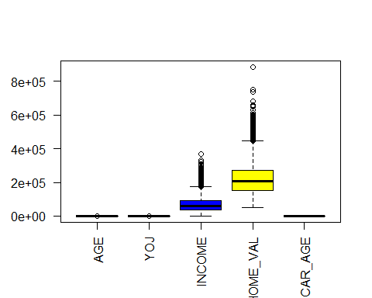

## vars n mean sd median trimmed mad min  
## AGE 1 8155 44.79 8.63 45 44.83 8.90 16  
## YOJ 2 7707 10.50 4.09 11 11.07 2.97 0  
## INCOME 3 7101 67258.94 45810.25 58438 61952.41 39533.53 5  
## HOME_VAL 4 5403 220620.68 96145.72 206692 211487.81 85498.58 50223  
## CAR_AGE 5 7651 8.33 5.70 8 7.96 7.41 -3  
## max range skew kurtosis se  
## AGE 81 65 -0.03 -0.06 0.10  
## YOJ 23 23 -1.20 1.18 0.05  
## INCOME 367030 367025 1.30 2.50 543.63  
## HOME_VAL 885282 835059 1.09 1.97 1308.01  
## CAR_AGE 28 31 0.28 -0.75 0.07

We next replace all NA values with mean values for cases that are missing values and rerun sapply function to confirm there are no longer any missing values.

## INDEX TARGET_FLAG TARGET_AMT KIDSDRIV AGE HOMEKIDS   
## 0.0 0.0 0.0 0.0 0.1 0.0   
## YOJ INCOME PARENT1 HOME_VAL MSTATUS SEX   
## 5.6 13.0 0.0 33.8 0.0 0.0   
## EDUCATION JOB TRAVTIME CAR_USE BLUEBOOK TIF   
## 0.0 6.4 0.0 0.0 0.0 0.0   
## CAR_TYPE RED_CAR OLDCLAIM CLM_FREQ REVOKED MVR_PTS   
## 0.0 0.0 0.0 0.0 0.0 0.0   
## CAR_AGE URBANICITY   
## 6.2 0.0

## Clerical Doctor Home Maker Lawyer Manager   
## 1271 246 641 835 988   
## Professional Student z_Blue Collar NA's   
## 1117 712 1825 526

## [1] 6

## Clerical Doctor Home Maker Lawyer Manager   
## 1271 246 641 835 988   
## Professional Student z_Blue Collar   
## 1117 712 2351

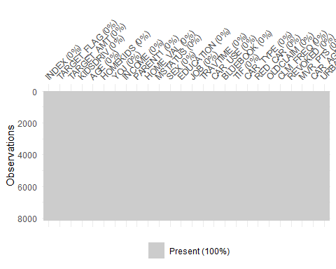

## vars n mean sd median trimmed mad min  
## AGE 1 8161 44.79 8.62 45.00 44.83 8.90 16  
## YOJ 2 8161 10.50 3.98 11.00 11.05 2.97 0  
## INCOME 3 8161 67258.94 42731.37 66367.00 62497.52 36362.25 5  
## HOME_VAL 4 8161 220620.68 78227.99 220620.68 214305.03 41344.79 50223  
## CAR_AGE 5 8161 8.33 5.52 8.33 7.98 5.44 -3  
## max range skew kurtosis se  
## AGE 81 65 -0.03 -0.06 0.10  
## YOJ 23 23 -1.24 1.42 0.04  
## INCOME 367030 367025 1.40 3.32 473.02  
## HOME_VAL 885282 835059 1.34 4.50 865.95  
## CAR_AGE 28 31 0.29 -0.60 0.06

We have this way derived a dataset with no missing values. We can use this set of data for our modeling design. We chose to work with this data as opposed to the first “complete” set in which rows with missing data were eliminated.

# Build Model

Modeling design will be divided in two phases. First we will design a model to predict if the person is in a car crash, that is predict TARGET_FLAG. In a second phase, we will predict TARGET_AMT, the cost of the crash.

## TARGET_FLAG Modeling

This response variable being binary, o or 1, we will be looking at logistic regression models to find a good fit. We will start with a naive model with all the predictors included as a baseline. First approach will be to simply the model by reducing the predictors used. We will look at several model metrics such as AIC, BIC. We will also include confusion tables and ROC plot to better understand each model.

**Model 1: all predictors**

We start out with a straightforward logit logistical regression with all predictors included. As a note, we need to make sure we do not include the TARGET_AMT responce variable in our model as a predictor.

##   
## Call:  
## glm(formula = TARGET_FLAG ~ . - INDEX - TARGET_AMT, family = binomial(link = "logit"),   
## data = InsTrain)  
##   
## Deviance Residuals:   
## Min 1Q Median 3Q Max   
## -2.5548 -0.7184 -0.4032 0.6346 3.1472   
##   
## Coefficients:  
## Estimate Std. Error z value Pr(>|z|)   
## (Intercept) -4.750e-01 2.748e-01 -1.728 0.083915 .   
## KIDSDRIV 3.847e-01 6.101e-02 6.306 2.87e-10 ***  
## AGE -8.588e-04 4.011e-03 -0.214 0.830483   
## HOMEKIDS 5.680e-02 3.720e-02 1.527 0.126829   
## YOJ -1.914e-02 8.888e-03 -2.154 0.031261 *   
## INCOME -2.155e-06 1.162e-06 -1.855 0.063585 .   
## PARENT1Yes 3.795e-01 1.095e-01 3.467 0.000526 ***  
## HOME_VAL -9.005e-07 5.908e-07 -1.524 0.127471   
## MSTATUSz_No 6.329e-01 7.272e-02 8.703 < 2e-16 ***  
## SEXz_F -7.739e-02 1.118e-01 -0.692 0.488791   
## EDUCATIONBachelors -4.599e-01 1.144e-01 -4.018 5.86e-05 ***  
## EDUCATIONMasters -5.141e-01 1.532e-01 -3.357 0.000789 ***  
## EDUCATIONPhD -4.617e-01 1.880e-01 -2.456 0.014063 *   
## EDUCATIONz_High School -1.365e-02 9.467e-02 -0.144 0.885335   
## JOBDoctor -7.034e-01 2.656e-01 -2.648 0.008092 **   
## JOBHome Maker -6.625e-02 1.425e-01 -0.465 0.642047   
## JOBLawyer -1.851e-01 1.616e-01 -1.146 0.251943   
## JOBManager -9.248e-01 1.356e-01 -6.822 8.98e-12 ***  
## JOBProfessional -2.485e-01 1.215e-01 -2.045 0.040901 *   
## JOBStudent -2.503e-03 1.301e-01 -0.019 0.984651   
## JOBz_Blue Collar -1.727e-01 1.049e-01 -1.645 0.099934 .   
## TRAVTIME 1.464e-02 1.878e-03 7.791 6.64e-15 ***  
## CAR_USEPrivate -7.768e-01 9.085e-02 -8.550 < 2e-16 ***  
## BLUEBOOK -2.204e-05 5.235e-06 -4.210 2.56e-05 ***  
## TIF -5.561e-02 7.333e-03 -7.583 3.37e-14 ***  
## CAR_TYPEPanel Truck 4.823e-01 1.577e-01 3.058 0.002230 **   
## CAR_TYPEPickup 5.241e-01 9.983e-02 5.250 1.52e-07 ***  
## CAR_TYPESports Car 1.022e+00 1.297e-01 7.883 3.20e-15 ***  
## CAR_TYPEVan 5.776e-01 1.251e-01 4.618 3.87e-06 ***  
## CAR_TYPEz_SUV 7.609e-01 1.112e-01 6.842 7.83e-12 ***  
## RED_CARyes -1.577e-03 8.608e-02 -0.018 0.985383   
## OLDCLAIM -1.404e-05 3.902e-06 -3.598 0.000320 ***  
## CLM_FREQ 1.992e-01 2.847e-02 6.997 2.62e-12 ***  
## REVOKEDYes 8.955e-01 9.104e-02 9.837 < 2e-16 ***  
## MVR_PTS 1.152e-01 1.357e-02 8.489 < 2e-16 ***  
## CAR_AGE -5.591e-04 7.516e-03 -0.074 0.940704   
## URBANICITYz_Highly Rural/ Rural -2.383e+00 1.129e-01 -21.103 < 2e-16 ***  
## ---  
## Signif. codes: 0 '***' 0.001 '**' 0.01 '*' 0.05 '.' 0.1 ' ' 1  
##   
## (Dispersion parameter for binomial family taken to be 1)  
##   
## Null deviance: 9418.0 on 8160 degrees of freedom  
## Residual deviance: 7327.1 on 8124 degrees of freedom  
## AIC: 7401.1  
##   
## Number of Fisher Scoring iterations: 5

From the model’s summary itself we see that there are several predictors which are not statistically relevant, which suggest a simpler model should be possible. We build a second model without the non-significant predictors.

**Model 2: reduced predictors**

##   
## Call:  
## glm(formula = TARGET_FLAG ~ . - INDEX - TARGET_AMT - AGE - INCOME -   
## JOB - BLUEBOOK - CAR_AGE - RED_CAR, family = binomial(link = "logit"),   
## data = InsTrain)  
##   
## Deviance Residuals:   
## Min 1Q Median 3Q Max   
## -2.4982 -0.7289 -0.4194 0.6476 3.1224   
##   
## Coefficients:  
## Estimate Std. Error z value Pr(>|z|)   
## (Intercept) -6.275e-01 1.842e-01 -3.406 0.000658 ***  
## KIDSDRIV 3.483e-01 5.950e-02 5.854 4.79e-09 ***  
## HOMEKIDS 9.058e-02 3.372e-02 2.687 0.007219 **   
## YOJ -2.828e-02 7.362e-03 -3.842 0.000122 ***  
## PARENT1Yes 3.696e-01 1.077e-01 3.432 0.000598 ***  
## HOME_VAL -2.108e-06 4.702e-07 -4.483 7.38e-06 ***  
## MSTATUSz_No 6.213e-01 7.191e-02 8.641 < 2e-16 ***  
## SEXz_F -2.529e-01 8.790e-02 -2.878 0.004007 **   
## EDUCATIONBachelors -7.334e-01 9.571e-02 -7.663 1.82e-14 ***  
## EDUCATIONMasters -8.017e-01 1.049e-01 -7.642 2.14e-14 ***  
## EDUCATIONPhD -9.544e-01 1.391e-01 -6.864 6.70e-12 ***  
## EDUCATIONz_High School -1.246e-01 9.123e-02 -1.366 0.172010   
## TRAVTIME 1.496e-02 1.866e-03 8.017 1.08e-15 ***  
## CAR_USEPrivate -8.298e-01 7.286e-02 -11.388 < 2e-16 ***  
## TIF -5.428e-02 7.270e-03 -7.466 8.26e-14 ***  
## CAR_TYPEPanel Truck 1.106e-01 1.317e-01 0.839 0.401223   
## CAR_TYPEPickup 5.561e-01 9.698e-02 5.734 9.81e-09 ***  
## CAR_TYPESports Car 1.208e+00 1.201e-01 10.053 < 2e-16 ***  
## CAR_TYPEVan 4.075e-01 1.186e-01 3.435 0.000592 ***  
## CAR_TYPEz_SUV 9.573e-01 1.017e-01 9.411 < 2e-16 ***  
## OLDCLAIM -1.403e-05 3.862e-06 -3.632 0.000281 ***  
## CLM_FREQ 2.006e-01 2.824e-02 7.104 1.21e-12 ***  
## REVOKEDYes 9.037e-01 9.019e-02 10.021 < 2e-16 ***  
## MVR_PTS 1.205e-01 1.347e-02 8.946 < 2e-16 ***  
## URBANICITYz_Highly Rural/ Rural -2.283e+00 1.119e-01 -20.400 < 2e-16 ***  
## ---  
## Signif. codes: 0 '***' 0.001 '**' 0.01 '*' 0.05 '.' 0.1 ' ' 1  
##   
## (Dispersion parameter for binomial family taken to be 1)  
##   
## Null deviance: 9418.0 on 8160 degrees of freedom  
## Residual deviance: 7425.7 on 8136 degrees of freedom  
## AIC: 7475.7  
##   
## Number of Fisher Scoring iterations: 5

The new model has a slightly higher AIC which would tells us the first model is slightly less complex.

### AIC Step Method Model 3

Another way of selecting which predictors to use in the model is by calculating the AIC of the model. This metric is similar to the adjusted R-square of a model in that it penalizes models with more predictors over simpler model with few predictors. We use Stepwise function in r to find the lowest AIC with different predictors.

## Start: AIC=7401.13  
## TARGET_FLAG ~ (INDEX + TARGET_AMT + KIDSDRIV + AGE + HOMEKIDS +   
## YOJ + INCOME + PARENT1 + HOME_VAL + MSTATUS + SEX + EDUCATION +   
## JOB + TRAVTIME + CAR_USE + BLUEBOOK + TIF + CAR_TYPE + RED_CAR +   
## OLDCLAIM + CLM_FREQ + REVOKED + MVR_PTS + CAR_AGE + URBANICITY) -   
## INDEX - TARGET_AMT  
##   
## Df Deviance AIC  
## - RED_CAR 1 7327.1 7399.1  
## - CAR_AGE 1 7327.1 7399.1  
## - AGE 1 7327.2 7399.2  
## - SEX 1 7327.6 7399.6  
## <none> 7327.1 7401.1  
## - HOMEKIDS 1 7329.4 7401.4  
## - HOME_VAL 1 7329.5 7401.5  
## - INCOME 1 7330.6 7402.6  
## - YOJ 1 7331.8 7403.8  
## - PARENT1 1 7339.2 7411.2  
## - OLDCLAIM 1 7340.3 7412.3  
## - BLUEBOOK 1 7345.2 7417.2  
## - EDUCATION 4 7356.1 7422.1  
## - KIDSDRIV 1 7366.9 7438.9  
## - CLM_FREQ 1 7375.4 7447.4  
## - JOB 7 7390.8 7450.8  
## - TIF 1 7386.8 7458.8  
## - TRAVTIME 1 7388.0 7460.0  
## - MVR_PTS 1 7399.8 7471.8  
## - CAR_USE 1 7401.4 7473.4  
## - MSTATUS 1 7402.8 7474.8  
## - CAR_TYPE 5 7415.2 7479.2  
## - REVOKED 1 7422.2 7494.2  
## - URBANICITY 1 7971.7 8043.7  
##   
## Step: AIC=7399.13  
## TARGET_FLAG ~ KIDSDRIV + AGE + HOMEKIDS + YOJ + INCOME + PARENT1 +   
## HOME_VAL + MSTATUS + SEX + EDUCATION + JOB + TRAVTIME + CAR_USE +   
## BLUEBOOK + TIF + CAR_TYPE + OLDCLAIM + CLM_FREQ + REVOKED +   
## MVR_PTS + CAR_AGE + URBANICITY  
##   
## Df Deviance AIC  
## - CAR_AGE 1 7327.1 7397.1  
## - AGE 1 7327.2 7397.2  
## - SEX 1 7327.7 7397.7  
## <none> 7327.1 7399.1  
## - HOMEKIDS 1 7329.4 7399.4  
## - HOME_VAL 1 7329.5 7399.5  
## - INCOME 1 7330.6 7400.6  
## - YOJ 1 7331.8 7401.8  
## - PARENT1 1 7339.2 7409.2  
## - OLDCLAIM 1 7340.3 7410.3  
## - BLUEBOOK 1 7345.2 7415.2  
## - EDUCATION 4 7356.1 7420.1  
## - KIDSDRIV 1 7366.9 7436.9  
## - CLM_FREQ 1 7375.4 7445.4  
## - JOB 7 7390.9 7448.9  
## - TIF 1 7386.8 7456.8  
## - TRAVTIME 1 7388.0 7458.0  
## - MVR_PTS 1 7399.8 7469.8  
## - CAR_USE 1 7401.4 7471.4  
## - MSTATUS 1 7402.9 7472.9  
## - CAR_TYPE 5 7415.3 7477.3  
## - REVOKED 1 7422.2 7492.2  
## - URBANICITY 1 7971.7 8041.7  
##   
## Step: AIC=7397.13  
## TARGET_FLAG ~ KIDSDRIV + AGE + HOMEKIDS + YOJ + INCOME + PARENT1 +   
## HOME_VAL + MSTATUS + SEX + EDUCATION + JOB + TRAVTIME + CAR_USE +   
## BLUEBOOK + TIF + CAR_TYPE + OLDCLAIM + CLM_FREQ + REVOKED +   
## MVR_PTS + URBANICITY  
##   
## Df Deviance AIC  
## - AGE 1 7327.2 7395.2  
## - SEX 1 7327.7 7395.7  
## <none> 7327.1 7397.1  
## - HOMEKIDS 1 7329.5 7397.5  
## - HOME_VAL 1 7329.5 7397.5  
## - INCOME 1 7330.6 7398.6  
## - YOJ 1 7331.8 7399.8  
## - PARENT1 1 7339.2 7407.2  
## - OLDCLAIM 1 7340.3 7408.3  
## - BLUEBOOK 1 7345.2 7413.2  
## - EDUCATION 4 7365.8 7427.8  
## - KIDSDRIV 1 7366.9 7434.9  
## - CLM_FREQ 1 7375.4 7443.4  
## - JOB 7 7390.9 7446.9  
## - TIF 1 7386.8 7454.8  
## - TRAVTIME 1 7388.0 7456.0  
## - MVR_PTS 1 7399.8 7467.8  
## - CAR_USE 1 7401.4 7469.4  
## - MSTATUS 1 7402.9 7470.9  
## - CAR_TYPE 5 7415.3 7475.3  
## - REVOKED 1 7422.3 7490.3  
## - URBANICITY 1 7971.8 8039.8  
##   
## Step: AIC=7395.18  
## TARGET_FLAG ~ KIDSDRIV + HOMEKIDS + YOJ + INCOME + PARENT1 +   
## HOME_VAL + MSTATUS + SEX + EDUCATION + JOB + TRAVTIME + CAR_USE +   
## BLUEBOOK + TIF + CAR_TYPE + OLDCLAIM + CLM_FREQ + REVOKED +   
## MVR_PTS + URBANICITY  
##   
## Df Deviance AIC  
## - SEX 1 7327.7 7393.7  
## <none> 7327.2 7395.2  
## - HOME_VAL 1 7329.5 7395.5  
## - HOMEKIDS 1 7330.1 7396.1  
## - INCOME 1 7330.7 7396.7  
## - YOJ 1 7332.1 7398.1  
## - PARENT1 1 7339.5 7405.5  
## - OLDCLAIM 1 7340.4 7406.4  
## - BLUEBOOK 1 7345.7 7411.7  
## - EDUCATION 4 7365.8 7425.8  
## - KIDSDRIV 1 7367.8 7433.8  
## - CLM_FREQ 1 7375.4 7441.4  
## - JOB 7 7391.1 7445.1  
## - TIF 1 7386.8 7452.8  
## - TRAVTIME 1 7388.0 7454.0  
## - MVR_PTS 1 7400.0 7466.0  
## - CAR_USE 1 7401.4 7467.4  
## - MSTATUS 1 7403.2 7469.2  
## - CAR_TYPE 5 7415.5 7473.5  
## - REVOKED 1 7422.3 7488.3  
## - URBANICITY 1 7972.5 8038.5  
##   
## Step: AIC=7393.74  
## TARGET_FLAG ~ KIDSDRIV + HOMEKIDS + YOJ + INCOME + PARENT1 +   
## HOME_VAL + MSTATUS + EDUCATION + JOB + TRAVTIME + CAR_USE +   
## BLUEBOOK + TIF + CAR_TYPE + OLDCLAIM + CLM_FREQ + REVOKED +   
## MVR_PTS + URBANICITY  
##   
## Df Deviance AIC  
## <none> 7327.7 7393.7  
## - HOME_VAL 1 7330.1 7394.1  
## - HOMEKIDS 1 7330.6 7394.6  
## - INCOME 1 7331.3 7395.3  
## - YOJ 1 7332.6 7396.6  
## - PARENT1 1 7339.9 7403.9  
## - OLDCLAIM 1 7340.9 7404.9  
## - BLUEBOOK 1 7354.0 7418.0  
## - EDUCATION 4 7366.4 7424.4  
## - KIDSDRIV 1 7368.4 7432.4  
## - CLM_FREQ 1 7376.1 7440.1  
## - JOB 7 7391.2 7443.2  
## - TIF 1 7387.4 7451.4  
## - TRAVTIME 1 7388.7 7452.7  
## - MVR_PTS 1 7400.4 7464.4  
## - CAR_USE 1 7401.8 7465.8  
## - MSTATUS 1 7403.7 7467.7  
## - REVOKED 1 7423.1 7487.1  
## - CAR_TYPE 5 7433.7 7489.7  
## - URBANICITY 1 7973.3 8037.3

##   
## Call:  
## glm(formula = TARGET_FLAG ~ KIDSDRIV + HOMEKIDS + YOJ + INCOME +   
## PARENT1 + HOME_VAL + MSTATUS + EDUCATION + JOB + TRAVTIME +   
## CAR_USE + BLUEBOOK + TIF + CAR_TYPE + OLDCLAIM + CLM_FREQ +   
## REVOKED + MVR_PTS + URBANICITY, family = binomial(link = "logit"),   
## data = InsTrain)  
##   
## Deviance Residuals:   
## Min 1Q Median 3Q Max   
## -2.5546 -0.7187 -0.4041 0.6353 3.1526   
##   
## Coefficients:  
## Estimate Std. Error z value Pr(>|z|)   
## (Intercept) -5.106e-01 2.178e-01 -2.345 0.019047 *   
## KIDSDRIV 3.823e-01 6.002e-02 6.370 1.88e-10 ***  
## HOMEKIDS 5.820e-02 3.452e-02 1.686 0.091808 .   
## YOJ -1.934e-02 8.772e-03 -2.205 0.027427 *   
## INCOME -2.171e-06 1.161e-06 -1.869 0.061576 .   
## PARENT1Yes 3.804e-01 1.090e-01 3.491 0.000481 ***  
## HOME_VAL -9.027e-07 5.898e-07 -1.531 0.125877   
## MSTATUSz_No 6.331e-01 7.264e-02 8.716 < 2e-16 ***  
## EDUCATIONBachelors -4.625e-01 1.077e-01 -4.293 1.76e-05 ***  
## EDUCATIONMasters -5.204e-01 1.335e-01 -3.899 9.66e-05 ***  
## EDUCATIONPhD -4.712e-01 1.731e-01 -2.721 0.006501 **   
## EDUCATIONz_High School -1.446e-02 9.436e-02 -0.153 0.878209   
## JOBDoctor -6.976e-01 2.651e-01 -2.632 0.008499 **   
## JOBHome Maker -8.113e-02 1.406e-01 -0.577 0.563927   
## JOBLawyer -1.849e-01 1.610e-01 -1.148 0.251040   
## JOBManager -9.240e-01 1.352e-01 -6.833 8.32e-12 ***  
## JOBProfessional -2.488e-01 1.214e-01 -2.050 0.040397 *   
## JOBStudent -4.305e-03 1.299e-01 -0.033 0.973563   
## JOBz_Blue Collar -1.714e-01 1.049e-01 -1.634 0.102164   
## TRAVTIME 1.464e-02 1.878e-03 7.796 6.39e-15 ***  
## CAR_USEPrivate -7.756e-01 9.080e-02 -8.542 < 2e-16 ***  
## BLUEBOOK -2.383e-05 4.700e-06 -5.070 3.97e-07 ***  
## TIF -5.559e-02 7.332e-03 -7.583 3.39e-14 ***  
## CAR_TYPEPanel Truck 5.273e-01 1.467e-01 3.594 0.000326 ***  
## CAR_TYPEPickup 5.228e-01 9.974e-02 5.242 1.59e-07 ***  
## CAR_TYPESports Car 9.666e-01 1.073e-01 9.007 < 2e-16 ***  
## CAR_TYPEVan 6.030e-01 1.208e-01 4.993 5.96e-07 ***  
## CAR_TYPEz_SUV 7.069e-01 8.587e-02 8.232 < 2e-16 ***  
## OLDCLAIM -1.404e-05 3.902e-06 -3.599 0.000320 ***  
## CLM_FREQ 1.993e-01 2.846e-02 7.002 2.52e-12 ***  
## REVOKEDYes 8.966e-01 9.102e-02 9.850 < 2e-16 ***  
## MVR_PTS 1.152e-01 1.356e-02 8.494 < 2e-16 ***  
## URBANICITYz_Highly Rural/ Rural -2.385e+00 1.129e-01 -21.115 < 2e-16 ***  
## ---  
## Signif. codes: 0 '***' 0.001 '**' 0.01 '*' 0.05 '.' 0.1 ' ' 1  
##   
## (Dispersion parameter for binomial family taken to be 1)  
##   
## Null deviance: 9418.0 on 8160 degrees of freedom  
## Residual deviance: 7327.7 on 8128 degrees of freedom  
## AIC: 7393.7  
##   
## Number of Fisher Scoring iterations: 5

This reduces the predictors used to 25 from 30. The AIC is reduced from 7401.13 (our original general model) to 7393.7, just slightly and but we benefit by having a simpler model less prone to overfitting.

Also, the predictors in the model now are all signficant (under 0.05 pr level) and all but one under .02 or very significant. Which is much improved over the first model.

### BIC Method Model 4

To determine the number of predictors and which predictors to be used we will use the Bayesian Information Criterion (BIC).

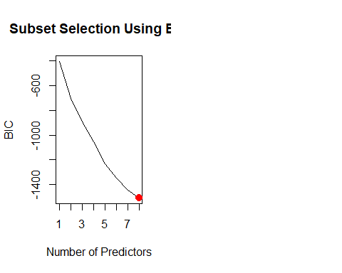

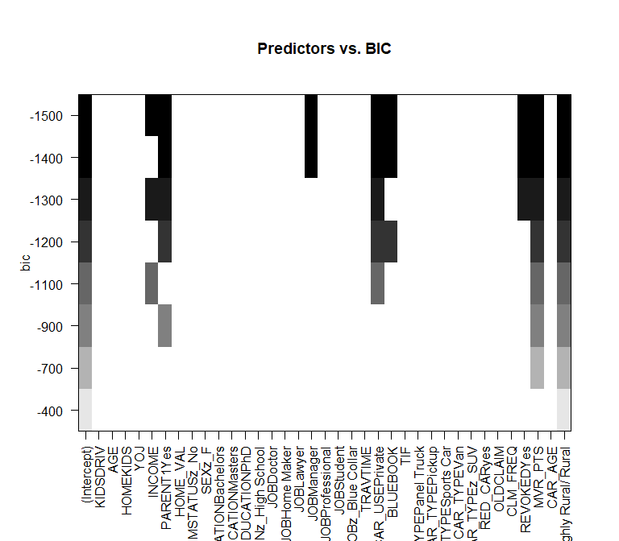

The plot on the right shows that the number of predictors with the lowest BIC are PARENT , HOMEVAL, CAR_USE, ‘CAR_TYPE’, ‘REVOKED’, ‘MVR_PTS’, ‘CAR_AGE’ and ‘URBANICITY’. We will use those predictors to build the next model

|  |  |  |  |  |
| --- | --- | --- | --- | --- |
|  | Estimate | Std. Error | z value | Pr(>|z|) |
| **(Intercept)** | -0.2576 | 0.125 | -2.061 | 0.03932 |
| **PARENT1Yes** | 0.9691 | 0.07619 | 12.72 | 4.658e-37 |
| **HOME_VAL** | -3.481e-06 | 4.244e-07 | -8.201 | 2.387e-16 |
| **CAR_USEPrivate** | -0.8617 | 0.06755 | -12.76 | 2.888e-37 |
| **CAR_TYPEPanel Truck** | 0.1519 | 0.1238 | 1.227 | 0.2197 |
| **CAR_TYPEPickup** | 0.5368 | 0.09355 | 5.738 | 9.6e-09 |
| **CAR_TYPESports Car** | 1.022 | 0.1012 | 10.09 | 5.897e-24 |
| **CAR_TYPEVan** | 0.3704 | 0.1135 | 3.264 | 0.001097 |
| **CAR_TYPEz_SUV** | 0.7982 | 0.08094 | 9.862 | 6.074e-23 |
| **REVOKEDYes** | 0.78 | 0.07661 | 10.18 | 2.393e-24 |
| **MVR_PTS** | 0.158 | 0.01225 | 12.9 | 4.487e-38 |
| **URBANICITYz_Highly Rural/ Rural** | -2.044 | 0.1058 | -19.32 | 3.648e-83 |
| **CAR_AGE** | -0.036 | 0.005397 | -6.669 | 2.571e-11 |

(Dispersion parameter for binomial family taken to be 1 )

|  |  |
| --- | --- |
| Null deviance: | 9418 on 8160 degrees of freedom |
| Residual deviance: | 7827 on 8148 degrees of freedom |

### Select Model

### Compare Model Statistics

### Model 1 - General Model

**ROC Curve**

The ROC Curve helps measure true positives and true negative. A high AUC or area under the curve tells us the model is predicting well.

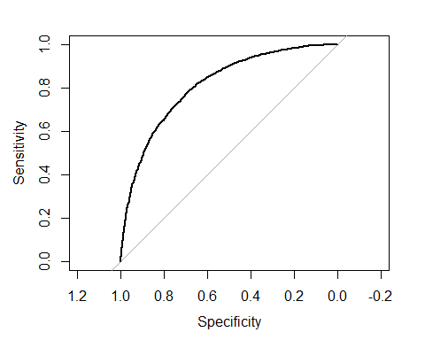

The AUC value of 0.81, tells us this model predicted values are accurate.

**Confusion Matrix**

##   
## targethat 0 1  
## 0 5554 1249  
## 1 454 904

**Create a binned diagnostic plot of residuals vs prediction** There are definite patterns here, which bear investigating.

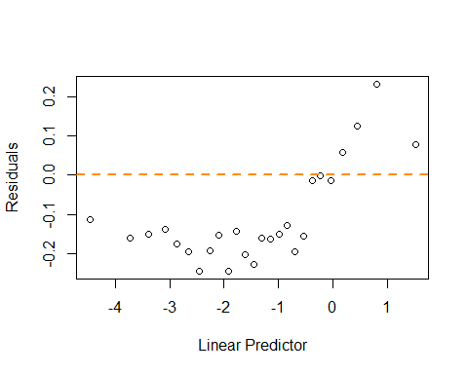

**Plot leverages.**

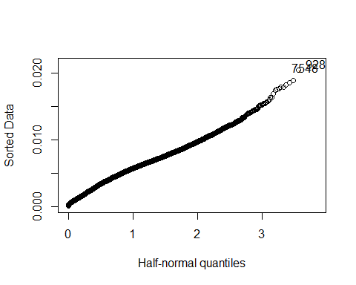

We don’t see any strong outliers with the leverage plot. The points identified (3608,5686) are essentially in the plot of the line formed, so they are not likely pulling our model in any direction.

**Plot Goodness of fit**

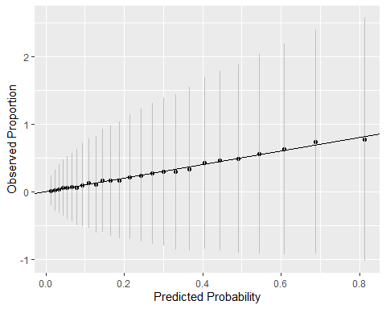

We see that our predictors fall close to the line.

### Model 2 - Reduced General Model

**ROC Curve**

The ROC Curve helps measure true positives and true negative. A high AUC or area under the curve tells us the model is predicting well.

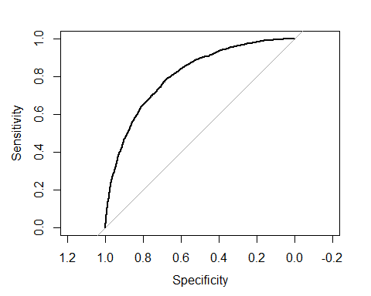

The AUC value of 0.8, tells us this model predicted values are acurate.

**Confusion Matrix**

##   
## targethat 0 1  
## 0 5559 1296  
## 1 449 857

**Create a binned diagnostic plot of residuals vs prediction** There are definite patterns here, which bear investigating.

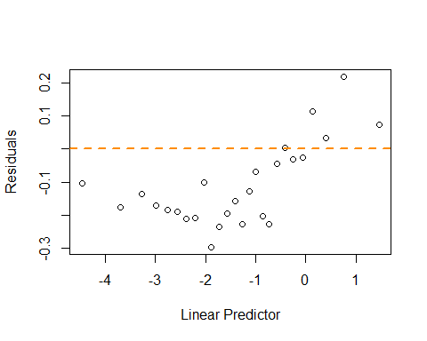

**Plot leverages.**

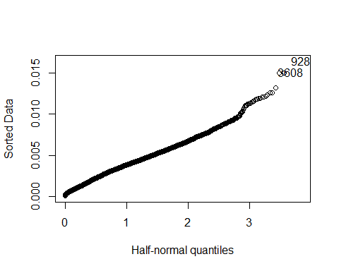

We don’t see any strong outliers with the leverage plot. The points identified (3608,5686) are essentially in the plot of the line formed, so they are not likely pulling our model in any direction.

**Plot Goodness of fit**

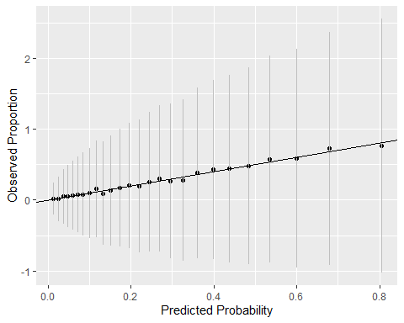

We see that our predictors fall close to the line.

### Model 3 - Srep AIC Model

**ROC Curve**

The ROC Curve helps measure true positives and true negative. A high AUC or area under the curve tells us the model is predicting well.

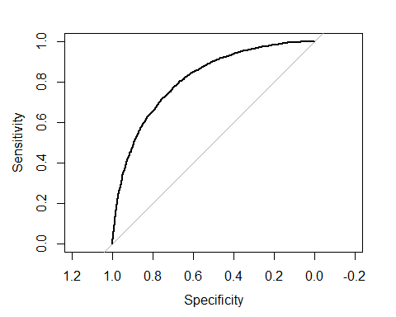

The AUC value of 0.81, tells us this model predicted values are accurate.

**Confusion Matrix**

##   
## targethat 0 1  
## 0 5555 1246  
## 1 453 907

**Create a binned diagnostic plot of residuals vs prediction** There are definite patterns here, which bear investigating.

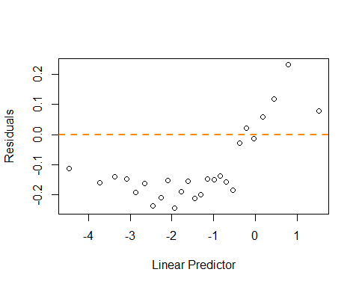

**Plot leverages.**

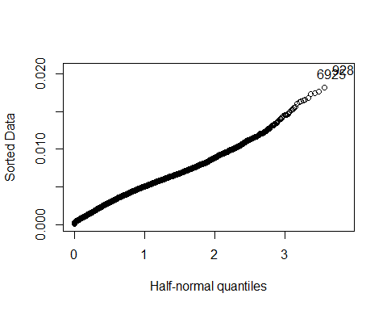

We don’t see any strong outliers with the leverage plot. The points identified (3608,5686) are essentially in the plot of the line formed, so they are not likely pulling our model in any direction.

**Plot Goodness of fit**

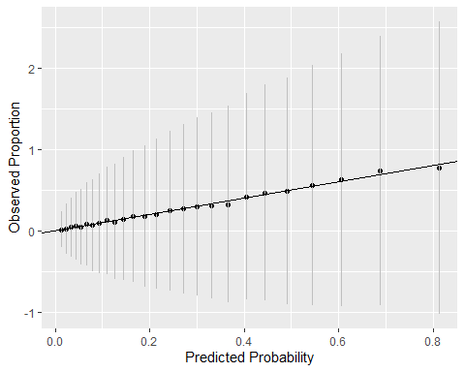

We see that our predictors fall close to the line.

### Model 4 - Srep BIC Model

**ROC Curve**

The ROC Curve helps measure true positives and true negative. A high AUC or area under the curve tells us the model is predicting well.

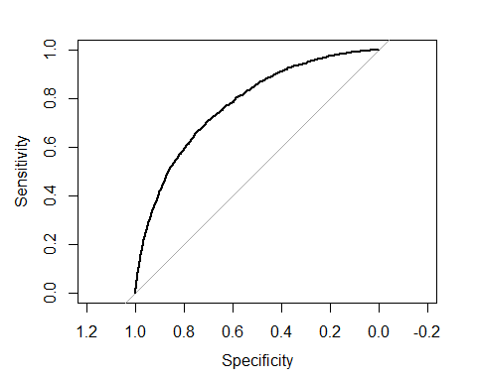

The AUC value of 0.77, tells us this model predicted values are accurate.

**Confusion Matrix**

##   
## targethat 0 1  
## 0 5621 1469  
## 1 387 684

**Create a binned diagnostic plot of residuals vs prediction** There are definite patterns here, which bear investigating.

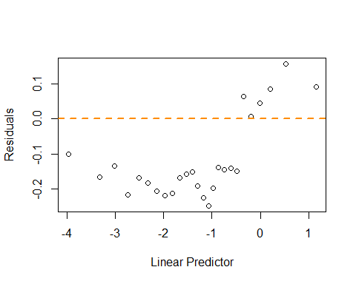

**Plot leverages.**

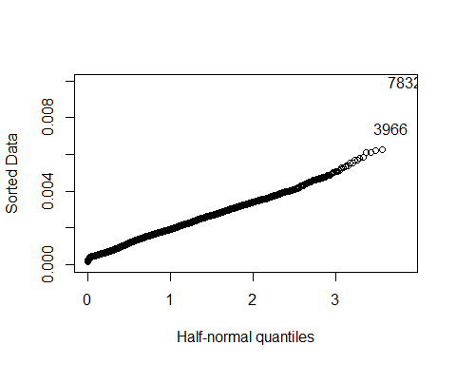

We don’t see any strong outliers with the leverage plot. The points identified (3608,5686) are essentially in the plot of the line formed, so they are not likely pulling our model in any direction.

**Plot Goodness of fit**

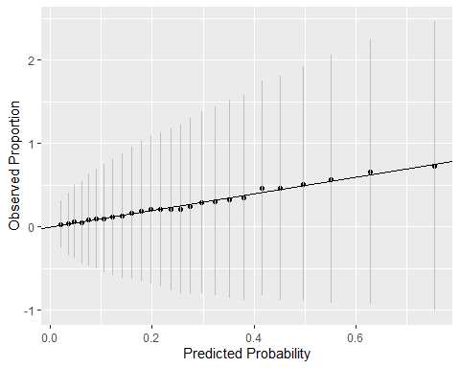

We see that our predictors fall close to the line.

### Pick the best regression model

|  |  |  |  |  |
| --- | --- | --- | --- | --- |
| Metric | Model 1 | Model 2 | Model 3 | Model 4 |
| AIC | 7401.1283155 | 7475.6655813 | 7393.7376519 | 7853.4388014 |
| BIC | 7660.3918291 | 7650.843631 | 7624.9726775 | 7944.5313873 |

With 4 models computed, we select the model with the lowest combination of AIC and BIC. The the table we can see the model to pick is model 3.

## TARGET_AMT Modeling

**Model 1: all predictors**

Same as with the logistic model before, we start with a model that includes all predictors

##   
## Call:  
## lm(formula = TARGET_AMT ~ . - TARGET_FLAG, data = InsTrain)  
##   
## Residuals:  
## Min 1Q Median 3Q Max   
## -5887 -1705 -762 340 103729   
##   
## Coefficients:  
## Estimate Std. Error t value Pr(>|t|)   
## (Intercept) 1.728e+03 4.874e+02 3.545 0.000395 ***  
## INDEX 5.912e-04 1.695e-02 0.035 0.972179   
## KIDSDRIV 3.143e+02 1.132e+02 2.777 0.005498 **   
## AGE 6.023e+00 7.064e+00 0.853 0.393912   
## HOMEKIDS 8.755e+01 6.557e+01 1.335 0.181875   
## YOJ -1.500e+01 1.558e+01 -0.963 0.335611   
## INCOME -3.815e-03 2.007e-03 -1.901 0.057371 .   
## PARENT1Yes 5.761e+02 2.024e+02 2.846 0.004435 **   
## HOME_VAL -5.116e-04 9.887e-04 -0.517 0.604880   
## MSTATUSz_No 6.231e+02 1.254e+02 4.969 6.86e-07 ***  
## SEXz_F -3.613e+02 1.838e+02 -1.966 0.049383 *   
## EDUCATIONBachelors -3.318e+02 2.025e+02 -1.638 0.101447   
## EDUCATIONMasters -2.261e+02 2.664e+02 -0.849 0.396011   
## EDUCATIONPhD -1.204e+01 3.225e+02 -0.037 0.970227   
## EDUCATIONz_High School -1.187e+02 1.715e+02 -0.692 0.488993   
## JOBDoctor -7.980e+02 4.030e+02 -1.980 0.047738 *   
## JOBHome Maker -4.945e+01 2.494e+02 -0.198 0.842812   
## JOBLawyer -9.920e+01 2.749e+02 -0.361 0.718167   
## JOBManager -9.034e+02 2.257e+02 -4.003 6.32e-05 ***  
## JOBProfessional -2.168e+01 2.122e+02 -0.102 0.918646   
## JOBStudent -1.169e+02 2.356e+02 -0.496 0.619786   
## JOBz_Blue Collar -1.020e+02 1.890e+02 -0.540 0.589356   
## TRAVTIME 1.207e+01 3.224e+00 3.745 0.000182 ***  
## CAR_USEPrivate -8.186e+02 1.629e+02 -5.024 5.17e-07 ***  
## BLUEBOOK 1.342e-02 8.609e-03 1.559 0.119094   
## TIF -4.835e+01 1.218e+01 -3.968 7.30e-05 ***  
## CAR_TYPEPanel Truck 1.558e+02 2.708e+02 0.575 0.565184   
## CAR_TYPEPickup 3.366e+02 1.695e+02 1.986 0.047021 *   
## CAR_TYPESports Car 1.019e+03 2.179e+02 4.677 2.96e-06 ***  
## CAR_TYPEVan 4.651e+02 2.115e+02 2.199 0.027895 *   
## CAR_TYPEz_SUV 7.457e+02 1.794e+02 4.157 3.25e-05 ***  
## RED_CARyes -4.248e+01 1.491e+02 -0.285 0.775670   
## OLDCLAIM -1.064e-02 7.439e-03 -1.430 0.152812   
## CLM_FREQ 1.437e+02 5.505e+01 2.611 0.009048 **   
## REVOKEDYes 5.574e+02 1.736e+02 3.212 0.001324 **   
## MVR_PTS 1.764e+02 2.592e+01 6.806 1.07e-11 ***  
## CAR_AGE -2.682e+01 1.280e+01 -2.095 0.036209 *   
## URBANICITYz_Highly Rural/ Rural -1.647e+03 1.391e+02 -11.841 < 2e-16 ***  
## ---  
## Signif. codes: 0 '***' 0.001 '**' 0.01 '*' 0.05 '.' 0.1 ' ' 1  
##   
## Residual standard error: 4546 on 8123 degrees of freedom  
## Multiple R-squared: 0.07032, Adjusted R-squared: 0.06609   
## F-statistic: 16.61 on 37 and 8123 DF, p-value: < 2.2e-16

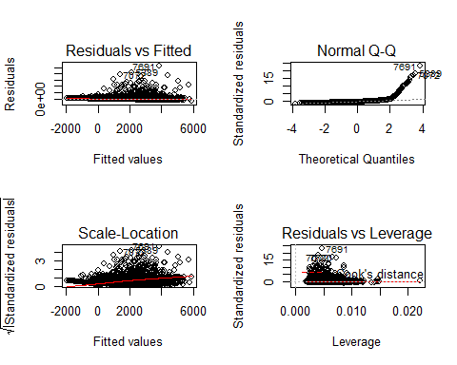

This model shows an adj $R^{2}$ as 0.28, and F-statistic of 87.86 with a small p-value. The result is not a very good model showing a very low $R^{2}$. We also observe several parameters which are not very significant. We try a second model without these parameters, although we do not expect it so be much better that this first model.

**Model 2: Significant predictors**

##   
## Call:  
## lm(formula = TARGET_AMT ~ +AGE + EDUCATION + REVOKED + MVR_PTS +   
## JOB + YOJ + CLM_FREQ + HOME_VAL + URBANICITY + PARENT1 +   
## MSTATUS + TRAVTIME + BLUEBOOK, data = InsTrain)  
##   
## Residuals:  
## Min 1Q Median 3Q Max   
## -5426 -1685 -762 231 104766   
##   
## Coefficients:  
## Estimate Std. Error t value Pr(>|t|)   
## (Intercept) 8.602e+02 3.888e+02 2.212 0.026983 *   
## AGE 6.055e+00 6.519e+00 0.929 0.353029   
## EDUCATIONBachelors -3.005e+02 1.843e+02 -1.631 0.102943   
## EDUCATIONMasters -3.921e+02 2.269e+02 -1.728 0.083988 .   
## EDUCATIONPhD -2.272e+02 2.832e+02 -0.802 0.422482   
## EDUCATIONz_High School 4.008e+01 1.647e+02 0.243 0.807697   
## REVOKEDYes 5.263e+02 1.555e+02 3.384 0.000719 ***  
## MVR_PTS 1.908e+02 2.590e+01 7.369 1.89e-13 ***  
## JOBDoctor -1.121e+03 3.979e+02 -2.818 0.004850 **   
## JOBHome Maker -9.377e+01 2.451e+02 -0.383 0.702049   
## JOBLawyer -4.025e+02 2.689e+02 -1.496 0.134568   
## JOBManager -1.009e+03 2.247e+02 -4.492 7.15e-06 ***  
## JOBProfessional -1.416e+02 2.116e+02 -0.669 0.503241   
## JOBStudent 2.289e+02 2.285e+02 1.002 0.316516   
## JOBz_Blue Collar 2.877e+02 1.695e+02 1.697 0.089718 .   
## YOJ -6.070e+00 1.481e+01 -0.410 0.681963   
## CLM_FREQ 1.437e+02 4.896e+01 2.935 0.003346 **   
## HOME_VAL -1.486e-03 8.013e-04 -1.855 0.063629 .   
## URBANICITYz_Highly Rural/ Rural -1.568e+03 1.395e+02 -11.242 < 2e-16 ***  
## PARENT1Yes 8.668e+02 1.802e+02 4.810 1.54e-06 ***  
## MSTATUSz_No 5.094e+02 1.204e+02 4.231 2.35e-05 ***  
## TRAVTIME 1.223e+01 3.238e+00 3.777 0.000160 ***  
## BLUEBOOK 9.345e-03 6.611e-03 1.414 0.157475   
## ---  
## Signif. codes: 0 '***' 0.001 '**' 0.01 '*' 0.05 '.' 0.1 ' ' 1  
##   
## Residual standard error: 4571 on 8138 degrees of freedom  
## Multiple R-squared: 0.05819, Adjusted R-squared: 0.05565   
## F-statistic: 22.86 on 22 and 8138 DF, p-value: < 2.2e-16

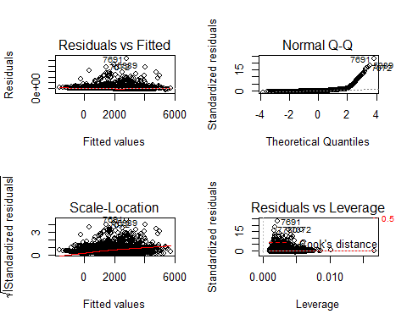

This model shows an adj $R^{2}$ as 0.056, and F-statistic of 22.86 with a small p-value.

Using the reduced predictors, let’s now do a stepwise regression:

**Model 3: Stepwise Regression**

## Start: AIC=137577.4  
## TARGET_AMT ~ +AGE + EDUCATION + REVOKED + MVR_PTS + JOB + YOJ +   
## CLM_FREQ + HOME_VAL + URBANICITY + PARENT1 + MSTATUS + TRAVTIME +   
## BLUEBOOK  
##   
## Df Sum of Sq RSS AIC  
## - YOJ 1 3509293 1.7006e+11 137576  
## - AGE 1 18026179 1.7007e+11 137576  
## - EDUCATION 4 154037045 1.7021e+11 137577  
## <none> 1.7006e+11 137577  
## - BLUEBOOK 1 41765295 1.7010e+11 137577  
## - HOME_VAL 1 71907597 1.7013e+11 137579  
## - CLM_FREQ 1 179988338 1.7024e+11 137584  
## - REVOKED 1 239252115 1.7030e+11 137587  
## - TRAVTIME 1 298134916 1.7035e+11 137590  
## - MSTATUS 1 374117944 1.7043e+11 137593  
## - PARENT1 1 483407044 1.7054e+11 137599  
## - JOB 7 1186770595 1.7124e+11 137620  
## - MVR_PTS 1 1134624808 1.7119e+11 137630  
## - URBANICITY 1 2640997262 1.7270e+11 137701  
##   
## Step: AIC=137575.6  
## TARGET_AMT ~ AGE + EDUCATION + REVOKED + MVR_PTS + JOB + CLM_FREQ +   
## HOME_VAL + URBANICITY + PARENT1 + MSTATUS + TRAVTIME + BLUEBOOK  
##   
## Df Sum of Sq RSS AIC  
## - AGE 1 16550382 1.7008e+11 137574  
## - EDUCATION 4 153627889 1.7021e+11 137575  
## - BLUEBOOK 1 41120143 1.7010e+11 137576  
## <none> 1.7006e+11 137576  
## - HOME_VAL 1 72557883 1.7013e+11 137577  
## - CLM_FREQ 1 180284088 1.7024e+11 137582  
## - REVOKED 1 239230021 1.7030e+11 137585  
## - TRAVTIME 1 297722480 1.7036e+11 137588  
## - MSTATUS 1 398431642 1.7046e+11 137593  
## - PARENT1 1 479908120 1.7054e+11 137597  
## - JOB 7 1194946049 1.7125e+11 137619  
## - MVR_PTS 1 1138469809 1.7120e+11 137628  
## - URBANICITY 1 2638652491 1.7270e+11 137699  
##   
## Step: AIC=137574.4  
## TARGET_AMT ~ EDUCATION + REVOKED + MVR_PTS + JOB + CLM_FREQ +   
## HOME_VAL + URBANICITY + PARENT1 + MSTATUS + TRAVTIME + BLUEBOOK  
##   
## Df Sum of Sq RSS AIC  
## - EDUCATION 4 152052323 1.7023e+11 137574  
## <none> 1.7008e+11 137574  
## - BLUEBOOK 1 45832097 1.7012e+11 137575  
## - HOME_VAL 1 68168845 1.7014e+11 137576  
## - CLM_FREQ 1 183048294 1.7026e+11 137581  
## - REVOKED 1 237194155 1.7031e+11 137584  
## - TRAVTIME 1 299955129 1.7038e+11 137587  
## - MSTATUS 1 407190173 1.7048e+11 137592  
## - PARENT1 1 468406609 1.7054e+11 137595  
## - JOB 7 1179606130 1.7126e+11 137617  
## - MVR_PTS 1 1129124172 1.7121e+11 137626  
## - URBANICITY 1 2630482199 1.7271e+11 137698  
##   
## Step: AIC=137573.6  
## TARGET_AMT ~ REVOKED + MVR_PTS + JOB + CLM_FREQ + HOME_VAL +   
## URBANICITY + PARENT1 + MSTATUS + TRAVTIME + BLUEBOOK  
##   
## Df Sum of Sq RSS AIC  
## - BLUEBOOK 1 32875890 1.7026e+11 137573  
## <none> 1.7023e+11 137574  
## - HOME_VAL 1 119051672 1.7035e+11 137577  
## - CLM_FREQ 1 181086747 1.7041e+11 137580  
## - REVOKED 1 241380620 1.7047e+11 137583  
## - TRAVTIME 1 292522009 1.7052e+11 137586  
## - MSTATUS 1 387615210 1.7062e+11 137590  
## - PARENT1 1 485655803 1.7071e+11 137595  
## - MVR_PTS 1 1137578413 1.7137e+11 137626  
## - JOB 7 1790035008 1.7202e+11 137645  
## - URBANICITY 1 2578301343 1.7281e+11 137694  
##   
## Step: AIC=137573.2  
## TARGET_AMT ~ REVOKED + MVR_PTS + JOB + CLM_FREQ + HOME_VAL +   
## URBANICITY + PARENT1 + MSTATUS + TRAVTIME  
##   
## Df Sum of Sq RSS AIC  
## <none> 1.7026e+11 137573  
## - HOME_VAL 1 95590131 1.7036e+11 137576  
## - CLM_FREQ 1 178112068 1.7044e+11 137580  
## - REVOKED 1 237961372 1.7050e+11 137583  
## - TRAVTIME 1 293078406 1.7055e+11 137585  
## - MSTATUS 1 393037079 1.7065e+11 137590  
## - PARENT1 1 476844375 1.7074e+11 137594  
## - MVR_PTS 1 1131360137 1.7139e+11 137625  
## - JOB 7 1781608903 1.7204e+11 137644  
## - URBANICITY 1 2593045561 1.7285e+11 137695

##   
## Call:  
## lm(formula = TARGET_AMT ~ REVOKED + MVR_PTS + JOB + CLM_FREQ +   
## HOME_VAL + URBANICITY + PARENT1 + MSTATUS + TRAVTIME, data = InsTrain)  
##   
## Residuals:  
## Min 1Q Median 3Q Max   
## -5553 -1689 -758 210 104765   
##   
## Coefficients:  
## Estimate Std. Error t value Pr(>|t|)   
## (Intercept) 1.158e+03 2.268e+02 5.106 3.36e-07 ***  
## REVOKEDYes 5.246e+02 1.555e+02 3.374 0.000744 ***  
## MVR_PTS 1.903e+02 2.587e+01 7.357 2.07e-13 ***  
## JOBDoctor -1.202e+03 3.378e+02 -3.559 0.000374 ***  
## JOBHome Maker -1.700e+02 2.227e+02 -0.763 0.445339   
## JOBLawyer -6.757e+02 2.156e+02 -3.135 0.001727 **   
## JOBManager -1.170e+03 2.081e+02 -5.621 1.97e-08 ***  
## JOBProfessional -2.957e+02 1.951e+02 -1.516 0.129666   
## JOBStudent 2.284e+02 2.154e+02 1.060 0.289019   
## JOBz_Blue Collar 2.416e+02 1.656e+02 1.459 0.144644   
## CLM_FREQ 1.428e+02 4.893e+01 2.919 0.003521 **   
## HOME_VAL -1.569e-03 7.339e-04 -2.138 0.032512 *   
## URBANICITYz_Highly Rural/ Rural -1.548e+03 1.390e+02 -11.138 < 2e-16 ***  
## PARENT1Yes 8.206e+02 1.718e+02 4.776 1.82e-06 ***  
## MSTATUSz_No 5.129e+02 1.183e+02 4.336 1.47e-05 ***  
## TRAVTIME 1.212e+01 3.237e+00 3.744 0.000182 ***  
## ---  
## Signif. codes: 0 '***' 0.001 '**' 0.01 '*' 0.05 '.' 0.1 ' ' 1  
##   
## Residual standard error: 4572 on 8145 degrees of freedom  
## Multiple R-squared: 0.05706, Adjusted R-squared: 0.05532   
## F-statistic: 32.86 on 15 and 8145 DF, p-value: < 2.2e-16

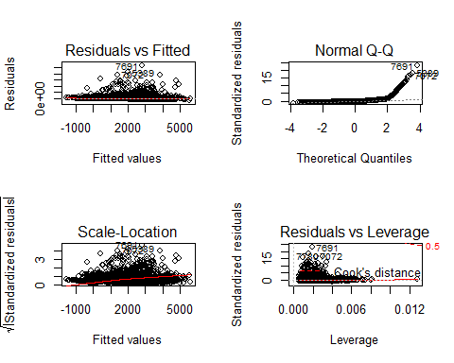

This model shows an adj $R^{2}$ as 0.055, and F-statistic of 32.86 with a small p-value. As expected this model isn’t any better than the first one. It is simpler, but its performance is basically the same. What we do notice, and very visible in the Q-Q plot, is that these seem to be a high number of data points distance from the normal. This suggest a different kind of model.

**Model 4: Weighted coefficients**

We build a Hubber weigthed model to account for the distant points observed in the previous models.

##   
## Call: rlm(formula = TARGET_AMT ~ . - TARGET_FLAG, data = InsTrain,   
## maxit = 40)  
## Residuals:  
## Min 1Q Median 3Q Max   
## -2047.0 -492.2 -133.3 503.8 106540.0   
##   
## Coefficients:  
## Value Std. Error t value   
## (Intercept) 676.8268 94.2063 7.1845  
## INDEX -0.0001 0.0033 -0.0153  
## KIDSDRIV 139.0172 21.8765 6.3546  
## AGE -0.0529 1.3652 -0.0387  
## HOMEKIDS 8.7242 12.6732 0.6884  
## YOJ -8.8665 3.0102 -2.9455  
## INCOME -0.0009 0.0004 -2.2019  
## PARENT1Yes 274.0114 39.1159 7.0051  
## HOME_VAL 0.0001 0.0002 0.7054  
## MSTATUSz_No 169.7873 24.2341 7.0061  
## SEXz_F -26.5180 35.5257 -0.7464  
## EDUCATIONBachelors -168.5739 39.1421 -4.3067  
## EDUCATIONMasters -173.2367 51.4839 -3.3649  
## EDUCATIONPhD -190.1227 62.3261 -3.0505  
## EDUCATIONz_High School 11.8464 33.1433 0.3574  
## JOBDoctor -146.8373 77.8923 -1.8851  
## JOBHome Maker 7.0630 48.1974 0.1465  
## JOBLawyer -82.4219 53.1218 -1.5516  
## JOBManager -281.5451 43.6208 -6.4544  
## JOBProfessional -88.4633 41.0165 -2.1568  
## JOBStudent -9.3306 45.5270 -0.2049  
## JOBz_Blue Collar -83.1141 36.5182 -2.2760  
## TRAVTIME 3.9424 0.6230 6.3281  
## CAR_USEPrivate -300.8995 31.4928 -9.5546  
## BLUEBOOK -0.0052 0.0017 -3.1514  
## TIF -15.6168 2.3549 -6.6317  
## CAR_TYPEPanel Truck 30.2631 52.3424 0.5782  
## CAR_TYPEPickup 130.2403 32.7521 3.9765  
## CAR_TYPESports Car 278.0083 42.1038 6.6029  
## CAR_TYPEVan 93.9587 40.8706 2.2989  
## CAR_TYPEz_SUV 199.0489 34.6674 5.7417  
## RED_CARyes -2.1157 28.8124 -0.0734  
## OLDCLAIM -0.0043 0.0014 -2.9666  
## CLM_FREQ 55.3530 10.6402 5.2023  
## REVOKEDYes 387.5239 33.5434 11.5529  
## MVR_PTS 63.4666 5.0093 12.6697  
## CAR_AGE -0.1901 2.4742 -0.0768  
## URBANICITYz_Highly Rural/ Rural -550.0751 26.8871 -20.4587  
##   
## Residual standard error: 733.5 on 8123 degrees of freedom

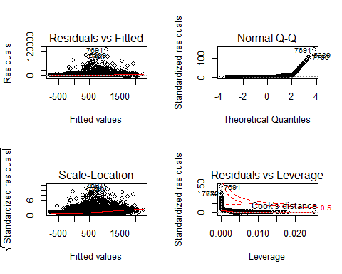

The models doesn’t seem to help with weigthed coefficients, we stil see the effects of several datapoints in the data.

### Pick the best regression model

|  |  |  |  |  |
| --- | --- | --- | --- | --- |
| Metric | Model 1 | Model 2 | Model 3 | Model 4 |
| AIC | 1.60663510^{5} | 1.60739310^{5} | 1.607351410^{5} | 1.613370610^{5} |
| BIC | 1.609367710^{5} | 1.609074810^{5} | 1.608542610^{5} | 1.616103410^{5} |

With 4 models computed, we select the model with the lowest combination of AIC and BIC. The model to pick is model 3.

## Conclusion

For both the logistic regression and linear regressions we picked model 3. Results for the logistic regression were rather good, but the linear regression doesn’t seem to be a good model, even when using weigthed coefficients.

## Observations: 2,141  
## Variables: 4  
## $ INCOME <fct> "$52,881", "$50,815", "$43,486", "$21,204", "$87,460"...  
## $ HOME_VAL <fct> "$0", "$0", "$0", "$0", "$0", "$207,519", "$182,739",...  
## $ BLUEBOOK <fct> "$21,970", "$18,930", "$5,900", "$9,230", "$15,420", ...  
## $ OLDCLAIM <fct> "$0", "$3,295", "$0", "$0", "$44,857", "$2,119", "$0"...  
## Observations: 2,141  
## Variables: 4  
## $ INCOME <int> 52881, 50815, 43486, 21204, 87460, NA, 37940, 33212, ...  
## $ HOME_VAL <int> 0, 0, 0, 0, 0, 207519, 182739, 158432, 344195, 0, 176...  
## $ BLUEBOOK <int> 21970, 18930, 5900, 9230, 15420, 25660, 11290, 24000,...  
## $ OLDCLAIM <int> 0, 3295, 0, 0, 44857, 2119, 0, 0, 0, 0, 0, 0, 0, 2045...

# APPENDIX

**Code used in analysis**

knitr::opts_chunk$set(echo = FALSE, warning = FALSE)  
require(knitr)  
library(ggplot2)  
library(tidyr)  
library(MASS)  
library(psych)  
library(kableExtra)  
library(dplyr)  
library(faraway)  
library(gridExtra)  
library(reshape2)  
library(leaps)  
library(pROC)  
library(caret)  
library(naniar)  
library(pander)  
library(pROC)  
#Get the data. Added na.strings to add na for records that have a blank value  
InsTrain <- read.csv("insurance_training_data.csv",na.strings="",header=TRUE)  
InsEval <- read.csv("insurance-evaluation-data.csv",na.strings="",header=TRUE)  
InsEval <- subset(InsEval, select=-c(TARGET_FLAG,TARGET_AMT))  
InsEval <- read.csv("insurance-evaluation-data.csv",na.strings="",header=TRUE)  
ins1 <- describe(InsTrain, na.rm = F)  
ins1$na_count <- sapply(InsTrain, function(y) sum(length(which(is.na(y)))))  
ins1$na_count_perc <- sapply(InsTrain, function(x) round(sum(is.na(x))/nrow(InsTrain)*100,1))  
colsTrain<-ncol(InsTrain)  
colsEval<-ncol(InsEval)  
missingCol<-colnames(InsTrain)[!(colnames(InsTrain) %in% colnames(InsEval))]  
cc<-summary(complete.cases(InsTrain))  
cInsTrain<-subset(InsTrain, complete.cases(InsTrain))  
cc  
glimpse(cInsTrain)  
#sapply(InsTrain, function(x) round(sum(is.na(x))/nrow(InsTrain)*100,1))  
vis_miss(InsTrain)  
gg_miss_upset(InsTrain)  
nrow(subset(InsTrain,TARGET_FLAG == 0))  
nrow(subset(InsTrain,TARGET_AMT == 0))  
nrow(subset(InsTrain,TARGET_FLAG > 0))  
nrow(subset(InsTrain,TARGET_AMT > 0))  
#TJ  
cat(colnames(InsTrain[ sapply(InsTrain, is.factor)]), "\n\n")  
glimpse(InsTrain)  
sapply(InsTrain, function(x) round(sum(is.na(x))/nrow(InsTrain)*100,1))  
# TJ  
c<-c('INCOME','HOME_VAL','BLUEBOOK','OLDCLAIM')  
if(c %in% colnames(InsTrain)){  
   
 glimpse(InsTrain[,(c)])  
 InsTrain[,c] <- sapply(InsTrain[,(c)],   
 function(x) as.integer(gsub('[$,]','',as.character(x))))  
   
 glimpse(InsTrain[,(c)])  
   
} else {  
   
 cat("Please review your selection of columns:", c)  
   
}  
#TJ  
# TODO Analysis on how many 0s  
# FINAL LIST: AGE YOJ INCOME HOME_VAL CAR_AGE  
# JOB is char  
# INCOME AND HOME_VAL have 0's, impossible so convert to NA  
InsTrain$INCOME <- na_if(InsTrain$INCOME, 0)  
InsTrain$HOME_VAL <- na_if(InsTrain$HOME_VAL, 0)  
r <- colnames(InsTrain[ sapply(InsTrain, function(x) return(anyNA(x) && is.integer(x)))])  
boxplot(InsTrain[,r],names = r,las = 2,col = c("orange","red", "blue", "yellow", "brown", "green"))  
describe(subset(InsTrain, select =r))  
sapply(InsTrain, function(x) round(sum(is.na(x))/nrow(InsTrain)*100,1))  
#TJ  
InsTrain[,r] <- replace_na(InsTrain[,r], as.list(colMeans(InsTrain[,r], na.rm = TRUE)))  
#TJ jobs should be analyzed more before imputing  
Jobs <- summary(InsTrain$JOB)  
print(Jobs)  
JobsMode <- Jobs[which.max(Jobs)]   
ifelse(JobsMode[[1]] / nrow(InsTrain) > 2.5*(Jobs["NA's"][[1]] / nrow(InsTrain)),   
 InsTrain$JOB <- replace_na(InsTrain$JOB, names(JobsMode)),  
 na.omit(InsTrain)  
 )  
summary(InsTrain$JOB)  
vis_miss(InsTrain)  
describe(subset(InsTrain, select =r))  
#View(InsTrain)  
m1<-glm(TARGET_FLAG~.-INDEX-TARGET_AMT,data=InsTrain,family="binomial"(link="logit"))  
summary(m1)  
m2<-glm(TARGET_FLAG~.-INDEX-TARGET_AMT-AGE-INCOME-JOB-BLUEBOOK-CAR_AGE-RED_CAR,data=InsTrain,family="binomial"(link="logit"))  
summary(m2)  
m3 <- step(m1)  
summary(m3)  
InsTrainM4<-InsTrain[ , !(names(InsTrain) %in% c('INDEX','TARGET_AMT'))]  
regfit.full <- regsubsets(factor(TARGET_FLAG) ~ ., data=InsTrainM4)  
par(mfrow = c(1,2))  
reg.summary <- summary(regfit.full)  
plot(reg.summary$bic, xlab="Number of Predictors", ylab="BIC", type="l", main="Subset Selection Using BIC")  
BIC_num <- which.min(reg.summary$bic)   
points(BIC_num, reg.summary$bic[BIC_num], col="red", cex=2, pch=20)  
plot(regfit.full, scale="bic", main="Predictors vs. BIC", asp = 10)  
m4 <- glm(TARGET_FLAG ~ PARENT1 + HOME_VAL + CAR_USE + CAR_TYPE + REVOKED + MVR_PTS + URBANICITY + CAR_AGE, family=binomial, data = InsTrain)  
InsTrain$predicted_m3<- predict(m4, InsTrain, type='response')  
InsTrain$target_m4$target <- ifelse(InsTrain$predicted_m4>0.5, 1, 0)  
pander::pander(summary(m4))  
targethat<-predict(m1,type="response")  
g<-roc(TARGET_FLAG~targethat,data=InsTrain)  
plot(g)  
targethat[targethat<0.5]<-0  
targethat[targethat>=0.5]<-1  
table(targethat,InsTrain$TARGET_FLAG)  
InsMut <- mutate(InsTrain, Residuals = residuals(m1), linPred = predict(m1))  
grpIns <- group_by(InsMut, cut(linPred, breaks=unique(quantile(linPred, (0:25/26)))))  
diagIns <- summarise(grpIns, Residuals = mean(Residuals), linPred = mean(linPred))  
plot(Residuals ~ linPred, data = diagIns, xlab="Linear Predictor")  
abline(h = 0, lty = 2, col = "darkorange", lwd = 2)  
halfnorm(hatvalues(m1))  
linPred <- predict(m1)  
InsMut <- mutate(InsTrain, predProb = predict(m1, type = "response"))  
grpIns <- group_by(InsMut, cut(linPred, breaks = unique(quantile(linPred, (0:25)/26))))  
#hosmer-lemeshow stat  
hlDf <- summarise(grpIns, y= sum(TARGET_FLAG), pPred=mean(predProb), count = n())  
hlDf <- mutate(hlDf, se.fit=sqrt(pPred * (1-(pPred)/count)))  
ggplot(hlDf,aes(x=pPred,y=y/count,ymin=y/count-2*se.fit,ymax=y/count+2*se.fit)) +  
 geom_point()+geom_linerange(color=grey(0.75))+geom_abline(intercept=0,slope=1) +  
 xlab("Predicted Probability") +  
 ylab("Observed Proportion")  
targethat<-predict(m2,type="response")  
g<-roc(TARGET_FLAG~targethat,data=InsTrain)  
plot(g)  
targethat[targethat<0.5]<-0  
targethat[targethat>=0.5]<-1  
table(targethat,InsTrain$TARGET_FLAG)  
InsMut <- mutate(InsTrain, Residuals = residuals(m2), linPred = predict(m2))  
grpIns <- group_by(InsMut, cut(linPred, breaks=unique(quantile(linPred, (0:25/26)))))  
diagIns <- summarise(grpIns, Residuals = mean(Residuals), linPred = mean(linPred))  
plot(Residuals ~ linPred, data = diagIns, xlab="Linear Predictor")  
abline(h = 0, lty = 2, col = "darkorange", lwd = 2)  
halfnorm(hatvalues(m2))  
linPred <- predict(m2)  
InsMut <- mutate(InsTrain, predProb = predict(m2, type = "response"))  
grpIns <- group_by(InsMut, cut(linPred, breaks = unique(quantile(linPred, (0:25)/26))))  
#hosmer-lemeshow stat  
hlDf <- summarise(grpIns, y= sum(TARGET_FLAG), pPred=mean(predProb), count = n())  
hlDf <- mutate(hlDf, se.fit=sqrt(pPred * (1-(pPred)/count)))  
ggplot(hlDf,aes(x=pPred,y=y/count,ymin=y/count-2*se.fit,ymax=y/count+2*se.fit)) +  
 geom_point()+geom_linerange(color=grey(0.75))+geom_abline(intercept=0,slope=1) +  
 xlab("Predicted Probability") +  
 ylab("Observed Proportion")  
targethat<-predict(m3,type="response")  
g<-roc(TARGET_FLAG~targethat,data=InsTrain)  
plot(g)  
targethat[targethat<0.5]<-0  
targethat[targethat>=0.5]<-1  
table(targethat,InsTrain$TARGET_FLAG)  
InsMut <- mutate(InsTrain, Residuals = residuals(m3), linPred = predict(m3))  
grpIns <- group_by(InsMut, cut(linPred, breaks=unique(quantile(linPred, (0:25/26)))))  
diagIns <- summarise(grpIns, Residuals = mean(Residuals), linPred = mean(linPred))  
plot(Residuals ~ linPred, data = diagIns, xlab="Linear Predictor")  
abline(h = 0, lty = 2, col = "darkorange", lwd = 2)  
halfnorm(hatvalues(m3))  
linPred <- predict(m3)  
InsMut <- mutate(InsTrain, predProb = predict(m3, type = "response"))  
grpIns <- group_by(InsMut, cut(linPred, breaks = unique(quantile(linPred, (0:25)/26))))  
#hosmer-lemeshow stat  
hlDf <- summarise(grpIns, y= sum(TARGET_FLAG), pPred=mean(predProb), count = n())  
hlDf <- mutate(hlDf, se.fit=sqrt(pPred * (1-(pPred)/count)))  
ggplot(hlDf,aes(x=pPred,y=y/count,ymin=y/count-2*se.fit,ymax=y/count+2*se.fit)) +  
 geom_point()+geom_linerange(color=grey(0.75))+geom_abline(intercept=0,slope=1) +  
 xlab("Predicted Probability") +  
 ylab("Observed Proportion")  
targethat<-predict(m4,type="response")  
g<-roc(TARGET_FLAG~targethat,data=InsTrain)  
plot(g)  
targethat[targethat<0.5]<-0  
targethat[targethat>=0.5]<-1  
table(targethat,InsTrain$TARGET_FLAG)  
InsMut <- mutate(InsTrain, Residuals = residuals(m4), linPred = predict(m4))  
grpIns <- group_by(InsMut, cut(linPred, breaks=unique(quantile(linPred, (0:25/26)))))  
diagIns <- summarise(grpIns, Residuals = mean(Residuals), linPred = mean(linPred))  
plot(Residuals ~ linPred, data = diagIns, xlab="Linear Predictor")  
abline(h = 0, lty = 2, col = "darkorange", lwd = 2)  
halfnorm(hatvalues(m4))  
linPred <- predict(m4)  
InsMut <- mutate(InsTrain, predProb = predict(m4, type = "response"))  
grpIns <- group_by(InsMut, cut(linPred, breaks = unique(quantile(linPred, (0:25)/26))))  
#hosmer-lemeshow stat  
hlDf <- summarise(grpIns, y= sum(TARGET_FLAG), pPred=mean(predProb), count = n())  
hlDf <- mutate(hlDf, se.fit=sqrt(pPred * (1-(pPred)/count)))  
ggplot(hlDf,aes(x=pPred,y=y/count,ymin=y/count-2*se.fit,ymax=y/count+2*se.fit)) +  
 geom_point()+geom_linerange(color=grey(0.75))+geom_abline(intercept=0,slope=1) +  
 xlab("Predicted Probability") +  
 ylab("Observed Proportion")  
m1AIC <- AIC(m1)  
m1BIC <- BIC(m1)  
m2AIC <- AIC(m2)  
m2BIC <- BIC(m2)  
m3AIC <- AIC(m3)  
m3BIC <- BIC(m3)  
m4AIC <- AIC(m4)  
m4BIC <- BIC(m4)  
InsTrain<-InsTrain[ , !(names(InsTrain) %in% c('predicted_m3','target_m4'))]  
lm1<-lm(TARGET_AMT~.-TARGET_FLAG,InsTrain)  
summary(lm1)  
par(mfrow = c(2,2))  
plot(lm1)  
lm2 <- lm(TARGET_AMT ~ +AGE +EDUCATION +REVOKED +MVR_PTS +JOB +YOJ +CLM_FREQ +HOME_VAL +URBANICITY +PARENT1 +MSTATUS +TRAVTIME +BLUEBOOK, data = InsTrain)  
summary(lm2)  
par(mfrow = c(2,2))  
plot(lm2)  
lm3 <- step(lm2)  
summary(lm3)  
par(mfrow = c(2,2))  
plot(lm3)  
lm4<-rlm(TARGET_AMT~.-TARGET_FLAG,InsTrain,maxit=40)  
summary(lm4)  
par(mfrow = c(2,2))  
plot(lm4)  
lm1AIC <- AIC(lm1)  
lm1BIC <- BIC(lm1)  
lm2AIC <- AIC(lm2)  
lm2BIC <- BIC(lm2)  
lm3AIC <- AIC(lm3)  
lm3BIC <- BIC(lm3)  
lm4AIC <- AIC(lm4)  
lm4BIC <- BIC(lm4)  
# TJ  
c<-c('INCOME','HOME_VAL','BLUEBOOK','OLDCLAIM')  
if(c %in% colnames(InsEval)){  
   
 glimpse(InsEval[,(c)])  
 InsEval[,c] <- sapply(InsEval[,(c)],   
 function(x) as.integer(gsub('[$,]','',as.character(x))))  
   
 glimpse(InsEval[,(c)])  
   
} else {  
   
 cat("Please review your selection of columns:", c)  
   
}  
eval_plm<-predict(lm3,InsEval)  
write.csv(eval_plm,"predicted_eval_values_Target_Amt.csv")  
eval_p<-predict(m3,InsEval, type = "response")  
write.csv(eval_p,"predicted_eval_values_Target_Flag.csv")