R Notebook

BB

Week 7

<https://datascienceplus.com/how-to-perform-logistic-regression-lda-qda-in-r/>

library(MASS)  
library(ggplot2)  
library(ISLR)  
attach(Smarket)  
  
#Check Dimensions  
dim(Smarket)

## [1] 1250 9

#Check for missing values  
apply(Smarket, 2, function(x) {length(unique(x))})

## Year Lag1 Lag2 Lag3 Lag4 Lag5 Volume Today   
## 5 1044 1045 1045 1044 1044 1181 1044   
## Direction   
## 2

apply(Smarket, 2, function(x) {sum(is.na(x))})

## Year Lag1 Lag2 Lag3 Lag4 Lag5 Volume Today   
## 0 0 0 0 0 0 0 0   
## Direction   
## 0

apply(Smarket, 2, function(x) {sum(x==" ")})

## Year Lag1 Lag2 Lag3 Lag4 Lag5 Volume Today   
## 0 0 0 0 0 0 0 0   
## Direction   
## 0

#LDA

#split data  
  
set.seed(1)  
row.number = sample(1:nrow(Smarket), 0.6*nrow(Smarket))  
train = Smarket[row.number,]  
test = Smarket[-row.number]  
dim(train)

## [1] 750 9

dim(test)

## [1] 1250 4

model1 <- lda(factor(Direction)~., data=Smarket)  
  
premodel.train.lda <- predict(model1, data=train)  
table(Predicted = premodel.train.lda$class, Direction=Direction)

## Direction  
## Predicted Down Up  
## Down 557 5  
## Up 45 643

ldahist(premodel.train.lda$x[,1], g=premodel.train.lda$class)

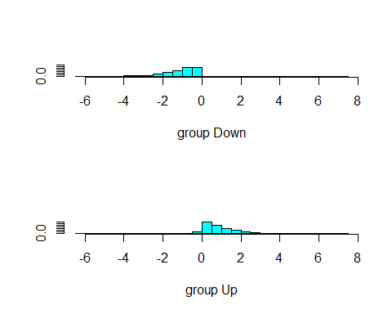

premodel.test.lda<- predict(model1, newdata = test)  
table(Predicted = premodel.test.lda$class, Direction=test$Direction)

## Direction  
## Predicted Down Up  
## Down 557 5  
## Up 45 643

ldahist(premodel.test.lda$posterior[,2], g=premodel.test.lda$class)

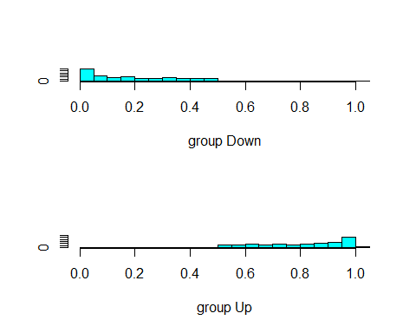

par(mfrow=c(1,1))  
plot(premodel.test.lda$posterior[,2], premodel.test.lda$class, col=test$Direction)

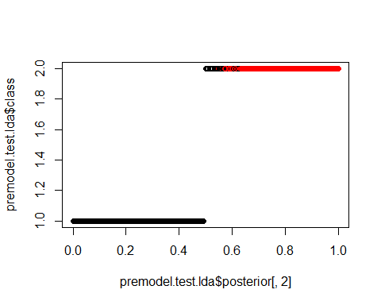

#QDA

model2 <- qda(factor(Direction)~., data=Smarket)  
  
premodel.train.qda <- predict(model2, data=train)  
table(Predicted = premodel.train.qda$class, Direction=Direction)

## Direction  
## Predicted Down Up  
## Down 546 10  
## Up 56 638

premodel.test.qda<- predict(model2, newdata = test)  
  
par(mfrow=c(1,1))  
plot(premodel.test.qda$posterior[,2], premodel.test.qda$class, col=Direction)

