NSTGRO PROGRESS REPORT – Grant Year 1 PR 1
NASA Grant Number 80NSSC22K1197
11/3/2022
Dual-Aperture Fiber Nulling for High Spatial and Spectral Resolution Studies of Exoplanets
The Ohio State University
Graduate Researcher | Anusha Pai Asnodkar
Faculty Advisor / Principal Investigator | Ji Wang
NASA Research Collaborator | Dimitri Mawet  NASA Jet Propulsion Laboratory

Goal
We are developing a “dual-aperture fiber nuller” (DAFN) as a technology to improve current standards of starlight suppression and angular resolution for direct imaging of Solar System giant planet analogs and habitable-zone planets.

Most Significant Technical Achievement(S)
During this reporting period, we have focused on reproducing the capabilities of the Vortex Fiber Nuller (VFN) in monochromatic light (Echeverri et al. 2019) before introducing a second beam for interferometric nulling. Our main achievements have been: 1) optimizing coupling into the output single mode fiber, 2) obtaining a preliminary profile of throughput as a function of angular separation for comparison with theoretical predictions, 3) implement routines for controlling the deformable mirror and imaging with our detector, and 4) simulating the electric field conjugation algorithm (Give’on et al. 2007) for wavefront sensing and correction to maximize coupling.

Activities and Accomplishments
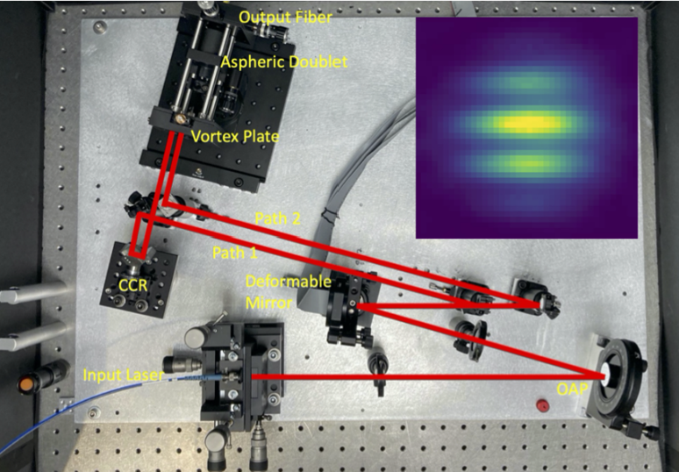
The lab setup can be seen in Figure 1. Currently, the CCR (corner cube reflector) has been removed. To elaborate upon the achievements listed in section 2:
- We tuned the alignment of the entire optical system and obtained a maximal coupling efficiency into the output fiber of ~58% in the lab without any active wavefront correction. The theoretical maximum is ~72%.
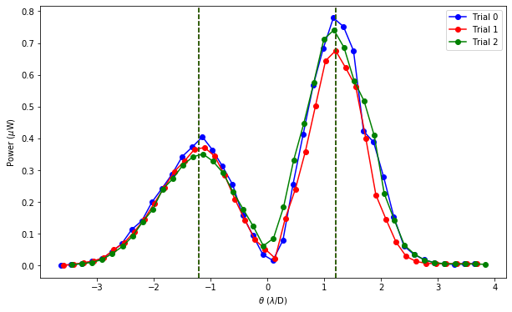
- We aim to reproduce the results of the VFN experiment in Echeverri et al. 2019 for comparison with our DAFN technology. We assembled the VFN setup in our optical system with just one beam and a vortex waveplate installed before the optics focusing the beam into the output fiber. We learned that backpropagating the light through the system is a critical step for alignment after the vortex is in place. We ran the same experiment of translating the output fiber as done in Echeverri et al. 2019 to simulate an off-axis planet and obtain a profile of the throughput as a function of angular separation (see Figure 2 for an example). The asymmetry of the peaks is not expected and maybe attributable to optical aberrations in the system. For this reason, our next course of action was to implement a routine for wavefront correction.
Figure 2
- Before implementing wavefront correction, we needed to develop a library of routines that could communicate with and manipulate our deformable mirror and CCD, the hardware that will be used in the next step, in an automated fashion. These routines were implemented in MATLAB.
- We chose the EFC for wavefront sensing and correction. Before implementing this algorithm in the lab, we simulated its performance in Python to ensure that we understood the implementation. Figure 3 shows the deviation of an example aberrated image from the image of an ideal, flat circular aperture before correction with EFC on the left and after correction on the right. The near-negligible deviations in the right plot (relative to the deviations in the plot on the left) suggest that our implementation of the algorithm performs sufficient correction of an aberrated wavefront.
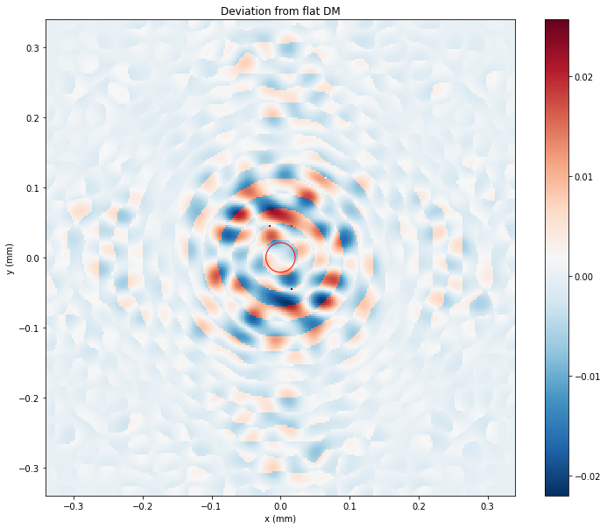 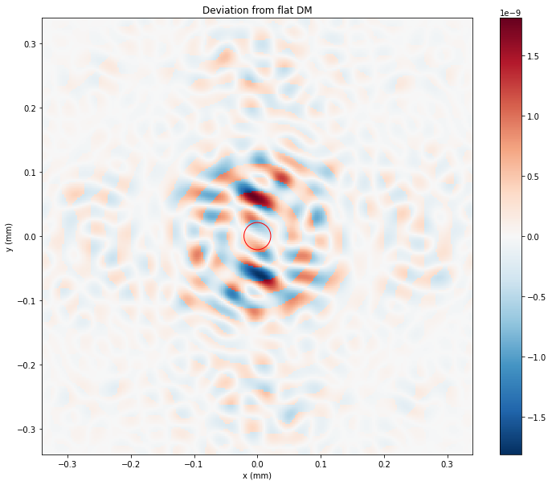
Figure 3

Planned Activities
For the next reporting period, we aim to:
- Implement and test the EFC algorithm in the lab
- Run the VFN experiment to measure throughput vs. angular separation, this time with wavefront correction.
- Introduce the second beam in the optical system and begin running the same experiment for the DAFN.

visiting technologist Experience(s)

COMPLETED Visiting Technologist Experience
Start Date | End Date | NASA Center or R&D Lab | Activities and Relevance to Research Goals
N/A | N/A | N/A | N/A
PLANNED Visiting Technologist Experience
Start Date | End Date | NASA Center or R&D Lab | Activities and Relevance to Research Goals
1/16/23 | 3/24/23 | NASA Jet Propulsion Laboratory | - Learn about and compare wavefront correction techniques. We adopt EFC for our purposes whereas the VFN group uses traditional Zernike optimization.  - Gain practical working knowledge of VFN and handling vortex coronagraphs.

Issues / Concerns
No foreseeable issues or concerns.

