NSTGRO RESEARCH TRAINING PLAN
Grant Class NSTGRO22 Grant Year 1
NASA Grant Number 80NSSC22K1197

11/28/2022
Dual-Aperture Fiber Nulling for High Spatial and Spectral Resolution Studies of Exoplanets
The Ohio State University
Graduate Researcher | Anusha Pai Asnodkar
Faculty Advisor / Principal Investigator | Ji Wang
NASA Research Collaborator | Dimitri Mawet  NASA Jet Propulsion Laboratory

Abstract

We are developing a “dual-aperture fiber nuller” (DAFN) testbed as a technology demonstration for atmospheric characterization of directly-imaged exoplanets. Such an instrument splits the source light into two beams that are offset in phase by π before they are allowed to interfere and couple into a single mode fiber. In this way, the on-axis light (starlight) is “nulled” while off-axis light (planet light) is transmitted to a high-resolution spectrograph to further distinguish the planet’s atmospheric signature from the host star’s light in velocity space The concept can potentially be deployed to preexisting interferometric frameworks such as the Large Binocular Telescope Interferometer, a NASA-funded facility to which we have institutional access.
Coronagraphic technologies require wavefront correction for effective starlight suppression. To this end, we are implementing a wavefront sensing and correction module to integrate into our testbed. Then we will work towards our first major milestone of demonstrating the DAFN in coherent light. We will perform comparative studies with another complementary technology, the vortex fiber nuller (VFN). This endeavor benefit immensely from our planned Visiting Technologist Experience at NASA JPL and the expertise of our NASA Research Collaborator. We anticipate reproducing the theoretical predictions for the throughput profiles and starlight suppression of both technologies in the lab by December 2023.

Research Description

Introduction

Exoplanet exploration has revealed a diverse array of planetary system architectures. To answer the ultimate question of how unique our Solar System is in the broader context of our Galaxy, we require radical advances in high contrast imaging technology for detection and characterization. Currently, Solar System analog giants are not easily observable with the precision and temporal baseline of ongoing radial velocity and direct imaging surveys. Direct imaging holds great potential for both the detection and atmospheric characterization of these elusive targets but is limited by two parameters: inner working angle and contrast ratio. Our science objectives will require a factor of ~few improvement from current technological performance to achieve ~1λ/D angular resolution and ~2 orders-of-magnitude improvement to attain 10⁻⁶ – 10⁻⁷ contrast ratios.
We propose the dual-aperture fiber nuller (DAFN) as a technology to fill this gap in observation. This technology has direct applications to existing large telescope optical interferometric frameworks like the Large Binocular Telescope Interferometer (LBTI) as well as upcoming extremely large telescopes (ELTs) and space-based technologies. This technology pertains to Technology Area (TA) 8.1.3.1 in the NASA Technology Area Roadmaps as a nulling interferometer.

Goal

Over the course the next year, we aim to demonstrate the DAFN concept in the lab with coherent optical laser light. We will compare against a complementary technology, the vortex fiber nuller (VFN), and assess sensitivity to low-order aberrations.
Our objectives for the year are as follows. We will first focus on developing methods for wavefront sensing and correction. We are currently testing 3 different approaches for this: 1) implicit electric field conjugation (iEFC), 2) Zernike optimization, and 3) closed-loop adaptive optics (AO) with a Shack-Hartmann sensor. After determining which of these techniques works best for our application, we will return to demonstrating the VFN in monochromatic light as we had previously pursued (see progress report 1). Finally, we will demonstrate the DAFN in coherent light and comparatively assess the performance of the VFN and DAFN.

Background

Wavefront sensing and correction
To achieve a deep null for high contrast imaging, wavefront aberrations introduced by the optical system require correction. This can be achieved with a deformable mirror (DM), a reflective membrane surface overlaying electrically controlled actuators, to shape the wavefront. The precision of the correction is limited by: 1) the accuracy of the wavefront estimation and 2) the ability of the DM to achieve arbitrary shapes. For now, the latter is beyond our control unless we choose to upgrade our 140 actuator DM to a kilo-DM down the line. Therefore, we focus our efforts on optimizing wavefront reconstruction.
We consider two focal plane wavefront sensing techniques. The first is electric field conjugation (EFC), which minimizes the aberrated electric field in the image plane by setting the DM actuators to superpose the negative of the electric field [1]. Traditional EFC requires an accurate model of the DM influence on the electric field in the image plane as a function of actuator lengths. To circumvent this, we are attempting to implement implicit EFC (iEFC), which is model-independent and instead minimizes difference images since they are simply a linear transformation of the electric field. The second technique we are implementing is Zernike optimization, in which we perform a grid search through Zernike modes and their corresponding amplitudes and optimize such that the intensity in the core of the resulting Airy disk in the image plane is maximized.
We are also testing pupil plane wavefront correction using a Shack-Hartmann sensor to measure the aberrations, which then informs the DM actuator positions (traditional closed loop AO). The limitation of this approach is that the optical system may introduce aberrations downstream of the pupil plane and thus will not be measured by the Shack-Hartmann.

VFN
The VFN uses a vortex waveplate to impose a phase ramp that cancels on-axis starlight when coupled into a single mode fiber (SMF) [2]. Like the DAFN, this technology promises ~1λ/D angular resolution and deep nulls for effective starlight suppression. The VFN is the expertise of the NASA Research Collaborator for this NSTGRO project. It is currently successfully being applied to the Keck Planet Imager and Characterizer (KPIC) [3].

DAFN
The DAFN combines nulling interferometry with a SMF connected to a high-resolution spectrograph to cancel out host star light and extract a planetary signal. The host star’s light is suppressed by interference fringes and filtered out by the SMF. The planet’s signal can be further distinguished from the host star’s in velocity space with high-resolution spectroscopy. This instrument concept is a direct extension of the LBTI framework with single-mode fiber and high-resolution spectrograph on the backend [4].

Approach/Methodology

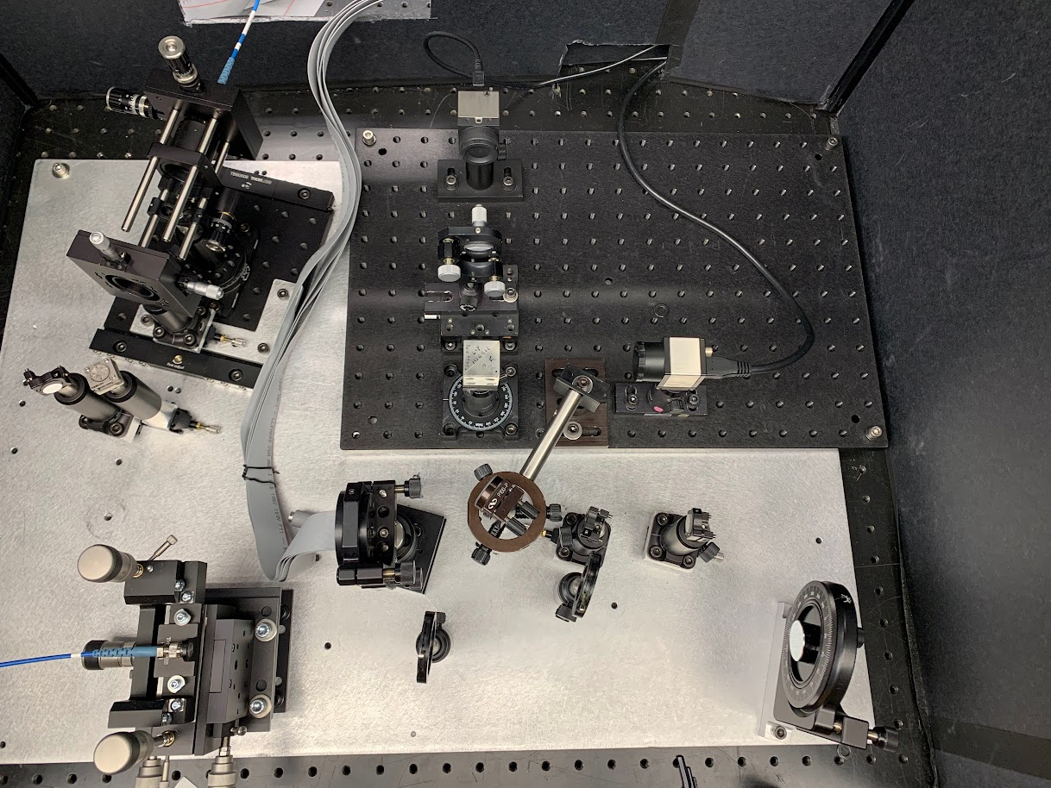
SMF
CCR
Fiber-coupling optics
Imaging
lens
Fiber injection unit
Right-angle prism mirror
CCD
Shack-Hartmann sensor
Beamsplitter
Fold
mirror
Beamsplitter
Deformable mirror
Off-axis parabola
Laser source
Vortex waveplate
Wavefront sensing
LBTI simulator
Figure 1: DAFN testbed. Not pictured: corner cube reflector (CCR) for beam interference with adjustable path length.

Testbed design
Our testbed layout is presented in Figure 1. The path of the beam starts on the bottom left in orange, then is later depicted in red and yellow after it is split into two beams with a beamsplitter to produce interference fringes. The region encompassed in magenta simulates the beam interference conducted by the LBTI. Currently, there is a fold mirror in this module of the testbed (right before the beam splitter) to direct the collimated light to the wavefront sensing module which we are currently testing. Without that fold mirror, the beam would get split and the yellow path would pass through the vortex waveplate before coupling into the SMF via the fiber injection unit to demonstrate VFN. If the corner cube reflector (CCR) were installed, both the yellow and red paths of the beam would interfere before entering the fiber injection unit, either with the vortex waveplate in place for dual-aperture VFN or without it for DAFN.

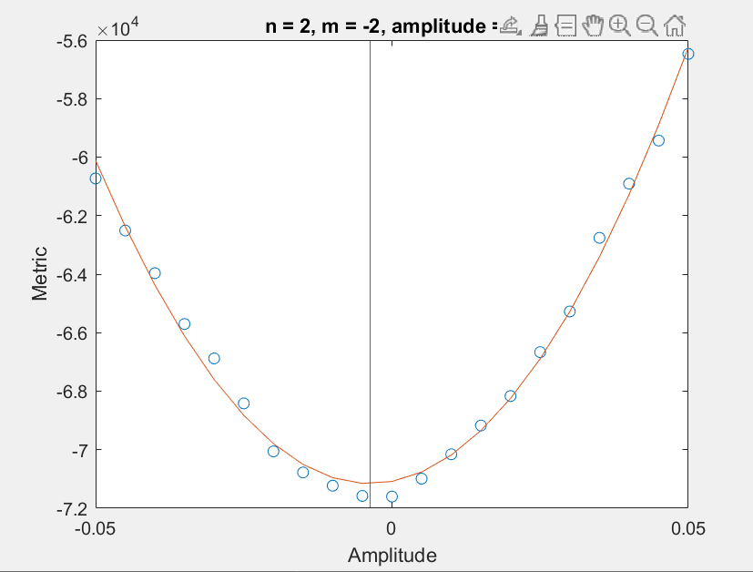
Wavefront sensing and correction
We have the following steps remaining for testing out wavefront sensing before integrating it into the design flow. With the Shack-Hartmann installed, we have mechanically aligned the sensor to minimize wavefront as much as possible. Now we can close the loop, i.e. use the aberrations measured by the sensor to apply a correction to the DM, to further minimize wavefront error. The other two techniques operate at the focal plane instead of the pupil plane and use the CCD instead of the Shack-Hartmann sensor. For the Zernike optimization technique, we have developed a MATLAB program that solves for the optimized amplitudes for each Zernike mode (see Figure 2). However, the solutions we obtain are beyond the stroke range of the DM. This suggests that we first need to improve the mechanical alignment of the CCD before applying this routine for wavefront correction. This applies to iEFC as well since it also operates in the focal plane. We have computationally demonstrated traditional EFC, but still have not successfully implemented iEFC. This will be our next step before applying iEFC in the lab.
Figure 2: Example of Zernike optimization for the oblique astigmatism mode amplitude.
To test the performance of each of these techniques, we can measure the Strehl ratio after correction and identify which technique yields a value closest to 1. We can also impose Zernike modes on the DM and check which technique is most sensitive to picking up those modes in the wavefront reconstruction.

VFN
We have previously attempted to demonstrate the VFN and developed skills along the way in optimizing the alignment of the vortex waveplate. All that remains for the VFN implementation is integrating wavefront correction into the testbed. This will require determining a point between the vortex waveplate and the output SMF at which to install a beamsplitter that will branch off one path into the wavefront sensing module of the testbed.

DAFN
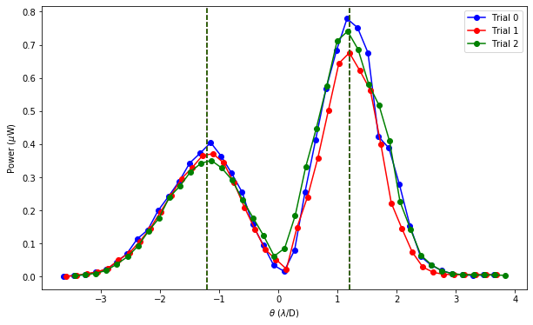
To complete our setup of the DAFN, we still need to install the corner cube reflector and adjust the path length until the on-axis destructive fringe intensity is minimized. The fringes will be measured with a CCD before they are aligned into the single mode fiber.

Throughput experiment
Our previous preliminary attempts at demonstrating the VFN involved reproducing the throughput experiment outlined in [2]. In this experiment, the output SMF is translated to measure coupling efficiency as a function of angular separation. This effectively determines the suppression of the on-axis source (starlight) spatially. Since the PSF of the system is independent of the shift of the source, a peak in the coupling efficiency corresponds to the separation at which planet light throughput is maximized. Thus, we can simulate a planet by translating the output fiber. This experiment allows us to constrain both the angular separation at which an off-axis source can be detected as well as the null depth and correspondingly a laboratory estimate of contrast ratio. We will apply this experiment to the DAFN as well for a self-consistent comparative analysis of these two technologies.
Figure 3: Preliminary VFN throughput experiment.
Figure 3 shows the results of our preliminary attempt at reproducing the results of the VFN experiment from [2]. We did not obtain the expected peak in coupling efficiency near 1λ/D. Furthermore, the throughput profile is asymmetric depending on the direction of translation. We believe that these issues may get resolved once we integrate wavefront correction into the testbed.
After successfully executing the throughput experiment, we will also determine each technology’s sensitivity to low order aberrations by assessing the degree of starlight suppression upon imposing different Zernike modes.

Expected Outcome(s)

For wavefront sensing, we anticipate reducing the wavefront error down to ~12 nm; this is nearly a factor of 2 greater than the idealized λ/100 assumed in [4]. We expect that our wavefront correction will eliminate the undesirable asymmetric coupling efficiency profile we obtain from the VFN throughput experiment. We also predict obtaining peaks in the throughput profile that match expectations from theory (separations slightly less than ~1 λ/D for both VFN and DAFN). Finally, we expect the VFN and DAFN to respond to low order aberrations according to theoretical estimates provided in Figures 3 and 10 of [4], which generally predict <10⁻⁵ stellar leakage for most Zernike modes.

References
[1] Give'on, A., Kern, B., Shaklan, S., Moody, D., & Pueyo, L. (2007). Broadband wavefront correction algorithm for high-contrast imaging systems. In Astronomical Adaptive Optics Systems and Applications III (pp. 66910A).
[2] Echeverri, D., Ruane, G., Jovanovic, N., Mawet, D., & Levraud, N. (2019). Vortex fiber nulling for exoplanet observations I Experimental demonstration in monochromatic light. Optics
Letters, 44(9), 2204.
[3] Echeverri, D., Ruane, G., Jovanovic, N., Delorme, J.R., Wang, J., Millar-Blanchaer, M., Xuan, J., Toman, K., & Mawet, D. (2021). Broadband vortex fiber nulling: high-dispersion exoplanet science at the diffraction limit. In Techniques and Instrumentation for Detection of Exoplanets X (pp. 118230A).
[4] Wang, J., & Jurgenson, C. (2020). Exoplanet Sciences with Nulling Interferometers and a Single-mode Fiber-fed Spectrograph. AJ, 160(5), 210.
[5] Mazoyer, J., Baudoz, P., Belikov, R., Crill, B., Fogarty, K., Galicher, R., Groff, T., Guyon, O., Juanola-Parramon, R., Kasdin, J., Leboulleux, L., Sayson, J., Mawet, D., Prada, C., Mennesson, B., N'Diaye, M., Perrin, M., Pueyo, L., Roberge, A., Ruane, G., Serabyn, E., Shaklan, S., Siegler, N., Sirbu, D., Soummer, R., Stark, C., Trauger, J., & Zimmerman, N. (2019). High-Contrast Testbeds for Future Space-Based Direct Imaging Exoplanet Missions. In Bulletin of the American Astronomical Society (pp. 101).

Relevance to NASA

Our proposed research is directly applicable to Technology Area 8.1.3.1, which encompasses coronagraphs and nulling interferometers like our instrument concept. The 2015 NASA Technology Roadmaps identifies a high-priority need for robust space-based coronagraph/nulling-interferometer technology this decade for an exoplanet direct imaging mission. Such a technology demonstration will support the goal of launching an exoplanet direct imaging mission that will combine the capabilities of the proposed HabEx and LUVOIR missions. A successful coronagraph must achieve a high contrast ratio, i.e. ~10⁻¹⁰ at optical/NIR wavelengths to observe exo-Earths and ~10⁻⁸ for mature Jupiters around Sun-like stars, small inner working angle (within ~3λ/D), and wide bandwidth (10% between 300-1800 nm) [5]. Generally, space-based direct imaging missions will be predominantly limited by spatial resolution especially around M-dwarfs which require tighter IWAs for the science cases of interest, e.g. observing Earth-like planets in the habitable zone.
A DAFN can alleviate some of these challenges by expanding the realm of detectability, particularly for planets in temperate zones. State-of-the-art space-based starlight suppression achieves ~10⁻⁹ contrast, which is ~3-4 orders of magnitude better than ground-based efforts. This is well below the planet-star contrast needed to study habitable planets around M dwarfs (~10⁻⁷). However, space-based technologies lack the large apertures necessary to achieve the spatial resolution required to detect planets in the habitable/temperate zones at closer separations around M dwarfs (than Sun-like stars). The DAFN can fill this gap in attaining the optimal spatial resolution. By configuring the dual-aperture setup for long-baseline interferometry, this technique can be optimized for smaller angular resolutions. Harnessing this advantage of interferometry will be preferrable to increasing a single aperture size for the same effect, which is more costly and logistically challenging for space-based applications. This advancement could enable space-based detection of terrestrial planets in the habitable zones of M dwarfs and by extension, temperate giants. We anticipate using this technology for follow-up atmospheric characterization of giants detected by radial velocities that are not accessible by transmission spectroscopy, e.g. 55 Cnc c and GJ 1148 b [4].
More importantly, DAFN paves the way for identifying biosignatures in the atmospheres
of temperate rocky planets, such as CH4 and CO2 in the near-infrared. Thus, extending characterization capability into the near-infrared is critical to search for biosignatures with future NASA missions. This ties into NASA Strategic Objective 1.2 to understand the universe and assess the habitability of alien worlds.

visiting technologist Experience(s)

This year’s VTE will be conducted at NASA JPL to learn from their VFN testbed. The technical objectives for this visit will be to: 1) gain working knowledge and learn best practices for optical alignment of such a system, 2) learn about effective wavefront correction techniques, and 3) learn about experimental design for troubleshooting as well as assessing the performance of the VFN technology. The expected outcomes for this work will be to reproduce an improved version of Figure 3 with the JPL testbed and then transferring those lessons to our implementation.

Conferences

Workshop: Use of light coherence for high-contrast exoplanet imaging with ground-based telescopes (June 21-23, 2023)

Anticipating presentation of ongoing progress towards DAFN in monochromatic light.

Schedule

Activity or Milestone |  | Estimated Date
Research
Wavefront sensing/correction testing |  | 04/2023
Wavefront sensing/correction integration into testbed |  | 06/2023
VFN monochromatic demonstration |  | 08/2023
DAFN integration into testbed |  | 10/2023
DAFN monochromatic demonstration |  | 12/2023
Fringe tracking |  | TBD
Beam shaping optic for DAFN optimization |  | TBD
DAFN optical spectral bandwidth demonstration |  | TBD
DAFN near-infrared spectral bandwidth demonstration |  | TBD
Academic / Degree
Thesis proposal defense |  | 09/2023
Thesis defense |  | 06/2025
On-Site Experience – NASA Center or R&D Lab |  | Start Date | End Date
Year 1: NASA Jet Propulsion Laboratory |  | 02/2023 | 04/2023
Year 2: NASA Jet Propulsion Laboratory |  | TBD | TBD
Year 3: NASA Jet Propulsion Laboratory |  | TBD | TBD
Conference | Location | Start Date | End Date
Use of light coherence for high-contrast exoplanet imaging with ground-based telescopes | Meudon, France | 06/21/23 | 06/23/23
SPIE Astronomical Telescopes and Instrumentation | Yokohama, Japan | 06/15/24 | 06/20/24

