

* **For First Come First Serve**

Ghant Chart is as follows:

|  |  |  |  |  |  |
| --- | --- | --- | --- | --- | --- |
| Process | Arrival Time | Burst Time | Completeion Time | Turn aroud time | Waiting time |
| P1 | 0 | 8 | 8 | 8 | 0 |
| P4 | 1 | 9 | 17 | 16 | 7 |
| P2 | 2 | 6 | 23 | 21 | 15 |
| P3 | 2 | 1 | 24 | 22 | 21 |
| P5 | 3 | 3 | 27 | 24 | 21 |

Turn around time = Completion time - arrival time = (8+16+21+22+24)/5=18.2

Waiting time= turn around time - burst time= (0+7+15+21+21)/5=12.8

* **Non preempitive scheduling algorithm(Assuming smaller the priority number,** highest the priority)

Ghantt Chart is as follows:

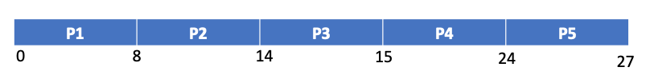

|  |  |  |  |  |  |  |
| --- | --- | --- | --- | --- | --- | --- |
| Process | Burst Time | Priority | Arrival Time | Completion Time | Turn around time | Waiting time |
| P1 | 8 | 4 | 0 | 8 | 8 | 0 |
| P2 | 6 | 1 | 2 | 14 | 12 | 6 |
| P3 | 1 | 2 | 2 | 15 | 13 | 12 |
| P4 | 9 | 2 | 1 | 24 | 23 | 14 |
| P5 | 3 | 3 | 3 | 27 | 24 | 21 |

Turn around time = Completion time - arrival time=(8+12+13+23+24)/5= 14.2

Waiting time= turn around time - burst time= (0+6+12+14+21)/5 = 10.6

* **Primitive priority scheduling(Assuming smaller the priority number, highest the priority)**

Ghantt Chart is as follows:

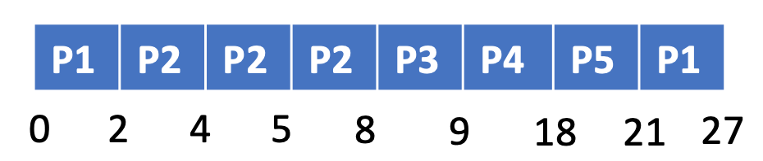

|  |  |  |  |  |  |  |
| --- | --- | --- | --- | --- | --- | --- |
| Process | Burst Time | Priority | Arrival Time | Completion Time | Turn around time | Waiting time |
| P1 | 8 | 4 | 0 | 27 | 27 | 19 |
| P2 | 6 | 1 | 2 | 8 | 6 | 0 |
| P3 | 1 | 2 | 2 | 9 | 7 | 6 |
| P4 | 9 | 2 | 1 | 18 | 17 | 8 |
| P5 | 3 | 3 | 3 | 21 | 18 | 15 |

Turn around time = Completion time - arrival time = (27+6+7+17+18)/5 = 15

Waiting time= turn around time - burst time= (19+0+6+8+15)/5 = 9.6

* **Round Robin (Considering the time as 1ms)**

Ghantt Chart is as follows:



Queue:

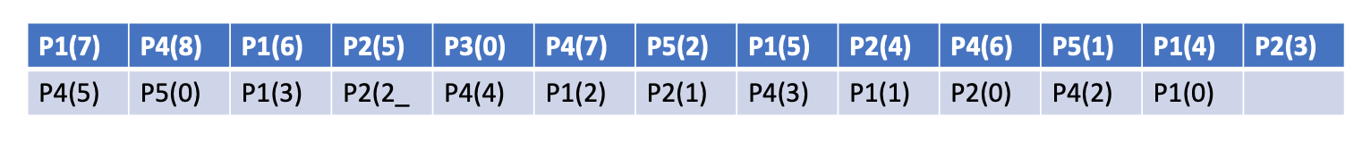

|  |  |  |  |  |  |  |
| --- | --- | --- | --- | --- | --- | --- |
| Process | Burst Time | Priority | Arrival Time | Completion Time | Turn around time | Waiting time |
| P1 | 8 | 4 | 0 | 25 | 25 | 17 |
| P2 | 6 | 1 | 2 | 23 | 21 | 15 |
| P3 | 1 | 2 | 2 | 5 | 3 | 2 |
| P4 | 9 | 2 | 1 | 27 | 26 | 17 |
| P5 | 3 | 3 | 3 | 15 | 12 | 9 |

Turn around time = Completion time - arrival time= (25+21+3+26+12)/5 = 17.4

Waiting time= turn around time - burst time = (17+15+2+17+9)/5 = 12

The shortest wait time is shown by primitive priority scheduling.

The fastest average turn around time is shown by non preempitive scheduling algorithm