Introduction: There are 10 million people worldwide who suffer from epilepsy in which their seizures have a focal onset and are medically refractory. For these people, physicians seek to treat the epileptogenic zone (EZ) with surgical resection. However, due to poor localization of the EZ, this surgery is successful only 50 percent of the time. In determining the location of this region, physicians often use EEG or iEEG recordings. Specifically, one marker they use to localize is interictal spikes (IIS), which are bursts of neuronal activity occurring in between periods of seizure. Physicians take note of where these spikes are occurring and use this information to predict the focal onset region. While these spikes are generally easy to identify, it can be tedious to examine days of data from hundreds of electrodes. As a result, automating this process could greatly improve the speed and efficiency of EZ localization. While many techniques, such as neural networks, data mining, and template matching, have been used in attempting to address this problem, these are often very complex and not interpretable. We have previously shown that with a novel normalization scheme, accurate detection is possible using just a simple threshold rule. The goal of this study is to improve upon the simple threshold model by utilizing a generalized linear model (GLM).

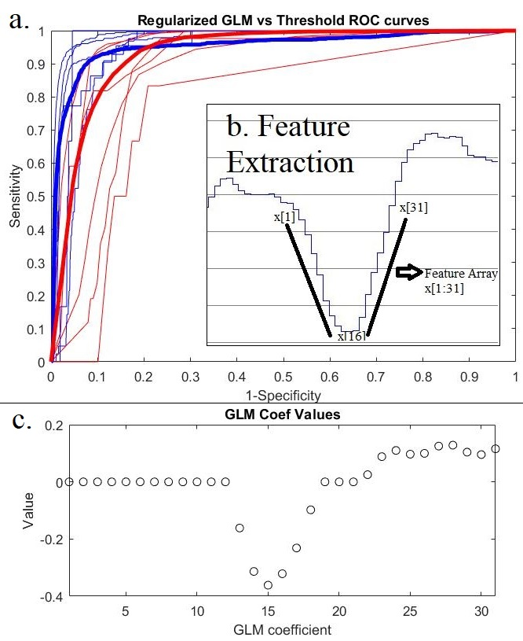
Materials and Methods: iEEG recordings were acquired through subdural grid arrays with for 7 epileptic patients, one of whom was omitted due to issues with recording. A single clinician marked IISs as they presumably occurred for an hour of data for each patient. The data was loaded into MATLAB, and normalized through a pipeline consisting of a notch filter, amplitude standardization, and subtraction of a moving average. Finally, the data was split into two second epochs, or time units, and varying thresholds were applied to every epoch/channel with a spike and compared to physician annotated spikes to construct a Receiver Operating Characteristic curve (ROC) for simple threshold detection. Afterwards, the local minimum from all epochs was calculated, 31 data points around each minimum were extracted as features for the regularized GLM with L1 & L2 penalization, using an alpha of .5. Training data was chosen randomly from channels that had any marked activity, and GLM coefficients were chosen that optimized the training data’s ROC. This optimized model was then tested on all epochs to produce another ROC curve. From this ROC curve, the GLM value threshold that minimized L2 distance to perfect classification was determined, as well as the corresponding sensitivity and specificity.

Results and Discussion: Shown in Figure 1 are the ROC curves for both the GLM(blue) and simple threshold (red) models. The AUC of the former is .9517 while the AUC of the latter is .9317, indicating an improved performance with the GLM. From the GLM coefficient plot, we can see that the center of the peak as well as points following it are key in classifying whether it is a spike. The optimal GLM value threshold was .2328, with the corresponding sensitivity and specificity being 91.01% and 91.74%, while the optimal simple threshold was -.6368, with a sensitivity and specificity of 90.4% and 83.93%.

Figure 1. a. The ROC curves of the simple threshold detector are in red, while the GLM detector ROC curves are in blue. The thin lines represent individual patients, while the thicker lines are all the patients together. b. Extraction of a feature vector for use in GLM from a local minimum. The center is x[16], and 31 data points around the center are extracted. c. Value of coefficients corresponding to each feature in GLM.

Conclusions: While both algorithms perform quite well, the GLM detector improves significantly upon the simple threshold detector in sensitivity, and slightly in specificity. However, with AUC’s of .9517 and .9317, both of these methods could be useful, quick, and interpretable diagnostic tools for interictal spike detection, and eventually, epileptogenic zone localization.

