Alexandre Pham (2048017)

Lab #1: Get Started with C# Programming Using Microsoft Visual Studio

Example-01: How to set up a C# project in Microsoft Visual Studio:

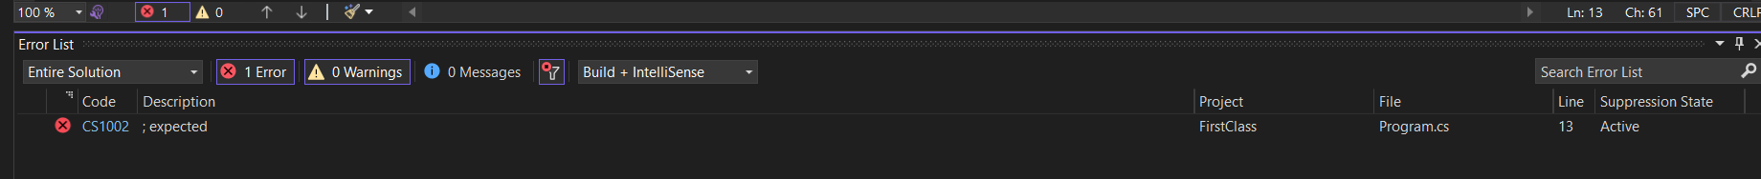

Example-02: Performing Arithmetic operation

4-

5-

Example-03: Using the string Data Type

