Alexandre Pham (2048017)

Lab #4: Developing GUI base applications Part‐II

1. Menus

2. DateTimePicker control

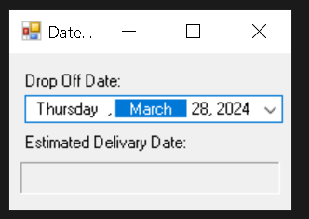

3. LinkLabel control

4. ListBox control

5. CheckedListBox control

6. ComboBox control

7. TreeView control

8. ListView control

9. TabControl control

10. Multiple Document Interface (MDI) Windows

11. Visual Inheritance

12. User‐Defined controls

