Alexandre Pham (2048017)

Develop the following example of File and Streams Processing from textbook’s Chapter‐17 : Files and Streams

1. Creating a Sequential‐Access Text File

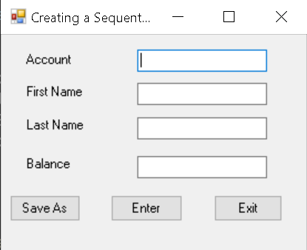

2. Reading Data from a Sequential‐Access Text File

3. Case Study: Credit‐Inquiry Program

4. Creating a Sequential‐Access File using Object Serialization

5. Reading and Deserializing Data from a Binary File

6. Classes File and Directory

7. Searching Directories with LINQ