**apalm1341-**Yesterday at 11:44 PM

[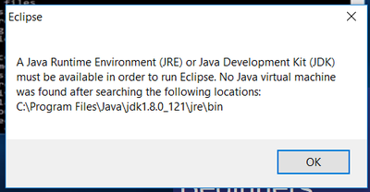](https://cdn.discordapp.com/attachments/245687663519203329/278385496281972736/unknown.png)

Hey all

got this message when trying to open/use/run eclipse up from my desktop

seems like maybe I should download/install JVM into that file path place?

I would like to be able to use eclipse as well as command prompt to run programs containing java code(edited)

my command prompt not even working either after following along with tutorial online

[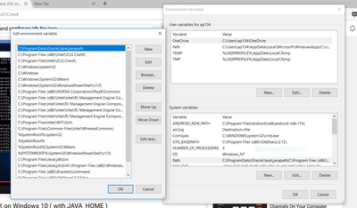](https://cdn.discordapp.com/attachments/245687663519203329/278386218817945600/unknown.png)

<https://www.youtube.com/watch?v=Wp6uS7CmivE>

**FanFreak247✓ᵛᵉʳᶦᶠᶦᵉᵈ ᵃᶜᶜᵒᵘᶰᵗ-**Yesterday at 11:51 PM

@Experienced Java

**@apalm1341** deletr the folder is specifies and try again

Delete everything Java related on your computer

That you can delete

Or try again

Try Jre instead of jdk

**February 7, 2017**

**apalm1341-**Today at 12:04 AM

oh

**Mee6BOT-**Today at 12:04 AM

cout <<**@apalm1341**<<"has leveled up to Level" <<1

**apalm1341-**Today at 12:04 AM

it might be working now?

idk

after I closed out of command prompt and went back in, it let me type in javac

and returned this

C:\Users\ap134>javac Usage: javac <options> <source files> where possible options include: -g Generate all debugging info -g:none Generate no debugging info -g:{lines,vars,source} Generate only some debugging info -nowarn Generate no warnings -verbose Output messages about what the compiler is doing -deprecation Output source locations where deprecated APIs are used -classpath <path> Specify where to find user class files and annotation processors -cp <path> Specify where to find user class files and annotation processors -sourcepath <path> Specify where to find input source files -bootclasspath <path> Override location of bootstrap class files -extdirs <dirs> Override location of installed extensions -endorseddirs <dirs> Override location of endorsed standards path -proc:{none,only} Control whether annotation processing and/or compilation is done. -processor <class1>[,<class2>,<class3>...] Names of the annotation processors to run; bypasses default discovery process -processorpath <path> Specify where to find annotation processors -parameters Generate metadata for reflection on method parameters -d <directory> Specify where to place generated class files -s <directory> Specify where to place generated source files -h <dir

returned lil bit more than this

and not the program is not recognizeable type of thing like before

C:\Users\ap134>javac Welcome.java C:\Users\ap134>java Welcome Error: could not open `C:\Program Files\Java\jre1.8.0_121\lib\amd64\jvm.cfg'

getting that tho

?

**Katie-**Today at 12:07 AM

Javac is the compiler

**apalm1341-**Today at 12:07 AM

right

**Katie-**Today at 12:07 AM

You need to type something like javac myFile(edited)

**apalm1341-**Today at 12:07 AM

it won't let me compile and run

i did

javac Welcome.java

**Katie-**Today at 12:08 AM

Huh

**apalm1341-**Today at 12:08 AM

?

javac (name of my file I wish to run via command prompt)

and then I typed in: java Welcome

**Katie-**Today at 12:09 AM

Java might be installed in C:\Program Files**(x86)** instead. Go check that

**apalm1341-**Today at 12:09 AM

ok

just checked

I don't see a java folder in that file path u mentioned

u think it might be within a specific folder within that file path??

?

**Katie-**Today at 12:13 AM

Might be. It's just a reflex for me to check if it's in the good path the way windows is built

Anyways

I doubt I can help you on that since your problem seems specific to what you have installed, ect

Retrace your steps one by one, see if you didn't miss anything or did something wrong

**apalm1341-**Today at 12:15 AM

my java folder

is actually inside the program files folder

not the program files (X86) one

not sure if that would help you or not??

**Katie-**Today at 12:16 AM

Nah, not really

**apalm1341-**Today at 12:17 AM

C:\Users\ap134>java Welcome Error: could not open `C:\Program Files\Java\jre1.8.0_121\lib\amd64\jvm.cfg'

so u don't know why this is happening?

**Katie-**Today at 12:18 AM

Bottom line, your Java installation is somehow corrupted, so as a first resort to resolve this issue, I suggest you to re-install jre. You should ensure that you're installing the right jre for your architecture.

Make sure you **uninstall** java first

**apalm1341-**Today at 12:19 AM

ok

**Mee6BOT-**Today at 12:19 AM

cout <<**@apalm1341**<<"has leveled up to Level" <<2

**Katie-**Today at 12:20 AM

Make sure to also verify the checksum

**apalm1341-**Today at 12:21 AM

checksum?

**Katie-**Today at 12:21 AM

A special hash (number) that tells you if the file you downloaded is corrupt

If you don't know what it is don't bother with it

**apalm1341-**Today at 12:23 AM

ok

ya I don't know what that is/u r talking about

**Katie-**Today at 12:24 AM

Never mind the checksum then. You job is to make sure Java is proprely uninstalled

**apalm1341-**Today at 12:29 AM

hey there

thx for helping

I will look into that tomorrow when I get the chance

and see how things go from there

**Katie-**Today at 10:28 AM

Kk

**apalm1341-**Today at 10:05 AM

hey all

**_0x17de™-**Today at 10:05 AM

yoo

**apalm1341-**Today at 10:05 AM

do you guys recommend that I uninstall java?

**_0x17de™-**Today at 10:05 AM

yes(edited)

**apalm1341-**Today at 10:05 AM

I assume you saw my issues earlier?

**_0x17de™-**Today at 10:05 AM

(i was just kidding)

**apalm1341-**Today at 10:05 AM

oh

**_0x17de™-**Today at 10:05 AM

a reinstall won't cost you any money

**apalm1341-**Today at 10:06 AM

I am having issues with compiling/running my program written in java code

**_0x17de™-**Today at 10:06 AM

they'll just setup yahoo as your default website if you don't pay too much attention

can't remember your issue

you should read out your error messages loud if you have some

**apalm1341-**Today at 10:07 AM

C:\Users\ap134>javac Welcome.java C:\Users\ap134>java Welcome Error: could not open `C:\Program Files\Java\jre1.8.0_121\lib\amd64\jvm.cfg'

this is what happens when I try to compile and run my one program written in java

**_0x17de™-**Today at 10:08 AM

reinstall

**apalm1341-**Today at 10:08 AM

using command prompt is when that happens to me

oh and ok

**_0x17de™-**Today at 10:08 AM

by that i mean uninstall all java stuff first

**apalm1341-**Today at 10:09 AM

also, how can I tell if a program is written in java code?

**_0x17de™-**Today at 10:09 AM

<https://www.java.com/en/download/uninstalltool.jsp> <-

**apalm1341-**Today at 10:10 AM

just from the .java extension on a file?

that I write code in?

**_0x17de™-**Today at 10:10 AM

if it eats all your memory it is written in java

**apalm1341-**Today at 10:14 AM

well that helps lol

alright time to uninstall

[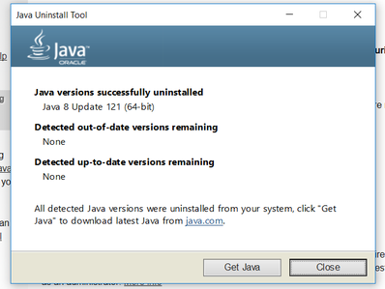](https://cdn.discordapp.com/attachments/245687663519203329/278546180651089920/unknown.png)

odd

I had the latest version of Java installed they said(edited)

wouldn't you think that would be good enough?

**FanFreak247✓ᵛᵉʳᶦᶠᶦᵉᵈ ᵃᶜᶜᵒᵘᶰᵗ-**Today at 10:25 AM

¯\_(ツ)_/¯

**stmfd sp!, {lr}-**Today at 10:26 AM

Good enough for what

**apalm1341-**Today at 10:32 AM

in order to be able to compile and run my code

alright I successfully installed java

I guess I have to restart the whole process with the environment variable stuff

?

**NEW MESSAGES**

**_0x17de™-**Today at 10:40 AM

good enough to still produce the same error

**apalm1341-**Today at 10:38 AM

I just uninstalled and reinstalled java for my computer

what do you recommend doing now?

**Katie-**Today at 10:38 AM

Get a Java IDE

**apalm1341-**Today at 10:39 AM

ok

I have eclipse and netbeans already

[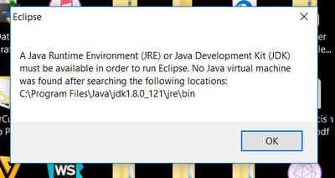](https://cdn.discordapp.com/attachments/278396899965403137/278550415988228100/unknown.png)

when I try to open up/run eclipse tho, this message appears

and won't let me use eclipse at all

**Katie-**Today at 10:40 AM

Did you try downloading JDK?

**apalm1341-**Today at 10:42 AM

[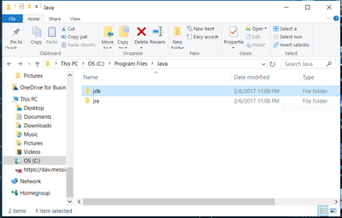](https://cdn.discordapp.com/attachments/278396899965403137/278551086464368640/unknown.png)

it looks like I have it already?

**Katie-**Today at 10:43 AM

Can you try renaming jdk?

**apalm1341-**Today at 10:43 AM

I would like to be able to run my java programs from both an IDE and/or my command prompt also

what should I rename it to?

**Katie-**Today at 10:44 AM

jdk1.8.0_121

**apalm1341-**Today at 10:48 AM

[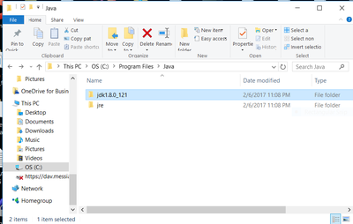](https://cdn.discordapp.com/attachments/278396899965403137/278552585127067648/unknown.png)

ya

it lets me rename it to that

so?

**Katie-**Today at 10:49 AM

Does it works?

**apalm1341-**Today at 10:49 AM

eclipse?

**Katie-**Today at 10:49 AM

Yes

**apalm1341-**Today at 10:50 AM

[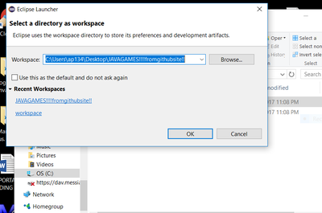](https://cdn.discordapp.com/attachments/278396899965403137/278552961767047168/unknown.png)

ah

sweet

I am guessing it is working now

cause this didn't show up before

**Katie-**Today at 10:50 AM

Try to not have weird characters in your directory

**apalm1341-**Today at 10:50 AM

like what?

how did u know that would work for me to be to use eclipse??

for renaming the folder

?

I still would like to be able to use the command prompt tho(edited)

u know how I can get that working properly?

**Katie-**Today at 10:52 AM

No, the windows command promp is pretty shitty

You can try getting it to work but don't get your hopes up

**apalm1341-**Today at 10:52 AM

oh ok

interesting

it looks like it is working for me

the command prompt i mean

I just want to be able to use it to learn java basics right now

and not have to deal with the IDE and learning that crap

cause I tried learning it and it got overwhelming

really overwhelming

**Katie-**Today at 10:54 AM

Trust me, it's way easier using an IDE than doing it with the console

**apalm1341-**Today at 10:54 AM

ok

[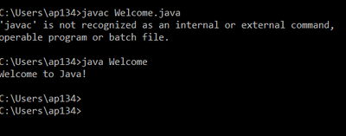](https://cdn.discordapp.com/attachments/278396899965403137/278554378229645323/unknown.png)

look at this

this is so weird

it runs the message it is supposed to after doing javac Welcome and java Welcome

but it looks like it isn't recognizing javac?

as a command?

weird

how could my program be working then??

**Katie-**Today at 10:56 AM

Probably because Javac isn't in your %PATH%

**apalm1341-**Today at 10:57 AM

should I be concerned/worried about this??

**Katie-**Today at 10:57 AM

Not really

**apalm1341-**Today at 10:58 AM

so I guess I don't need to compile first in order to run my programs using command prompt??

I can just run/execute them?

**Katie-**Today at 10:58 AM

No you don't have to. Java can be interpreted

**apalm1341-**Today at 11:00 AM

I don't have to compile u mean?

**Katie-**Today at 11:00 AM

No you don't

You can if you want to

**apalm1341-**Today at 11:01 AM

ok

cool

what is the point then in compiling if u don't need to use it?

**Katie-**Today at 11:02 AM

If you compile it, it will run faster, and you won't have to distribute DLLs when you share your program

**apalm1341-**Today at 11:02 AM

DLLs?

**Katie-**Today at 11:02 AM

Not that it matters much because pretty much everyone has the required DLLs anyways

**apalm1341-**Today at 11:02 AM

ah ok

**Katie-**Today at 11:02 AM

Dynamic-link library

**apalm1341-**Today at 11:03 AM

that is kinda confusing

I don't quite understand what u mean

**Katie-**Today at 11:03 AM

Don't worry about it

**apalm1341-**Today at 11:04 AM

ok

thx for helping me

greatly have been appreciating it

**Katie-**Today at 11:04 AM

No problem

**apalm1341-**Today at 11:04 AM

r u a programmer/developer if I may ask?

**Katie-**Today at 11:04 AM

I've coded as a hobby for about a decade now

But it's not my job

**apalm1341-**Today at 11:05 AM

sweet

u mentioned not to have weird characters in my directory before

seems like that did the trick for fixing up both my eclipse and command prompt to get working

how did u know that?

and why does that work?

**Katie-**Today at 11:08 AM

Yeah, JAVAGAMES!!!!fromgithubsite!! is a potentially problematic name

**apalm1341-**Today at 11:08 AM

how tho?

oh

u r talking about for eclipse after starting up program

**Katie-**Today at 11:09 AM

I'm talking in general

**apalm1341-**Today at 11:09 AM

I am talking about how did u know how to fix my renaming issue?

with the jdk folder I had

?

**Katie-**Today at 11:10 AM

Because the error message said so

**apalm1341-**Today at 11:10 AM

and how did that get eclipse and command prompt for me working?

what error message?

the javac is not recognized as an external command one?

**Katie-**Today at 11:11 AM

<https://images.discordapp.net/.eJwVyEsOhCAMANC7cAC-otTbECRo1JbQmllM5u4T3_J91TMutapdpPNqzHZwobFpFhq5Vd2I2lVzP1gXuk0WyWW_Kwobv6QAcwKAOU42uLC8FaOdXISUvE_OWvPgifRB3bGp3x8LqSLy.ITHmzrIcirzYXrHZv5Mv6DHvx-8>

This one

**apalm1341-**Today at 11:13 AM

don't understand how renaming did the trick?

looks like it wanted to to download/install java virtual machine?

**Katie-**Today at 11:14 AM

Well, it searched a precise location

But it didn't exist

So renaming did the trick

**apalm1341-**Today at 11:14 AM

well dang

who would have thought renaming something would make something search for a precise location

u r just renaming a folderlol

that is crazy