# compareDist.png

Figure which compares the hourly distribution of EV arrivals. Y-axis is density, X-axis is count of EVs.

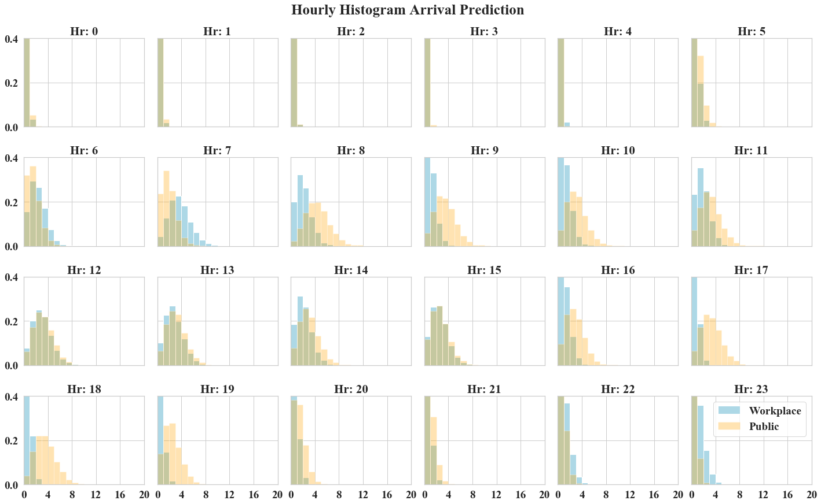

# distSmry_results.xlsx

Excel file with summary results of the Bayesian parameter learning. ‘mu__x’ values, in the **mean** column present the expected mu parameter, for the Poisson distribution, for each hour of the day. The last column **Rhat** is the Gelman-Rubin stat. Rhat values close to 1 indicate model sampling convergence.

# hModel_Work.png

Hierarchical model structure.

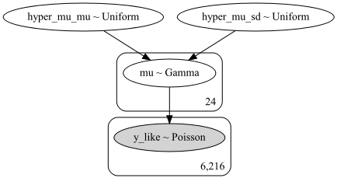

# public_ppc.xlsx

Posterior Predictive Count sampling results (10,000) drawn from the resulting hourly Poisson distributions. This spreadsheet has two columns [Connected, Hr] providing the number of EVs connected per hours among all EV chargers in Salt Lake City.

# Public2018wkdy.xlsx

The input data set, i.e. [‘Hour’, ‘DayCnt’, ‘DayYr’, ‘Connected’] for Public EV chargers.