**#NEVERAGAIN: USING DATA VISUALISATION, SOCIAL NETWORK AND SENTIMENT ANALYSIS TO UNDERSTAND THE FIRST 100 DAYS ON X [FORMERLY TWITTER]**

By

Apampa, O.R.

Email: [apamps2000@gmail.com](mailto:apamps2000@gmail.com)

**Abstract**

Social media offers ordinary citizens with a platform to push for policy reforms and advocacy. Such was the case with the Stoneman Douglas High School in Parkland, Florida, where in February of 2018, a lone gunman opened fire on several students of the school, killing 17 and injuring many others. The incidence led to an outcry from concerned Americans, leading to several school walk-outs and an online campaign by some of the affected students using the hashtag never again (#NeverAgain).

Data was collected from Twitter using #NeverAgain over a period of 100 days, and was subjected to data visualization and social network analyses in Tableau and Gephi respectively. The results revealed that the #NeverAgain campaign trended heavily on Twitter thereby influencing the civil society to the extent that legislations were passed in the state of Florida within the first 100 days of the campaign on social media.

**Keywords:** Big data, data activism, data visualization, social network analysis, Twitter, tweets

**Background**

On the 14th of February 2018, a lone gunman by the name Nikolas Cruz gained entrance into the Stoneman Douglas High School building in Parkland, Florida. Armed with an AR-15 assault rifle, the assailant, a former student of the school subsequently opened fire, killing a total of 17 persons, including 14 students and three staff members in the process, while 17 others sustained various degrees of injuries due to bullet wounds. At the time of the attack, the United States had already recorded a total of seven mass shootings in public High Schools prompting outrage from multifarious sectors of the American society, which eventually led to the #NeverAgain campaign on social media and several school walk-outs by High School students to protest the nonchalant attitude of politicians towards gun control legislation. The campaign informed the signing into law of a Bill proposed by Governor of the State of Florida at the time, Rick Scott. The bill amongst other provisions limited the legal age for the acquisition of assault rifles from 18 to 21, and the banning of bump stocks. The legislation also expanded the period for background checks and proposed arming teachers who have trainings in the handling and use of fire-arms.

The #NeverAgain campaign also brought many student activists to national limelight in its wake, including the likes of Emma Gonzalez, David Hogg, Cameron Kasky, Alfonso Calderon, Sarah Chadwick, Jaclyn Corin, Ryan Deitsch and Alex Wind amongst others. These activists whether working alone or combining forces managed to bring the attention of the public, social commentators, social advocacy groups, parents and concerned individuals around the world to the unending epidemic of gun violence and mental health issues amongst teenagers in America.

**Objectives of Study and Research Questions**

The objective of the study is to analyze and understand the trajectory of the #NeverAgain campaign on the social network site Twitter, and its impact on society in its first 100 days (February 14 till May 23, 2018). The effects of expressed opinions, commentaries, posts and other forms of communication and how they influenced perceptions, debates and public policy formulation in the first 100 days of the tragedy that prompted the campaign in the first place were researched extensively in the study. Using data scrapped from the microblog Twitter using TAGS (Twitter Archiving Google Sheets), the collected data were analyzed using data mining techniques and machine learning algorithms available in the *Pandas* and *NumPy* ecosystem for data analysis in Python. Tableau also offered useful visual insights on the trajectory of the #NeverAgain campaign, while using Gephi, we were able to ascertain the nature of the unfolding networks formed on Twitter in the wake of the tragedy.

**Literature Review**

***Data activism:*** Renzi and Langlois (2015) explored how data partake in generating individual and collective action in new media platforms and concluded that data activism entails *“new modes of being and acting together through a direct engagement with data and its means of mobilization”*. Milan and Van de Velden (2016) posited that “data activism is yet another possible manifestation of activism in the information society – one that, however, explicitly engages with the new forms information and knowledge and their production take today, challenging dominant understandings of datafication”. Milan and Gutierrez (2015) observed that human communication activities in cyberspace leave behind imprints that are collected in logs of communication metadata by service providers. The ability to generate vast quantity of data and make sense of them is behind the phenomenon that is big data. Characterized by the four Vs of volume, velocity, variety and veracity. Many researchers have taunted the idea of a fifth characteristic; ***value***. Big data include also the extraordinary amount of video and audio files, texts, links and tags that result from online distribution and archiving, and the information generated by human interactions in social networking platforms (Milan and Gutierrez, 2015).

For this paper, big data is restricted to the sizeable amount of data generated through texts and links that have been shared on the microblogging social media platform Twitter. Social media platforms such as Twitter, Facebook, Instagram, LinkedIn, Google+ and YouTube have been known to accommodate social discuss and topical conversations of interest amongst users within the limitations imposed by the specific platform. Milan and Gutierrez in their elaborate work on data activism submitted that:

*“Data activism indicates social practices that take a critical approach to big data. Data activism also embraces tactics of resistance to massive data collection by private companies and governments, such as the encryption of private communication, or obfuscation tactics that put sand into the data collection machine”.*

Available literature suggested that data activism is at the intersection of big data analytics, digital media activism, data journalism and citizens media empowerment. Overall, data activism is a theoretical construct that is based on empirical observations in the digital sphere, especially from databases of public institutions and social media platforms. Data activism combines communicative practices and the social elements of collective organizing with information at its outermost complexity: *“Big Data”.*

***Theoretical Framework***

Unlike media activism, data activism is not restricted to small circles of professionals with the technical know-how but aims at reaching out to ordinary citizens. This is in part due to the availability of software applications that makes data analysis and data visualization easier to present. Milan and Gutierrez (2015) identified two sub-fields of data activism: re-active and pro-active. Re-active data activism comprises the practices of resistance to the threats to civil and human rights that derive from corporate and government privacy intrusion. Pro-active data activism embraces those individuals and civil society organizations that take advantage of the possibility for social change and civic engagement offered by big data. Re-active and pro-active data activism constitute two facets of the same phenomenon, which has data and information at its core.

The proposed theoretical framework for the study posited that activists and social advocacy groups/organizations rely on social media platforms to engage citizens and the civil society to inform, energize, orientate, instigate and organize citizens towards an identified course, while relying on collaborative networks and content communities to organize themselves as a group. Data activism as a construct arose from the effort to revolt against datafication; the online profiling and collection of citizens data by corporate organizations and the government.

**CITIZENS AND**

**CIVIL SOCIETY**

**COLLABORATION**

**NETWORKS**

**CONTENT COMMUNITIES**

**ACTIVISTS AND**

**SOCIAL ADVOCACY GROUPS/ORGANISATIONS**

**SOCIAL NETWORK SITES**

***(SOCIAL MEDIA PLATFORMS& WEBLOGS)***

**POLICY MAKERS**

**Figure 1: Theoretical Framework for the study**

***Communication on social media/social networks***

The advent of Web 2.0 has led to the widespread adoption and use of social media platforms such as Facebook, Twitter, Instagram, LinkedIn and Google+ to mention but a few for justice and social advocacy campaigns amongst other forms of uses. Kietzmann *et al* (2011) described social media as web-based platforms developed for individuals and communities to share information, opinions and to co-create content. For Bryer and Zavattaro (2011), social media are described as “technologies that facilitate social interaction, make possible collaboration, and enable deliberation across stakeholders”. According to Bruns *et al* (2014) “the widespread adoption of these social media platforms has led to a rise in research projects cutting across the humanities and social sciences which seek to analyze the use of these platforms”. Wisdom and Gupta (2016), opined that social networks and microblogging sites have become the unparalleled source of unstructured data. This data is enormous in quantity and in terms of the useful information they can provide if processed effectively. However, as Ediger *et al* (2010) rightly observed; social media provide tremendous challenges for researchers and analysts trying to gain insight into human and group dynamics. Social media platforms provide API access to user activity data to enable the development and use of third-party tools and applications which can enhance the user experience and provide additional functionality. Twitter is particularly useful for the study of discrete studies, such as tweets with specific hashtags (#). According to Atefeh and Khreich (2013) Twitter is among the fastest-growing microblogging and online social networking services. Messages posted on Twitter (tweets) have been reporting everything from daily life stories to the latest local and global news and events.

In this case we are interested in studying tweets with the hashtag; #NeverAgain. Hashtags helps researchers in streamlining the research interest and required data. This view was corroborated by Bruns *et al* (2014) when they opined that:

*“A hashtag-based research approach also depends crucially on the existence of a common and widely adopted hashtag. Hashtag research is especially valuable, therefore, in the context of foreseeable events (with foreseeable hashtags), such as elections, sports, conferences, or media programming, and for unforeseen events for which a dominant hashtag quickly emerges (such as some socio-political crises and natural disasters). It is far less able to address more general themes of discussion such as music/movie fandom, the state of the economy, the progress of scholarly research and the likes”.*

Tweets by design are short messages consisting of letters and symbols up to 140 characters in length. A Retweet is a re-post of an earlier tweet. It could be someone else’s tweet or that of an individual re-posting an old tweet. The symbol @ stands for the word “at” and is used often in tweets. Mentions refer to how many times a user name appears or is associated with a specific tweet or retweet. Mentions are denoted by @username. Hashtags (#) are used to mark or monitor topics of interest on twitter. Hashtags are also used to search for trending topic of interest marked with the hashtag, for example *#BringBackOurGirls, #BlackLivesMatter, #RoyalWedding* and *#NeverAgain*. According to Wisdom and Gupta (2016), a single tweet contains a lot of information related to users, the text of the tweet, created date of the tweet, the location of the tweet and many more fields.

Jenders *et al* (2014) noted that as the number of hashtags in a tweet grows, the expected number of retweets decreases. This can be explained by the increased character consumption of multiple hashtags, leaving less space for the actual information…using some mentions increases the number of retweets a tweet receives on average, whereas larger number of mentions decreases the average number of retweets.

While the activities of the students of the Stoneman Douglas High School viz-a-viz the campaign for sensible gun control has been lauded by sections of the American society, it has also been condemned in other sections of the American society. Thus, a sentiment analysis of the tweets with the hashtag #NeverAgain will be conducted in the study. Vinodhini and Chandrasekaran (2012) defined sentiment analysis as a type of natural language processing for tracking the mood of the public about a product or topic. There are several challenges involved in sentiment analysis or opinion mining as it is also known. The challenges were highlighted by Vinodhini and Chandrasekaran (2012) as follows:

*“An opinion word considered as positive in one situation may be considered negative in another situation. Another challenge is that people don't always express opinions in a same way. Most traditional text processing relies on the fact that small differences between two pieces of text don't change the meaning very much”.*

Atefeh and Khreich (2013), also observed that in contrast with the well-written, structured, and edited news releases, tweets are restricted in length and written by anyone. Therefore, tweets include large amounts of informal, irregular, and abbreviated words, large number of spelling and grammatical errors, and improper sentence structures and mixed languages. This poses a serious problem for analysis. Thus, tweets must be cleansed or wrangled after collection, and before any analysis is performed. However, the use of TAGS minimizes some of the errors inherent in typical tweets, but not all.

**Research Methods**

Data was collected from the social network site Twitter over a period of 14 weeks (February 20, 2018 till May 25, 2018) using TAGS 1.6. TAGS (Twitter Archiving Google Sheets) is a data collection program developed at the Digital Humanities Initiative Programme by Martin Hawksey. TAGs have highly developed features for extracting tweets from Twitter based on specified criteria using the Twitter Application Programming Interface (API). TAGS extracts tweets over a period of seven days and stores them in the form of DataFrame in a csv (comma separated values) file format for further analysis.

**Limitations**

Unfortunately, Twitter is not nearly as global as is often thought to be. The data collected from twitter are not representative of the opinions of all Americans on the unfortunate incidence surrounding the Stoneman Douglas High school shooting. According to the Pew Research Center’s social media update:

* Twitter users are not representative of the general public.
* Younger Americans are more likely than older Americans to be on Twitter.
* Almost a third of Twitter users in the U.S. are college educated and middle- or upper-middle class.

Furthermore, the Twitter Search API which the TAGS tool relies upon, has important limitations to consider, tweets that are older than seven days cannot be retrieved through the twitter API.

**Data Preparation**

As already espoused, TAGS extract Tweets and stores them in DataFrame format, thus bypassing some cleansing and wrangling steps that could be time-consuming. The tweets required for analysis were collected over a period, hence the need to merge them into a single file of twitter data using the *concat* function from Pandas module thus;

###NEVER AGAIN DATA WRANGLING 1

###Combining all the #NeverAgain.csv files into one single file using concat function

import pandas as pd

import numpy as np

import matplotlib.pyplot as plt

df1 = pd.read_csv ("#NeverAgain1.csv")

df3 = pd.read_csv ("#NeverAgain3.csv")

df4 = pd.read_csv ("#NeverAgain4.csv")

df5 = pd.read_csv ("#NeverAgain5.csv")

df6 = pd.read_csv ("#NeverAgain6.csv")

df7 = pd.read_csv ("#NeverAgain7.csv")

df8 = pd.read_csv ("#NeverAgain8.csv")

df9 = pd.read_csv ("#NeverAgain9.csv")

df10 = pd.read_csv ("#NeverAgain10.csv")

df11 = pd.read_csv ("#NeverAgain11.csv")

df12 = pd.read_csv ("#NeverAgain12.csv")

df13 = pd.read_csv ("#NeverAgain13.csv")

df_neveragain = pd.concat([df1, df3, df4, df5, df6, df7, df8, df9, df10, df11, df12, df13])

df_neveragain.to_csv('df_neveragain1.csv') #save as a new single file

##check for the summary of the saved df_neveragain.csv file

df_neveragain.shape

df_neveragain.head(5)

df_neveragain.tail(5)

We can now load our data and check for missing values:

df_neveragain = pd.read_csv ("df_neveragain1.csv")

## the number of null or NA values in each column

df_neveragain.isnull().sum()

Thus, we have 18 features and 274,729 instances in our dataset. The “***isnull”*** function was called to determine the number of row data that are missing from the dataset:

id_str 6

from_user 6

text 23

created_at 23

time 40

geo_coordinates 274656

user_lang 23

in_reply_to_user_id_str 257547

in_reply_to_screen_name 257530

from_user_id_str 23

in_reply_to_status_id_str 260108

source 23

profile_image_url 31

user_followers_count 790

user_friends_count 524

user_location 84890

status_url 40

entities_str 40

dtype: int64

From the above, the most important features in our analysis (*id_str, from_user, text, time, created_at and from_user_id_str*) have fewer missing data, hence there is really no need to delete rows with missing data. We also retain all the column headers. This is the shape of the data that will be used to analyze the #NeverAgain campaign on Twitter.

**Data Analysis**

A combination of visual analytics (using Tableau) and social network analysis (using Gephi) were used to analyze and understand the trajectory of the #NeverAgain campaign on Twitter during the first 100 days after the mass shooting at the Stoneman Douglas High School in Parkland, Florida.

***Visual Analytics***

Tableau is a data visualization software application that allows for quick exploration and analysis of Twitter data once it is cleansed and uploaded on the platform. Tableau Professional (version 2018.2) was used for the analysis of the data. Any other version of Tableau works with Twitter data except for Tableau Public. A graph of the numbers of unique tweets versus the time frame (figure 2) revealed that the highest number of tweets (6, 247 tweets) was recorded on the 25th of March 2018 at approximately 1PM local time. This spike in tweets came a day after the orgainised “March for Our Lives” rally in Washington DC, in the United States by student activists from Parkland High School, Florida.

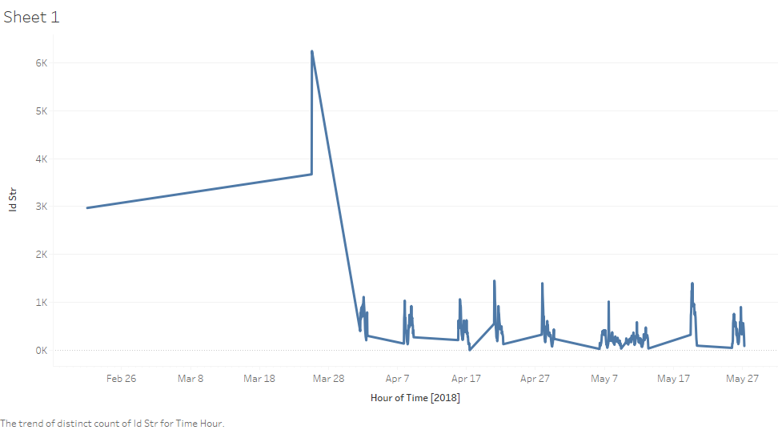

Figure 2: Trends in the numbers of unique tweets over 100 days

To determine the numbers of unique (original) tweets, retweets (@RT) and mentions (@mentions), the variable “Text” in Dimensions is converted into Tweet Type by first turning it into a “Calculated Field”, followed by some lines of code instructing it on how to distinguish tweet types, and then dragging it onto color. Below are the said lines of code:

**IF CONTAINS([Text], "RT @") THEN "retweet"**

**ELSEIF CONTAINS([Text], "@") THEN "@mention"**

**ELSE "original tweet" END**

Figure 3 below distinguished between original tweets, retweets and mentions.

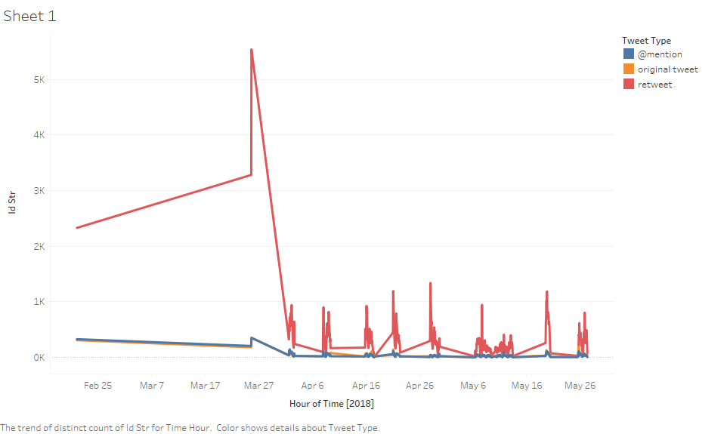

Figure 3: Original tweets, retweets (@RT) and mentions (@mentions)

A cross tabulation of tweet id and the texts in the tweets yielded a graph of the most prominent tweets in our twitter data. As observed from figure 4 the most prominent tweets consist mainly of retweets (‘’RT@user”).

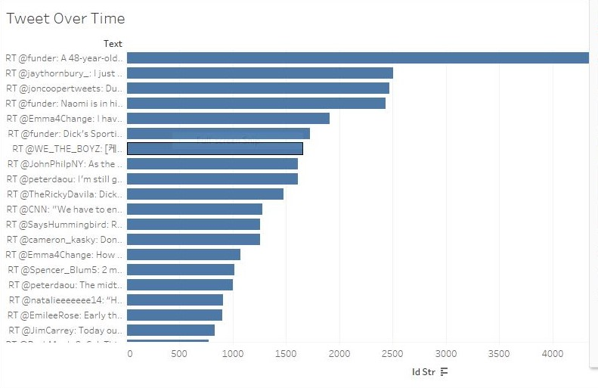

Figure 4: The number of tweets over time for the #NeverAgain campaign

Retweets could be messy, especially when users introduce small variations in the text manually. Tableau will interpret these variations as different tweets due to the inability to cognitively distinguish such variations in the text. One way to tackle this problem in Tableau is to group the tweets together by sorting in alphabetic order such that tweets (or retweets) from same users follow each other on the graph.

***User Activity and User Visibility***

Figure 5 below is a depiction of the activity pattern in our dataset. Original tweets were depicted in the colour orange, red for retweets (RT@user) and blue for @mentions. It is obvious from the graph that there were user accounts that were focused entirely on retweets, other accounts are more focused on original tweets, while many others combine retweets with original tweets and @mentions in varying combinations. For instance, the user with the username NayaramAseye in figure 5 has a combination of 271 retweets, 40 original tweets and three mentions. There are also bots (programs that generate automated tweets), news organization such as Miami papers (178 retweets) in the graph below, social advocacy such as usgunviolence6 (48 original tweets, and 80 @mention).

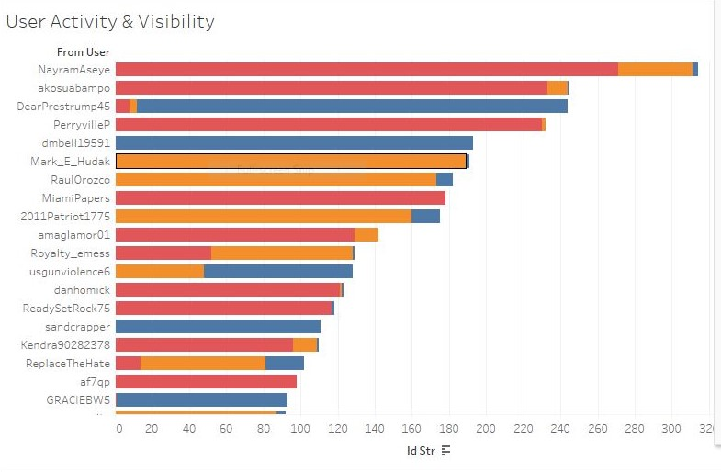

Figure 5: User Activity

Manipulating the “Text” under Dimensions in Tableau as a *“Calculated Field“* and using the **REGEXP_EXTRACT function** allows for the determination of user visibility as indicated in figure 6 below. Detailed information about the most retweeted and @mentioned users in our #NeverAgain dataset were revealed. In our dataset, Emma Gonzalez (@emma4change) was found to be the most visible amongst the student activist from Stoneman Douglas High School. Emma had 3,067 retweets (in red) and 323 @mentions as indicated in blue in graph below in figure 5. Other student activists such as Cameron Kasky had 1,448 retweets and 183 @mention, David Hogg had 171 retweets and 801 @mention, Ryan Deitsch had 1, 141 retweets and 41 @mention. The Cable News Network (@CNN) had 1,507 retweets and 144 @mention, while United States President (@realdonaldtrump) had 161 retweets and 793 @mention of his original tweets on the Stoneman Douglas High School shooting within the first 100 days after the incidence occurred. These were all indicators of how wide the #NeverAgain campaign travelled across the twitter universe.

When the graph of User Activity is compared to that of User Visibility, we realize that the number of retweets is not related to the frequency of tweets by specific accounts, the number of retweets is rather correlated with the contents and messages in the tweets.

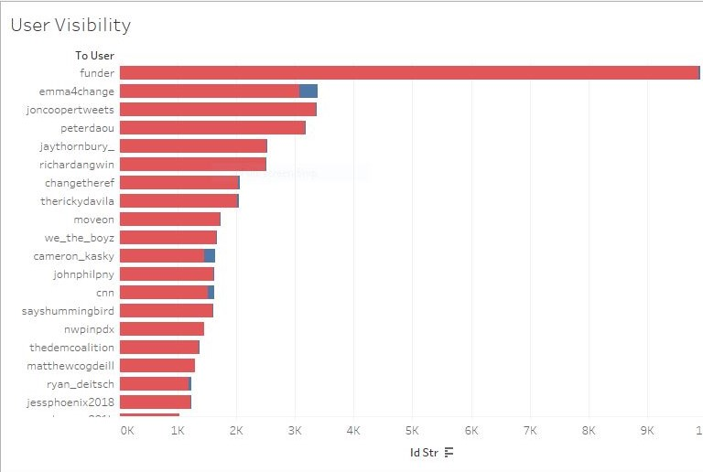

Figure 6: User Visibility

***User Followers***

Computing the “User follower” metric in Tableau is not straightforward. The cross-tabulation of “From User” and “User Followers Count” yielded the present status of the number of follows with respect to each User account in our dataset. To achieve our aim, we drag the ID Str (Count (Distinct)) into “Labels” in Marks in Tableau worksheet. This manipulation yielded a list of prominent Twitter users as a measure of the number of followers they have, which also revealed the actual number of tweets they have contributed to our dataset. Figure 7 showed that CNN has the highest number of followers in our dataset with 40, 225, 393 followers. The duo of Teen Vogue and Marie Claire magazine also registered notable presence with 3, 535, 576 and 2, 338, 190 followers respectively. Surprisingly Jake Tapper (host of State of the Union on CNN) with just a tweet also had a sizeable number of followers (1, 706, 632) with respect to the #NeverAgain campaign. Emma Gonzalez (@Emma4Change) had the highest number of followers amongst the student activists with 1, 624, 761 followers to her credit within the first 100 days of the #NeverAgain campaign on Twitter. The other closest student activist was David Hogg (@davidhogg111) with 804, 190 followers as of May 2018.

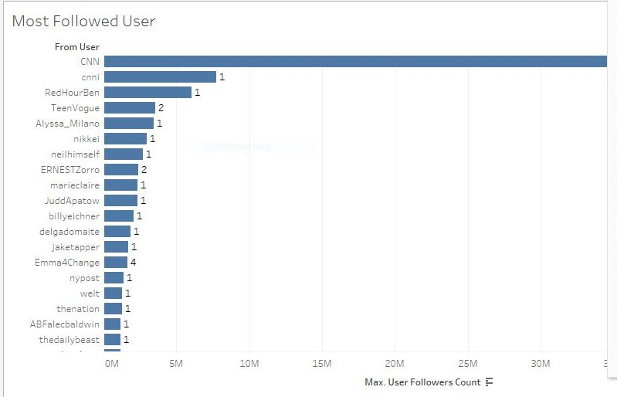

Figure 7: Most followed users

An estimate of the number of followers that each tweet could have potentially reached during the first 100 days of the #NeverAgain campaign was computed by using a cross-tabulation of “Text groups” in rows versus “User Follower Counts” in column. This is rather simplistic, as it assumes that all the followers received and read the tweets. This analysis is hardly the case in real life, thus the analysis was further refined by introducing a probability factor of 0.1 using the “Edit in Shelf” option. This assumed that only 10% of the followers will receive and read the tweets. This is about the least significant number statistically. The result put the number of tweet reach at a conservative estimate of 89, 276, 185 followers (figure 8 below).

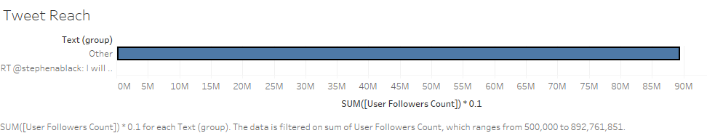

Figure 8: Tweet Reach in numbers of followers

***Hashtags***

Manipulating the Text field in our data using the **REGEXP_EXTRACT** function from “Calculated field” in Tableau yielded the “Hashtag” field, from where the trending hashtags in the dataset were discovered. With the program below, we can determine the Hashtags in our Text data:

**IF(LOWER(REGEXP_EXTRACT_NTH([text],'\#([a-zA-Z0-9_]+)',1)) = 'neveragain') THEN**

**LOWER(REGEXP_EXTRACT_NTH([text],'\#([a-zA-Z0-9_]+)',2)) ELSE**

**LOWER(REGEXP_EXTRACT_NTH([text],'\#([a-zA-Z0-9_]+)',1)) END**

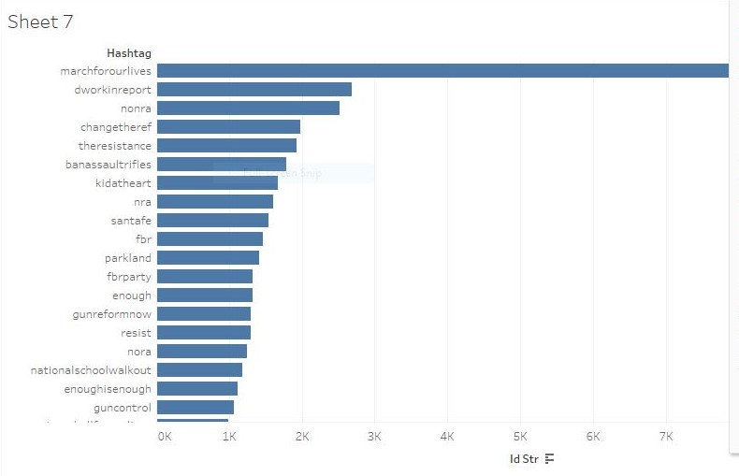

Figure 9: Number of Secondary hashtags in the dataset

Manipulating our dataset further by placing the Hashtag field in the Filter and replacing it with Id_Str in rows and Time in column yielded a graph of how the 20 most popular hashtags used trended over the 100 days period under investigation. It is noteworthy that the dataset was scrapped of twitter weekly starting from February 20 till the end of May. The hashtag #marchforourlives was found to have peaked on the 25th of March 2018 after a steady increase in twitter activity during the weeks before the rally in Washington D.C. The rally was held on the 24th of March 2018. figure 10 is an uncluttered display of how the secondary hashtags trended during the first 100 days of the #NeverAgain campaign.

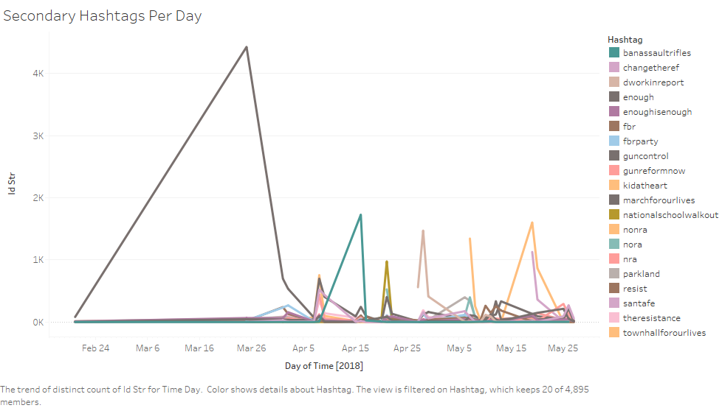

Figure 10: Trending secondary hashtags per day

***User Visibility per Day***

When the graph of user visibility is duplicated and manipulated in Tableau it yielded a graph of user visibility per day. This is a useful indicator of how and when tweets from certain prominent individuals have gone viral through retweets over the 100 days period being investigated. For instance, on April 28, 2018, the student activist Cameron Kasky was found to have 830 retweets, the highest during the period.

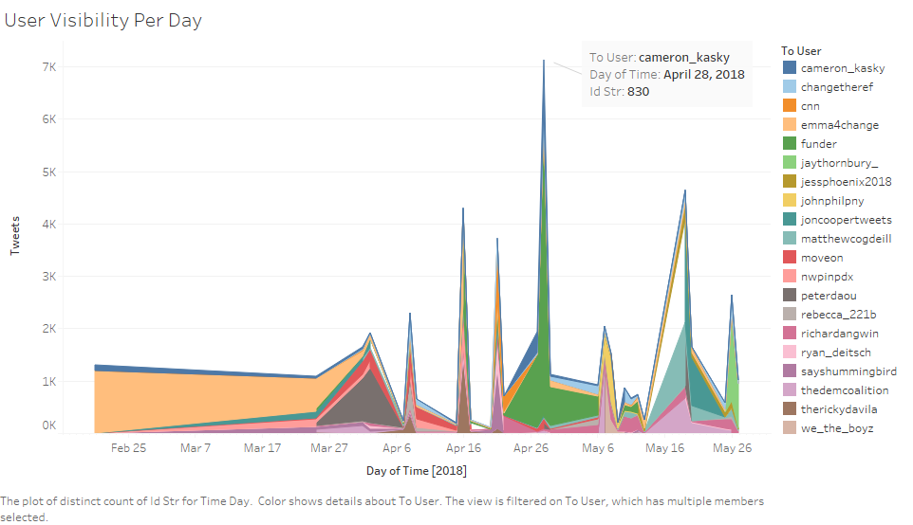

Figure 11: User visibility per day

We can also glance through the interrelationships between users and followers viz-a-viz their original tweets, retweets and @mention. Table 1 below depicts this interrelationship. The #NeverAgain data was prepared and exported into notepad on Windows 10 operating system using the (.tsv) file extension for further analysis.

Table 1: Network edges

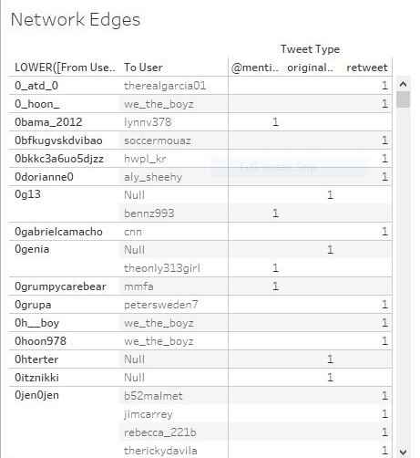

***Social Network Analysis***

We use Gephi for analyzing the inter-relationships formed during the first 100 days of the #NeverAgain campaign on Twitter. Gephi is a data visualization application that is suitable for analyzing social networks. We use Gephi 0.9.2 for Windows in our analysis. We can observe the network edges in our dataset in Gephi as shown in Table 2 below:

Table 2: Network Edges in Gephi

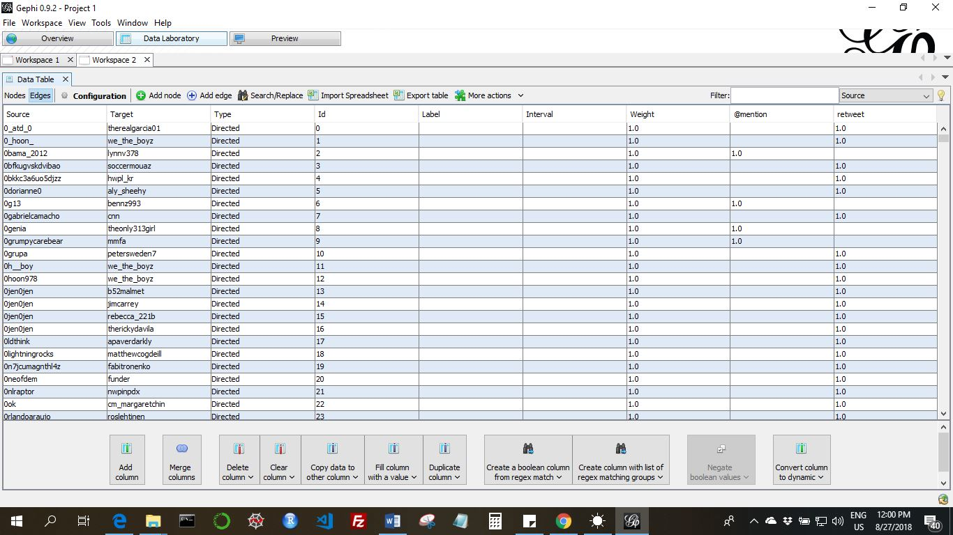

Similarly, table 3 revealed in detail the characteristics of the nodes in our network. The account @funder is ranked highest (weighted degree = 8931.0), followed by @Emma4Change (the twitter account of student activist Emma Gonzalez) with a weighted degree of 3326.0.

Network visualization is a profoundly subjective matter in Gephi. There are many ways to visualize a network using any of the available algorithms, it all boils down to choose and preference. Force Atlas 2 is a user-friendly algorithm popular amongst social media analysts, was used for the analysis of our network. It has quality graphical representation that reveals in the detail the strength of the relationships between users (nodes) in a given social network.

Table 3: Network Nodes in Gephi

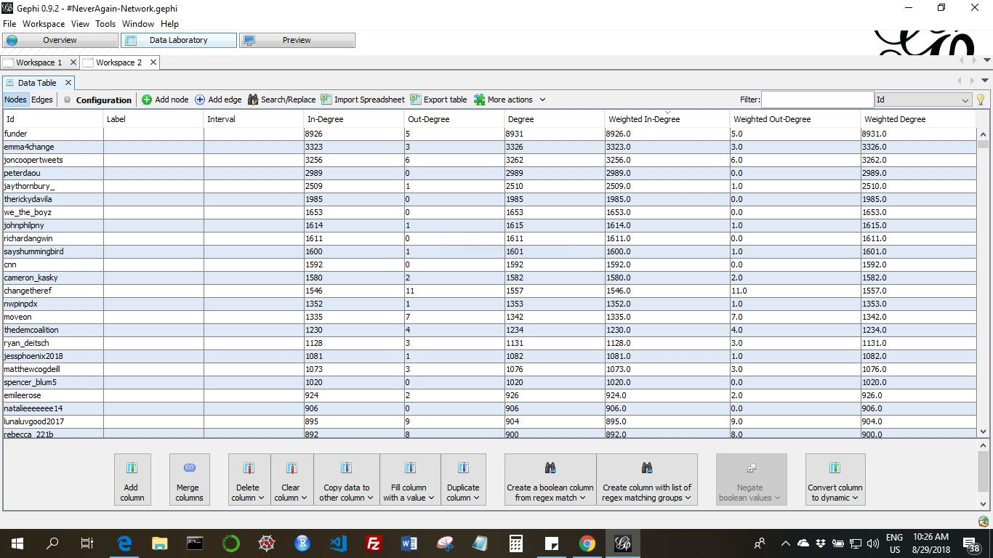

To speed up the processing of our network data we filter out all the nodes that do not have at least a weighted degree of two. That is, all accounts that have been observed not to interact with one another twice through incoming and/or outgoing @mentions or retweets. We now have 26, 577 nodes with 27.62% visible, and 75, 685 edges with 53.36% visible. Checking the LinLog box and setting the Tolerance level to 1000 under the Force Atlas 2 algorithm yielded a depiction of the network for the #NeverAgain campaign on Twitter. by reducing the value of the scaling from 2.0 to 0.005.

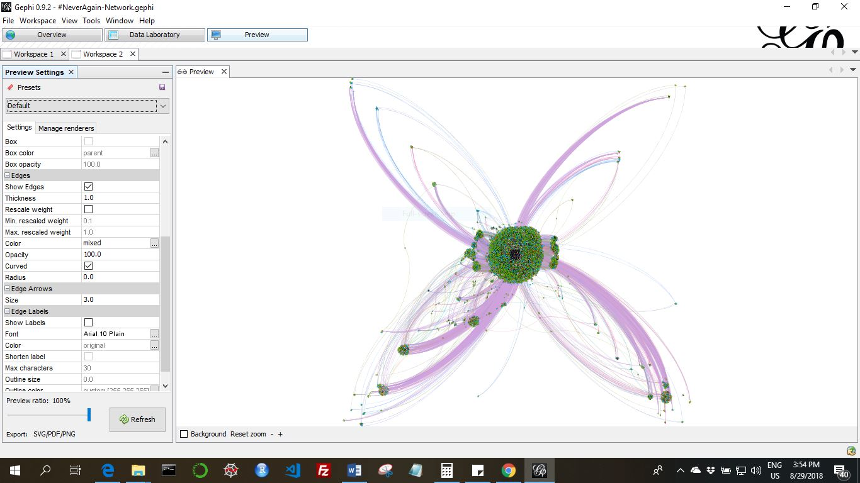Figure 12: Network of the #NeverAgain campaign in colour and with no overlaps

Clusters are identified communities or sub-networks within the main network. Gephi has built in algorithms to identify and analyze the modularity of a network; that is the tendency of a network to separate into clusters. By setting the parameters to “No Overlap” still using the Atlas 2 algorithm and setting up the colour scheme we have our #NeverAgain network as depicted in figure 11 below. It is noteworthy that edges are all curved in the graph below. Curved edges are typically read in a clockwise direction in network analysis. Edges were indicated by the purple lines in the graph below, edges connect user in a community, sub-network or network. The edge colour was set to black with an opacity of 50% to allow better readability (figure 12).

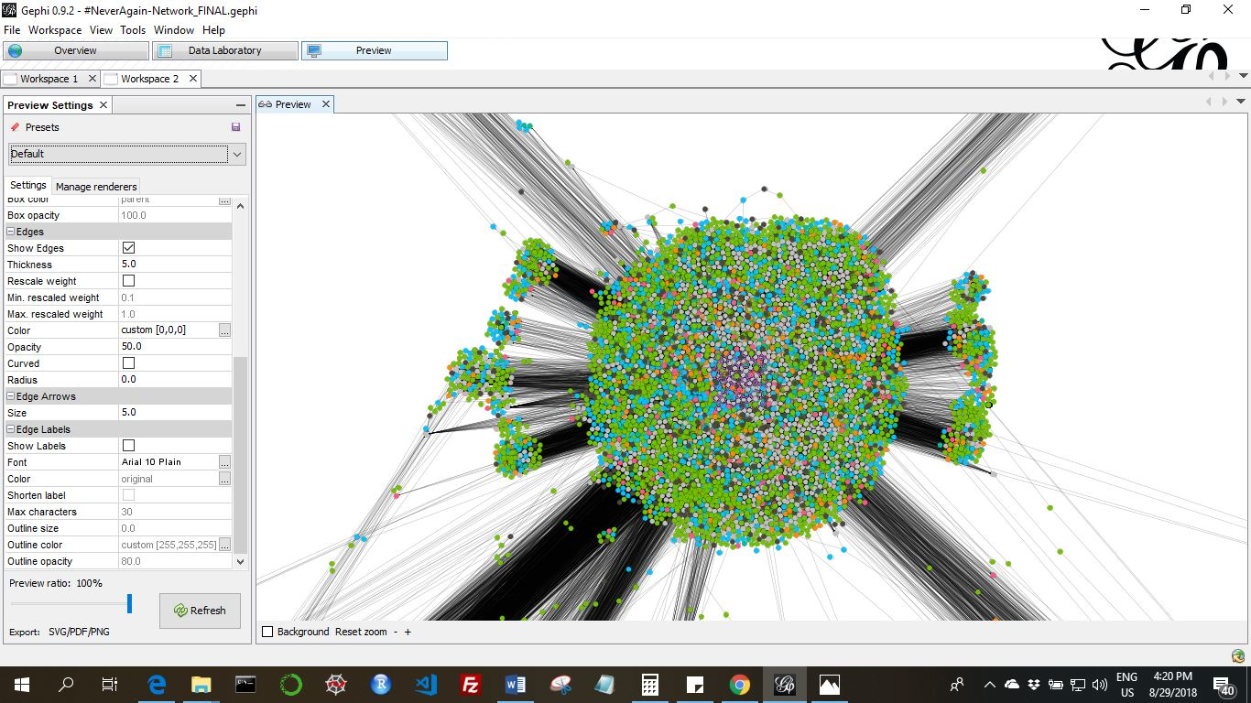

Figure 13: Network edges (in black) for the #NeverAgain campaign

**Conclusion**

It is clear from the results obtained from the visual and network analyses that the #NeverAgain campaign on Twitter did influence the civil society such that laws were enacted prohibiting the use of bump-stocks and the legal age for the acquisition of firearm was increased from 18 to 21 in the State of Florida. Also, politicians were forced to take a stand on the gun control issue, and propose ways to make schools safe for students. All of these might not have come to light were it not for the social media campaigns embarked upon by students of the Stoneman Douglas High School, in Parkland Florida.

While it’s is difficult to prove scientifically of the direct correlation between causes and effects. It should be borne in mind that social media advocacy through what is now commonly refer to as data activism does influence the civil society and the formulation of policies that affect citizens data collection and other social-political issues.

**References**

Atefeh, F. and Khreich, W. (2013). A Survey of Techniques for Event Detection in Twitter. *Computational Intelligence*, Volume 0, Number 0. Wiley Periodicals, Inc.

Association of Internet Research (2012). *Ethical Decision Making and Internet Research.* Available at: <http://aoir.org/reports/ethics2.pdf>

Bruns, A., Burgess, J., and Highfield, T. (2014). A ‘Big Data’ Approach to Mapping the Australian Twittersphere. In Arthur, Paul Longley & Bode, Katherine (Eds.) Advancing Digital Humanities: Research, Methods, Theories. Palgrave Macmillan, Houndmills, pp. 113-129.

Bryer, T. A., & Zavattaro, S. M. (2011). Social Media and Public Administration: Theoretical Dimensions and Introduction to the Symposium. *Administrative Theory & Praxis, 33,* 325-340. http://dx.doi.org/10.2753/ATP1084-1806330301

Digital Humanities Initiative – Collecting social media data for research. Rutgers University. Available at: [*http://dh.rutgers.edu/collecting-social-media-data-for-research/*](http://dh.rutgers.edu/collecting-social-media-data-for-research/)

Ediger, D., Jiang, K., Reidy, J., Bader, D., Corley, C., Farber, R., Reynolds, W.N. (2010). 39th International Conference on Parallel Processing

Hawksey, M. TAGS. Available at: [*https://mashe.hawksey.info/category/tags/*](https://mashe.hawksey.info/category/tags/)

Jenders, M., Kasneci, G., and Naumann, F. (). Analyzing and predicting viral tweets. International World Wide Web Conference Committee (IW3C2). WWW 2013 Companion, May 13–17, 2013, Rio de Janeiro, Brazil. ACM 978-1-4503-2038-2/13/05. DOI: 10.1145/2487788.2488017. Available at*:* [*https://www.researchgate.net/publication/262166912*](https://www.researchgate.net/publication/262166912)

Kietzmann, J. H., Hermkens, K., McCarthy, I. P., & Silvestre, B. S. (2011). Social media? Get serious! Understanding the functional building blocks of social media. *Business Horizons* , *54* (3), 241–251.

Milan, S. and Guteirrez (2015). Citizens’ media meets big data: the emergence of data activism. ENERO – June 2015.

Milan, S. and Van der Velden, L. (2016). The Alternative Epistemologies of Data Activism. *Digital Culture and Society,* Vol. 2, Issue 2.

### Pew Research Center (2016). Social Media Update 2016: Usage and demographics of social media platforms. Available at*:* [*http://www.pewinternet.org/2016/11/11/social-media-update-2016/*](http://www.pewinternet.org/2016/11/11/social-media-update-2016/)

Pigott, F. (2018). Do more with twitter data. Available at: [*https://twitterdev.github.io/do_more_with_twitter_data/finding_the_right_data.html*](https://twitterdev.github.io/do_more_with_twitter_data/finding_the_right_data.html)

Renzi, A., and Langlois, G. (2015): “Data Activism.” In: Greg Elmer/ Ganaele Langlois/Joanna Redden (eds.), Compromised Data: From Social Media to Big Data, London: Bloomsbury, pp. 202–25.

TAGs 1.6 by Martin Hawksey. Available at: *https://tags.hawksey.info/get-tags/*

Vinodhini, G. and Chandrasekaram, R.M. (2012). Sentiment analysis and opinion mining: a survey. *International Journal of Advanced Research in Computer Science and Software Engineering (IJARCSSE).* Volume 2, Issue 6, June 2012. ISSN: 2277 128X. available at: *www.ijarcsse.com*

Wikipedia (2018). Stoneman Douglas High School shooting: Available at: [*https://en.wikipedia.org/wiki/Stoneman_Douglas_High_School_shooting*](https://en.wikipedia.org/wiki/Stoneman_Douglas_High_School_shooting)

Wikipedia (2018). #NeverAgain MSD: Available at: [*https://en.wikipedia.org/wiki/Never_Again_MSD*](https://en.wikipedia.org/wiki/Never_Again_MSD)

Wisdom, V. and Gupta, R. (2016). An introduction to Twitter Data Analysis in Python. Available at: https://www.researchgate.net/publication/308371781