MICROSOFT FABRIC
Factory Digital Twin Demo
Architecture, Build Guide, and Running the Simulation
Case study: PT Nusantara Manufaktur (simulated company and data)
Fabric workspace: ws_demo_digital_twin
Prepared by Angger Pamungkas · Microsoft
October 2026

1. Executive Summary
This document describes a factory Digital Twin demo built end-to-end on Microsoft Fabric, covering the solution architecture, the steps used to build every component, how the telemetry simulator works, and how to run and present the demo. It was built from scratch, solo, as an exploration of Fabric for industrial IoT/OT and digital twin scenarios.
The demo shows how sensor data from factory machines can stream in real time, be mapped into a digital twin model, be visualized in an operational dashboard, and trigger automated action — all on a single data & AI platform, without stitching together separate tools.

1.1 Fabric Components Used
Fabric Component | Role in the Demo
Lakehouse | Stores master data (sites, lines, machines, work orders) and gives unified SQL/Spark access to telemetry via a shortcut.
Notebook (PySpark) | Seeds the master-data tables in the Lakehouse from a JSON file.
Eventhouse + KQL Database | Stores telemetry history and the live stream; computes health status, scores, and anomalies with KQL functions.
Eventstream | Receives real-time sensor data from the simulator and forwards it to the Eventhouse.
OneLake Shortcut | Links the KQL telemetry table into the Lakehouse without copying data (unified access).
Ontology (Fabric IQ) | The digital twin model: Site → ProductionLine → Machine → WorkOrder entities and their relationships, bound directly to data in the Lakehouse and Eventhouse.
Real-Time Dashboard | Operational visualization: plant map, machine status, temperature/vibration trends, OEE per line, and an anomaly list.
Activator | Automated business rules: sends an email when machine vibration or temperature crosses a threshold.
Catatan: All data (company name, plants, machines, and sensor history) is simulated for demo purposes — it is not customer or production data.

2. Business Scenario & Demo Data
Company (fictitious): PT Nusantara Manufaktur — a components manufacturer with 3 plants, 6 production lines, and 24 machines.

2.1 Plants (Sites)
Site ID | Plant Name | Location | Plant Manager | Employees
PLT-CKR | Cikarang Plant | Jababeka Industrial Estate, Bekasi, West Java | Hendra Gunawan | 820
PLT-KRW | Karawang Plant | KIIC Industrial Estate, Karawang, West Java | Dewi Lestari | 640
PLT-SBY | Surabaya Plant | SIER Rungkut Industrial Estate, Surabaya, East Java | Rizky Hidayat | 710

2.2 Production Lines
Line ID | Line Name | Type | Target Units/Hour
LN-CKR-01 | Cikarang Injection Molding Line 1 | Injection Molding | 1,200
LN-CKR-02 | Cikarang Assembly Line 2 | Assembly | 720
LN-KRW-01 | Karawang CNC Machining Line 1 | Machining | 240
LN-KRW-02 | Karawang Packaging Line 2 | Packaging | 2,400
LN-SBY-01 | Surabaya Injection Molding Line 1 | Injection Molding | 1,200
LN-SBY-02 | Surabaya Assembly Line 2 | Assembly | 720
Each line has 4 machines (24 in total), each with full technical attributes: machine type, manufacturer, model, serial number, install date, rated power (kW), nominal RPM, temperature/vibration thresholds, and a criticality rating (A/B/C). The full dataset lives in data\master_data.json in the project folder.

2.3 Telemetry Data
Every machine emits one sensor reading per interval, with the following columns:
Column | Type | Description
Timestamp | datetime | Reading time (UTC).
SiteId / LineId / MachineId | string | Plant, line, and machine identity.
MachineType | string | Machine type, e.g. InjectionMolder, Chiller, Conveyor.
Status | string | Running, Idle, Blocked, or Fault.
TemperatureC | real | Machine temperature (°C).
VibrationMmS | real | Machine vibration (mm/s) — ISO 10816 zone D threshold.
PressureBar | real | Hydraulic/pneumatic pressure (bar).
PowerKw | real | Power draw (kW).
Rpm | real | Rotational speed (RPM).
UnitsProduced / UnitsRejected | int | Units produced and rejected in the interval (the basis for OEE).
Seven days of history are generated for every machine (~240,000 rows), plus a live stream every 10 seconds from the simulator while a demo session is running.

2.4 Three Anomaly Scenarios
Three situations are deliberately seeded into the data so the dashboard, ontology, and Activator all have a real story to tell:
1. Bearing wear — air compressor M-CKR-L2-04 (Cikarang Assembly Line 2) shows vibration slowly climbing from ~2.5 to ~8 mm/s over the last 3 days — a classic bearing-wear pattern that only shows up when you watch a medium-term trend, not a single snapshot.
2. Scheduled overheating — injection molder M-SBY-L1-01 (Surabaya) has repeated temperature spikes of 98–105 °C over the last 6 hours, crossing the 95 °C threshold.
3. Sudden fault stop — conveyor M-KRW-L2-03 (Karawang) stopped (RPM 0, Status Fault) from 14:00–14:45 local time yesterday, and both packaging machines on the same line also turned Blocked.
Catatan: Each scenario demonstrates a different angle: a medium-term trend (dashboard & ontology), an instant threshold crossing (Activator), and a cascading effect across machines on the same line.

3. Solution Architecture
The data flow follows a simple pattern common to real-time intelligence (RTI) solutions on Fabric:
1. The telemetry simulator (Python) sends each machine’s sensor reading to Eventstream through a Custom Endpoint.
2. Eventstream forwards the data straight through to the Eventhouse (KQL Database), with no extra transformation.
3. The Eventhouse stores the raw data in the MachineTelemetry table, and KQL functions compute health status, scores, OEE, and anomalies on the fly.
4. A OneLake shortcut in the Lakehouse reads the MachineTelemetry table from the Eventhouse without copying it, giving the Lakehouse SQL/Spark access to both live and historical data.
5. Ontology (Fabric IQ) binds Site/ProductionLine/Machine/WorkOrder entities to the dimension tables in the Lakehouse and the time-series data in the Eventhouse — this is the digital twin layer.
6. The Real-Time Dashboard reads directly from the KQL Database for operational visualization.
7. Activator watches attributes (vibration, temperature) and sends an email when a threshold is crossed.
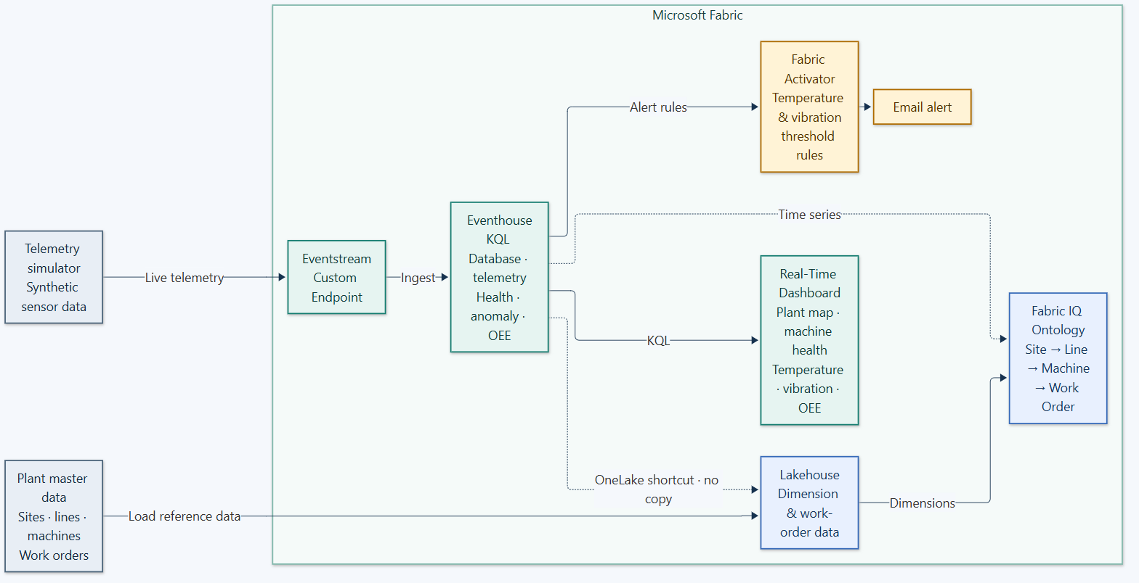
Figure 1 — Fabric Digital Twin solution architecture.
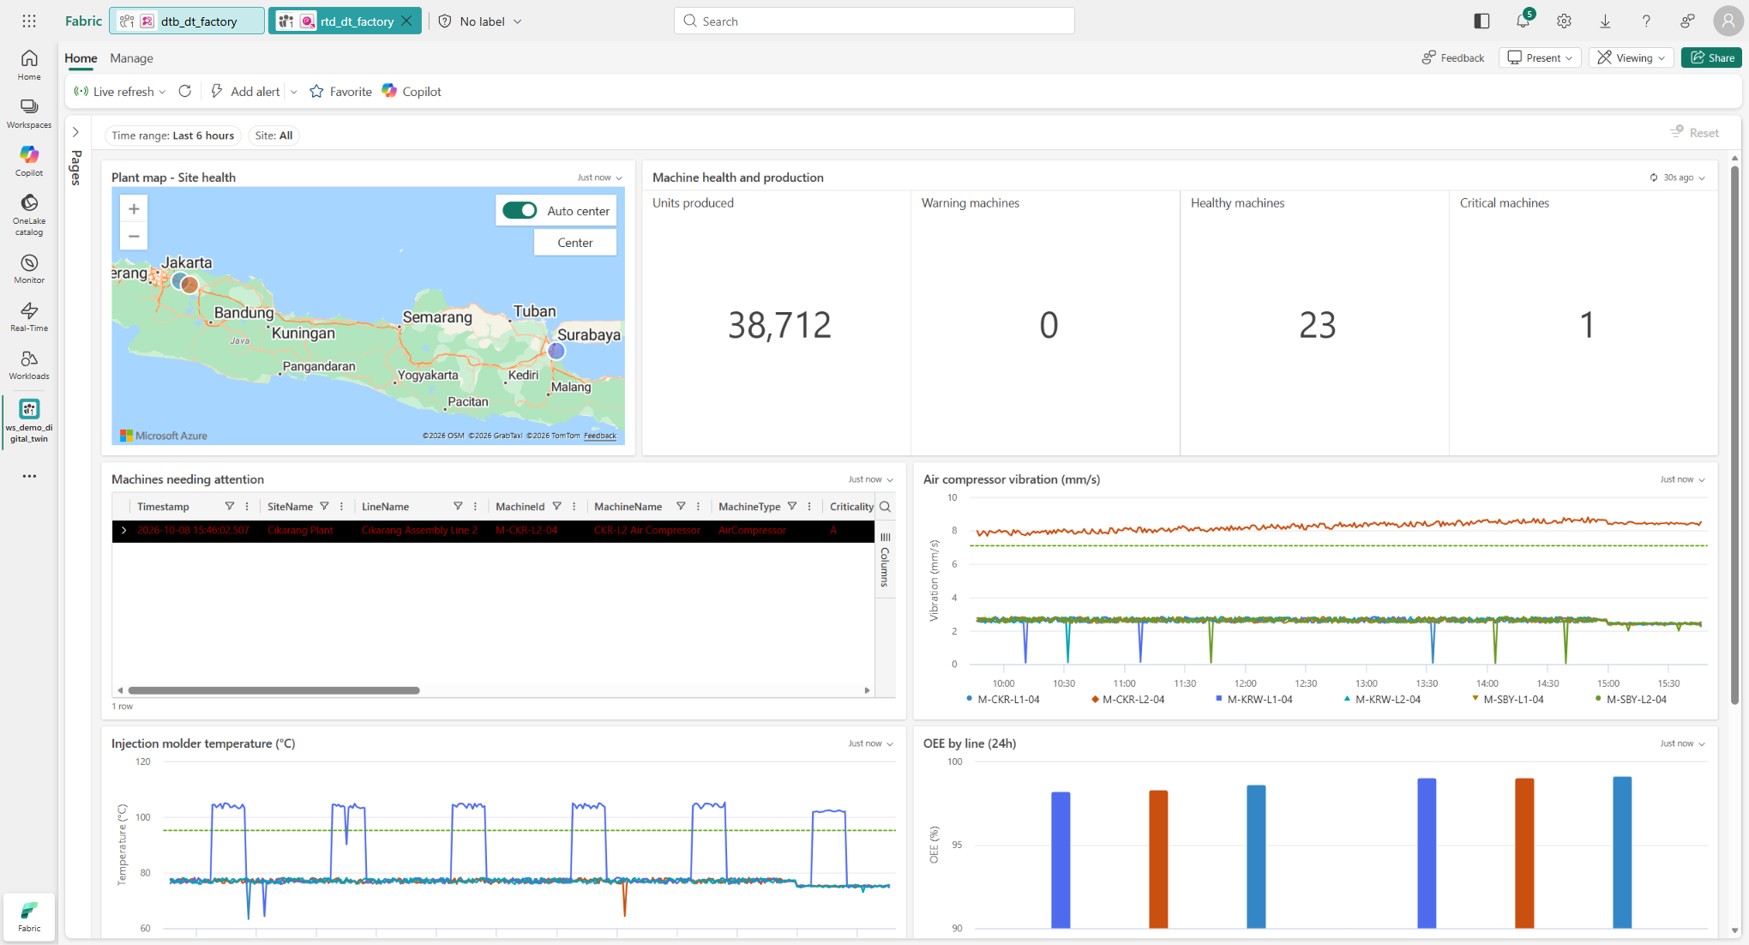
Figure 2 — Real-Time Dashboard rtd_dt_factory: plant map, machine status, and vibration/temperature trends.

3.1 Workspace, Capacity, and Tenant
Item | Value
Workspace | ws_demo_digital_twin
Fabric capacity | apfabricsea — F8 SKU, Southeast Asia region
Tenant | YourTenantName (demo tenant)
Demo admin account | admin@YourTenantName.onmicrosoft.com
Note: Full workspace, item, and endpoint IDs are in Appendix A. These IDs are specific to this demo instance — rebuilding in a different tenant/capacity will produce different IDs.

4. Prerequisites

4.1 Access & Licensing
- An active Microsoft Fabric capacity (F2 minimum; F8 or higher recommended so Eventhouse, Activator, and Ontology all run comfortably together).
- Admin or Member role on the target Fabric workspace.
- A Microsoft 365 account on the same tenant (to receive Activator email alerts).

4.2 Local Tooling
Tool | Purpose
Python 3.11+ | Runs the build scripts (scripts\*.py) and the telemetry simulator.
azure-eventhub (Python package) | Used by the simulator to send events to the Eventstream Custom Endpoint.
Azure CLI (az), signed in | Obtains a Microsoft Entra ID token for calling the Fabric REST API and managing the capacity.
PowerShell 5.1+ | Runs the operational scripts (prepare_demo.ps1, start/stop simulator).
# Example Python virtual environment setup
python -m venv %USERPROFILE%\.venvs\fabric-dt
%USERPROFILE%\.venvs\fabric-dt\Scripts\pip install azure-eventhub
# Azure CLI login (once per session / expired token)
az login --tenant <tenant-id>

4.3 Connection Secret
The Eventstream Custom Endpoint connection string is stored locally at %USERPROFILE%\.secrets\fabric-dt-demo.env with two keys: EVENTHUB_CONNECTION_STRING and EVENTHUB_NAME. It is copied from the Eventstream source’s "Custom Endpoint" page the first time it is built, and is never committed to a repository or printed to a log.
Security: This secret file is personal to each user. If you rebuild the demo, take a fresh connection string from your own Eventstream source (see section 5.4).

5. Step-by-Step Build Guide
Every step below runs through the Python scripts in scripts\, which call the Fabric REST API via the fabric_api.py helper module (Azure CLI token authentication, long-running-operation polling, and Kusto/OneLake helpers). Each item’s ID is saved to ids.json so later scripts can reference earlier ones.

5.1 Workspace & Capacity
Create a new workspace and assign it to an active Fabric capacity (via the Fabric portal, or a REST API POST /v1/workspaces call followed by assigning capacityId). Save workspaceId and capacityId to ids.json — every later script reads them from there.

5.2 Lakehouse & Master Data
- gen_master_data.py produces data\master_data.json: 3 sites, 6 lines, and 24 machines with full technical attributes (manufacturer, model, temperature/vibration thresholds, criticality).
- build_lakehouse.py creates the Lakehouse item lh_dt_factory and the Notebook nb_dt_seed_assets.
- The notebook (PySpark) is run to write master_data.json into Delta tables: dim_site, dim_production_line, dim_machine, and maintenance_work_order.
python scripts\gen_master_data.py
python scripts\build_lakehouse.py

5.3 Eventhouse (KQL Database)
build_eventhouse.py creates the Eventhouse item eh_dt_factory and its KQL Database, then runs the KQL scripts in the kql\ folder in order:
KQL File | Contents
01_schema.kql | Creates the MachineTelemetry, DimSite, DimLine, DimMachine tables; the JSON ingestion mapping; streaming ingestion and a 365-day retention policy.
02_dims.kql | Populates the dimension tables (DimSite/DimLine/DimMachine) from the master data.
03_history.kql / --fill-gap | Generates 7 days of telemetry history (or backfills the gap since the simulator last ran).
04_functions.kql | Creates the MachineLatestState materialized view and the MachineCurrentState(), MachineHealthScore(), MachineAnomalies(), LineOEE(), and SiteStatus() functions; enables OneLake mirroring on MachineTelemetry.
python scripts\build_eventhouse.py # full build: schema + dims + 7-day history + functions
python scripts\build_eventhouse.py --functions-only # (re)deploy KQL functions only
python scripts\build_eventhouse.py --fill-gap # backfill the gap since the simulator last ran
Catatan: The Eventhouse mirroring policy (TargetLatencyInMinutes=5) is what makes the MachineTelemetry table available in OneLake as Parquet files — a prerequisite for the Lakehouse shortcut in section 5.5 to read it.

5.4 Eventstream
build_eventstream.py creates the Eventstream item es-dt-telemetry with a Custom Endpoint source named MachineGateway, wired straight to the MachineTelemetry table in eh_dt_factory (destination "TelemetryEventhouse").
python scripts\build_eventstream.py
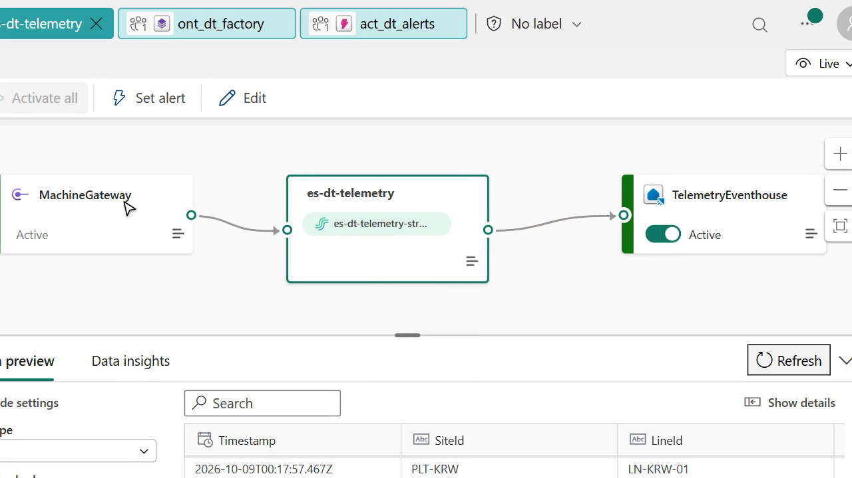
Figure 3 — Eventstream es-dt-telemetry: MachineGateway → es-dt-telemetry → TelemetryEventhouse.

5.5 OneLake Shortcut
A shortcut named machine_telemetry is created inside the lh_dt_factory Lakehouse, pointing at the MachineTelemetry table in the KQL Database (via OneLake availability, not a data copy). This gives the SQL endpoint/Spark the same telemetry data without duplication, and is the time-series source for the Machine entity in Ontology.

5.6 Ontology (Fabric IQ)
build_ontology.py creates the Ontology item ont_dt_factory using the latest TMDL experience, with 4 entity types and 3 relationships:
Entity Type | Data Source | Key
Site | dim_site | SiteId
ProductionLine | dim_production_line | LineId
Machine | dim_machine + machine_telemetry time series | MachineId
WorkOrder | maintenance_work_order | WorkOrderId
- Relationship "Line In Site": ProductionLine → Site
- Relationship "Machine On Line": Machine → ProductionLine
- Relationship "Work Order For Machine": WorkOrder → Machine
python scripts\build_ontology.py
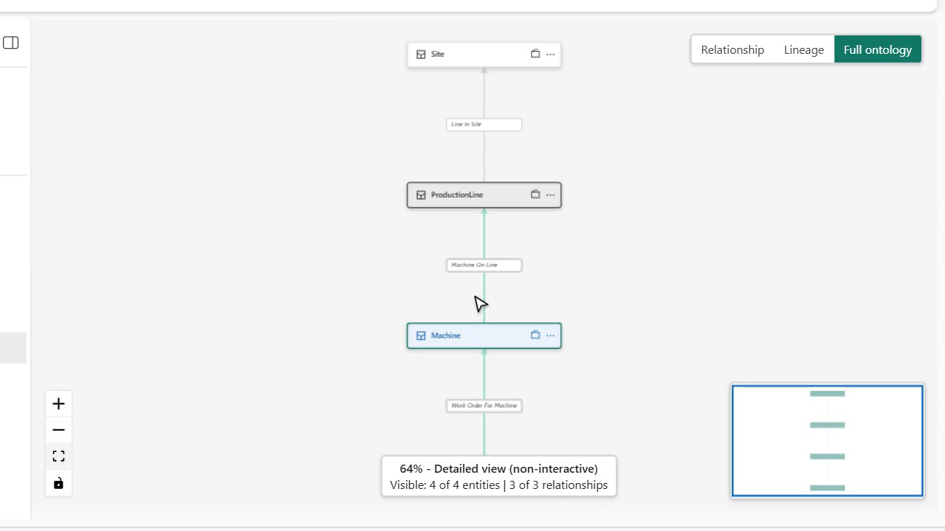
Figure 4 — The ont_dt_factory ontology model: Site → ProductionLine → Machine → WorkOrder.

5.7 Real-Time Dashboard
build_dashboard.py (with an agent assisting on layout) creates the rtd_dt_factory item with 2 pages and 13 tiles, reading directly from the eh_dt_factory KQL Database:
Page | Tile | Visual Type
Plant Overview | Plant map - Site health | Map
Plant Overview | Machine health and production | Multistat (4 numbers)
Plant Overview | Machines needing attention | Table
Plant Overview | Air compressor vibration (mm/s) | Line chart
Plant Overview | Injection molder temperature (°C) | Line chart
Plant Overview | OEE by line (24h) | Column chart
Plant Overview | Recent anomalies | Table
Plant Overview | Health score ranking (last hour) | Table
Machine Drilldown | Selected machine health | Card
Machine Drilldown | Machine temperature / vibration / power / RPM | Line chart (×4)
python scripts\build_dashboard.py
python scripts\patch_dashboard.py # layout fixes: 24-column grid and the multistat visual type

5.8 Activator
build_activator.py creates the act_dt_alerts item with 2 rules that watch the MachineTelemetry table:
Rule | Condition | Action
High vibration (> 7.1 mm/s) | Vibration (mm/s) increases above 7.1 | Email to admin@YourTenantName.onmicrosoft.com — subject "[Digital Twin] High vibration on {Machine}"
Overheating (> 95 C) | Temperature (C) increases above 95.0 | Email to admin@YourTenantName.onmicrosoft.com — subject "[Digital Twin] Overheating on {Machine}"
python scripts\build_activator.py
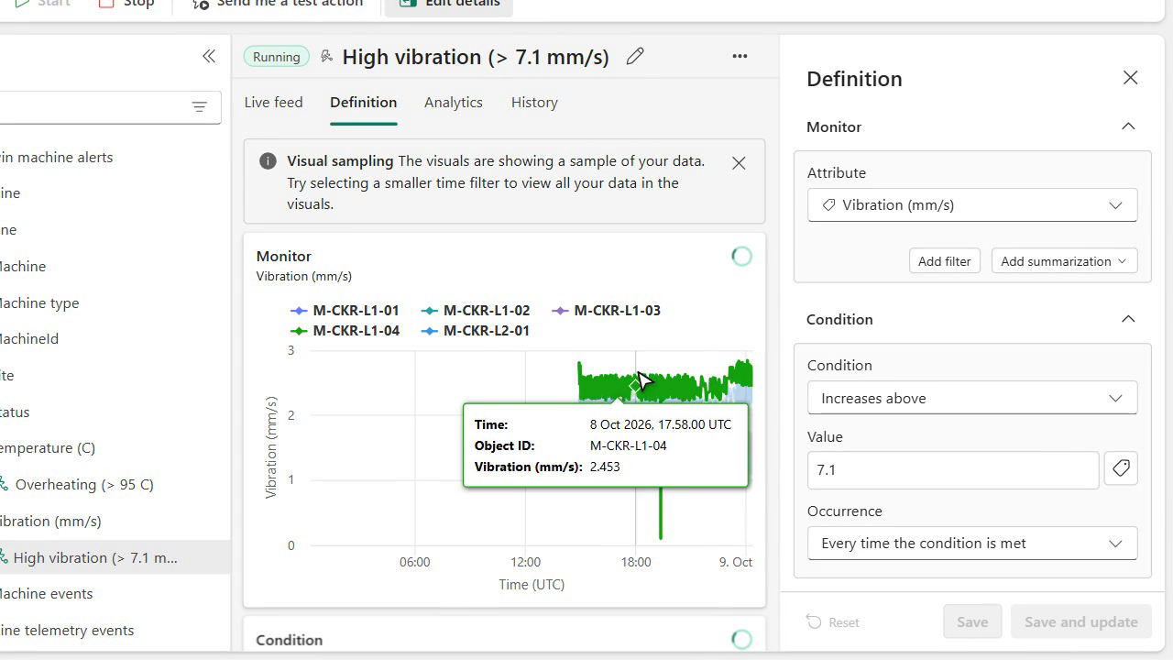
Figure 5 — The Activator "High vibration (> 7.1 mm/s)" rule, with its condition and activation history.

6. Telemetry Simulator
simulator\simulate_telemetry.py sends one JSON event per machine (24 machines) to Eventstream every intervalSeconds seconds (10 seconds by default) using the azure-eventhub SDK, connected through the MachineGateway Custom Endpoint. The scenario can be changed while the simulator is running by editing simulator\scenario.json — the file is re-read on every tick.

6.1 scenario.json Parameters
Parameter | Type | Effect
intervalSeconds | number | Delay between sends (seconds).
bearingWear | boolean | Keeps the rising-vibration (bearing wear) trend on compressor M-CKR-L2-04 — anomaly scenario #1.
overheatSchedule | boolean | Machine M-SBY-L1-01 overheats on a schedule, at minutes 08–24 of every hour — anomaly scenario #2.
forceOverheat | boolean | Forces M-SBY-L1-01 to overheat immediately — for demonstrating a live Activator alert.
conveyorFault | boolean | Conveyor M-KRW-L2-03 faults, and both packaging machines on its line turn Blocked.
vibrationSpikeMachine | string (MachineId) | Any machine gets an extra +6.5 mm/s of vibration — leave as "" to disable.
{
"intervalSeconds": 10,
"bearingWear": true,
"overheatSchedule": true,
"forceOverheat": false,
"conveyorFault": false,
"vibrationSpikeMachine": ""
}

6.2 Running the Simulator
Script | Function
simulator\start_simulator.ps1 [-Minutes N] | Runs the simulator in the background (hidden window) for N minutes (480 by default), recording its PID to simulator.pid and logging to simulator.log.
simulator\stop_simulator.ps1 | Stops the running simulator process found via simulator.pid.
simulator\prepare_demo.ps1 [-Minutes N] | Backfills any data gap (build_eventhouse.py --fill-gap) if the simulator had stopped, then runs start_simulator.ps1. The recommended script to run before every demo session.
cd simulator
.\prepare_demo.ps1 -Minutes 240 # backfill + run the simulator for 4 hours
Catatan: The simulator is a local Python process that publishes to the cloud — keep the machine running it powered on and connected to the internet for the full requested duration.

7. Running the Demo (Runbook)

7.1 Before a Demo Session
1. Make sure the az login session is still valid (every Python script relies on the Azure CLI token).
2. If the Fabric capacity shows as Paused, resume it: az resource invoke-action --action resume --ids <capacity-resource-id>
3. Run simulator\prepare_demo.ps1 so there is no data gap and the live stream is active.
4. Open the ws_demo_digital_twin workspace in the Fabric portal, open rtd_dt_factory, and set the time range to "Last 6 hours" or "Last 3 days".
5. (Optional) Pre-stage a scenario.json trigger such as forceOverheat or vibrationSpikeMachine for a live "wow" moment during the presentation.

7.2 Recommended Presentation Flow
The following order matches the demo video that was produced for this project (see the video\ folder):
1. Real-Time Dashboard — show the plant map, 24 machines, 1 critical machine, the rising compressor vibration trend, injection molder temperature, and OEE per line.
2. Eventstream — show the MachineGateway → es-dt-telemetry → TelemetryEventhouse flow and a live preview of incoming data.
3. Ontology (Fabric IQ) — show the Site → ProductionLine → Machine → WorkOrder model and how machine properties are bound to Lakehouse tables.
4. Activator — show the "High vibration" and "Overheating" rules, their activation history, and the alert email content.
5. (Optional, live) Edit scenario.json (forceOverheat: true, or set vibrationSpikeMachine) and wait about a minute to watch a new alert email arrive.

7.3 After a Demo Session
1. Reset scenario.json to its defaults (forceOverheat: false, conveyorFault: false, vibrationSpikeMachine: "").
2. Stop the simulator: simulator\stop_simulator.ps1.
3. Suspend the Fabric capacity to save cost: az resource invoke-action --action suspend --ids <capacity-resource-id>

8. Demo Video
A recorded walkthrough (~77 seconds, Indonesian narration and subtitles, produced for a LinkedIn post) is kept in the project folder: video\demo-digital-twin-fabric.mp4.
File | Description
demo-digital-twin-fabric.mp4 | Final cut with burned-in Indonesian subtitles — ready to upload to LinkedIn.
demo-digital-twin-fabric.clean.mp4 | Subtitle-free version, for uploading with a separate caption track if needed.
captions.id.srt | Standalone subtitle file (SRT format).
timeline.json | Timestamps for every narration line and chapter, for reference if the video needs re-editing.
record.cjs / postprocess.cjs | The recorder (Playwright + CDP screencast) and post-production (ffmpeg) scripts — for re-recording if the demo is updated.

9. Project File Reference
Project folder: Documents\Microsoft Scout\fabric-digital-twin-demo\
Folder / File | Contents
ids.json | IDs of every Fabric item created so far (read and written by all scripts).
data\master_data.json | Master data: sites, lines, machines (the scenario’s source of truth).
data\scenario_anchors.json | Reference timestamps for the three anomaly scenarios.
kql\*.kql | Eventhouse schema, dimension, history, and function KQL scripts.
definitions\rtd_dt_factory.json | The full Real-Time Dashboard definition (pages & tiles).
definitions\ont_dt_factory\ | The Ontology TMDL definition (entity types & relationships).
definitions\act_dt_alerts.ReflexEntities.json | The full Activator rule definition.
scripts\fabric_api.py | REST/Kusto/OneLake helper module (authentication, LRO polling, Kusto queries).
scripts\build_*.py, patch_dashboard.py, gen_master_data.py | The build script for each component (see section 5).
simulator\ | The telemetry simulator, its scenario file, and operational scripts (see section 6).
video\ | The final demo video, subtitles, and recorder scripts (see section 8).
docs\ | This document.

Appendix A — Item IDs & Endpoints
Item | Value
Tenant ID | <TENANT_ID>
Workspace ID (ws_demo_digital_twin) | <WORKSPACE_ID>
Capacity ID (apfabricsea, F8) | <CAPACITY_ID>
Lakehouse (lh_dt_factory) | <LAKEHOUSE_ID>
Notebook (nb_dt_seed_assets) | <NOTEBOOK_ID>
Eventhouse (eh_dt_factory) | <EVENTHOUSE_ID>
KQL Database (eh_dt_factory) | <KQL_DATABASE_ID>
Query URI (KQL) | https://<your-cluster>.kusto.fabric.microsoft.com
SQL Analytics Endpoint ID | <SQL_ENDPOINT_ID>
Eventstream (es-dt-telemetry) | <EVENTSTREAM_ID>
Eventstream Source (MachineGateway) | <EVENTSTREAM_SOURCE_ID>
Real-Time Dashboard (rtd_dt_factory) | <DASHBOARD_ID>
Ontology (ont_dt_factory) | <ONTOLOGY_ID>
Activator (act_dt_alerts) | <ACTIVATOR_ID>

Appendix B — Useful KQL Queries

Current machine status & health
MachineCurrentState()
| where HealthState in ("Critical", "Warning")
| order by HealthState asc

Health score over the last 24 hours, worst first
MachineHealthScore(24h)
| order by HealthScore asc

Vibration anomalies over the last 3 days
MachineAnomalies(3d, "VibrationMmS", 2.5)
| order by Timestamp desc

OEE per line, last 24 hours
LineOEE(24h)
| order by OEE asc

Per-plant status summary (the map tile’s source)
SiteStatus()

