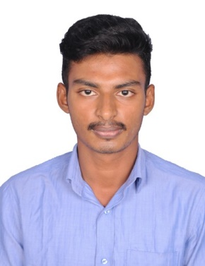Sammengi Sai Lokesh

### FRONTEND DEVELOPER

Hno :25-14-21, kurupam market, Visakhapatnam, AP-530001 Contact NO : +91 7997193781

[sammengi.sailokesh@gmail.com](mailto:sammengi.sailokesh@gmail.com) https://[www.linkedin.com/in/sammengi-sai-lokesh](http://www.linkedin.com/in/sammengi-sai-lokesh) https://github.com/apanacode

To learn and gain new experience while utilizing my interpersonal skills to help achieve business goals. Excellent analytical and developmental skills for a software enginner role. Looking to work for a dynamic organization with opportunities for career growth . Quick learner and problem solver.

# Educational Background Projects

## Dr.Lankapalli Bullayya College

### ANDHRA UNIVERSITY

Master's Degree in Computer Application

2021-2023

CGPA : 8.1

## Dr.Lankapalli Bullayya College

### ANDHRA UNIVERSITY

Bachelor's Degree in Computer Science

2018-2021

CGPA : 8.22

# Skills & Proficiences

 **Frontend languages** : HTML, CSS , JavaScript, React

 **Backend languages** : C , Java

 **Database** : MySQL

# Shipyard System Project

* Language/Technology : HTML, CSS, JavaScript, React, MySQL
* Employed JavaScript to enhance interactivity and responsiveness, enabling real-time updates and dynamic data rendering for improved user engagement.
* It aims to streamline maritime operations by centralizing vessel management, maintenance tracking, and resource alloction process.

# Immigrants GeoInsight

* + Language/Technology : HTML, CSS, JavaScript, MySQL, Python
  + Developed using K means clustering on Geolocational data to recommend accommodations to immigrants to a city.
  + Demonstrated significant enhancement in prediction accuracy from 70% t0 75%.

## Website Development

* + **Cricket Academy Management System:**
  + Languages : HTML, CSS , JavaScript
  + The focus has been on efficient management of player registration, scheduling of coaching sessions and tracking of player progress which is based on CRUD operations.

# Certification & Achievements

* **3** star rated coder rated on Codestudio.
* Hackerrank Java Intermediate Certification .
* Completed Project Management Fundamentals Certification provided by IBM Skill Build.
* Accomplished various running (Marathon) race certifications.
* Won various coding competitions organized at college.