**Cognizant Deep Skilling Mandatory Hands-On Questions**

**TOPIC- React Exercises**

**Exercise 9:** Create a React Application named “cricketapp” with the following components:

1. ListofPlayers

* Declare an array with 11 players and store details of their names and scores using the map feature of ES6
* Filter the players with scores below 70 using arrow functions of ES6.

1. IndianPlayers
   1. Display the Odd Team Player and Even Team players using the Destructuring features of ES6
   2. Declare two arrays T20players and RanjiTrophy players and merge the two arrays and display them using the Merge feature of ES6

Ans)

Step1) Download and install the LTS version from ‘<https://nodejs.org/en/download>’ and install the necessary tools required

Step2) In VS Code terminal, type ‘npx create-react-app cricketapp’ to create a new React project called “cricketapp”

Step3) Open the same project folder in VS Code

Step4) Add 2 js files in ‘Components’ named

(i) ListofPlayers.js 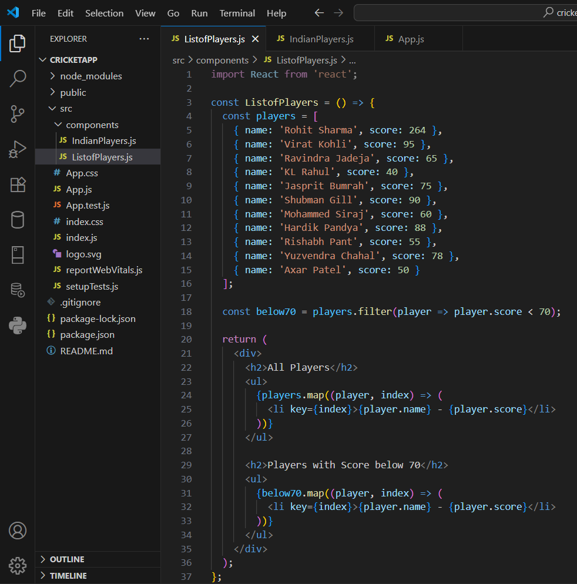

(ii) IndianPlayers.js 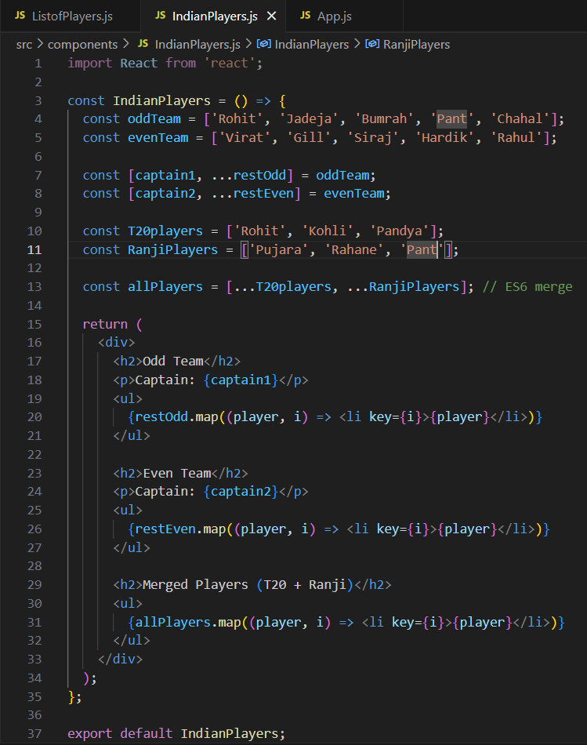

Step5) Replace the ‘App.js’ code with the following code 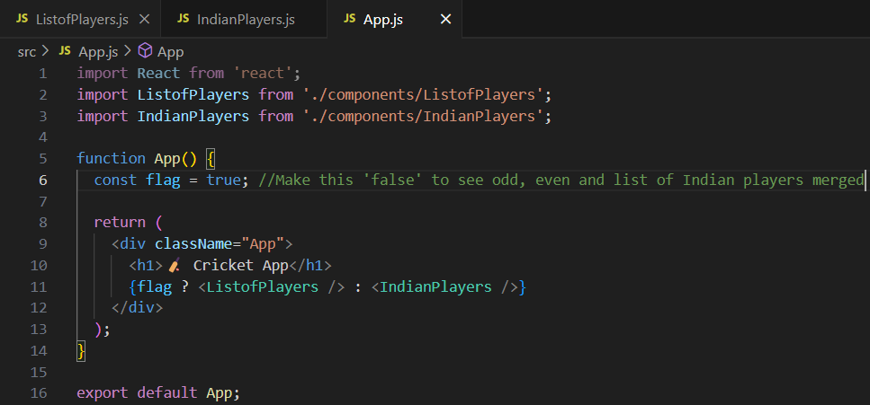

Step6) Open the terminal in VS Code and type ‘npm start’ which will launch the React app in the browser

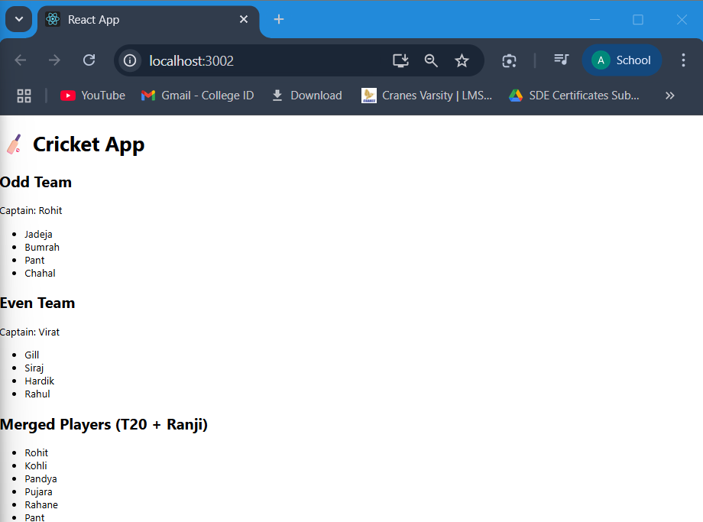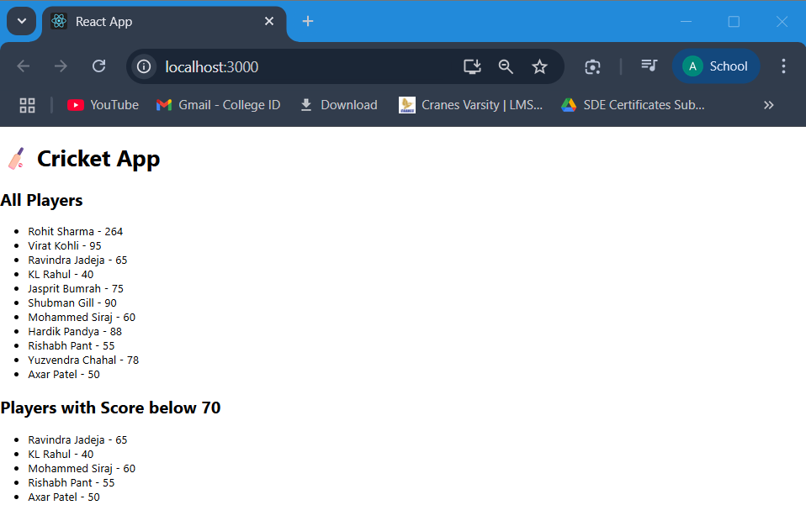**OUTPUT**

**Exercise 10:** Create a React Application named “officespacerentalapp” which uses React JSX to create elements, attributes and renders DOM to display the page.

Create an element to display the heading of the page.

Attribute to display the image of the office space

Create an object of office to display the details like Name, Rent and Address.

Create a list of Object and loop through the office space item to display more data.

To apply Css, Display the color of the Rent in Red if it’s below 60000 and in Green if it’s above 60000.

Ans)

Step1) In VS Code terminal, type ‘npx create-react-app officespacerentalapp’ to create a new React project called “officespacerentalapp”

Step2) Open the same project folder in VS Code

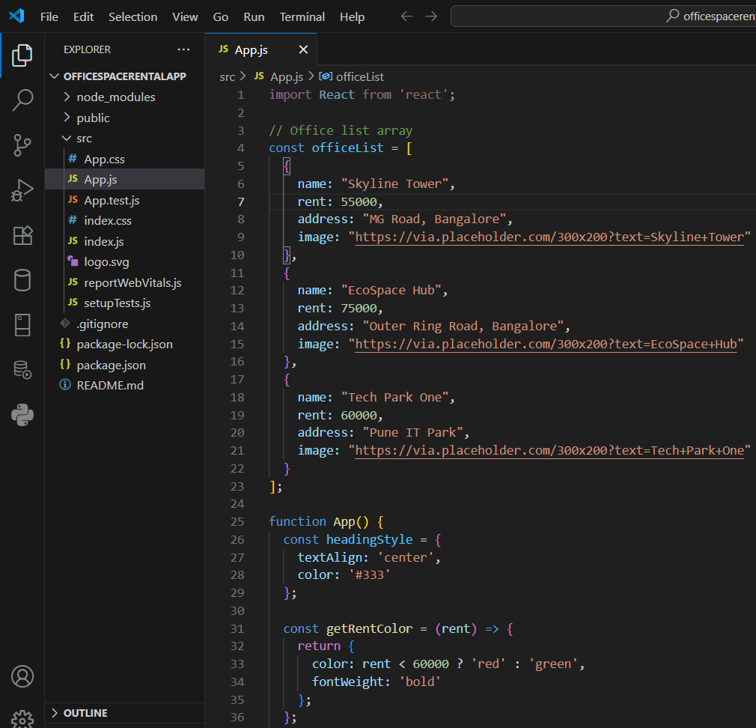Step3) Replace the ‘App.js’ code with the following code

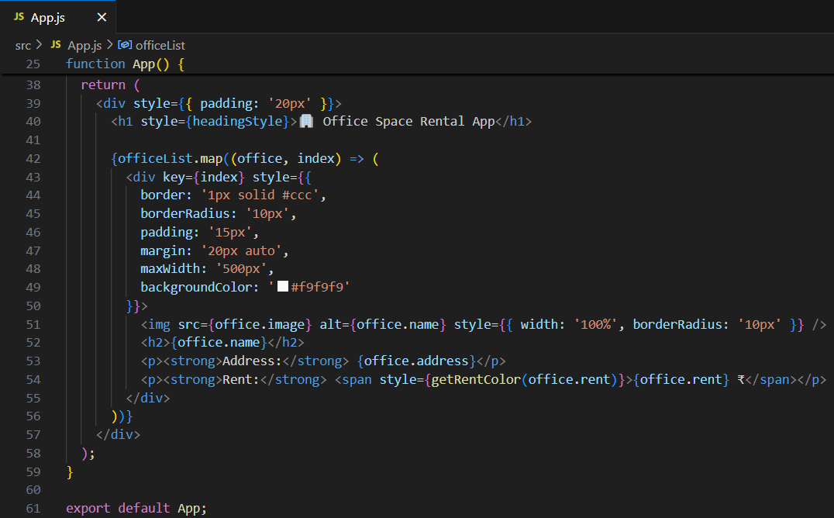

Step4) Open the terminal in VS Code and type ‘npm start’ which will launch the React app in the browser

**OUTPUT**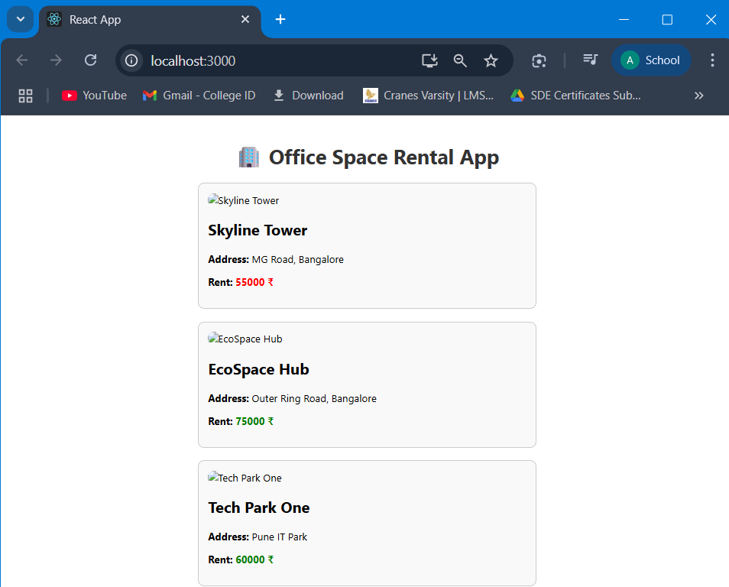

**Exercise 11:** Create a React Application “eventexamplesapp” to handle various events of the form elements in HTML.

1. Create “Increment” button to increase the value of the counter and “Decrement” button to decrease the value of the counter. The “Increase” button should invoke multiple methods.
   1. To increment the value
   2. Say Hello followed by a static message.
2. Create a button “Say Welcome” which invokes the function which takes “welcome” as an argument.
3. Create a button which invokes synthetic event “OnPress” which display “I was clicked”

Create a “CurrencyConvertor” component which will convert the Indian Rupees to Euro when the Convert button is clicked.

Handle the Click event of the button to invoke the handleSubmit event and handle the conversion of the euro to rupees.

Ans)

Step1) In VS Code terminal, type ‘npx create-react-app eventexamplesapp’ to create a new React project called “eventexamplesapp”

Step2) Open the same project folder in VS Code

Step3) Add a file in the ‘src’ named ‘CurrencyConvertor.js’ and write the following code in that 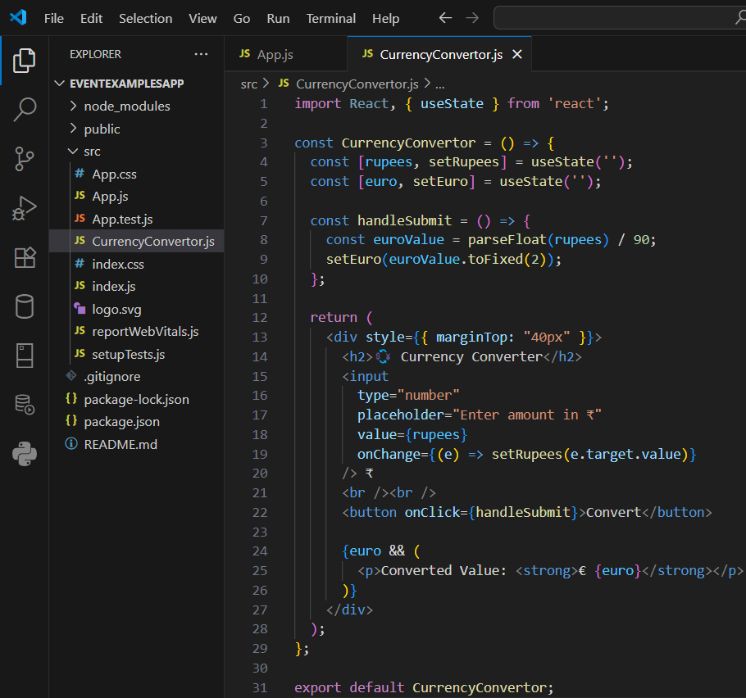

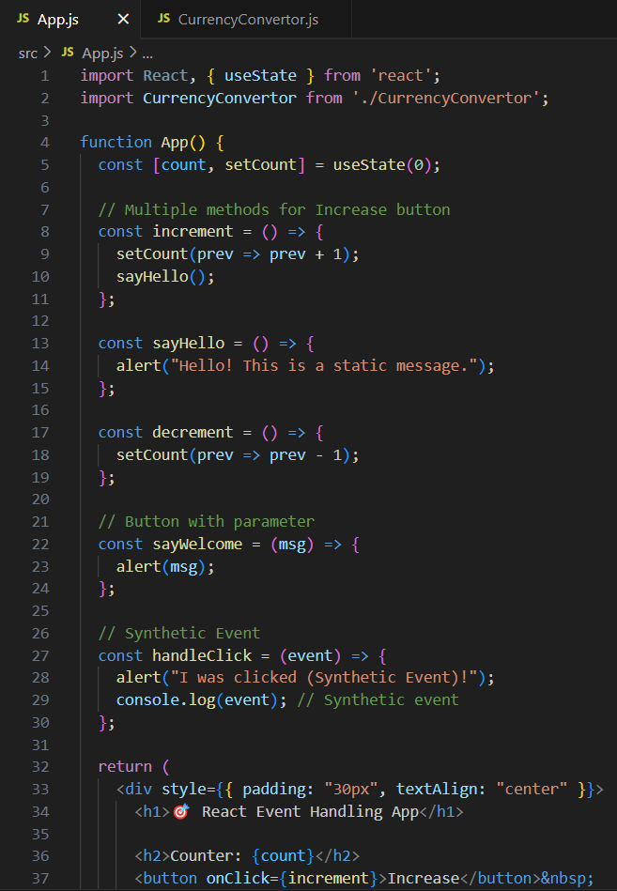Step4) Replace the ‘App.js’ code with the following code

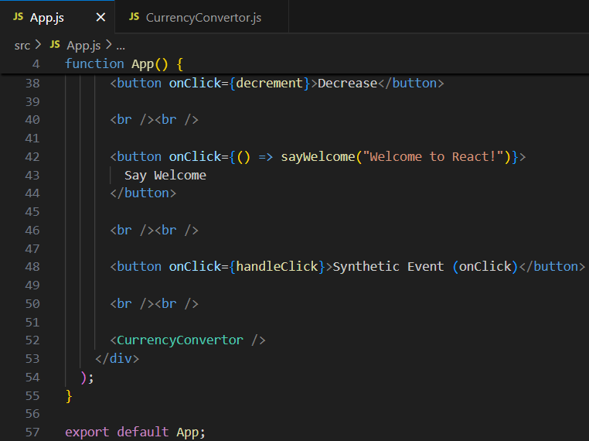

Step5) Open the terminal in VS Code and type ‘npm start’ which will launch the React app in the browser

**OUTPUT**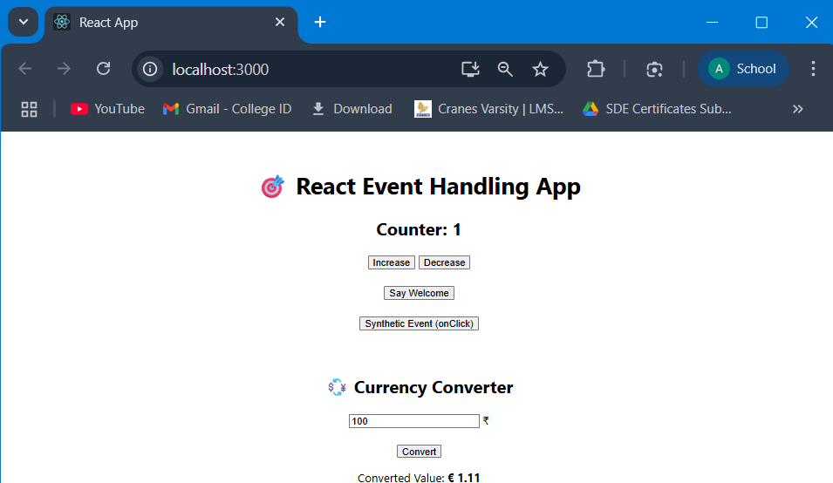

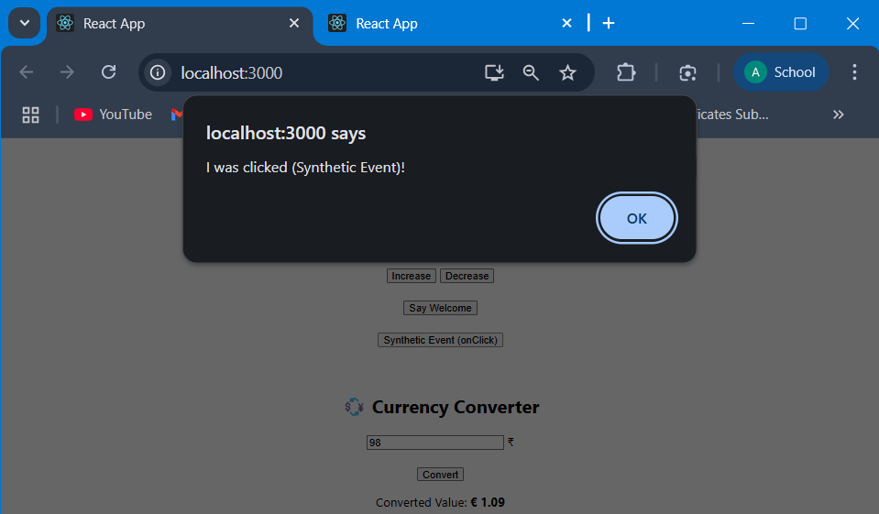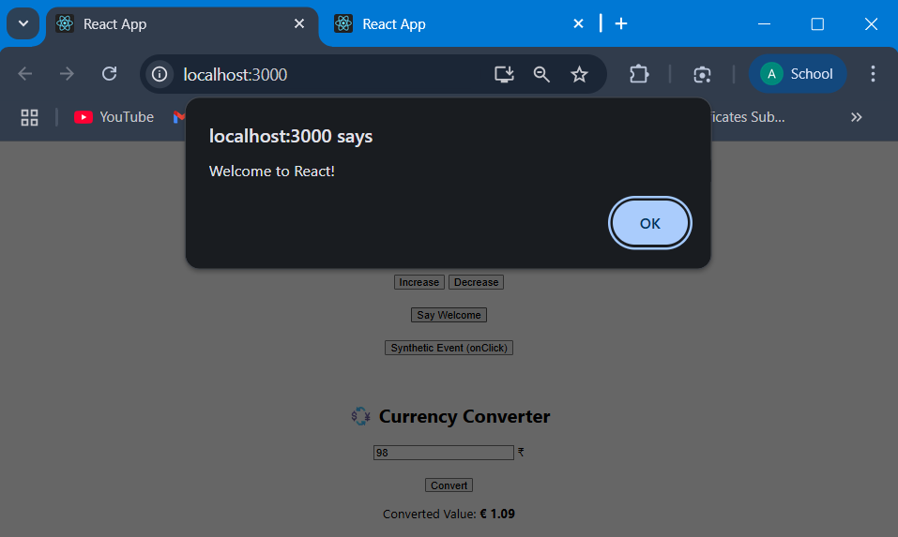

**Exercise 12:** Create a React Application named “ticketbookingapp” where the guest user can browse the page where the flight details are displayed whereas the logged in user only can book tickets.

The Login and Logout buttons should accordingly display different pages. Once the user is logged in the User page should be displayed. When the user clicks on Logout, the Guest page should be displayed.

Ans)

Step1) In VS Code terminal, type ‘npx create-react-app ticketbookingapp’ to create a new React project called “ticketbookingapp”

Step2) Open the same project folder in VS Code

Step3) Add a folder in the ‘src’ named ‘Components’

Step4) Add 2 js files in ‘Components’ named   
(i) GuestPage.js 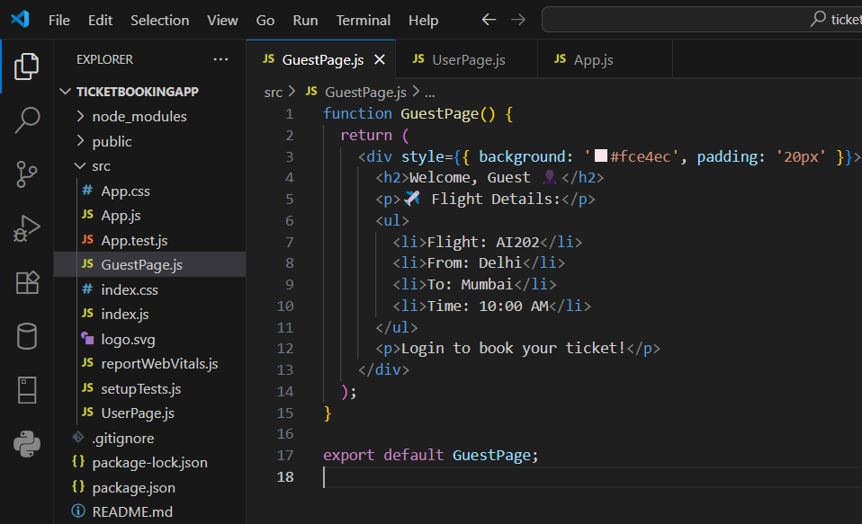

(ii) UserPage.js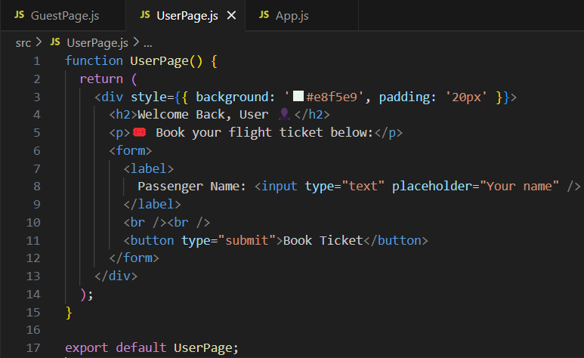

Step5) Replace the ‘App.js’ code with the following code 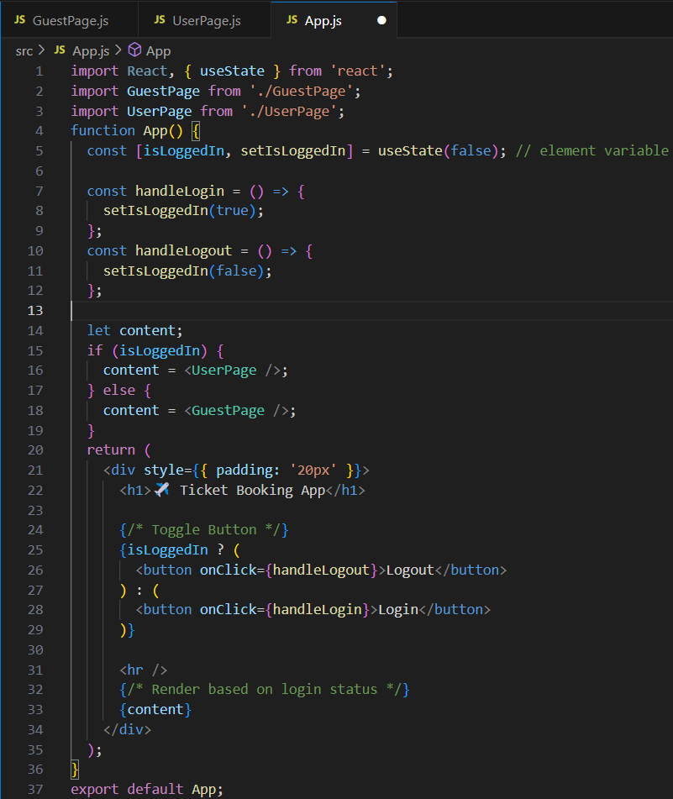

Step6) Open the terminal in VS Code and type ‘npm start’ which will launch the React app in the browser

**OUTPUT**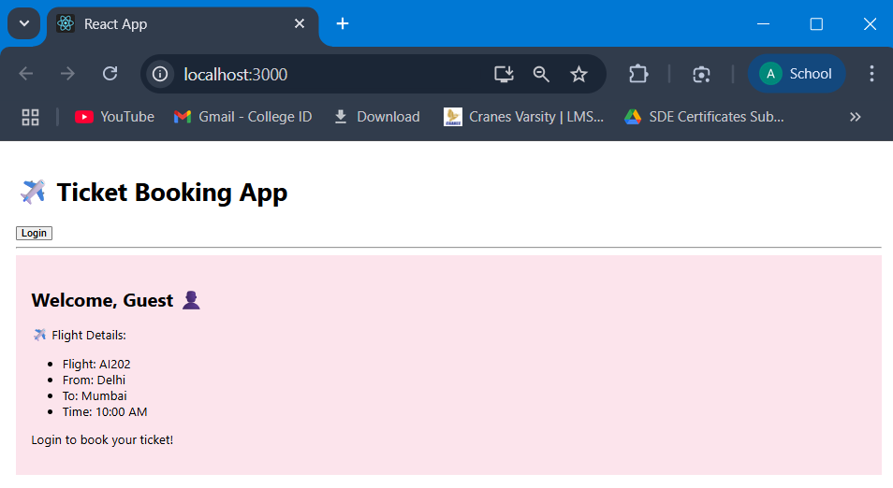

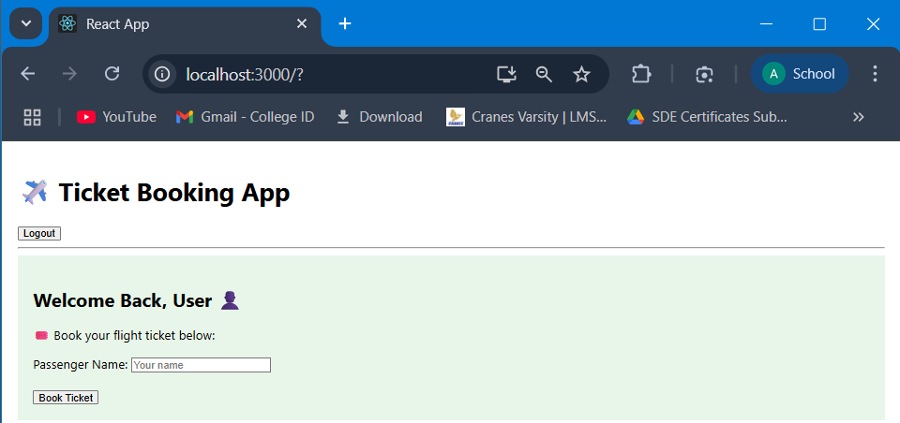

**Exercise 13:** Create a React App named “bloggerapp” in with 3 components.

1. Book Details
2. Blog Details
3. Course Details

Implement this with as many ways possible of Conditional Rendering.

Ans)

Step1) In VS Code terminal, type ‘npx create-react-app ticketbookingapp’ to create a new React project called “ticketbookingapp”

Step2) Open the same project folder in VS Code

Step3) Add a folder in the ‘src’ named ‘Components’

Step4) Add 3 js files in ‘Components’ named   
(i) BookDetails.js 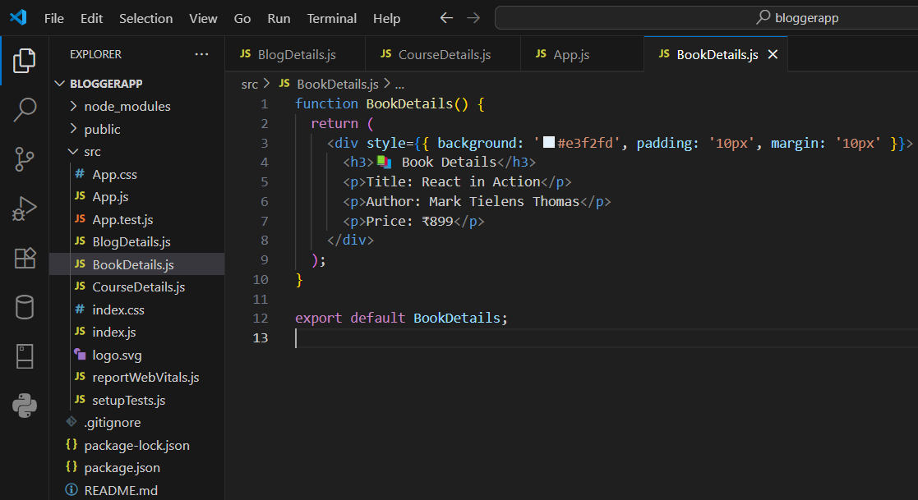(ii) BlogDetails.js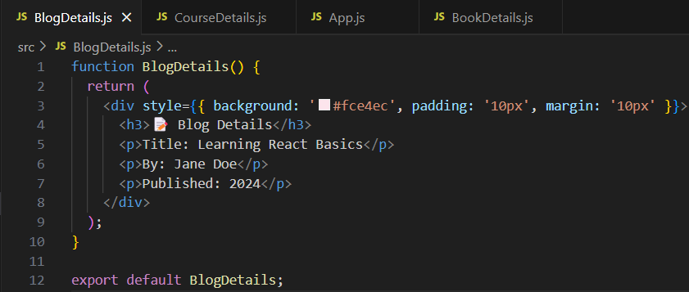

(iii) CourseDetails.js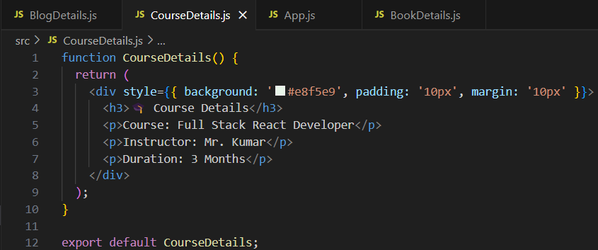

Step5) Replace the ‘App.js’ code with the following code 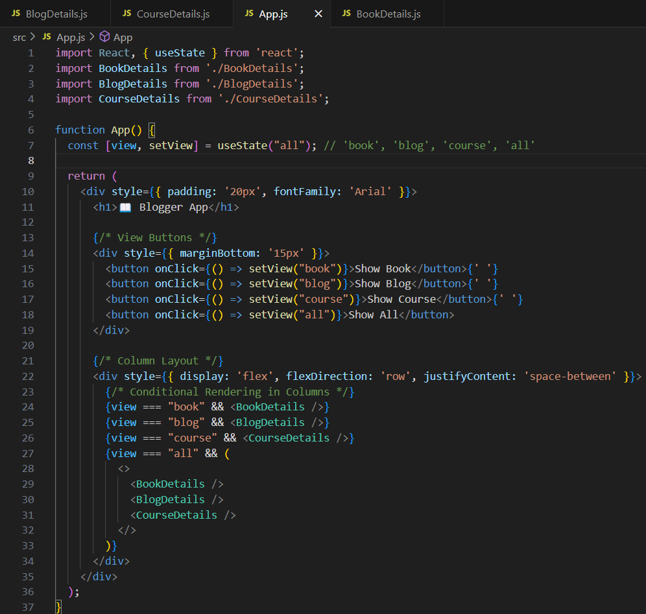

Step6) Open the terminal in VS Code and type ‘npm start’ which will launch the React app in the browser

**OUTPUT**