**Cognizant Deep Skilling Mandatory Hands-On Questions**

**TOPIC- React Exercises**

**Exercise 1:** Create a new React Application with the name “myfirstreact”, Run the application to print “welcome to the first session of React” as heading of that page.

Ans)

Step1) Download and install the LTS version from ‘<https://nodejs.org/en/download>’ and install the necessary tools required

Step2) In VS Code terminal, type ‘npx create-react-app my-first-react’ to create a new React project called ‘my-first-react’

Step3) Open the same project folder in VS Code

Step4) Replace the ‘App.js’ code with the following code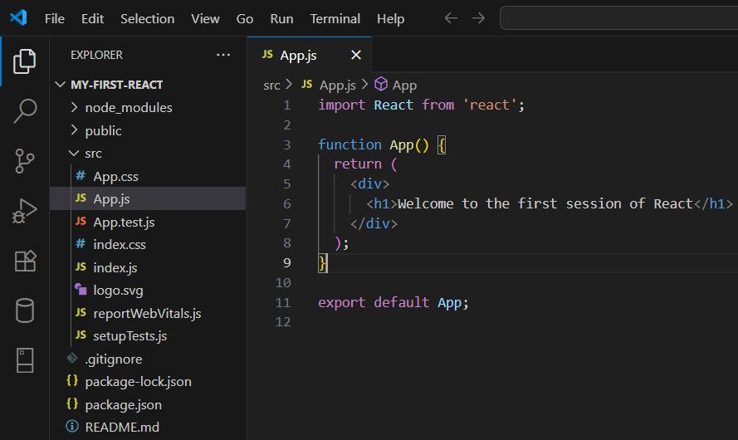

Step5) Open the terminal in VS Code and type ‘npm start’ which will launch the React app in the browser

**OUTPUT**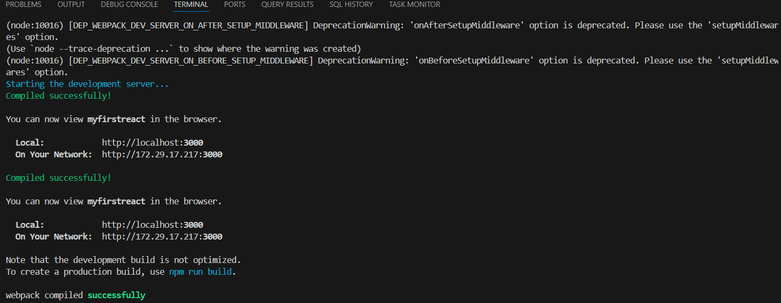

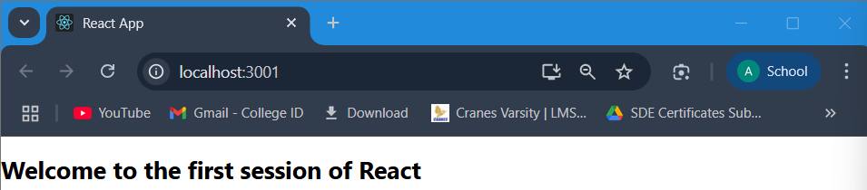

**Exercise 2:** Create a react app for Student Management Portal named StudentApp and create a component named Home which will display the Message “Welcome to the Home page of Student Management Portal”. Create another component named About and display the Message “Welcome to the About page of the Student Management Portal”. Create a third component named Contact and display the Message “Welcome to the Contact page of the Student Management Portal”. Call all the three components.

Ans)

Step1) In VS Code terminal, type ‘npx create-react-app student-app’ to create a new React project called “student-app”

Step2) Open the same project folder in VS Code

Step3) Add a folder in the ‘src’ named ‘Components’

Step4) Add 3 js files in ‘Components’ named   
(i) About.js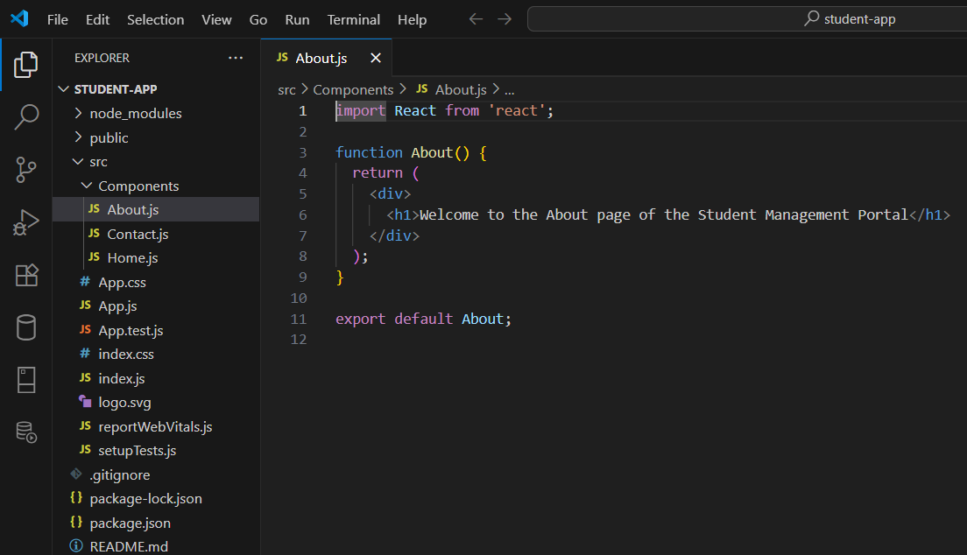

(ii) Contact.js 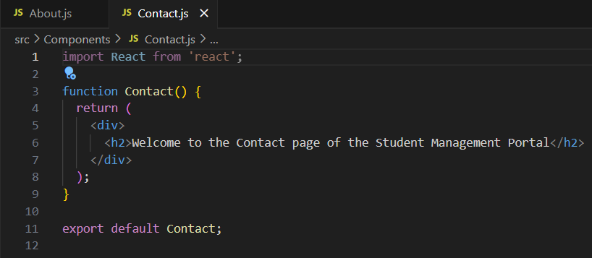(iii) Home.js 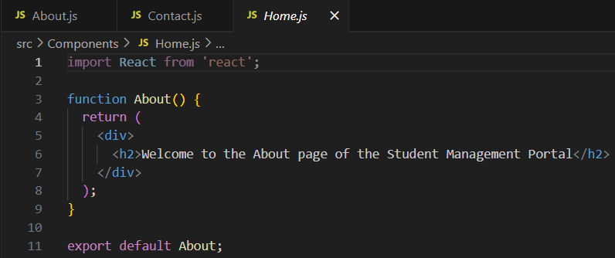

Step4) Replace the ‘App.js’ code with the following code 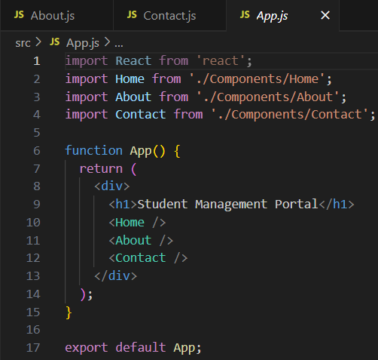

Step5) Open the terminal in VS Code and type ‘npm start’ which will launch the React app in the browser

**OUTPUT**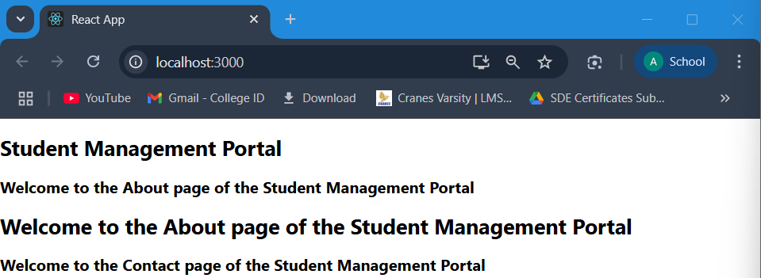

**Exercise 3:** Create a react app for Student Management Portal named scorecalculatorapp and create a function component named “CalculateScore” which will accept Name, School, Total and goal in order to calculate the average score of a student and display the same.

Ans)

Step1) In VS Code terminal, type ‘npx create-react-app student-app’ to create a new React project called “student-app”

Step2) Open the same project folder in VS Code

Step3) Add 2 folders in the ‘src’ named ‘Components’ and ‘Stylesheets’

Step4) Create a ‘CalculatorScore.js’ file inside ‘Components’ and write the following code in that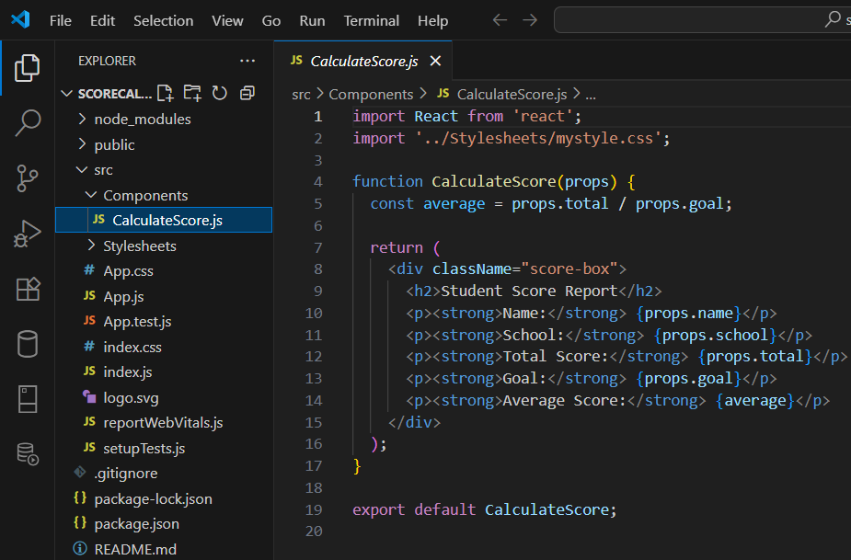

Step5) Create a ‘mystyle.css’ file inside ‘Stylesheets’ and write the following code in that 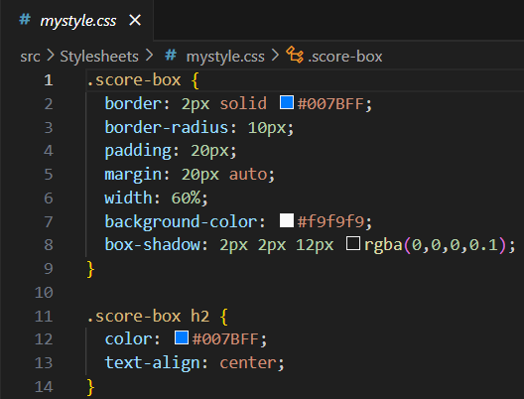

Step6) Replace the ‘App.js’ code with the following code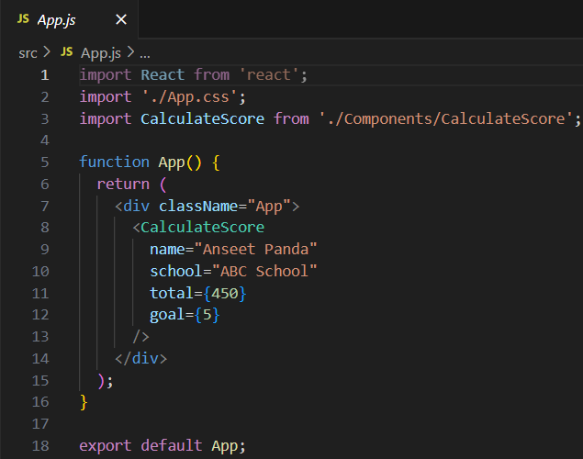

Step7) Open the terminal in VS Code and type ‘npm start’ which will launch the React app in the browser

**OUTPUT**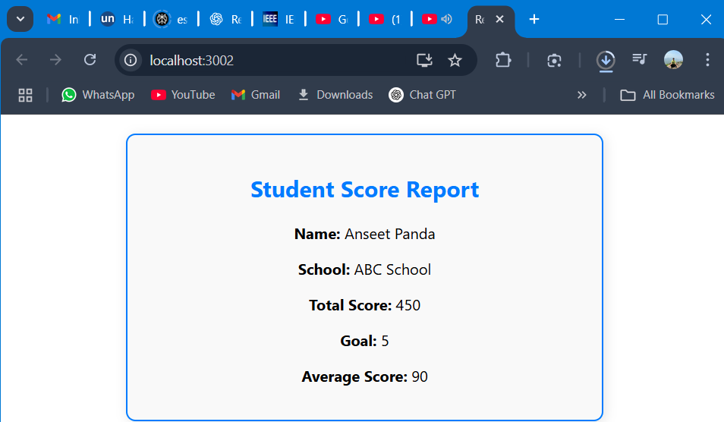

**Exercise 4:** Create a new react application using *create-react-app* tool with the name as “blogapp”

Ans)

Step1) In VS Code terminal, type ‘npx create-react-app blogapp’ to create a new React project called “blogapp”

Step2) Open the same project folder in VS Code

Step3) Add a file in the ‘src’ named ‘Post.js’ and write the following code in that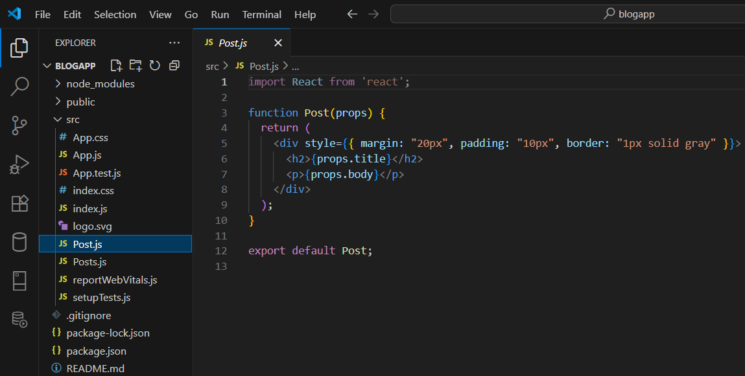

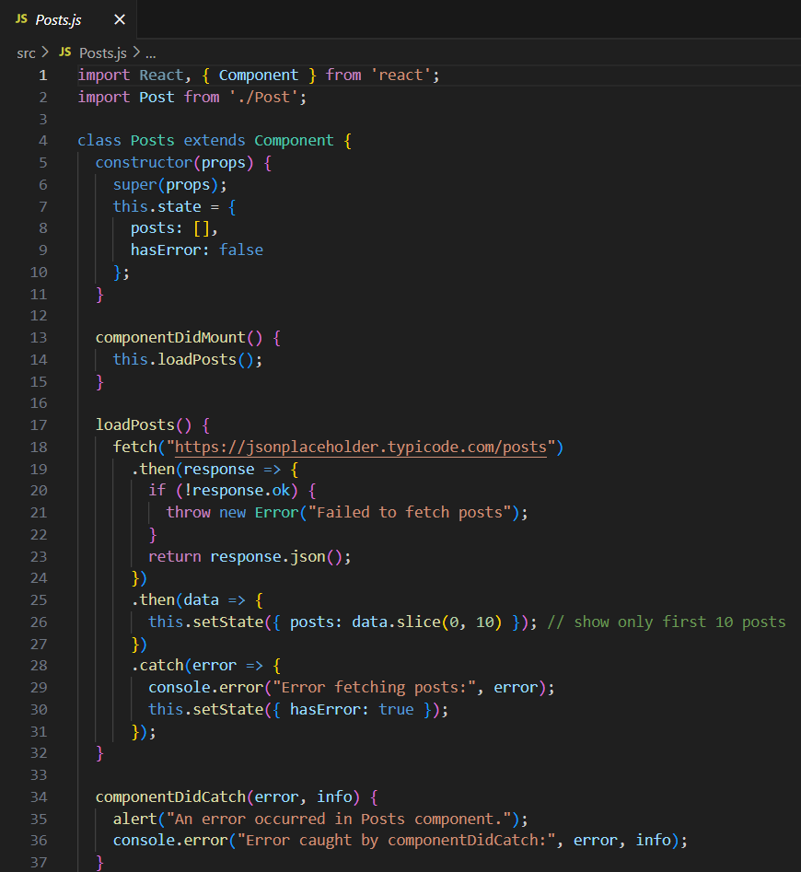Step4) Add a file in the ‘src’ named ‘ Posts.js’ and write the following code in that

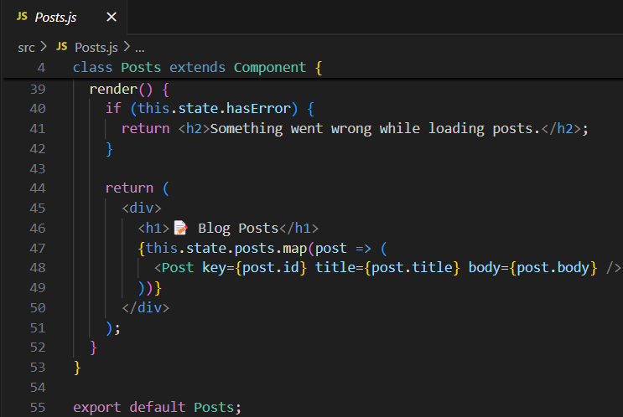

Step6) Replace the ‘App.js’ code with the following code 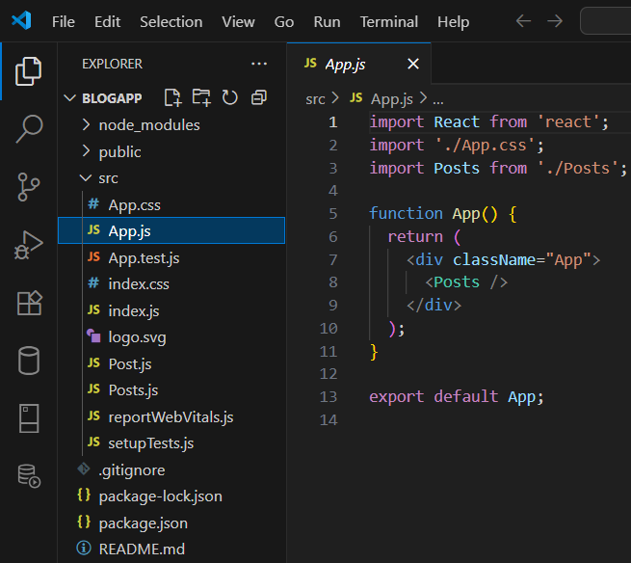

Step7) Open the terminal in VS Code and type ‘npm start’ which will launch the React app in the browser

**OUTPUT**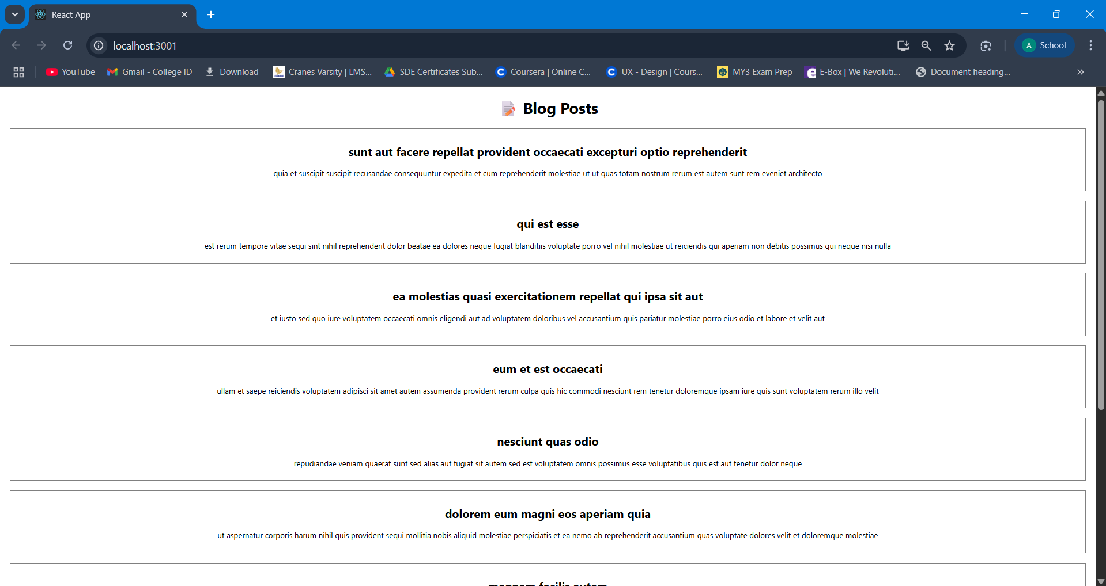

**Exercise 5:** My Academy team at Cognizant want to create a dashboard containing the details of ongoing and completed cohorts. A react application is created which displays the detail of the cohorts using react component. You are assigned the task of styling these react components.

Ans)

Step1) In VS Code terminal, type ‘npx create-react-app cohort-dashboard’ to create a new React project called “cohort-dashboard”

Step2) Open the same project folder in VS Code

Step3) Add a folder in the ‘src’ named ‘components’

Step4) Add 2 files in the ‘components’ named “CohortDetails.js” and “CohortDetails.module.css”

Step5) Write the following code in ‘CohortDetails.module.css’ 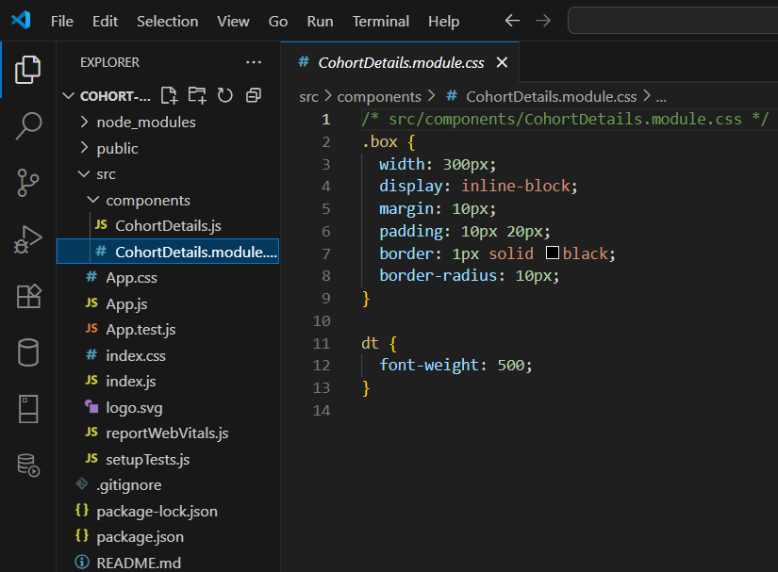

Step6) Write the following code in ‘CohortDetails.js’ 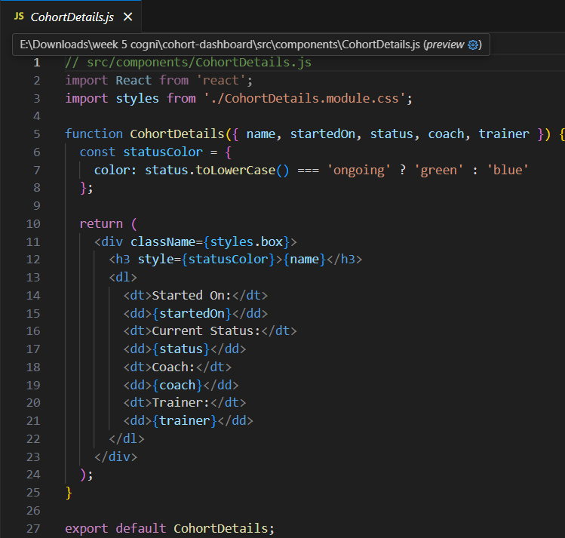

Step6) Replace the ‘App.js’ code with the following code 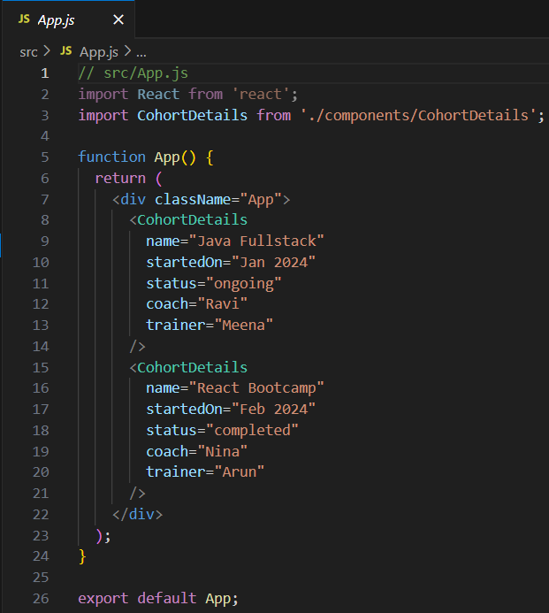

Step7) Open the terminal in VS Code and type ‘npm start’ which will launch the React app in the browser

**OUTPUT**