### Q1: Expected points

Select all of the starting locations of drives, and the average number of points scored on each of those drives. This is the expected points of each drive, more or less. The results will look something like this (not exactly like, of course, because I haven’t processed all of the data):

|  |  |
| --- | --- |
| starting location | expected points |
| 1 | 0.1 |
| 2 | 0.2 |
| ... | |
| 99 | 5.8 |

These results should help us generate a graph that looks something like this (from the 4th down study previously linked):

Select Distinct Location,Avg(points)

From drives

### Q2: 4th down

Select the number of 4th down plays where the team successfully went for it (i.e. there is a record in the goforit table with success=1), the total number of goforit attempts, and show the percent of those plays that were successful (i.e. either scored points or got a first down). For example (and this is making up data; I’m just showing the format of what we’re looking for):

|  |  |  |
| --- | --- | --- |
| success | total | percent |
| 900 | 2000 | .45 |

### Select

### ~~Q4~~ Q3:s 4th down and distance

Select the distance to go for 4th down play where the team went for it (i.e. goforit has a record), the number of successful attempts, the t,,otal number of attempts, and the percentage of each of those plays that was successful. So this will look something like this (not *exactly* like this, because I am making up the data):

|  |  |  |  |
| --- | --- | --- | --- |
| distance | succeeded | total | percent |
| 1 | 55 | 66 | .83 |
| 2 | 33 | 44 | .75 |
| 3 | 40 | 100 | .40 |
| and so on... | | | |

The idea is to generate data that could be used to produce a graph like this:

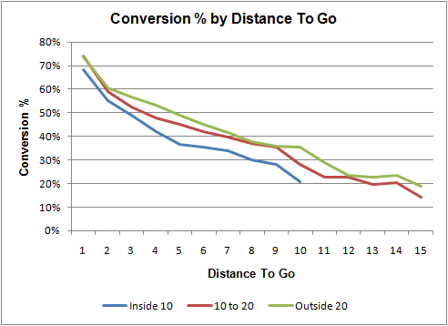

### Q4: Punts

Select the average distance of a punt (i.e. yards that the ball traveled) and the average net distance of a punt (i.e. net, which is the distance kicked, minus the return distance).

|  |  |
| --- | --- |
| average | net |
| 39.5 | 32.5 |

Select Avg(distance) as average,Avg(net)From

Punts

### Q5: Punts by field position

Select the location of a punt (i.e. the line of scrimmage or location of a punt play) and the total average and net average from that location. Sort by the location in ascending order.

|  |  |  |
| --- | --- | --- |
| location | total avg | net avg |
| 10 | 40.0 | 37.5 |
| 11 | 41.0 | 38.5 |
| etc. | | |

The goal is to collect the data to make a chart like this one:

### 3688474079_224025b011_o.png

### Q6: Field Goals

Select the locations of field goal attempts, the number of successful kicks from that distance, the total number of kicks from that distance, and the percent that were successful. Sort by the location in ascending order.

|  |  |  |  |
| --- | --- | --- | --- |
| location | successful | total | percent |
| 1 | 400 | 500 | .80 |
| 2 | 375 | 500 | .75 |
| and so on... | | | |

This will help us generate a chart like this:

