Code.Hub Skills and Certifications Platform

Software Architecture Document

Version 1.0

Revision History
Date | Version | Description | Author
11/Nov/26 | 1.0 | Initial architecture description | [Your name]

Table of Contents
1. Introduction 4
1.1 Purpose 4
1.2 Scope 4
1.3 Definitions, Acronyms, and Abbreviations 4
1.4 References 4
1.5 Overview 4
2. Architectural Representation 4
3. Architectural Goals and Constraints 5
4. Use-Case View 5
4.1 Use-Case Realizations 5
5. Logical View 6
5.1 Overview 6
5.2 Architecturally Significant Design Packages 6
6. Process View 6
7. Deployment View 7
8. Implementation View 7
8.1 Overview 7
8.2 Layers 7
9. Data View (optional) 8
10. Size and Performance 10
11. Quality 10

Software Architecture Document

Introduction
This Software Architecture Document (SAD) describes the architecture of the Code.Hub Skills and Certifications Platform.

Purpose
This document provides a comprehensive architectural overview of the system, using a number of different architectural views to depict different aspects of the system. It is intended to capture and convey the significant architectural decisions which have been made on the system. It is written for the development team (to build the system), testers (to plan integration and performance tests) and the Code.Hub contact person (to approve the technical approach).

Scope
The document applies to the first release of the platform, which covers the must-have requirements of the SRS: accounts and roles, learner profiles, skills catalogue, skill evidence, certifications with file upload, review workflow, and the admin overview with CSV export.

Definitions, Acronyms, and Abbreviations
Term | Definition
API / REST | Application Programming Interface / a style of web API using HTTP and JSON.
SPA | Single-Page Application: a web front end that runs in the browser.
JPA | Java Persistence API, used to map Java classes to database tables.
JWT | JSON Web Token: a signed token that identifies a logged-in user.
RBAC | Role-Based Access Control.
CI/CD | Continuous Integration / Continuous Delivery.
Other terms | See the Business Glossary, v1.0.

References
Document | Source / Date
Skills and Certifications Management for Learners: Requirements | Code.Hub, 2026
Software Requirements Specification (SRS), v1.0 | Project team 4, 11/Nov/26
Business Glossary, v1.0 | Project team 4, 11/Nov/26
Use-Case Specifications, v1.0 | Project team 4, 11/Nov/26
User-Interface Prototype, v1.0 | Project team 4, 11/Nov/26

Overview
Section 2 explains how the architecture is represented. Section 3 lists the goals and constraints. Sections 4 to 9 present the Use-Case, Logical, Process, Deployment, Implementation and Data views. Sections 10 and 11 cover size, performance and quality.

Architectural Representation
The platform is a three-tier web application: a browser front end (React SPA), a back-end REST API (Java Spring Boot) and a relational database (PostgreSQL), plus private file storage for certificates. The architecture is described with the 4+1 view model:
View | Content
Use-Case View | Architecturally significant use cases and how they are realised.
Logical View | Layers and design packages with their main classes.
Process View | Runtime processes and how they communicate.
Deployment View | Physical nodes and network connections.
Implementation View | Source code layers and components.
Data View | Persistent data model.

Architectural Goals and Constraints
- Security and privacy: role-based access (learner – own records; trainer – assigned learners; admin – all); profiles and files never public; GDPR compliance; HTTPS everywhere.
- Responsive web only: must work on desktop and mobile browsers; no native mobile app.
- Localisation: all UI text in translation files (English first, Greek later).
- Branding: Code.Hub fonts, colours and logo, applied through a central theme.
- Extensibility: open decisions (single sign-on, email reminders, integrations) must be addable later without redesign – e.g. authentication behind an interface, email behind an adapter.
- Technology: Java 21 + Spring Boot 3, React + TypeScript, PostgreSQL 16, Docker; source control on GitHub with CI (GitHub Actions).
- Team and schedule: small team, MVP-first delivery of the must-have features.

Use-Case View
The following use cases are architecturally significant because together they exercise every layer, the file storage, the email service and the access-control rules:
- UC-01 Log In / UC-02 Reset Password – authentication, email service.
- UC-08 Add / Edit Certification – validation, file upload, private storage.
- UC-09 Review Record – role-based access, workflow states, audit trail.
- UC-10 / UC-11 Search, Filter and Export – complex queries and CSV generation.

Use-Case Realizations
UC-08 Add / Edit Certification:
1. The React dialog validates the form and sends a multipart request (data + file) to POST /api/certifications with the user's JWT.
2. The Security filter checks the token and that the role is Learner.
3. CertificationController passes the data to CertificationService, which validates dates, file type and size.
4. FileStorageAdapter saves the file in private object storage and returns a storage key.
5. CertificationRepository saves the record with status PENDING and the storage key.
6. The API returns the new record; the SPA updates the profile.
UC-09 Review Record:
1. The trainer opens the review queue: GET /api/reviews/pending returns only records of assigned learners (checked in ReviewService using TrainerAssignment).
2. The trainer submits a decision: POST /api/reviews with status, feedback and assessed level.
3. ReviewService updates the record status and stores a Review entry (who, when, feedback) for the audit trail.

Logical View

Overview
The system is divided into four layers. Each layer only calls the layer directly below it.
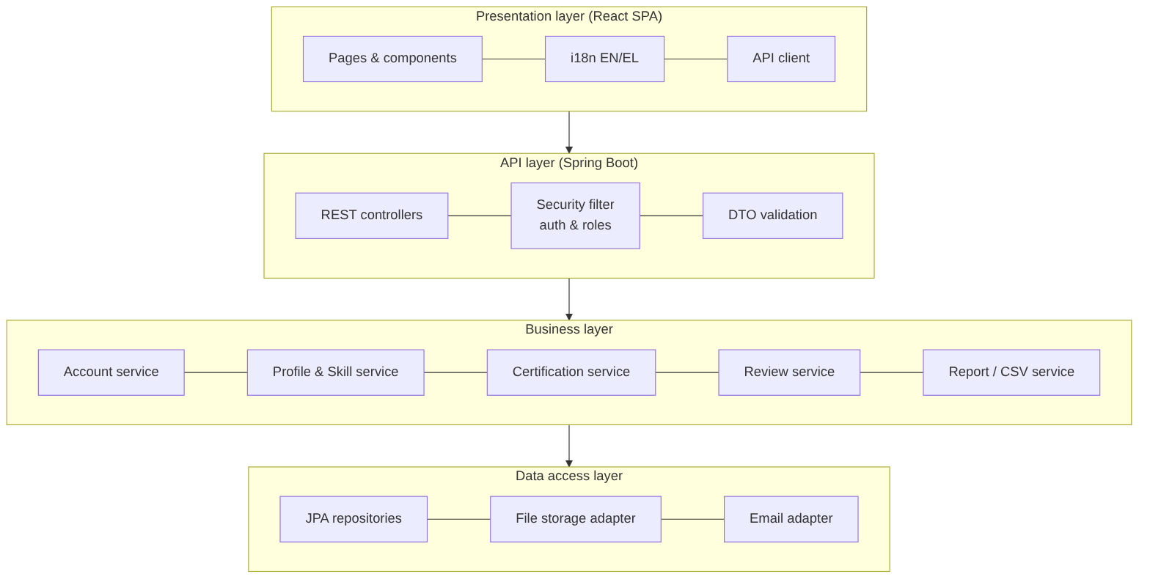
Figure 1 – Logical layers

Architecturally Significant Design Packages
Package | Main classes | Responsibility
account | User, Role, AuthController, AccountService, InvitationService | Log in/out, password reset, invitations, roles.
profile | LearnerProfile, Programme, Enrolment, ProfileService | Learner profile and programme membership.
skills | SkillCategory, Skill, LearnerSkill, Evidence, SkillService | Catalogue management, learner skills, proficiency and evidence.
certification | Certification, StoredFile, CertificationService | Certification records, file upload and expiry status.
review | Review, ReviewStatus, TrainerAssignment, ReviewService | Review workflow, feedback and trainer–learner access rules.
reporting | LearnerFilter, ReportService, CsvExporter | Admin search/filter and CSV export.
common | SecurityConfig, FileStorageAdapter, EmailAdapter, I18n | Cross-cutting services: security, storage, email, translations.

Process View
The system runs as the following processes:
- Browser process – the React SPA; communicates with the API over HTTPS using JSON (and multipart for uploads).
- API process – one or more stateless Spring Boot instances; each HTTP request is handled in its own thread. Because the API is stateless (JWT), more instances can be added behind a load balancer.
- Database process – PostgreSQL, accessed through a connection pool (JDBC).
- Email sending – done asynchronously in a background thread so the user does not wait for the email provider.
- Scheduled job (future) – a daily job for certification expiry reminders, if approved (OD-4).

Deployment View
The platform is deployed to a cloud provider in an EU region (for GDPR). All traffic uses HTTPS.
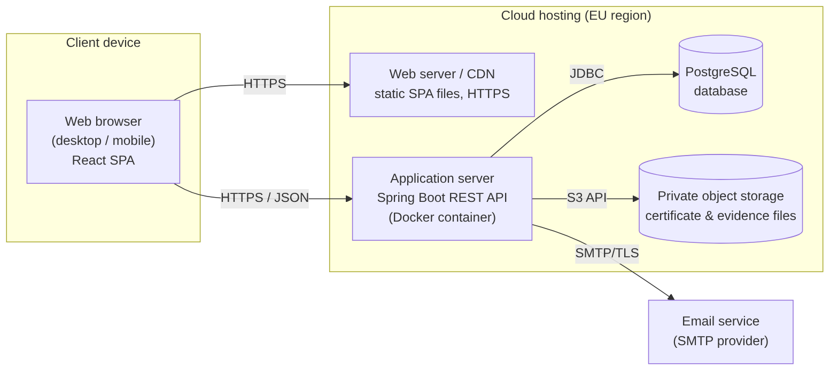
Figure 2 – Deployment diagram
Node | Software | Notes
Client device | Modern web browser | Desktop or mobile.
Web server / CDN | Static hosting of the React build | Serves HTML, JS, CSS and images.
Application server | Spring Boot API in Docker | Stateless; can scale horizontally.
Database server | PostgreSQL 16 (managed) | Daily automatic backups.
Object storage | S3-compatible private bucket | Files accessed only through the API.
Email service | External SMTP provider | Invitations and password reset.

Implementation View

Overview
The code is kept in one GitHub repository with two main folders: /frontend (React + TypeScript) and /backend (Spring Boot, Maven). Each back-end package from the Logical View is a Java package split into controller, service and repository sub-packages. GitHub Actions builds and tests both parts on every pull request.

Layers
Layer | Components | Rules
Presentation | React pages, components, i18n files, API client | No business rules; calls only the REST API.
API | REST controllers, DTOs, security filter, exception handler | Validates input, checks roles, converts DTOs.
Business | Services per package | All business rules and access checks; transactional.
Data access | JPA repositories, FileStorageAdapter, EmailAdapter | Only layer that talks to the database, storage or email.

Data View (optional)
The main entities and relationships are shown below. Files are stored in object storage; the database keeps only a reference (StoredFile).
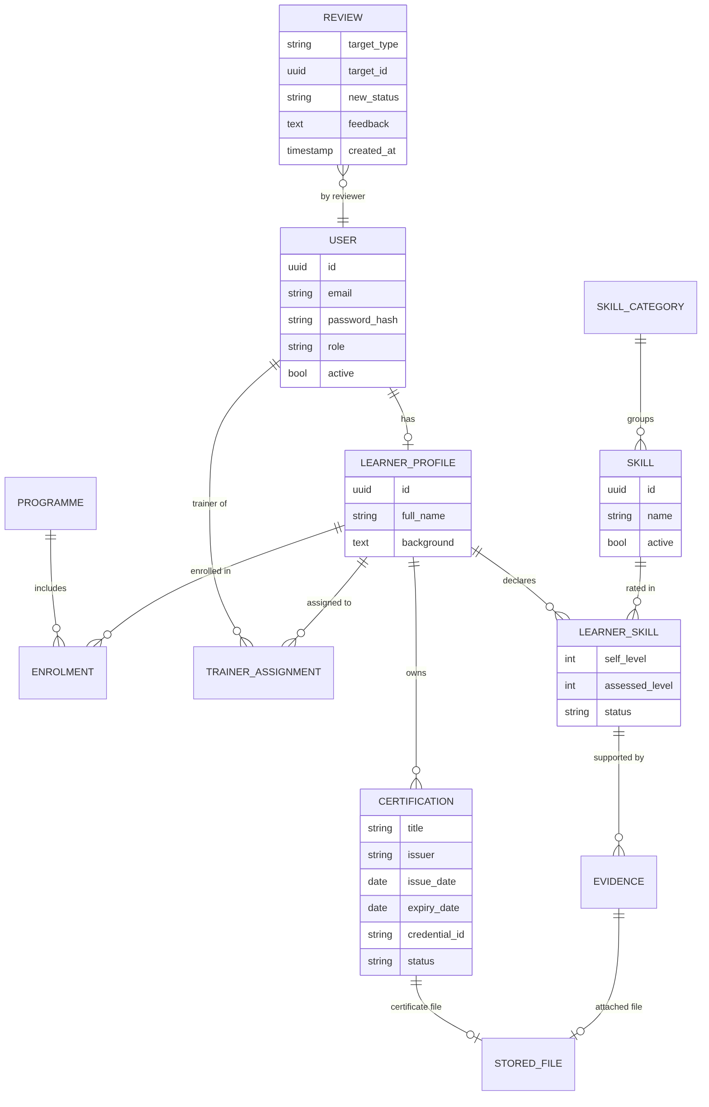
Figure 3 – Data model (simplified)

Size and Performance
- Expected size at launch: about 2,000 learners, 50 trainers, 10 administrators; up to 200 concurrent users.
- Storage: about 5 files per learner, max 10 MB each – under 100 GB in the first years.
- Target: pages load within 3 seconds; API responses under 500 ms for 95% of requests.
- Admin search uses database indexes on programme, skill, proficiency and expiry date; results are paged.
- CSV export of up to 10,000 rows is generated as a stream.

Quality
Quality attribute | How the architecture supports it
Security | HTTPS, hashed passwords (bcrypt), JWT with short expiry, RBAC checked in the service layer, private file storage, login lockout after 5 failed attempts.
Privacy (GDPR) | EU hosting, data access limited by role, personal data export/deletion on request, audit trail of reviews.
Extensibility | Adapters for authentication, email and storage allow single sign-on, reminders and integrations to be added later.
Reliability | Managed database with daily backups; stateless API instances can be restarted or replaced without data loss.
Portability | Docker containers run on any cloud provider.
Usability / Localisation | Responsive React UI, WCAG 2.1 AA, translation files for English and Greek.
Maintainability | Layered design, automated tests and CI on every pull request.

