Code.Hub Skills and Certifications Platform

User-Interface Prototype

Version 1.0

Revision History
Date | Version | Description | Author
11/Nov/26 | 1.0 | Initial prototype of the main screens | Kriton Panigyris

Table of Contents
1. Introduction 4
1.1 Purpose 4
1.2 Scope 4
1.3 Definitions, Acronyms, and Abbreviations 4
1.4 References 4
1.5 Overview 4
2. Primary Windows 5
2.1 My Profile (Learner) 5
2.1.1 Purpose 5
2.1.2 Objects and actions 5
2.1.3 Composites 5
2.1.4 Visual Dimensions 5
2.1.5 Screenshot Sample 6
2.2 Learner Overview (Administrator) 6
2.2.1 Purpose 6
2.2.2 Objects and actions 6
2.2.3 Composites 6
2.2.4 Visual Dimensions 6
2.2.5 Screenshot Sample 7
3. Secondary Windows: Property windows 7
3.1 Log In Screen 8
3.1.1 Purpose 8
3.1.2 Objects and actions 8
3.1.3 Composites 8
3.1.4 Visual Dimensions 8
3.1.5 Screenshot Sample 9
4. Secondary Windows: Other types 9
4.1 Add Certification Dialog with Calendar Pop-up 10
4.1.1 Purpose 10
4.1.2 Objects and actions 10
4.1.3 Composites 10
4.1.4 Visual Dimensions 10
4.1.5 Screenshot Sample 11
5. Graphics Standards 12
6. Other Standards 12
7. Browsing Hierarchies 12

User-Interface Prototype

Introduction
This document describes the User-Interface Prototype of the Code.Hub Skills and Certifications Platform. It shows the main screens, the objects on each screen, how users interact with them, and how the screens are linked.

Purpose
The purpose of this prototype is to let Code.Hub review and approve the look and behaviour of the platform before development, and to give developers and testers a clear reference for each screen.

Scope
The prototype covers the screens of the first release: the learner's My Profile page, the administrator's Learner Overview, the Log In screen, and the Add Certification dialog with its calendar pop-up. Other screens (Review Record panel, Skills Catalogue, Users) follow the same layout and standards. Mockups use placeholder colours and a logo placeholder until Code.Hub provides the brand assets.

Definitions, Acronyms, and Abbreviations
See the project Business Glossary, v1.0. Additional terms: Mockup – a static image of a screen; Modal – a window that blocks the page behind it until closed; Responsive – a layout that adapts to screen width.

References
Document | Source / Date
Skills and Certifications Management for Learners: Requirements | Code.Hub, 2026
Software Requirements Specification (SRS), v1.0 | Project team 4, 11/Nov/26
Business Glossary, v1.0 | Project team 4, 11/Nov/26
Use-Case Specification: UC-08 Add / Edit Certification | Project team 4, 11/Nov/26
Code.Hub Brand Guidelines (fonts, colours, logo) | Code.Hub, to be provided
WCAG 2.1 – Web Content Accessibility Guidelines | W3C, 2018

Overview
Section 2 describes the primary windows, Section 3 the property windows, and Section 4 other secondary windows (dialogs and pop-ups). Sections 5 and 6 list the graphics and other standards, and Section 7 shows how the screens are linked. Red numbered markers on each screenshot match the numbers in the Objects and actions tables.

Primary Windows
Primary windows are the main pages where users spend most of their time. All primary windows share the same top navigation bar.

My Profile (Learner)

Purpose
The home page of a learner after log in (UC-04). It shows the learner's details and a consolidated view of skills and certifications, and is the starting point for adding skills (UC-06), evidence (UC-07) and certifications (UC-08).

Objects and actions
# | Object | Action / Interaction
1 | Navigation bar | Links to My Profile, Skills and Certifications. The active page is underlined.
2 | Notifications, language, user menu | Bell shows review results; EN | EL switches language; user menu has Change password and Log out.
3 | Profile summary card | Shows name, background, programmes and counters. "Edit profile" opens the profile form.
4 | Skills table + "Add skill" | Lists skills with self-declared and trainer-assessed levels and status. Clicking a row opens the skill and its evidence; "+ Add skill" opens the Add Skill dialog.
5 | Certifications table + "Add certification" | Lists certifications with dates, file and status. "+ Add certification" opens the dialog in Section 4.

Composites
- Top bar = logo + navigation bar + notifications + language switch + user menu.
- Profile summary card = avatar + name + background + programme tags + counters.
- Skills card = title + Add button + skills table (status tags).
- Certifications card = title + Add button + certifications table + disclaimer note.

Visual Dimensions

Position
Full browser window, scrollable vertically. Parent of the Add Skill and Add Certification dialogs.

Size
Desktop: two columns (profile card 300 px, content fills the rest). Below 768 px width the columns stack and tables become cards.

Shape
Rectangular cards with 8 px rounded corners.

Color
Dark navy top bar; white cards on a light grey background. Status tags: yellow = Pending, green = Reviewed, red = Changes required. Final colours will follow Code.Hub branding.
Figure 1 – My Profile (Learner)

Learner Overview (Administrator)

Purpose
The main page for administrators (UC-10, UC-11). It lets them search and filter learners and export the results to CSV.

Objects and actions
# | Object | Action / Interaction
1 | Filter bar | Search by name/email and filter by programme, skill, minimum proficiency and certification status. "Apply" runs the search; "Clear" resets.
2 | Export CSV button | Downloads the current filtered results as a CSV file.
3 | Results table | Paged list of learners. Clicking a row opens the learner's profile; clicking a pending count opens the review queue for that learner.

Composites
- Filter card = text field + four drop-down lists + Apply / Clear / Export buttons.
- Results card = result counter + table + pagination.

Visual Dimensions

Position
Full browser window, scrollable. Parent of the learner profile view and Review Record panel.

Size
Uses the full width. On mobile the filters collapse into a "Filters" button.

Shape
Rectangular cards with rounded corners.

Color
Same palette as My Profile; the Export button uses the accent colour to stand out

Figure 2 – Learner Overview (Administrator)

Secondary Windows: Property windows

Log In Screen

Purpose
Lets every user sign in to the platform (UC-01) and start a password reset (UC-02).

Objects and actions
# | Object | Action / Interaction
1 | Email field | User types their email address.
2 | Password field | Masked input for the password.
3 | "Forgot password?" link | Opens the Reset Password screen.
4 | Log in button | Submits the form; on success opens the home page for the user's role.
5 | Error message | Shown on failed log in. The text is generic and does not say which field was wrong.

Composites
- Log in card = logo + title + email field + password field + remember me + forgot link + button + error area + language links.

Visual Dimensions

Position
Centred on the page. Not movable. Orphan window (no parent).

Size
Fixed width 380 px on desktop; full width with 16 px margins on mobile.

Shape
Rectangular card with rounded corners.

Color
White card on the dark brand background; errors in red.
Figure 3 – Log In Screen

Secondary Windows: Other types
Dialogs and pop-ups are opened from primary windows and close when the task is completed or cancelled.

Add Certification Dialog with Calendar Pop-up

Purpose
A modal dialog used to add or edit a certification (UC-08). The calendar pop-up opens when the user clicks a date field and helps them pick the issue or expiry date.

Objects and actions
# | Object | Action / Interaction
1 | Title and Issuing organisation fields | Required text fields.
2 | Issue date and Expiry date fields | Clicking a field or the calendar icon opens the calendar pop-up. Expiry date is optional.
3 | Calendar pop-up | Month navigation (‹ ›), day grid, "Today" and "Clear". Selecting a day fills the field and closes the pop-up.
4 | Certificate file area | Drag and drop or "browse" to upload a PDF, JPG or PNG up to 10 MB. Shows file name and size when done.
5 | Cancel / Save & submit for review | Cancel closes without saving (asks to confirm if data was entered). Save validates and submits the record.

Composites
- Dialog = header with close (✕) + form grid of six fields + upload area + button row.
- Calendar pop-up = month header + weekday row + day grid + Today/Clear links.

Visual Dimensions

Position
Dialog: modal, centred over My Profile (its parent), page behind is dimmed. Calendar: floating pop-up attached to the date field (child of the dialog).

Size
Dialog 640 px wide, full-screen on mobile. Calendar 260 px wide. Neither is resizable; both are closeable.

Shape
Rectangular with rounded corners; the calendar has a drop shadow.

Color
White on a dimmed background. The selected day and the focused field use the brand primary colour; required fields are marked with *.

Figure 4 – Add Certification dialog with the calendar pop-up open

Graphics Standards
- Fonts, colours and logo follow the Code.Hub Brand Guidelines (placeholders are used in this prototype).
- Icons: one consistent open-source icon set (e.g. Material Icons), 16–24 px.
- Spacing based on an 8 px grid; cards have 8 px rounded corners.
- Text contrast at least 4.5:1 (WCAG 2.1 AA). Status is never shown by colour only – each tag also has a text label.
- Responsive breakpoints: mobile < 768 px, tablet 768–1199 px, desktop ≥ 1200 px.

Other Standards
- Language: English at launch; all texts in translation files for Greek (EN | EL switch in the top bar).
- Dates shown as DD/MM/YYYY; files accepted: PDF, JPG, PNG, max 10 MB.
- Required fields marked with *; validation messages shown next to the field.
- Every destructive or unsaved action asks for confirmation.
- Full keyboard navigation and visible focus states.

Browsing Hierarchies
After log in, each role lands on its own home page. Dialogs are opened from these pages and return to them when closed.
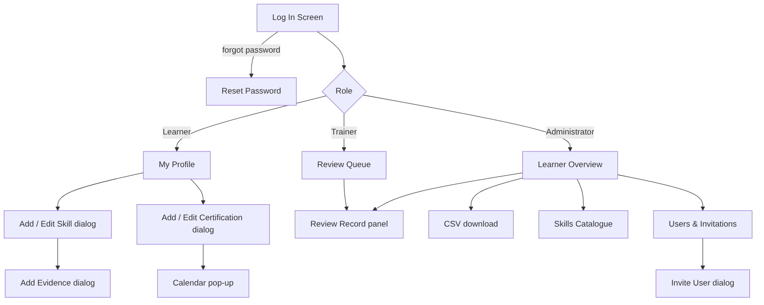
Figure 5 – Navigation map

