Method selectStudent

**public** StudentModel selectStudent(String npm) {

**for**(**int** i=0; i<*studentList*.size(); i++) {

StudentModel student = *studentList*.get(i);

**if** (student.getNpm().equals(npm))

{

**return** student;

}

}

**return** **null**;

}

Tutorial

Controller

localhost:8080/student/add?npm=12345&name=chanek&gpa=3.43

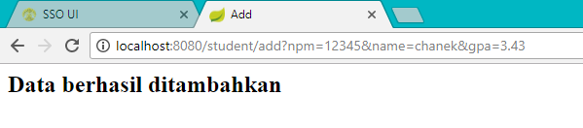

localhost:8080/student/add?npm=12345&name=chanek

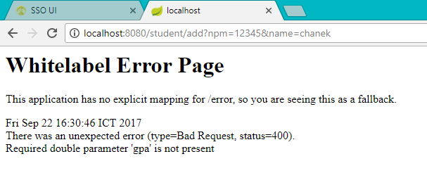

Localhost:8080/student/add?npm=12345&name=chanek&gpa=3.43

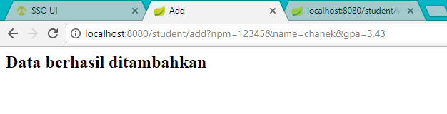

Localhost:8080/student/view?npm=12345

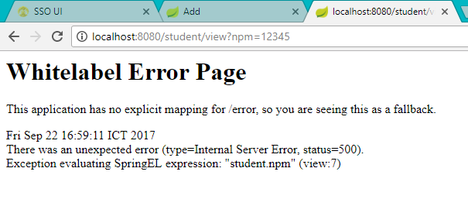

Karena disimpan di local sehingga tidak ada data yang masuk.

Localhost:8080/student/add?npm=67890&name=lala&gpa=3.90

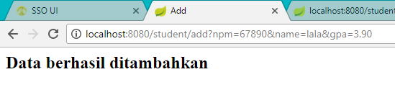

Localhost:8080/student/view?npm=67890

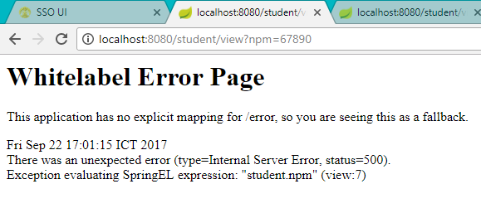

View All

Localhost:8080/student/add?npm=12345&name=chanek&gpa=3.43

Localhost:8080/student/viewall

Tambahkan data student lain

Localhost:8080/student/viewall

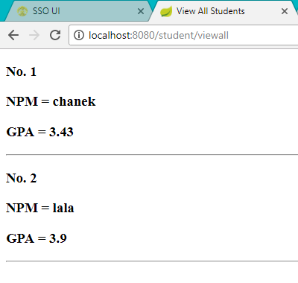

Latihan

1. **View**

Localhost:8080/student/view/14769

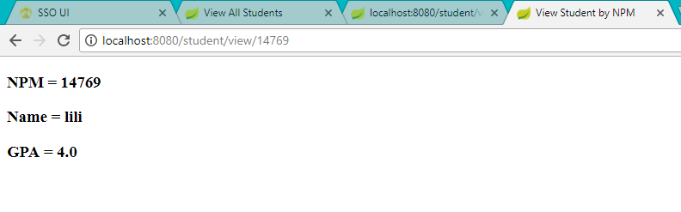

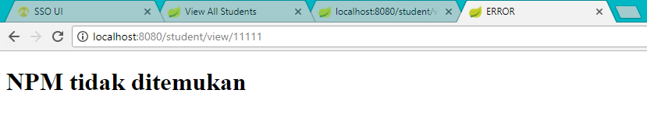

2. delete

