**SAP GUI 7.40 for Windows Installation Procedure**



**Step 1**

To install SAP GUI 7.40 for Windows 8.1 and above, MUST un-install any prior version of SAP GUI from your machine.

And, you will require two important files:

# SAP GUI for Windows 7.40 installation software

You can download the installation software from the following URL.

<http://uccweb01.qut.edu.au/tech_support/download/SAPGUI_Windows/SAPGUI740.zip>

**Please note:** If you will be using **Business Intelligence** you will need to download the FULL SAP GUI using the following URL:

<http://uccweb01.qut.edu.au/tech_support/download/SAPGUI_Windows/SAPGUI740full.zip>

# Server configuration file

Please download the server configuration files from the following URL.

<http://uccweb01.qut.edu.au/tech_support/download/INI_FILES/saplogon.zip>

1. If you will be using GBI 3.0, you will also need the latest patch:

<http://uccweb01.qut.edu.au/tech_support/download/SAPGUI_Windows/gui740_10-10013011.exe>

**Step 2**

To install SAP GUI 7.40, please go through the following steps:

1. Locate the downloaded SAPGUI740.zip file, and double click. *Notes: It might take several minutes to unzip the file.*

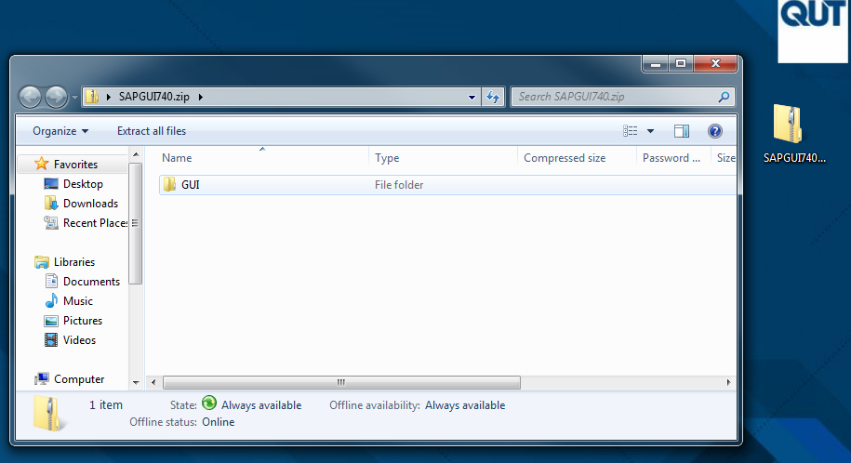

1. Extract the whole GUI folder to a local directory.
2. Navigate to GUI 🡪 WINDOWS 🡪 WIN32 folder, and double click ‘SetupAll.exe’ file.

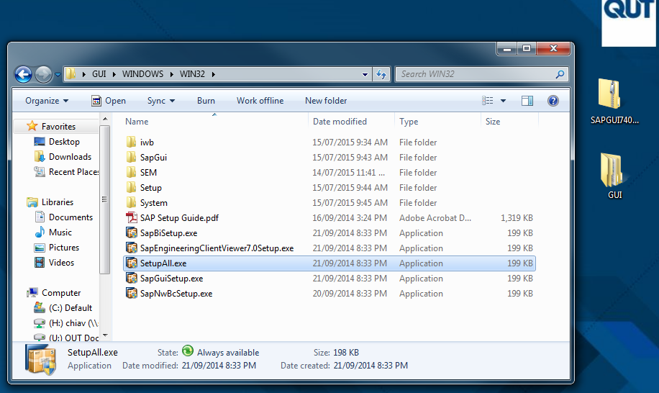

1. Click ‘Yes’ when the ‘User Account Control’ windows popped up.
2. Then, an installation wizard will be displayed.
3. Click ‘Next’ in the following wizard.

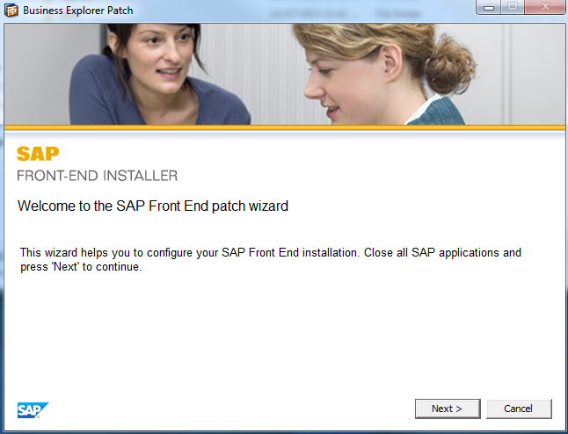

1. Select both items, ‘SAP GUI for Windows 7.40 (Compilation 1)’ and ‘Business Explorer’.

PLEASE NOTE: You may only select Business Explorer if you have downloaded the FULL SAP GUI using the following URL:

<http://uccweb01.qut.edu.au/tech_support/download/SAPGUI_Windows/SAPGUI740full.zip>

1. Then, click ‘Next’ to proceed.

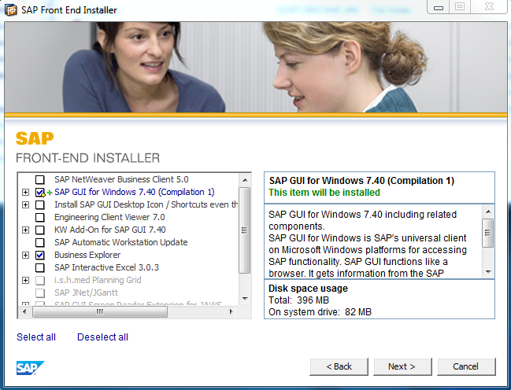

1. Click ‘Next’ to proceed, unless you want to change the target installation directory.

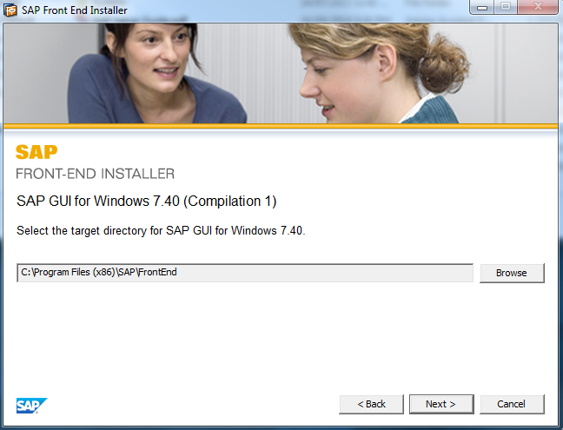

1. The installation process will be started. And, it will normally take few minutes.

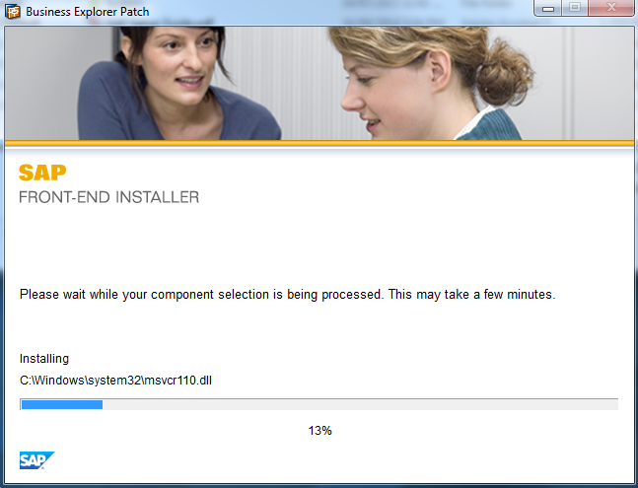

1. Once it is done, click ‘Close’.

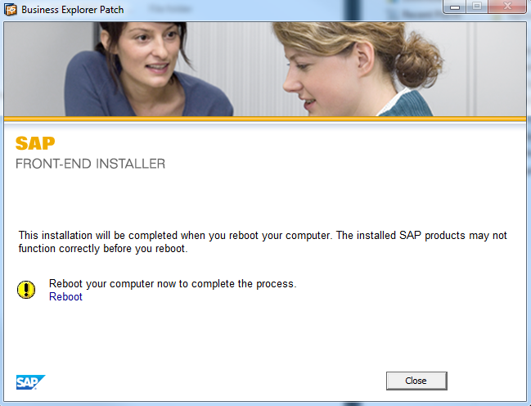

*Notes: If you didn’t uninstall the previous version of SAPGUI completely, you will be encountering the following installation errors. Anyhow, you can ignore it.*

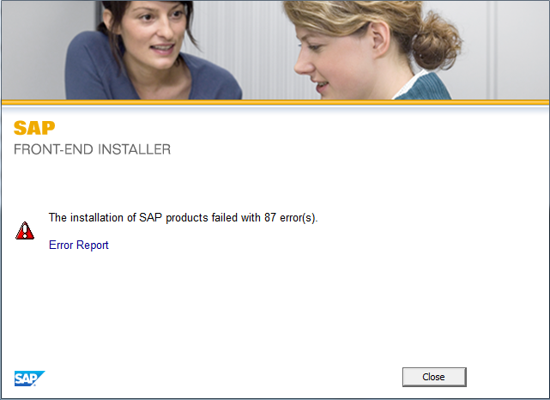

1. Reboot your computer.
2. You should be able to see a SAP logon icon on your desktop after the reboot.

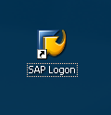

**Step 3**

To configure the server connection files, please go through the following steps:

1. Locate the downloaded saplogon.zip file, and double click.

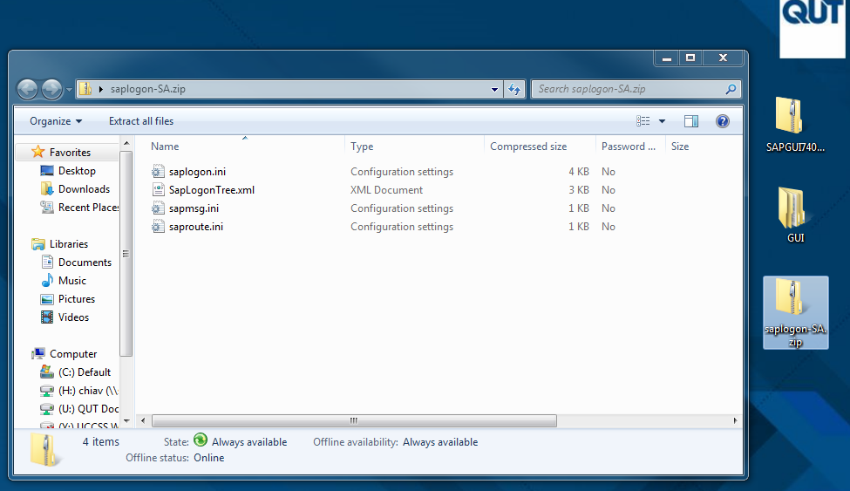

1. Extract all four files (saplogon.ini, SapLogonTree.xml, sapmsg.ini and saproute.ini) to the folder, C:\Users*<UserName>*\AppData\Roaming\SAP\Common. *Notes: <UserName> refers to your Windows login name.*

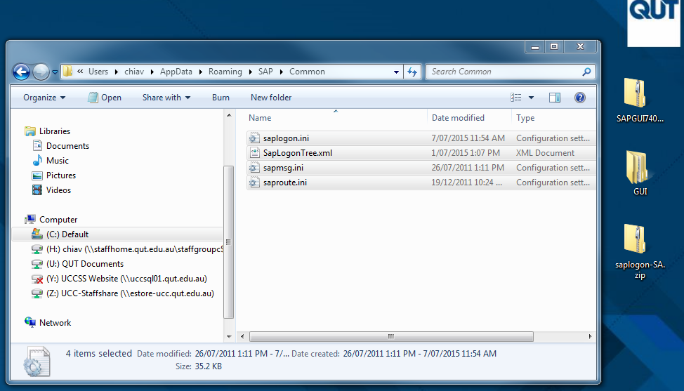

1. If you can’t find the AppData folder in C:\Users*<UserName>*\ folder, please do the following. Or else, please proceed to **Step 4**.
   1. Navigate to C:\Users*<UserName>*\ folder.
   2. Press ‘Alt’ on your keyboard.
   3. Select ‘Tools’ on the menu bar, then ‘Folder options...’

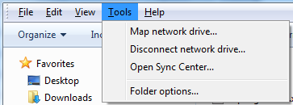

* 1. The Folder Options windows will be displayed.
  2. Click the ‘View’ tab.
  3. Select ‘Show hidden files, folders and drives’ option.

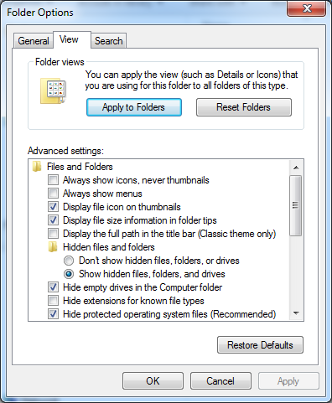

**Step 4**

To start using SAP GUI 7.40, please go through the following steps:

1. To open the SAP Logon windows, locate and double click the ‘SAP Logon’ icon on your desktop.
2. Or alternatively, go to Start 🡪 All Programs 🡪 SAP Front End, and select ‘SAP Logon’.



1. The SAP Logon windows will be appeared. If you can see a list of servers as below, that means the server connection files have been setup correctly. If not, please go to **Step 5**.
2. Double click on one of the connection entry (e.g. G19).

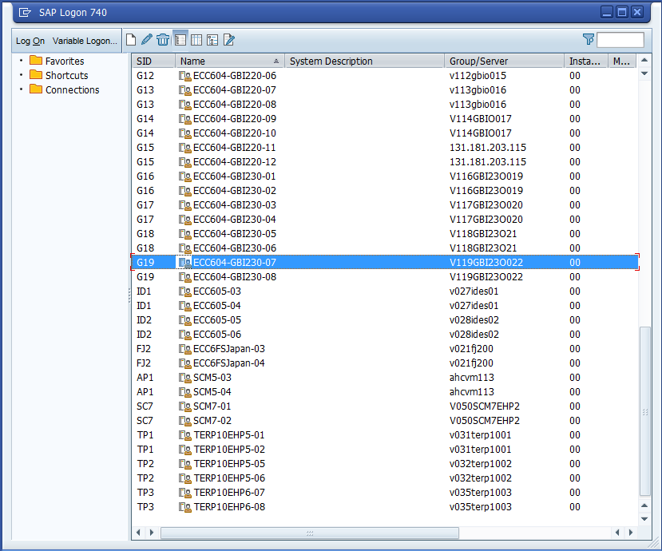

1. A login page will be appeared.

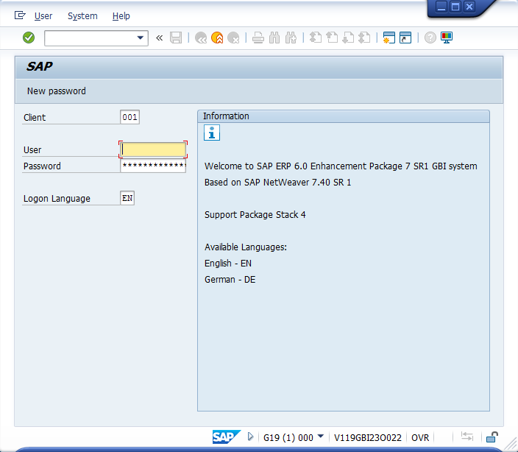

1. Fill in the client number, user name and password. *Notes: These details will be provided in a separate document or email. Please check with your course coordinator or tutor.*
2. Click ‘Enter’ button.

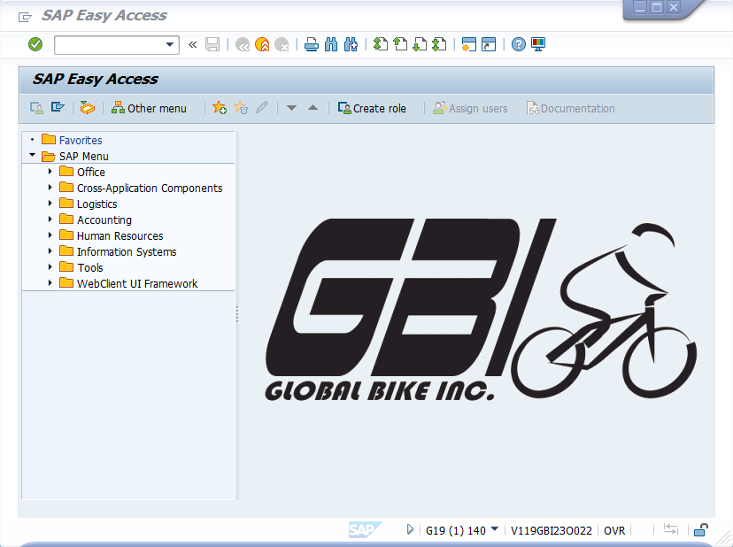

**Step 5**

If you are not seeing a list of servers in your SAP Logon windows, please go through the following steps.

1. Open a SAP Logon windows, locate and double click the ‘SAP Logon’ icon on your desktop. Or, go to Start 🡪 All Programs 🡪 SAP Front End, and select ‘SAP Logon’.
2. Click the icon at the top left corner of the title bar.

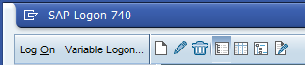

1. Select ‘Options…’ from the menu.

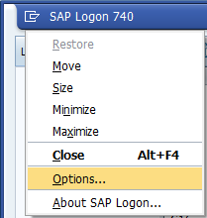

1. The ‘SAP GUI options’ windows will be appeared.
2. Go to ‘SAP Logon Options’ folder.
3. Select ‘Local Configuration Files’ option. Notes: Make sure that the path of ‘Local Configuration Files’ is correctly pointing to the right directory, C:\Users*<UserName>*\AppData\Roaming\SAP\Common.

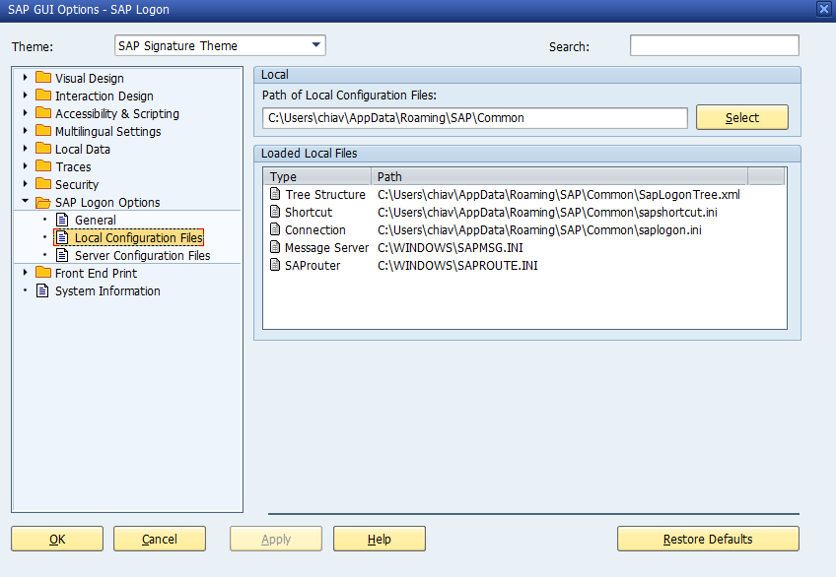

1. If the path is different, click ‘Select’.
2. Navigate to the location of the correct folder.



1. Once done, click ‘OK’.

**Step 6**

To patch the newly installed GUI, simply run the downloaded executable.

<http://uccweb01.qut.edu.au/tech_support/download/SAPGUI_Windows/gui740_10-10013011.exe>

**Appendix – Supported Operating Systems and Office versions**

**SAP GUI for Windows 7.40 is supported on**

* Windows Vista (Business / Ultimate), 32 and 64 (AMD64, EM64T) bit versions
* Windows Server 2008, 32 and 64 (AMD64, EM64T) bit versions
* Windows Server 2008 R2, 64 (AMD64, EM64T) bit version
* Windows 7 (Business Editions), 32 and 64 (AMD64, EM64T) bit versions
* Windows 8 and 8.1 (Business Editions), 32 and 64 (AMD64, EM64T) bit versions
* Windows Server 2012 and Server 2012 R2 64 (AMD, EM64T) bit versions

*(Details can be found in note 66971)*

**Microsoft Office Support**

* Since SAP GUI for Windows 7.30 patch 3 we support the 32 bit version of the Microsoft Office 2013. The use of the 32 bit version of Microsoft Office 2013 is also supported on 64 bit versions of the operating system.
* Since SAP GUI for Windows 7.30 patch 7 we support the 64 bit version of the Microsoft Office for SAP Desktop Office Integration.
* Since Microsoft Office 365 ProPlus (msi or Click2Run) installs Office 2013 it is also supported in the same way.

*(Details can be found in note 722513 and 1442028)*

***Notes: The SAPGUI is not supported for most tablets. The GUI is for full Windows operating systems. Only tablets that run full window operating systems functionality will support GUI installation.***

**Appendix – How to resolve logon load balancing errors?**

**Problem statement**

The Load Balancing error is one of the most common errors which SAP-UCC customers are experiencing while attempting to connect to a system. While attempting to logon, a common error experienced by many SAP users is:

***Logon balancing error 88: Cannot connect to message server (rc=9)***

**Explanation**

In order to dynamically distribute users to application server instances, SAP-UCC uses 2 routers for the management of load distribution. They are: uccsaprouter1.qut.edu.au and uccsaprouter2.qut.edu.au

* If the above mentioned error occurs, please check the message details by pressing ‘**Yes**’.
* If ‘WSAEWOULDBLOCK’ is displayed in the following message, it indicates that your firewall needs to be configured properly.

To test this, we recommend attempting to telnet from your computer with the command prompt:

* Click Start 🡪 Run 🡪 cmd
* Enter ‘telnet 131.181.203.22 3299’
* Enter ‘telnet 131.181.203.23 3299’

If your connection is successful, you will see a **blank** screen. (You will be logged out automatically after a short period of inactivity)

**Solution**

More often than not, the solution is relatively simple. Please check to make sure the following services have been opened in your firewall:

* Port 3299 (outbound) for hostnames:
* uccsaprouter1.qut.edu.au (131.181.203.22) and;
* uccsaprouter2.qut.edu.au (131.181.203.23).

If you are still unable to connect, please be aware that there may be external factors which can cause the blockage; these include:

1. Your University’s firewall
2. Internet Service Provider
3. VPN authentication access
4. The firewalls in wireless routers
5. Network outages (somewhere between you and QUT) can be a contributing factor.

**Appendix – Connect to SAP server**

1. To ensure that the connection to SAP client environment is working, your infrastructure support team must make sure the following ports, **3299 / TCP (outbound)** is opened in the firewall, authentication access (if any), wireless router firewall (if any), and University ISP (if any) for the following IP Addresses:
2. 131.181.203.22 (uccsaprouter1.qut.edu.au)
3. 131.181.203.23 (uccsaprouter2.qut.edu.au)
4. Please make sure that you are logging into the correct system (e.g. G19), client (e.g. 180) with the user name (e.g. GBI-188) and password assigned to you by our support team.