Occupancy rate  (n = 954) | Total population
33.82% | 394.5

Households with proxy and/or actual data about tenants
Total households | Total female-headed | Rate of female headship
140 | 26 | 18.57%

Total number of children under 5 | Number in female-headed households | Percent
31.5 | 11.5 | 36.51%

Total number of school age children* | Percent who live in female-headed households*  (n = 42) | Percent who are currently in school**
70 | 60.00% | 91.11%
* Household and proxy data
** Household data only; n = 45

Total number of people over 65* | Employment rate among people over 65**
39.5 | 7.69%
* Household and proxy data
** Household data only; n = 26

Average age (using household data only) | Average household size
41.4 | 2.51

Race/ethnicity by age
Proxy and household data
Age | Mixed households | Black | White | Asian | Hispanic | Total | Percentage
Under 5 | 1 | 26.5 |  |  |  | 27.5 | 8.11%
5-18 | 4 | 63 |  |  |  | 67 | 19.76%
19-64 | 10 | 158.5 | 3 | 9 | 27.5 | 208 | 60.64%
Over 65 | 3 | 33.5 |  | 4 |  | 40.5 | 11.81%
Total | 18 | 281.5 | 3 | 13 | 27.5 | 343
Percentage | 5.25% | 82.07% | 0.87% | 3.79% | 8.02%

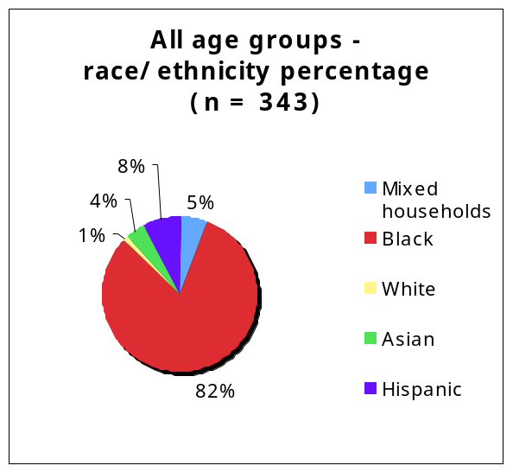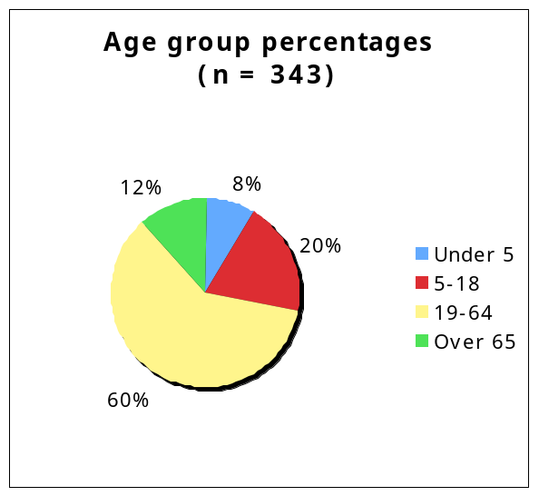
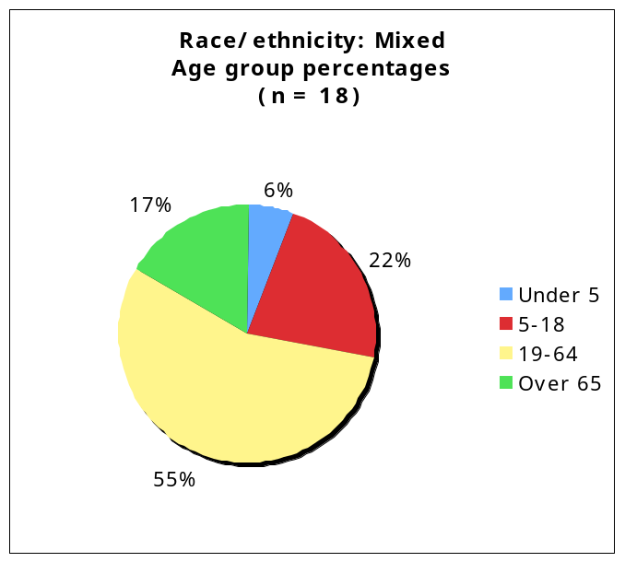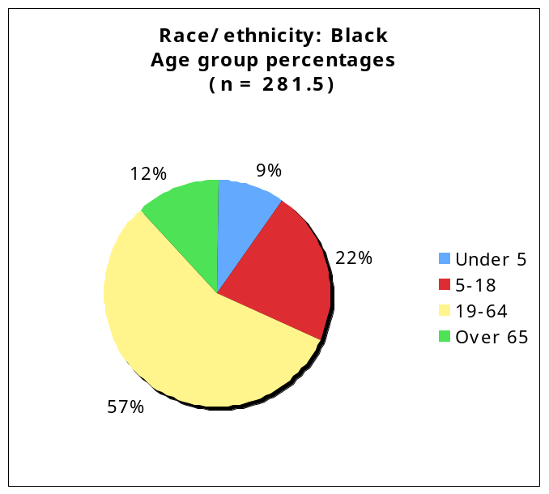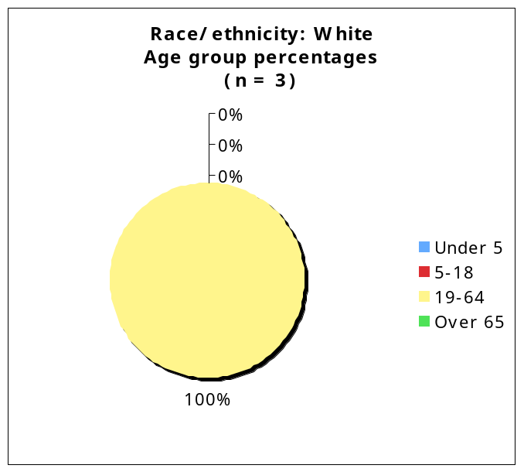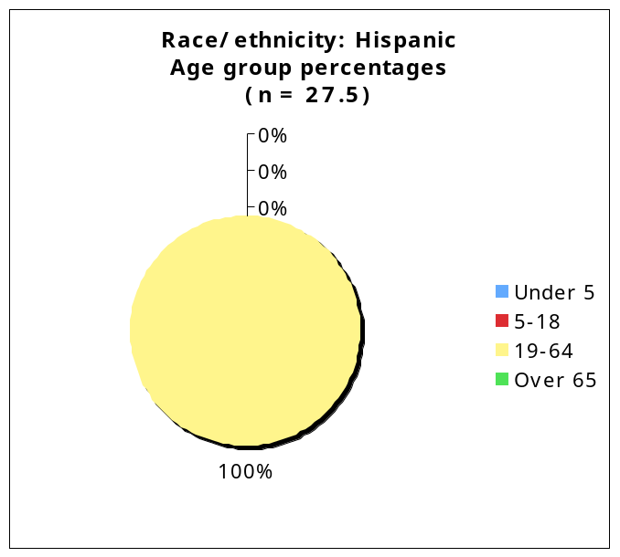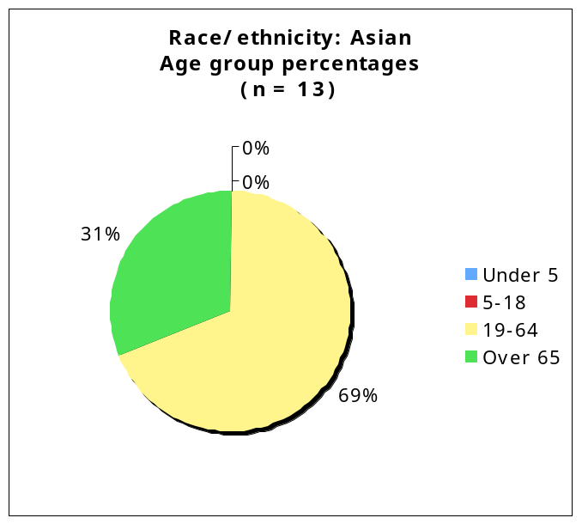

Fuzzy location of Hispanic residents
Block ID | Number of households
20 | 1
45 | 3
104 | 3
203 | 2
Missing | 1
Total | 10
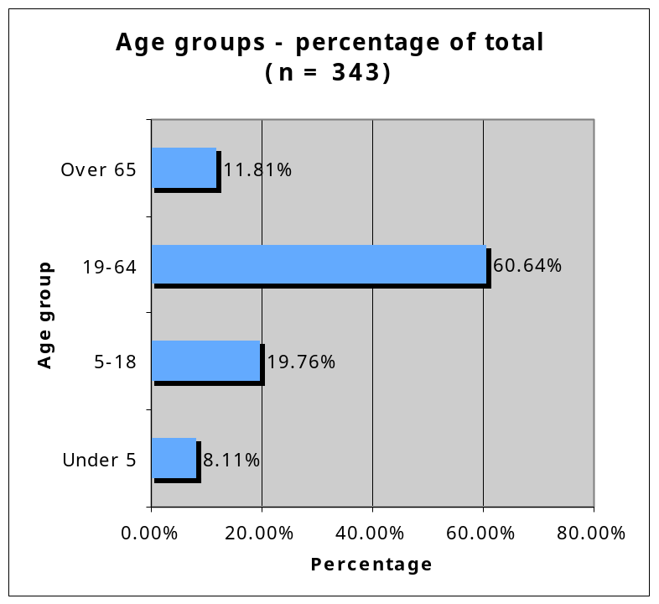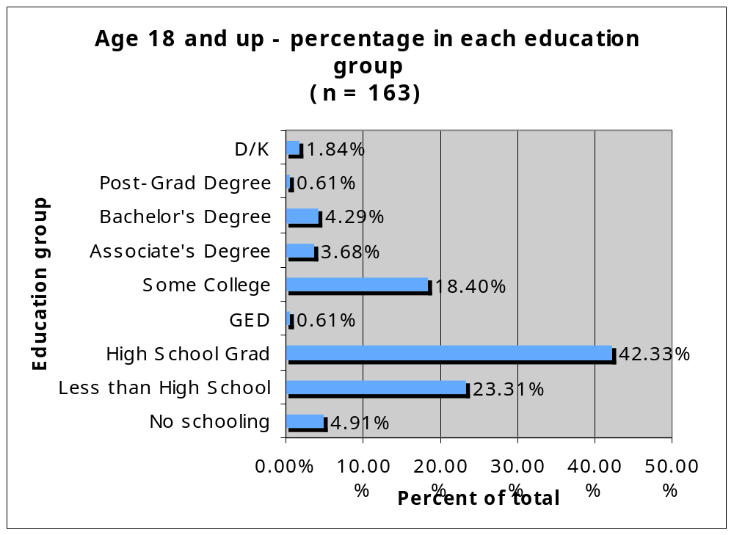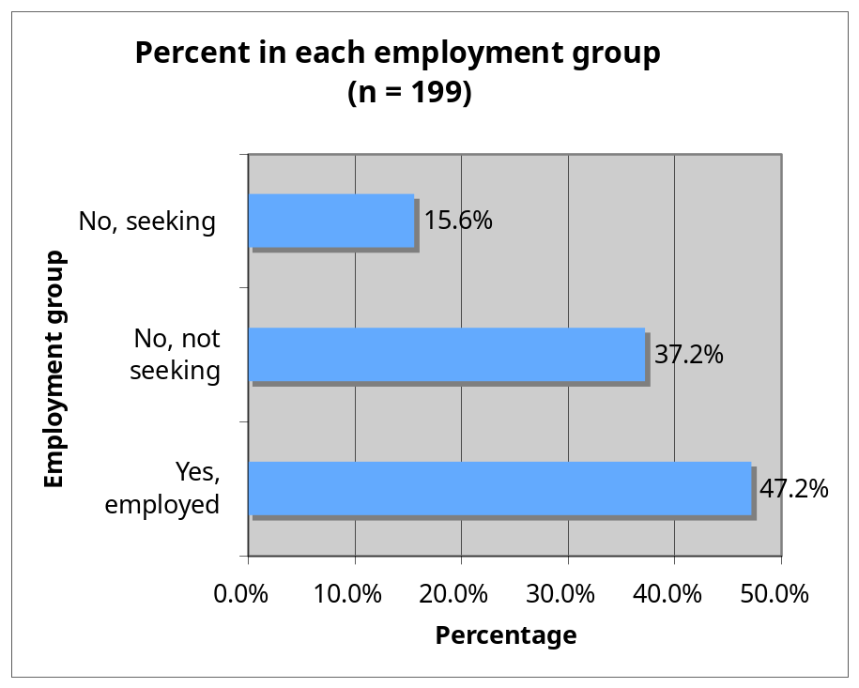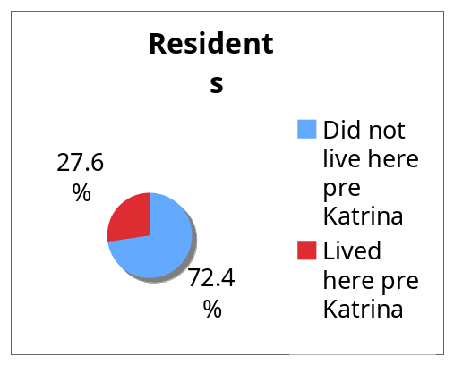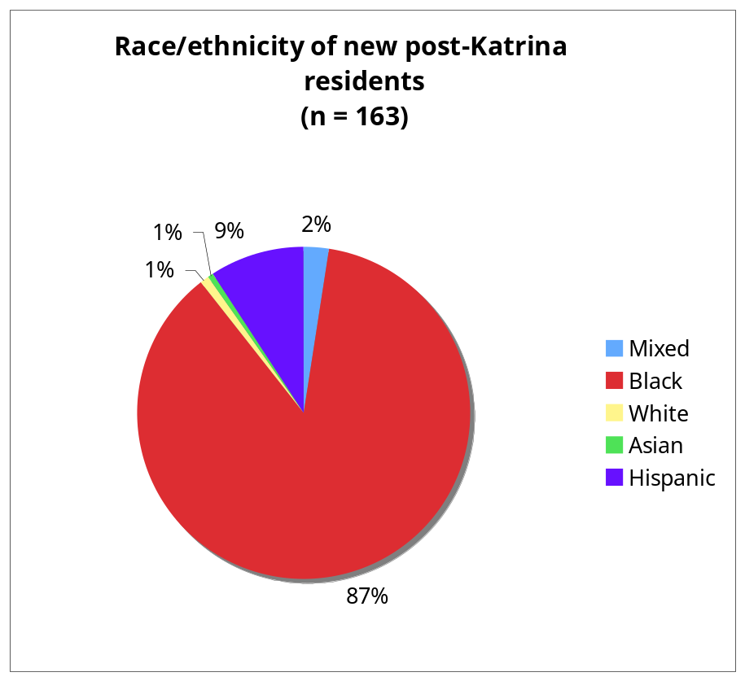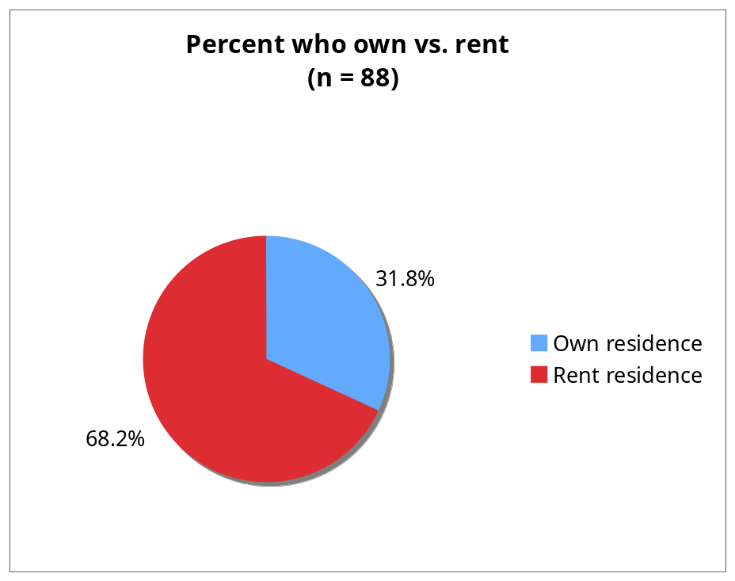

Problem | Frequency mentioned  (total responses = 117)
Finances | 13
Grocery stores | 13
No problems | 12
Restoring own house | 10
Trash pickup/clean up dilapidated houses/clean streets | 9
Employment | 5
Housing cost/supply | 5
Schools | 5
Transportation | 5
Mail | 4
Road Home | 4
Labor for restoring own house (access, reliability) | 3
Medical access, including counseling | 3
Crime, safety, drugs | 2
Electricity (cost, slow return) | 2
FEMA | 2
Medical expenses | 2
Parks/recreation spaces | 2
Space and stability | 2
Can't return to same apartment | 1
Clothing/food/shelter | 1
Coping | 1
Functionality | 1
Gas leaks | 1
Lack of city assistance | 1
Noise at night | 1
Rodents | 1
Sewage | 1
Still moving | 1
Still no furniture | 1
Thrift store | 1
Water cost | 1
Water in lines | 1

Priority Services
Service | Priority 1 | Priority 2 | Priority 3 | Total Responses
Skills | 20 | 7 | 10 | 37
Elderly | 11 | 7 | 10 | 28
Police/Crime | 10 | 9 | 6 | 25
Sports/  afterschool | 8 | 10 | 6 | 24
Housing | 6 | 5 | 6 | 17
Tutoring | 5 | 10 | 12 | 27
Adult Social | 5 | 4 | 7 | 16
Other health | 5 | 8 | 2 | 15
Mental health | 3 | 4 | 4 | 11
Adult Ed | 2 | 3 | 5 | 10
Legal | 2 | 3 | 4 | 9
Arts | 1 | 3 | 3 | 7
Small business | 1 | 1 | 4 | 6
Youth entrepreneur |  | 4 | 2 | 6
Other |  |  |  | 0

Easy access to services? (Percentage of respondents)
Service | No | Yes | Don't know | Total  responses
Child care | 26% | 19% | 55% | 91
Elder care | 39% | 11% | 50% | 90
Mental  health | 41% | 21% | 38% | 90
Primary  health | 41% | 52% | 8% | 91
Jobs | 46% | 30% | 24% | 89
Small  business | 44% | 14% | 41% | 90
Youth/  recreation | 47% | 26% | 27% | 89
Housing | 56% | 18% | 27% | 90
Legal | 38% | 36% | 27% | 90
Food | 59% | 38% | 2% | 91

Service | Where | Frequency mentioned
Child care  (total responses = 12) | About 50-50-not really easy but available | 1
Child care  (total responses = 12) | EOC Central City | 1
Child care  (total responses = 12) | Felicity | 1
Child care  (total responses = 12) | friends | 1
Child care  (total responses = 12) | head start, child care assistance | 1
Child care  (total responses = 12) | Little Gentleman-Claiborne | 1
Child care  (total responses = 12) | Mcmillan First Step | 1
Child care  (total responses = 12) | Napoleon | 1
Child care  (total responses = 12) | nearby | 1
Child care  (total responses = 12) | nursery at the corner | 1
Child care  (total responses = 12) | Simon Bolivar | 1
Child care  (total responses = 12) | Tommy Tiny's Toes | 1
Elder care  (total responses = 7) | Insurance | 2
Elder care  (total responses = 7) | John Jay Nengle (day care center) | 1
Elder care  (total responses = 7) | Kinglsey House | 1
Elder care  (total responses = 7) | neighbor assistance only | 1
Elder care  (total responses = 7) | Rampart | 1
Elder care  (total responses = 7) | Simon Bolivar | 1
Mental health  (total responses = 10) | Hotlines | 2
Mental health  (total responses = 10) | Because daughter is RN | 1
Mental health  (total responses = 10) | Central District | 1
Mental health  (total responses = 10) | hospitals | 1
Mental health  (total responses = 10) | Jackson Ave. | 1
Mental health  (total responses = 10) | job | 1
Mental health  (total responses = 10) | LA Spirit | 1
Mental health  (total responses = 10) | on Jackson | 1
Mental health  (total responses = 10) | organizations | 1
Primary Health  (total responses = 33) | Napoleon | 4
Primary Health  (total responses = 33) | Touro | 3
Primary Health  (total responses = 33) | Children Hospital | 2
Primary Health  (total responses = 33) | Ochsner | 2
Primary Health  (total responses = 33) | Own/private doctor | 2
Primary Health  (total responses = 33) | University Hospital | 2
Primary Health  (total responses = 33) | charity | 1
Primary Health  (total responses = 33) | dentist (have primary) | 1
Primary Health  (total responses = 33) | Edna Pillsberry | 1
Primary Health  (total responses = 33) | Jackson Ave. | 1
Primary Health  (total responses = 33) | local doctor | 1
Primary Health  (total responses = 33) | LSU-Napoleon | 1
Primary Health  (total responses = 33) | Magazine | 1
Primary Health  (total responses = 33) | Med Center | 1
Primary Health  (total responses = 33) | Ms George Green Ms. Rita | 1
Primary Health  (total responses = 33) | musicians clinic | 1
Primary Health  (total responses = 33) | needs dental | 1
Primary Health  (total responses = 33) | pritanya street | 1
Primary Health  (total responses = 33) | Simon Blvd. | 1
Primary Health  (total responses = 33) | St Simons | 1
Primary Health  (total responses = 33) | St. Andrew and Magazine | 1
Primary Health  (total responses = 33) | takes bus to get to doctor | 1
Primary Health  (total responses = 33) | Veterans Hospital | 1
Primary Health  (total responses = 33) | walk-in clinic, need more | 1
Jobs  (total responses = 9) | Job One | 3
Jobs  (total responses = 9) | CBD area | 1
Jobs  (total responses = 9) | Employment Center | 1
Jobs  (total responses = 9) | Job fair | 1
Jobs  (total responses = 9) | not close, but in the area | 1
Jobs  (total responses = 9) | temp service on Claiborne | 1
Jobs  (total responses = 9) | yes to training, no to jobs | 1
Small business  (total responses = 7) | Bank | 2
Small business  (total responses = 7) | Canal | 1
Small business  (total responses = 7) | Capitol One | 1
Small business  (total responses = 7) | Internet | 1
Small business  (total responses = 7) | seen businesses (not know assistance) | 1
Small business  (total responses = 7) | Washington & Claiborne | 1
Youth/recreation  (total responses = 13) | Taylor Park | 4
Youth/recreation  (total responses = 13) | Park (unspecified) | 2
Youth/recreation  (total responses = 13) | Magazine | 2
Youth/recreation  (total responses = 13) | YET | 1
Youth/recreation  (total responses = 13) | church - Castlerock, White Dove Fellowship, Greater St. Stephen on Liberty, Ashe Cultural Arts Cente | 1
Youth/recreation  (total responses = 13) | New YMCA at Wilson | 1
Youth/recreation  (total responses = 13) | Through School | 1
Youth/recreation  (total responses = 13) | Unknown | 1
Housing  (total responses = 8) | FEMA | 2
Housing  (total responses = 8) | Available but expensive | 1
Housing  (total responses = 8) | getting better | 1
Housing  (total responses = 8) | Jackson Ave. | 1
Housing  (total responses = 8) | landlord | 1
Housing  (total responses = 8) | MLK apt. building | 1
Housing  (total responses = 8) | Public Housing/Sec. 8 | 1
Legal  (total responses = 12) | Legal Aid/CBD Legal Aid | 3
Legal  (total responses = 12) | Because daughter is at city hall | 1
Legal  (total responses = 12) | Canal St. | 1
Legal  (total responses = 12) | Claiborne | 1
Legal  (total responses = 12) | Downtown | 1
Legal  (total responses = 12) | KB Building | 1
Legal  (total responses = 12) | lawyers' organization | 1
Legal  (total responses = 12) | St Joseph's | 1
Legal  (total responses = 12) | Tulane and Broad | 1
Legal  (total responses = 12) | Waiting list | 1
Food  (total responses = 33) | Walmart | 13
Food  (total responses = 33) | Winn Dixie | 4
Food  (total responses = 33) | Sav-a-Center/Rouses | 3
Food  (total responses = 33) | Tchoupitoulas | 3
Food  (total responses = 33) | Claiborne | 2
Food  (total responses = 33) | Broad Street | 1
Food  (total responses = 33) | Catholic Charities | 1
Food  (total responses = 33) | cornerstore "sweet shop" | 1
Food  (total responses = 33) | daughter drives | 1
Food  (total responses = 33) | food pantries | 1
Food  (total responses = 33) | if you have a car | 1
Food  (total responses = 33) | right here! (at his store) | 1
Food  (total responses = 33) | Wegman | 1

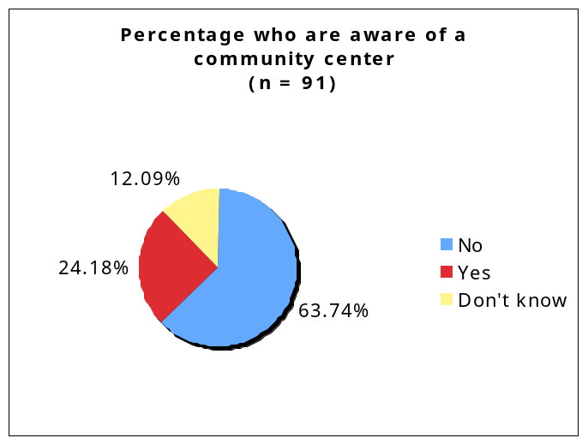
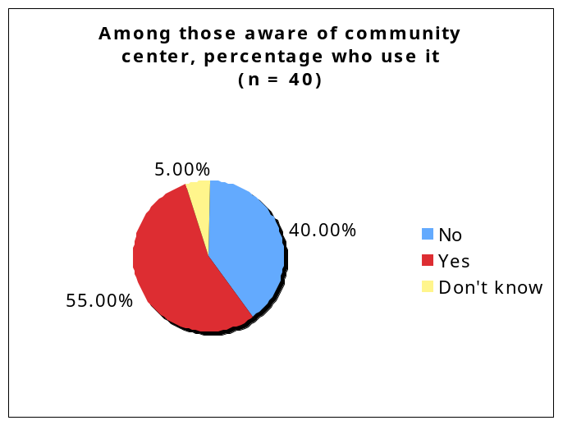
Where people access services
Location | Frequency mentioned  (total responses = 22)
2020 Jackson/Jackson Ave | 6
Jackson/Total Community Action | 2
Washington Ave | 2
Ashe on OC Haley | 1
Castle Rock | 1
Catholic Charities | 1
Church across Claiborne | 1
Constant St. | 1
Elna Pillsbury | 1
Jackson/Catholic Charities | 1
On Tulane | 1
St Jude on Rampart | 1
St. Charles | 1
St. Phillips | 1
The Kingsley House | 1
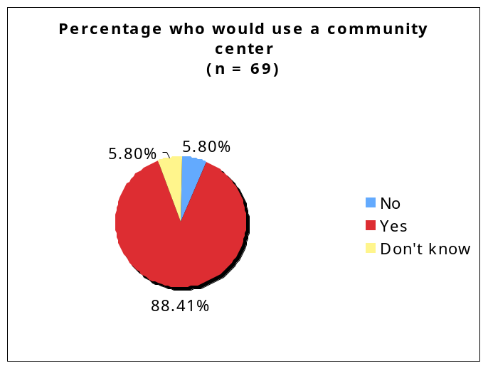
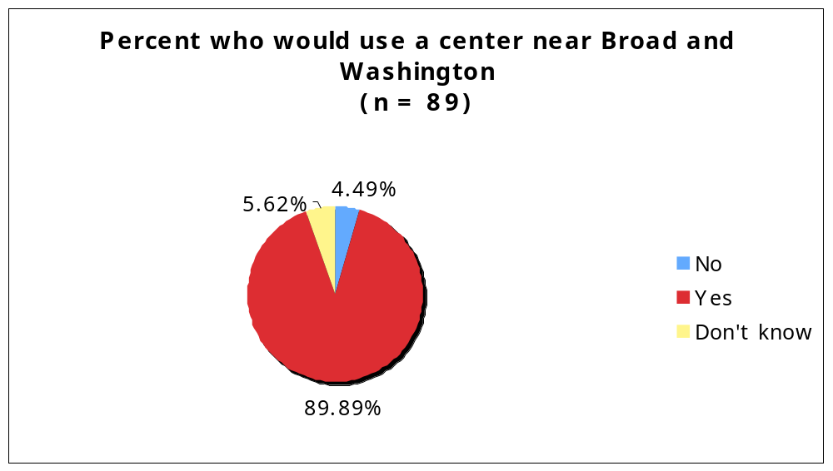
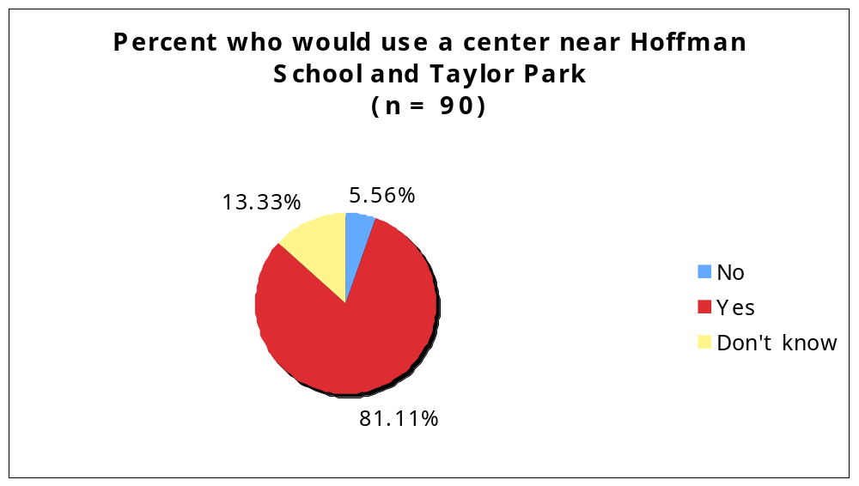
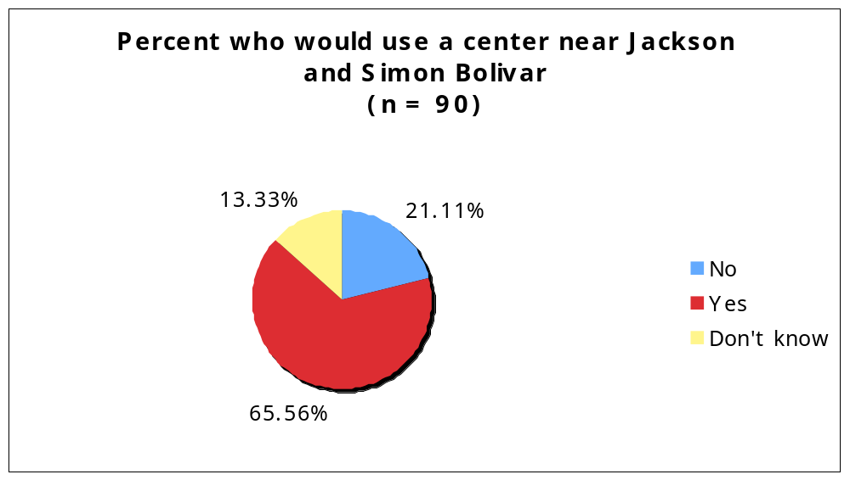
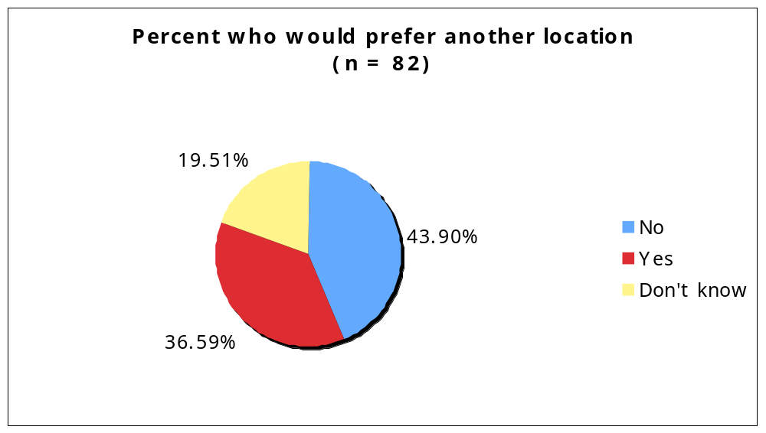

Other location | Frequency mentioned  (total responses = 32)
Claiborne | 3
Closer | 2
2600 Block of Washington | 1
Anywhere in the Broadmoor area | 1
anywhere on a bus route | 1
Broad and Fountainbleau | 1
Broadman Library | 1
Broadmore center | 1
Canal | 1
Claiborne btwn. Washington and Toledano | 1
Clark/Signature schools are closed | 1
Earheat/Carrolton area - developing; near Friedman's Association | 1
Hartman School | 1
in area | 1
Jackson & Galvez | 1
Jackson/MLK - former center | 1
Louisiana Ave. | 1
MLK/Broad area | 1
MLK/Claiborne | 1
more spread out | 1
Near precinct | 1
On Tulane | 1
Robertson & Magnolia (former police station) | 1
Roman and Washington | 1
School down street-Derrol Junior High, Tonti and 4th | 1
School on Martin Luther | 1
Telemachus-Gertown | 1
Tulane and Jeff Davis | 1
Washington | 1
