**Saint Joseph Medical Clinic**

**Diabetes Registry**

**Administrator Manual**

Version 1

April 13, 2016

Table of Contents

**1.0 Introduction…………………………………………………………………………........3**

**1.1 Overview………….……………………………………………………………………..........3**

**1.2 Purpose………………………………………………………………………………….….…..3**

**2.0 Administration Functions……………………………………………………..……4**

**2.1 Find Administrative Functions………………………………………………………4**

**2.2 Add New Clinic………………………………………………………………………….……6**

**2.3 Update Clinic………………………………………………………………………………….7**

**2.4 Control User Access………………………………………………………………….…….9**

**3.0 Important Notes ………………………………………………………………………..10**

**3.1 Security………………………………….…………………………………………………….10**

**3.2 Other Considerations…………………………………………………………………...11**

**1.0 Introduction**

**1.1 Overview**

The administrative functions in the web application of the Saint Joseph Medical Clinic Diabetes Registry provide a way for the administrator to add new clinics to the registry, modify clinic information in the database, and control user access to the registry. The role of registry administrator is not set in the application interface; the role may only be set by direct database access.

**1.2 Purpose**

The goal of this manual is to explain and demonstrate the administrative functions provided by the application interface of the system. This manual describes the procedures for adding new clinics to the database, updating clinic information in the database, viewing user details, and changing access permissions for users.

**2.0 Administrative Functions**

**2.1 Find Administrative Functions**

A user with the role of administrator will have automatic access to administrative functions within the web application interface. To find the administrative section of the application, sign in to arrive at the home page. On this page and other pages of the application, a link for “Administration” can be found in the upper right corner. Click on this link to navigate to the administration functions area.

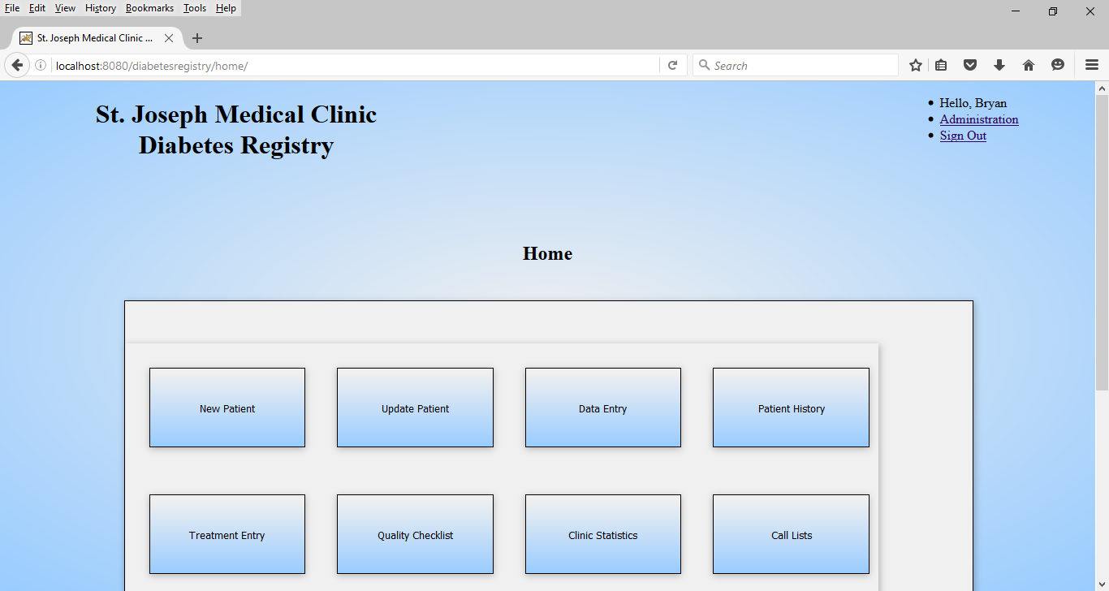

*Figure 1*. Home Page.

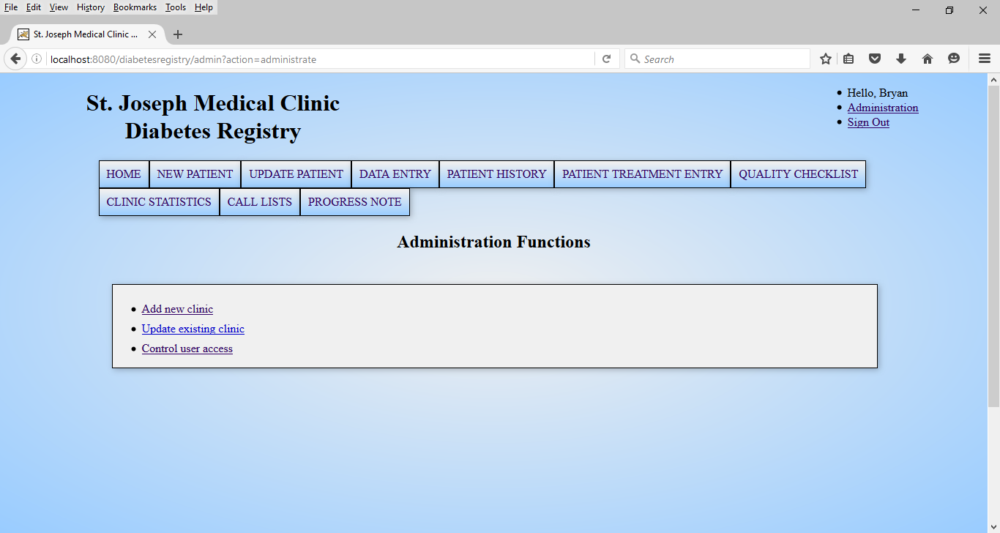

*Figure 2*. Administrative Functions.

**2.2 Add New Clinic**

To add a new clinic to the database, select the “Add new clinic” link from the navigation menu of the administration functions. The “New Clinic” form will appear; this form is to be populated with clinic details. Clinic name, address, and phone number are required details for the new clinic. To add a clinic, the administrator’s clinic must have a valid email address stored in the database. An attempt to add a new clinic without an administrator email will trigger an error message as seen in Figure 3.

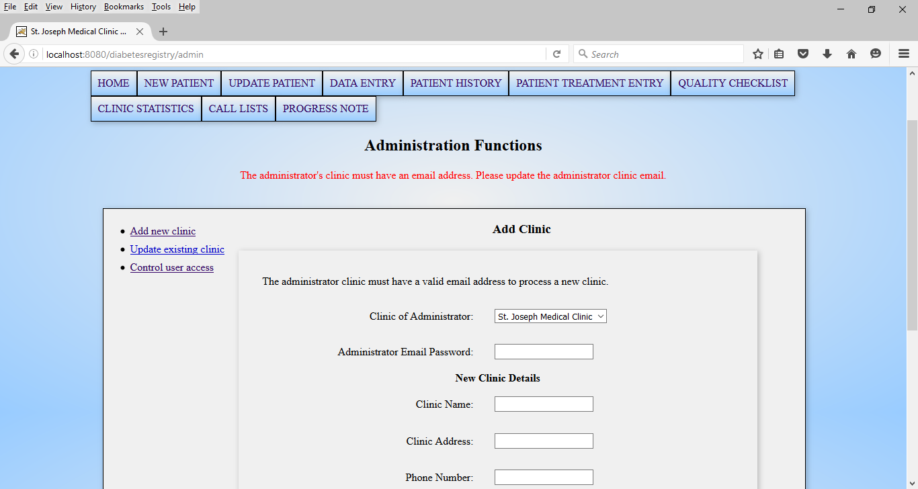

*Figure 3*. Error Message.

The email address for the administrator is required to receive the automatically generated registration key for the users of the new clinic. This key must be given to users of the new clinic by the administrator to enable the registration process. To add or update an email address for the administrator, see section 2.3 of this manual.

Add the new clinic to the database by entering the administrator email password into the input field labeled “Administrator Email Password”, and then complete the form by populating the rest of the input fields with the new clinic details. Finally, select the “Add Clinic” button at the bottom of the form. When the operation completes, a message indicating success will appear at the top of the page.

**2.3 Update Clinic**

To find the form for updating clinic information, select the “Update existing clinic” link from the administration functions menu. The “Update Clinic” option will appear with a drop-down selection to choose the appropriate clinic to update.

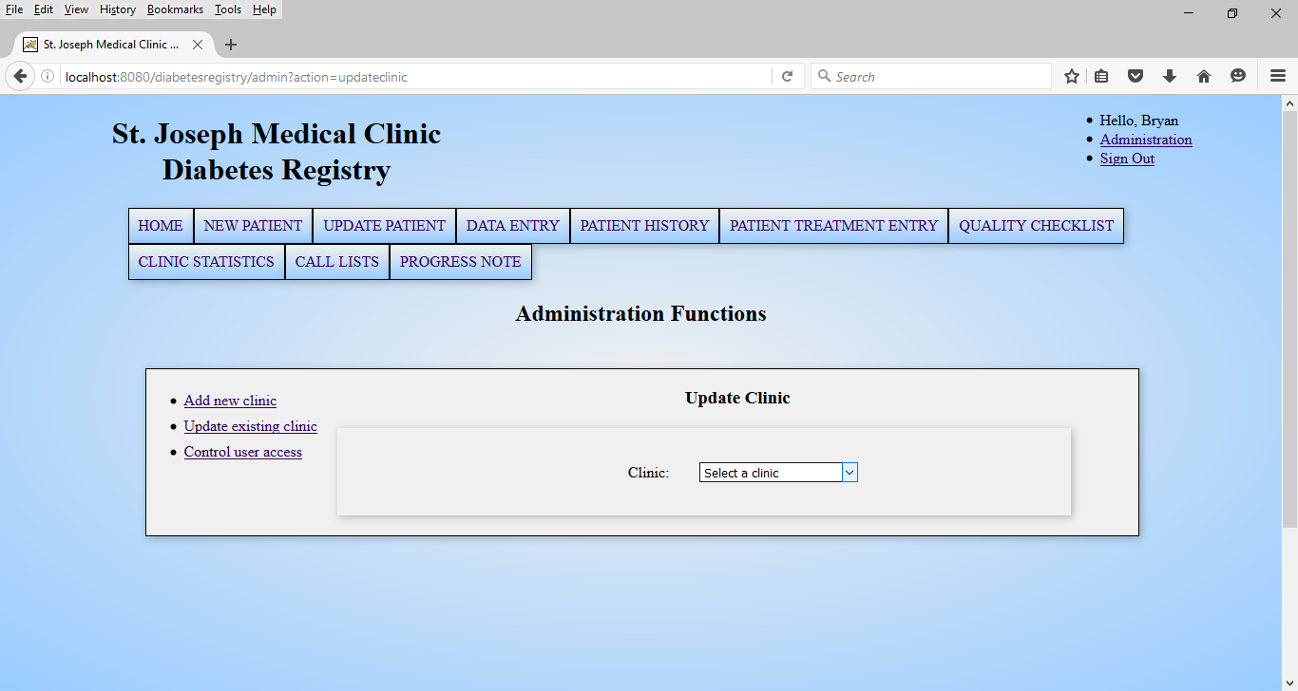

*Figure 4*. Update Clinic.

Upon selection of a clinic, the update form will appear, populated with the clinic’s current information stored in the database as seen in Figure 5.

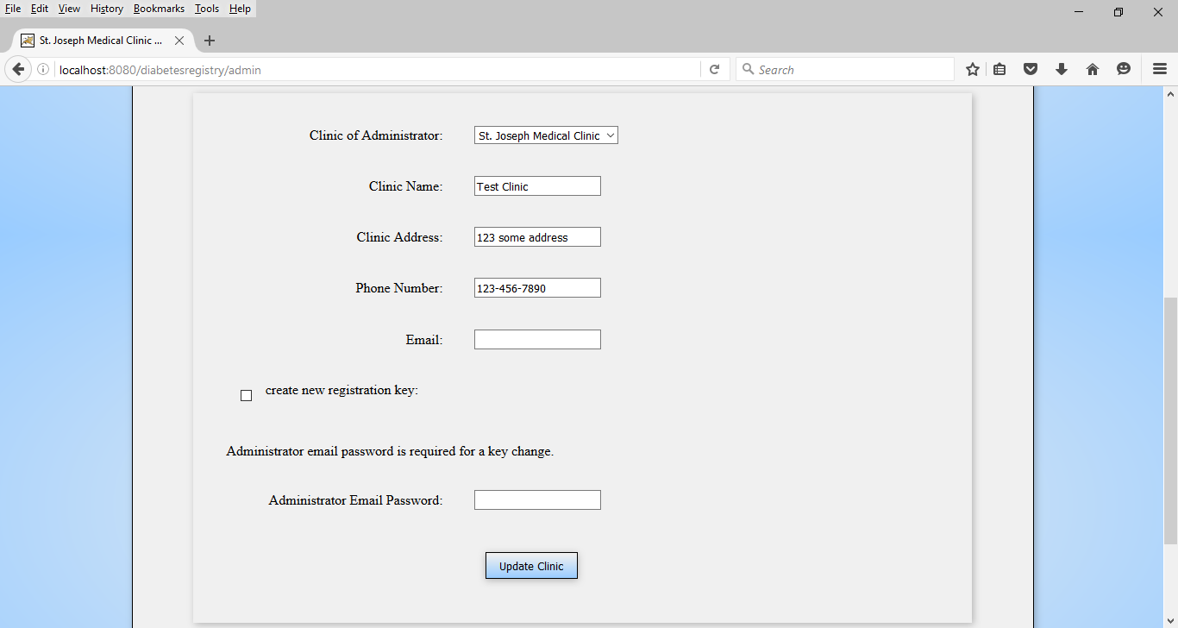

*Figure 5*. Update Clinic Form.

When the information has been updated in the form, select the “Update Clinic” button at the bottom of the form to save the changes. If a new registration key needs to be generated for the selected clinic, the administrator email password must be given so the new registration key can be sent to the administrator.

**2.4 Control User Access**

To restrict or revoke a user’s access to the registry, click on the “Control User Access” link in the administration functions navigation menu. A drop-down selection is visible at the top of the form to choose the desired registered user. When a user is selected, options for access control will appear, as seen in Figure 6.

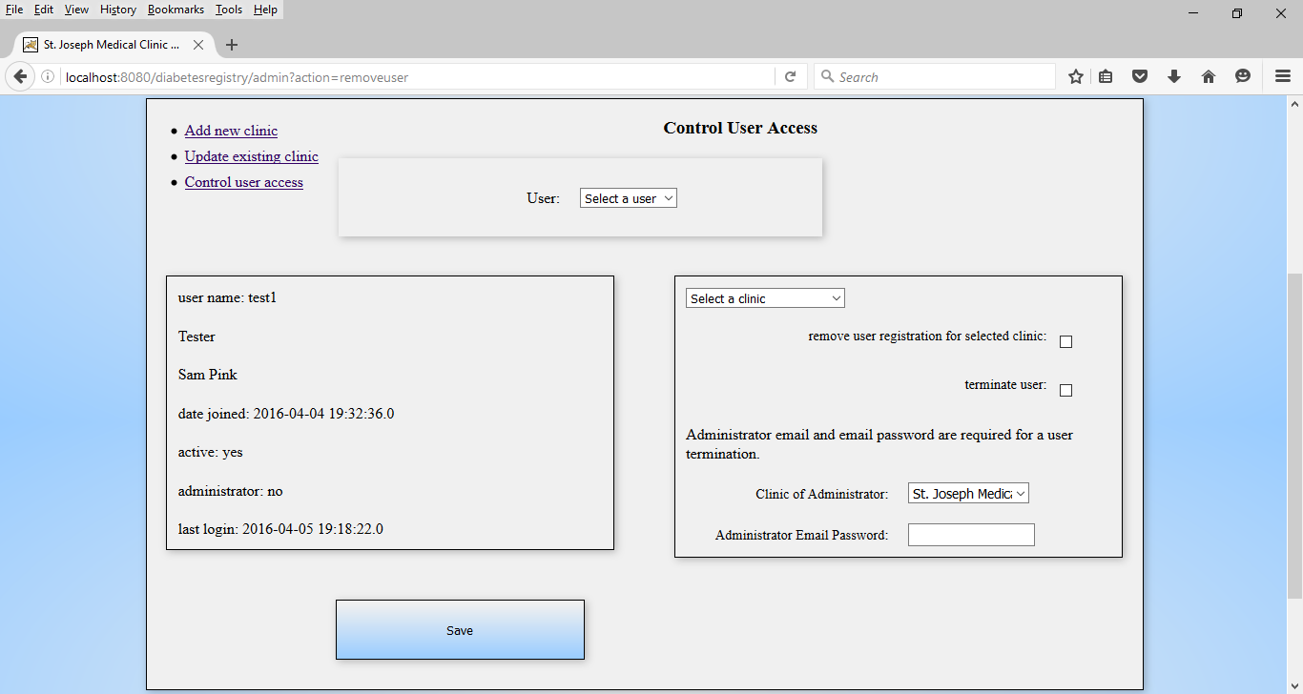

*Figure 6*. Control User Access.

For a situation where a registered user transfers from one clinic in the system to another clinic in the system, the user’s access to the registry does not need to be completely revoked, however, the registration for the previous clinic is not required by the user. To remove a user’s registration for a single clinic while keeping the user active in the registry, take the following steps:

* In the form, select the clinic to eliminate from the user’s access.
* Check the box labeled, “remove user registration for selected clinic”.
* Select the “Save” button at the bottom of the form.

A message indicating success will appear at the top of the page when the operation is complete.

For a situation where a registered user is no longer associated with the Saint Joseph Medical Clinic Diabetes Registry, or any other situation where a registered user is no longer authorized to access the system, take the following steps:

* Check the box labeled, “terminate user”.
* Enter the administrator email password in the field provided.
* Select the “Save” button at the bottom of the form.

A message indicating success will appear at the top of the page when the operation is complete.

The administrator email password is required for user termination as the existing registration keys associated with the terminated user are replaced in the database by auto-generated keys to prevent re-registration by the terminated user and the new keys are sent to the administrator to enable registrations for new users. Active users in the database will automatically be associated with the newly generated keys for their respective clinics.

**3.0 Important Notes**

**3.1 Security**

3.1.1 Registration Keys

Keep track of the latest registration keys for each clinic and ensure that users do not have possession of keys for clinics they are not authorized to access. If a user’s registration is removed for a clinic, make sure that the clinic is updated to replace the existing key.

3.1.2 IP Address Filter

The Remote Address Filter is contained in the Tomcat configuration file WEB-INF/web.xml. Only specify IP addresses in the param-value element of the Remote Address Filter which are needed by authorized users for access to the registry. If an address is temporarily added to the filter, remove it after use.

**3.2 Other Considerations**

3.2.1 Adding Clinics

When a new clinic is added to the system, Tomcat must be restarted to store clinic information in memory.

3.2.2 Web Mail

The Simple Mail Transfer Protocol (SMTP) server utilized by the email functions of the call list page and the administration tasks is specified in the XML file, WEB-INF/mail.xml. A deployment necessitating a different web host will require updating the mail.xml file to hold the correct SMTP host name.

The system does not support automated emails from multiple webmail hosts. Each clinic in a network sharing the same application may use different email addresses, but the mail service provider must be the same provider hosting the application.

3.2.3 Call List Automated Messages

Automated reminder messages for the call list page of the application are retrieved from the database according to clinic ID. Therefore, each clinic in the system requires its own set of reminder messages stored in the database for proper operation of the email reminder functions.