# Personas

## FITNESS ENTHUSIAST

|  |  |  |  |  |  |
| --- | --- | --- | --- | --- | --- |
|  | |  | **MOTIVATIONS** |  | **CHALLENGES AND OBSTACLES** |
| Strives for peak physical fitness, enjoys challenging workouts, and values maintaining a healthy lifestyle | Balancing a demanding job with a rigorous fitness routine, occasional time constraints for meal planning and nutrition tracking |
|  |  |
| **QUOTATION** | |
| *Pushing my limits every day brings me closer to my fitness goals!* | |
| **NAME** | |
| Alex Johnson | |
| **AGE** | |  |  |
| 28 years old | | **GOALS** | **BACKGROUND** |
| **GENDER** | | Track and analyze diverse exercise routines, monitor progress, set fitness goals, access personalized workout plans, and manager a balanced nutrition profile | Works in a demanding job, prioritizes fitness as a stress-reliever, and seeks continuous improvement in performance |
| Male | |
| **LOCATION** | |
| Urban, Los Angeles | |
| **OCCUPATION** | |
| Marketing Manager | |
| **JOB TITLE** | |
| Marketing Manager | |
| **HIGHEST LEVEL OF EDUCATION** | |
| Bachelor’s Degree in Marketing | |
| **ANNUAL INCOME** | |
| $80,000 | |

## WELLNESS NOVICE

|  |  |  |  |  |  |
| --- | --- | --- | --- | --- | --- |
|  | |  | **MOTIVATIONS** |  | **CHALLENGES AND OBSTACLES** |
| Recognizes the importance of health and wellness, eager to adopt a healthier lifestyle, and values simplicity and guidance | Limited prior knowledge about wellness practices, struggles with incorporating new habits into a freelance work schedule |
|  |  |
| **QUOTATION** | |
| *I’m ready to make positive changes for a healthier, happier life* | |
| **NAME** | |
| Emily Rodriguez | |
| **AGE** | |  |  |
| 35 years old | | **GOALS** | **BACKGROUND** |
| **GENDER** | | Receive beginner-friendly guidance, track basic health metrics (daily steps, water intake), access easy-to-follow tips for improving overall wellness, and manage daily nutrition intake | Works from home, has recently developed an interest in wellness, and seeks accessible and easy-to-follow tips for improving overall health |
| Female | |
| **LOCATION** | |
| Suburban, Dallas | |
| **OCCUPATION** | |
| Graphic Designer | |
| **JOB TITLE** | |
| Marketing Manager | |
| **HIGHEST LEVEL OF EDUCATION** | |
| Associate’s Degree in Graphic Design | |
| **ANNUAL INCOME** | |
| Variable (Freelancer) | |

## Chronic Health Condition Manager

|  |  |  |  |  |  |
| --- | --- | --- | --- | --- | --- |
|  | |  | **MOTIVATIONS** |  | **CHALLENGES AND OBSTACLES** |
| Necessity-driven health monitoring, seeks to manage chronic conditions effectively, values tools for simplifying health management | Managing a chronic health condition while juggling part-time work, occasional emotional challenges associated with health management |
|  |  |
| **QUOTATION** | |
| *Every day is a step towards better health, and I’m committed to the journey* | |
| **NAME** | |
| Taylor Lee | |
| **AGE** | |  |  |
| 45 years old | | **GOALS** | **BACKGROUND** |
| **GENDER** | | Monitor health metric, set medication reminders, receive personalized insights on lifestyle adjustments for better health management, and track nutritional intake | Works part-time, manages a chronic health condition, and desires a platform that helps monitor health metrics specific to their condition |
| Non-binary | |
| **LOCATION** | |
| Suburban, Chicago | |
| **OCCUPATION** | |
| Social Worker | |
| **JOB TITLE** | |
| Licensed Clinical Social Worker | |
| **HIGHEST LEVEL OF EDUCATION** | |
| Master’s Degree in Social Work | |
| **ANNUAL INCOME** | |
| $60,000 | |

## Senior Citizen

|  |  |  |  |  |  |
| --- | --- | --- | --- | --- | --- |
|  | |  | **MOTIVATIONS** |  | **CHALLENGES AND OBSTACLES** |
| Values maintaining independence and staying active in later years, prioritizes health for a fulfilling retirement | Physical limitations associated with aging, adapting to a retired lifestyle, occasional memory-related challenges |
|  |  |
| **QUOTATION** | |
| *Age is just a number; staying active and healthy is the real secret* | |
| **NAME** | |
| Margaret Thompson | |
| **AGE** | |  |  |
| 70 years old | | **GOALS** | **BACKGROUND** |
| **GENDER** | | Track daily activities, monitor vital signs, access resources on senior-friendly exercises, receive reminders for medication and doctor appointments, and manage a balanced diet | Retired, enjoys gardening and community activities, and seeks tools for maintaining a healthy and active lifestyle in senior years |
| Female | |
| **LOCATION** | |
| Rural, Pheonix | |
| **OCCUPATION** | |
| Retired School Teacher | |
| **JOB TITLE** | |
| Former Elementary School Teacher | |
| **HIGHEST LEVEL OF EDUCATION** | |
| Bachelor’s Degree in Education | |
| **ANNUAL INCOME** | |
| $45,000 | |

# Journey Maps

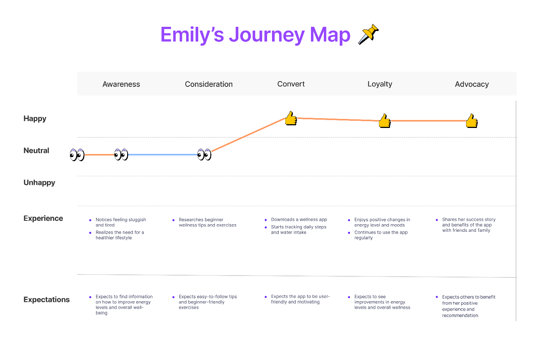

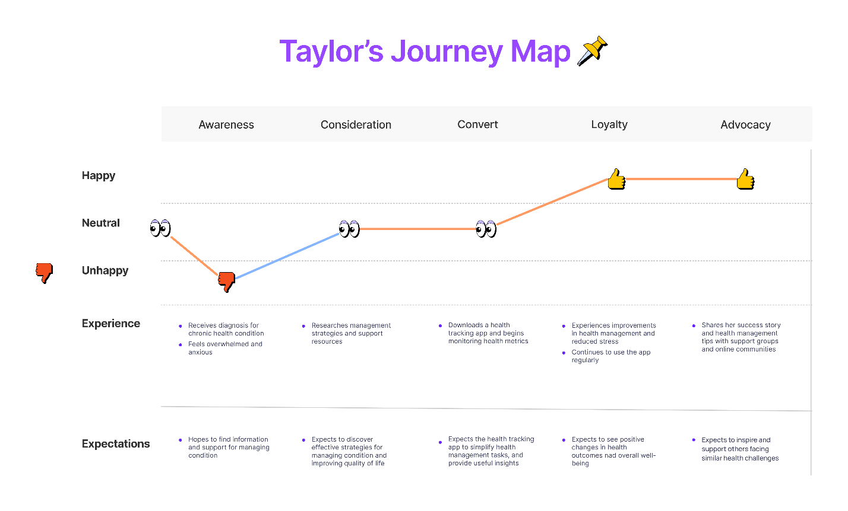

# Paper Prototype

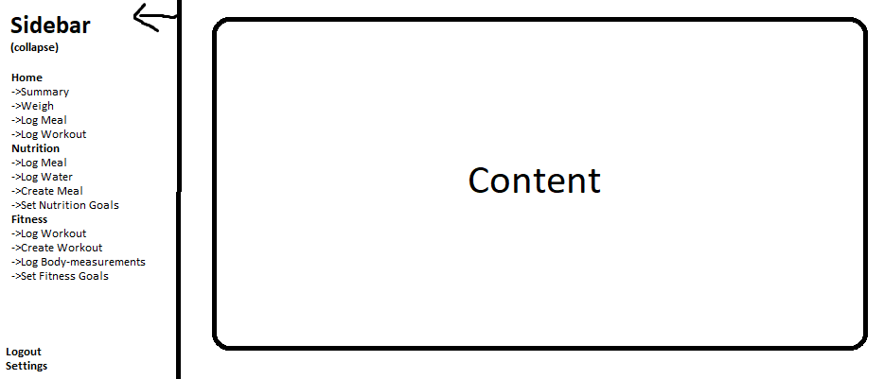

# Wireframes

