Open NetBeans app

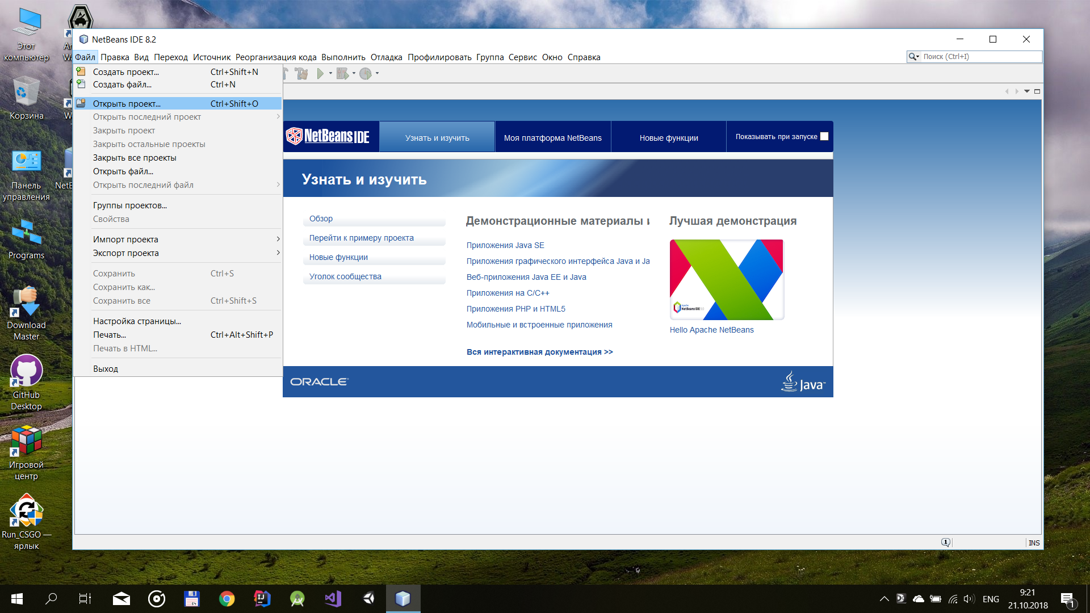

Press open project

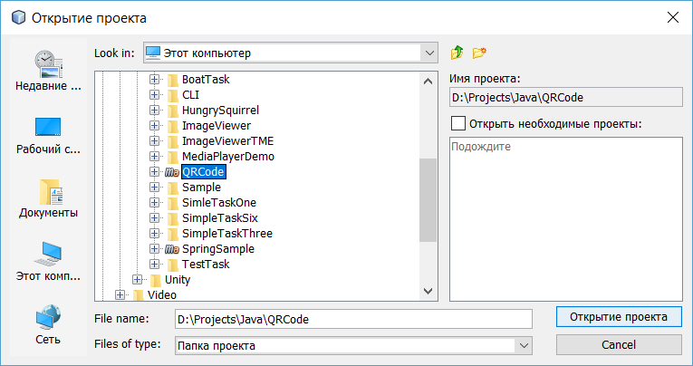

Choose directory of the project and press open project

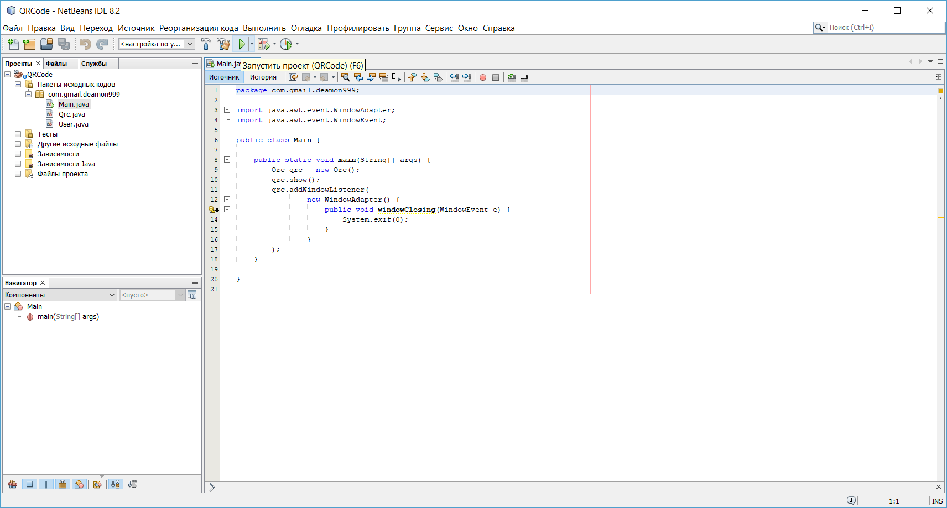

You need to find main.class and open it and then press run project (green triangle at the top)

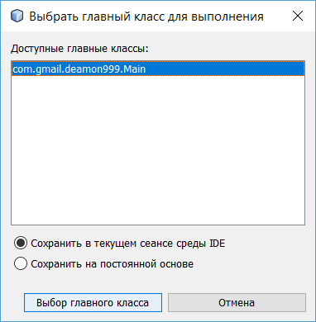

Then you will see this window, here you need confirm main class of the program

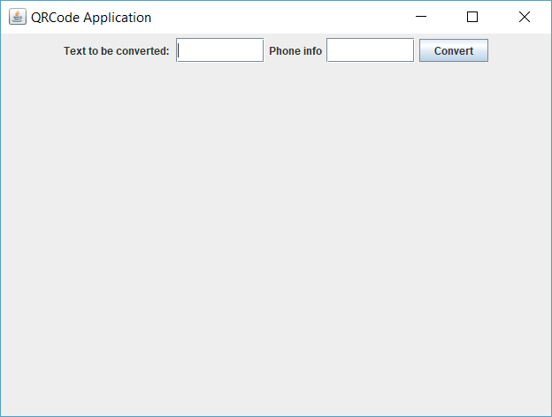

And after you will see that the program is working