**INTRODUCTION**

**American Sign Language**

ASL also known as American Sign Language originated in the early 19th century in the American School for the Deaf (ASD) in West Hartford. Since then, ASL use has propagated widely by schools for the deaf & dumb community for an ease of communication.

There was need of a technology which can make the sign language interpreting process easier. One of the earliest attempts in creating the system was by Mr. Pugeault and Mr. Bowden in 2011. They developed a classifier for 24 letters of American Sign Language.

Since, it is a standard collection of hand gestures which represents several characters and Alphabets. Hence it has gained popularity and systems are being devised in this area to improve the communication process with the help of technology.

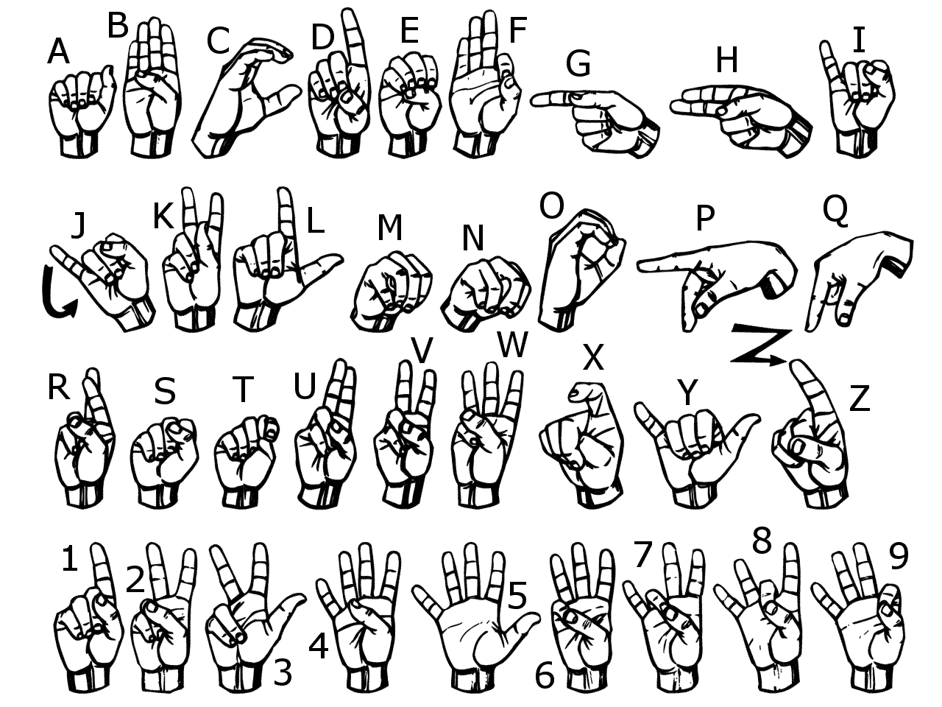

**PRESENT SYSTEM**

This project aims to bridge the gap between the deaf and dumb people. The basic idea of this project is to make a system using which these community people can use to significantly communicate with all other people using their normal hand gestures. The system requires the background to be perfectly white. The project uses trained CNN model to identify, standard English alphabetic sign language used by the deaf people to communicate and converts them into text so that normal people can understand.

Using technologies like opencv and convolutional neural network (deep learning), which is a subset of Artificial Intelligence a system is devised such that when a hand gesture is made in live camera, it predicts the accurate sign language or hand gesture according to standard American sign language format. It also ensure that the system ignores the minimal hand gestures error as every person has different hand size and may slightly make different hand gestures. Hence, angle, shape, size are some of the features that are taken care of. For that the model is trained in a diversified dataset, which is self created and contain appropriate number of images per gesture for a proper functioning of the system. Data of more than one person is taken to maintain diversity and each gesture is having 750 train images and 250 set of test images. The American sign language interpreter predicts 26 different sign languages with a good accuracy and also help in sentence formation, edition and deletion. All this happens on real-time basis. For features like removal and deletion I have added 4 extra gestures in the dataset. The extra gestures are respectively for blank space, one letter removal, entire sentence removal and an additional no gesture dataset. This additional data is for situation when no gesture is made. It is like default sign so that our model will not make random false prediction.

This a software which can act as a mediator between two people who want to communicate with each other in American sign language. It interprets the signs made by different hand gestures and also form accurate sentences in live video feed using the software. The system is fast enough to catch up with communication in real time and provides a decent accuracy at the same time. It is also be flexible enough to provide sentence formation feature as well features like edit, remove etc. to minimize human error.

**PROPOSED SYSTEM**

Sign Language is a primary means of communication for many deaf and dumb people. They make different hand gestures which represents the signs. But this sign language is only understood by very few people.

There are situations when one person who is unable to speak and his or her only means of communication is the sign language, wants to communicate something to another person who does not recognizes the gestures. To communicate, the other person will either need to learn the hand gesture or make a guess.

Develop a software which can act as a mediator between two people. It should interpret the signs made by different hand gestures and also form accurate sentences in live video feed using the software. The system should be fast enough to catch up with communication in real time and provide a decent accuracy at the same time. It should also be flexible enough to provide sentence formation feature as well features like edit, remove etc. to minimize human error.

Using technologies like deep learning, which is a subset of Artificial Intelligence a system needs to be devised such that when a hand gesture is made in live camera, it should predict the accurate sign language or hand gesture according to standard American sign language format. Also, ensure that the system should ignore the minimal hand gestures error as every person has different hand size and may slightly make different hand gestures. Hence, angle, shape, size are some of the features that needs to be taken care of. So, a diverse dataset is appreciated.

The model should be trained in a diversified dataset, which should be self created and contain appropriate number of images per gesture for a proper functioning of the system. The American sign language interpreter will predict 26 different sign languages with a good accuracy and also help in sentence formation, edition and deletion. All this will happen on real-time basis. For features like removal and deletion add 4 extra gestures in your dataset. The extra gestures will be respectively for blank space, one letter removal, entire sentence removal and an additional no gesture dataset. This additional data is for situation when no gesture is made. It is like default sign so that our model will not make random false prediction.

The project should be a camera­ based sign language recognition system which would be in use for the deaf for converting sign language gestures to text data. The objective is to design a solution that is intuitive and simple. Communication for the majority of people is not difficult and an integral part of life. It should be the same way for the deaf and dumb community.