**PROJECT DETAIL**

1. **Collecting Data**

* Firstly, a dataset will be created of different hand gestures using OS lirary.
* Create folders using os library.
* Draw a rectangle for extracting region of interest (roi) from each frame.
* Convert roi to grayscale image
* Feed the new roi to threshold function
* The threshold function gives entire black and white image using thresh_binary method
* Write the image to the train and test folders separately.

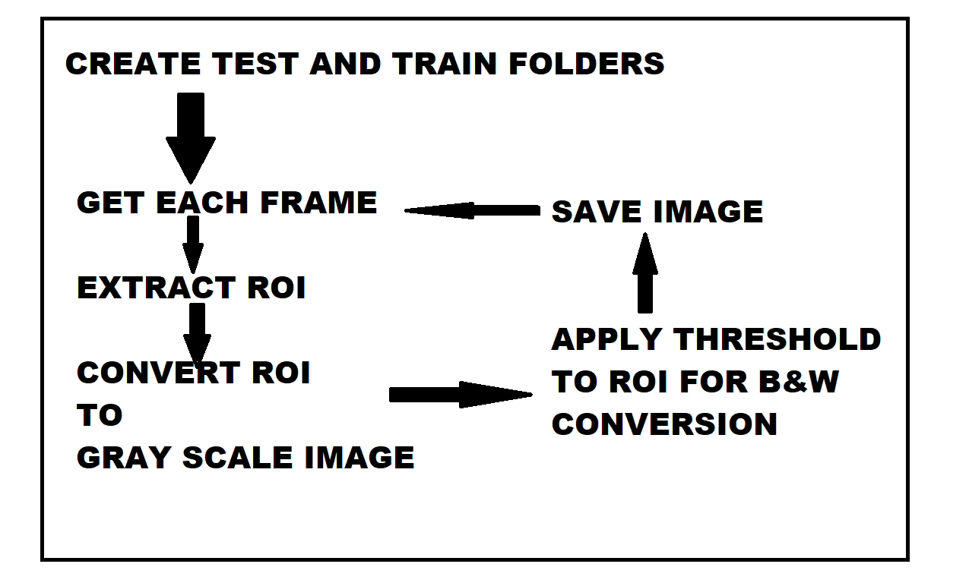

2. Training

Then we will train our data using CNN. A Convolutional Neural Network (ConvNet/CNN) is a Deep Learning algorithm which can take in an input image, assign importance (learnable weights and biases) to various aspects/objects in the image and be able to differentiate one from the other.

3. Prediction

Hand gestures will be captured in live video feed and predict the sign languages in real time. The system will also form sentences.

Python

AI

CNN

Keras

OpenCV