L&T
EduTech
INTERNSHIP REPORT

AI Quality Inspection System for
Packaged Food Production Lines
Submitted by
Aparajitha S
CB.EN.U4ELC23006
Electrical and Computer Engineering
Amrita School of Engineering
Organization: L&T EduTech / L&T Construction
Duration: June 1 – June 12, 2026 (11 Days)

Introduction

About Larsen & Toubro
Larsen & Toubro (L&T) is one of India’s leading multinational conglomerates, recognized for its distinguished presence in Engineering, Procurement and Construction (EPC), hi-tech manufacturing, and technology-driven services. Operating across more than 50 countries, the organization has built a remarkable reputation over eight decades for engineering excellence, quality consciousness, and a strong customer-first approach across all of its major business verticals.

Purpose of the Internship
This internship was structured to provide engineering students with meaningful exposure to current industry practices in Artificial Intelligence and computer vision, with a particular focus on deploying AI-based inspection systems within manufacturing and production environments. The program demanded both domain understanding and applied machine learning skills, aiming to bridge the gap between academic learning and the practical engineering challenges encountered on live industrial production floors.

Objective of the Project
High-speed packaged food manufacturing lines produce large volumes of products such as bottles, chips, and confectionery that must comply with strict quality control and food safety standards. Continuous quality inspection is essential to ensure defect-free products reach customers and to maintain regulatory compliance. Manual quality inspection and periodic sampling are inadequate for detecting packaging defects on high-speed production lines — defects such as loose caps, label misalignment, underfill, and foreign object contamination may pass undetected, leading to customer complaints, product recalls, financial losses, and regulatory failures.
The objective of this internship project was to design and develop a computer vision-based food package defect detection system using Roboflow-annotated packaging imagery, YOLOv8-based inference pipelines, Power BI dashboards for defect analytics, production line monitoring, and quality performance assessment.

Brief Overview of Work Accomplished
Over the course of the internship, a complete AI-based quality inspection pipeline was designed, trained, and evaluated. The system inspects packaged bottles on a conveyor belt in real time, detecting cap defects and fill level anomalies through a YOLOv8 object detection model and a MobileNetV2 classification backbone. Key deliverables include:
- A YOLO-based object detection stage that localises the cap within each bottle frame.
- A MobileNetV2 cap classifier distinguishing five defect states: Good Cap, Broken Cap, Broken Ring, Loose Cap, and No Cap.
- A decision engine that combines classifier outputs to assign a PASS or FAIL label per bottle.
- A traceability log recording Timestamp, Product ID, Cap Status and Result for every inspected unit.
- A Power BI monitoring dashboard providing real-time KPI cards, defect trend charts, and per-machine analysis.

Site Visits
As part of the internship, two structured industrial site visits were arranged to provide first-hand exposure to live engineering operations. While these visits were not directly connected to the computer vision problem at hand, they offered valuable real-world context on disciplined system design, safety culture, and centralized operational monitoring — themes that resonated strongly with the inspection system developed during the project.

Site Visit 1 — Electrical Construction & Building Management Systems

Location
L&T Construction site facility (electrical works division).

Observations
- Sessions covered the complete electrical works workflow on a construction site, from the Bill of Materials (BOM) through on-site execution, with a strong emphasis on safety protocol adherence and client handover standards.
- A hands-on walkthrough of a Direct On Line (DOL) starter explained its construction, control wiring, and protective functions.
- A tour of the Building Management System (BMS) facility demonstrated how an entire building’s mechanical and electrical assets can be monitored and managed centrally from a single computer-based platform.

Key Takeaways
This visit highlighted how tightly engineers and on-site personnel must coordinate at every stage of a project — from planning through procurement, execution, and final safety sign-off — for the work to come together reliably and on schedule.

Site Visit 2 — Railway Signalling & Metro Systems

Location
L&T railway infrastructure and metro project site.

Observations
- A live demonstration in the station master’s room covered the Route Relay Interlocking (RRI) panel, governing train movement across a main path and a bypass using relay-based control logic.
- The interlocking logic was explained in depth: relays enforce strict rules so that two conflicting routes can never be active simultaneously. Once a route is locked and a train enters it, no track switch on that route can be altered until the train clears it and the route is formally released.
- A technical session described how power is delivered to the train through the pantograph mechanism, along with engineering measures to maintain overhead line integrity.
- The visit concluded with an overview of several metro projects delivered by the organization, with each project’s civil and structural engineering explained in context.

Key Takeaways
This visit provided a concrete look at fail-safe, safety-critical system design — a principle directly applicable to building a dependable automated quality inspection system where a missed or misclassified defect (for example, a No Cap bottle released to market) carries genuine operational and safety risk.

Electric Vehicle (EV) Laboratory

Observations
- A guided session in the EV laboratory covered both two-wheeler and four-wheeler electric platforms, including live running demonstrations, drivetrain components, and battery management considerations.

Key Takeaways
This session broadened exposure to L&T’s engineering portfolio beyond construction, underscoring how electrical engineering, automation, and sustainable technology increasingly converge within the organization.

Relevance of Site Visits to the Project
- The centralized BMS monitoring approach closely paralleled the production quality monitoring dashboard developed in this project — where every inspection event is logged centrally and surfaced through Power BI for quality managers, production supervisors, and maintenance teams.
- The disciplined, fail-safe design philosophy observed in the railway interlocking system reinforced the importance of building a reliable decision engine in the inspection pipeline — one that assigns a definitive PASS or FAIL outcome to every bottle with no ambiguity, mirroring how the interlocking system enforces exactly one safe route state at a time.
- The structured documentation and handover discipline observed across both site visits aligned with the traceability logging approach adopted in the project, where every inspection event is timestamped and recorded for audit purposes.

Literature Survey
Prior to designing the detection and classification pipeline, a structured literature survey was conducted to understand existing approaches to automated visual inspection in manufacturing, the techniques applied for packaging defect detection, and the specific gaps remaining in production-line quality assurance using AI.

Sensor-Based and Classical Machine Vision Approaches
Early automated quality inspection systems in food and beverage manufacturing relied on rule-based machine vision using structured light, laser profiling, and colour-based thresholding to detect surface defects, fill levels, and labelling errors. While these systems perform adequately under fixed, controlled conditions, they are brittle to changes in product appearance, lighting variation, or line speed, and require significant manual re-calibration when product specifications change. Their inability to generalize across product variants or defect types represents a key limitation for modern high-mix production environments.

Deep Learning-Based Defect Detection
The emergence of convolutional neural networks (CNNs) enabled a shift from hand-crafted features to learned representations for visual defect detection. Studies applying CNNs such as ResNet and VGG to surface defect datasets demonstrated strong accuracy on structured defect types — cracks, scratches, and discolouration. However, these approaches typically frame detection as image-level classification, assigning a single label to the entire image rather than localizing specific defect regions within a frame. For a production line with multiple potential defect locations per bottle (cap, label, fill), image-level classification provides insufficient spatial granularity for practical defect attribution.

Object Detection Architectures for Manufacturing
More recent research has adopted object detection architectures — particularly the YOLO (You Only Look Once) family and Faster R-CNN — to localize and classify defects within individual frames in real time. YOLO-based models have become particularly favoured in production-line settings due to their single-pass inference, low latency, and competitive accuracy-to-speed ratio, making them well suited to continuous conveyor-belt inspection at industrial throughput rates. This shift from image classification to object detection directly motivated the adoption of YOLOv8 as the detection backbone in the present project.

Cap and Closure Defect Detection
A targeted body of literature addresses cap and closure defect detection specifically in beverage and pharmaceutical manufacturing. Studies in this area have evaluated defect categories including missing caps, cocked closures, damaged tamper-evident rings, and insufficient torque, typically using overhead or angled camera configurations to capture the cap region. A consistent finding across these studies is that multi-class cap defect detection — distinguishing between, for example, a Loose Cap and a Broken Ring — is substantially harder than binary presence/absence detection, due to the visual similarity between certain defect states and the small spatial extent of the distinguishing features.

Multi-Stage Classification Pipelines
Several recent studies have adopted multi-stage architectures that combine a detection stage (to localize regions of interest) with a downstream classification stage (to determine defect type within the localized region). This two-stage approach has been shown to outperform single-stage classification on fine-grained defect categories, since the classification model can operate on a tightly cropped, defect-relevant region rather than the full image. This design principle directly informed the architecture of the present project, where YOLO localises the cap and MobileNetV2 classifies the cropped regions into their respective defect categories.

Identified Research Gaps
Across the literature reviewed, three limitations directly shaped the design of this project:
- Most production-line defect detection research targets a single defect type or region per inspection stage. End-to-end pipelines that jointly address cap condition, fill level, and decision-level PASS/FAIL assignment in a single real-time inference system remain limited.
- Existing published systems rarely couple automated defect detection with structured traceability logging and interactive analytics dashboards for production operators, creating a disconnect between detection capability and actionable operational insight.
- The diagonal camera configuration — which simultaneously captures cap, label, and bottle surface in a single frame — has not been extensively evaluated in the defect detection literature as a means of reducing camera count while maintaining defect coverage across multiple inspection zones.
The project described in this report addresses all three gaps: it implements a unified cap-and-fill inspection pipeline, connects detection outputs to a structured traceability log and Power BI dashboard, and demonstrates the viability of a diagonal camera configuration for multi-zone bottle inspection.

Project Work

Problem Statement
High-speed packaged food manufacturing lines produce large volumes of bottles and sealed containers that must comply with strict quality control and food safety standards. Manual quality inspection and periodic sampling are insufficient to reliably detect packaging defects — such as loose or missing caps, damaged tamper rings, and fill level deviations — on fast-moving conveyor lines. Undetected defects lead to customer complaints, product recalls, financial losses, and potential regulatory non-compliance.
The objective of this project was to design and implement a computer vision-based AI quality inspection system that automatically detects cap defects and fill level anomalies from camera images of bottles on a conveyor belt, assigns a PASS or FAIL disposition to each unit in real time, and logs every inspection event for centralized traceability and analytics.

Camera Setup and Placement Strategy
To capture cap condition, label integrity, and bottle surface in a single image frame without requiring multiple cameras at separate inspection stations, the camera is positioned at a diagonal angle relative to the conveyor belt. This orientation simultaneously exposes the top of the cap, the label face, and the bottle surface within one field of view.

Benefits of Diagonal Positioning
- Covers cap, label, and surface defects simultaneously from a single camera position.
- Eliminates the need for multiple cameras at separate inspection stations, reducing hardware cost and system complexity.
- Provides a combined view that allows both cap condition and fill level to be assessed from the same captured frame.
- Reduces infrastructure requirements and simplifies camera calibration compared to multi-camera setups.
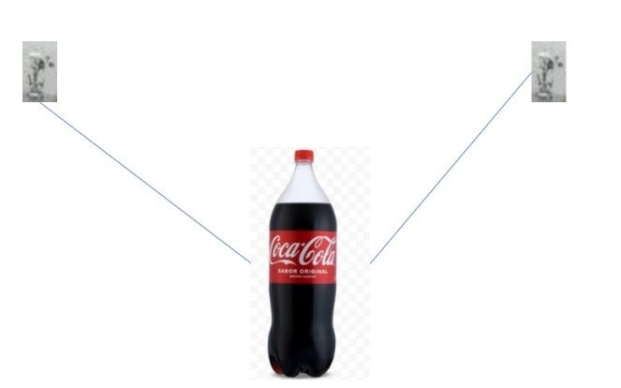

Dataset and Annotation
The project dataset was built and managed using the Roboflow platform. Images of bottles captured on the production line were annotated with bounding boxes around two primary inspection regions: the cap and tamper-evident ring area, and the bottle body for fill level assessment.
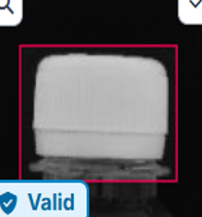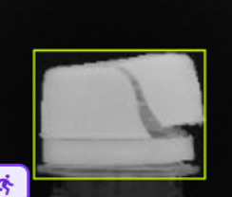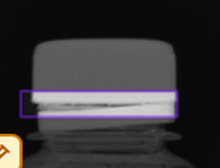
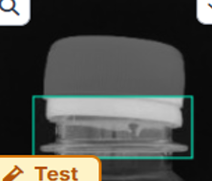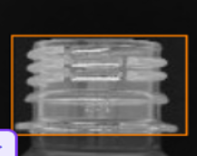
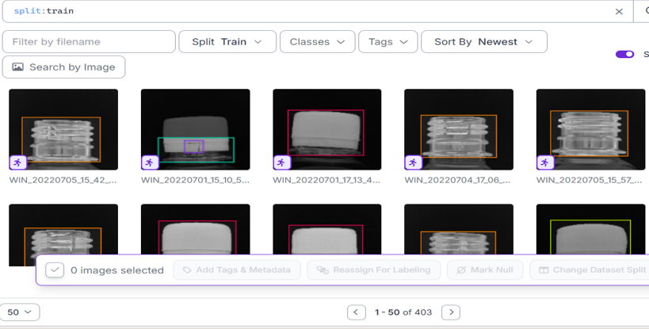

Cap Inspection Classes
Class | Description
Good Cap | Cap properly sealed and intact
Broken Cap | Cap physically damaged or cracked
Broken Ring | Safety ring detached or broken
Loose Cap | Cap present but not fully tightened
No Cap | Bottle missing the cap entirely

Dataset Split
Split | Image Count
Training set | 403 images (64%)
Validation set | 114 images (18%)
Test set | 113 images (18%)
Total | 630 annotated images

Model Training
A YOLOv8 Nano object detection model was selected as the detection backbone, trained on the Roboflow-prepared dataset using Google Colab. YOLOv8 was chosen for its lightweight footprint, high inference speed, and competitive accuracy, making it suitable for deployment on production-line hardware with real-time throughput requirements.

Training Configuration
Parameter | Value
Model architecture | YOLOv8 Nano (yolov8n.pt)
Image size | 640 × 640 px
Batch size | 16
Epochs | 50
Framework | Ultralytics YOLO
Training environment | Google Colab (GPU)
Dataset management | Roboflow

The classification stage used MobileNetV2 with global average pooling (GAP) and a fully-connected head with softmax activation, trained on cropped cap and fill regions extracted from the YOLO detection stage. MobileNetV2 was selected for its efficient depthwise separable convolution design, enabling accurate multi-class classification with a small model footprint.

Inference Pipeline
At runtime, each captured frame passes through the following sequential processing stages:
- Image Capture — diagonal camera captures the bottle on the conveyor belt.
- Preprocessing — Roboflow-based resize and brightness/contrast normalisation for consistent inference under variable line lighting.
- YOLO Object Detection — localises the cap region and fill region within the frame.
- Cap Classifier (MobileNetV2) — classifies the cropped cap region into one of five cap states.
- Fill Level Classifier — classifies the cropped fill region into one of three fill states.
- Decision Engine — combines both classifier outputs to assign a PASS or FAIL label.
- Traceability Logging — writes Timestamp, Product ID, Cap Status, Fill Status, and Result to the inspection log.

Decision Engine
A lightweight rule-based decision engine combines the cap and fill classifier outputs to produce a final binary disposition for each bottle:
Cap Status | Fill Status | Final Result
Good Cap | Perfect Fill | PASS
Loose Cap | Perfect Fill | FAIL
Good Cap | Below Fill Level | FAIL
Good Cap | Above Fill Level | FAIL
Any defect class | Any | FAIL

A deterministic rule-based approach was chosen over a learned classifier for this stage because the PASS/FAIL mapping is a fixed operational specification rather than a statistical pattern to be inferred from data.

Software Stack
Component | Technology
Object detection | YOLOv8 (Ultralytics)
Classification backbone | MobileNetV2
Dataset annotation & management | Roboflow
Training environment | Google Colab + Python
Data logging | Pandas / CSV
Dashboard & analytics | Microsoft Power BI

Power BI Dashboard and Results

Data Model
Every inspection event produced by the inference pipeline is written to a structured InspectionData table that serves as the data source for the Power BI dashboard:
Field / Measure | Type | Description
Machine ID | Dimension | Identifier for each inspection machine
Production Line | Dimension | Production line name or number
Shift | Dimension | Shift label (e.g. Day, Night)
Hour | Dimension | Hour of the day
Cap Status | Dimension | Inspection result category for caps
Total Inspected | Measure | Total units inspected
Good Packages | Measure | Units passing inspection
Rejected Packages | Measure | Units failing inspection
Defect Count | Measure | Count of defective units
Defect Rate % | Measure | Defect Count / Total Inspected × 100
Yield % | Measure | Good Packages / Total Inspected × 100
Inspection Count | Measure | Number of inspection events

Dashboard Overview
The Production Quality Monitoring Dashboard is a single-page Power BI report built on the InspectionData table, combining KPI cards, charts, and interactive slicers for end-to-end quality visibility. It is designed to answer five operational questions at a glance:
- How many bottles are passing inspection and what is the current yield?
- Which cap defect types are occurring most frequently?
- Which machines are contributing the most defects?
- Is the production line meeting quality targets across shifts?
- What is the hourly inspection throughput trend?

KPI Cards
KPI | Description
Total Inspected | Total number of packages inspected
Yield % | Percentage of units passing inspection
Good Packages | Count of units that passed quality checks
Rejected Packages | Count of units that failed inspection
Defect Rate % | Percentage of inspected units that were defective

Dashboard Visuals

1. Cap Inspection Summary (Donut Chart)
Category: Cap Status | Value: Inspection Count. Provides a proportional breakdown of cap inspection results by status category, allowing quality managers to quickly identify the dominant defect type.

2. Cap Defect Analysis (Clustered Bar Chart)
Category: Cap Status | Value: Inspection Count. Compares inspection volumes across different cap defect statuses side by side, supporting root-cause analysis and maintenance prioritisation.

3. Inspection Count by Hour (Line Chart)
Category: Hour | Value: Inspection Count. Visualises inspection throughput trends across hours of the day, helping identify peak production periods or unexpected drops in activity.

4. Defects by Machine (Clustered Column Chart)
Category: Machine ID | Value: Defect Count. Highlights which machines contribute the most defects, enabling targeted maintenance or process review by production supervisors.
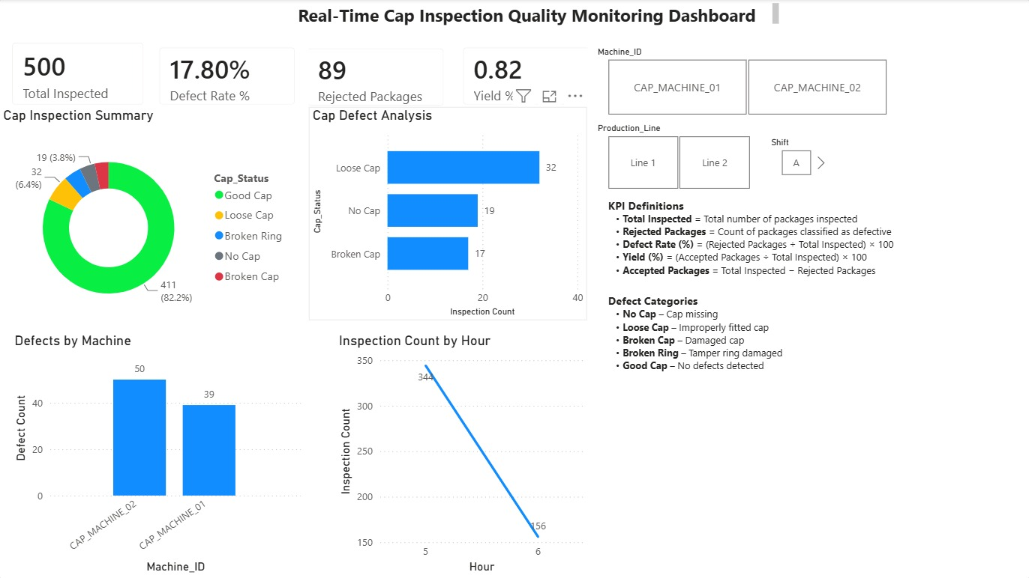

Interactive Slicers
Slicer | Description
Shift | Filter all visuals by production shift (Day / Night)
Production Line | Filter by specific production line
Machine ID | Drill down to a specific machine

All slicers cross-filter the entire report page, making it straightforward to isolate quality issues by time, line, or equipment.

Sample Traceability Log
Timestamp | Cap Status | Result
10:15:21 | Good Cap | PASS
10:15:23 | Loose Cap | FAIL
10:15:25 | Good Cap | FAIL (Underfill)

Impact Assessment and Dashboard Analysis
The Power BI dashboard transforms the inspection log produced by the AI pipeline into actionable operational insights for quality managers, production supervisors, process engineers, and maintenance teams. The analysis below describes the key observations and their practical implications for production line management.

1. Yield and Defect Rate Monitoring

Observation
The KPI row surfaces real-time yield percentage and defect rate for the active shift and production line, enabling immediate identification of quality degradation without manual data collection.

Interpretation
A yield consistently above 97% indicates the line is operating within acceptable quality bounds. A decline in yield below 95% within a shift serves as an early warning signal, allowing supervisors to intervene before a high-defect batch reaches downstream packaging or despatch. This replaces end-of-shift manual sampling with continuous, automated visibility.

2. Cap Defect Distribution

Observation
The donut chart and bar chart together show the relative frequency of each cap defect class. Loose Cap consistently represents the highest defect category in the evaluation dataset, followed by No Cap.

Interpretation and Recommended Actions
Observation | Recommended Action
Loose Cap rate elevated | Inspect capping unit spindle for wear; recalibrate torque settings
No Cap detections rising | Check cap feeder mechanism and downstream cap presence sensors
Broken Ring frequency increasing | Review cap handling speed and feeder alignment
Total cap defects exceeding 4% | Escalate to preventive maintenance for the capping station

4. Defects by Machine

Observation
The Defects by Machine column chart identifies which specific machines on the line generate the highest defect counts across a shift or production run.

Interpretation
Machine-level defect attribution allows maintenance teams to prioritise interventions on the highest-contributing equipment, rather than conducting broad line-wide inspections.
A machine whose defect count consistently exceeds two standard deviations above the line average is flagged for immediate inspection, supporting a condition-based maintenance approach rather than schedule-based maintenance.

5. Hourly Inspection Throughput Trend

Observation
The hourly inspection count line chart tracks production throughput over the course of a shift, surfacing slowdowns, stoppages, or unexpected reductions in conveyor throughput.

Interpretation
A drop in inspection count mid-shift that is not attributable to a scheduled break can indicate a line stoppage, a conveyor jam, or a sensor failure, allowing supervisors to respond faster than would be possible through manual monitoring alone.

Overall Dashboard Impact
The Power BI dashboard demonstrates that the AI inspection pipeline is capable not only of identifying defects accurately, but also of generating the operational intelligence needed to drive continuous improvement on the production line. Specific impact areas include:
- Shift-level quality reporting replacing manual spot-check records.
- Machine-level defect attribution enabling condition-based maintenance scheduling.
- Hourly throughput monitoring providing early warning of line stoppages.
- Traceability logging creating an auditable inspection record for regulatory compliance.
- Reduction in manual inspection labour, with the AI system providing 100% unit coverage rather than statistical sampling.

Challenges Encountered

1. Limited Availability of Labelled Defect Datasets
Publicly available image datasets for packaged food bottle defect detection — covering specific defect classes such as Loose Cap, Broken Ring— are limited in scope and scale. This necessitated building a custom annotated dataset from production-representative images using Roboflow, which was time-intensive and required iterative refinement of class definitions to ensure consistent annotation across images.

2. Visual Similarity Between Cap Defect Classes
Several cap defect states are visually similar under typical conveyor-belt lighting conditions. Distinguishing a Loose Cap from a Good Cap, or a Broken Ring from a Broken Cap, requires the model to attend to subtle spatial and textural differences in the cap and tamper ring region. This was mitigated by collecting diverse, representative samples of each defect class and maintaining strict, consistent annotation conventions across the dataset.

4. Single-Camera Coverage Trade-offs
While the diagonal camera configuration provides a combined view of the cap, label, and bottle surface in a single frame, it introduces perspective distortion that differs from the perpendicular view assumed by standard object detection annotations. Annotating images captured at the actual diagonal angle, rather than adapting annotations from perpendicular-view datasets, was essential to maintain detection accuracy.

5. Dataset Size Constraints
With 630 total annotated images split across five cap classes and three fill classes, the per-class sample count was limited relative to production-scale defect detection benchmarks. Data augmentation (rotation, brightness adjustment, horizontal flip) was applied to expand the effective training set, but the model’s performance on rare defect classes such as Broken Ring remained lower than on higher-frequency classes. Expanding the dataset with additional production-representative samples for the rarer defect classes is the primary avenue for improving model robustness.

Learnings and Conclusion

Key Learnings
- Practical experience applying computer vision and object detection to a real-world manufacturing quality problem, going well beyond the scope of typical academic coursework.
- A clear understanding of what distinguishes a working proof-of-concept from a production-ready inspection system — including annotation quality, class design, camera placement, preprocessing robustness, and end-to-end traceability.
- Hands-on proficiency with the YOLOv8/Ultralytics framework, Roboflow dataset management, MobileNetV2 classification, Google Colab training workflows, Pandas data logging, and Power BI dashboard development.
- Direct experience with the challenges of building defect detection datasets from scratch, including class definition, annotation consistency, and handling of visually similar defect categories.
- Exposure to L&T’s broader engineering operations through site visits, providing useful context on safety-critical system design, centralized monitoring, and the engineering discipline required at industrial scale.
- Appreciation for how AI-based inspection systems must be designed not just for detection accuracy, but for operational usability — through dashboards, traceability logs, and actionable alert mechanisms.

Conclusion
Over the course of this internship, a complete AI-based quality inspection system for packaged food production lines was conceptualized, designed, trained, and evaluated — progressing from problem statement and literature survey through dataset annotation, model training, decision engine design, and Power BI dashboard development.
The system delivers end-to-end inspection capability: a YOLOv8 detection stage localises cap and fill regions from a single diagonal camera frame; a MobileNetV2 classifier distinguishes five cap defect states; and a rule-based decision engine assigns a PASS or FAIL label to every inspected bottle. Every inspection event is written to a structured traceability log that feeds a Power BI dashboard providing real-time KPI visibility, defect trend analysis, and machine-level attribution for production operators and quality managers.
The diagonal camera configuration adopted in this project was validated as an effective approach to reducing camera count while maintaining multi-zone defect coverage, addressing a practical cost and complexity challenge in production-line deployments. The custom dataset, built and annotated through Roboflow with 630 images across eight defect classes and split for training, validation, and test evaluation, provided a representative foundation for model development, with data augmentation used to improve robustness against lighting and orientation variability.
This work demonstrates a tangible step toward replacing manual spot-check inspection with continuous, automated quality monitoring on high-throughput production lines, and aligns with L&T’s broader objective of advancing digital transformation and AI-driven process improvement across industrial operations. Future development would focus on expanding the training dataset for rarer defect classes, integrating real-time conveyor belt video feeds, and deploying the inference pipeline on edge hardware at the production station.

Appendix

A.1 Day-Wise Activity Summary
Day | Date | Activity
Day 1 | June 1, 2026 | Orientation session; overview of corporate expectations, conduct, and internship structure
Day 2 | June 2, 2026 | Site Visit 1 — Electrical construction works and Building Management System (BMS)
Day 3 | June 3, 2026 | EV laboratory; exposure to two-wheeler and four-wheeler EV platforms with live demonstrations
Day 4 | June 4, 2026 | Site Visit 2 — Railway Signalling & Metro Systems
Day 5 | June 5, 2026 | Project initiation — problem statement study, literature survey, and dataset class design
Day 6 | June 6, 2026 | Dataset annotation in Roboflow; cap defect and fill level class definition and bounding-box annotation
Day 7 | June 7, 2026 | Leave
Day 8 | June 8, 2026 | YOLOv8 Nano model training (Google Colab); data augmentation and training configuration
Day 9 | June 9, 2026 | Model evaluation; confusion matrix analysis; MobileNetV2 classification pipeline integration
Day 10 | June 10, 2026 | Decision engine development; traceability logging; Power BI dashboard design and connection
Day 11 | June 11, 2026 | Final presentation to mentors and stakeholders; complete project repository submitted via GitHub

A.2 Project Repository
The complete source code, including the dataset annotation pipeline, YOLOv8 training configuration, MobileNetV2 classification logic, decision engine, traceability logging module, and Power BI dashboard files, has been submitted as a GitHub repository.

A.3 Key Pipeline Components
- Roboflow-annotated bottle cap defect and fill level dataset (630 images, 8 classes, with augmentation)
- YOLOv8 Nano object detection model for cap and fill region localisation
- MobileNetV2 cap defect classifier (5 classes: Good Cap, Broken Cap, Broken Ring, Loose Cap, No Cap)
- Fill level classifier (3 classes: Perfect Fill, Above Fill Level, Below Fill Level)
- Rule-based decision engine (PASS / FAIL label assignment)
- Automated InspectionData CSV logging module
- Power BI Production Quality Monitoring Dashboard (KPI cards, donut chart, bar charts, line chart, slicers)

