Ashwagandha Root Extract (2.5–10% Withanolides): Nature’s Ancient Power for Modern Wellness
Meta Description: Discover the powerful benefits of Ashwagandha Root Extract (2.5–10% Withanolides), its uses, recipes, and why global buyers trust Indian herbal exporters for premium quality.

🌿 Introduction: The Timeless Power of Ashwagandha
For centuries, Withania somnifera—popularly known as Ashwagandha or “Indian Ginseng”—has been celebrated for its ability to rejuvenate mind and body. Modern extraction methods have concentrated its active compounds, known as withanolides, resulting in powerful root extracts standardized at 2.5%–10% potency.
At [Your Company Name], we specialize in herbal export from India, providing high-grade Ashwagandha Root Extract that retains the purity, aroma, and bioactive benefits of traditional Indian Ayurveda—optimized for the global wellness market.

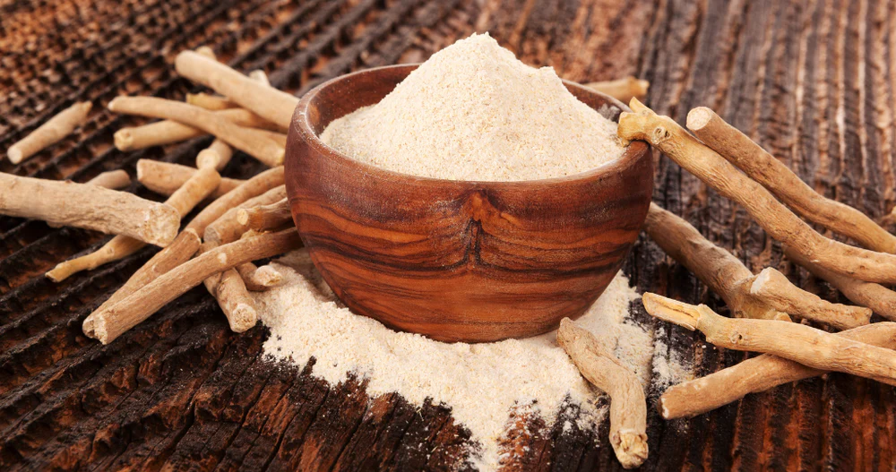
Caption: Premium-grade Ashwagandha Root Extract, carefully processed and exported directly from India.

🔬 What Makes Ashwagandha Root Extract Special?
Ashwagandha extract differs from regular root powder by concentration. While powder contains raw dried roots, extracts are standardized to ensure consistent withanolide levels—usually 2.5%–10%. These bioactives are responsible for Ashwagandha’s adaptogenic properties, helping the body resist stress and restore balance.
Key Technical Specifications for Premium Grade Extract:
Parameter | Specification
Appearance | Light brown fine powder
Withanolide Content | 2.5–10%
Solubility | Water-dispersible
Odor | Characteristic earthy aroma
pH | 5.0–7.0
Moisture | <5%
Microbial Load | <1000 cfu/g
By maintaining these quality parameters, Indian herbal exporters ensure pharmaceutical, nutraceutical, and cosmetic manufacturers receive globally compliant material.

🧘‍♀️ Top Health Benefits of Ashwagandha Root Extract

1. Stress Reduction and Hormonal Balance
Ashwagandha acts as a natural adaptogen—lowering cortisol levels, promoting calmness, and improving sleep. Studies suggest a significant drop in anxiety scores after eight weeks of standardized extract use.

2. Energy, Stamina, and Muscle Recovery
Athletes and gym enthusiasts use Ashwagandha extract for faster recovery and increased testosterone levels. A 10% withanolide extract helps reduce fatigue and improve VO₂ max in endurance training.

3. Cognitive and Memory Support
Ashwagandha enhances neuronal growth and combats oxidative stress. Its regular use supports focus, clarity, and long-term cognitive resilience.

4. Immunity and Anti-Inflammation
The herb strengthens immunity through immunomodulatory effects, making it valuable during seasonal changes or recovery phases.

5. Skin & Anti-Aging Benefits
Modern cosmetic science has embraced Ashwagandha for collagen protection, skin brightening, and protection from oxidative stress.

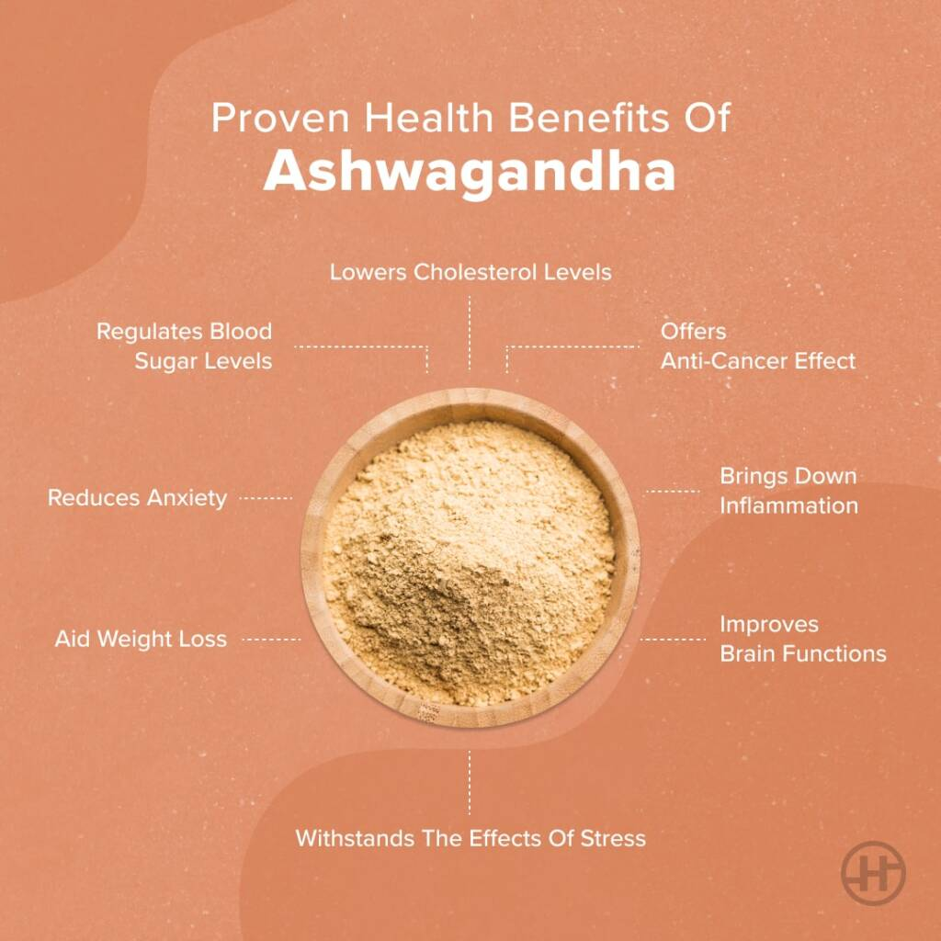
Caption: Scientifically validated benefits of Ashwagandha across wellness, fitness, and skincare domains.

🍵 How to Consume Ashwagandha Root Extract
Here are simple, globally adaptable ways to enjoy the benefits of Ashwagandha extract in daily life:

1. Ashwagandha Latte (Moon Milk)
Ingredients:
- 1 cup warm milk (dairy or oat)
- ½ tsp Ashwagandha Root Extract (2.5% withanolides)
- Pinch of cinnamon and turmeric
- 1 tsp honey
Instructions:
Warm milk gently, stir in the extract, add spices and honey. Perfect before bedtime for relaxation.
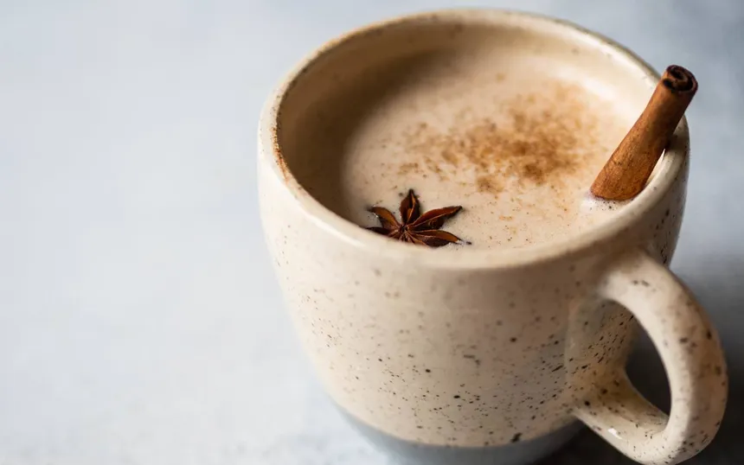
Caption: “Calming Ashwagandha bedtime drink.”

2. Morning Smoothie Boost
Ingredients:
- 1 banana
- 1 cup almond milk
- ½ tsp Ashwagandha extract powder
- 1 tbsp peanut butter
- Ice cubes
Instructions:
Blend and enjoy—a balanced drink for focus and energy.

3. Ashwagandha Herbal Tea
Ingredients:
- 1 cup water
- ½ tsp Ashwagandha extract
- ¼ tsp ginger
- Dash of lemon juice
Instructions:
Boil, steep for 5 minutes, strain, and sip to refresh your mood and immunity.

4. Chocolate Energy Balls
Ingredients:
- 1 cup rolled oats
- ½ cup cocoa powder
- ½ tsp Ashwagandha extract
- ¼ cup honey or dates paste
Instructions:
Mix all, roll into balls, refrigerate for 30 minutes. Great for post-workout recovery.

🏭 Why Choose Indian Exporters for Ashwagandha Root Extract?
India is the native home of Ashwagandha, with soil and climate ideal for high-withanolide root growth. Our export process ensures traceability from farm to formulation.
Advantages of Partnering with Indian Herbal Exporters:
- Standardized Extracts (2.5–10% Withanolides) suitable for supplements and beverages.
- ISO, GMP, and FSSAI certifications for consistent quality.
- Bulk packaging options for global nutraceutical buyers.
- Customized labeling and private branding for overseas distributors.
We export worldwide—from the USA and Europe to the Middle East and Southeast Asia—meeting global herbal supply standards.

🧴 Ashwagandha in Skincare and Cosmetics
Drawing insights from dermatological studies, Ashwagandha Root Extract improves skin vitality by:
- Reducing pigmentation and dullness.
- Protecting against UV damage.
- Supporting collagen synthesis and firmness.
It blends seamlessly into serums, creams, and herbal soaps—offering anti-aging and detoxifying benefits for all skin types.
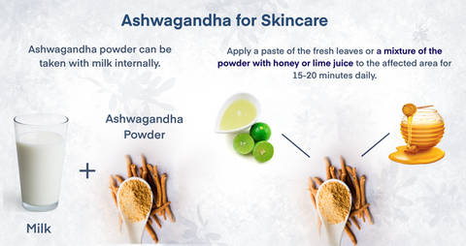
Caption: Ashwagandha for Skincare

🔗 Suggested Internal Links (for your website)
- Explore More Ayurvedic Herbs from India
- Shop Ashwagandha Extract Online
- View Herbal Ingredient Specifications
- Our Certification & Global Standards
- Contact Us for Bulk Orders

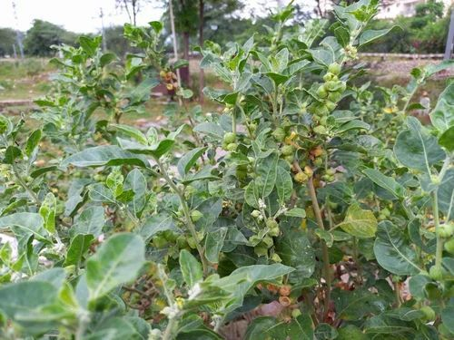
Caption: Ashwagandha plant

Fun Fact: Root vs. Powder
A key question buyers ask: Is Ashwagandha powder or extract better?
Powder is excellent for traditional use, while extract provides higher bioavailability and consistent active content, ideal for large-scale nutraceutical or beverage applications.

🌏 Conclusion: Partner with a Trusted Herbal Exporter from India
Ashwagandha Root Extract bridges ancient Ayurveda and modern science. Whether blended into wellness drinks, supplements, or beauty formulations, this adaptogenic marvel enhances energy, resilience, and calm.
As a leading Ashwagandha exporter from India, we ensure consistent potency, safety, and sustainability—delivering nature’s excellence in every shipment.
Keywords: Herbal export India, Ashwagandha exporter, Ashwagandha Root Extract 2.5–10% withanolides, herbal suppliers India, adaptogenic herbs, Ayurvedic supplements export.

