Nadia Dried Ginger – India’s Premium Spice for Wellness and Flavor

Meta Description: Discover premium Nadia Dried Ginger from The Export Express — India’s finest dried ginger variety for global spice, herbal, and wellness markets.

🌿 Introduction: The Root That Powers Traditions and Trade
For centuries, ginger (Zingiber officinale) has been one of India’s most cherished spices and healing roots. Known for its pungent warmth, zesty aroma, and therapeutic potency, ginger is both a kitchen essential and a cornerstone of Ayurvedic and traditional medicine systems across Asia.
At The Export Express, we specialize in exporting premium Nadia variety dried ginger, cultivated and processed under controlled conditions to preserve its flavor, oil content, and active gingerol compounds. Whether used for herbal formulations, teas, or culinary applications, our dried ginger delivers unmatched quality, purity, and consistency.

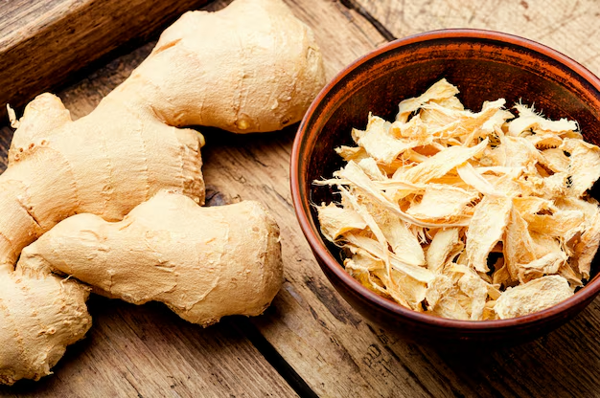
Caption: Premium Nadia variety dried ginger – rich in aroma, potency, and purity.

🧾 Product Specifications
Parameter | Specification
Form Type | Dried
Variety | Nadia (Premium Indian Variety)
Color | Yellowish White to Brown
Form | Whole / Granules
Packaging Type | Plastic Packet / Carton
Packaging Size | 1 kg (custom bulk packaging available)
Organic | Yes
Usage | Culinary, Herbal, and Medicinal
Shelf Life | 9–12 Months
Country of Origin | India
Availability | In Stock
Quality | A Grade
Can Be Used for Medicinal Purposes | Yes

🌱 The Nadia Variety: India’s Pride in Ginger Cultivation
Among India’s several ginger cultivars, Nadia stands out as one of the most premium and high-yielding varieties, primarily grown in Assam, Odisha, and North-Eastern states.

🌾 Key Traits of Nadia Ginger:
- Large rhizomes with smooth brown skin
- High essential oil and oleoresin content
- Strong, pungent aroma and zesty flavor
- Excellent for both fresh and dried applications
- High market demand for export and medicinal use
The combination of India’s fertile soils and monsoon-fed climate produces ginger with superior volatile oil content and long shelf life.

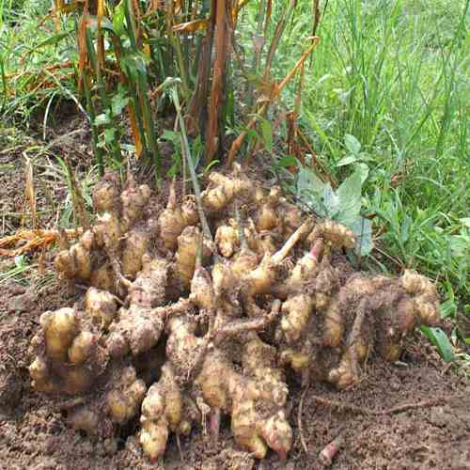
Caption: Cultivated organically in India’s fertile plains, Nadia ginger is globally recognized for its potency and purity.

💛 Taste and Aroma
- Taste: Spicy, warm, and slightly sweet with peppery undertones.
- Aroma: Refreshing and citrusy, with a distinct sharp note that enhances flavor in food and herbal blends.
Whether used in spice blends, teas, or remedies, Nadia ginger adds a rich depth of flavor and a warming sensation to every recipe.

🍴 Culinary Applications

1. Everyday Indian Cooking
Dried ginger (Saunth) is used in masalas, curries, and lentil dishes. It adds earthy heat and balance to Indian gravies.

2. Herbal Teas and Decoctions
Used in kadha, herbal infusions, and ginger tea, it supports immunity and digestion.

3. Bakery and Beverages
Popular in ginger cookies, cakes, ales, and herbal shots, adding both flavor and health appeal.

4. Ayurvedic Formulations and Nutraceuticals
Key ingredient in Ayurvedic tonics, digestive aids, and respiratory syrups.

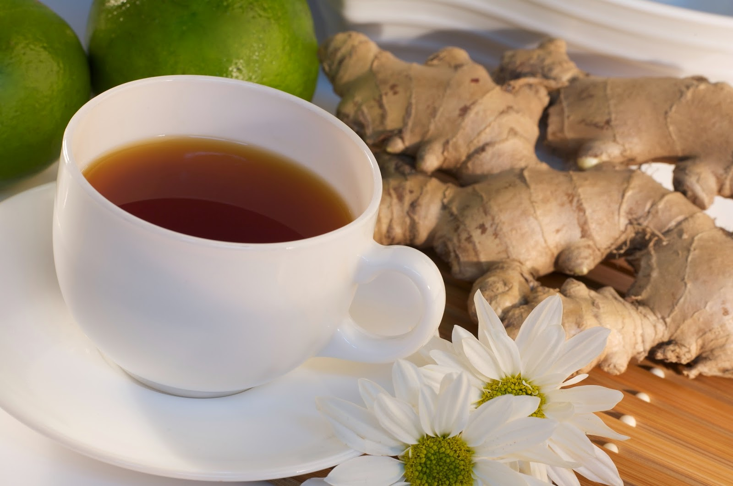
Caption: Dried ginger tea — a daily immunity and digestive tonic rooted in Ayurvedic tradition.

🩺 Health Benefits of Dried Ginger
According to Ayurveda and modern science, ginger is a powerhouse of wellness.

1. Supports Digestion
Ginger stimulates digestive enzymes and bile secretion, reducing bloating, gas, and nausea.

2. Anti-Inflammatory and Pain Relief
Its natural compounds — gingerol and shogaol — have anti-inflammatory effects that ease arthritis, headaches, and muscle soreness.

3. Boosts Immunity
Ginger helps fight infections and strengthens the immune system against seasonal flu and colds.

4. Improves Metabolism
Supports fat breakdown and increases thermogenesis, aiding weight management.

5. Heart and Respiratory Health
Regulates cholesterol and relieves congestion and sore throat symptoms.

6. Powerful Antioxidant Source
Neutralizes free radicals, supporting overall cellular health.

🌿 Ayurveda and Traditional Wisdom
In Ayurveda, ginger is known as the “Universal Medicine” (Vishvabhesaj). It is used to balance all three doshas (Vata, Pitta, Kapha) and promote Agni — the digestive fire.
Traditional Ayurvedic Uses:
- Fresh ginger: Detoxifying and invigorating tonic.
- Dried ginger (Saunth): Calms the stomach and supports respiratory health.
- Ginger paste or powder: Applied topically for pain and joint stiffness relief.
Common Ayurvedic formulations:
- Trikatu Churna (with black pepper and long pepper)
- Ardraka Leha (ginger herbal jam)
- Saunth Churna (digestive powder)

📊 Nutritional Value (per 100 g dried ginger)
Nutrient | Value
Energy | 350 kcal
Carbohydrates | 70 g
Protein | 8 g
Fat | 4 g
Fiber | 12 g
Iron | 12 mg
Potassium | 1320 mg
Vitamin C | 6 mg
Calcium | 115 mg

🏭 Why Choose The Export Express

✅ Premium Sourcing
Our ginger is sourced directly from certified farms cultivating Nadia and regular Indian ginger, ensuring purity and traceability.

✅ Scientific Drying & Processing
We use controlled drying processes to preserve gingerol potency and natural color.

✅ Global Quality Standards
Complies with FSSAI, ISO, and GMP export standards for food and herbal products.

✅ Custom Packaging & Labeling
Available in 1 kg retail packs or bulk loose cartons with private label options for international clients.

✅ Sustainable Practices
We work closely with local farmers to promote eco-friendly cultivation and fair trade practices.

📦 Packaging Options
Type | Size | Material | Use
Plastic Packet | 1 kg | Food-grade | Retail / Online Sales
Carton | 10 kg / 25 kg | Export Packaging | Bulk Trade
Vacuum Pack | 5 kg | Moisture Protection | Long Shelf Life

🌏 Export Excellence
India is one of the world’s largest producers of ginger, and The Export Express brings the best of it to global markets across:
USA · UAE · UK · Japan · Australia · Canada
Our Nadia Dried Ginger is in high demand for:
- Herbal medicine and supplements
- Organic tea blends
- Culinary spice mixes
- Essential oil and extract manufacturing

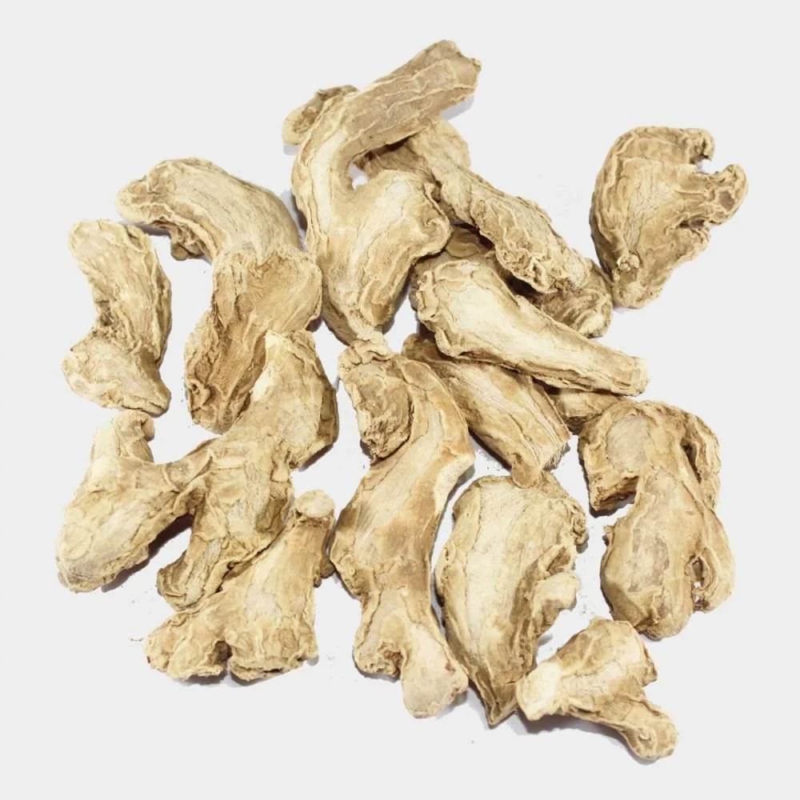
Caption: The Export Express – bringing India’s finest dried ginger to global markets.

🌾 Conclusion: India’s Golden Spice for Global Wellness
From the fertile fields of India to kitchens and wellness centers across the world, Nadia Dried Ginger embodies the best of Indian agriculture — pure, potent, and full of vitality.
At The Export Express, we’re proud to supply this golden spice with integrity, quality, and global export compliance — ensuring every shipment carries the warmth, wellness, and authenticity of India.

Keywords: ginger exporter India, herbal export India, dried ginger export, Nadia ginger, Indian spice export, The Export Express.

