**CAR RENTAL/DELIVERY APPLICATION**

**GROUP DETAILS :**

**GROUP 7**

1. Sayali Nagwekar - A20402126
2. Ajay Parameshwaran - A20410879

We are planning to implement a rental/delivery service system for the benefit of consumers who use uber and other taxies on a routine basis.

There are three primary login access types in our application. They are as follows:

* Admin (Service Provider)
* Consumer
* Drivers

Following are the two functionalities that we aim at implementing in this project:

* Rent (Taxi) – Uber
* Car Delivery

**PHASE 1:**

* 1. Requirement Specification Document (RSD)

Requirements table:

|  |  |  |  |
| --- | --- | --- | --- |
| **Req. ID** | **Description** | **Version** | **Priority** |
| 1 | Availability of a car in the requested location | 1.0 | High |
| 2 | Number of cars near a location | 1.0 | High |
| 3 | Payment received for a car order | 1.0 | Medium |
| 4 | Status of Delivery of a car | 1.0 | High |
| 5 | Payment mode of a rented car | 1.0 | Medium |

* 1. **Design Phase**

We are planning to implement the following modules which comprises the entire application into a package.

* **LOGIN MODULE** :

We are building the login module to implement different levels of access for the front end users. Primarily , we are targeting the end users to be admin (service provide), consumer and drivers.

* **AVAILABILITY MODULE** :

This module consists of features which would enable the consumers to look or search for cars. Admins can access this module to update the availability of type of cars. They can add new cars and delete the existing cars as well.

* **TRANSACTION MODULE** :

The aim of implementing this module is to process the billing transactions that is performed by the consumers after booking the cars or trips. This module is designed for the benefit of tracking the payments and to make sure tat it is a hassle free process.

* **DELIVERY/PICK-UP MODULE :**

This module is implemented to track the delivery or pick-status of cars which the customers has booked. It is used for time tracking and customer feedback solely rests on delivery time of the cars that they book.

**ENTITY RELATIONSHIP DIAGRAM**

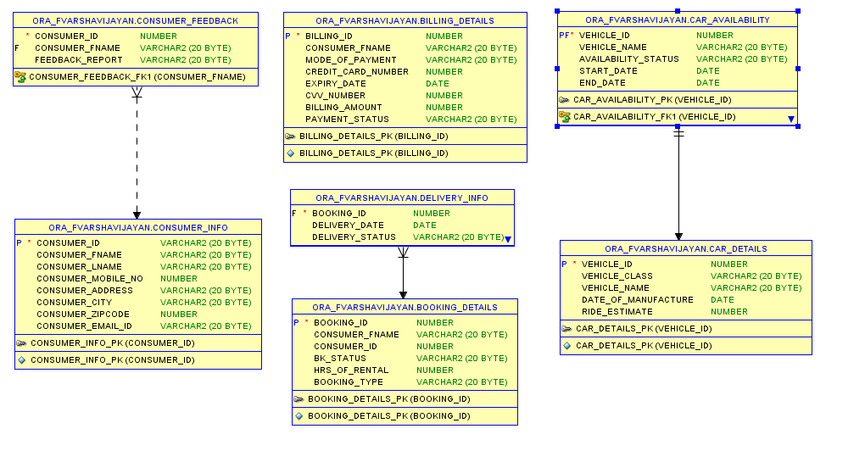

**UML DIAGRAM OF THE APPLICATION**



* 1. **Web Services Design**

ArrayList<String> getRentalCarByLocation(String location);

ArrayList<String> getCustomersByCity(String city);

ArrayList<String> getCarByCompany(String company);

ArrayList<String> getDriverDetails(String date);

ArrayList<String> getCarDetails();

ArrayList<String> getPaymentStatus(int payment_id);

ArrayList<String> getDelieveryStatus(String order_id);

ArrayList<String> getAllOrdersByLocation(String Location);

ArrayList<String> getAvailableCarInLocation(String location);

ArrayList<String> getCustomerOrders();