**Snapshot of Container running on EC2**

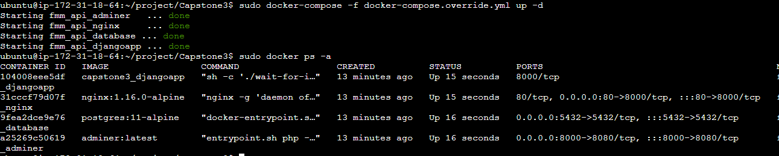

**Command History 07-May**

ubuntu@ip-172-31-18-64:~/project/Capstone3$ history

1 ll

2 mkdir project

3 cd project

4 git clone https://github.com/aparashare/Capstone3.git

5 ls -lst

6 cd Capstone3

7 ls -lst

8 sudo apt-get update

9 sudo apt-get install ca-certificates curl gnupg

10 echo "deb [arch="$(dpkg --print-architecture)" signed-by=/etc/apt/keyrings/docker.gpg] https://download.docker.com/linux/ubuntu \

"$(. /etc/os-release && echo "$VERSION_CODENAME")" stable" | sudo tee /etc/apt/sources.list.d/docker.list > /dev/null

11 sudo apt-get update

12 sudo apt-get install docker-ce docker-ce-cli containerd.io docker-buildx-plugin docker-compose-plugin

13 sudo docker run hello-world

14 sudo dpkg -i ./containerd.io_<version>_<arch>.deb ./docker-ce_<version>_<arch>.deb ./docker-ce-cli_<version>_<arch>.deb ./docker-buildx-plugin_<version>_<arch>.deb ./docker-compose-plugin_<version>_<arch>.deb

15 sudo apt-get update

16 sudo apt-get install ca-certificates curl gnupg

17 sudo install -m 0755 -d /etc/apt/keyrings

18 curl -fsSL https://download.docker.com/linux/ubuntu/gpg | sudo gpg --dearmor -o /etc/apt/keyrings/docker.gpg

19 sudo chmod a+r /etc/apt/keyrings/docker.gpg

20 echo "deb [arch="$(dpkg --print-architecture)" signed-by=/etc/apt/keyrings/docker.gpg] https://download.docker.com/linux/ubuntu \

"$(. /etc/os-release && echo "$VERSION_CODENAME")" stable" | sudo tee /etc/apt/sources.list.d/docker.list > /dev/null

21 sudo apt-get update

22 sudo apt-get install docker-ce docker-ce-cli containerd.io docker-buildx-plugin docker-compose-plugin

23 sudo docker run hello-world

24 sudo snap install docker

25 sudo apt install docker-compose

26 docker -v

27 docker-compose -v

28 ls -lst

29 sudo chmod -R 776 Capstone3

30 cd ..

31 ls -lst

32 ll

33 ls -ltr

34 ll

35 sudo chmod -R 776 Capstone3

36 ll

37 cd Capstone3

38 ll

39 sudo docker-compose -f docker-compose.override.yml up - d

40 sudo docker-compose -f docker-compose.override.yml up

41 sudo docker ps -a

42 history