

# MKSSS’s

**Cummins College of Engineering for Women, Pune**

**(An Autonomous Institute Affiliated to Savitribai Phule Pune University)**

**DEPARTMENT OF ELECTRONICS AND TELECOMMUNICATION**

# ENGINEERING

OPEN ENDED ASSIGNMENT - REPORT

ON

# ‘FUEL MONITORING SYSTEM’

SUBMITTED BY

**Name of group member: Roll No. & C.No**

Ojasvi Tummala 3844 & C 22020771845

Shraddha Raskar 3850 & C22020771851

Preeti Raut 3851 & C22020771852

Aparajita Sarkar 3853 & C22020771854

Smridhi Dhingra 3860 & C22021772861

# Guided by: Prof. Mahesh Pote sir

**TABLE OF CONTENTS**

**ABSTRACT**

1. **INTRODUCTION**
2. **BLOCK DIAGRAM**
3. **INTERFACING DIAGRAM OF OVERALL SYSTEM**
4. **COMPONENT INFORMATION AND ITS USES**
5. **ALGORITHM / FLOWCHART**
6. **SOFTWARE CODING**
7. **OUTPUT**
8. **APPLICATION & ADVANTAGES**
9. **LIMITATIONS**
10. **CONCLUSION**

**ABSTRACT:**

In this paper we have focused on developing an enhancement of the traditional fuel gauge system of a vehicle by SMS. This proposed methodology is derived for automatic fuel level measurement by smart device. The discovery of automobile vehicles is a blessing to human beings from engineering and science. The majority of the transport fuels are powered by traditional fuels like gasoline, octane, diesel etc. After refuelling, it sends a text message to the car owner with the exact amount of fuel filled. Additionally, it sends an alert to refuel when fuel level falls below a threshold. It helps to inform them of theft in the case that this value is not matching to what the owner paid for. The shortage of petrol has caused a tremendous spike in fuel prices, and also made the problem of fuel theft by petrol stations more pronounced. Consumer safety is extremely essential and thus we thought this was a necessary project. Our model (fuel monitoring and theft detection system) uses very few electronic components and looks very small and compact and can be mounted on vehicles easily.

**INTRODUCTION:**

The surprising fuel misfortune greatly affects the economy of a nation. It is disturbing and bothersome issue for creating nations like Bangladesh, India and China and so on. Oil and diesel robbery is a global issue. In the developing nations, the fuel burglary rate is extraordinarily high. Along these lines, the issue of fuel burglary has turned into a noteworthy inconvenience for the clients which may one of the causes to determine expanding fuel cost.

The traditional fuel gauge meter only provides an approximate idea of fuel in the tank. The steep increase in price of petrol has made it very profitable to steal petrol. Many petrol stations now-a-days have indulged in this illegal practice. The station’s indication reads a value higher than what is actually being filled and out of good faith many customers are being cheated and are still unaware. By our design of fuel monitoring and theft detection system we aim to stop such occurrences by making common people aware of those stations that indulge in these unfair practices. It would inform them of the accurate amount of petrol filed and thus in the case that this value is not matching to what the owner paid for they can either avoid going to that station again or take necessary legal action. Consumer safety is the main priority while building this project. This system has applications in cars, bikes and all other vehicles.

**BLOCK DIAGRAM:**

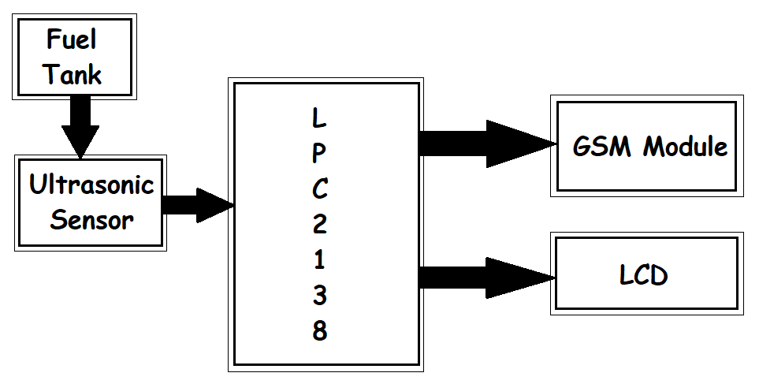

**INTERFACING DIAGRAM OF OVERALL SYSTEM :-**



**COMPONENT INFORMATION AND ITS USES:**

**LPC2148:** In-System Programming/In-Application Programming (ISP/IAP) via on-chip boot loader software.

**GSM:** Sending and receiving short messages. The ability to send and receive text messages to and from mobile phones is known as the Short Message Service (SMS).

**VIRTUAL TERINAL IN PROTEUS:** Virtual Terminal is a very useful tool available in the Proteus. With the help of Virtual Terminal one can easily simulate the serial communication that he / she use in his / her embedded systems.

**Ultrasonic sensor:** As the name indicates, ultrasonic sensors measure distance by using ultrasonic waves. The sensor head emits an ultrasonic wave and receives the wave reflected back from the target. Ultrasonic Sensors measure the distance to the target by measuring the time between the emission and reception.

**LCD**: LCD displays work by using individual pixels to display visuals, moving or stationary. Each pixel will display a colour mixed by the RGB colour filter with each colour’s filter associated with one of the pixel’s sub-pixels. The sub-pixels are where the degree of light is determined, thus affecting the degree of prominence of its respective colour.

**Why we used Ultrasonic Sensor:**

The ultrasonic fuel level sensor is designed for external level gauge of vehicles oil consumption. It provides continuous level measurement for oil tank. It doesn't need to cut oil tank, and just attach the sensor to bottom of tank. Then by special digital signal processing technology, the sensor produces standard digital signal and analog signal.

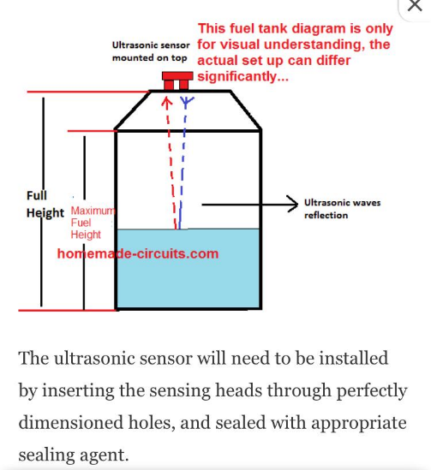

**WORKING PRINCIPLE:-**

Ultrasonic sensors work by emitting sound waves at a frequency too high for humans to hear. They then wait for the sound to be reflected back, calculating distance based on the time required. This is similar to how radar measures the time it takes a radio wave to return after hitting an object.

**ALGORITHM:-**

Step 1: Start

Step 2: Read ADC Data from level sensor into ‘read’

Step 3: If(read>temp) && (fill==0)

Memory = temp

Fill=1

(go to step 2)

Step 4: If(read>temp) && (fill==1)

temp = read

(go to step 2)

Step 5: If(read<=temp) && (fill==1)

Fill=0

quantity= temp-memory

send SMS using GSM module

“<quantity>” L of fuel has been filled

Step 6:If(read<threshold)

Send SMS using GSM module

“please refilled fuel<read> L of fuel remaining.”

go to step 2

Step 7: Stop

**SOFTWARE CODING:-**

**Main.c :**

#include <lpc213x.h>

#include "timer.c"

#include "ultrasonic.c"

#include "lcd.c"

#include "gsm.c"

#include <string.h>

#define delay for(i=0;i<65000;i++);

unsigned int range=0,i;

int main()

{

VPBDIV=0x02; // PCLK = 30MHz

IO1DIR=0xffffffff;

ultrasonic_init();

unsigned int read,range,memory,temp,quantity,threshold=2;

unsigned int fill=0,alert=0;

ser_init();

sms(NUMBER, "FUEL MONITORING SYSTEM");

delay;

range=get_range();

//read=(range/100)+48;

//read=(read*10)+((range/10)%10)+48;

//read=(read*10)+(range%10)+48;

temp=5-range/127;

delay;

delay;

delay;

while(1) {

lcd_init();

range=get_range();

//read=(range/100)+48;

//read=(read*10)+((range/10)%10)+48;

//read=(read*10)+(range%10)+48;

read=5-range/127;

delay;

if ((read>temp)&&(fill==0)) {

fill=1;

alert=0;

memory=temp;

show("Petrol Level:");

dat(((read/10)%10)+48);

dat((read%10)+48);

show("L");

}

else if ((read<=temp)&&(fill==1)) {

fill=0;

quantity=temp-memory;

lcd_init();

show("Petrol Filled:");

dat(((quantity/10)%10)+48);

dat((quantity%10)+48);

show("L");

ser_init();

sms(NUMBER, "Petrol Filled:)");

//message("Petrol filled: ");

//message(toString(quantity));

//message("L");

}

else if ((read<threshold)&&(alert==0)) {

alert=1;

lcd_init();

show("Petrol Low:");

dat(((read/10)%10)+48);

dat((read%10)+48);

show("L");

ser_init();

sms(NUMBER, "Warning!!! Petrol LOW");

//message("Warning! Petrol low: ");

//message(toString(read));

//message("L");

}

else {

show("Petrol Level:");

dat(((read/10)%10)+48);

dat((read%10)+48);

show("L");

}

delay;

delay;

delay;

delay;

temp=read;

}

return 0;

}

**gsm.c**

#include <lpc213x.h>

#define NUMBER "9876543210" //Here insert your number where you want to send message

void ser_init(void);

void tx(unsigned char c);

unsigned char rx(void);

void tx_str(unsigned char *s);

void sms(unsigned char *num1,unsigned char *msg);

void gsm_delay(void);

unsigned int dell;

void sms(unsigned char *num1,unsigned char *msg)

{

tx_str("AT");

tx(0x0d);

gsm_delay();

tx_str("AT+CMGF=1");

tx(0x0d);

gsm_delay();

tx_str("AT+CMGS=");

tx('"');

while(*num1)

tx(*num1++);

tx('"');

tx(0x0d);

gsm_delay();

while(*msg)

tx(*msg++);

tx(0x1a);

gsm_delay();

}

void gsm_delay()

{

unsigned long int gsm_del,ff;

for(gsm_del=0;gsm_del<=500000;gsm_del++)

for(ff=0;ff<25;ff++);

}

void ser_init()

{

VPBDIV=0x02; //PCLK = 30MHz

PINSEL0=0x5;

U0LCR=0x83;

U0DLL=195;

U0DLM=0;

U0LCR=0x03;

U0TER=(1<<7);

}

void tx(unsigned char c)

{

U0THR=c;

while((U0LSR&(1<<5))==0);

}

void tx_str(unsigned char *s)

{

while(*s) {

tx(*s++);

}

}

unsigned char rx()

{

while((U0LSR&(1<<0))==0);

return U0RBR;

}

**timer.c :**

void timer0delay(unsigned int a);

void timer1delay(unsigned int b);

void timer0delay(unsigned int a) //1ms

{

T0CTCR=0X0000;

T0PR=59999;

T0MR0=a;

T0MCR=0x00000004;

T0TCR=0X02;

T0TCR=0X01;

while(T0TC!=T0MR0);

T0TC=0;

}

void timer1delay(unsigned int b) //1us

{

T1CTCR=0X0000;

T1PR=59;

T1MR0=b;

T1MCR=0x00000004;

T1TCR=0X02;

T1TCR=0X01;

while(T1TC!=T1MR0);

T1TC=0;

}

**ultrasonic.c :**

#define trig (1<<8) //P0.8

#define echo (IO0PIN&(1<<9)) //P0.9 as EINT3

void ultrasonic_init()

{

IO0DIR|=(1<<8);

T0CTCR=0;

T0PR=59;

}

void send_pulse()

{

T0TC=T0PC=0;

IO0SET=trig; //trig=1

timer1delay(10); //10us delay

IO0CLR=trig; //trig=0

}

unsigned int get_range()

{

unsigned int get=0;

send_pulse();

while(!echo);

T0TCR=0x01;

while(echo);

T0TCR=0;

get=T0TC;

if(get<38000)

get=get/59;

else

get=0;

return get;

}

**lcd.c:**

#define bit(x) (1<<x)

void lcd_init();

void cmd(unsigned char a);

void dat(unsigned char b);

void show(unsigned char *s);

void lcd_delay();

void lcd_init()

{

cmd(0x38);

//lcd_delay();

//cmd(0x38);

//cmd(0x0e);

cmd(0x06);

cmd(0x0c);

cmd(0x01);

cmd(0x80);

}

void cmd(unsigned char a)

{

IO1PIN&=0x00;

IO1PIN|=(a<<24);

IO1CLR|=bit(16); //rs=0

IO1CLR|=bit(17); //rw=0

IO1SET|=bit(18); //en=1

lcd_delay();

IO1CLR|=bit(18); //en=0

}

void dat(unsigned char b)

{

IO1PIN&=0x00;

IO1PIN|=(b<<24);

IO1SET|=bit(16); //rs=1

IO1CLR|=bit(17); //rw=0

IO1SET|=bit(18); //en=1

lcd_delay();

IO1CLR|=bit(18); //en=0

}

void show(unsigned char *s)

{

while(*s) {

dat(*s++);

}

}

void lcd_delay()

{

unsigned int i;

for(i=0;i<=65000;i++);

}

**OUTPUT:**

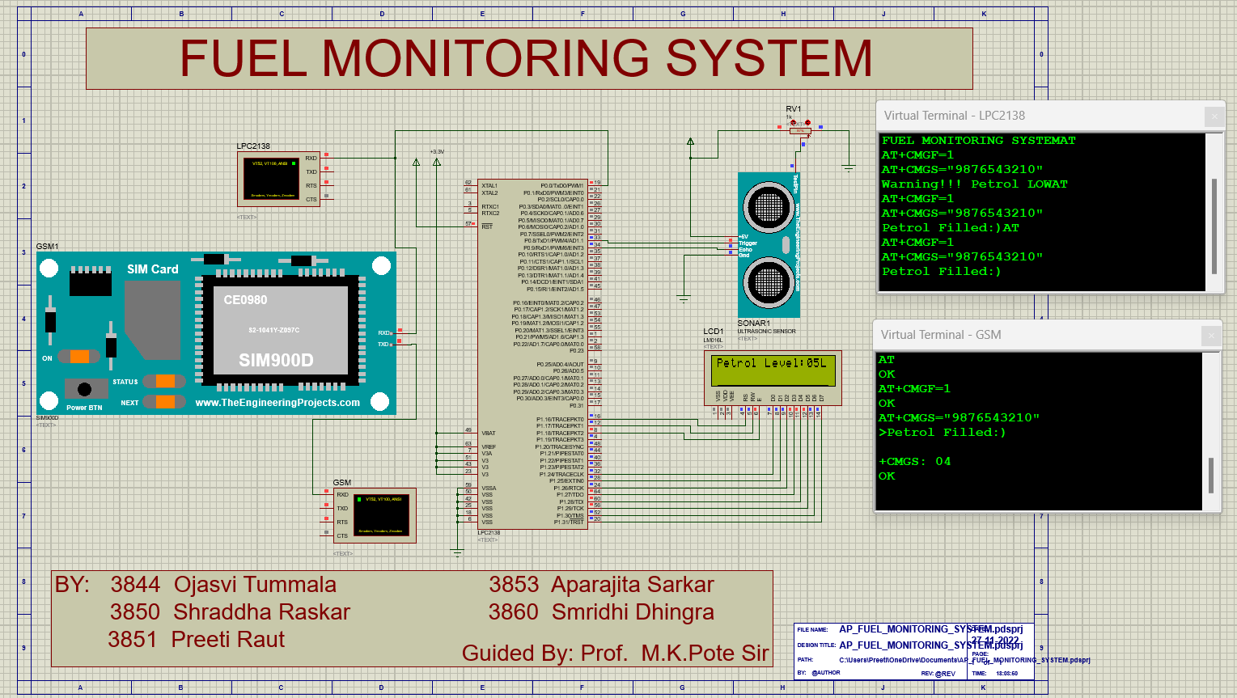

**APPLICATIONS & ADVANTAGES:**

The application of our system is in fuel theft detection. The system can monitor precisely the amount of fuel that has been filled at a petrol pump. Thus, for example if a consumer has paid for 5L and only 4.5L is filled, under normal circumstances, the consumer would not know they were cheated but with the help of our system they find out and take action accordingly.

Besides the above-mentioned application, our system also provides:

* Low fuel warning (alerts by a message on the vehicle owner’s phone and on the LCD)
* Petrol filled (message and LCD updated with the precise amount of fuel filled)
* Current fuel level (constantly monitored and displayed on the LCD)

Traditional fuel gauge meter only shows an approximate measure of fuel in the tank. We can propose to automobile companies to replace this fuel gauge with our system, as it provides the functionality of fuel gauge and has additional features of GSM interfacing, low fuel warning and precise fuel filled notification. These features would make refuelling a much easier task and also enable customers be more aware of petrol stations that cheat them of their hard-earned money.

**LIMITATIONS:**

1. Relatively low accuracy, especially in flat-shape fuel tanks
2. Impossibility to measure fuel consumption during short operation periods, when fuel volume is not changing distinctly
3. Hard to measure slow fuel draining from tank and impossible to detect fuel theft from return fuel line
4. Not applicable for machinery operated in rough terrain, quarries, mines where fuel in tank fluctuates noticeably
5. Ultrasonic sensors are not liquid resistant which means that it cannot come in direct contact with the fuel. Thus, there is an additional step of making a liquid proof chamber which will be isolated by using a sealant. Also , Ultrasonic sensors’ accuracy is affected by changes in temperature of 5-10 degrees or more.

**CONCLUSION:**

We have successfully designed a fuel monitoring and theft detection system. Amount of fuel that has been filled at a petrol pump can be precisely monitored. Consumers can be informed whether they are actually getting their money’s worth or are being cheated and take action accordingly.

The system uses both LCD as well as GSM to alert the user of various scenarios like- low fuel, petrol filled (with the precise amount of fuel filled), and fuel level at each instant. Our system can be used to replace traditional fuel gauge meter, as it provides the functionality of fuel gauge as well as above mentioned features.

The features offered by our system would make refuelling a much easier task, as customer would be timely alerted and also enable customers be more aware of petrol stations that cheat them by indulging in fuel theft.