University of Tartu

Institute of Computer Science

Indoor WiFi simulation

Project report

MTAT.08.040 Intelligent transport systems

Aleksander Parelo

Tartu 2019

Contents

1. Introduction 3

2. Theoretical background 4

2.1. Helmholtz equation 4

3. Implementation 5

Conclusions 9

Bibliography 10

# Introduction

For my course project in the Intelligent transport systems course I chose to simulate Wi-Fi signals in an enclosed space. I chose this project because it seemed like an interesting challenge and a reasonable amount of work for me to solve alone.

This project uses the Helmholtz equation to model the propagation of waves in a space, by setting the source of the wave to be at the location of the Wi-Fi router the signal propagation can be modeled and visualized.

This report consists of two main parts, the theoretical background and the description of the implementation.

# Theoretical background

## Helmholtz equation

Helmholtz equation is used for physical problems involving partial differential equations, it represents a time independent form of the wave equation. The Helmholtz equation has been numerically solved for many basic shapes. For an electromagnetic wave in space the Helmholtz equation looks like this [1]

$$∇^{2}E+\frac{k^{2}}{n^{2}}E=f(x)$$

Here f is the source function of the wave, k is the wave number of the wave we are modeling, n(x) is a refractive index distribution of the space the wave is propagating in and E is the electric field. If we rewrite this equation for a 2D space of size NxM, then we get an equation that looks like this.

$$\frac{E\left(i+1, j\right)+E\left(i-1,j\right)-2E(i,j)}{∆x^{2}}+\frac{E\left(i, j+1\right)+E\left(i,j-1\right)-2E(i,j)}{∆y^{2}}+\frac{k^{2}}{{n\left(i,j\right)}^{2}}E\left(i,j\right)=f(i,j)$$

Here every cell E(i,j) depends on its 4 neighbors. This equation can then be solved for each square to get the propagation of the wave. [2]

# Implementation

The simulation was implemented in Python 3 using the Opencv and NumPy libraries. An image of a room was used as the refractive index map, black areas in the image corresponded to areas with a high refractive index and white areas corresponded to areas with a low refractive index. An example of the refractive index map can be seen in Figure 1. The code is available on GitHub <https://github.com/aparelo/indoorWifiSim>.

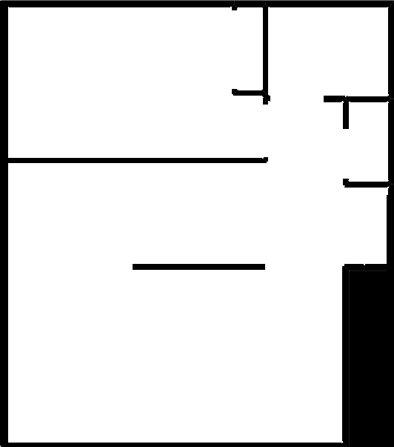

Figure 1: Example of refractive index map

Initially the simulation was done using the Bessel function to solve the Helmholtz equation, this worked quite well for modelling wave propagation in free space but adding in the refractive index map proved to be not possible. The visualization generated by this method can be seen in Figure 2.

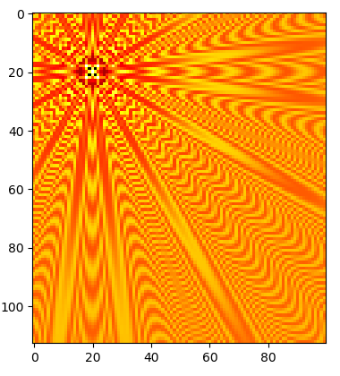

Figure 2: Wave model using Bessel equation

Then the equation was solved by calculating the value of the wave at each point of the computational grid. This method also worked quite well for simulating the wave in free space, this time the refractive index map was also visible but it did not affect the propagation of the wave in any way. The wave just propagated through the absorbing portions of the map without being affected. The results of this implementation can be seen in Figure 3.

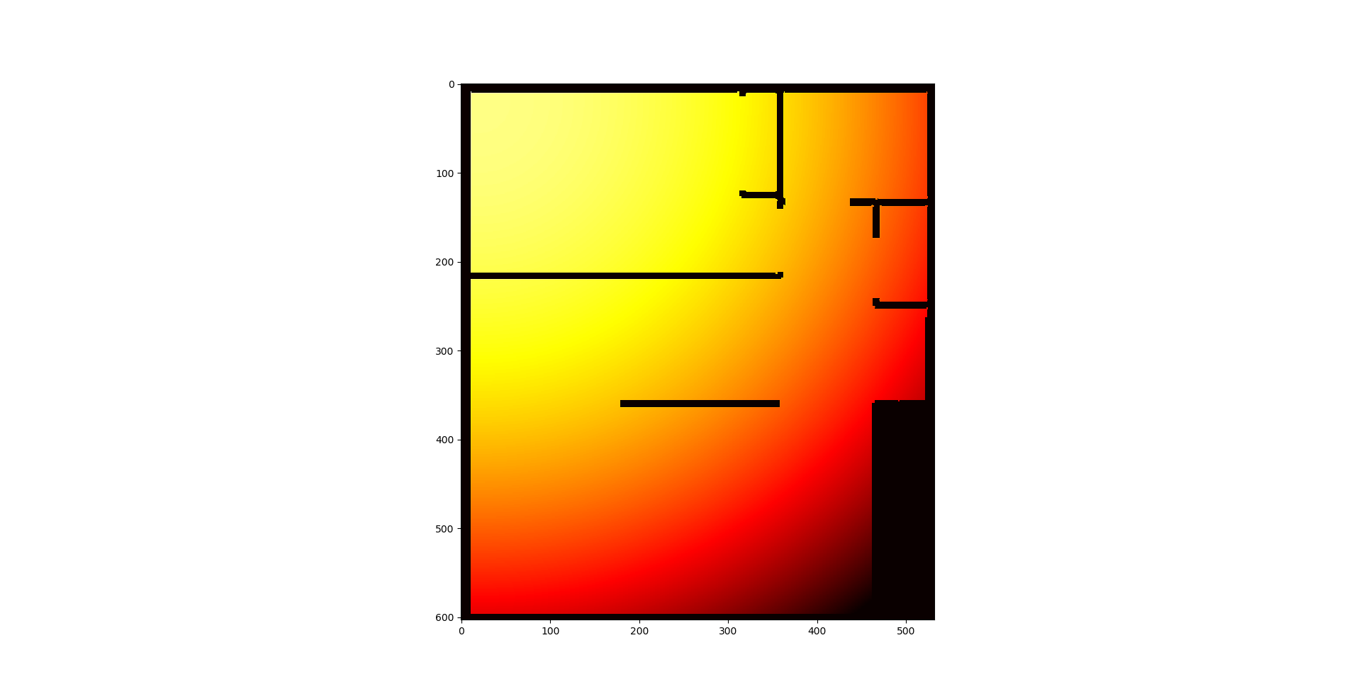

Figure 3: Wave model using Helmholtz equation

To overcome the problem of the refractive index map not being accounted for the simulation was turned into a matrix equation and solved using linear algebra. This method solved the equation simultaneously for every point on the grid. This solution looks a lot more promising, however due to time constraints there wasn’t enough time to properly tune the model. It can be seen from the results that the wave interacts with the walls but the propagation of the wave is not very clear. This is probably due to poorly chosen model parameters.

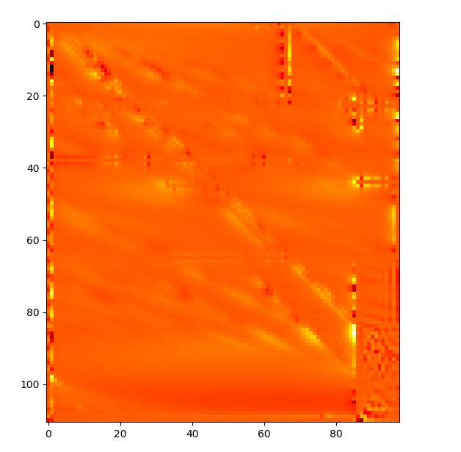

Figure 4: Wave model calculated with linear algebra

# Conclusions

Overall the project was mostly successful, it was shown that Helmholtz equations can be used to model the propagation of electromagnetic waves in a space. Unfortunately, due to time constraints the model was not as good as is necessary to draw any reasonable conclusions, however this could be improved in the future by tuning the model parameters further.

# Bibliography

|  |  |
| --- | --- |
| [1] | Wikipedia, "Helmholtz Equation," [Online]. Available: https://www.wikiwand.com/en/Helmholtz_equation. |
| [2] | J. Cole, "Helmhurts - Almost looks like work," 25 August 2014. [Online]. Available: https://jasmcole.com/2014/08/25/helmhurts/. [Accessed 31 December 2019]. |