Question 1

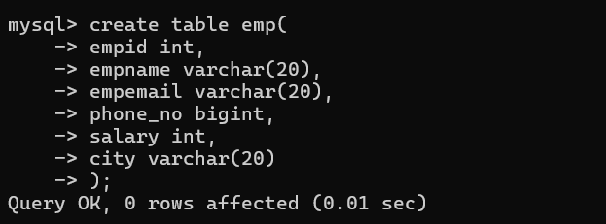

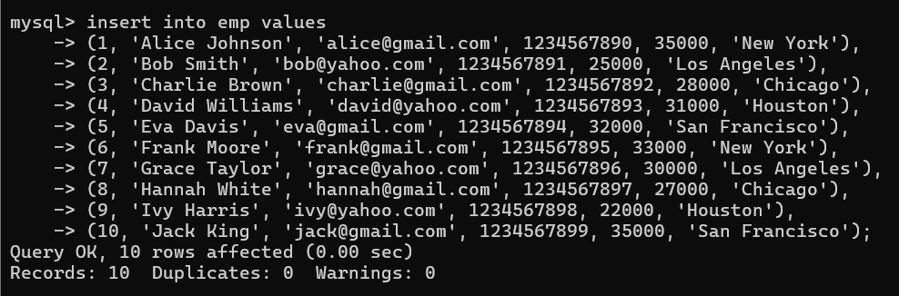

1. Write a query to retrieve the number of employees in each city.

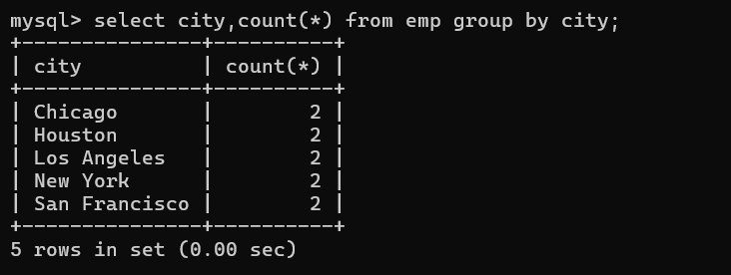

1. Write a query to retrieve the number of employees having different salaries in each city

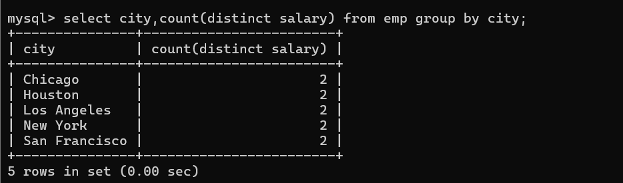

1. Write a query to retrieve the number of employees in each city, sorted in descending order.

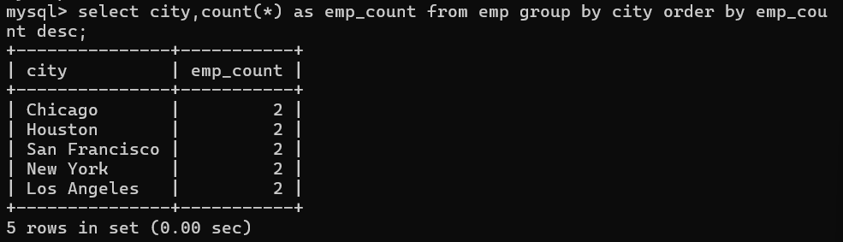

1. Write a query to retrieve the salary of all the employees, sorted in ascending order.

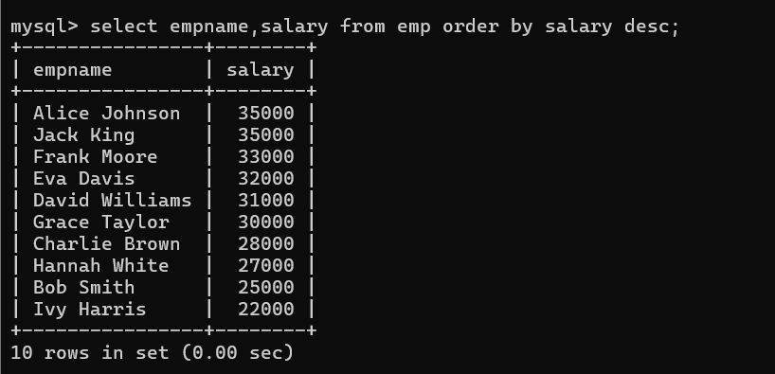

1. Write a query to retrieve the number of employees in each city, having salary > 30000

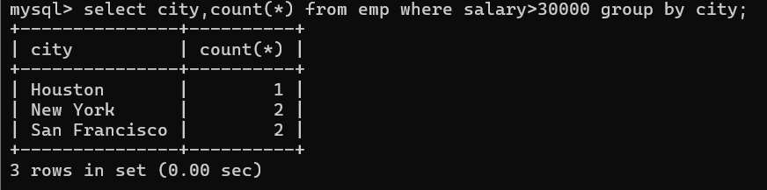

1. write a query to retrieve the details of all the employees who have gmail or yahoo account.

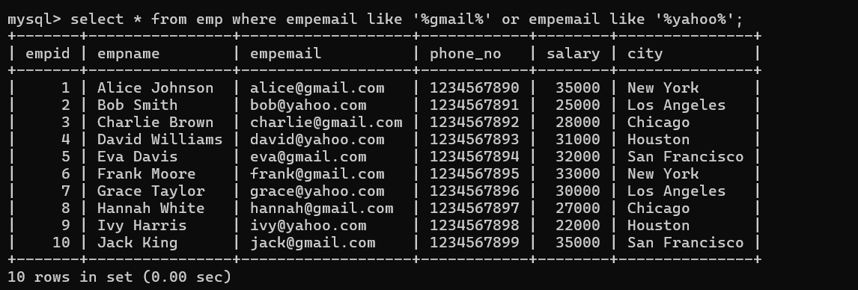

1. Write a query to find the number of employees whose average salary is greater than 15000 and also print their names in ascending order.

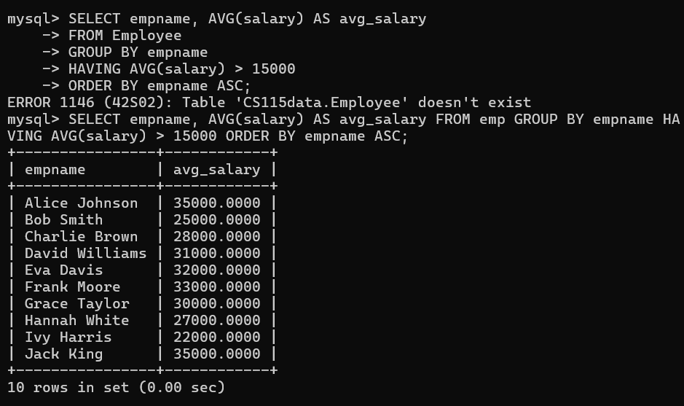

Question 2

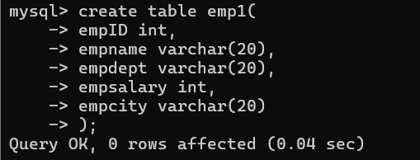

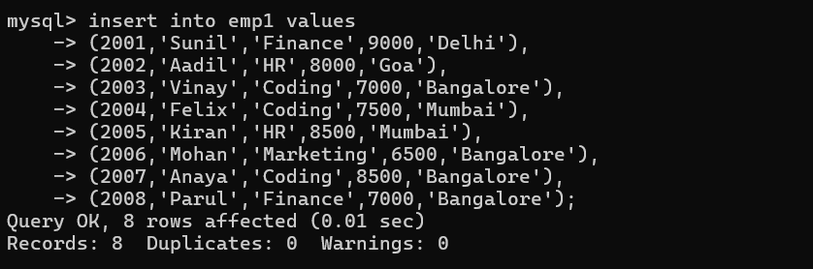

1. Add the salaries of employees of each city

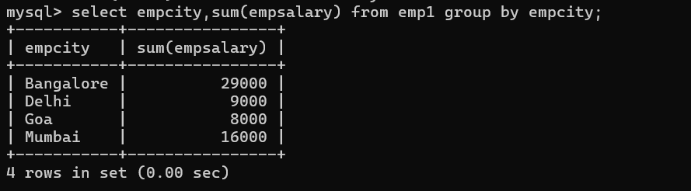

1. show those cities whose total salary of employees is more than or equal to 8000

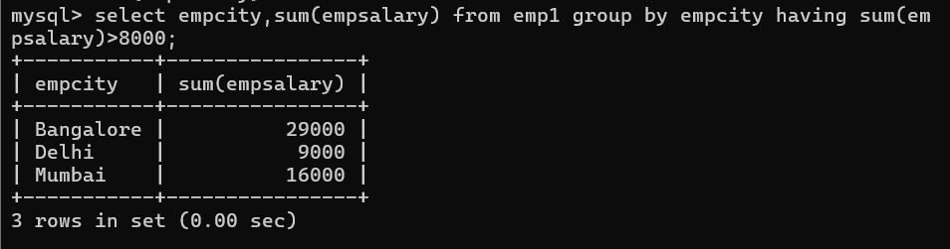

1. show each department and the minimum salary in each department

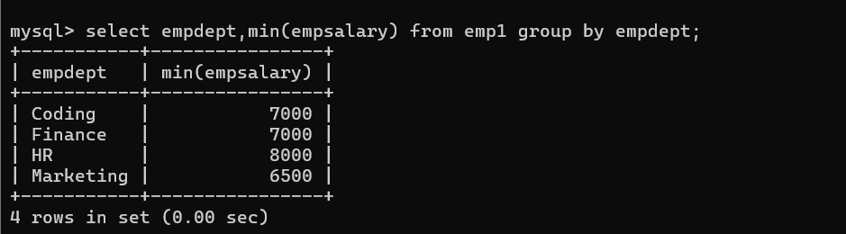

1. show only those departments whose minimum salary of employees is greater than 7500

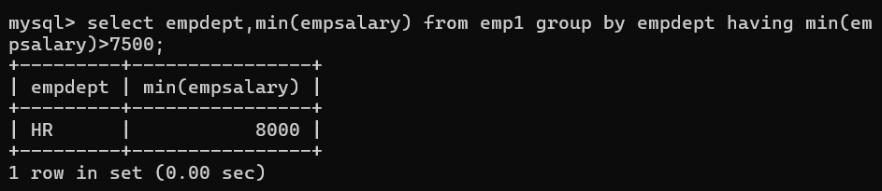

1. list each department and the maximum salary in each department

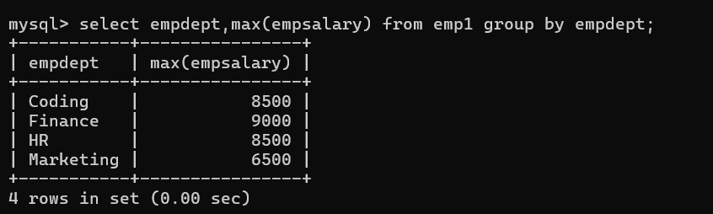

1. show only those departments whose maximum salary of employees is less or equal to 7000

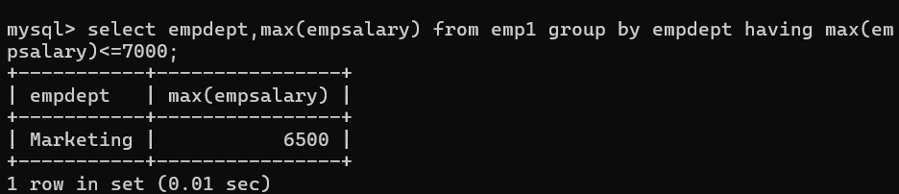

1. find the average salary of employees in each department

