Question 1
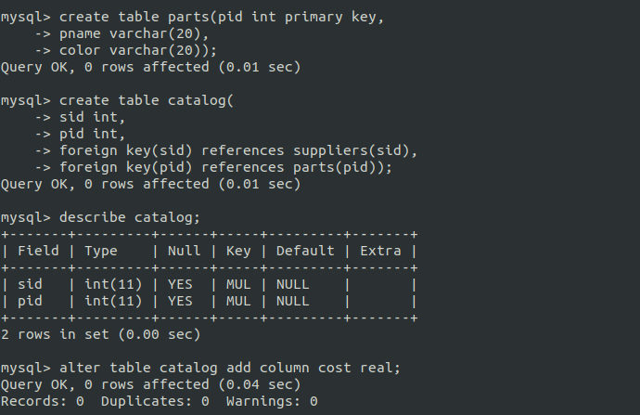
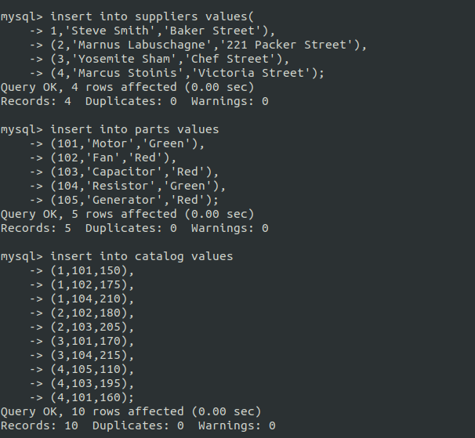
1. Find the names of suppliers who supply some red part.
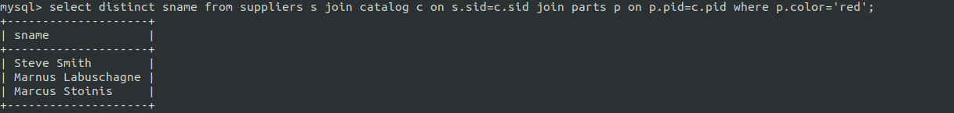
2. Find the sids of suppliers who supply some red or green part.
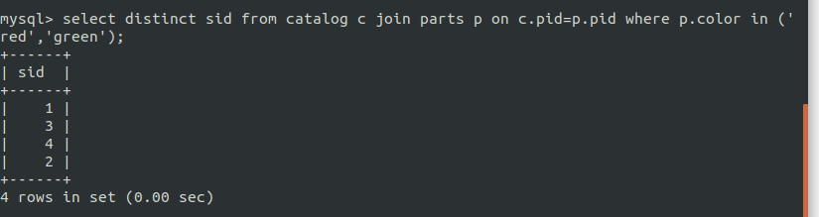
3. Find the sids of suppliers who supply some red part or are at 221 Packer Street.
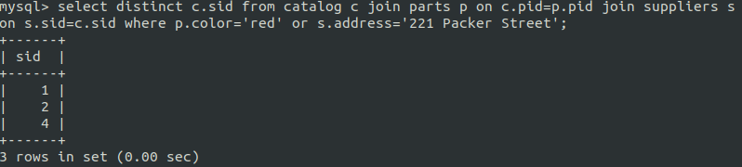

9. Find pairs of sids such that the supplier with the first sid charges more for some part than the
supplier with the second sid.
