VENDOR & CONTRACT MANAGEMENT
A 360° Use-Case Analysis for Northbridge Health Network — powered by Microsoft Work IQ

Prepared for | Northbridge Health Network — Supply Chain & Vendor Management Office
Prepared by | Microsoft Work IQ — Solution Architecture
Date | July 2026 · Version 2.0 (adds automations, technical plan & delivery backlog)
Classification | Confidential — Administrative use only (No PHI / no clinical data)
Scope | Non-clinical vendor & contract management across 3 hospital campuses and 14 outpatient clinics

Note: vendor names, systems and figures in this document are illustrative examples used to design the solution; specific values are to be populated from Northbridge's own contract records. Section 6 draws on the current Northbridge scenario data set (the Lumina EHR go-live and Joint Commission readiness data).

Contents

1. Executive Summary
Northbridge Health Network runs three hospital campuses and fourteen outpatient clinics, and depends on a large ecosystem of vendors — EHR and IT platforms, biomedical equipment, facilities and building services, clinical supplies, staffing and professional services. Today the authoritative picture of any vendor relationship — what was committed, what has been escalated, which SLAs are at risk, and when a contract renews — is scattered across email, meeting recaps, Teams channels, shared files, a contract system and a work-order tracker. No single person or app sees a vendor whole, so the monthly vendor review is rebuilt by hand and renewals and SLA breaches are caught late.
This document analyses the Vendor & Contract Management use-case end to end and shows how Microsoft Work IQ — the reasoning layer over the Microsoft 365 work graph, reachable programmatically over MCP and A2A — turns that fragmented reality into a single grounded, cited, permission-trimmed view, and then closes the loop by writing status back to the systems of record. It covers the contract types in scope and their specifics, the systems to integrate, the stakeholders involved, a 360° analysis, a catalogue of agent-initiated automations, the governed write-back actions, a technical implementation plan, a step-by-step delivery backlog, and a phased roadmap.

Key outcomes
- One plain-English question returns a full, cited Vendor 360 across every signal — no app-hopping.
- Renewals, SLA breaches and overdue commitments are surfaced proactively, not discovered late.
- The monthly vendor review assembles in minutes instead of days.
- Work IQ updates trackers, work orders and tasks as a governed action — always as the signed-in user, with human approval on external or financial steps.
- Beyond Q&A, agents run unattended — scheduled, event- and threshold-triggered — to post status reports, raise alerts, draft chases and update trackers automatically (Section 6).

2. Business Context: Northbridge's Vendor Landscape
Vendor and contract management is one of Northbridge's core non-clinical coordination functions, alongside quality programs, credentialing, the EHR rollout and regulatory readiness. Running the portfolio spans sourcing, negotiation, onboarding, SLA and performance monitoring, escalations, renewals and offboarding — across dozens of vendors serving seventeen sites. The scope of this analysis is strictly administrative: procurement and vendor governance, not patient care, and no PHI is in scope.
A single major event — an EHR go-live at the Westgate clinic, a chiller failure at a campus, or a supply escalation — instantly spins up cross-functional work context: coordination meetings, engineering and vendor email, a building-ops Teams channel, a shared works-log file, and a Dataverse work-order tracker (with ServiceNow and Maximo data). The commitments that matter get made fast and recorded nowhere a person can search. This is exactly the gap Work IQ is built to close.

3. Types of Contracts Signed by Northbridge and Their Vendors
Northbridge's vendor agreements fall into eight broad categories. The table below summarises each category with representative vendors, what the contract covers, and the commercial terms that must be tracked over its life.
Contract category | Representative vendors (illustrative) | What it covers | Key terms to track
EHR & clinical software | Epic, Oracle Health, departmental systems | License, implementation & support of the EHR and clinical apps | Subscription term, go-live milestones, uptime SLA, BAA, support tiers
IT & managed services | Cloud (Azure/M365), cybersecurity, help desk | SaaS subscriptions, managed IT & security services | Per-user pricing, availability SLA, SOC 2 / HITRUST, data-processing terms
Medical & biomedical equipment | Imaging, lab & biomedical OEMs | Capital purchase, warranty & preventive maintenance | Purchase price, warranty, PM schedule, response-time SLA, parts coverage
Facilities & building services | HVAC/mechanical, janitorial, security, waste | Planned & reactive maintenance across buildings | Response/resolution SLAs, per-building scope, penalties, KPI credits
Clinical supplies & pharmacy distribution | Distributors, GPO agreements | Administrative procurement of supplies & pharmaceuticals | Rate cards, volume commitments & rebates, fill-rate SLA, GPO tier
Staffing & agency | Locum/agency, credentialing-verification services | Temporary staffing and credentialing support | Bill rates, term, credentialing turnaround, compliance
Professional services & consulting | Accreditation, revenue-cycle, legal, advisory | Project-based SOWs and retainers | Deliverables/milestones, rate cards, acceptance, termination
Utilities & telecom | Energy providers, connectivity carriers | Recurring utility & telecom service | Rate schedule, term, service credits, renewal notice

Contract specifics to track across every category
Regardless of category, each agreement carries a set of attributes and clauses that determine when action is needed and where risk sits. These are the fields Work IQ correlates across signals and systems.
Attribute / clause | Why it matters | Where it lives today
Term & renewal (auto-renew, notice) | Drives when to act to avoid evergreen lock-in | CLM / contract file / email
Pricing & rate cards | Governs spend and invoice validation | CLM / ERP / contract PDF
SLAs & KPIs | The performance you are owed | Contract + ITSM tickets + scorecards
Penalties / service credits | Remedies for breach | Contract clauses
Termination (cause / convenience) | Exit rights and notice periods | Contract
Indemnity, liability & insurance | Risk allocation | Contract + insurance certificates
BAA / HIPAA data protection | Required where a vendor touches data | BAA addendum
Compliance certifications | Vendor assurance (SOC 2, HITRUST) | Vendor-risk records
Change orders / amendments | Scope & price changes over time | Email + SOW + CLM
Escalation & governance cadence | How issues are raised and reviewed | Meetings + email + Teams
Payment terms & milestones | Cash-flow and delivery gates | ERP / SOW
Volume commitments & rebates | Savings capture | GPO / ERP

4. The Problem Today
- Vendor truth is fragmented across email, meetings, Teams, files, a contract system and a work-order tracker — no single view exists.
- The monthly vendor review is reconstructed by hand from five or more sources.
- Renewals and auto-renew deadlines sneak up; the network loses negotiating leverage and pays evergreen rates.
- SLA breaches and overdue commitments are noticed late — after the operational impact.
- When a vendor manager is out or rolls off, the relationship context does not transfer.
- Verbal commitments made in coordination calls never make it into a system of record.

5. How Work IQ Helps
Work IQ grounds in the live work graph the user already has access to, reasons across it to answer single-signal and multi-signal questions with citations, decomposes compound questions agentically, and then acts through its Tools capability. It adds value at every stage of the contract lifecycle.
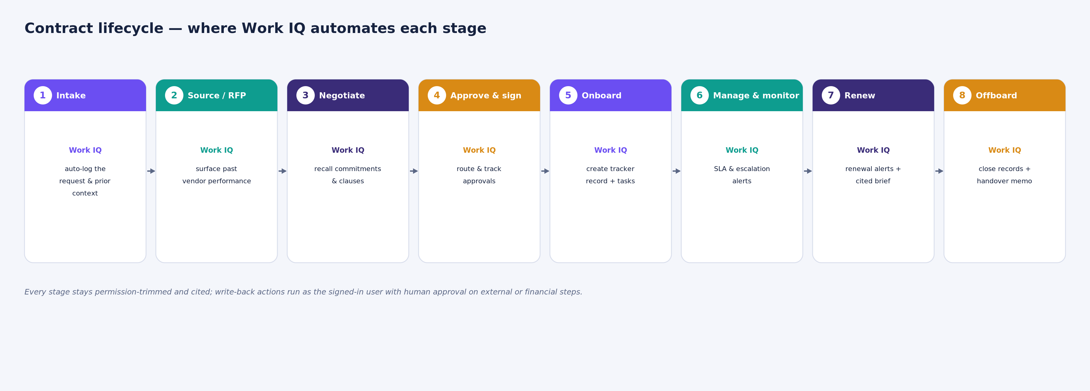
Figure 1 — The contract lifecycle, with the Work IQ action that automates each stage.

Capability mapping
- Context — grounded retrieval across email, meetings, Teams, files and people, plus Dataverse and connector data — all permission-trimmed.
- Chat (ask) — one plain-English question returns a synthesised, cited Vendor 360.
- Tools — governed create / update / do_action on trackers, work orders and tasks to close the loop.
- Workspaces — tenant-bounded state for long-running vendor agents (renewal watch, portfolio scans).

Questions Work IQ can answer today
- “Give me the 360 on [Vendor] — open work orders, escalations, commitments, upcoming renewals and the owner.”
- “Which vendors have an SLA breach or a renewal in the next 90 days across all buildings, and who owns each?”
- “What did the mechanical contractor email us about the Calder Tower repair scope and their ETA?”
- “Summarise the open scope-change discussion for [Vendor] across email and the delivery channel.”
- “What changed on the [Vendor] account in the last two weeks — decisions, new risks, slipped milestones?”

6. Agent-Initiated Automations — Proactive Reports & Actions
Beyond answering questions on demand, a Work IQ agent can run unattended — triggered by a schedule, an event or a threshold — to produce cited reports and take governed actions with no question asked. The automations below are grounded in Northbridge's current scenario data: the Lumina Health Systems EHR go-live at the Westgate clinic, an unresponsive facilities signage vendor, and the Joint Commission CAPA tracker. Each runs as a delegated identity, cites its source signals, and honours sensitivity labels.

How the triggers work
Trigger type | How it works | Northbridge example
Scheduled | Runs on a timer (daily / weekly) | Weekly Vendor & Commitment Status — Mondays 07:00 to the Quality Program channel
Event-driven | Fires when a condition is detected | Stalled-commitment alert when a due date passes with no confirmation email
Threshold-based | Fires when a metric crosses a line | Escalation when two or more CAPAs on the readiness critical path are past due

The automation catalogue
# | Automation | Trigger | Output & governed action
1 | Weekly Vendor & Commitment Status | Scheduled (Mon 07:00) | Cited status pack — Lumina go-live health plus the overdue facilities vendor — posted to Teams and emailed to the VMO lead
2 | SLA & Commercial-Exposure Alert | Event — go-live < 14 days with an open dependency | Leadership-only alert on MSA Clause 7.4 penalty exposure with delay-attribution guidance (sensitivity-label honoured)
3 | Stalled-Commitment Alert + Auto-Draft | Event — a vendor confirmation is overdue | Teams alert, a chase email auto-drafted into the owner's Drafts (pending human send), and a tracked follow-up entry
4 | CAPA Blocker Escalation | Threshold — 2+ CAPAs past due | Escalation to the director with blockers, owners and recommended actions
5 | Cross-Committee Closure Propagation | Event — a linked CAPA is closed by another committee | Notification to the dependent committee and auto-update of the readiness checklist and CAPA tracker
6 | Joint Commission Readiness Report | Scheduled (Friday) | Weekly CAPA status, vendor-blocked items, a readiness score and the auto-actions taken that week

Worked example — one event, one governed loop
Automation 3 shows the pattern end to end when a vendor confirmation goes overdue:
- Detect — the action item “obtain written go-live confirmation from Lumina” was due but no confirmation email has arrived; the Teams channel says “ready to issue” but no actual sign-off is posted.
- Correlate — the dependent migration-validation task is due the same day and sits at 90%; the confirmation is contingent on it.
- Alert — the agent posts a cited alert to the Quality Program channel and @-mentions the two owners.
- Act — it auto-drafts a chase email into the owner's Drafts, CC the director — the send stays human-in-the-loop.
- Track — it creates a follow-up record with an auto-escalation date if no response arrives.
Every step is cited back to the underlying emails, meeting action items and Teams messages, and nothing is sent externally without human approval.
The pattern compounds: a handful of live signals — a few emails, meeting recaps, Teams messages, shared files and CAPA records — become several automated, cited reports and governed actions each week, with zero questions asked. The write-back actions these automations perform are catalogued in Section 10.

7. 360° Analysis
A vendor relationship has to be understood from every angle at once. Work IQ assembles eight signal dimensions into one governed, cited view — so no single blind spot leaves a vendor un-managed.
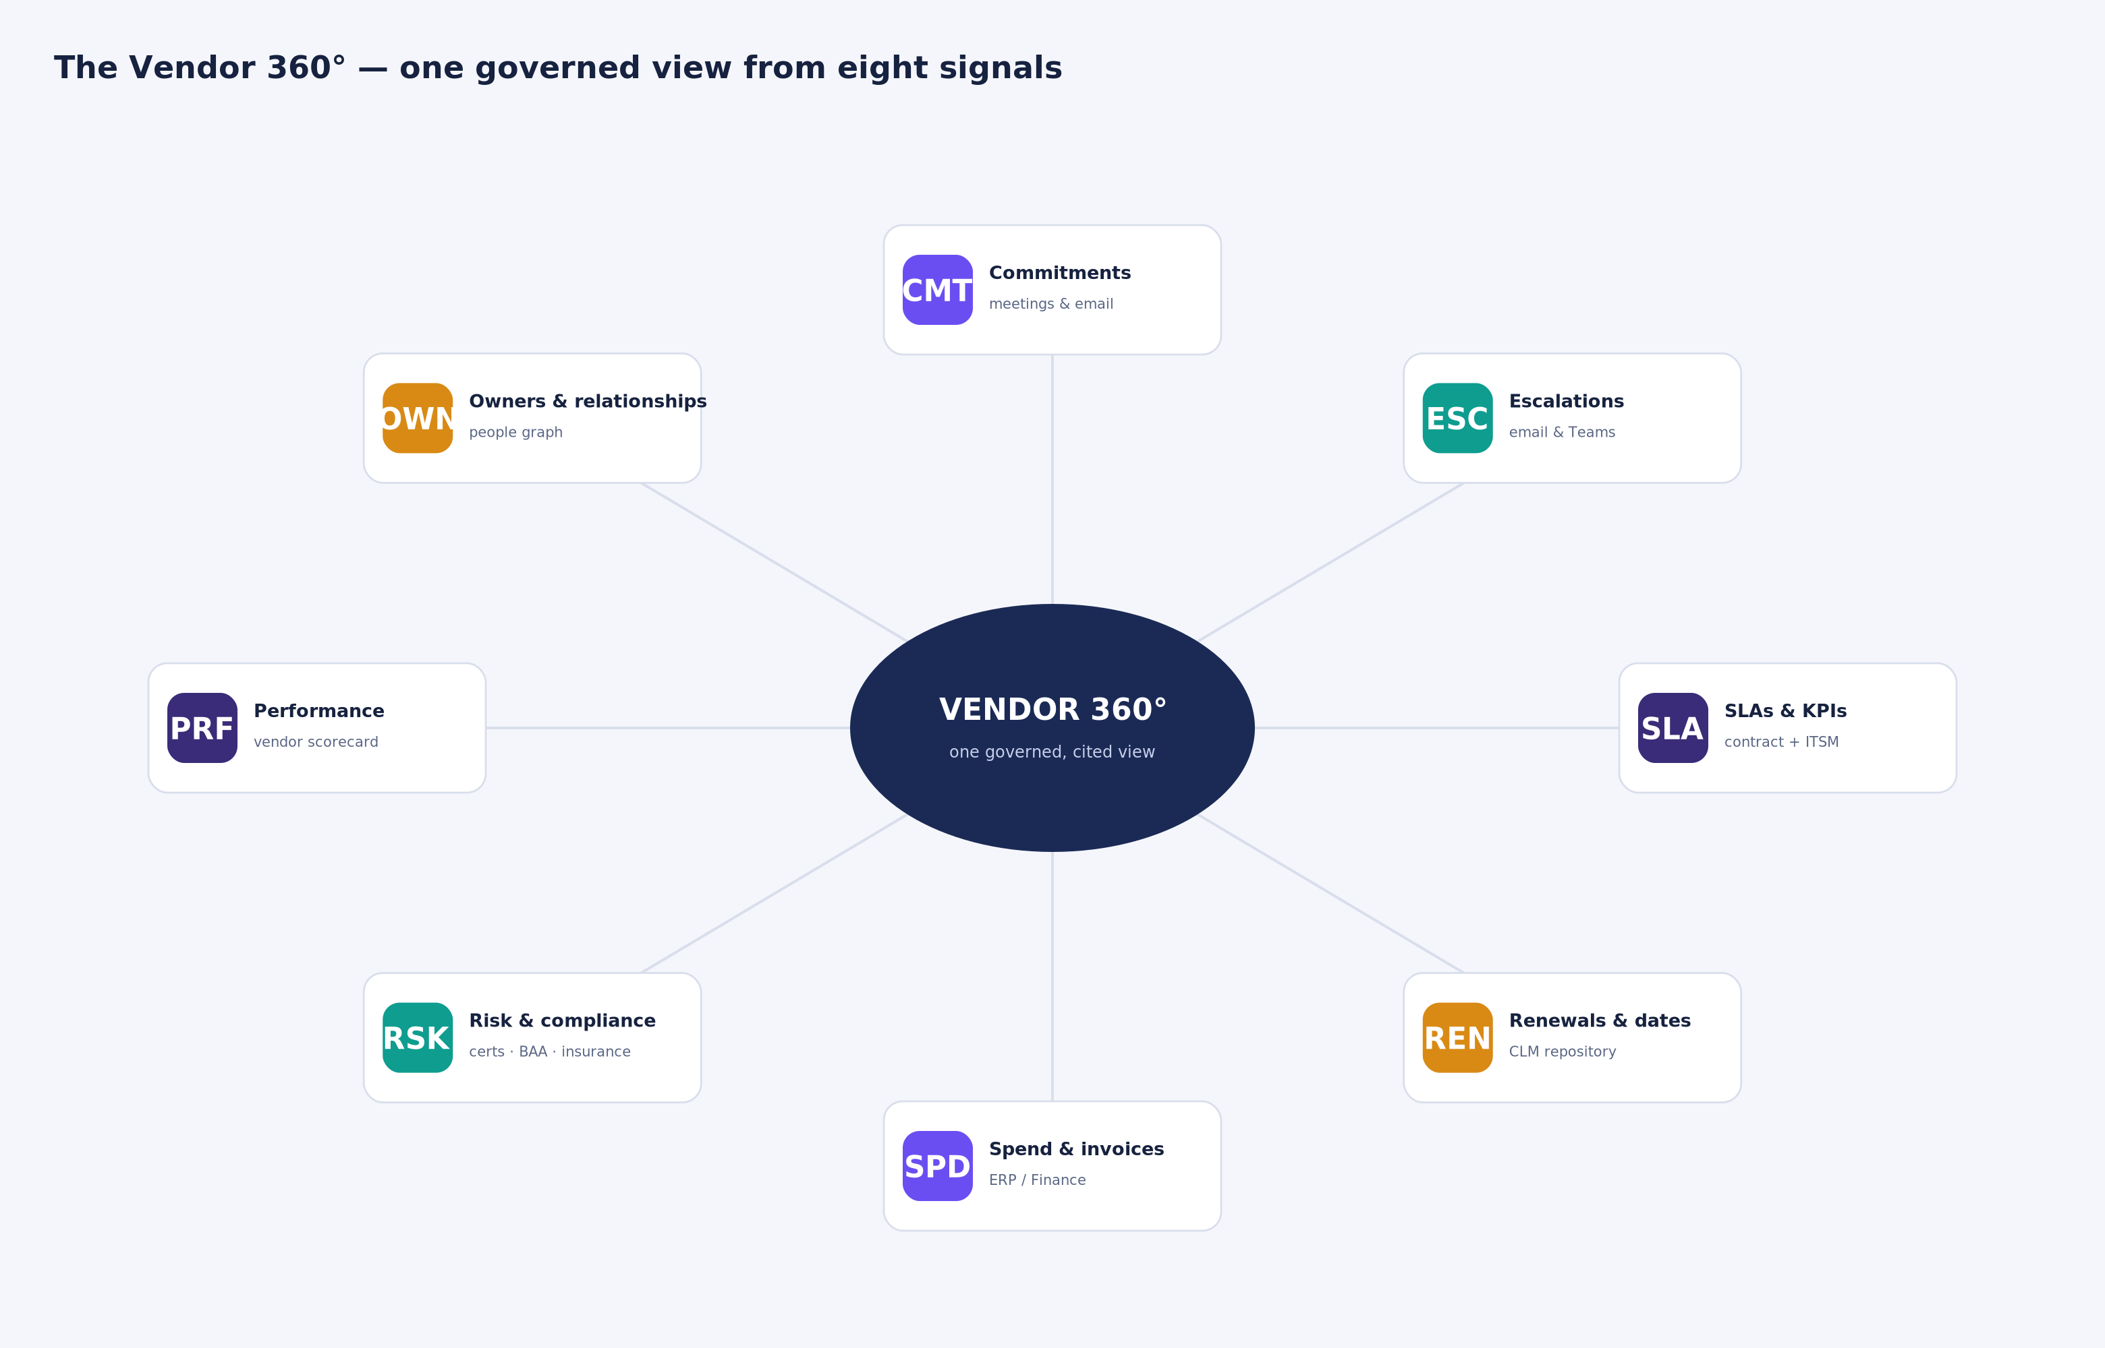
Figure 2 — The Vendor 360°: eight dimensions Work IQ synthesises into one answer.

Six lenses on the use-case
- People — stakeholders across procurement, legal, finance, IT, facilities, compliance and the business owner (detailed in Section 9).
- Process — the eight-stage contract lifecycle; Work IQ adds value at intake, sourcing, negotiation, approval, onboarding, monitoring, renewal and offboarding.
- Signals & data — where vendor truth lives: email, meetings, Teams, files and the people graph, plus Dataverse and connector systems.
- Systems — the systems of record to integrate under one reasoning layer (Section 8).
- Risk & compliance — renewals, SLAs, BAA/HIPAA, insurance, certifications and segregation of duties.
- Value & outcomes — hours saved, negotiating leverage preserved, breaches caught early, and institutional memory retained (KPIs in Section 15).

Current state vs. future state
Dimension | Today | With Work IQ
Vendor 360 | Days of manual reconciliation | One cited answer in seconds
Renewals | Discovered late | Alerted before the notice deadline
SLA breaches | Noticed after impact | Flagged as they happen
Monthly review | Rebuilt by hand | Auto-assembled cited pack
Trackers | Stale spreadsheets | Kept current by governed write-back
Handover | Context lost at rollover | Full cited history on demand

8. Source Systems to Integrate with Work IQ
Work IQ reaches the Microsoft 365 work graph natively and connects to line-of-business systems of record through Copilot connectors and Dataverse — bringing contract, ticketing, asset, finance and risk data under one governed reasoning layer. All access is delegated-only and permission-trimmed; confidential contracts are honoured per their sensitivity labels.
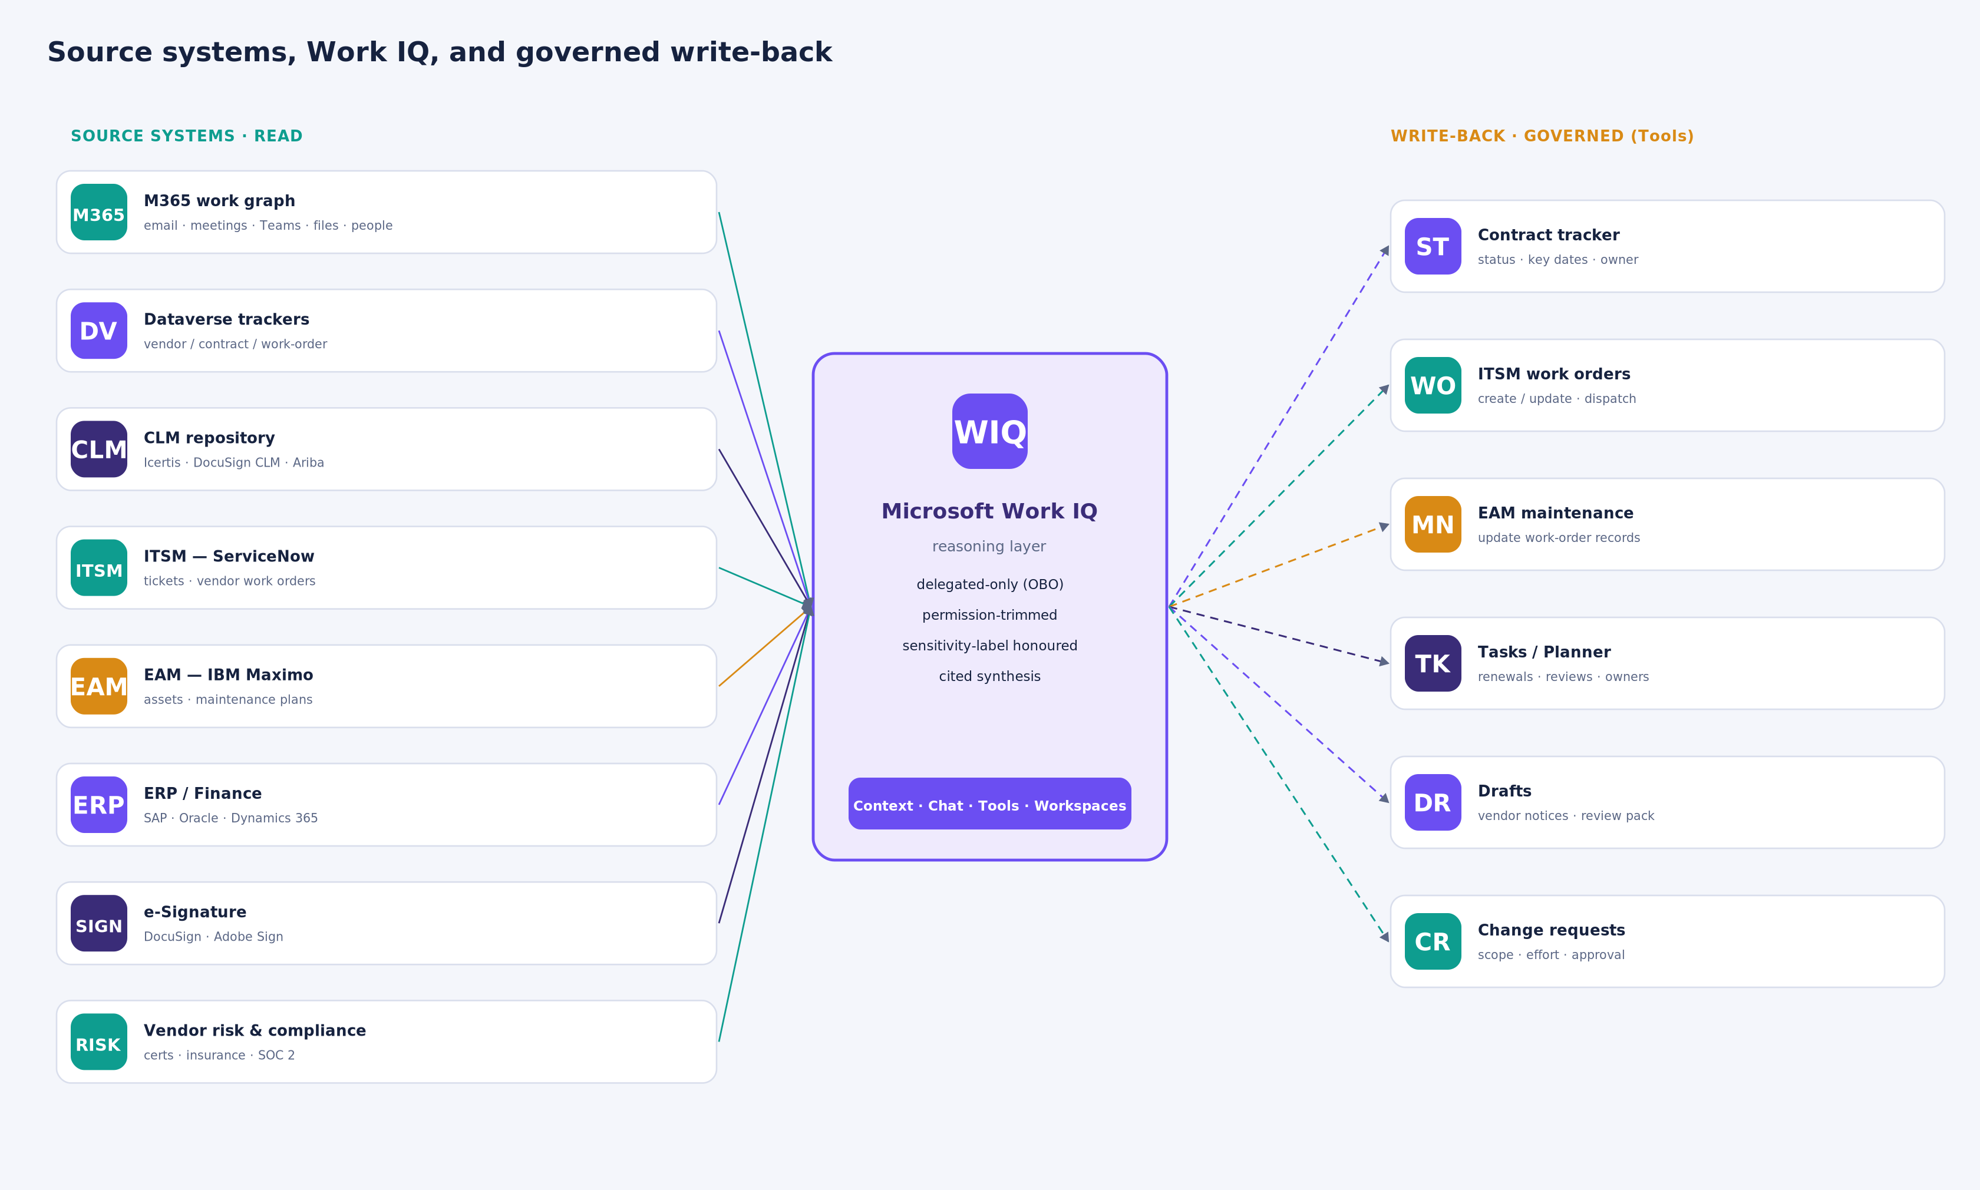
Figure 3 — Source systems (read) into Work IQ, and the governed write-back targets (Tools).
System | Type | Role in vendor management | Integration path | R / W
Outlook / Exchange | M365 | Vendor correspondence, escalations, commitments | Native work graph | Read
Teams (chats & channels) | M365 | Coordination, dispatch, ad-hoc decisions | Native | Read
Meetings & transcripts | M365 | Vendor-review & coordination recaps | Native | Read
SharePoint / OneDrive | M365 | SOWs, contracts, works log, review decks | Native | Read
People graph | M365 | Who owns which vendor, reporting lines | Native | Read
Dataverse trackers | Native | Vendor / contract / work-order records | Tools | R / W
CLM (Icertis, DocuSign CLM, Ariba) | LOB | Contract repository, clauses, key dates | Copilot connector | Read
ITSM — ServiceNow | LOB | Vendor tickets and work orders | Copilot connector | R / W
EAM — IBM Maximo | LOB | Assets and maintenance work orders | Copilot connector | R / W
ERP / Finance (SAP, Oracle, D365) | LOB | POs, invoices, spend, payment terms | Copilot connector | Read*
e-Signature (DocuSign, Adobe Sign) | LOB | Signature and execution status | Copilot connector | Read
Vendor risk & compliance | LOB | Certifications, insurance, SOC 2 | Copilot connector | Read
* Financial write-back (e.g., PO change requests) is supported but gated behind explicit human approval.

9. Stakeholders Involved in Contract Management
Contract management is a team sport. Work IQ serves each stakeholder in their own context — permission-trimmed to what they are allowed to see — so the same reasoning layer supports procurement, legal, finance, IT, facilities, compliance and leadership.
Stakeholder | Role in contract management | How Work IQ helps them
Vendor / Contract Manager (VMO) | Owns day-to-day relationship & performance | Instant Vendor 360, proactive alerts, one-click status updates
Procurement / Sourcing lead | Runs sourcing, RFPs and negotiation | Recall of prior performance and commitment history
Category managers | Own a vendor category (IT, facilities, biomed, supplies) | Portfolio scans across their category
Legal / Contracts counsel | Drafts & negotiates terms, manages risk | Surfaces clauses, amendments and obligations
Compliance & Privacy officer | BAA/HIPAA, certifications | Flags missing BAAs and expiring certificates
Finance / Accounts Payable | Budgets, payment terms, invoices | Spend & invoice context, rebate-capture prompts
IT & Security | Data protection for IT vendors | Security-term and incident context
Facilities / Building operations | Building-level service & work orders | Per-building vendor status; work-order updates
Department / business owner | The internal customer of the vendor | Plain-English answers on their vendor
Executive sponsor (COO / VP Supply Chain) | Portfolio oversight | Cross-network risk 360
Internal audit | Controls and evidence | Full cited audit trail of decisions & actions

10. Write-Back: What Work IQ Can Write to Systems
Work IQ closes the loop through its Tools capability — create_entity, update_entity and do_action — always executed as the signed-in user (delegated, never app-only). External-facing and financial actions are gated behind human approval: the agent proposes, a person commits.
Write-back action | Target system | Work IQ tool | Governance
Update vendor / contract tracker (status, renewal decision, dates, owner) | Dataverse | update_entity | Delegated · audited
Create renewal / review task with owner & due date | Dataverse / Planner | create_entity | Delegated
Log an escalation record against a vendor | Dataverse | create_entity | Delegated
Update SLA-breach flag / performance scorecard | Dataverse | update_entity | Delegated
Create or update an ITSM work order (dispatch, status, notes) | ServiceNow | create/update_entity | Delegated · role-scoped
Update an EAM maintenance work-order record | IBM Maximo | update_entity | Delegated
Create a change-request record (scope, effort, owner) | Dataverse / CLM | create_entity | Human approval
Draft a vendor follow-up or notice (not send) | Outlook | do_action (draft) | Human review before send
Assemble & update the monthly vendor-review pack | SharePoint / Dataverse | do_action | Delegated
Add a decision to the vendor decision ledger | Dataverse | create_entity | Delegated
Flag an invoice discrepancy / PO change request | ERP | do_action | Human approval (financial)
Post a status or escalation alert to a Teams channel | Teams | do_action | Delegated
Propagate a cross-committee closure (update the readiness checklist) | SharePoint / Dataverse | update_entity | Delegated
Section 6 shows these write-backs in action as scheduled, event- and threshold-triggered automations — every external send stays human-in-the-loop.

11. Next Steps & Implementation Roadmap
A phased path lets Northbridge prove value quickly on a read-only Vendor 360, then layer in proactive alerts and governed write-back, and finally scale to a multi-agent portfolio capability. The same agent code runs against the local Work IQ simulator first and repoints to the tenant unchanged.
Phase | Focus | Key activities & deliverables | Governance gate
0 · Discovery (2–3 wks) | Data & scope mapping | Inventory vendors, contracts, systems and owners; define the vendor & contract data model in Dataverse; confirm sensitivity labels | Admin consent for WorkIQAgent.Ask; connector approvals
1 · Vendor 360 (4–6 wks) | Read-only synthesis | Connect M365 signals + CLM/ITSM connectors; deliver Vendor 360 and portfolio scan; auto-assemble the monthly review pack | Permission-trimming & label honouring verified
2 · Proactive (Q+1) | Monitoring & alerts | Scheduled renewal & SLA-breach alerts; morning vendor briefings to owners | Delegated, per-user trimming
3 · Write-back (Q+1/Q+2) | Close the loop | Update trackers & work orders; create tasks; draft notices | Human-in-the-loop on external / financial writes
4 · Scale (Q+2+) | Multi-agent & portfolio | A2A specialist agents (sourcing, SLA, renewals, risk); Portfolio Risk 360; integrate ERP/Finance | Segregation of duties; full audit

Immediate next steps
- Confirm the priority vendor categories and the systems of record to connect first.
- Stand up the vendor & contract data model in Dataverse.
- Build the Phase 1 Vendor 360 on the local Work IQ simulator, then repoint to the tenant.
- Nominate a Vendor Management Office owner and an executive sponsor.

12. Technical Implementation — Next Steps
Moving from concept to a running solution assembles a well-defined set of building blocks on the Work IQ and Azure AI stack. The table lists the components; the ordered steps below describe how they come together. The same agent code runs against the local Work IQ simulator first and repoints to the tenant unchanged.
Layer | Technology | Purpose
Reasoning model | Azure AI Foundry (GPT-4o / 4o-mini) | Decomposes compound questions; decides when to retrieve and act
Agent runtime | Microsoft Agent Framework (Python) | Hosts the model; runs the tool-calling loop and planning
Grounding | Work IQ over MCP + A2A (WorkIQAgent.Ask, OBO) | Permission-trimmed retrieval and governed Tools write-back
Supplemental RAG | Azure AI Search (vector + hybrid) + embeddings | Index contracts, SOWs, policy drafts and minutes
System of record | Dataverse (vendor, contract, SLA, work-order, escalation, follow-up, CAPA, decision ledger) | Structured state and the write-back target
LOB connectors | Copilot connectors — CLM, ServiceNow, Maximo, ERP | Bring contract, ticket, asset and finance data under Work IQ
Automation engine | Timers + Graph change-notifications / Dataverse triggers + Work IQ Workspaces | Schedule, event and threshold triggers for unattended runs
Actions | Tools: create/update_entity, do_action; Outlook draft; Teams post | Close the loop, with human approval on external / financial acts
Safety | Azure AI Content Safety (Prompt Shields, groundedness, PII) | Guard untrusted retrieved content and agent output
Identity & security | Entra ID, Managed Identity, Key Vault, Private Endpoints | Delegated OBO; secretless auth; network isolation
Hosting | Azure Container Apps (VNet-integrated) + Container Registry | Run the agent and automation workers; KEDA autoscale
Observability & eval | App Insights, Log Analytics, Purview audit, Foundry evaluations | Trace, audit and score groundedness and safety
DevOps | GitHub Actions + Bicep / Terraform (azd) | CI/CD and infrastructure as code across dev / test / prod

Step-by-step technical path
- Provision the platform with IaC — an Azure AI Foundry project and model deployment, an Azure Container Apps environment, Azure AI Search, Key Vault and a Dataverse environment; enforce private endpoints and store secrets in Key Vault.
- Grant access — admin consent for the WorkIQAgent.Ask scope and approval of the CLM / ServiceNow / Maximo / ERP Copilot connectors in a test tenant.
- Model the data — create the Dataverse entities and relationships, and map the scenario signals (email, meetings, Teams, files, CAPA records) to those entities.
- Wire grounding — register the Work IQ MCP server and the A2A agent card; acquire a delegated WorkIQAgent.Ask token via on-behalf-of; confirm cited answers.
- Build the read agent — with the Microsoft Agent Framework on a Foundry model: run the tool-calling loop, deliver Vendor 360 and the portfolio scan, and enforce citations.
- Add supplemental RAG — an ingestion job chunks and embeds contracts and policies into Azure AI Search for clause-level retrieval.
- Implement governed write-back — create/update_entity and do_action tools for trackers, work orders and tasks; Outlook drafting and Teams posting; a human-approval gate on external and financial actions.
- Build the automation engine — scheduled timers, Graph change-notification / Dataverse triggers and threshold evaluators; persist run state in Work IQ Workspaces so the six automations fire unattended.
- Apply safety and governance — Content Safety Prompt Shields on retrieved content, sensitivity-label handling, segregation-of-duties approval flow, and full audit logging.
- Test, deploy and observe — validate on the local Work IQ simulator (data integrity, per-persona behaviour, MCP wire contract), repoint to the tenant, ship via CI/CD to Azure Container Apps, and monitor with App Insights and Foundry evaluations.

13. Implementation Backlog — Step-by-Step Path
The work is organised as a product backlog of epics, each decomposed into user stories with acceptance criteria and sequenced into two-week sprints. Earlier epics unblock later ones: platform → data → grounding → write-back → automation → governance → scale.

How to build and run the backlog
- Turn each solution capability (Vendor 360, supplemental RAG, write-back, automations, governance, scale) into an epic.
- Decompose each epic into user stories written in the “As a … I want … so that …” form, tied to a persona and an outcome.
- Write acceptance criteria for every story (Given / When / Then) so “done” is testable.
- Identify dependencies, order the stories, and assign each to a sprint; size with story points and prioritise with MoSCoW (M/S/C).
- Agree a Definition of Ready and Definition of Done, and load the backlog into Azure DevOps or GitHub Projects.
- Groom weekly; demo and run a retrospective at the end of every sprint; re-prioritise from what the demo reveals.

Definition of Ready / Definition of Done
- Ready — value statement, acceptance criteria, dependencies identified, and test data available (simulator fixtures).
- Done — code and tests pass the three-layer validation, cited output verified, write-back visible on re-query, security review passed, and deployed to the target environment.

Epic 0 — Foundation & environment
ID | User story | Acceptance criteria | Spr | Pri
US-01 | As a platform engineer, I want IaC to provision Foundry, ACA, AI Search, Key Vault and Dataverse, so environments are reproducible. | azd provisions all resources in dev; no public PaaS; secrets in Key Vault. | S0 | M
US-02 | As an admin, I want admin consent for WorkIQAgent.Ask and the LOB connectors, so the agent can reach Work IQ and connector data. | Delegated scope consented; ServiceNow/CLM connectors approved in test tenant. | S0 | M
US-03 | As a developer, I want the local Work IQ simulator wired over MCP + A2A, so I can build offline. | Smoke test passes; ask_work_iq returns cited answers. | S0 | M

Epic 1 — Data model & ingestion
ID | User story | Acceptance criteria | Spr | Pri
US-04 | As a VMO analyst, I want a Dataverse vendor/contract data model, so records can be correlated and updated. | Vendor, Contract, SLA, WorkOrder, Escalation, Follow-up, CAPA, Decision entities + relationships created. | S1 | M
US-05 | As a developer, I want scenario fixtures mapped to entities, so tests use realistic data. | Fixtures load; IDs resolve; scenario validator green. | S1 | M
US-06 | As a compliance officer, I want sensitivity labels on contract docs, so restricted items are honoured. | Labelled docs excluded or redacted in agent output. | S1 | S

Epic 2 — Grounding & Vendor 360
ID | User story | Acceptance criteria | Spr | Pri
US-07 | As a VMO manager, I want a Vendor 360, so I see commitments, escalations, SLAs, renewals and owner in one cited view. | One question returns synthesis with a citation per claim across 2+ signal types. | S2 | M
US-08 | As a category manager, I want a portfolio scan, so I see SLA breaches and renewals due in 90 days. | Multi-signal query returns a ranked list with owners and citations. | S2 | M
US-09 | As any user, I want answers permission-trimmed, so I never see data I cannot access. | Under-privileged persona gets a redacted result plus a governance note. | S2 | M

Epic 3 — Supplemental RAG
ID | User story | Acceptance criteria | Spr | Pri
US-10 | As a developer, I want an ingestion job that chunks and embeds contracts/policies into AI Search, so detail is retrievable. | Indexer runs on schedule; hybrid query returns relevant chunks. | S2 | S
US-11 | As legal counsel, I want clause-level retrieval, so I can surface penalty or termination terms. | Query returns the correct clause with its source document. | S2 | S

Epic 4 — Governed write-back
ID | User story | Acceptance criteria | Spr | Pri
US-12 | As a duty manager, I want the agent to update a work order (status/owner/due), so the tracker reflects reality. | update_entity write visible on re-query; audit-logged. | S3 | M
US-13 | As a VMO manager, I want the agent to create renewal/follow-up tasks with owner and due date, so nothing slips. | create_entity task appears; idempotent on re-run. | S3 | M
US-14 | As an owner, I want a vendor chase email auto-drafted (not sent), so I approve before send. | Draft appears in Drafts; send requires a human action. | S3 | M
US-15 | As a finance approver, I want financial writes gated, so no PO change commits without approval. | do_action on ERP requires an explicit approval step. | S3 | S

Epic 5 — Agent-initiated automations
ID | User story | Acceptance criteria | Spr | Pri
US-16 | As the VMO, I want a scheduled Weekly Vendor & Commitment Status posted to Teams and email, so the team starts the week informed. | Fires Mon 07:00; cited; matches the sample pack. | S4 | M
US-17 | As leadership, I want an event-driven Clause 7.4 exposure alert restricted to leadership, so we manage penalty risk. | Fires on go-live < 14 days with an open dependency; restricted visibility; cites the clause and evidence. | S4 | M
US-18 | As an EHR lead, I want a stalled-commitment alert + auto-draft + follow-up, so overdue confirmations are chased. | Detects overdue action; posts alert; drafts email; creates follow-up with an auto-escalate date. | S4 | M
US-19 | As a director, I want a threshold escalation when 2+ CAPAs are past due, so I intervene early. | Fires on the threshold; lists blockers, owners and recommendations. | S4 | S
US-20 | As Quality Steering, I want cross-committee closure propagation, so a closed dependency updates my checklist. | On a linked CAPA closure, notify and update the checklist and tracker. | S4 | S

Epic 6 — Governance, safety & observability
ID | User story | Acceptance criteria | Spr | Pri
US-21 | As a security lead, I want Content Safety Prompt Shields on retrieved content, so injected instructions are blocked. | An adversarial fixture is blocked and logged. | S4 | M
US-22 | As an auditor, I want every question, source and write-back logged, so actions are traceable. | App Insights and Purview audit entries exist per run. | S4 | M
US-23 | As an AI lead, I want groundedness/safety evaluations in CI, so quality gates block bad releases. | Foundry eval suite runs in the pipeline; thresholds enforced. | S4 | S

Epic 7 — Pilot, hardening & scale
ID | User story | Acceptance criteria | Spr | Pri
US-24 | As a sponsor, I want a tenant pilot with real users, so we validate value and KPIs. | Repoint to tenant; KPIs baselined; feedback captured. | S5 | M
US-25 | As an architect, I want A2A specialist sub-agents (sourcing/SLA/renewals/risk), so compound work scales. | Orchestrator delegates to 2+ sub-agents; delegated identity preserved. | S5 | S
US-26 | As leadership, I want a Portfolio Risk 360 across all vendors and sites, so I see network-wide risk. | Portfolio synthesis feeds a dashboard. | S5 | C

Sprint roadmap
Sprint | Goal | Epics | Exit criteria
S0 | Foundation | E0 | Environments provisioned; simulator wired; admin consent granted
S1 | Data & first answers | E1, E2 (start) | Data model live; a first Vendor 360 draft returns
S2 | Vendor 360 + RAG | E2, E3 | Cited Vendor 360 + portfolio scan; clause-level retrieval
S3 | Governed write-back | E4 | Trackers and work orders updated; drafts with approval gates
S4 | Automations + governance | E5, E6 | Six automations live; safety, audit and evals in place
S5 | Pilot & scale | E7 | Tenant pilot; multi-agent A2A; Portfolio Risk 360

14. Governance, Risk & Compliance
- Permission-trimmed — every answer honours the signed-in user's Microsoft 365 permissions; Work IQ never widens access.
- Sensitivity labels on confidential contracts are honoured and redacted by the platform.
- Delegated-only (WorkIQAgent.Ask) via on-behalf-of — there is no app-only write path.
- Human-in-the-loop on all external-facing and financial actions; segregation of duties enforced.
- Full audit trail of every question, source and write-back (Microsoft Purview and Application Insights).
- Grounded and cited — no fabricated commitments; least-privilege connector scopes; administrative scope only — no PHI.

15. Success Metrics
Metric | Today (baseline) | Target with Work IQ
Time to assemble the monthly vendor review | Days | Minutes
Renewals actioned before the notice deadline | Reactive / late | 100% alerted ≥ 90 days out
SLA breaches detected | After impact | At time of breach
Vendor escalation cycle time | Variable / manual | Reduced (measured in pilot)
Contract data completeness & accuracy | Partial / stale | Current via governed write-back
Analyst hours per review cycle | High | Quantified saving (pilot)
Baselines and targets to be calibrated during the Phase 1 pilot.

Appendix

A. Illustrative Dataverse data model
A minimal set of entities lets Work IQ correlate and write back consistently:
- Vendor — name, category, owner, risk rating, status.
- Contract — vendor, type, term, renewal date, notice period, value, sensitivity.
- Contract line / rate — pricing, rate cards, volume commitments.
- SLA / KPI — metric, target, current, breach flag.
- Work order — asset, building, status, owner, due date, source (ServiceNow/Maximo).
- Escalation — vendor, raised-by, date, status, resolution.
- Renewal / review task — vendor, due date, owner, decision.
- Change request — vendor, scope, estimated effort, approver.
- Decision-ledger entry — vendor, decision, date, source citation.

B. Glossary
- Work IQ — reasoning layer over the Microsoft 365 work graph. MCP / A2A — protocols to reach Work IQ (Model Context Protocol; Agent-to-Agent).
- CLM — Contract Lifecycle Management. ITSM — IT Service Management. EAM — Enterprise Asset Management. ERP — Enterprise Resource Planning.
- BAA — Business Associate Agreement (HIPAA). GPO — Group Purchasing Organization. SLA — Service-Level Agreement. VMO — Vendor Management Office. SoD — Segregation of Duties. OBO — On-Behalf-Of.

