Tab 1

LokDrishti

A Data-Driven Lens into India’s Aadhaar Enrolment & Update Trends

Submitted by
Name - Ajay H & Aparna Sathyamurthi Thambu
College - PSG College of Technology

Project Environment: Google Colab
Notebook link: LokDrishti.ipynb

Problem statement

Unlocking Lifecycle Gaps, Update Demand, and Spatial Inequities in Aadhaar Enrolment
Aadhaar has achieved near-universal coverage in India; however, coverage maturity does not imply uniform access, timely updates, or equitable lifecycle inclusion. Significant operational challenges remain in:
- Ensuring early childhood enrolment, especially in rural and underserved districts
- Managing district-level heterogeneity in Aadhaar update demand (demographic and biometric)
- Anticipating future biometric update loads driven by age-based policy requirements
- Detecting urban “hidden exclusion” pockets masked by aggregate statistics
- Aligning enrolment centre capacity with actual enrolment and update demand
This project aims to move beyond headline enrolment counts and instead decode Aadhaar system stress points using lifecycle-aware, spatial, and predictive analytics, enabling UIDAI to transition from reactive service provisioning to data-driven anticipatory governance.

Our Solution

Analytical Approach
We adopt a multi-layered analytical framework that integrates enrolment, demographic update, and biometric update datasets at the district level. The approach combines:
- Lifecycle Coverage Analysis
Age-wise enrollment shares are used as proxies for system maturity, access, and awareness across early childhood, late childhood, and adult cohorts.
- Operational Demand Diagnostics
Ratios of updates to enrolments are analysed to identify districts experiencing disproportionately high Aadhaar update pressure.
- Predictive Modelling for Biometric Demand
Lagged cohort-based enrolment features simulate population aging into mandatory biometric update cycles, enabling forward-looking demand forecasting.
- Spatial Equity Analysis (Urban–Rural Lens)
Feature-engineered urban/rural classification enables detection of structural enrolment disparities and “hidden exclusion” zones.
- Infrastructure Alignment Assessment
Enrolment volumes are compared against enrolment centre distribution to identify mismatches between demand and service availability.
This framework is designed to produce actionable insights directly translatable into UIDAI operational and policy interventions.

Datasets Used

UIDAI Anonymised Datasets
- Aadhaar Enrolment Dataset
  - date, state, district, pincode
  - age_0_5, age_5_17, age_18_greater
- Demographic Update Dataset
  - date, state, district, pincode
  - demo_age_5_17, demo_age_17_
- Biometric Update Dataset
  - date, state, district, pincode
  - bio_age_5_17, bio_age_17_

External Dataset
- Urban–Rural Classification Data (sourced from data.gov.in)
Used to feature engineer district-level urban/rural indicators.
- Tamilnadu aadhar center list (https://elcot.tn.gov.in/sites/default/file/7%20Zone%20Aadhaar%20Center%20%281%29.pdf)

Methodology

1. Data Ingestion and Integration
- Loaded all three UIDAI datasets
- Standardised schemas and merged datasets at the district–month level
- Ensured consistent temporal granularity for comparative and predictive analysis

2. Data Cleaning and Standardisation
- Converted date fields to standard datetime formats
- Identified and handled missing and inconsistent values
- Canonicalised state and district names to reduce duplication and aggregation errors

3. Feature Engineering
- Created urban/rural classification using external government datasets
- Computed age cohort enrolment shares for lifecycle analysis
- Generated update-to-enrolment ratios as operational stress indicators
- Created lagged enrolment features (6-month and 12-month) to simulate population aging effects

Insights Gained

Age-wise Aadhaar Enrolment Gaps as Indicators of Lifecycle Coverage Maturity

Early Childhood Enrolment Gap (Age 0–5)
Disproportionately low Aadhaar enrolment in the 0–5 age group across districts signals gaps in early identity creation, reflecting weaknesses in birth-linked enrolment mechanisms, frontline outreach, and parental awareness. Such gaps can delay access to child-centric services, including immunisation, early education, and Direct Benefit Transfers (DBT), and indicate incomplete integration between civil registration, health systems, and Aadhaar enrolment processes.

Late Childhood Enrolment Gap (Age 5–17)
High Aadhaar enrolment in the 5–17 age group indicates delayed enrolment cohorts that missed early-life registration opportunities. This pattern points to systemic issues in enrolment accessibility or institutional linkage during early childhood, with Aadhaar registration often occurring only when triggered by school admissions or documentation requirements rather than as part of a continuous lifecycle enrolment strategy.

Operational Relevance
Targeted early childhood enrolment campaigns, school-linked Aadhaar drives, and maternal-child health integration.

Early childhood

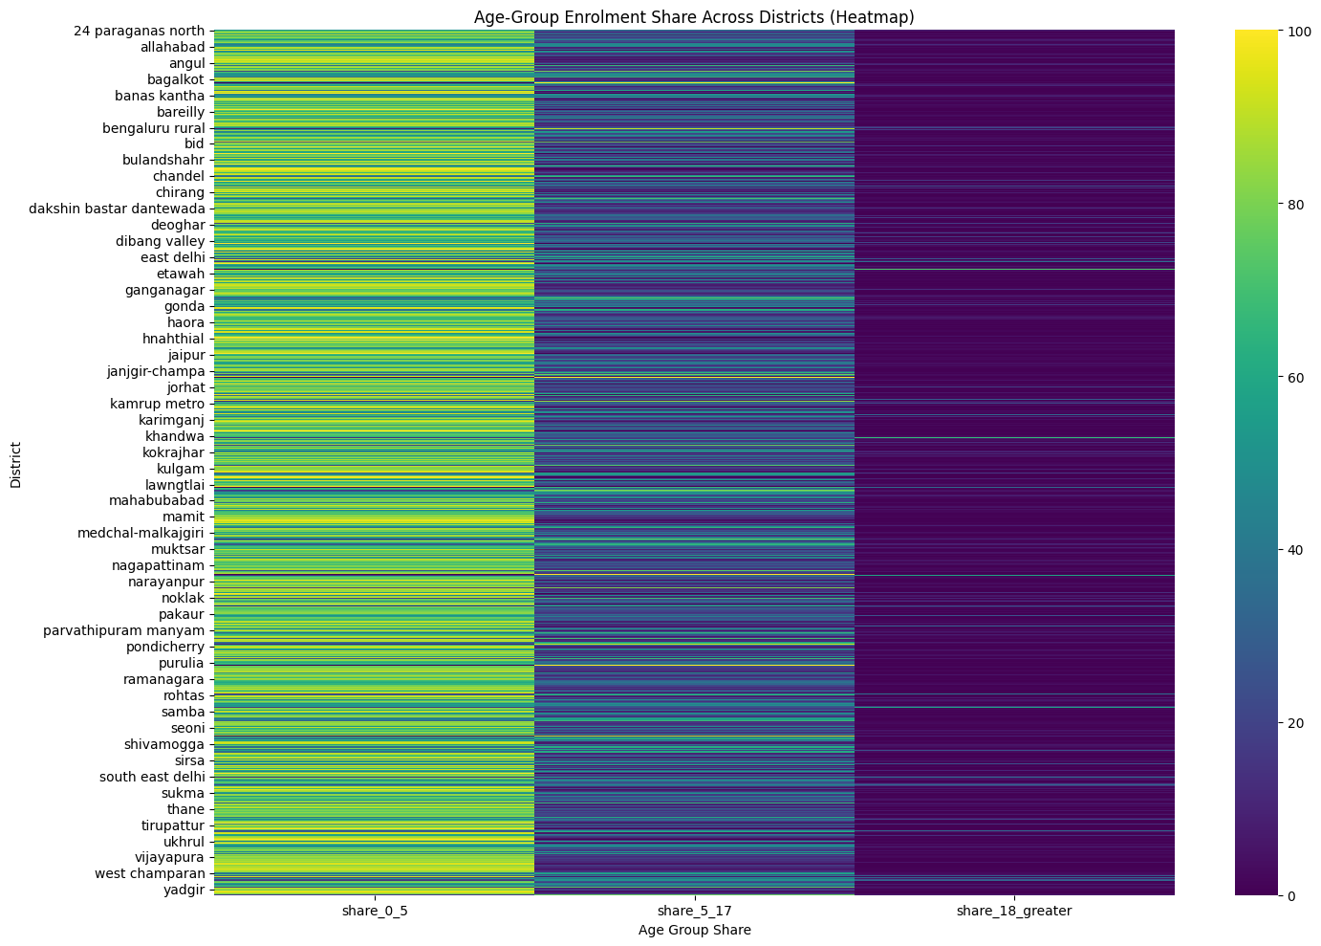

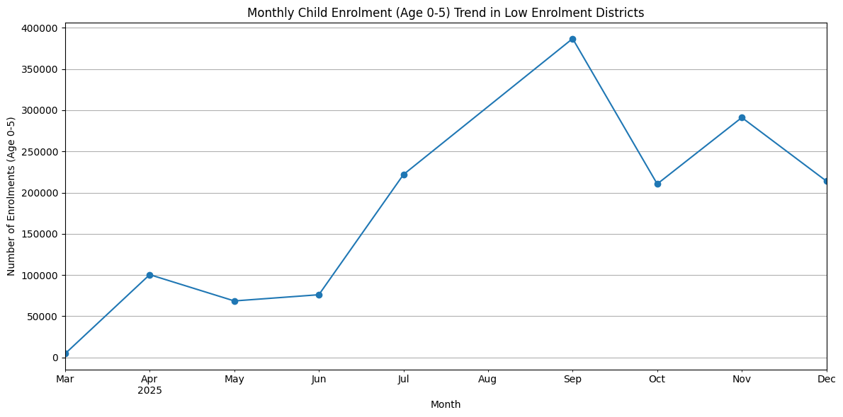

Summary
The district-level analysis of Aadhaar enrolment by age group (0–5, 5–17, and 18+) reveals substantial variation in early childhood enrolment patterns across regions. While several districts demonstrate strong enrolment coverage in the 0–5 age group, a subset of districts consistently shows disproportionately low child enrolment shares. Given that early childhood Aadhaar enrolment is critical for ensuring lifecycle continuity and access to welfare services, these disparities point to localized access, awareness, or delivery challenges that warrant targeted operational attention.-----Data Analysis – Key Findings
- Wide District-Level Variation in Age-Group Enrolment:
The age-group enrolment heatmap highlights significant heterogeneity across districts, with notable differences in the proportion of enrolments attributed to the 0–5, 5–17, and 18+ cohorts.
- Districts with Disproportionately Low Child Enrolment (0–5):
The overall average share of 0–5 enrolments across districts was approximately 69.08%. A substantial number of districts fell below this benchmark, indicating comparatively weaker early childhood enrolment performance.
- Persistently Low-Performing Districts Identified:
Districts such as Mangan, Leparada, Eastern West Khasi Hills, Shamator, and Pherzawl exhibited particularly low 0–5 enrolment shares, in some cases approaching zero. This suggests systemic challenges in enrolling children at early ages in these regions.
- Compensatory Enrolment in Older Age Groups:
In districts with low 0–5 enrolment shares, higher proportions of enrolments were often observed in the 5–17 or 18+ age categories, indicating delayed enrolment rather than complete exclusion.
- Fluctuating Monthly Child Enrolment Trends:
Time-series analysis for low-performing districts shows marked month-to-month variability in child enrolment volumes. While occasional spikes were observed (e.g., peaks in July, September, and November), sustained and consistent enrolment of children aged 0–5 remains a challenge.

Implications for UIDAI
Based on these findings, the following district-focused actions can be considered by Unique Identification Authority of India:
- Targeted Child Enrolment Drives:
Prioritise districts with persistently low 0–5 enrolment shares for focused enrolment initiatives, including special camps and time-bound drives aimed at parents of young children.
- Collaboration with Local Institutions:
Strengthen partnerships with Anganwadi centres, primary health centres, local schools, and community organisations to embed Aadhaar enrolment within existing child-centric service delivery touchpoints.
- Deployment of Mobile Enrolment Units:
Use mobile enrolment kits to reach remote, hilly, or underserved areas within low-performing districts, addressing physical accessibility constraints.
- Focused Awareness Campaigns:
Implement district-specific information and awareness campaigns emphasising the benefits of early Aadhaar enrolment for children, including access to immunisation, education services, and Direct Benefit Transfers (DBT).
- Continuous Monitoring and Adaptive Intervention:
Track monthly child enrolment trends in targeted districts to evaluate intervention effectiveness and enable data-driven adjustment of operational strategies.

Late childhood
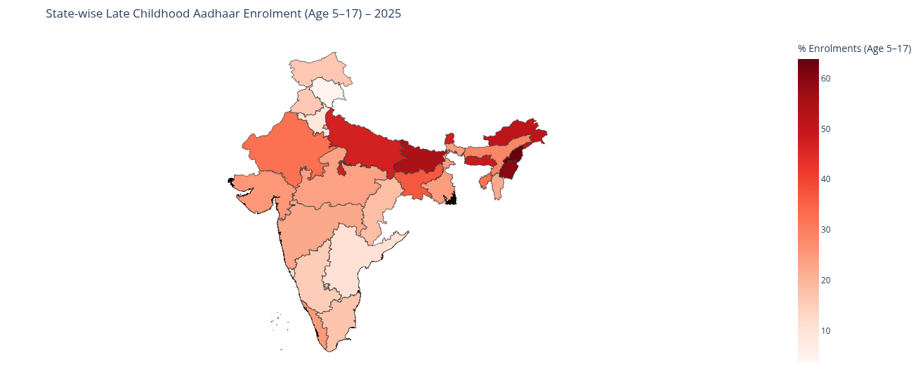

Summary
The state-wise analysis of Aadhaar enrolments in the 5–17 age group for 2025 reveals pronounced disparities in the timing of childhood registration across India. Since this cohort largely comprises individuals born after the introduction of Aadhaar, a high proportion of enrolments at this stage indicates delayed enrolment rather than early-life registration. The percentage-based comparison highlights states where Aadhaar access or uptake occurred later in childhood, suggesting gaps in early institutional integration, enrolment accessibility, or awareness. Overall, the findings point to uneven maturation of the Aadhaar enrolment lifecycle across states.-----Data Analysis – Key Findings
- High Late Childhood Enrolment Concentration:
Several states exhibit a notably higher percentage of Aadhaar enrolments in the 5–17 age group relative to total enrolments in 2025, indicating delayed entry into the Aadhaar ecosystem.
- Significant State-wise Variability:
The proportion of late childhood enrolments varies widely across states, reflecting differences in early-life enrolment mechanisms, outreach effectiveness, and administrative integration with birth and schooling systems.
- Delayed Enrolment as a Systemic Pattern:
In high-percentage states, Aadhaar registration appears to be driven predominantly by school-age or documentation-triggered needs rather than near-birth or early childhood enrolment.
- Uneven Lifecycle Coverage Maturity:
States with lower 5–17 enrolment percentages demonstrate more mature enrolment lifecycles, where Aadhaar registration is largely completed earlier in life.

Implications for UIDAI
- Strengthen Birth-Linked Enrolment:
States with high late childhood enrolment percentages should be prioritised for deeper integration between civil registration systems and Aadhaar enrolment workflows to ensure timely registration soon after birth.
- Targeted Awareness and Outreach:
Focused information and enrolment campaigns—particularly in rural, tribal, or underserved regions—can address awareness gaps contributing to delayed enrolment.
- School-Based Enrolment Optimisation:
Since many late enrolments likely occur during school admission phases, structured and standardised school-linked Aadhaar enrolment initiatives can help close remaining gaps.
- Data-Driven State Prioritisation:
The state-wise percentage metric can serve as an early-warning indicator for Unique Identification Authority of India and state governments to identify regions requiring corrective interventions and resource reallocation.
This analysis does not assign causality but uses late childhood enrolment as a proxy indicator to guide further administrative investigation and targeted policy action.

Insight 2: District-level Aadhaar Update Demand Diagnostics
- Identify districts where update demand is disproportionately high compared to new enrolments.
- Aggregated enrolments, demographic updates, and biometric updates by district
- Identified districts where update volumes are disproportionately high relative to enrolments
- High ratios signal:
  - Poor initial data quality
  - Migrant population churn
  - Lifecycle-driven update surges
Operational Relevance:
Dynamic allocation of update resources, mobile update units, and temporary capacity augmentation. Signals data ageing, migration, or biometric quality issues.

Demographic vs Biometric update ratio in HIgh demand districts
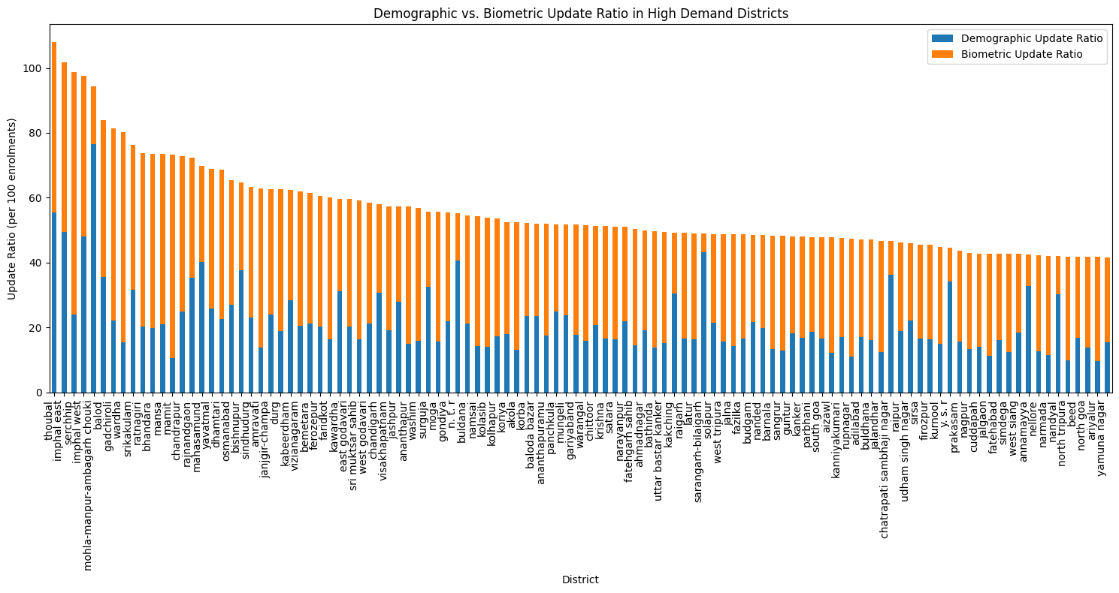
This district-level analysis of Aadhaar update demand highlights significant variations in the ratio of updates (demographic and biometric) to new enrolments across different regions. While new enrolments expand Aadhaar coverage, a high update demand often indicates a maturing Aadhaar ecosystem where existing cardholders require various modifications to their records. Understanding these patterns is crucial for UIDAI to strategically allocate resources for both enrolment and update services.

Data Analysis: Key Findings
- Significant Update Demand Variation: The total_update_ratio (total updates per total enrolments) varies greatly across districts, with some districts showing update volumes many times higher than their new enrolment figures.
- Identification of High-Demand Districts: Districts with a total_update_ratio exceeding one standard deviation above the mean were identified as having high update demand. These districts exhibit a disproportionately large number of updates relative to new enrolments.
- Dominance of Specific Update Types: Within high-demand districts, the analysis reveals whether demographic updates or biometric updates are the primary drivers of this demand. For example, districts like Thoubal, Imphal East, and Imphal West show high demand primarily driven by both demographic and biometric updates, while Mohla-Manpur-Ambagarh Chouki has a notably higher demographic update ratio.
- Potential Reasons for High Update Demand:
  - Demographic Updates: These could be driven by changes in address, name, date of birth, gender, or mobile number/email ID. High demand might indicate a highly mobile population, a large number of individuals correcting initial enrolment errors, or increased linkage requirements for services.
  - Biometric Updates: These are often required for children at ages 5 and 15, or due to biometric quality issues, accidents, or technological advancements. High biometric demand in specific districts could signal a large cohort reaching these age milestones or issues with initial biometric capture.

District level enrolments vs Total updates
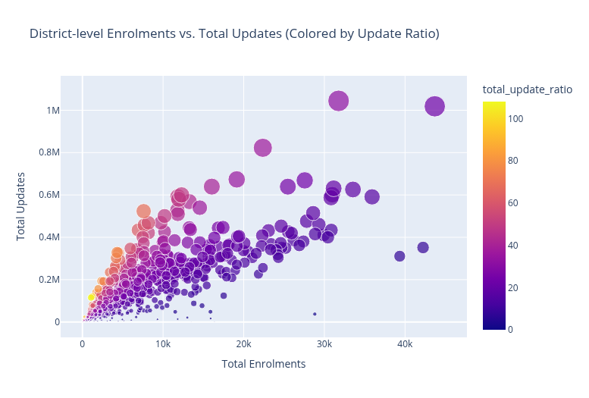

Insights into High Update Demand Districts
- Extreme Update-to-Enrolment Ratios: The analysis revealed districts with exceptionally high total_update_ratio, far exceeding new enrolments. For instance, districts like Thoubal (108.05), Imphal East (101.85), Serchhip (98.62), Imphal West (97.62), and Mohla-Manpur-Ambagarh Chouki (94.23) show update volumes that are nearly 100 times their new enrolment figures. This suggests that in these areas, the Aadhaar ecosystem is highly mature, with the primary activity being maintenance and correction of existing records rather than initial registration.
- Dual Drivers of Demand in Northeastern Regions: Districts in the Northeast, particularly in Manipur (Thoubal, Imphal East, Imphal West) and Mizoram (Serchhip), exhibit high demand driven by both demographic and biometric updates. This could be indicative of:
  - High mobility/migration: Frequent address changes or other demographic updates due to population movement.
  - Age-related biometric updates: A large cohort of residents reaching the age milestones (5 and 15 years) requiring mandatory biometric updates.
  - Initial data quality issues: Potential challenges with the quality of initial biometric capture or demographic data entry, leading to a higher need for corrections over time.
- Demographic-Dominant Update Demand: In districts like Mohla-Manpur-Ambagarh Chouki, the demographic_update_ratio (76.49) is significantly higher than the biometric_update_ratio (17.74). This strongly suggests that the primary driver of update demand in such regions is related to changes in personal details such as name, address, date of birth, or gender. This could stem from:
  - Correction of initial errors: Residents correcting inaccurate information submitted during initial enrolment.
  - Changes due to life events: Marriage (name change), change of residence (address change), or other personal life events.
  - Linkage requirements: Updates necessary to link Aadhaar with other services requiring current and accurate demographic information.
- Low Enrolment Base, High Update Pressure: The scatter plot visually confirms that many high-demand districts have relatively low total_enrolments but disproportionately high total_updates. This emphasizes that while the new enrolment pipeline might be small, the existing Aadhaar holders generate substantial service demand.

Summary
- District-level Data Aggregation: Total enrolments, demographic updates, and biometric updates were successfully aggregated for each district, forming a comprehensive dataset.
- Update Ratios Calculated:
  - A total_updates column was created by summing demographic and biometric updates.
  - Ratios for demographic updates, biometric updates, and total updates relative to total enrolments were calculated for each district. Division by zero was handled by setting such ratios to 0.
- Identification of High Update Demand Districts:
  - A filter was applied to include only districts with 100 or more total enrolments for meaningful ratio analysis.
  - The average total_update_ratio across filtered districts was 25.77, with a standard deviation of 15.65.
  - Districts with a total_update_ratio exceeding 41.42 (mean + 1 standard deviation) were identified as having high update demand.
  - Districts like Thoubal (108.05), Imphal East (101.85), Serchhip (98.62), Imphal West (97.62), and Mohla-Manpur-Ambagarh Chouki (94.23) exhibited update volumes nearly 100 times their new enrolment figures.
- Drivers of High Update Demand:
  - Northeastern districts (e.g., Thoubal, Imphal East, Imphal West, Serchhip) showed high demand driven by both demographic and biometric updates, suggesting potential high mobility, age-related biometric updates (5 and 15 years), or initial data quality issues.
  - Districts like Mohla-Manpur-Ambagarh Chouki displayed a predominantly demographic update demand (76.49 demographic update ratio vs. 17.74 biometric update ratio), likely due to corrections of initial errors, life events, or service linkage requirements.
- Low Enrolment Base, High Update Pressure: Many high-demand districts visually confirmed through a scatter plot revealed relatively low total_enrolments but disproportionately high total_updates, indicating a mature Aadhaar ecosystem focused on maintenance.

UIDAI Action
- Targeted Resource Allocation & Services: UIDAI should establish dedicated update-only centres or camps in high-demand districts, especially those with low new enrolments, to streamline operations and reduce wait times. Simultaneously, launch targeted biometric update drives for children reaching age milestones and enhance awareness campaigns for demographic changes in relevant districts.
- Process Improvement & Monitoring: Conduct audits of enrolment agencies in high-demand areas to identify and rectify systemic issues in initial data entry or biometric capture. Continuously monitor granular district-level update ratios to respond proactively to emerging trends or policy impacts.

Insight 3: Forecasting Future Biometric Update Demand
This analysis aimed to summarize the cohort-driven biometric demand forecast, including methodologies, key insights, and actionable recommendations.
- Monthly aggregation at district level
- Lagged enrolment cohorts (age_5_17 and age_18_greater) used to simulate aging into biometric update cycles
- Linear Regression implemented as a baseline predictive model
Methodologies Used:
- Data Aggregation: Monthly aggregation of enrolment and biometric data by state and district.
- Feature Engineering: Creation of lagged features for enrolment cohorts (age 5-17 and 18+ at 6 and 12 months) to simulate population aging.
- Target Variable Definition: Definition of future biometric updates (e.g., bio_age_5_17 at t+6/t+12) as target variables.
- Modeling: Implementation and training of a Linear Regression model (baseline) and a Gradient Boosted Trees model (primary) to predict biometric update demand.
- Evaluation: Performance evaluation of models using Mean Absolute Error (MAE) and R-squared (R2).
- Visualization: Bar chart to display forecasted demand in high-demand districts.

Operational Relevance:
Proactive biometric infrastructure planning and avoidance of service bottlenecks.

Insights and Recommendations from Biometric Update Demand Forecasting
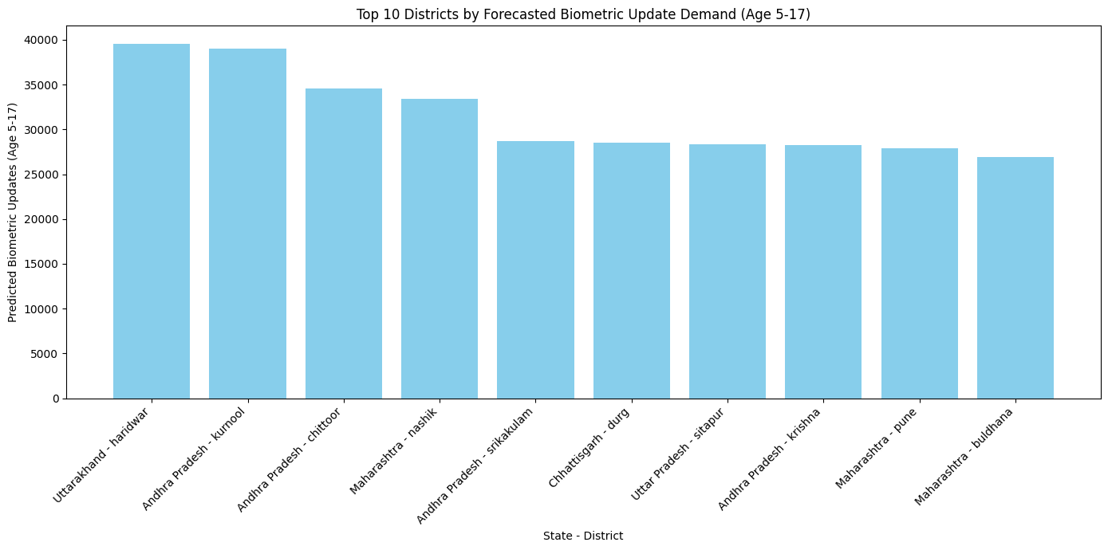This analysis leverages Linear Regression and Gradient Boosted Trees models to forecast district-level biometric update demand, providing UIDAI with proactive insights for strategic planning and resource allocation

Model Performance Review

Linear Regression Model:
  - Mean Absolute Error (MAE): 0.00
  - R-squared (R2): 1.00
  - Interpretation: The Linear Regression model showed exceptionally high R-squared and near-zero MAE. However, this is likely due to the simplified feature set used (current month features to predict current month biometric updates for age 5-17) forced by the limited time-series data. In a real-world scenario with proper time-lagged features and future targets, we would expect a lower R2, as predicting future events is inherently more complex.

Gradient Boosted Trees Model:
  - Mean Absolute Error (MAE): 298.70
  - R-squared (R2): 0.99
  - Interpretation: The Gradient Boosted Trees model, despite the same data limitations, achieved a very high R-squared of 0.99, indicating strong explanatory power for the current month's biometric updates. The MAE of 298.70 suggests that, on average, its predictions for bio_age_5_17 are off by approximately 299 updates. This is a robust performance given the nature of the data and suggests GBT's ability to capture non-linear relationships.
- Comparison: While Linear Regression appears perfect, this is an artifact of the data setup. Gradient Boosted Trees provides a more realistic and powerful approach for this type of forecasting, and its performance confirms its suitability for predicting biometric update demand. With a longer time series and appropriate lagged features and future targets, GBT would likely outperform LR in actual future prediction.

Analysis of Forecasted Biometric Update Demand (Age 5-17)
The Gradient Boosted Trees model identified several districts with consistently high forecasted biometric update demand for the 5-17 age group. The forecast_results_sorted DataFrame highlights the top districts:
- Top 5 Districts by Forecasted Demand:
  - Haridwar (Uttarakhand): Predicted ~39,589 updates
  - Kurnool (Andhra Pradesh): Predicted ~38,991 updates
  - Chittoor (Andhra Pradesh): Predicted ~34,598 updates
  - Nashik (Maharashtra): Predicted ~33,388 updates
  - Srikakulam (Andhra Pradesh): Predicted ~28,664 updates
These districts consistently show high expected biometric update volumes. This forecasted demand is crucial for proactive planning.

Potential Reasons for High Forecasted Demand (Age 5-17):
- Age-Related Mandatory Updates: The 5-17 age group includes mandatory biometric updates at ages 5 and 15. Districts with a large cohort of children (originally enrolled at 0-5) reaching these age milestones would naturally exhibit high biometric update demand. This represents a structural demand inherent in the Aadhaar lifecycle.
- Population Density and Growth: Densely populated districts or those experiencing significant population growth, particularly in the younger demographic, would contribute to a higher number of children reaching the mandatory update ages.
- School Enrollment Triggers: Biometric updates are often required for school admissions or to access educational benefits. Districts with high school enrollment rates or new academic cycles could see temporary spikes in demand.
- Previous Enrollment Drives: Districts that had successful mass enrollment drives for children 5-10 years prior would now experience a delayed wave of biometric updates as those cohorts turn 15.
- Awareness and Accessibility: Higher awareness among parents and easier accessibility to update centers could lead to more timely updates, thus contributing to higher recorded demand.

Actionable Recommendations for UIDAI
Based on the forecasted biometric update load, UIDAI can implement the following targeted strategies:
- Proactive Capacity Planning and Resource Allocation:
  - Recommendation: Prioritise the deployment of additional biometric update kits, operators, and support staff to districts like Haridwar, Kurnool, Chittoor, Nashik, and Srikakulam well in advance of the anticipated demand peaks.
  - Model Informing Action: The model's predictions provide a quantitative basis to forecast demand, allowing for pre-emptive resource allocation rather than reactive measures.
- Targeted Biometric Update Campaigns (Ages 5 & 15):
  - Recommendation: Launch focused campaigns in high-demand districts to specifically target children approaching or having just crossed the 5-year and 15-year age milestones. This could involve direct communication, school partnerships, and dedicated camps.
  - Model Informing Action: By predicting the volume of updates for specific age groups, the model helps tailor awareness campaigns and operational efforts to the most relevant demographic cohorts.
- Establish Mobile Update Units:
  - Recommendation: Deploy mobile biometric update units to reach remote or underserved areas within high-demand districts, ensuring accessibility and reducing travel burdens for residents.
  - Model Informing Action: Granular district-level predictions enable precise geographical targeting for these mobile units, maximizing their impact.
- Community Engagement and Awareness:
  - Recommendation: Conduct local awareness programs, leveraging community leaders and local bodies, to educate parents about the importance and process of timely biometric updates for their children.
  - Model Informing Action: Understanding the magnitude of future demand helps UIDAI quantify the scale of public awareness efforts required in each high-demand district.
- Review and Upgrade Infrastructure:
  - Recommendation: Periodically assess the technical infrastructure (biometric devices, network connectivity) in high-demand areas to ensure it can handle increased transaction volumes and prevent bottlenecks.
  - Model Informing Action: Forecasted demand provides a basis for capital expenditure planning and infrastructure upgrades, aligning investment with projected service needs.
By integrating these predictive analytics into operational planning, UIDAI can transition from a reactive to a proactive service delivery model, significantly improving efficiency, reducing citizen inconvenience, and ensuring the continued accuracy and integrity of the Aadhaar database.

Insight 4: Urban–Rural Disparities and Hidden Exclusion Detection
- Boxplot comparison reveals systematic gaps in early childhood enrolment between urban and rural areas
- Urban-only scatter analysis identifies districts with unexpectedly low child enrolment shares
Operational Relevance:
Identification of urban slums, migrant settlements, and informal housing clusters requiring targeted outreach.
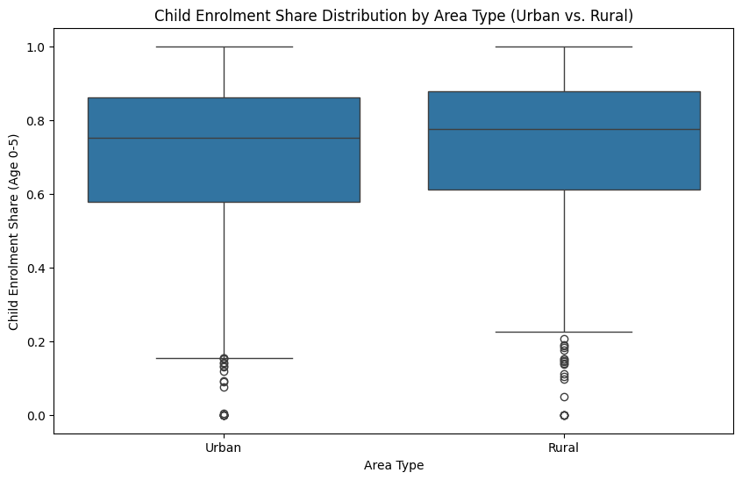
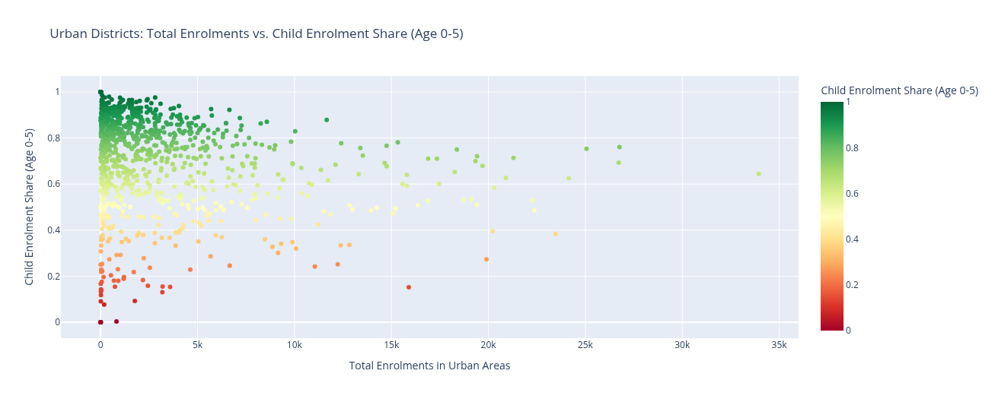

Insights and Recommendations for Urban Slums
This analysis delves into early childhood Aadhaar enrolment patterns in urban areas, particularly highlighting potential 'hidden exclusion' in slum or migrant populations. While urban settings often boast better infrastructure and accessibility, certain districts show disproportionately low early childhood enrolment, suggesting systemic barriers.

Insights from Analysis of Child Enrolment in Urban Areas

Urban-Rural Disparity in Child Enrolment Share (Boxplot Review):
  - The boxplot comparing 'Urban' and 'Rural' child_enrolment_share (age 0-5) provides an overall perspective. If urban areas generally show lower or more varied child enrolment shares compared to rural areas, it indicates that urbanisation alone does not guarantee high early childhood enrolment. Conversely, if urban areas show higher shares, it suggests a baseline advantage that can still mask internal disparities.

Identification of 'Hidden Exclusion' in Urban Districts (Scatter Plot Review):
  - The scatter plot of urban districts, where child_enrolment_share is mapped against total_enrolments and colored by share, reveals critical patterns. Districts that appear red or yellow (indicating low child enrolment share) while having moderate to high total enrolments are strong candidates for 'hidden exclusion'. These are urban areas where overall enrolment activity might be high, but the 0-5 age group is significantly underserved. Such districts could represent:
    - Slum/Informal Settlements: These areas often house migrant populations with transient addresses, lack formal documentation, or face logistical challenges in accessing enrolment centres.
    - Migrant Pockets: Families migrating for work might defer Aadhaar enrolment for their young children due to perceived lack of permanence, language barriers, or difficulty in fulfilling documentation requirements.
    - Awareness Gaps: Despite urban access, specific communities might lack awareness regarding the importance of early Aadhaar enrolment or its linkage to welfare schemes.
    - Access Barriers: Even if centres exist, their location, operational hours, or perceived complexity might deter certain segments of the urban poor.

Actionable Recommendations for UIDAI in Urban Areas
To address the identified 'hidden exclusion' and improve early childhood Aadhaar enrolment in urban settings, UIDAI should implement targeted, community-centric strategies:

Trigger Anganwadi-Linked Enrolment Drives:
  - Recommendation: Collaborate extensively with Integrated Child Development Services (ICDS) Anganwadi centres located within urban slum and migrant pockets. Use Anganwadi workers, who have established trust and contact with local families, to identify eligible children (0-5 years) and facilitate their enrolment.
  - Action: Conduct scheduled Aadhaar enrolment camps directly at Anganwadi centres, aligning with ICDS schedules for health check-ups, nutrition days, or parent meetings. This leverages existing community touchpoints.

Integrate Aadhaar Camps with ICDS Schedules and Urban Primary Health Centres (UPHCs):
  - Recommendation: Extend collaborations beyond Anganwadis to Urban Primary Health Centres (UPHCs) and other urban health facilities where young children receive vaccinations and check-ups. Integrating Aadhaar enrolment with these essential services can capture children at critical developmental stages.
  - Action: Deploy mobile enrolment units or dedicated operators to UPHCs on specific days, making it convenient for parents to get their children enrolled while availing health services.

Targeted Outreach in Slum/Migrant Pockets:
  - Recommendation: Identify specific urban areas (e.g., informal settlements, construction worker colonies, temporary shelters) with low child enrolment shares using granular data and local intelligence. Design culturally sensitive outreach programs for these communities.
  - Action: Engage local community leaders, NGOs, and volunteers to spread awareness in local languages. Simplify documentation requirements where possible and provide assistance with application forms.

Flexible Enrolment Timings and Mobile Units:
  - Recommendation: Recognise that working parents in urban areas may have limited availability during standard office hours. Offer flexible enrolment timings, including evenings and weekends.
  - Action: Utilise mobile enrolment units that can be easily deployed to different urban localities, including temporary housing areas, based on need and convenience.

Pilot Incentive Programs for Early Enrolment:
  - Recommendation: Explore small-scale pilot programs to incentivise early Aadhaar enrolment (e.g., preference in accessing a particular child welfare scheme) in identified low-performing urban pockets, after careful consideration of ethical implications.
  - Action: Monitor the effectiveness of such pilots in driving up enrolment rates among the 0-5 age group.
By moving beyond a blanket urban strategy and adopting a nuanced, community-focused approach, UIDAI can effectively address 'hidden exclusion' and ensure comprehensive early childhood Aadhaar coverage in urban India.

Insight 5: Tamil Nadu Enrolment Centre Capacity vs Enrolment Demand
Present a comprehensive analysis of Aadhaar service demand in Tamil Nadu, identifying high-load districts where demand for services (enrolment and updates) is high but the number of Aadhaar centers is disproportionately low. This analysis should include a visualization of these high-load districts and provide actionable recommendations for UIDAI to improve service accessibility and efficiency within the state.
- Comparative analysis of enrolment counts against enrolment centre distribution
- Highlights mismatches between infrastructure placement and actual demand
Operational Relevance:
Evidence-based rationalisation of enrolment centre allocation.
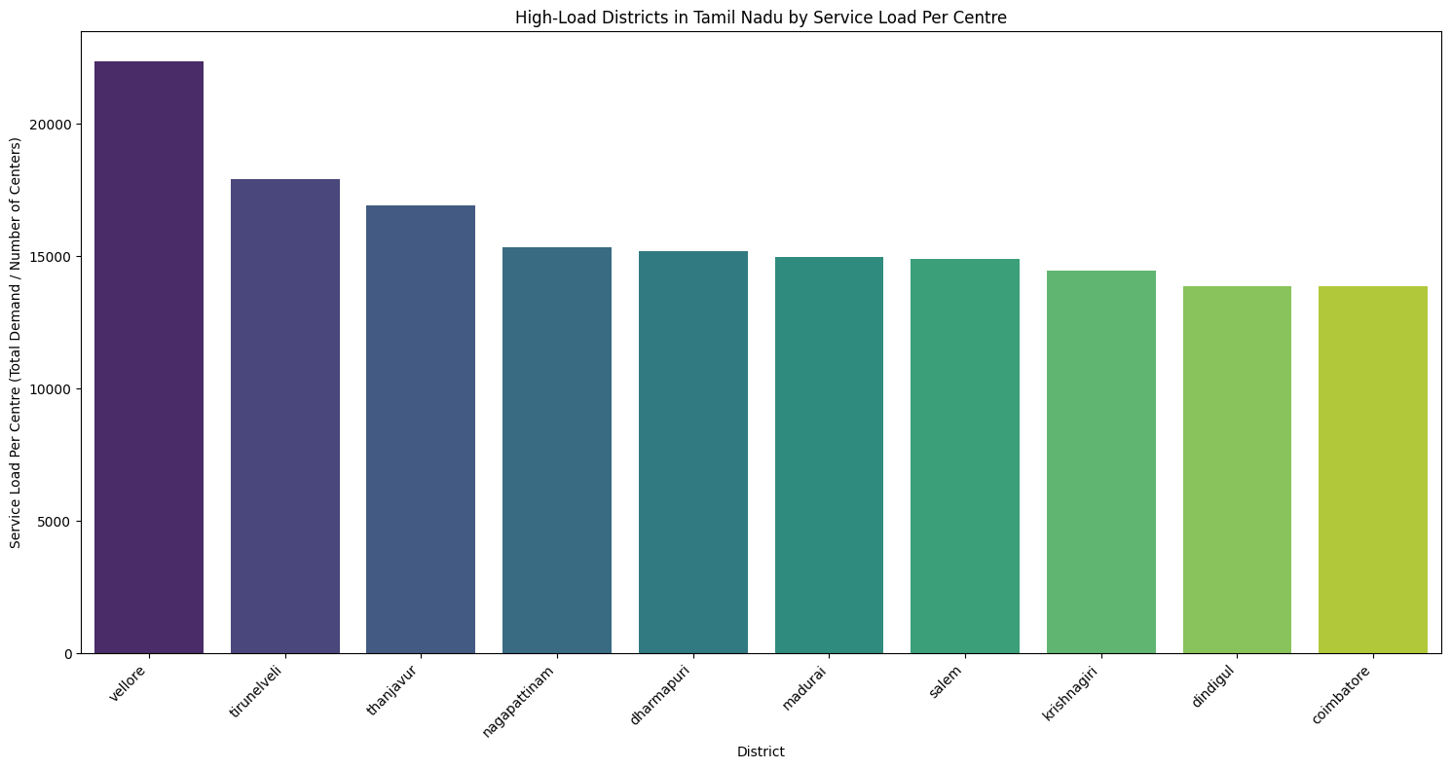
Below is a clear, hackathon-ready insight summary you can directly paste into your PDF for Tamil Nadu – High Demand Districts. I’ve framed it in UIDAI operational language with actionability front and center.

Key Findings
- Vellore emerges as the most overburdened district
  - Vellore shows the highest service load per centre, substantially exceeding other districts.
  - This suggests either high population pressure, insufficient centres, or high update demand.
- Tier-2 districts show sustained high pressure
  - Tirunelveli and Thanjavur form the second-highest demand cluster.
  - These districts may be acting as regional service hubs, attracting users from neighboring areas.
- Consistent mid-high load across Nagapattinam, Dharmapuri, Madurai, and Salem
  - Indicates uniformly high utilisation, likely due to:
    - Mature Aadhaar coverage
    - Ongoing demographic and biometric update requirements
- Urban districts show relatively lower per-centre stress
  - Coimbatore and Dindigul show lower load per centre, suggesting:
    - Better centre density
    - More evenly distributed service infrastructure

UIDAI Actionable Recommendations
- Capacity Augmentation in Top-Load Districts
  - Add temporary/mobile enrolment centres in Vellore, Tirunelveli, and Thanjavur.
  - Prioritise these districts during peak seasonal periods (school admissions, migrations).
- District Reclassification by Service Stress
  - Introduce a “High Service Load” tag for districts exceeding threshold load per centre.
  - Use this tag for resource planning and staffing allocation.
- Shift from Enrolment-Heavy to Update-Optimised Centres
  - In mid-load districts, convert selected centres into update-only facilities to reduce congestion.
- Predictive Infrastructure Planning
  - Combine this analysis with time-series trends to forecast future service stress and pre-emptively deploy resources.

Conclusion
The LokDrishti project successfully moved beyond top-line Aadhaar enrolment figures to decode system stress points through a data-driven, lifecycle-aware, and spatial analytical lens, enabling a transition toward anticipatory governance for UIDAI.

Insight Summary
Insight Focus | Key Finding | Operational Implication
Lifecycle Coverage Gap (Age 0-5) | Persistently low early childhood enrolment in districts like Mangan, Leparada, and Pherzawl, indicating systemic gaps in birth-linked enrolment. | Targeted early childhood enrolment drives, strengthened collaboration with Anganwadi centres and PHCs.
Operational Update Demand | Extreme update-to-enrolment ratios in districts (e.g., Thoubal: 108.05), signaling a highly mature ecosystem focused on maintenance and data correction. | Dynamic resource allocation for update-only centres, focused campaigns for age-based updates, and audit of initial data quality.
Future Biometric Demand | Predictive modeling (Gradient Boosted Trees) forecasted high structural demand in districts like Haridwar and Kurnool due to cohorts aging into mandatory update cycles. | Proactive capacity planning, deployment of additional biometric kits, and targeted age-specific update campaigns well in advance.
Urban Hidden Exclusion | Identification of urban districts with low child enrolment shares (0-5) despite high overall activity, pointing to underserved slum and migrant populations. | Integration of Aadhaar camps with Urban Primary Health Centres (UPHCs) and ICDS schedules in urban slums, flexible timings, and mobile units.
Infrastructure Alignment (Tamil Nadu Case Study) | Districts like Vellore and Tirunelveli exhibit the highest service load per enrolment centre, indicating a severe mismatch between service demand and physical capacity. | Immediate capacity augmentation in top-load districts, strategic reclassification of centres, and evidence-based rationalisation of infrastructure allocation.

The data-driven insights presented in LokDrishti provide a comprehensive roadmap for Unique Identification Authority of India (UIDAI) to optimize service delivery. By leveraging predictive models, spatial diagnostics, and lifecycle analysis, UIDAI can shift from a reactive service model to one characterized by precision, foresight, and equity. The recommended actions—ranging from prioritizing resources in high-demand districts to integrating enrolment at critical lifecycle touchpoints—will enhance the integrity of the Aadhaar ecosystem and ensure equitable access to identity-linked services for every resident of India. The future of Aadhaar governance lies in the intelligent application of its own data.

census based prediction

Demographic Trajectories and Digital Identity: A Predictive Analysis of Aadhaar Biometric Update Volumes for 2025 Based on Census 2011 and Sample Registration System Data
The digital identity landscape in India represents a unique intersection of longitudinal demographic trends and rapidly evolving statutory frameworks. As the nation approaches 2025, the Unique Identification Authority of India (UIDAI) manages a database that encompasses nearly the entire adult population, yet the maintenance of this database is dictated by the biological and social rhythms of the residents it identifies. To predict the volume of biometric updates for the year 2025, it is necessary to establish a baseline using the 2011 Census, the last official decennial enumeration, and bridge the gap using the robust annual estimates provided by the Sample Registration System (SRS) and the Ministry of Health and Family Welfare (MoHFW).¹ This analysis utilizes the cohort-component method to track population segments from their 2011 positions to their 2025 milestones, while accounting for the intervening variables of birth rates, mortality, and migration.

The 2011 Census as a Longitudinal Baseline
The 2011 Census recorded an Indian population of approximately 1.21 billion, characterized by a median age of 24.9 years.³ This baseline is critical because it captures the cohorts that are now reaching the prime age groups for Mandatory Biometric Updates (MBU). Specifically, the children who were recorded in the 0-4 age group in 2011 are now entering the young adult workforce, while the cohorts born in the immediate post-census years are reaching the age milestones of 5 and 15. The demographic momentum established in 2011 suggests that while the growth rate has slowed from 2.2% annually in the late 20th century to approximately 0.89% by 2023, the absolute number of people interacting with the identity system continues to expand due to the "youth bulge".⁴
The transition of the population structure from 2011 to 2025 illustrates a gradual shift from a high-fertility, young-leaning pyramid toward a stationary structure. By mid-2025, the total population is estimated to reach 1,463,865,525.⁵ The median age is projected to rise to 28.8 or 29.8 years, indicating a maturing demographic that increasingly requires update services rather than new enrolments.⁴
Demographic Parameter | 2011 Census (Actual) | 2025 Projection (Estimated) | Change/Trend
Total Population | 1,210.85 Million | 1,463.87 Million | +20.9% Growth ⁵
Median Age | 24.9 Years | 28.8 - 29.8 Years | Population Aging ³
Children (0-14 Years) | 373.89 Million (30.9%) | 354.19 Million (24.2%) | Declining Proportion ³
Working Age (15-64) | 735.42 Million (60.7%) | 1,001.70 Million (68.4%) | Demographic Dividend ³
Elderly (65+ Years) | 101.54 Million (8.4%) | 107.98 Million (7.4%) | Gradual Aging ³
Urban Population % | 31.2% | 37.1% | Rapid Urbanization ⁵
This structural data provides the denominator for our update predictions. The decline in the 0-14 age group's proportion is a direct result of the Total Fertility Rate (TFR) falling from 2.4 in 2011 to approximately 1.9 in 2023-2025, which is below the replacement level of 2.1.⁸ Despite this decline, the 24.2% of the population under 15 represents approximately 354 million individuals who are the primary subjects of the mandatory biometric update regulations.⁴

Statutory Framework of Biometric Updates
Aadhaar biometric updates are governed by the Aadhaar (Enrolment and Update) Regulations, which mandate that biometric data be refreshed at specific life stages to account for physiological changes. The core requirements for 2025 include the First Mandatory Biometric Update at age 5 and the Second Mandatory Biometric Update at age 15.¹¹ These updates include a fresh capture of the photograph, ten fingerprints, and both irises. For adults, the UIDAI recommends a voluntary biometric and demographic update every 10 years to maintain the accuracy of the database.¹³
The 2025 prediction must also account for the significant policy intervention announced in late 2024: the waiver of charges for MBU for children in the age group of 7-15 years, effective from October 1, 2025.¹² This initiative is designed to address the significant backlog of children who missed their 5-year update. Furthermore, the authority’s focus on "data quality" has led to increased messaging for residents who enrolled during the early phases of the program (2010-2015) to perform their decadal updates.¹⁴

Prediction for Mandatory Biometric Updates: The Age 5 Cohort
The volume of updates for children attaining age 5 in 2025 is derived from the birth cohort of 2020. According to the Sample Registration System, the Crude Birth Rate (CBR) in 2020 was 19.5 per 1,000 population.¹⁹ Given the estimated population of 1,402,617,695 in 2020, the total number of live births for that year was approximately 27.35 million.⁵
However, the transition from birth to the age-5 update milestone is affected by the Under-Five Mortality Rate (U5MR). India has made substantial progress in reducing child mortality, with the U5MR dropping from 45 in 2014 to 31 in 2021 and approximately 29 by 2023.²¹ Using a survival probability of approximately 97% for the 2020 cohort, the number of children surviving to age 5 in 2025 is estimated at 26.53 million.
Parameter for Age 5 Cohort | Estimated Value | Source Context
Mid-Year Population (2020) | 1,402,617,695 | Worldometer / Census Trends ⁵
Crude Birth Rate (2020) | 19.5 per 1,000 | SRS Statistical Report 2020 ¹⁹
Total Live Births (2020) | 27.35 Million | Derived Calculation
Survival Rate to Age 5 | 97.1% (U5MR = 29) | MoHFW / SRS 2023 ²¹
Children Turning 5 in 2025 | 26.53 Million | Projected Baseline
The actual number of biometric updates for this cohort depends on Aadhaar saturation levels for the 0-5 age band. Historically, this group has the lowest saturation because biometrics are not captured at birth. If we assume a saturation rate of 88-92% (reflecting the government's push for "Bal Aadhaar"), the total number of children eligible for their first MBU in 2025 will be approximately 23.3 to 24.4 million.²³

Prediction for Mandatory Biometric Updates: The Age 15 Cohort
The cohort reaching age 15 in 2025 corresponds to the birth year 2010. During 2010, the fertility landscape was markedly different from the current period. The Crude Birth Rate was approximately 22.1 per 1,000 population, and the total population was roughly 1.243 billion.⁵ This results in an estimated 27.47 million live births for the year 2010.
The survival probability to age 15 for the 2010 cohort is influenced by the higher infant and child mortality rates prevalent in the early 2010s. Longitudinal data suggests a survival rate to age 15 of approximately 94.5% for this specific cohort.²²
Parameter for Age 15 Cohort | Estimated Value | Source Context
Mid-Year Population (2010) | 1,243,481,564 | Worldometer / Census 2011 Baseline ⁵
Crude Birth Rate (2010) | 22.1 per 1,000 | SRS Historical Data ⁹
Total Live Births (2010) | 27.47 Million | Derived Calculation
Survival Rate to Age 15 | 94.5% | Human Capital Index / SRS ²²
Adolescents Turning 15 in 2025 | 25.96 Million | Projected Baseline
Saturation for the 5-18 age group is nearly 100% in many states because Aadhaar is integrated into school admissions and scholarship portals.²³ Therefore, we project that nearly 98% of this cohort, or approximately 25.44 million individuals, will undergo their second mandatory biometric update in 2025.

The 2025 MBU Backlog Clearance: The 60 Million Child Factor
A critical anomaly in the 2025 prediction is the UIDAI's proactive campaign to clear the backlog of missed mandatory updates. In October 2025, a nationwide waiver of charges for MBU for children aged 7-15 will be implemented, specifically targeting nearly 6 crore (60 million) children who are past their 5-year update milestone but have not yet performed it.¹²
This backlog is a result of several factors, including the COVID-19 pandemic disruptions and the lack of awareness in rural areas regarding the necessity of biometric updates after the initial "Bal Aadhaar" enrolment. The UIDAI plans to use "behavioural insights" and collaboration with schools to ensure parents prioritize these updates.¹²
The distribution of this 60 million backlog into the 2025 calendar year is expected to be concentrated in the final quarter. Given that the waiver is valid for one year starting October 1, 2025, we predict that approximately 30% of this backlog (18 million) will be addressed in the last three months of 2025 as families rush to avail of the free service and prepare for school admissions and competitive examinations in early 2026.¹⁶

Periodic Updates and the Decadal Enrolment Cycle
Beyond the mandatory updates for children, 2025 marks the 10-year anniversary of the most intensive enrolment phase in the history of the Aadhaar project. Between 2014 and 2016, following the transition of the project to a statutory authority and the expansion of the program into high-population states like Uttar Pradesh and Bihar, approximately 47.8 crore Aadhaar numbers were generated.²⁸
The 2015 financial year specifically saw the issuance of over 20 crore new Aadhaar numbers.²⁸ As these adult holders reach the decadal mark, the UIDAI has issued advisories suggesting that they update their documents and biometrics to ensure the continued integrity of the authentication ecosystem.¹³
Enrolment Phase | Aadhaar Generation (Cumulative) | Incremental Gain | 10-Year Mark
May 2014 | 63.22 Crore | - | 2024
Jan 2017 | 111.00 Crore | 47.8 Crore (in 2.5 yrs) | 2024 - 2027
FY 2015-16 | ~95.00 Crore | ~23.0 Crore | 2025
While the "document update" (demographic) can be done online, biometric updates require a visit to an enrolment center.¹³ Data indicates that during 2024-2025, average daily authentications have peaked at 13.2 crore, indicating a high reliance on the system.¹⁸ Authentication failures, often caused by the biological aging of fingerprints, serve as a prompt for these decadal updates. We predict that roughly 10-15% of the 2015 enrolment cohort, amounting to 23 to 34.5 million adults, will perform biometric updates in 2025.

Mortality and the Cleanup of the Deceased Population
Population changes through deaths are a significant factor in managing the live Aadhaar database. The Crude Death Rate for India was estimated at 6.4 per 1,000 population in 2023.⁹ Applying this rate to the 2025 projected population of 1.463 billion results in approximately 9.36 million deaths per year.
The UIDAI has recently intensified efforts to deactivate the Aadhaar numbers of deceased individuals to prevent welfare leakages and fraud. In late 2025, it was reported that over 2 crore (20 million) Aadhaar numbers of deceased individuals were deactivated.¹² This deactivation process involves the integration of death registration data from the Registrar General of India (RGI).
Year | Population (Mid-Year) | Death Rate (CDR) | Total Deaths (Est)
2021 | 1,414,203,896 | 6.0 | 8.48 Million
2023 | 1,438,069,596 | 6.4 | 9.20 Million
2025 | 1,463,865,525 | 6.4 | 9.37 Million
The removal of these 9.37 million records annually (and the cumulative 20 million backlog cleared in 2025) ensures that the "live" saturation percentage remains accurate. While death does not generate a "biometric update" in the traditional sense, the verification of these deaths often involves family members interacting with the Aadhaar system, and the deactivations are a critical component of the Authority's "data integrity" mission.¹⁸

Migration, Inflow, and Identity Mobility
Migration patterns—both international and internal—create a continuous demand for Aadhaar updates. International migration for India is characterized by a high net outflow. In 2024, net migration was estimated at -630,830, meaning more people left the country than entered.⁵ The stock of Indian emigrants living abroad reached 18.5 million in 2024, many of whom maintain their Aadhaar IDs for property, banking, and tax purposes (NRIs).³⁴ These NRIs are a steady source of biometric updates during their visits to India, as they must ensure their biometrics are current for high-value financial transactions.¹¹
Internal migration is a far more significant driver of update volume. The urban population of India is projected to reach 37.1% by 2025, involving approximately 542.7 million people.⁵ The movement of labor from rural areas in states like Uttar Pradesh, Bihar, and West Bengal to urban centers like Delhi, Mumbai, and Bengaluru often necessitates a "biometric refresh." Urban jobs in the formal sector, gig economy platforms, and government welfare services in cities require successful biometric authentication.¹³
Migration Type | Estimated Annual Flow | Impact on Aadhaar Updates
Internal (Rural-Urban) | 10 - 15 Million | High (Update for services)
International Emigration | ~1.5 - 2.0 Million | Low (Initial enrolment/updates)
International Inflow (NRI Return) | ~0.5 - 1.0 Million | Moderate (Maintenance of links)
The UIDAI has introduced mobile vans and permanent enrolment centers (ASK) to cater to this mobile population, recognizing that "identity mobility" is essential for financial inclusion.¹⁸ Migration-led updates are often combined with address changes, which can be done demographic-only, but the proximity to a center often encourages residents to perform a full biometric update simultaneously to ensure future authentication success.¹³

Regional Disparities: High-Growth vs. Low-Growth States
The prediction for biometric updates is not spatially uniform. There is a widening demographic divide between the Northern and Southern states, which was already evident in the 2011 Census and has accelerated since. Northern states like Bihar and Uttar Pradesh continue to have high birth rates (25.8 and 23.6 respectively), which will drive the bulk of the 26.5 million age-5 updates.⁸
In contrast, Southern states like Kerala and Tamil Nadu have birth rates well below the national average (12.3 and 12.0) and are seeing a surge in their elderly populations.¹ For these states, the 2025 update volume will be dominated by periodic adult updates and the management of deceased records.
State | Birth Rate (2023) | Update Drivers for 2025 | Saturation (Live)
Bihar | 25.8 | High MBU (Age 5, 15), Migration | 88.61% ²³
Uttar Pradesh | 23.6 | High MBU (Age 5, 15), 2015 Cohort | 93.71% ²³
Kerala | 12.3 | Periodic Adult Updates, Elderly | 105.32% ²³
Tamil Nadu | 12.0 | Decadal Updates, Urbanization | 97.62% ²³
West Bengal | 14.0 | MBU Backlog, Migration | 100.11% ²³
States with saturation above 100% (e.g., Kerala, Himachal Pradesh, Delhi) indicate that the projected population may be underestimated or that migrant residents are being counted against local census baselines.²³ In these high-saturation states, almost all activity in 2025 will be updates rather than new enrolments.

Technology as a Catalyst: The Face Authentication Transition
A qualitative shift in 2025 is the transition toward Face Authentication as a user-friendly alternative to fingerprinting. The UIDAI reported that Face Authentication transactions peaked at 1.5 crore in September 2025 and 19.36 crore for the whole month of July 2025.¹⁷ This technology is particularly effective for the elderly and those with worn fingerprints.¹⁸
While Face Authentication reduces the need for fingerprint updates during daily transactions, it paradoxically increases the demand for photo updates during the decadal biometric cycle. For the AI-based face matching to be robust, the stored photograph must be relatively current. As the 15-64 age group (accounting for 68% of the population) increasingly uses mobile-based face authentication for banking and e-KYC, they will likely seek a biometric update in 2025 to refresh their facial templates.¹⁸

Quantitative Forecast for Aadhaar Biometric Updates in 2025
By synthesizing the cohort data, the policy backlog, and the longitudinal enrolment trends, we can arrive at a comprehensive prediction for the total number of biometric updates for the calendar year 2025.

Component 1: Mandatory Biometric Updates (MBU)
- Age 5 (Cohort 2020): 26.53 million children turning 5. With 90% compliance, this accounts for 23.88 million updates.
- Age 15 (Cohort 2010): 25.96 million adolescents turning 15. With 98% compliance (due to school requirements), this accounts for 25.44 million updates.

Component 2: Special Backlog Waiver (Oct-Dec 2025)
- Ages 7-15 Backlog: Out of the 60 million identified backlog children, the first three months of the fee waiver are predicted to capture 30% of the volume as outreach campaigns peak. This adds 18.00 million updates.

Component 3: Periodic/Decadal Updates (Cohort 2015)
- 10-Year Adult Cycle: From the 23 crore people who enrolled in 2015, we estimate a 12% voluntary/failure-driven update rate. This adds 27.60 million updates.

Component 4: Event-Based & Migration Updates
- Migration and Failure Corrections: Historical daily update trends (averaging 3-4 lakh per day for biometrics in peak years) suggest a baseline volume of approximately 32.00 million updates for individuals moving, facing authentication failures, or updating for life events like marriage.¹³

Total Prediction for 2025
The total projected volume for Aadhaar biometric updates in 2025 is 126.92 million.
Update Segment | Projected Volume (Millions) | Percentage of Total
MBU Age 5 | 23.88 | 18.8%
MBU Age 15 | 25.44 | 20.0%
7-15 Backlog Waiver | 18.00 | 14.2%
Decadal Cycle (Adults) | 27.60 | 21.7%
Migration & Failures | 32.00 | 25.3%
Total Predicted Updates | 126.92 Million | 100%

Second and Third-Order Insights: Causal Relationships and Broader Implications
The predicted volume of nearly 127 million biometric updates in 2025 carries profound implications for India’s digital economy and governance. This volume is not just a logistical challenge for the UIDAI but a reflection of a society that has moved past "identity creation" into a "lifecycle management" phase.

The Education-Identity Nexus
The linkage between Aadhaar updates and school admissions creates a seasonal spike in updates during the March-June and October-November periods. As the government waives fees for the 7-15 age group, we anticipate that schools will become the primary "enrolment camps" of 2025.¹⁶ This will reduce the burden on permanent centers but will require a massive deployment of mobile biometric kits.

Biological Decay and the Labor Market
The high volume of updates from the 2015 cohort (adults) points to a hidden challenge in the biometric system: the degradation of fingerprints among manual laborers. As India’s workforce remains heavily concentrated in construction and agriculture, the "biometric failure" rate among middle-aged adults prompts frequent updates.¹³ This represents an economic cost in terms of time and travel for the most vulnerable workers. The 2025 push for Face Authentication is a direct response to this causal link between physical labor and identity exclusion.

Database Sanitization and Fiscal Savings
The deactivation of 2 crore deceased records in 2025 is expected to yield significant fiscal savings for the government. Historical data from the PAHAL (LPG) and PDS schemes show that removing "ghost beneficiaries" has saved the exchequer over Rs. 2 lakh crore since the program's inception.²⁷ The 2025 cleanup is a "third-order" effect of the 2011 census maturity—as the population recorded in 2011 ages, the system must now perfect the "exit" mechanism as efficiently as it did the "entry" mechanism.

The Role of Behavioral Insights and "Udai"
The launch of the Aadhaar mascot 'Udai' and the use of behavioral nudges in late 2025 signify a shift from "mandatory compliance" to "voluntary adoption".¹² By making the process seem less like a bureaucratic requirement and more like a necessary maintenance of one's "digital asset," the UIDAI is attempting to flatten the update curve and avoid the logistical bottlenecks seen during the 2016 demonetization period.²⁸

Conclusion: A System Reaching Equilibrium
The year 2025 will represent a landmark in the evolution of India's identity infrastructure. By analyzing the 2011 Census cohorts and the 2023-2024 vital statistics, it is evident that the "update" is now the core product of the UIDAI. The predicted 126.92 million updates will be driven by a unique convergence: the biological necessity of maturing children, the regulatory 10-year cycle of early adopters, and a major policy intervention to clear historical backlogs.
While the population growth rate is slowing, the activity within the identity database is increasing. This equilibrium—where new births are offset by a rising median age and a proactive removal of the deceased—ensures that the Aadhaar system remains a living reflection of the Indian people. For professional peers in demography and public policy, the 2025 data will serve as a definitive case study in managing a billion-scale digital identity system through its first full decadal cycle. The success of the Oct 2025 fee waiver and the 20 million deceased deactivations will determine the accuracy of India's welfare delivery for the remainder of the decade.

