* **Atomicity - Either all or none**

**If any subprocesses fail – rollback all**

**Failed transaction cannot be resumed, it will restart**

* **Consistency**

**Before transaction starts and after the transaction is completed sum of total money should be same**

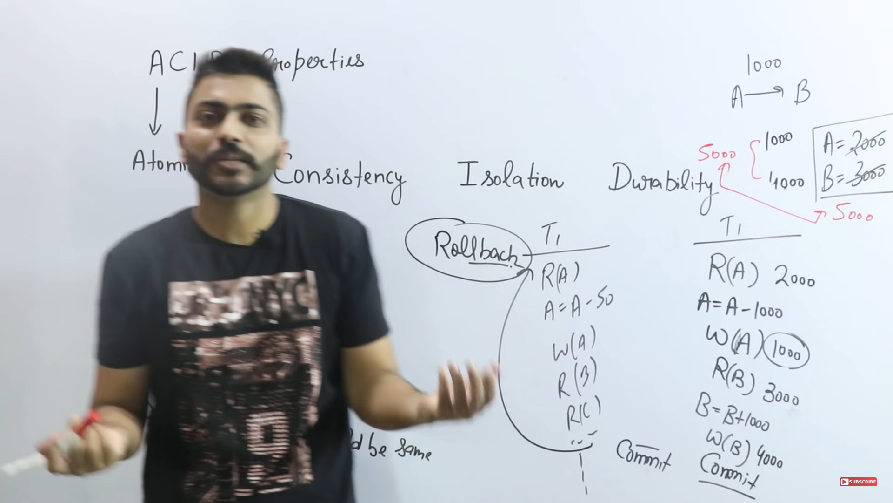

* **Isolation**

**Convert parallel schedule into serial that’s isolation. Serial is always consistent. Multiple transaction occur independently without interference**

* **Durability**

**All changes in database should be permanent. Once you made those changes it will be there for eternity unless u change. The changes of successful transaction occurs even if the system failure occurs**

Transaction management system