**MYSQL (task-2)**

1. **To find the address (Location_ id, street _ address, city, state _ province, country_ name) of all the departments by using natural join.**

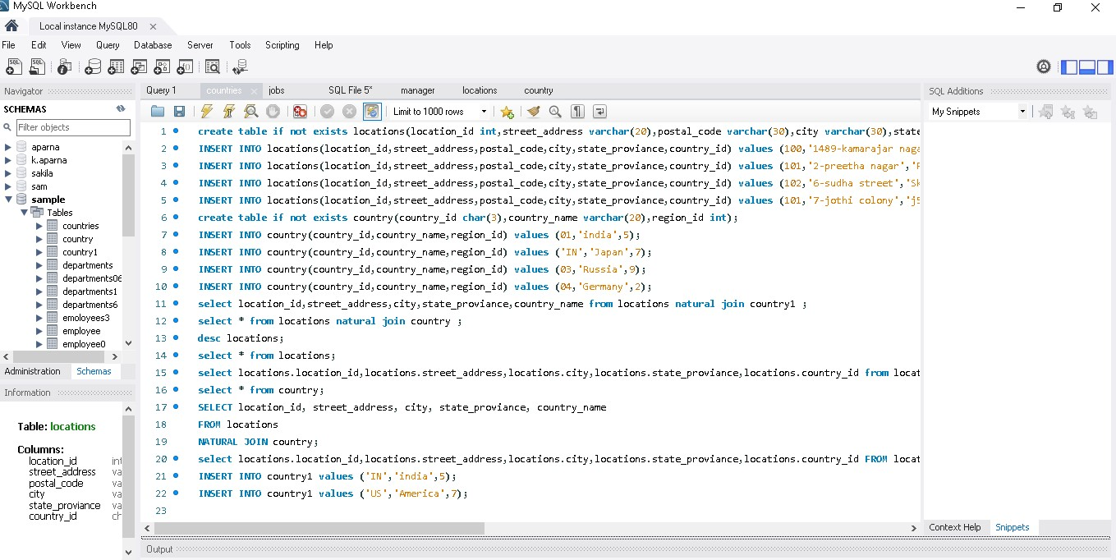

**Output:**

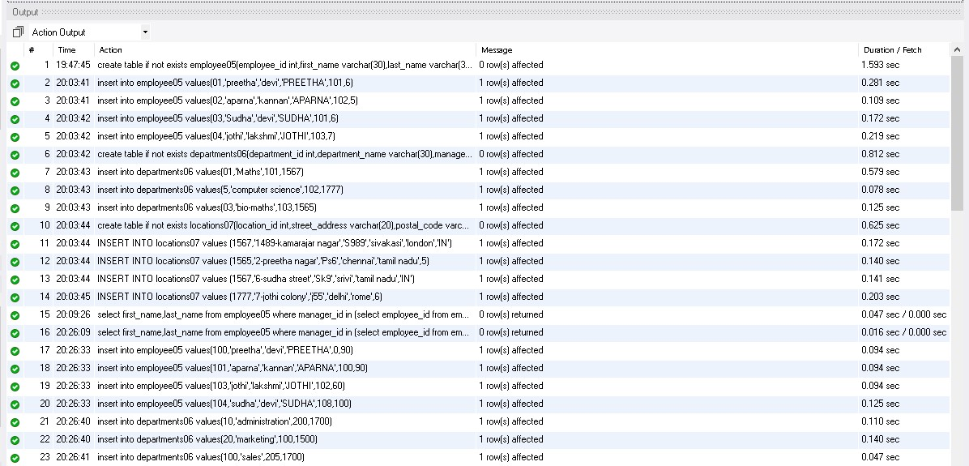

**Output Table:**

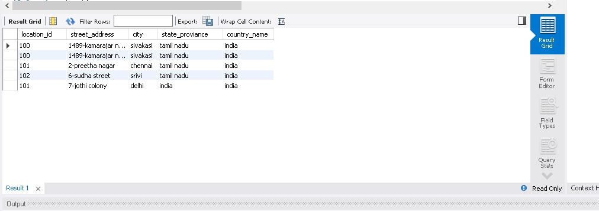

1. **To find the name(first_ name, last_ name) department_ id and name of all the employees.**

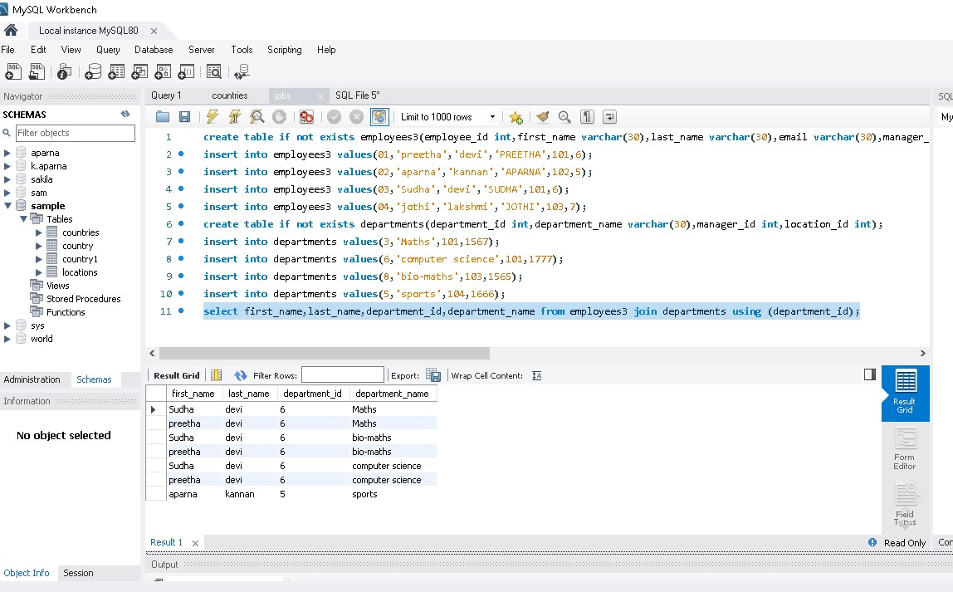

**Output :**

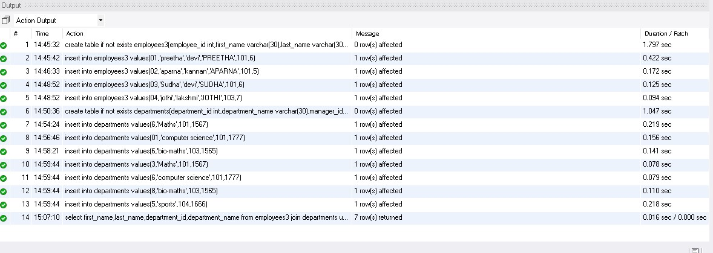

1. **To find the name (first_ name, last_ name), job, department_ id and name of the employees who works in London.**

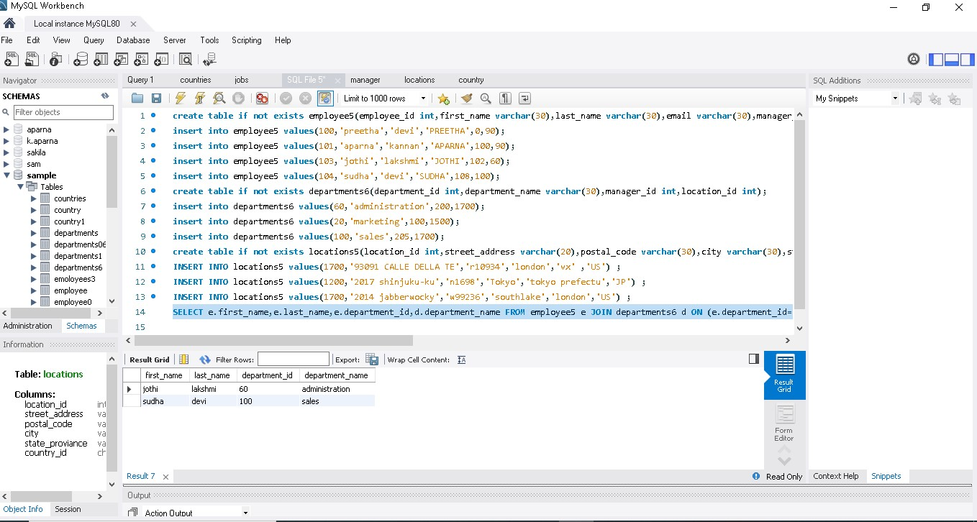

**Output table:**

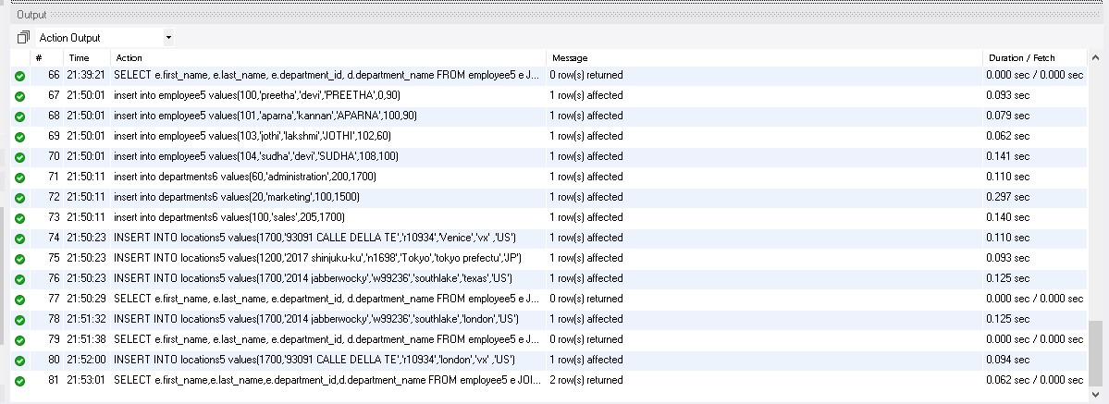

1. 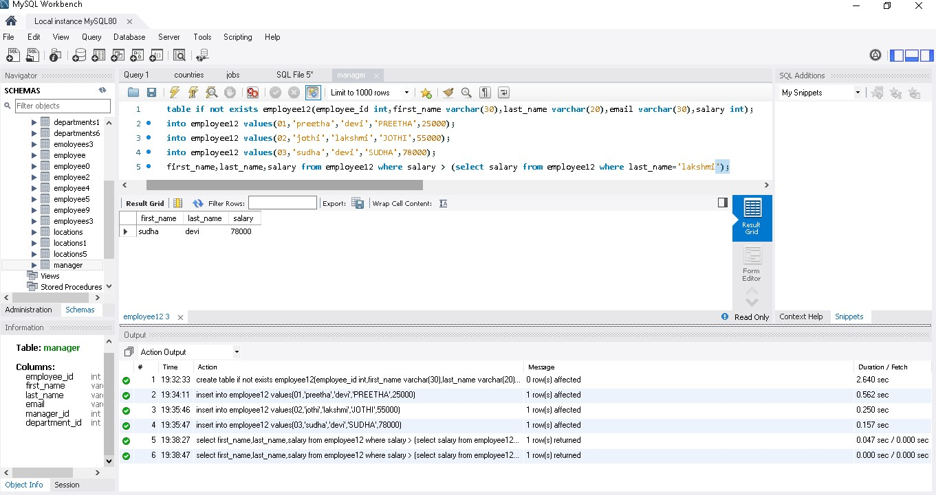**To find the name (first_ name, last_ name) and the salary of the employees who have a higher salary than the employee whose last_ name = ’ Lakshmi ’.**
2. **To find the name (first _ name, last_ name) of the employees who have a manager and worked in a USA based department.**

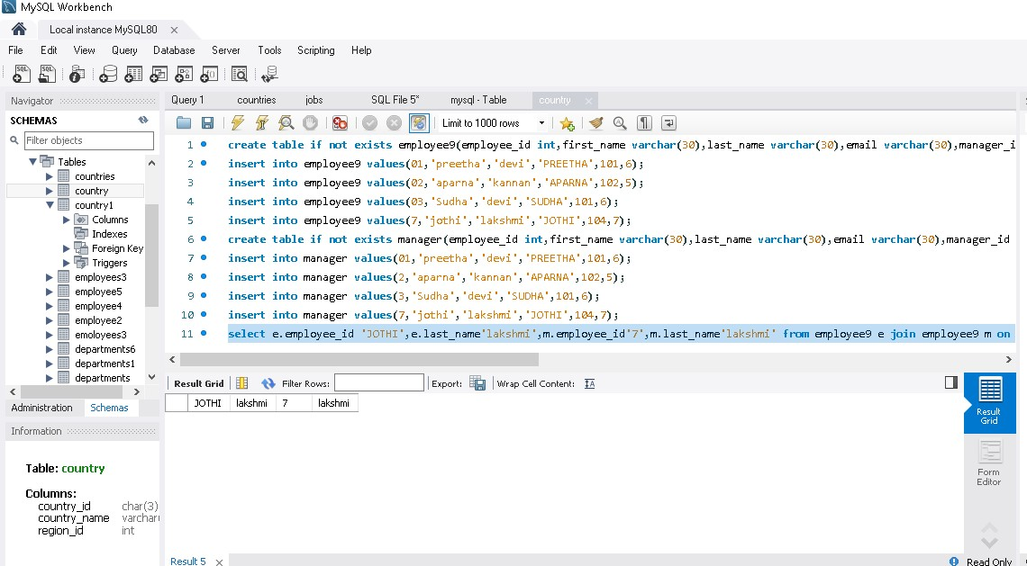

**Output :**

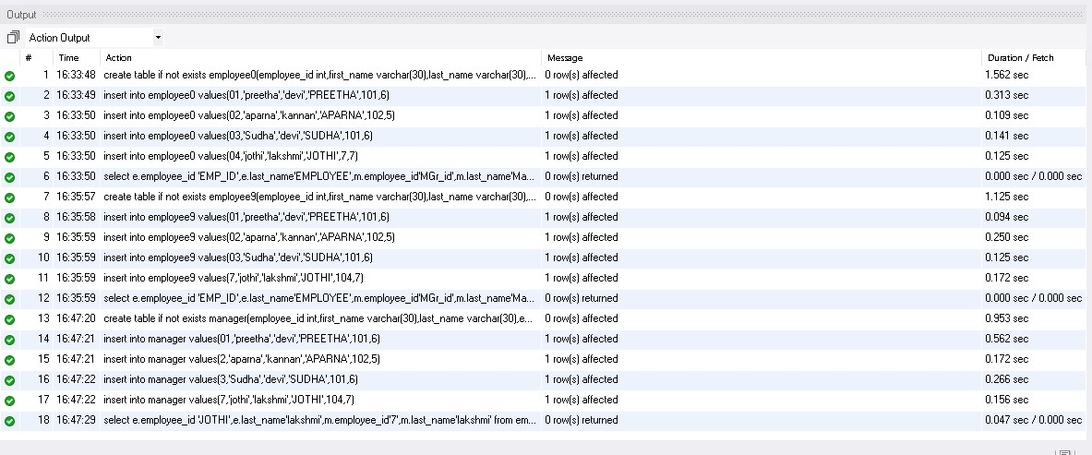

1. **To find the name (first_ name, last_ name) of the employees who are managers.**

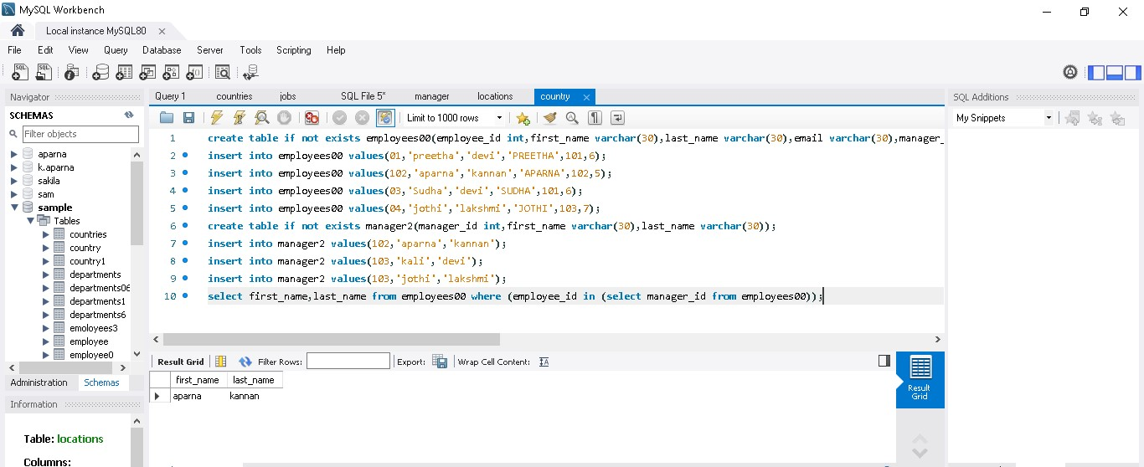

**Output table :**

