**TRIGGERS**

create database test;

use database test;

create table employee(id integer primary key, name varchar(20), sal integer);

insert into employee values(1,'aparna',80000),(2,'sneha',70000),(5,'rameez',90000);

create table audit(id integer primary key,name varchar(20),sal integer, action varchar(30),time datetime);

**INSERT**

delimiter $$

create trigger trig_insert

before insert on employee

for each row

begin insert into audit

set id = new.id, name = new.name, sal = new.sal, action= 'insert', time = now();

end$$

Insert into employee values(3,’ram’,50000);

select * from audit;

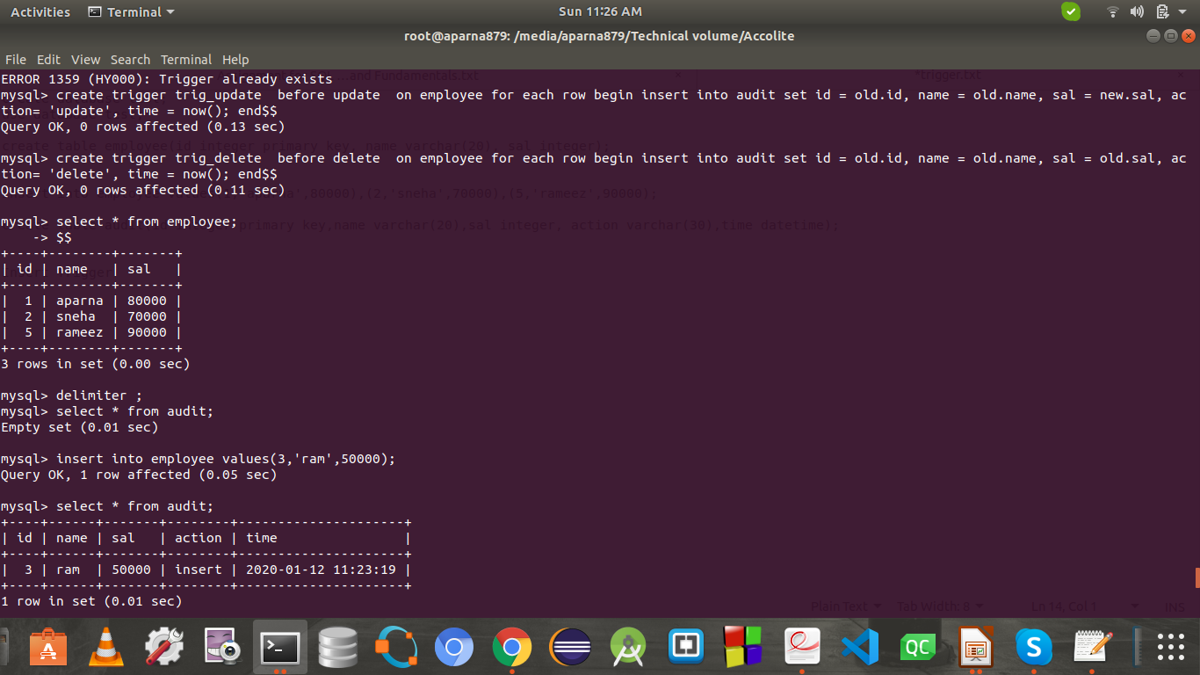

**UPDATE**

create trigger trig_update

before update on employee for each row

begin

insert into audit set id = old.id, name = old.name, sal = new.sal, action= 'update', time = now(); end$$

update employee set sal = 120000 where id =1;

Select * from employee;

Select * from audit;

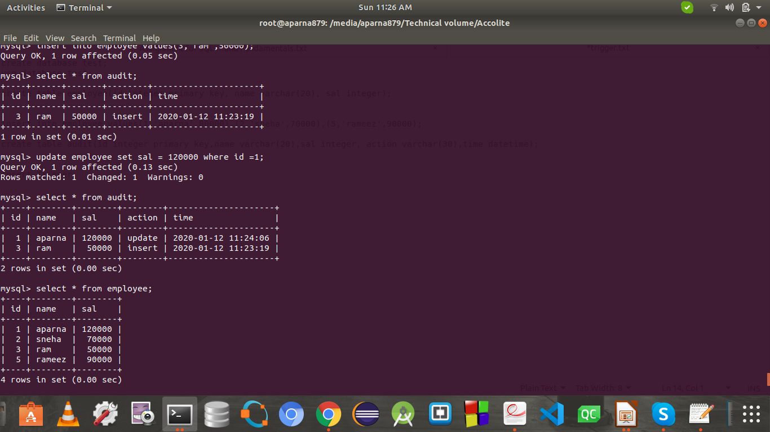

**DELETE**

create trigger trig_delete

before delete on employee for each row

begin

insert into audit set id = old.id, name = old.name, sal = old.sal, action= 'delete', time = now(); end$$

Delete from employee where id = 5;

Select * from employee;

Select * from audit;

