Select * from employee;

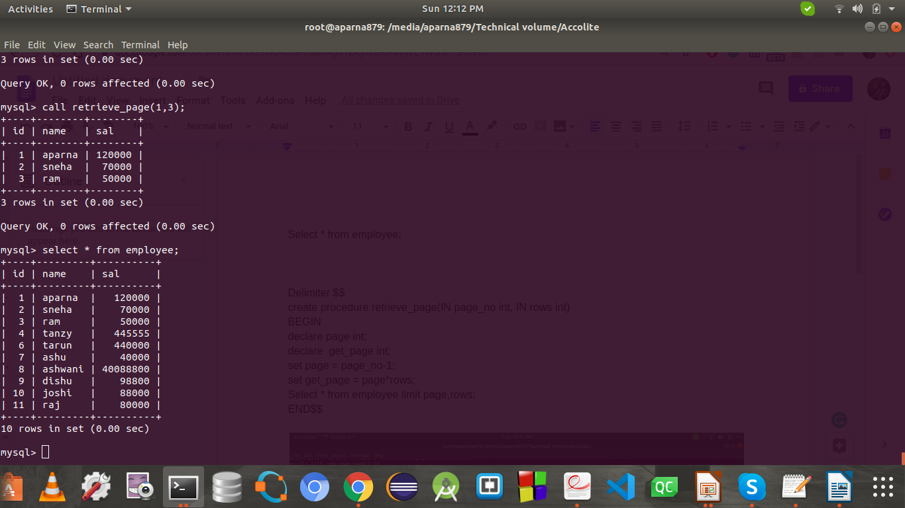

Delimiter $$

create procedure retrieveee_page(IN page_no int, IN rows int)

BEGIN

declare page int;

declare get_page int;

set page = page_no-1;

set get_page = page*rows;

Select * from employee limit get_page,rows;

END$$

call(4,3);

