**JAVASCRIPT ASSIGNMENT 1**

**1. concat()**

**var a =[1,2,3,4,5];**

**var b = [6,7,8,9];**

**a = a.concat(b);**

**console.log(a);**

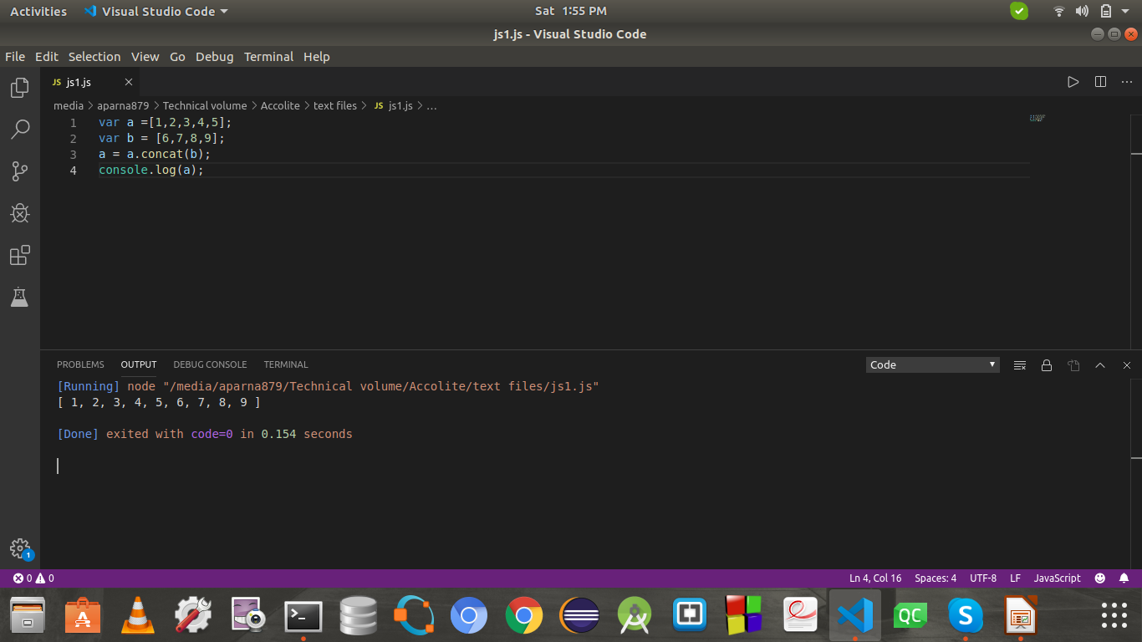

**2. every()**

var price = [45,97,12,20];

function check(price){

return price<=100;

}

console.log(price.every(check));

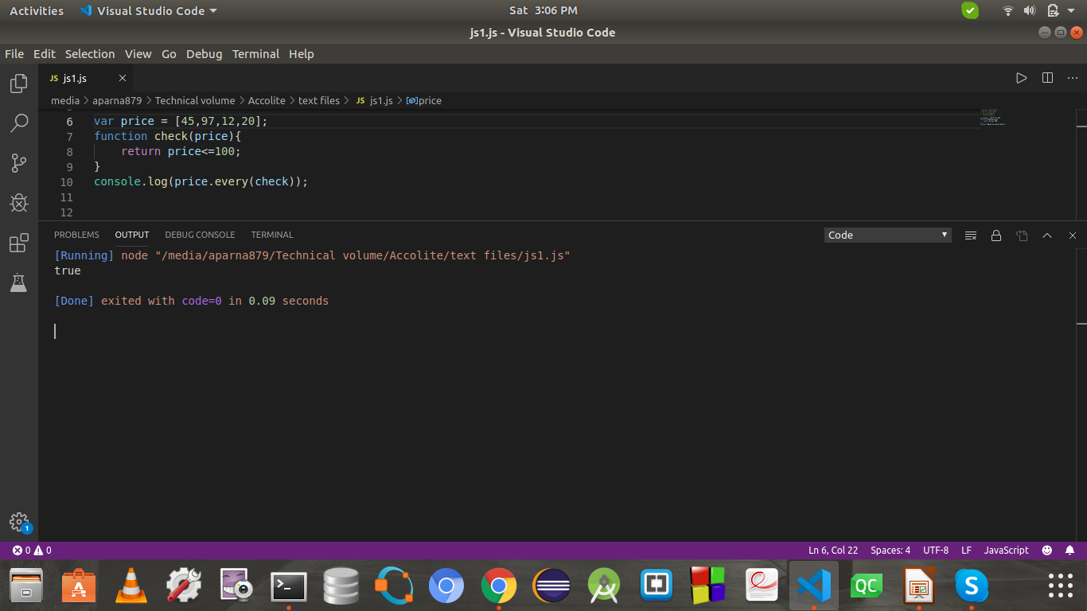

**3. filter()**

**var a = [100, 45, 60, 30, 20, 50,120];**

**b = a.filter((item) => item<=50);**

**console.log(b);**

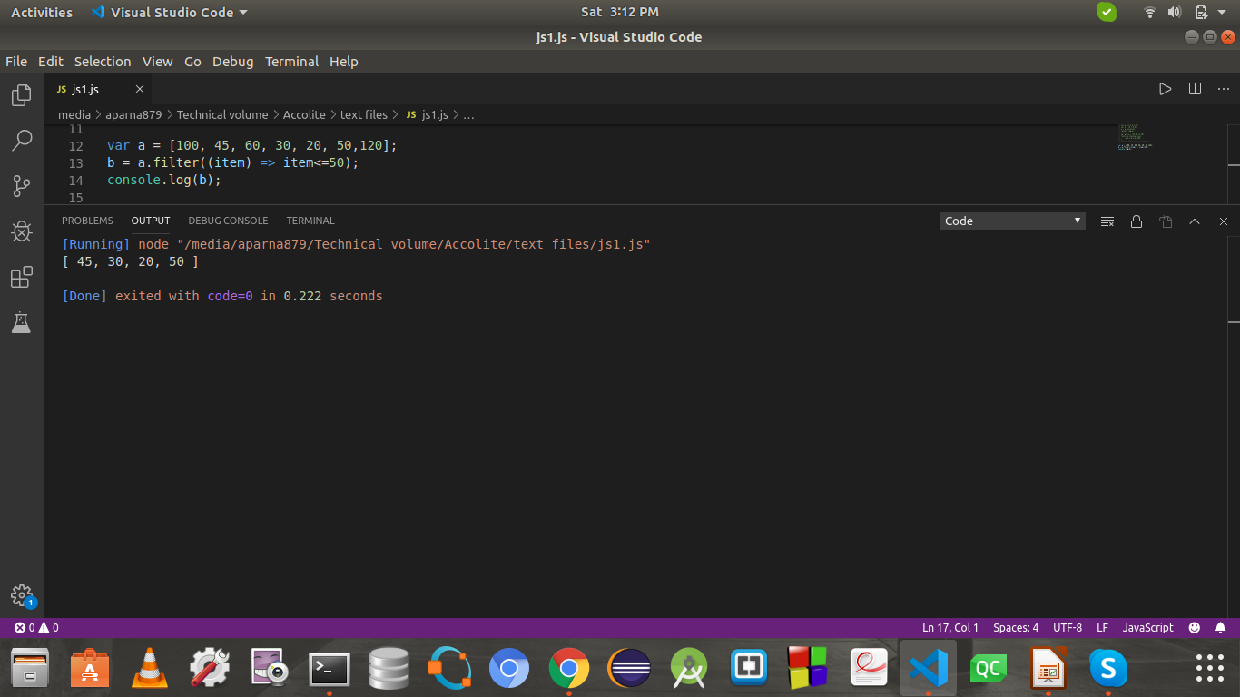

**4. forEach()**

**var a = [3,7,9,33,100,89];**

**var sum=0;**

**a.forEach((item)=>sum+=item);**

**console.log(sum);**

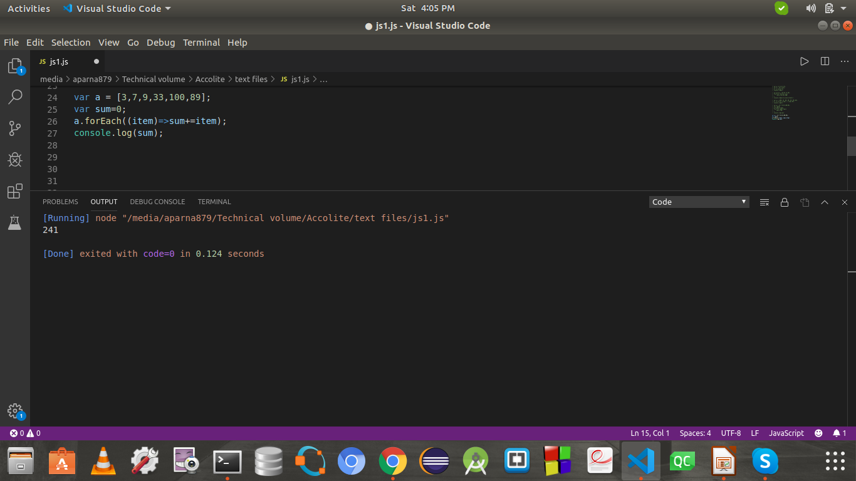

**5. indexOf()**

**var a = [1,2,3,4,5];**

**console.log(a.indexOf(3));**

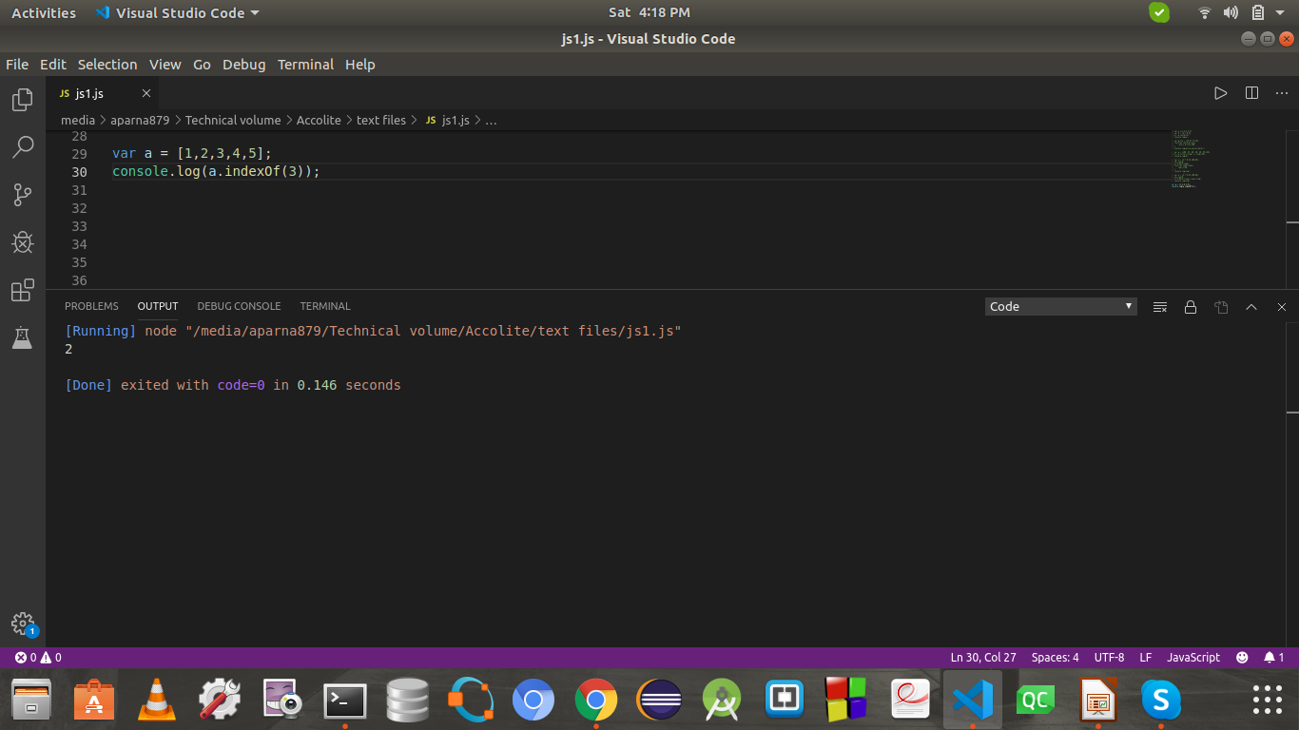

**6. join()**

**var name = ["aparna","tarun","tanzy","rameez","tushar"];**

**console.log(name.join("|"));**

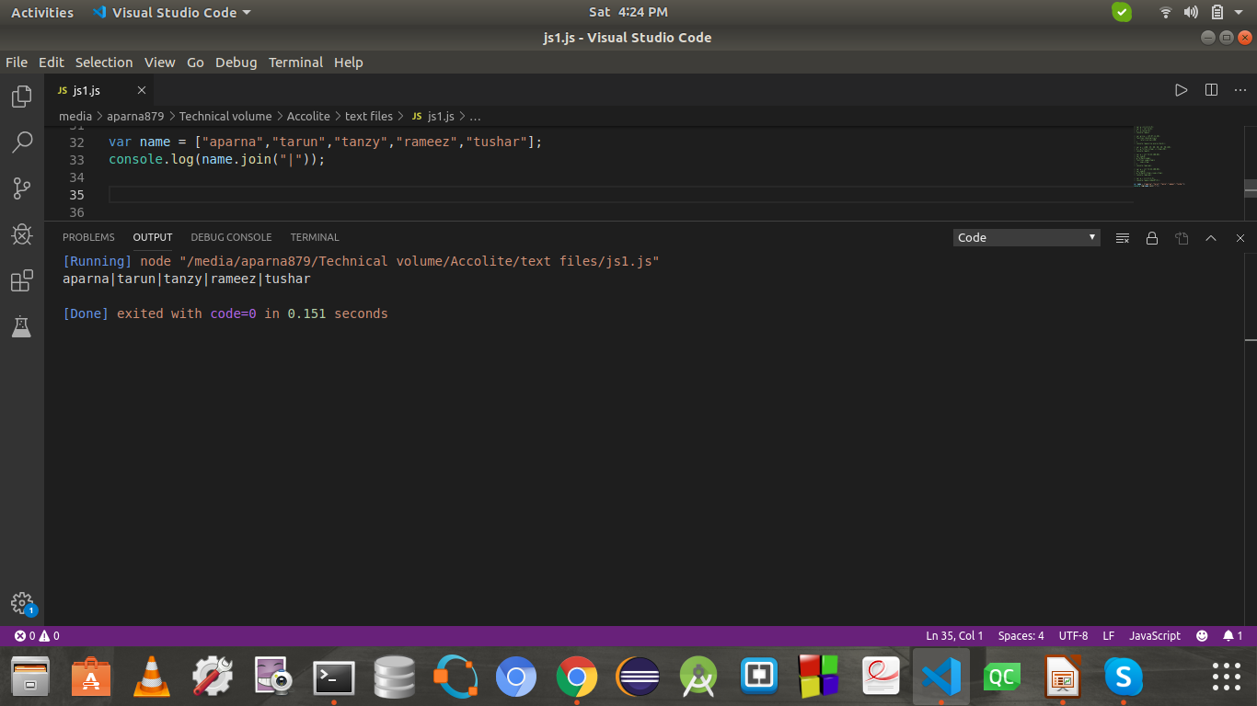

**7. lastIndexof()**

**var a = [1,2,3,4,5];**

**console.log(a.indexOf(3,1));**

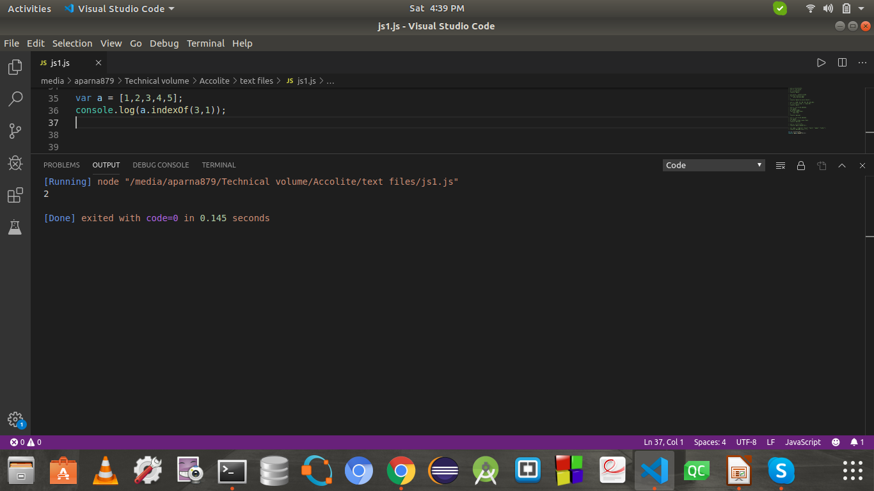

**8. map()**

**var a = [4,9,16,25,36];**

**console.log(a.map(Math.sqrt))**

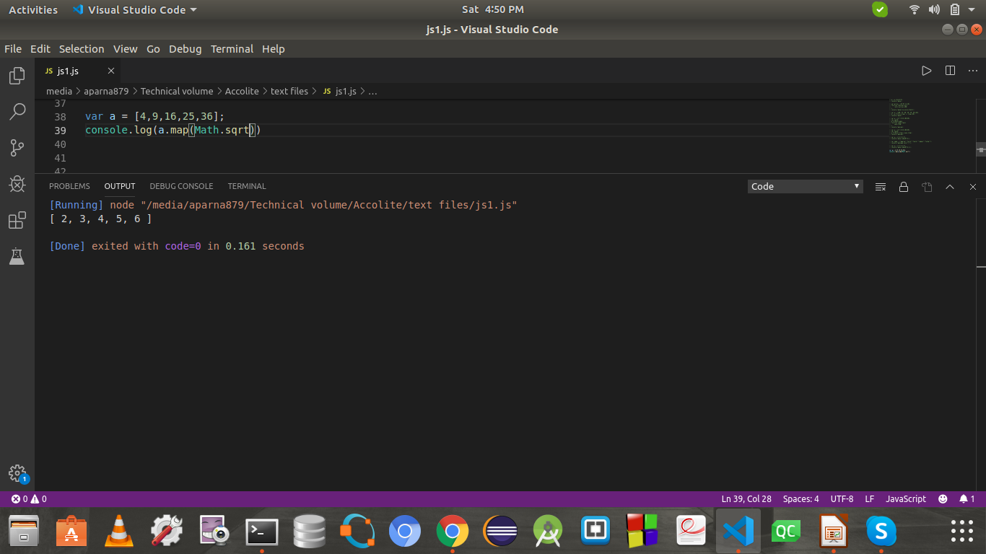

**9. pop()**

**var a = [4,9,16,25,36];**

**a.pop();**

**console.log(a);**

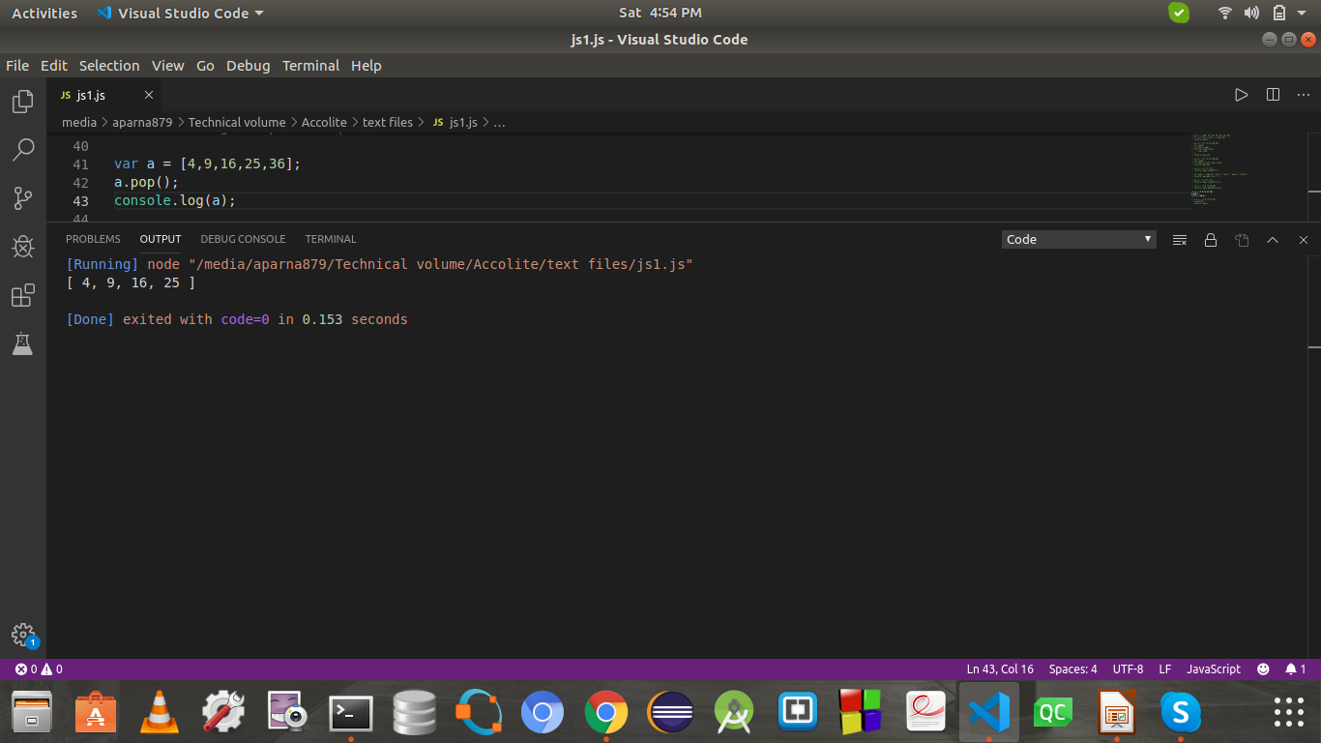

**10. push()**

**var a = [4,9,16,25,36];**

**a.push(81);**

**console.log(a);**

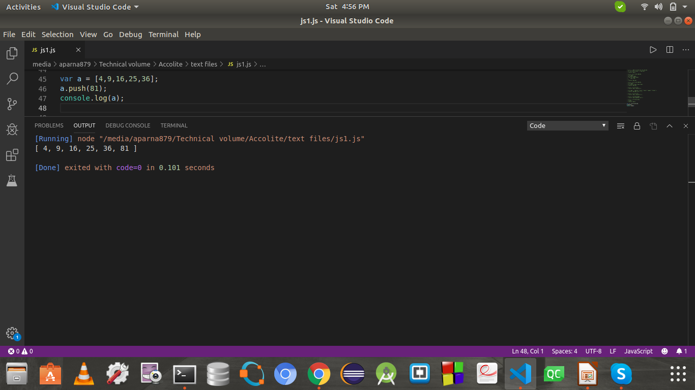

**11. reduce()**

**var a = [100,25,55];**

**console.log(a.reduce((total,item)=>(total-item)));**

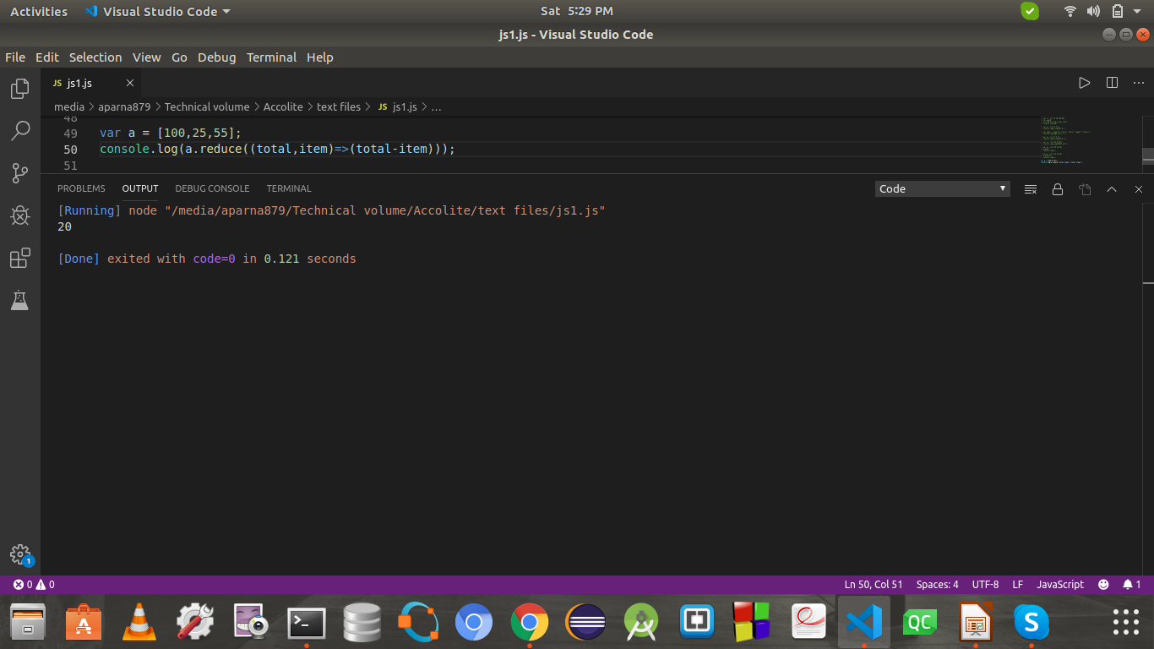

**12. reduceRight()**

**var a = [100,25,55];**

**console.log(a.reduceRight((total,item)=>(total-item)));**

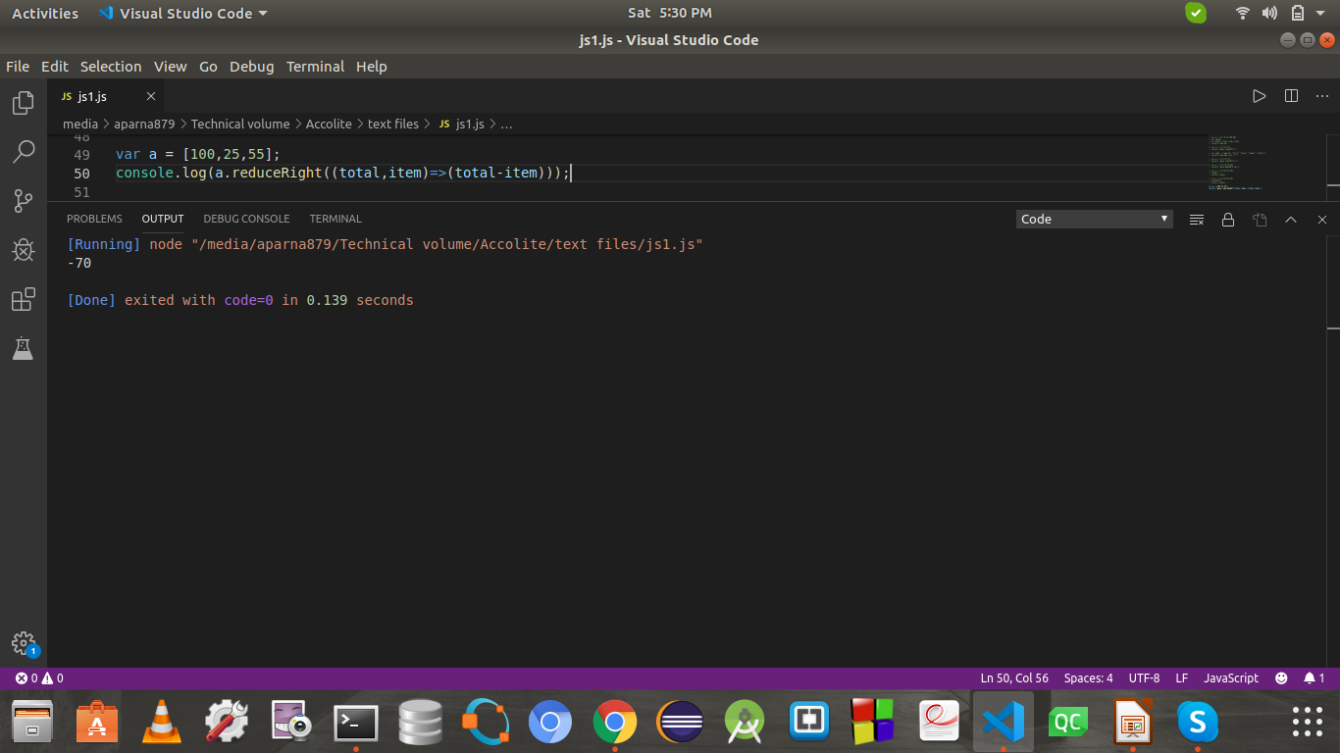

**13. reverse()**

**var a = [1,2,3,4,5]**

**console.log(a.reverse());**

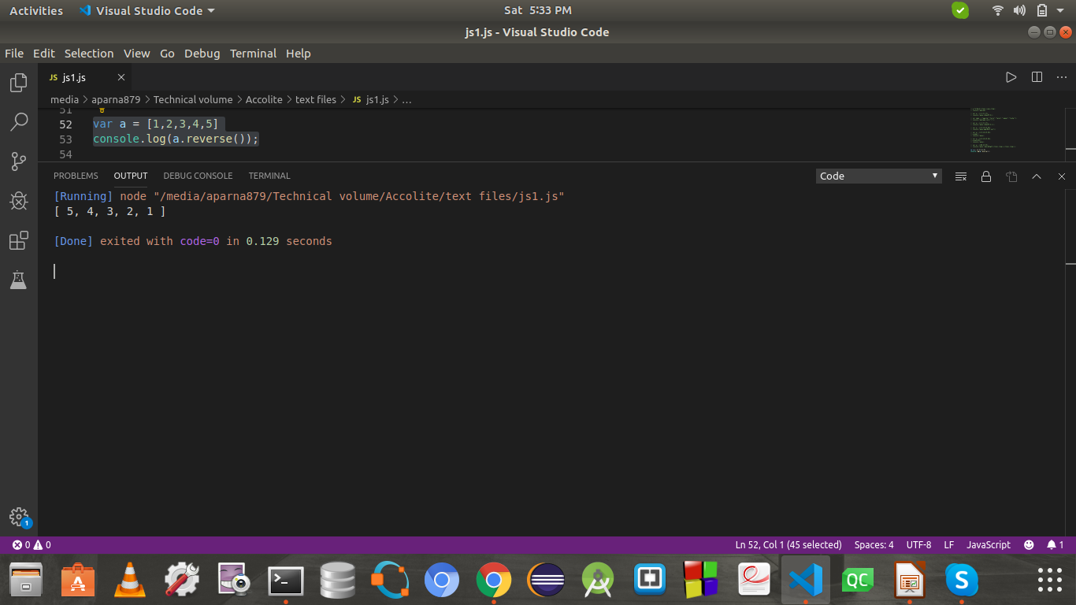

**14. shift()**

**var a = [1,2,3,4,5]**

**a.shift();**

**console.log(a);**



**15. unshift()**

**var a = [1,2,3,4,5]**

**a.unshift(0);**

**console.log(a);**

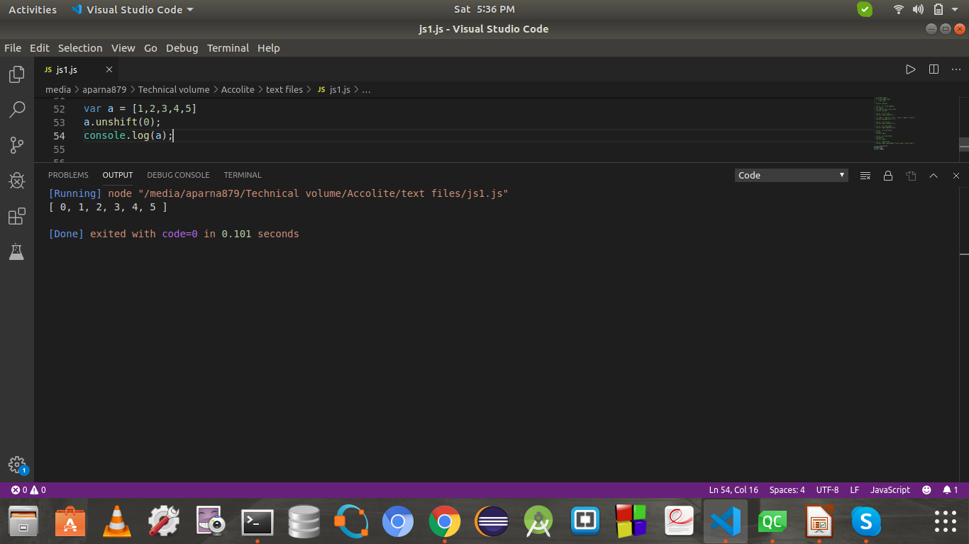

**16. slice()**

**var a = [1,2,3,4,5,6,7,8,9,10];**

**console.log(a.slice(2,7));**

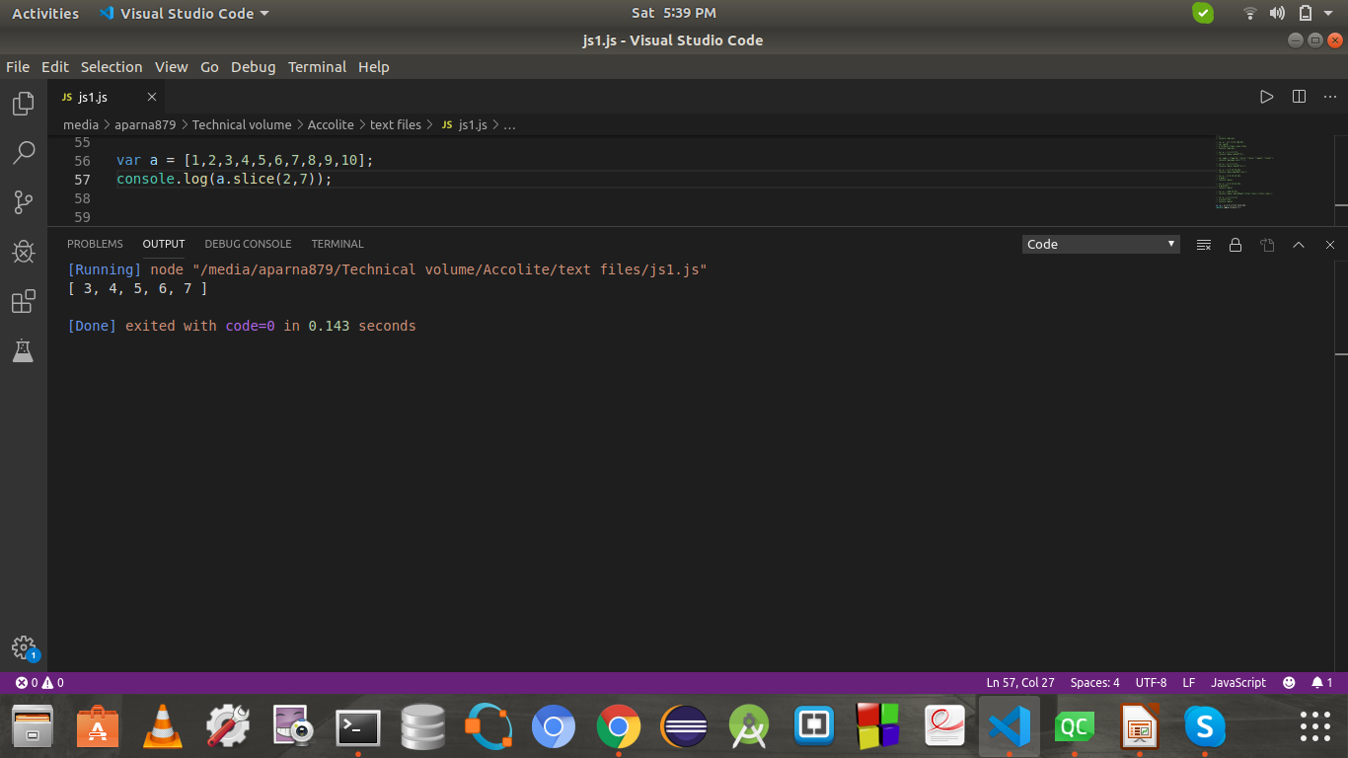

**17. some()**

var price = [45,97,12,200];

function check(price){

return price>=100;

}

console.log(price.some(check));

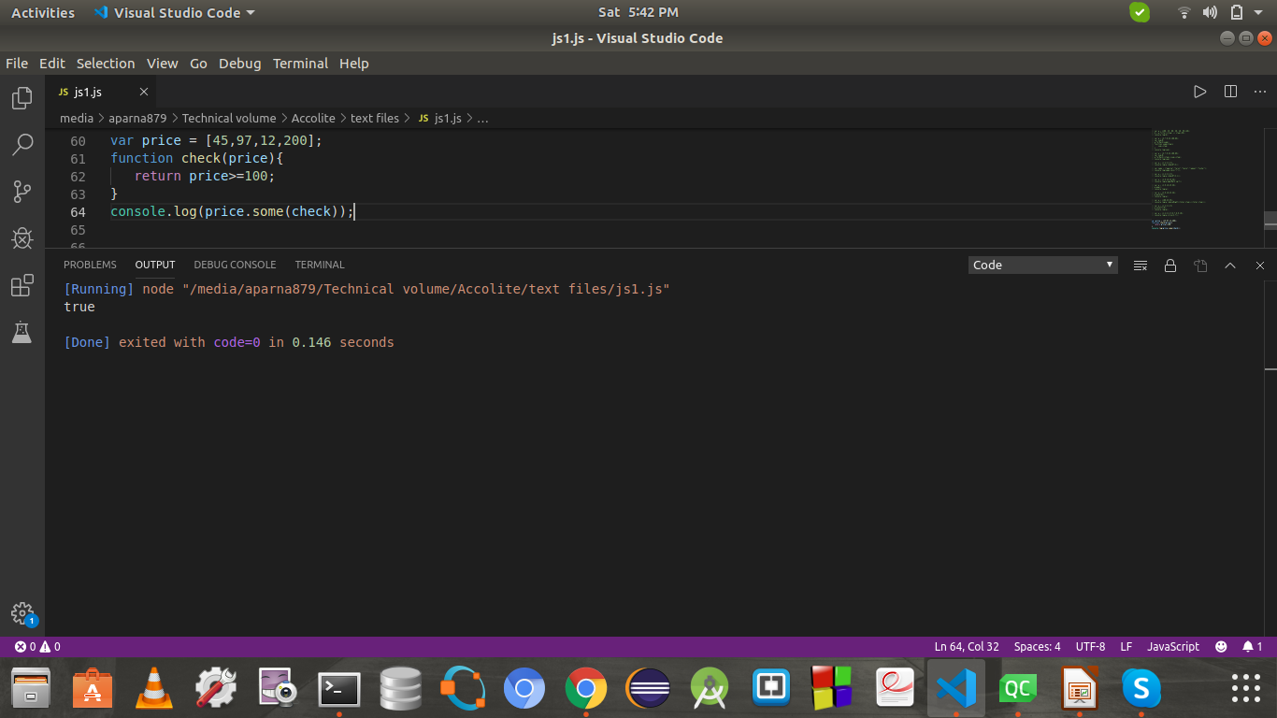

**18. sort()**

**var a = [4,6,1,5,9,0];**

**console.log(a.sort());**

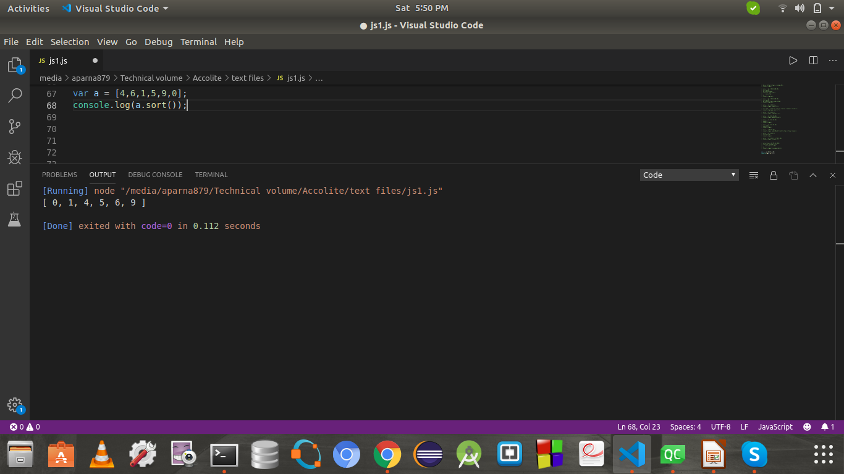

**19. splice()**

**var fruits = ["Banana", "Orange", "Apple", "Mango"];**

**fruits.splice(2, 1, "Lemon", "Kiwi");**

**console.log(fruits);**

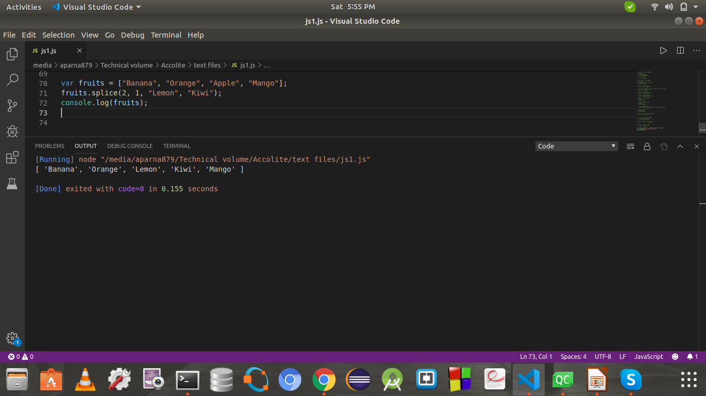

**20. tostring()**

**var a = ["hello","world"];**

**console.log(a.toString());**

