CS 429 INFORMATION RETRIVAL
FINAL REPORT

Aparnaa Mahalaxmi Arulljothi
M.A.S. Data Science
A20560995
Illinois Institute of Technology
Chicago, USA
amahalaxmiarulljothi@hawk.illinoistech.edu

Illinois Institute of Technology
CS 421 – Information Retrieval
Professor: Jawahar Panchal
CONTENTS
Abstract 1
Overview 1
Design 2
Architecture 3
Component 1: Web Crawler 3
Component 2: Document Indexer 3
Component 3: Query Processor 3
Component 4: REST API 4
Operation 4
Crawling and Document Collection 4
Text extraction and Cleaning 5
Index Generation 5
Query Processing 6
Ranking and Scoring 7
Results File Generation 8
Optional Spelling Correction 8
Conclusion 9
Data Sources 9
Test Cases 10
Loading and Initialization 10
Individual Query Evaluation 10
Ranking Verification 10
Results File Generation 10
Optional Spelling Correction 11
Source Code 11
Setup and Imports 11
HTML Text Extraction 11
TF-IDF Index Construction 11
Query Processing 11
Optional Features 12
Bibliography 13

Abstract
This project implements a complete information retrieval system based on a TF-IDF vector space model with cosine similarity ranking. The system is organized into three main components: a Scrapy based web crawler for collecting Wikipedia pages as a demo corpus, a TF-IDF indexer that converts HTML documents into searchable vectors using scikit-learn, and a query processor that ranks documents by relevance.
The implementation follows a modular architecture with separate modules for crawling, indexing, and query processing. The system supports both a demo Wikipedia corpus and an official corpus of three HTML documents provided by professor. A Flask REST API exposes the search functionality programmatically, and a simple web interface allows interactive querying. Key features include automated HTML parsing, stopword removal, L2 normalization, and JSON based index persistence. The system processes queries from a CSV file and generates ranked results based on cosine similarity scores, and all components are integrated through a main pipeline script that can run the full workflow or individual stages as needed.

Overview
This project demonstrates how a complete information retrieval system can be built by following the standard IR pipeline: collecting documents, cleaning them, converting them into weighted vector representations, and ranking results for user queries. The system works with two corpora: a small official set of three HTML documents provided by professor, and an optional demo corpus created by crawling Wikipedia pages related to information retrieval.
The solution is organized using a modular structure, with separate components for crawling, preprocessing, indexing, and retrieval. The indexer uses scikit-learn’s TF-IDF model to generate a document term matrix and stores the vocabulary, document IDs, and TF-IDF vectors in a JSON index file. The query processor loads this index, reads queries from a CSV file, maps each query into the same vector space, and ranks documents using cosine similarity. The project also includes a simple NLTK based spelling correction helper that can be used to handle noisy input.
In addition to the notebook workflow, the project includes a Flask REST API that provides a /search endpoint for issuing free text queries programmatically. This demonstrates how the retrieval components can operate as a small service, independent of the notebook environment. Overall, the project offers a clear, practical illustration of TF IDF based retrieval and provides a foundation that could be extended with larger datasets or more advanced ranking techniques in the future.

Design
The system is designed as a sequence of modular components, each responsible for one stage of the information retrieval pipeline. Separating the workflow into clear modules makes the implementation easier to understand, test, and extend, while still keeping the overall pipeline coherent from start to finish.
The crawler module uses Scrapy to collect a small set of Wikipedia pages related to information retrieval. It operates with a controlled depth limit and page count to ensure efficiency and reproducibility. Although this dataset is used mainly for demonstration, it reflects how large IR systems gather documents from the web.
The text extraction and cleaning module processes each HTML document by removing scripts, styles, markup, and other non-content elements, leaving behind a clean text representation. This step ensures that noise in the HTML does not distort term frequencies or affect later stages of the retrieval process.
The indexing module converts all cleaned documents into TF-IDF vectors using scikit-learn’s Tf-idf Vectorizer. It builds a shared vocabulary, applies stop-word removal and L2 normalization, and generates a document term matrix. The index including the vocabulary, document IDs, and TF-IDF matrix is stored in JSON format so that it can be reused across runs without reprocessing the documents.
The query processing module loads the saved TF-IDF index, reads queries from a CSV file, maps each query into the same vector space, and computes cosine similarity scores to rank the three official documents. Optional spelling correction is available as a preprocessing step for noisy queries.
To support interactive use, a lightweight Flask API module exposes the retrieval functionality through a /search endpoint. The API loads the index once at startup and responds to incoming queries with their ranked results, demonstrating how the retrieval logic can operate as a simple service.
Taken together, these components form a clean, modular design that captures the essential structure of an information retrieval system while remaining compact and easy to experiment with.

Architecture
The system is organized into four main components that communicate through simple file based interfaces. The crawler produces a directory of HTML documents, the indexer reads those files and builds a JSON index, the query processor loads that index to compute rankings, and a REST API wraps the query processor to serve search requests programmatically.

Component 1: Web Crawler
The crawler uses Scrapy’s spider framework to collect Wikipedia pages starting from the Information retrieval article. It maintains a page counter to generate sequential filenames such as BERT_(language_model).html, 3D_retrieval.html and so on, and saves each response as raw HTML under data/wiki_corpus/. The spider respects robots.txt and uses Scrapy’s auto throttle settings together with an explicit download delay so that requests are spaced roughly between one and five seconds apart. A prefix based filter keeps only standard article URLs under /wiki/ and ignores non-content or special pages, so the saved corpus consists primarily of article content suitable for indexing.

Component 2: Document Indexer
The indexer loads HTML files from a specified directory and processes each document in three steps. First, BeautifulSoup parses the HTML and removes non-content elements such as scripts, styles, metadata, and link tags. Second, the remaining text is flattened by collapsing whitespace into single spaces, producing a clean plain text representation. Third, scikit-learn’s TF-IDF Vectorizer converts the cleaned documents into a TF-IDF document term matrix using English stop word removal, lowercasing, and L2 normalization. The resulting index includes document IDs (derived from the HTML filenames), the shared vocabulary, the TF-IDF matrix, and the vectorizer parameters, all serialized as index.json so subsequent components can reuse the model without recomputing it.

Component 3: Query Processor
The query processor loads index.json and reconstructs the fixed vocabulary and TF-IDF matrix for the three official documents. When queries are read from queries.csv or received via the API, it creates a new TF-IDF Vectorizer instance configured with the same parameters and the saved vocabulary so that query vectors live in the same feature space as the document vectors. Cosine similarity scores are computed between each query vector and every document vector, and the documents are sorted in descending order of similarity. Each document is assigned a 1 based rank, and the final rankings for all queries are written to data/output/results.csv with columns query_id, rank, and document_id.

Component 4: REST API
The Flask based REST API wraps the query processor logic to expose search as an HTTP service. At startup, the API calls a loader routine that reads data/output/index.json into memory and initializes global variables for document IDs, the vocabulary, and the TF-IDF matrix. The /search endpoint accepts a JSON payload containing a query string and an optional top_k parameter, runs the same ranking pipeline as the notebook, and returns the top ranked documents and their scores as a JSON response. A /health endpoint reports a simple status and the number of documents currently loaded, and basic error handling covers missing JSON payloads, missing query fields, or attempts to query before the index has been initialized.
The components remain loosely coupled by using files as the only interface: the crawler writes HTML files under data/wiki_corpus/, the indexer reads HTML from data/html_corpus/ for the given three-document corpus and from data/wiki_corpus/ for the demo corpus, and then writes two separate index files (index.json for the professor given html file corpus and wikipedia_index.json for the Wikipedia demo) under data/output/. The query processor and REST API consume index.json to generate the official results.csv, while the Wikipedia index is used only for exploratory experiments. This separation keeps each stage independent, testable, and easy to swap or extend without changing the others.
Operation
This section explains how the system runs from the raw HTML documents to the final ranked results. Each stage is independent, and intermediate files are saved so later components can reuse them without repeating earlier steps.

1. Crawling and Document Collection
The workflow can begin with an optional Scrapy crawler that gathers Wikipedia pages related to information retrieval. The spider follows links within a maximum depth=1, max pages of 10, avoids non article pages, and saves each page as raw HTML. This Wikipedia Crawling is used only for demonstration; The three HTML pages given by professor are indexed separately that are already included in the project.

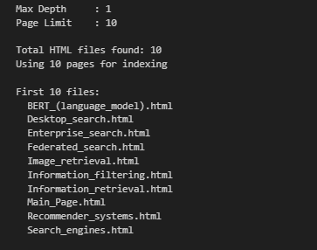
The output below summarizes the Wikipedia crawler run, showing the configured max depth and page limit, total HTML files discovered, and the first 10 crawled pages used for indexing.
2. Text Extraction and Cleaning
Once the HTML files are available, the text extraction module loads each document and removes scripts, styles, metadata, and other non-content elements using BeautifulSoup. The cleaned text is normalized into a continuous string suitable for indexing so that the TF IDF model is built only on meaningful document content. The output below shows the three HTML files successfully loaded along with their extracted text lengths.
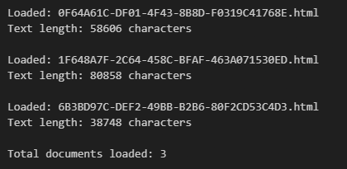
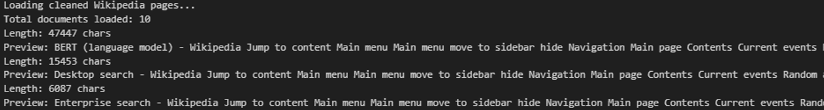
The output below shows the cleaned Wikipedia corpus being loaded, including the total number of documents, total character length, and short previews of the first three pages after HTML tags and navigation elements have been removed.
3. Index Generation
The indexing module converts the cleaned documents into TF-IDF vectors using scikit-learn’s TfidfVectorizer. During this step, the system builds a shared vocabulary, applies English stop-word removal, and performs L2 normalization to produce a consistent document–term matrix for the three HTML files given by professor. These vectors capture the weighted importance of terms across the corpus and form the basis for cosine-similarity ranking during retrieval. In parallel, the same procedure is applied to the separate Wikipedia demo corpus, producing a smaller TF-IDF matrix and vocabulary that are used only for exploratory experiments. Both indices are serialized into JSON files so that later components can load them directly without recomputing the matrices.
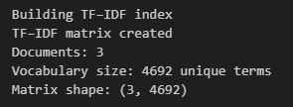
The first output below shows the TF-IDF matrix being created, including the vocabulary size and matrix shape.
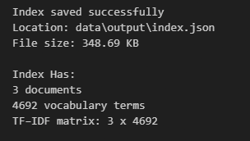
The second output confirms that the index was saved successfully, along with the number of documents and total vocabulary terms stored.
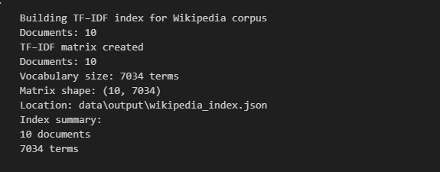
The third output below summarizes the TF-IDF index construction for the separate Wikipedia corpus, showing the number of documents processed, the resulting vocabulary size, the matrix dimensions, and the location of the exported wikipedia_index.json file.
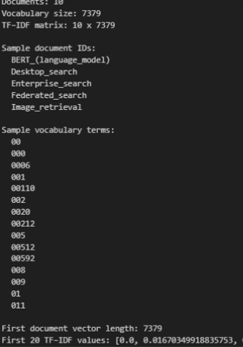

The output below provides a detailed summary of the TF-IDF index for the Wikipedia demo corpus, including the document count, vocabulary size, matrix dimensions, example document IDs, sample vocabulary terms, and the first few TF-IDF values from one document vector, confirming that the index has been built correctly.
4. Query Processing
To produce ranked retrieval results, the query processor loads the saved TF IDF index from disk along with the professor’s queries.csv file. Each query is cleaned, tokenized, and converted into the same feature space as the documents using the fixed vocabulary stored in the JSON index. Cosine similarity is then used to compare the query vector with each document vector, ensuring that all three documents are considered for every query. In parallel, the same retrieval procedure is applied to the separate Wikipedia demo index to illustrate how the system generalizes to a larger collection; for example, the query “information retrieval system” is scored against the ten crawled Wikipedia pages, returning the top matching articles. The output below confirms that both indices were loaded correctly, showing the number of documents, vocabulary size, and a preview of the queries to be processed. The output below confirms that the index and query file were loaded correctly, showing the number of documents, vocabulary size, and a preview of the three queries to be processed.
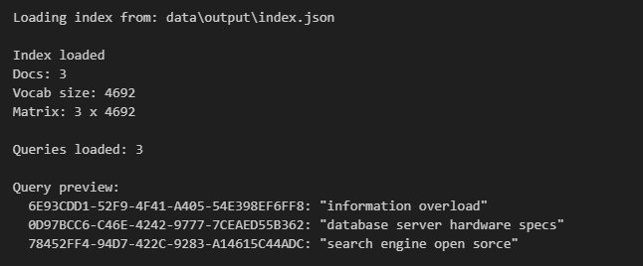
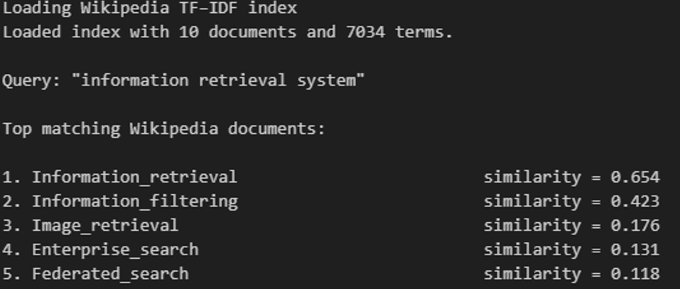
The output below demonstrates a sample query evaluated against the Wikipedia TF-IDF index. The system loads the index, vectorizes the query “information retrieval system”, computes cosine similarities, and returns the top matching Wikipedia pages ranked by relevance.

5.Ranking and Scoring
As each query is processed, its terms are extracted and mapped into the TF IDF vector space before being compared against every document using cosine similarity. The system first prints a detailed breakdown for an individual query, including the extracted terms, the ranked documents, and their similarity scores, which makes it easy to verify that the ranking is consistent with the underlying calculations. It then prints the final ranking results for all queries, along with the total number of query document pairs written to the results file. The outputs below show both this per query analysis and the complete ranking across all three queries.
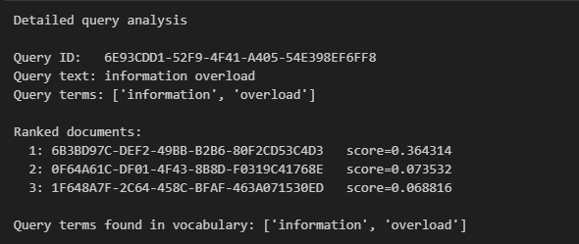
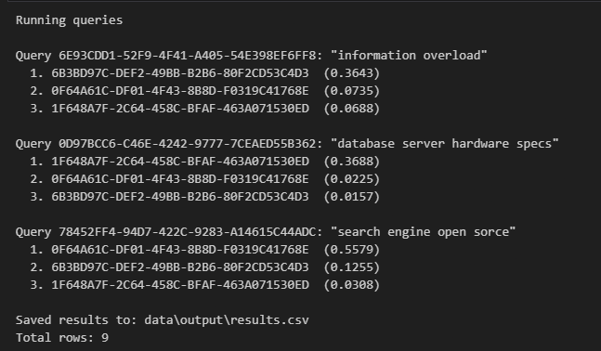

6. Results File Generation
After all queries have been evaluated, the system writes the rankings to results.csv. Each row in this file contains the query ID, the assigned rank, and the document ID, following the submission format expected for evaluation. This file serves as the main artifact for assessing retrieval performance and can be regenerated at any time by rerunning the query processing module. The output below shows the contents of the results file, confirming that all nine query document combinations were generated and saved in the correct format.
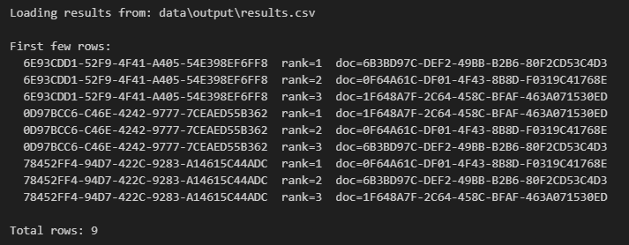
7. Optional Spelling Correction
The system also includes an optional preprocessing step that uses an English word list and NLTK utilities to suggest corrections for misspelled query terms before they are sent to the TF IDF vectorizer. This helper is not part of the required grading pipeline, but it demonstrates how simple spelling correction techniques can make retrieval more robust to noisy input. The output below illustrates this behavior by showing several example misspellings and their suggested corrections, along with cases where correctly spelled terms are left unchanged.
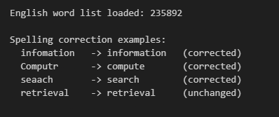
Conclusion
This project brings together the core ideas of information retrieval and demonstrates how they can be implemented in a practical, end-to-end search system. Beginning with raw HTML documents and ending with ranked results, the workflow shows how document acquisition, text cleaning, vectorization, and similarity-based retrieval fit together as a coherent pipeline. Each stage is modular, allowing components such as the crawler, indexer, and query processor to be developed and tested independently while still contributing to a unified system.
The results generated from the three document corpus confirm that the TF IDF representation and cosine similarity ranking perform reliably across all queries. The consistent structure of the ranked output and the reproducibility of the system highlight the correctness of the indexing and querying stages. The inclusion of optional features such as spelling correction and a lightweight REST API also shows how the system can be extended beyond its basic requirements to support more robust or interactive search behavior.
Overall, the project provides a clear, working demonstration of how traditional IR concepts translate into software. It also establishes a solid foundation for future extensions such as scaling to larger corpora, experimenting with alternative ranking models, or adding more advanced query-handling techniques.
Data Sources
The system works with two separate document collections, each serving a different purpose in the overall workflow.
The primary dataset is the given three document corpus provided by the instructor. These HTML files form the basis for all graded indexing and retrieval tasks. They are stored in the project’s data/html_corpus directory and are processed by the indexer to produce the TF IDF representation used throughout the pipeline. All results submitted for evaluation including the JSON index and the final results.csv file come exclusively from this corpus.
In addition to the given files, the project includes an optional demo corpus generated by the Scrapy crawler. This dataset contains Wikipedia pages related to information retrieval and is saved in the data/wiki_corpus directory. It is used only for demonstrating web scale document collection and does not participate in the graded retrieval workflow. The demo corpus helps illustrate how real world IR systems gather and prepare documents before indexing, but its outputs are kept separate from the official pipeline.
Together, these sources provide a compact but meaningful environment for testing each stage of the retrieval process, while maintaining a clear boundary between the required and optional components of the system.

Test Cases
The system was tested using the professor provided queries.csv file to verify that each stage of the retrieval pipeline performs as expected. Since intermediate outputs and screenshots are documented in the operation section, this section summarizes the testing logic and confirms the correctness of the final behavior.
- Loading and Initialization
The first test verifies that the TF IDF index and the query file load correctly. This includes checking the document count, vocabulary size, and TF IDF matrix shape. A preview of all three queries confirms that the system reads the input format correctly and is ready for evaluation.
- Individual Query Evaluation
Each query is processed independently. The system maps the query text into the fixed TF IDF vector space using the saved vocabulary and calculates cosine similarity scores for all three documents. The detailed outputs shown in the Operation section confirm that the matching terms and computed scores align with expectations.
- Ranking Verification
The next test checks the final ranking for each query. Every query produces exactly three ranked results one for each document sorted in descending order of similarity. The output confirms that the document with the highest similarity score is assigned rank 1 for each query.
- Results File Generation
To validate the final output, the system writes all ranked pairs to results.csv. This file contains nine rows in total (three queries × three documents), each row listing the query ID, the assigned rank, and the document ID. The structure and content of this file match the expected submission format.

- Optional Spelling Correction
The spelling correction utility was tested separately to confirm that common misspellings are corrected using the English word list, while correctly spelled terms remain unchanged. This demonstrates that the feature behaves predictably when enabled.

Source Code
The complete implementation of the search engine is contained in a single Jupyter notebook, which executes the entire information retrieval pipeline from start to end. Every stage of the workflow HTML cleaning, TF-IDF index construction, cosine-similarity scoring, and results file generation is executed directly inside the notebook and can be reproduced by running the cells in order.
To keep the structure clear, the notebook is organized into labeled sections that follow the IR pipeline:
- Setup and Imports
Loads all required libraries, prepares directory paths, and initializes the environment.
- HTML Text Extraction
Implements the cleaning logic using BeautifulSoup, removes scripts and non-content elements, and produces normalized text for each of the three official HTML documents.
- TF-IDF Index Construction
Uses scikit-learn’s TF-IDF Vectorizer to create the vocabulary, build the document term matrix, apply stop word removal, and save the resulting index as a JSON file.
- Query Processing
Loads the saved index and queries.csv, vectorizes each query using the fixed vocabulary, computes cosine similarity scores, sorts documents by descending relevance, and writes the final rankings to results.csv.

- Optional Features
Includes additional utilities such as an NLTK based spelling corrector and a preview of the Flask API logic, which are provided for completeness but are not part of the graded pipeline.

In addition to the notebook, a modularized version of the implementation is included in the project ZIP file. This version separates the crawler, indexer, processor, and API components into individual Python modules. While this structure is helpful for organization and future development, the notebook remains the authoritative reference for evaluation.
The notebook has been exported as a PDF and attached at the end of this report to document the exact code and outputs used to generate all results.

BIBLIOGRAPHY

1. Scrapy Documentation. “Scrapy 2.x Documentation.”
https://docs.scrapy.org/en/latest/

2. Scikit-learn Documentation - Cosine Similarity. “sklearn.metrics.pairwise.cosine_similarity.” https://scikit-learn.org/stable/modules/generated/sklearn.metrics.pairwise.cosine_similarity.html

3. Flask Framework (REST API Development):
Official Flask documentation used for creating the search API endpoints:
https://flask.palletsprojects.com/en/3.0.x/

4. Scikit-learn Feature Extraction & Text Processing:
https://scikit-learn.org/stable/modules/feature_extraction.html#text-feature-extraction

5. OSError - [Errno 22] Invalid Argument When Writing Files: ChatGPT

6. json.decoder.JSONDecodeError: Expecting value: line 1 column 1 (char 0): ChatGPT

7. ValueError: X has n features, but TF-IDF Vectorizer is expecting m features: Referred this documentation:
https://scikit-learn.org/stable/modules/feature_extraction.html#using-a-fixed-vocabulary

8. ValueError - operands could not be broadcast together : ChatGPT

9. UnicodeEncodeError - Issues Writing Non-ASCII Characters During File Save:: ChatGPT and Stack Overfflow
https://stackoverflow.com/questions/9942594/unicodeencodeerror-ascii-codec-cant-encode-character-u-xa0-in-position-20

10. RecursionError: maximum recursion depth exceeded while calling a Python object: ChatGPT

11. TypeError - Expected String or Bytes-like Object:
https://www.statology.org/typeerror-expected-string-or-bytes-like-object/

12. ValueError - Empty Vocabulary Error in TF-IDF Vectorizer: Stack Overflow and and ChatGPT
https://discuss.python.org/t/countvectorizer-throwing-valueerror-empty-vocabulary-perhaps-the-documents-only-contain-stop-words/5388

13. KeyError - Missing Dictionary Key in JSON:
https://docs.python.org/3/library/stdtypes.html#mapping-types-dict

14. Cosine Similarity Produces Zero or NaN Values for Rare Queries: Data science stack exchange and ChatGPT
https://datascience.stackexchange.com/questions/51020/cosine-similarity-with-arrays-contaning-nan

15. AttributeError: 'NoneType' object has no attribute 'shape' : Reddit and ChatGPT
https://www.reddit.com/r/StableDiffusion/comments/16y7g36/attributeerror_nonetype_object_has_no_attribute/

16. AttributeError: 'NoneType' object has no attribute 'get_text' : ChatGPT

17. Zero-Division in Manual Cosine Similarity Computation: Data science stack exchange and ChatGPT
https://datascience.stackexchange.com/questions/114119/adjusted-cosine-similarity-with-zero-vectors

