**REACT-JS HOL**

**1 : React-App**

App.js:

function App() {

  return (

    <div>

      <h1>Welcome to the first session of React</h1>

    </div>

  );

}

export default App;

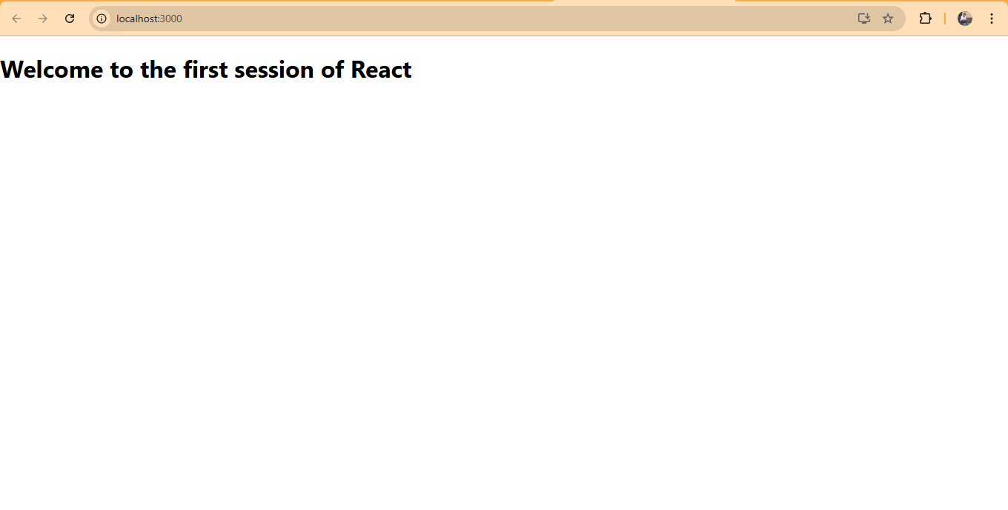

**2 : React-App**

App.js :

import React from 'react';

import Home from './Components/Home';

import About from './Components/About';

import Contact from './Components/Contact';

function App() {

  return (

    <div>

      <Home />

      <About />

      <Contact />

    </div>

  );

}

export default App;

Home.js :

import React, { Component } from 'react';

class Home extends Component {

  render() {

    return (

      <h2>Welcome to the Home page of Student Management Portal</h2>

    );

  }

}

export default Home;

About.js :

import React, { Component } from 'react';

class About extends Component {

  render() {

    return (

      <h2>Welcome to the About page of the Student Management Portal</h2>

    );

  }

}

export default About;

Contact.js :

import React, { Component } from 'react';

class Contact extends Component {

  render() {

    return (

      <h2>Welcome to the Contact page of the Student Management Portal</h2>

    );

  }

}

export default Contact;

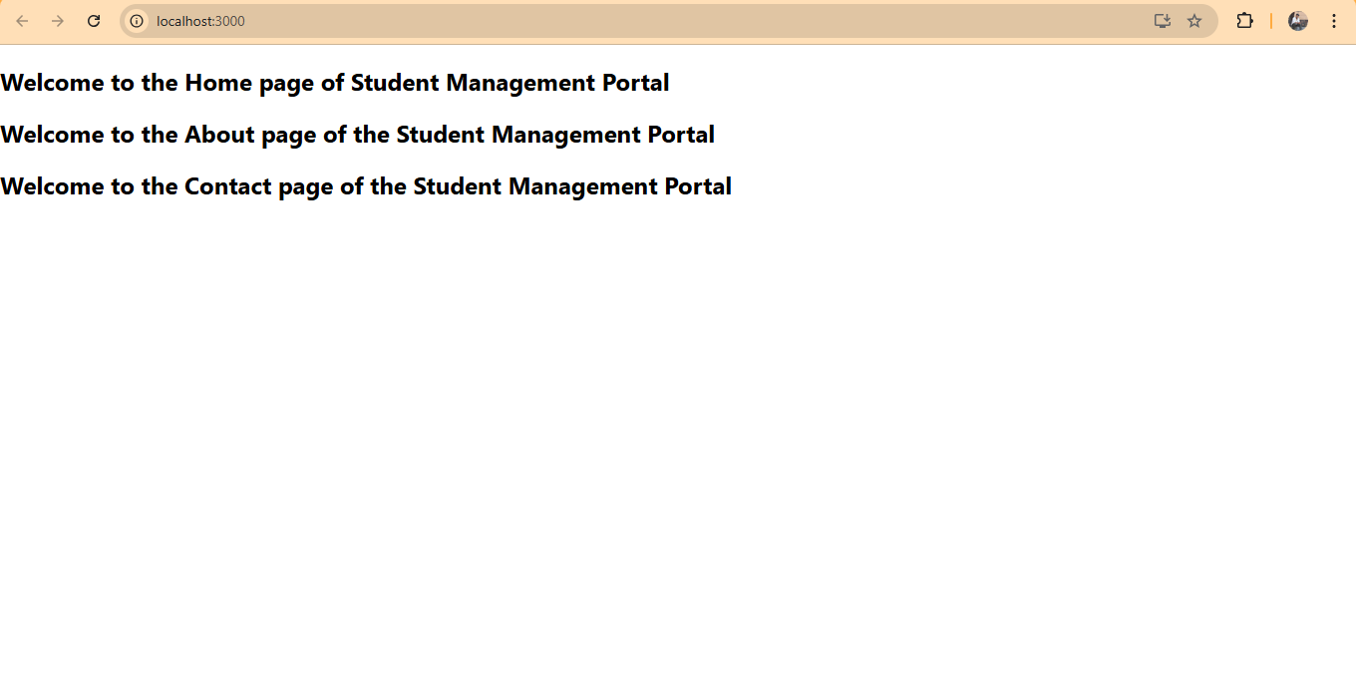

**3 : React-App**

App.js :

import React from 'react';

import CalculateScore from './Components/CalculateScore';

function App() {

  return (

    <div className="App">

      <CalculateScore name="John Doe" school="ABC High School" total={450} goal={5} />

    </div>

  );

}

export default App;

CalculateScore.js :

import React from 'react';

import '../Stylesheets/mystyle.css';

function CalculateScore(props) {

  const average = props.total / props.goal;

  return (

    <div className="score-container">

      <h2>Student Score Calculator</h2>

      <p><strong>Name:</strong> {props.name}</p>

      <p><strong>School:</strong> {props.school}</p>

      <p><strong>Total Marks:</strong> {props.total}</p>

      <p><strong>Goal:</strong> {props.goal}</p>

      <p className="average-score"><strong>Average Score:</strong> {average.toFixed(2)}</p>

    </div>

  );

}

export default CalculateScore;

mystyle.css :

.score-container {

    background-color: #f0f8ff;

    border: 2px solid #007bff;

    border-radius: 10px;

    padding: 20px;

    width: 300px;

    margin: 20px auto;

    text-align: left;

    font-family: Arial, sans-serif;

}

h2 {

    color: #007bff;

}

.average-score {

    font-weight: bold;

    color: green;

}

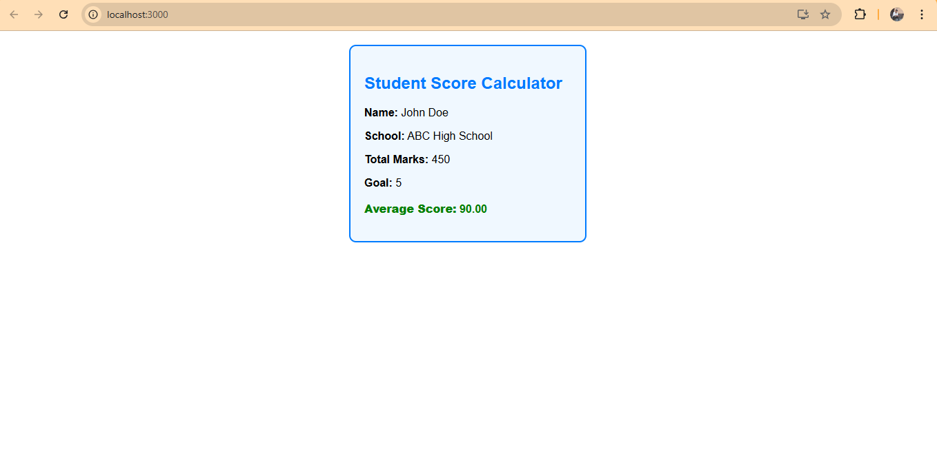

**4 : React.App**

App.js :

import React from 'react';

import Posts from './Posts';

function App() {

  return (

    <div className="App">

      <Posts />

    </div>

  );

}

export default App;

Post.js :

import React from 'react';

function Post(props) {

  return (

    <div>

      <h3>{props.title}</h3>

      <p>{props.body}</p>

    </div>

  );

}

export default Post;

Posts.js :

import React, { Component } from 'react';

import Post from './Post';

class Posts extends Component {

  constructor(props) {

    super(props);

    this.state = {

      posts: [],

      hasError: false

    };

  }

  loadPosts = () => {

    fetch('https://jsonplaceholder.typicode.com/posts')

      .then(response => response.json())

      .then(data => this.setState({ posts: data }))

      .catch(error => {

        console.error("Error fetching posts:", error);

        this.setState({ hasError: true });

      });

  }

  componentDidMount() {

    this.loadPosts();

  }

  componentDidCatch(error, info) {

    alert("An error occurred: " + error);

    console.error("Error caught in componentDidCatch:", error, info);

    this.setState({ hasError: true });

  }

  render() {

    if (this.state.hasError) {

      return <h2>Something went wrong while loading posts.</h2>;

    }

    return (

      <div>

        <h1>Blog Posts</h1>

        {this.state.posts.map(post => (

          <Post key={post.id} title={post.title} body={post.body} />

        ))}

      </div>

    );

  }

}

export default Posts;

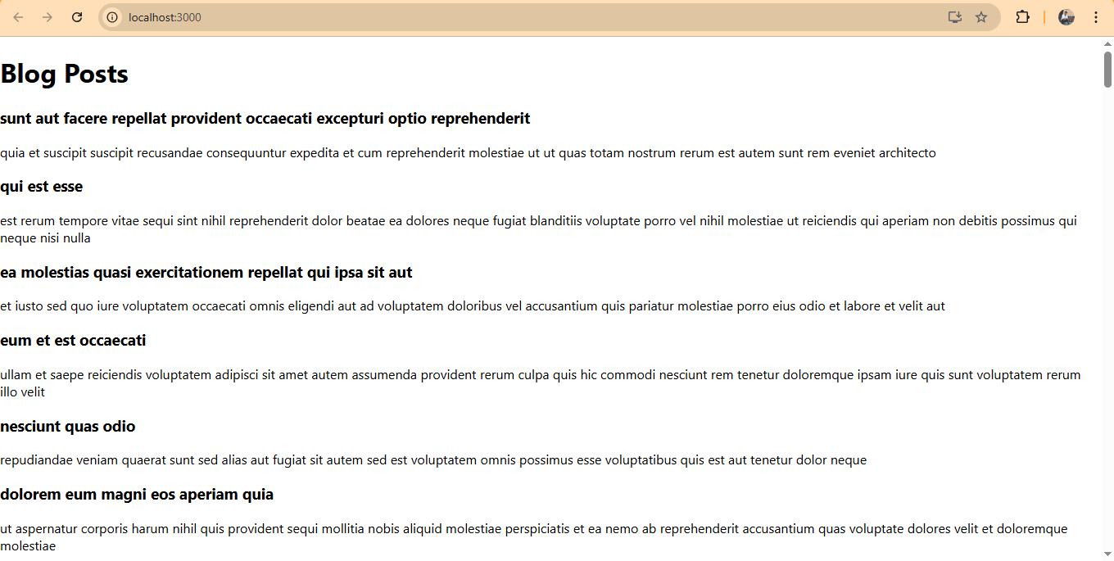

**5 : React-App**

App.js :

import React from 'react';

import CohortDetails from './CohortDetails';

function App() {

  const cohorts = [

    {

      name: 'React Training Batch 1',

      status: 'ongoing',

      startDate: '2025-07-01',

      endDate: '2025-09-30'

    },

    {

      name: 'Angular Training Batch 2',

      status: 'completed',

      startDate: '2025-04-01',

      endDate: '2025-06-30'

    }

  ];

  return (

    <div className="App">

      <h1>My Academy Cohort Dashboard</h1>

      {cohorts.map((cohort, index) => (

        <CohortDetails key={index} cohort={cohort} />

      ))}

    </div>

  );

}

export default App;

CohortDetails.module.css :

import React from 'react';

import styles from './CohortDetails.module.css';

function CohortDetails({ cohort }) {

  return (

    <div className={styles.box}>

      <h3 style={{ color: cohort.status === 'ongoing' ? 'green' : 'blue' }}>

        {cohort.name}

      </h3>

      <dl>

        <dt>Status:</dt>

        <dd>{cohort.status}</dd>

        <dt>Start Date:</dt>

        <dd>{cohort.startDate}</dd>

        <dt>End Date:</dt>

        <dd>{cohort.endDate}</dd>

      </dl>

    </div>

  );

}

export default CohortDetails;

CohortDetails.js :

/* import styles from './CohortDetails.module.css'; */

.box {

    width: 300px;

    display: inline-block;

    margin: 10px;

    padding: 10px 20px;

    border: 1px solid black;

    border-radius: 10px;

}

dt {

    font-weight: 500;

}

