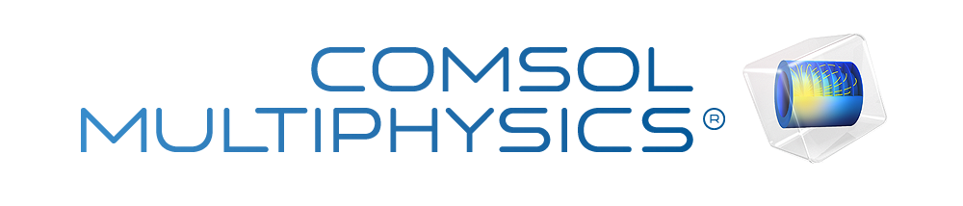

WG TE11
Author | Aparna Bhuvanagiri
Report date | Oct 21, 2026, 11:17:01 PM
Report version | 0

Summary
Basic Waveguide Analysis for TE11 operation at 5GHz frequency
Contents
1. Global Definitions
1.1. Shared Properties
2. Component 1
2.1. Definitions
2.2. Geometry 1
2.3. Materials
2.4. Electromagnetic Waves, Frequency Domain
2.5. Mesh 1
3. Study 1
3.1. Boundary Mode Analysis
3.2. Boundary Mode Analysis 1
3.3. Frequency Domain
3.4. Solver Configurations
4. Results
4.1. Datasets
4.2. Derived Values
4.3. Tables
4.4. Plot Groups

Global Definitions
Date | Sep 19, 2026, 6:16:37 PM

Global settings
Name | WG TE11.mph
Path | C:\Users\ADITYA\Videos\WG_TE11.mph
Version | COMSOL Multiphysics 6.3 (Build: 290)
Unit system | SI

Used products
RF Module
COMSOL Multiphysics
Design Module
CAD Import Module

Computer information
CPU | Intel64 Family 6 Model 126 Stepping 5, 4 cores, 15.77 GB RAM
Operating system | Windows 11

Shared Properties

Default Model Inputs
Tag | cminpt

Component 1
Date | Sep 19, 2026, 3:11:28 PM

Settings
Description | Value
Unit system | Same as global system (SI)
Geometry shape function | Automatic

Spatial frame coordinates
First | Second | Third
x | y | z

Material frame coordinates
First | Second | Third
X | Y | Z

Geometry frame coordinates
First | Second | Third
Xg | Yg | Zg

Mesh frame coordinates
First | Second | Third
Xm | Ym | Zm

Definitions

Coordinate Systems

Boundary System 1
Coordinate system type | Boundary system
Tag | sys1

Coordinate names
First | Second | Third
t1 | t2 | n

Geometry 1
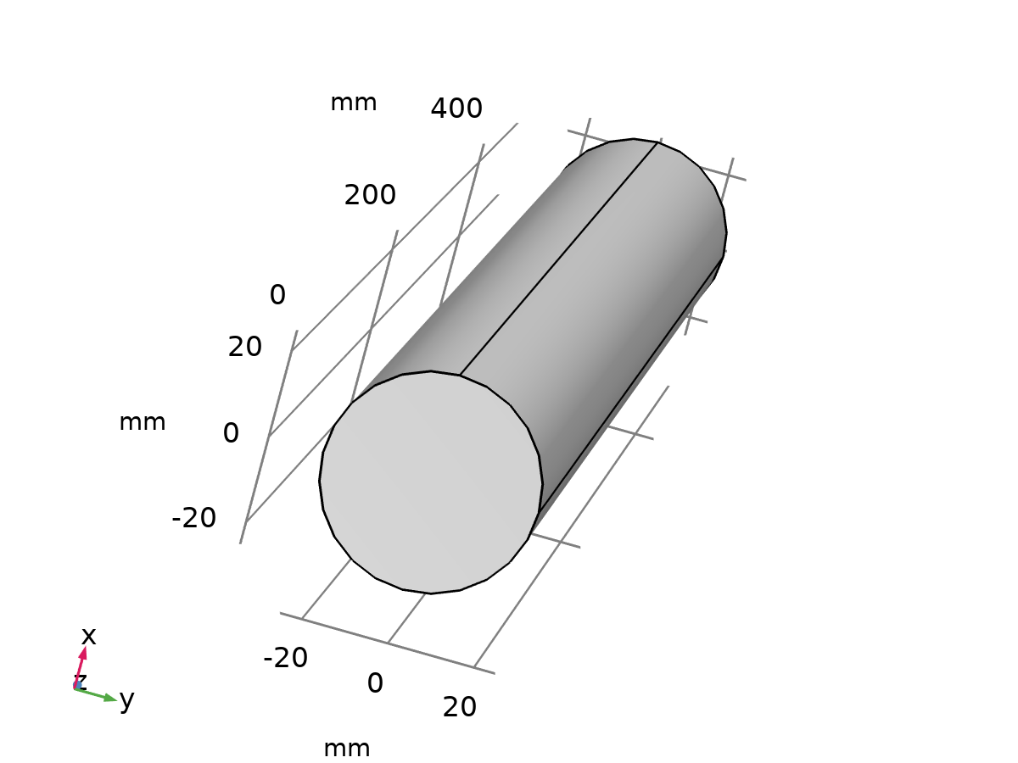
Geometry 1
Units
Length unit | mm
Angular unit | deg

Geometry statistics
Description | Value
Space dimension | 3
Number of domains | 1
Number of boundaries | 6
Number of edges | 12
Number of vertices | 8

Cylinder 1 (cyl1)
Size and shape
Description | Value
Radius | 25
Height | 500

Position
Description | Value
Position | {0, 0, 0}

Axis
Description | Value
Axis type | z - axis

Form Union (fin)
Information
Description | Value
Build message | Formed union of 1 solid object. Union has 1 domain, 6 boundaries, 12 edges, and 8 vertices.

Materials

Perfect_Vaccum
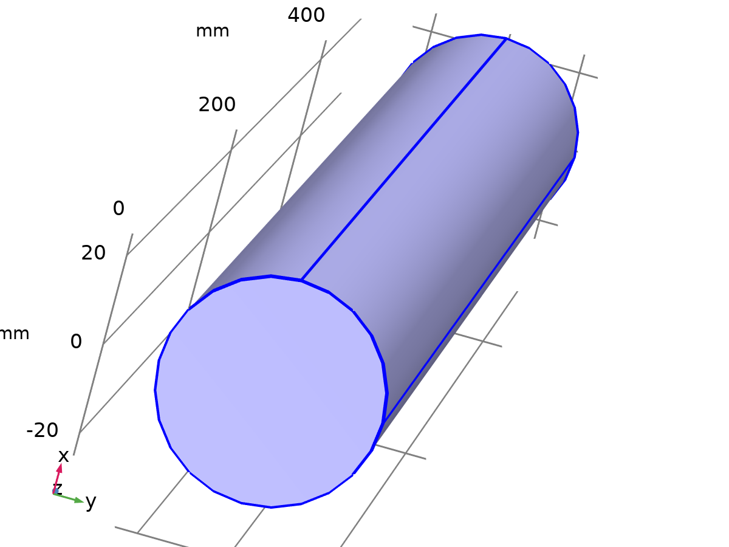
Perfect_Vaccum
Selection
Geometric entity level | Domain
Selection | Geometry geom1: Dimension 3: All domains

Material parameters
Name | Value | Unit | Property group
Relative permittivity | 1 | 1 | Basic
Relative permeability | 1 | 1 | Basic
Electric conductivity | 0 | S/m | Basic

Basic
Description | Value | Unit
Relative permittivity | 1 | 1
Relative permeability | 1 | 1
Electric conductivity | 0 | S/m

Electromagnetic Waves, Frequency Domain
Used products
RF Module
COMSOL Multiphysics

Electromagnetic Waves, Frequency Domain
Selection
Geometric entity level | Domain
Selection | Geometry geom1: Dimension 3: All domains

Equations
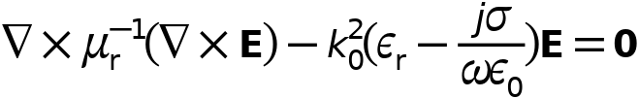
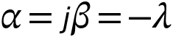
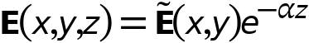

Interface Settings

Discretization
Settings
Description | Value
Electric field | Quadratic

Physics-Controlled Mesh
Settings
Description | Value
Maximum mesh element size control parameter | From study
Resolve wave in lossy media | Off
Refine conductive edges | Off
Add far-field boundary layers | Off

Formulation
Settings
Description | Value
 | Full field

Port Sweep Settings
Settings
Description | Value
Use manual port sweep | Off

Analysis Methodology
Settings
Description | Value
Methodology options | Fast

Variables
Name | Expression | Unit | Description | Selection | Details
emw.Ebx | 0 | V/m | Background electric field, x-component | Domain 1
emw.Eby | 0 | V/m | Background electric field, y-component | Domain 1
emw.Ebz | 0 | V/m | Background electric field, z-component | Domain 1
emw.curlEbx | d(emw.Ebz,y)-d(emw.Eby,z) | V/m² | Curl of background electric field, x-component | Domain 1
emw.curlEby | -d(emw.Ebz,x)+d(emw.Ebx,z) | V/m² | Curl of background electric field, y-component | Domain 1
emw.curlEbz | d(emw.Eby,x)-d(emw.Ebx,y) | V/m² | Curl of background electric field, z-component | Domain 1
emw.nx | dnx |  | Normal vector, x-component | Boundaries 1–6
emw.ny | dny |  | Normal vector, y-component | Boundaries 1–6
emw.nz | dnz |  | Normal vector, z-component | Boundaries 1–6
emw.nPMLx | dnx | 1 | Normal vector, x-component | Boundaries 1–6
emw.nPMLy | dny | 1 | Normal vector, y-component | Boundaries 1–6
emw.nPMLz | dnz | 1 | Normal vector, z-component | Boundaries 1–6
emw.nmeshx | dnxmesh |  | Normal vector (mesh), x-component | Boundaries 1–6
emw.nmeshy | dnymesh |  | Normal vector (mesh), y-component | Boundaries 1–6
emw.nmeshz | dnzmesh |  | Normal vector (mesh), z-component | Boundaries 1–6
emw.unmeshx | unxmesh |  | Mesh normal vector, upside, x-component | Boundaries 1–6
emw.unmeshy | unymesh |  | Mesh normal vector, upside, y-component | Boundaries 1–6
emw.unmeshz | unzmesh |  | Mesh normal vector, upside, z-component | Boundaries 1–6
emw.dnmeshx | dnxmesh |  | Mesh normal vector, downside, x-component | Boundaries 1–6
emw.dnmeshy | dnymesh |  | Mesh normal vector, downside, y-component | Boundaries 1–6
emw.dnmeshz | dnzmesh |  | Mesh normal vector, downside, z-component | Boundaries 1–6
emw.k0 | emw.iomega*sqrt(mu0_const*epsilon0_const)/i | rad/m | Wave number in free space | Global
emw.k | emw.k0*sqrt((emw.murxx*(emw.epsilonrxx+emw.sigmaxx/(emw.iomega*epsilon0_const))+emw.murxy*(emw.epsilonryx+emw.sigmayx/(emw.iomega*epsilon0_const))+emw.murxz*(emw.epsilonrzx+emw.sigmazx/(emw.iomega*epsilon0_const))+emw.muryx*(emw.epsilonrxy+emw.sigmaxy/(emw.iomega*epsilon0_const))+emw.muryy*(emw.epsilonryy+emw.sigmayy/(emw.iomega*epsilon0_const))+emw.muryz*(emw.epsilonrzy+emw.sigmazy/(emw.iomega*epsilon0_const))+emw.murzx*(emw.epsilonrxz+emw.sigmaxz/(emw.iomega*epsilon0_const))+emw.murzy*(emw.epsilonryz+emw.sigmayz/(emw.iomega*epsilon0_const))+emw.murzz*(emw.epsilonrzz+emw.sigmazz/(emw.iomega*epsilon0_const)))/3) | rad/m | Wave number | Domain 1
emw.TypicalWavelength | 2*pi/emw.k | m | Typical wavelength | Domain 1
emw.Jsx | 0 | A/m | Surface current density, x-component | Boundaries 1–6 | + operation
emw.Jsy | 0 | A/m | Surface current density, y-component | Boundaries 1–6 | + operation
emw.Jsz | 0 | A/m | Surface current density, z-component | Boundaries 1–6 | + operation
emw.normJs | sqrt(realdot(emw.Jsx,emw.Jsx)+realdot(emw.Jsy,emw.Jsy)+realdot(emw.Jsz,emw.Jsz)) | A/m | Surface current density norm | Boundaries 1–6
emw.normJsi | sqrt(real(emw.Jsx)^2+real(emw.Jsy)^2+real(emw.Jsz)^2) | A/m | Instantaneous surface current density norm | Boundaries 1–6
emw.intWe | emw.integratewee(emw.dWe) | J | Total electric energy | Global | + operation
emw.intWm | emw.integratewee(emw.dWm) | J | Total magnetic energy | Global | + operation
emw.tEx | emw.tEdepx | V/m | Tangential electric field, x-component | Boundaries 1–6
emw.tEy | emw.tEdepy | V/m | Tangential electric field, y-component | Boundaries 1–6
emw.tEz | emw.tEdepz | V/m | Tangential electric field, z-component | Boundaries 1–6
emw.tEx | emw.tEdepx | V/m | Tangential electric field, x-component | Edges 1–12
emw.tEy | emw.tEdepy | V/m | Tangential electric field, y-component | Edges 1–12
emw.tEz | emw.tEdepz | V/m | Tangential electric field, z-component | Edges 1–12
emw.tEdepx | tEx | V/m | Tangential electric field, x-component | Boundaries 1–6
emw.tEdepy | tEy | V/m | Tangential electric field, y-component | Boundaries 1–6
emw.tEdepz | tEz | V/m | Tangential electric field, z-component | Boundaries 1–6
emw.tEdepx | tEx | V/m | Tangential electric field, x-component | Edges 1–12
emw.tEdepy | tEy | V/m | Tangential electric field, y-component | Edges 1–12
emw.tEdepz | tEz | V/m | Tangential electric field, z-component | Edges 1–12
emw.symPlaneCount | 0 |  | Symmetry plane count | Global | + operation
emw.omega | 2*pi*5[GHz] | rad/s | Angular frequency | Global
emw.freq | 5[GHz] | Hz | Frequency | Global
emw.iomega | emw.omega*i | rad/s | Complex angular frequency | Global
emw.port1.Pin | 1[W] | W | Port input power | Global
emw.port2.Pin | 1[W] | W | Port input power | Global
emw.S11 | if(abs(emw.beta_1)>1.0E-7*emw.intport1(emw.k)/emw.Area_1&&(abs(arg(emw.beta_1))<=0.25*pi||abs(arg(emw.beta_1))>=0.75*pi),emw.S1x*exp(-j*phase),0) | 1 | S11 | Global
emw.S21 | if(abs(emw.beta_2)>1.0E-7*emw.intport2(emw.k)/emw.Area_2&&(abs(arg(emw.beta_2))<=0.25*pi||abs(arg(emw.beta_2))>=0.75*pi),emw.S2x*exp(-j*phase),0) | 1 | S21 | Global
emw.S11dB | 10*log10(realdot(if(abs(emw.beta_1)>1.0E-7*emw.intport1(emw.k)/emw.Area_1&&(abs(arg(emw.beta_1))<=0.25*pi||abs(arg(emw.beta_1))>=0.75*pi),emw.S1x*exp(-j*phase),0),if(abs(emw.beta_1)>1.0E-7*emw.intport1(emw.k)/emw.Area_1&&(abs(arg(emw.beta_1))<=0.25*pi||abs(arg(emw.beta_1))>=0.75*pi),emw.S1x*exp(-j*phase),0))) | 1 | S11 | Global
emw.S21dB | 10*log10(realdot(if(abs(emw.beta_2)>1.0E-7*emw.intport2(emw.k)/emw.Area_2&&(abs(arg(emw.beta_2))<=0.25*pi||abs(arg(emw.beta_2))>=0.75*pi),emw.S2x*exp(-j*phase),0),if(abs(emw.beta_2)>1.0E-7*emw.intport2(emw.k)/emw.Area_2&&(abs(arg(emw.beta_2))<=0.25*pi||abs(arg(emw.beta_2))>=0.75*pi),emw.S2x*exp(-j*phase),0))) | 1 | S21 | Global
emw.VSWR_1 | (1+sqrt(realdot(if(abs(emw.beta_1)>1.0E-7*emw.intport1(emw.k)/emw.Area_1&&(abs(arg(emw.beta_1))<=0.25*pi||abs(arg(emw.beta_1))>=0.75*pi),emw.S1x*exp(-j*phase),0),if(abs(emw.beta_1)>1.0E-7*emw.intport1(emw.k)/emw.Area_1&&(abs(arg(emw.beta_1))<=0.25*pi||abs(arg(emw.beta_1))>=0.75*pi),emw.S1x*exp(-j*phase),0))))/(1-sqrt(realdot(if(abs(emw.beta_1)>1.0E-7*emw.intport1(emw.k)/emw.Area_1&&(abs(arg(emw.beta_1))<=0.25*pi||abs(arg(emw.beta_1))>=0.75*pi),emw.S1x*exp(-j*phase),0),if(abs(emw.beta_1)>1.0E-7*emw.intport1(emw.k)/emw.Area_1&&(abs(arg(emw.beta_1))<=0.25*pi||abs(arg(emw.beta_1))>=0.75*pi),emw.S1x*exp(-j*phase),0)))) | 1 | Voltage standing wave ratio | Global
emw.ABCD_A | 0.5*((1+emw.S11)*(1-emw.S11)+emw.S21^2)/emw.S21 | 1 | Two-port ABCD-parameter, A | Global
emw.ABCD_C | 0.01*((1-emw.S11)^2-emw.S21^2)/emw.S21 | 1 | Two-port ABCD-parameter, C | Global
emw.ABCD_B | 25*((1+emw.S11)^2-emw.S21^2)/emw.S21 | 1 | Two-port ABCD-parameter, B | Global
emw.ABCD_D | 0.5*((1-emw.S11)*(1+emw.S11)+emw.S21^2)/emw.S21 | 1 | Two-port ABCD-parameter, D | Global
emw.zref | 50[ohm] | Ω | Reference impedance | Global

Wave Equation, Electric 1
Wave Equation, Electric 1
Selection
Geometric entity level | Domain
Selection | Geometry geom1: Dimension 3: All domains

Equations
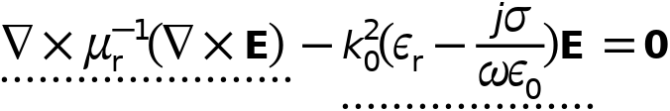

Electric Displacement Field
Settings
Description | Value
Electric displacement field model | Relative permittivity
Relative permittivity | From material

Magnetic Field
Settings
Description | Value
Constitutive relation | Relative permeability
Relative permeability | From material

Conduction Current
Settings
Description | Value
Electric conductivity | From material

Coordinate System Selection
Settings
Description | Value
Coordinate system | Global coordinate system

Model Input
Settings
Description | Value
Temperature | Common model input

Properties from material
Property | Material | Property group
Relative permittivity | Perfect_Vaccum | Basic
Relative permeability | Perfect_Vaccum | Basic
Electric conductivity | Perfect_Vaccum | Basic

Variables
Name | Expression | Unit | Description | Selection | Details
emw.Qsh | 0 | W/m² | Surface losses | Boundaries 1–6 | + operation
emw.Qe | emw.Qrh | W/m³ | Electromagnetic power loss density | Domain 1 | + operation
emw.Qh | emw.Qrh | W/m³ | Total power dissipation density | Domain 1 | + operation
emw.Jx | emw.sigmaxx*emw.Ex+emw.sigmaxy*emw.Ey+emw.sigmaxz*emw.Ez+emw.Jdx | A/m² | Current density, x-component | Domain 1 | + operation
emw.Jy | emw.sigmayx*emw.Ex+emw.sigmayy*emw.Ey+emw.sigmayz*emw.Ez+emw.Jdy | A/m² | Current density, y-component | Domain 1 | + operation
emw.Jz | emw.sigmazx*emw.Ex+emw.sigmazy*emw.Ey+emw.sigmazz*emw.Ez+emw.Jdz | A/m² | Current density, z-component | Domain 1 | + operation
emw.tJx | 0 | A/m² | Tangential current density, x-component | Boundaries 1–6 | + operation
emw.tJy | 0 | A/m² | Tangential current density, y-component | Boundaries 1–6 | + operation
emw.tJz | 0 | A/m² | Tangential current density, z-component | Boundaries 1–6 | + operation
emw.Wav | 0 | J/m³ | Energy density time average | Domain 1 | + operation
emw.W | emw.We+emw.Wm | J/m³ | Energy density | Domain 1 | + operation
emw.Jmsx | 0 | V/m | Surface magnetic current density, x-component | Boundaries 1–6 | + operation
emw.Jmsy | 0 | V/m | Surface magnetic current density, y-component | Boundaries 1–6 | + operation
emw.Jmsz | 0 | V/m | Surface magnetic current density, z-component | Boundaries 1–6 | + operation
emw.epsilonrxx | material.epsilonr11 | 1 | Relative permittivity, xx-component | Domain 1 | Meta
emw.epsilonryx | material.epsilonr21 | 1 | Relative permittivity, yx-component | Domain 1 | Meta
emw.epsilonrzx | material.epsilonr31 | 1 | Relative permittivity, zx-component | Domain 1 | Meta
emw.epsilonrxy | material.epsilonr12 | 1 | Relative permittivity, xy-component | Domain 1 | Meta
emw.epsilonryy | material.epsilonr22 | 1 | Relative permittivity, yy-component | Domain 1 | Meta
emw.epsilonrzy | material.epsilonr32 | 1 | Relative permittivity, zy-component | Domain 1 | Meta
emw.epsilonrxz | material.epsilonr13 | 1 | Relative permittivity, xz-component | Domain 1 | Meta
emw.epsilonryz | material.epsilonr23 | 1 | Relative permittivity, yz-component | Domain 1 | Meta
emw.epsilonrzz | material.epsilonr33 | 1 | Relative permittivity, zz-component | Domain 1 | Meta
emw.epsilonr_iso | material.epsilonr_iso | 1 | Relative permittivity | Domain 1 | Meta
emw.Px | epsilon0_const*(emw.epsilonrxx*emw.Ex+emw.epsilonrxy*emw.Ey+emw.epsilonrxz*emw.Ez-emw.Ex) | C/m² | Polarization, x-component | Domain 1 | + operation
emw.Py | epsilon0_const*(emw.epsilonryx*emw.Ex+emw.epsilonryy*emw.Ey+emw.epsilonryz*emw.Ez-emw.Ey) | C/m² | Polarization, y-component | Domain 1 | + operation
emw.Pz | epsilon0_const*(emw.epsilonrzx*emw.Ex+emw.epsilonrzy*emw.Ey+emw.epsilonrzz*emw.Ez-emw.Ez) | C/m² | Polarization, z-component | Domain 1 | + operation
emw.normP | sqrt(realdot(emw.Px,emw.Px)+realdot(emw.Py,emw.Py)+realdot(emw.Pz,emw.Pz)) | C/m² | Polarization norm | Domain 1
emw.Dx | epsilon0_const*emw.Ex+emw.Px | C/m² | Electric displacement field, x-component | Domain 1 | + operation
emw.Dy | epsilon0_const*emw.Ey+emw.Py | C/m² | Electric displacement field, y-component | Domain 1 | + operation
emw.Dz | epsilon0_const*emw.Ez+emw.Pz | C/m² | Electric displacement field, z-component | Domain 1 | + operation
emw.normD | sqrt(realdot(emw.Dx,emw.Dx)+realdot(emw.Dy,emw.Dy)+realdot(emw.Dz,emw.Dz)) | C/m² | Electric displacement field norm | Domain 1
emw.normDi | sqrt(real(emw.Dx)^2+real(emw.Dy)^2+real(emw.Dz)^2) | C/m² | Instantaneous electric displacement field norm | Domain 1
emw.normPi | sqrt(real(emw.Px)^2+real(emw.Py)^2+real(emw.Pz)^2) | C/m² | Instantaneous polarization norm | Domain 1
emw.epsrAv | (emw.epsilonrxx+emw.epsilonryy+emw.epsilonrzz)/3 | 1 | Relative permittivity, average | Domain 1
emw.murxx | material.mur11 | 1 | Relative permeability, xx-component | Domain 1 | Meta
emw.muryx | material.mur21 | 1 | Relative permeability, yx-component | Domain 1 | Meta
emw.murzx | material.mur31 | 1 | Relative permeability, zx-component | Domain 1 | Meta
emw.murxy | material.mur12 | 1 | Relative permeability, xy-component | Domain 1 | Meta
emw.muryy | material.mur22 | 1 | Relative permeability, yy-component | Domain 1 | Meta
emw.murzy | material.mur32 | 1 | Relative permeability, zy-component | Domain 1 | Meta
emw.murxz | material.mur13 | 1 | Relative permeability, xz-component | Domain 1 | Meta
emw.muryz | material.mur23 | 1 | Relative permeability, yz-component | Domain 1 | Meta
emw.murzz | material.mur33 | 1 | Relative permeability, zz-component | Domain 1 | Meta
emw.murAv | (emw.murxx+emw.muryy+emw.murzz)/3 | 1 | Relative permeability, average | Domain 1
emw.sigmaxx | material.sigma11 | S/m | Electric conductivity, xx-component | Domain 1 | Meta
emw.sigmayx | material.sigma21 | S/m | Electric conductivity, yx-component | Domain 1 | Meta
emw.sigmazx | material.sigma31 | S/m | Electric conductivity, zx-component | Domain 1 | Meta
emw.sigmaxy | material.sigma12 | S/m | Electric conductivity, xy-component | Domain 1 | Meta
emw.sigmayy | material.sigma22 | S/m | Electric conductivity, yy-component | Domain 1 | Meta
emw.sigmazy | material.sigma32 | S/m | Electric conductivity, zy-component | Domain 1 | Meta
emw.sigmaxz | material.sigma13 | S/m | Electric conductivity, xz-component | Domain 1 | Meta
emw.sigmayz | material.sigma23 | S/m | Electric conductivity, yz-component | Domain 1 | Meta
emw.sigmazz | material.sigma33 | S/m | Electric conductivity, zz-component | Domain 1 | Meta
emw.sigma_iso | material.sigma_iso | S/m | Electric conductivity, isotropic value | Domain 1 | Meta
emw.Ex | Ex | V/m | Electric field, x-component | Domain 1
emw.Ey | Ey | V/m | Electric field, y-component | Domain 1
emw.Ez | Ez | V/m | Electric field, z-component | Domain 1
emw.curlEx | curlEx | V/m² | Curl of electric field, x-component | Domain 1
emw.curlEy | curlEy | V/m² | Curl of electric field, y-component | Domain 1
emw.curlEz | curlEz | V/m² | Curl of electric field, z-component | Domain 1
emw.testdepEx | test(Ex) | V/m | Electric field, x-component | Domain 1
emw.testdepEy | test(Ey) | V/m | Electric field, y-component | Domain 1
emw.testdepEz | test(Ez) | V/m | Electric field, z-component | Domain 1
emw.curltestdepEx | test(curlEx) | V/m² | Curl of electric field, x-component | Domain 1
emw.curltestdepEy | test(curlEy) | V/m² | Curl of electric field, y-component | Domain 1
emw.curltestdepEz | test(curlEz) | V/m² | Curl of electric field, z-component | Domain 1
emw.dBdtx | -emw.curlEx | V/m² | Magnetic flux density, time derivative, x-component | Domain 1
emw.dBdty | -emw.curlEy | V/m² | Magnetic flux density, time derivative, y-component | Domain 1
emw.dBdtz | -emw.curlEz | V/m² | Magnetic flux density, time derivative, z-component | Domain 1
emw.Bx | -emw.curlEx/emw.iomega | T | Magnetic flux density, x-component | Domain 1
emw.By | -emw.curlEy/emw.iomega | T | Magnetic flux density, y-component | Domain 1
emw.Bz | -emw.curlEz/emw.iomega | T | Magnetic flux density, z-component | Domain 1
emw.murinvxx | (emw.muryy*emw.murzz-emw.muryz*emw.murzy)/(emw.murxx*emw.muryy*emw.murzz+emw.murxy*emw.muryz*emw.murzx+emw.murxz*emw.muryx*emw.murzy-emw.murxx*emw.muryz*emw.murzy-emw.murxy*emw.muryx*emw.murzz-emw.murxz*emw.muryy*emw.murzx) | 1 | Inverse of relative permeability, xx-component | Domain 1
emw.murinvyx | (emw.muryz*emw.murzx-emw.muryx*emw.murzz)/(emw.murxx*emw.muryy*emw.murzz+emw.murxy*emw.muryz*emw.murzx+emw.murxz*emw.muryx*emw.murzy-emw.murxx*emw.muryz*emw.murzy-emw.murxy*emw.muryx*emw.murzz-emw.murxz*emw.muryy*emw.murzx) | 1 | Inverse of relative permeability, yx-component | Domain 1
emw.murinvzx | (emw.muryx*emw.murzy-emw.muryy*emw.murzx)/(emw.murxx*emw.muryy*emw.murzz+emw.murxy*emw.muryz*emw.murzx+emw.murxz*emw.muryx*emw.murzy-emw.murxx*emw.muryz*emw.murzy-emw.murxy*emw.muryx*emw.murzz-emw.murxz*emw.muryy*emw.murzx) | 1 | Inverse of relative permeability, zx-component | Domain 1
emw.murinvxy | (emw.murxz*emw.murzy-emw.murxy*emw.murzz)/(emw.murxx*emw.muryy*emw.murzz+emw.murxy*emw.muryz*emw.murzx+emw.murxz*emw.muryx*emw.murzy-emw.murxx*emw.muryz*emw.murzy-emw.murxy*emw.muryx*emw.murzz-emw.murxz*emw.muryy*emw.murzx) | 1 | Inverse of relative permeability, xy-component | Domain 1
emw.murinvyy | (emw.murxx*emw.murzz-emw.murxz*emw.murzx)/(emw.murxx*emw.muryy*emw.murzz+emw.murxy*emw.muryz*emw.murzx+emw.murxz*emw.muryx*emw.murzy-emw.murxx*emw.muryz*emw.murzy-emw.murxy*emw.muryx*emw.murzz-emw.murxz*emw.muryy*emw.murzx) | 1 | Inverse of relative permeability, yy-component | Domain 1
emw.murinvzy | (emw.murxy*emw.murzx-emw.murxx*emw.murzy)/(emw.murxx*emw.muryy*emw.murzz+emw.murxy*emw.muryz*emw.murzx+emw.murxz*emw.muryx*emw.murzy-emw.murxx*emw.muryz*emw.murzy-emw.murxy*emw.muryx*emw.murzz-emw.murxz*emw.muryy*emw.murzx) | 1 | Inverse of relative permeability, zy-component | Domain 1
emw.murinvxz | (emw.murxy*emw.muryz-emw.murxz*emw.muryy)/(emw.murxx*emw.muryy*emw.murzz+emw.murxy*emw.muryz*emw.murzx+emw.murxz*emw.muryx*emw.murzy-emw.murxx*emw.muryz*emw.murzy-emw.murxy*emw.muryx*emw.murzz-emw.murxz*emw.muryy*emw.murzx) | 1 | Inverse of relative permeability, xz-component | Domain 1
emw.murinvyz | (emw.murxz*emw.muryx-emw.murxx*emw.muryz)/(emw.murxx*emw.muryy*emw.murzz+emw.murxy*emw.muryz*emw.murzx+emw.murxz*emw.muryx*emw.murzy-emw.murxx*emw.muryz*emw.murzy-emw.murxy*emw.muryx*emw.murzz-emw.murxz*emw.muryy*emw.murzx) | 1 | Inverse of relative permeability, yz-component | Domain 1
emw.murinvzz | (emw.murxx*emw.muryy-emw.murxy*emw.muryx)/(emw.murxx*emw.muryy*emw.murzz+emw.murxy*emw.muryz*emw.murzx+emw.murxz*emw.muryx*emw.murzy-emw.murxx*emw.muryz*emw.murzy-emw.murxy*emw.muryx*emw.murzz-emw.murxz*emw.muryy*emw.murzx) | 1 | Inverse of relative permeability, zz-component | Domain 1
emw.Hx | (emw.murinvxx*emw.Bx+emw.murinvxy*emw.By+emw.murinvxz*emw.Bz)/mu0_const | A/m | Magnetic field, x-component | Domain 1
emw.Hy | (emw.murinvyx*emw.Bx+emw.murinvyy*emw.By+emw.murinvyz*emw.Bz)/mu0_const | A/m | Magnetic field, y-component | Domain 1
emw.Hz | (emw.murinvzx*emw.Bx+emw.murinvzy*emw.By+emw.murinvzz*emw.Bz)/mu0_const | A/m | Magnetic field, z-component | Domain 1
emw.dHdtx | (emw.murinvxx*emw.dBdtx+emw.murinvxy*emw.dBdty+emw.murinvxz*emw.dBdtz)/mu0_const | A/(m·s) | Magnetic field, time derivative, x-component | Domain 1
emw.dHdty | (emw.murinvyx*emw.dBdtx+emw.murinvyy*emw.dBdty+emw.murinvyz*emw.dBdtz)/mu0_const | A/(m·s) | Magnetic field, time derivative, y-component | Domain 1
emw.dHdtz | (emw.murinvzx*emw.dBdtx+emw.murinvzy*emw.dBdty+emw.murinvzz*emw.dBdtz)/mu0_const | A/(m·s) | Magnetic field, time derivative, z-component | Domain 1
emw.normE | sqrt(realdot(emw.Ex,emw.Ex)+realdot(emw.Ey,emw.Ey)+realdot(emw.Ez,emw.Ez)) | V/m | Electric field norm | Domain 1
emw.normEi | sqrt(real(emw.Ex)^2+real(emw.Ey)^2+real(emw.Ez)^2) | V/m | Instantaneous electric field norm | Domain 1
emw.Mx | emw.Bx/mu0_const-emw.Hx | A/m | Magnetization, x-component | Domain 1
emw.My | emw.By/mu0_const-emw.Hy | A/m | Magnetization, y-component | Domain 1
emw.Mz | emw.Bz/mu0_const-emw.Hz | A/m | Magnetization, z-component | Domain 1
emw.normM | sqrt(realdot(emw.Mx,emw.Mx)+realdot(emw.My,emw.My)+realdot(emw.Mz,emw.Mz)) | A/m | Magnetization norm | Domain 1
emw.Brx | 0 | T | Remanent flux density, x-component | Domain 1
emw.Bry | 0 | T | Remanent flux density, y-component | Domain 1
emw.Brz | 0 | T | Remanent flux density, z-component | Domain 1
emw.normBr | sqrt(realdot(emw.Brx,emw.Brx)+realdot(emw.Bry,emw.Bry)+realdot(emw.Brz,emw.Brz)) | T | Remanent flux density norm | Domain 1
emw.tBx | emw.Bx-(emw.nmeshx*emw.Bx+emw.nmeshy*emw.By+emw.nmeshz*emw.Bz)*emw.nmeshx | T | Tangential magnetic flux density, x-component | Boundaries 1–6
emw.tBy | emw.By-(emw.nmeshx*emw.Bx+emw.nmeshy*emw.By+emw.nmeshz*emw.Bz)*emw.nmeshy | T | Tangential magnetic flux density, y-component | Boundaries 1–6
emw.tBz | emw.Bz-(emw.nmeshx*emw.Bx+emw.nmeshy*emw.By+emw.nmeshz*emw.Bz)*emw.nmeshz | T | Tangential magnetic flux density, z-component | Boundaries 1–6
emw.normB | sqrt(realdot(emw.Bx,emw.Bx)+realdot(emw.By,emw.By)+realdot(emw.Bz,emw.Bz)) | T | Magnetic flux density norm | Domain 1
emw.normBi | sqrt(real(emw.Bx)^2+real(emw.By)^2+real(emw.Bz)^2) | T | Instantaneous magnetic flux density norm | Domain 1
emw.normH | sqrt(realdot(emw.Hx,emw.Hx)+realdot(emw.Hy,emw.Hy)+realdot(emw.Hz,emw.Hz)) | A/m | Magnetic field norm | Domain 1
emw.normHi | sqrt(real(emw.Hx)^2+real(emw.Hy)^2+real(emw.Hz)^2) | A/m | Instantaneous magnetic field norm | Domain 1
emw.Jix | emw.sigmaxx*emw.Ex+emw.sigmaxy*emw.Ey+emw.sigmaxz*emw.Ez | A/m² | Induced current density, x-component | Domain 1 | + operation
emw.Jiy | emw.sigmayx*emw.Ex+emw.sigmayy*emw.Ey+emw.sigmayz*emw.Ez | A/m² | Induced current density, y-component | Domain 1 | + operation
emw.Jiz | emw.sigmazx*emw.Ex+emw.sigmazy*emw.Ey+emw.sigmazz*emw.Ez | A/m² | Induced current density, z-component | Domain 1 | + operation
emw.Jdx | emw.iomega*emw.Dx | A/m² | Displacement current density, x-component | Domain 1
emw.Jdy | emw.iomega*emw.Dy | A/m² | Displacement current density, y-component | Domain 1
emw.Jdz | emw.iomega*emw.Dz | A/m² | Displacement current density, z-component | Domain 1
emw.normJ | sqrt(realdot(emw.Jx,emw.Jx)+realdot(emw.Jy,emw.Jy)+realdot(emw.Jz,emw.Jz)) | A/m² | Current density norm | Domain 1
emw.normJi | sqrt(real(emw.Jx)^2+real(emw.Jy)^2+real(emw.Jz)^2) | A/m² | Instantaneous current density norm | Domain 1
emw.dWe | emw.We | J/m³ | Integrand for total electric energy | Domain 1 | Meta
emw.We | 0[J/m^3] | J/m³ | Electric energy density | Domain 1 | + operation
emw.Qrh | emw.Jx*emw.Ex+emw.Jy*emw.Ey+emw.Jz*emw.Ez | W/m³ | Resistive losses | Domain 1 | + operation
emw.dWm | emw.Wm | J/m³ | Integrand for total magnetic energy | Domain 1 | Meta
emw.Wm | 0[J/m^3] | J/m³ | Magnetic energy density | Domain 1 | + operation
emw.unTx | 0 | Pa | Maxwell upward surface stress tensor, x-component | Boundaries 1–6 | + operation
emw.unTy | 0 | Pa | Maxwell upward surface stress tensor, y-component | Boundaries 1–6 | + operation
emw.unTz | 0 | Pa | Maxwell upward surface stress tensor, z-component | Boundaries 1–6 | + operation
emw.dnTx | emw.dnTmx+emw.dnTex | Pa | Maxwell downward surface stress tensor, x-component | Boundaries 1–6 | + operation
emw.dnTy | emw.dnTmy+emw.dnTey | Pa | Maxwell downward surface stress tensor, y-component | Boundaries 1–6 | + operation
emw.dnTz | emw.dnTmz+emw.dnTez | Pa | Maxwell downward surface stress tensor, z-component | Boundaries 1–6 | + operation
emw.unx | unx |  | Normal vector up direction, x-component | Boundaries 1–6
emw.uny | uny |  | Normal vector up direction, y-component | Boundaries 1–6
emw.unz | unz |  | Normal vector up direction, z-component | Boundaries 1–6
emw.dnx | dnx |  | Normal vector down direction, x-component | Boundaries 1–6
emw.dny | dny |  | Normal vector down direction, y-component | Boundaries 1–6
emw.dnz | dnz |  | Normal vector down direction, z-component | Boundaries 1–6
emw.unTmx | -0.5*emw.dnx*(up(emw.Bx)*up(emw.Hx)+up(emw.By)*up(emw.Hy)+up(emw.Bz)*up(emw.Hz))+up(emw.Bx)*(up(emw.Hx)*emw.dnx+up(emw.Hy)*emw.dny+up(emw.Hz)*emw.dnz) | Pa | Maxwell upward magnetic surface stress tensor, x-component | Boundaries 1–6
emw.unTmy | -0.5*emw.dny*(up(emw.Bx)*up(emw.Hx)+up(emw.By)*up(emw.Hy)+up(emw.Bz)*up(emw.Hz))+up(emw.By)*(up(emw.Hx)*emw.dnx+up(emw.Hy)*emw.dny+up(emw.Hz)*emw.dnz) | Pa | Maxwell upward magnetic surface stress tensor, y-component | Boundaries 1–6
emw.unTmz | -0.5*emw.dnz*(up(emw.Bx)*up(emw.Hx)+up(emw.By)*up(emw.Hy)+up(emw.Bz)*up(emw.Hz))+up(emw.Bz)*(up(emw.Hx)*emw.dnx+up(emw.Hy)*emw.dny+up(emw.Hz)*emw.dnz) | Pa | Maxwell upward magnetic surface stress tensor, z-component | Boundaries 1–6
emw.dnTmx | -0.5*emw.unx*(down(emw.Bx)*down(emw.Hx)+down(emw.By)*down(emw.Hy)+down(emw.Bz)*down(emw.Hz))+down(emw.Bx)*(down(emw.Hx)*emw.unx+down(emw.Hy)*emw.uny+down(emw.Hz)*emw.unz) | Pa | Maxwell downward magnetic surface stress tensor, x-component | Boundaries 1–6
emw.dnTmy | -0.5*emw.uny*(down(emw.Bx)*down(emw.Hx)+down(emw.By)*down(emw.Hy)+down(emw.Bz)*down(emw.Hz))+down(emw.By)*(down(emw.Hx)*emw.unx+down(emw.Hy)*emw.uny+down(emw.Hz)*emw.unz) | Pa | Maxwell downward magnetic surface stress tensor, y-component | Boundaries 1–6
emw.dnTmz | -0.5*emw.unz*(down(emw.Bx)*down(emw.Hx)+down(emw.By)*down(emw.Hy)+down(emw.Bz)*down(emw.Hz))+down(emw.Bz)*(down(emw.Hx)*emw.unx+down(emw.Hy)*emw.uny+down(emw.Hz)*emw.unz) | Pa | Maxwell downward magnetic surface stress tensor, z-component | Boundaries 1–6
emw.unTex | -0.5*emw.dnx*(up(emw.Dx)*up(emw.Ex)+up(emw.Dy)*up(emw.Ey)+up(emw.Dz)*up(emw.Ez))+up(emw.Dx)*(up(emw.Ex)*emw.dnx+up(emw.Ey)*emw.dny+up(emw.Ez)*emw.dnz) | Pa | Maxwell upward electric surface stress tensor, x-component | Boundaries 1–6
emw.unTey | -0.5*emw.dny*(up(emw.Dx)*up(emw.Ex)+up(emw.Dy)*up(emw.Ey)+up(emw.Dz)*up(emw.Ez))+up(emw.Dy)*(up(emw.Ex)*emw.dnx+up(emw.Ey)*emw.dny+up(emw.Ez)*emw.dnz) | Pa | Maxwell upward electric surface stress tensor, y-component | Boundaries 1–6
emw.unTez | -0.5*emw.dnz*(up(emw.Dx)*up(emw.Ex)+up(emw.Dy)*up(emw.Ey)+up(emw.Dz)*up(emw.Ez))+up(emw.Dz)*(up(emw.Ex)*emw.dnx+up(emw.Ey)*emw.dny+up(emw.Ez)*emw.dnz) | Pa | Maxwell upward electric surface stress tensor, z-component | Boundaries 1–6
emw.dnTex | -0.5*emw.unx*(down(emw.Dx)*down(emw.Ex)+down(emw.Dy)*down(emw.Ey)+down(emw.Dz)*down(emw.Ez))+down(emw.Dx)*(down(emw.Ex)*emw.unx+down(emw.Ey)*emw.uny+down(emw.Ez)*emw.unz) | Pa | Maxwell downward electric surface stress tensor, x-component | Boundaries 1–6
emw.dnTey | -0.5*emw.uny*(down(emw.Dx)*down(emw.Ex)+down(emw.Dy)*down(emw.Ey)+down(emw.Dz)*down(emw.Ez))+down(emw.Dy)*(down(emw.Ex)*emw.unx+down(emw.Ey)*emw.uny+down(emw.Ez)*emw.unz) | Pa | Maxwell downward electric surface stress tensor, y-component | Boundaries 1–6
emw.dnTez | -0.5*emw.unz*(down(emw.Dx)*down(emw.Ex)+down(emw.Dy)*down(emw.Ey)+down(emw.Dz)*down(emw.Ez))+down(emw.Dz)*(down(emw.Ex)*emw.unx+down(emw.Ey)*emw.uny+down(emw.Ez)*emw.unz) | Pa | Maxwell downward electric surface stress tensor, z-component | Boundaries 1–6

Shape functions
Name | Shape function | Unit | Description | Shape frame | Selection
Ex | Curl (Quadratic) | V/m | Electric field, x-component | Spatial | Domain 1
Ey | Curl (Quadratic) | V/m | Electric field, y-component | Spatial | Domain 1
Ez | Curl (Quadratic) | V/m | Electric field, z-component | Spatial | Domain 1

Perfect Electric Conductor 1
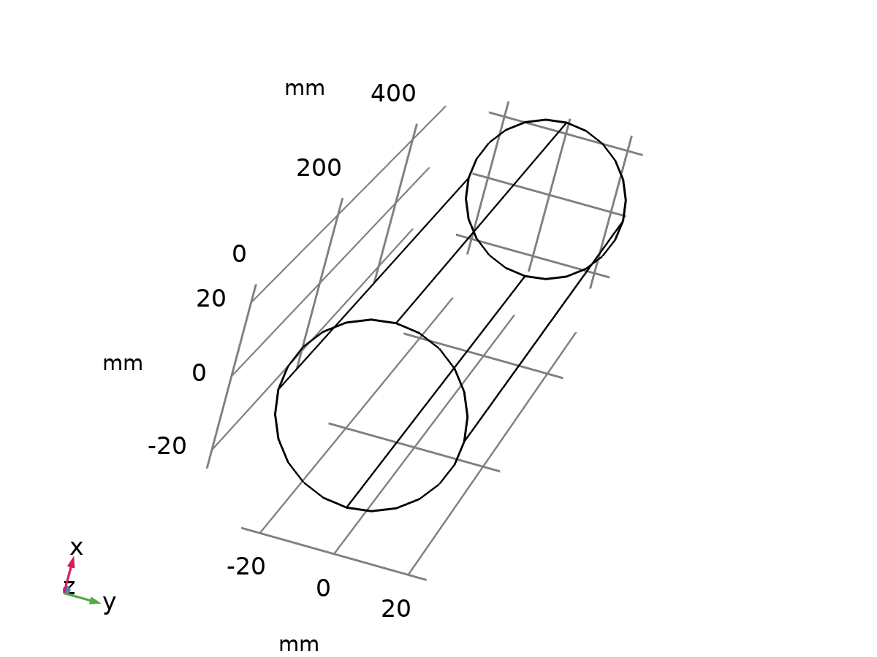
Perfect Electric Conductor 1
Selection
Geometric entity level | Boundary
Selection | Geometry geom1: Dimension 2: All boundaries

Equations
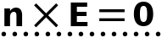

Initial Values 1
Initial Values 1
Selection
Geometric entity level | Domain
Selection | Geometry geom1: Dimension 3: All domains

Settings
Description | Value | Unit
Electric field | {0, 0, 0} | V/m

Coordinate System Selection
Settings
Description | Value
Coordinate system | Global coordinate system

Variables
Name | Expression | Unit | Description | Selection
emw.E_initx | 0 | V/m | Initial value for E, x-component | Domain 1
emw.E_inity | 0 | V/m | Initial value for E, y-component | Domain 1
emw.E_initz | 0 | V/m | Initial value for E, z-component | Domain 1

Perfect Electric Conductor 2
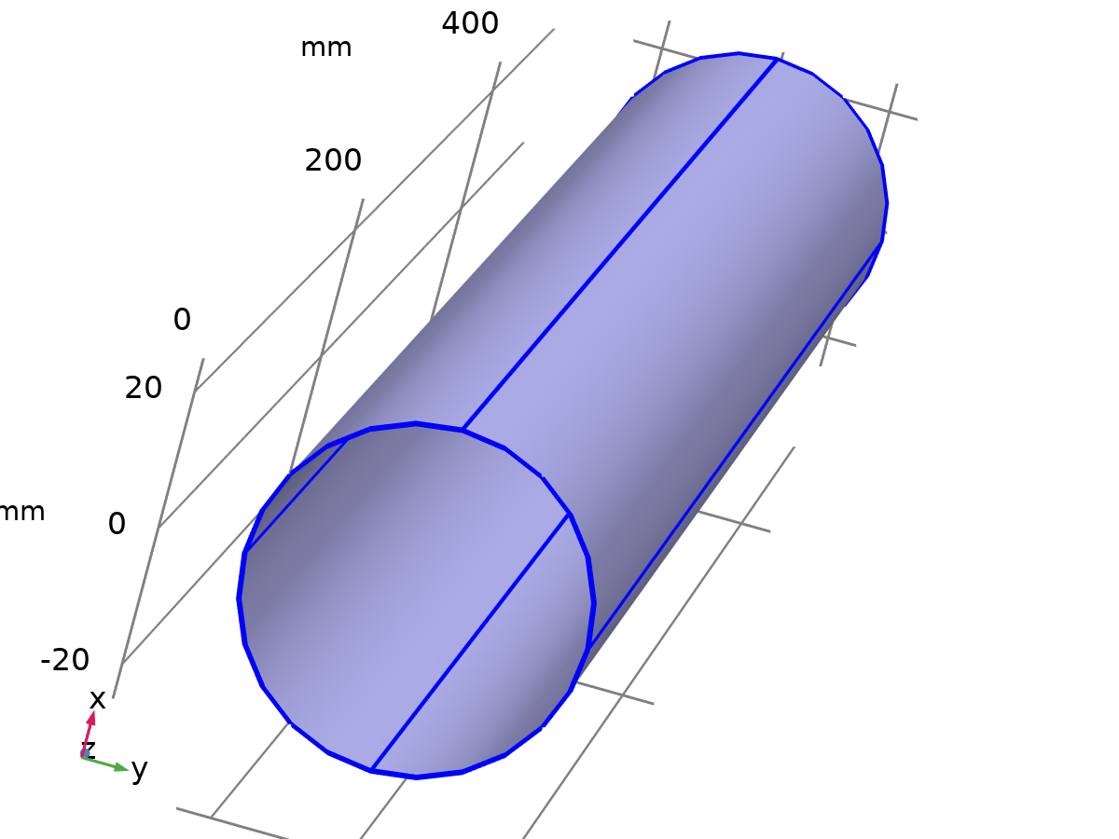
Perfect Electric Conductor 2
Selection
Geometric entity level | Boundary
Selection | Geometry geom1: Dimension 2: Boundaries 1–2, 5–6

Equations

Variables
Name | Expression | Unit | Description | Selection | Details
emw.Jsx | -down(emw.Hz)*emw.nmeshy+down(emw.Hy)*emw.nmeshz | A/m | Surface current density, x-component | Boundaries 1–2, 5–6 | + operation
emw.Jsy | down(emw.Hz)*emw.nmeshx-down(emw.Hx)*emw.nmeshz | A/m | Surface current density, y-component | Boundaries 1–2, 5–6 | + operation
emw.Jsz | -down(emw.Hy)*emw.nmeshx+down(emw.Hx)*emw.nmeshy | A/m | Surface current density, z-component | Boundaries 1–2, 5–6 | + operation
emw.testtEx | test(emw.tEx) | V/m | Tangential electric field, x-component | Boundaries 1–2, 5–6
emw.testtEy | test(emw.tEy) | V/m | Tangential electric field, y-component | Boundaries 1–2, 5–6
emw.testtEz | test(emw.tEz) | V/m | Tangential electric field, z-component | Boundaries 1–2, 5–6
emw.E0x | 0 | V/m | Electric field, x-component | Boundaries 1–2, 5–6
emw.E0y | 0 | V/m | Electric field, y-component | Boundaries 1–2, 5–6
emw.E0z | 0 | V/m | Electric field, z-component | Boundaries 1–2, 5–6

Constraints
Constraint | Constraint force | Shape function | Selection | Details
emw.E0x-emw.tEdepx | test(emw.E0x)-emw.testtEx | Curl (Quadratic) | Boundaries 1–2, 5–6 | Elemental
emw.E0y-emw.tEdepy | test(emw.E0y)-emw.testtEy | Curl (Quadratic) | Boundaries 1–2, 5–6 | Elemental
emw.E0z-emw.tEdepz | test(emw.E0z)-emw.testtEz | Curl (Quadratic) | Boundaries 1–2, 5–6 | Elemental

Port 1
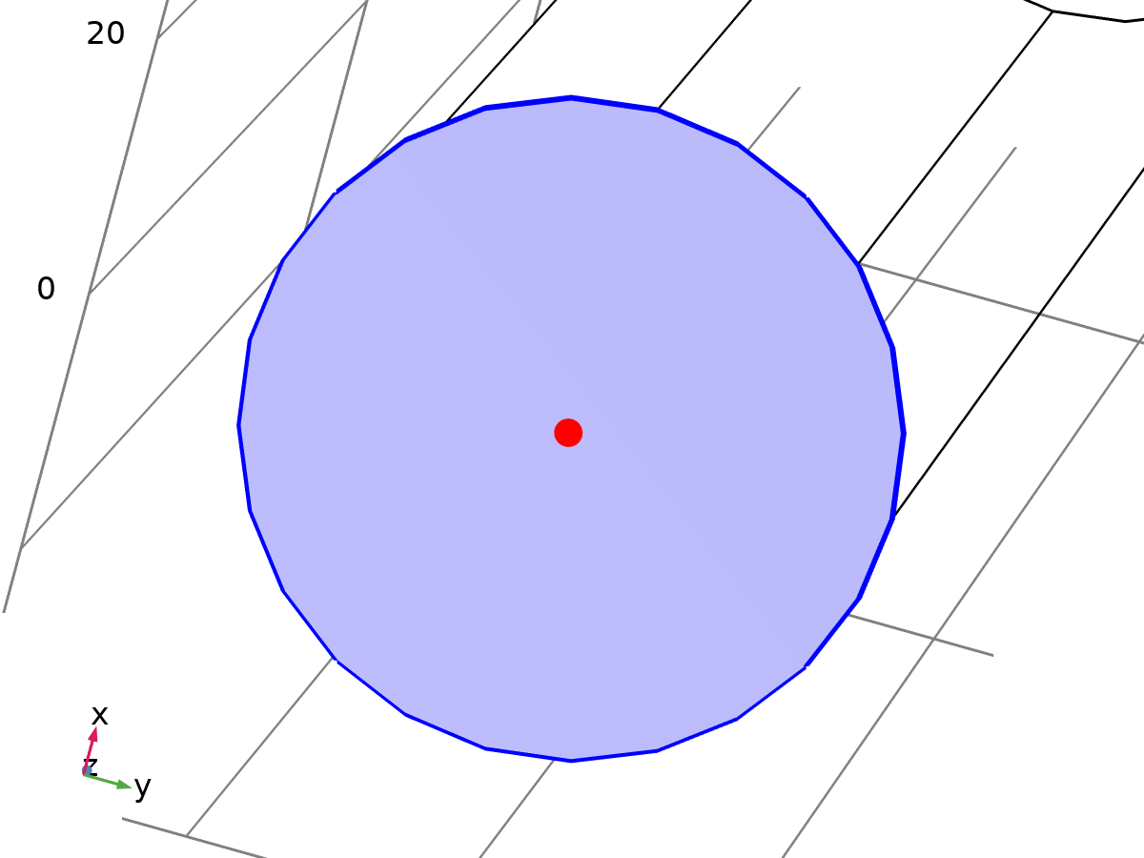
Port 1
Selection
Geometric entity level | Boundary
Selection | Geometry geom1: Dimension 2: Boundary 3

Equations

Port Properties
Settings
Description | Value | Unit
Port name | 1
Type of port | Numeric
Wave excitation at this port | On
Enable active port feedback | Off
Port input power | 1 | W
Activate slit condition on interior port | Off
Analyze as a TEM field | Off

Port Mode Settings
Settings
Description | Value | Unit
Mode phase | 0 | rad

De-Embedding Port
Settings
Description | Value | Unit
Port offset | 0 | m

Variables
Name | Expression | Unit | Description | Selection
emw.Area_1 | emw.intport1(1) | m² | Area | Global
emw.beta_1 | emw.intport1(-emw.alphaport_1*j)/emw.Area_1 | rad/m | Propagation constant | Global
emw.Pmode_1 | emw.intport1(if(imag(emw.alphaport_1)==0,1,real(0.5*(emw.nx*(conj(emw.tH0modez_1)*emw.tE0modey_1-conj(emw.tH0modey_1)*emw.tE0modez_1)+emw.ny*(-conj(emw.tH0modez_1)*emw.tE0modex_1+conj(emw.tH0modex_1)*emw.tE0modez_1)+emw.nz*(conj(emw.tH0modey_1)*emw.tE0modex_1-conj(emw.tH0modex_1)*emw.tE0modey_1))))) | W | Port mode power | Global
emw.tEmodex_1 | emw.tE0modex_1*sqrt(abs(emw.port1.Pin/emw.Pmode_1)) | V/m | Port tangential electric mode field, x-component | Boundary 3
emw.tEmodey_1 | emw.tE0modey_1*sqrt(abs(emw.port1.Pin/emw.Pmode_1)) | V/m | Port tangential electric mode field, y-component | Boundary 3
emw.tEmodez_1 | emw.tE0modez_1*sqrt(abs(emw.port1.Pin/emw.Pmode_1)) | V/m | Port tangential electric mode field, z-component | Boundary 3
emw.normtEmode_1 | sqrt(realdot(emw.tEmodex_1,emw.tEmodex_1)+realdot(emw.tEmodey_1,emw.tEmodey_1)+realdot(emw.tEmodez_1,emw.tEmodez_1)) | V/m | Port tangential electric mode field norm | Boundary 3
emw.tHmodex_1 | emw.tH0modex_1*sqrt(abs(emw.port1.Pin/emw.Pmode_1)) | A/m | Port tangential magnetic mode field, x-component | Boundary 3
emw.tHmodey_1 | emw.tH0modey_1*sqrt(abs(emw.port1.Pin/emw.Pmode_1)) | A/m | Port tangential magnetic mode field, y-component | Boundary 3
emw.tHmodez_1 | emw.tH0modez_1*sqrt(abs(emw.port1.Pin/emw.Pmode_1)) | A/m | Port tangential magnetic mode field, z-component | Boundary 3
emw.normtHmode_1 | sqrt(realdot(emw.tHmodex_1,emw.tHmodex_1)+realdot(emw.tHmodey_1,emw.tHmodey_1)+realdot(emw.tHmodez_1,emw.tHmodez_1)) | A/m | Port tangential magnetic mode field norm | Boundary 3
emw.tE0modex_1 | emw.tEbm1x | V/m | Port tangential electric mode field, x-component | Boundary 3
emw.tE0modey_1 | emw.tEbm1y | V/m | Port tangential electric mode field, y-component | Boundary 3
emw.tE0modez_1 | emw.tEbm1z | V/m | Port tangential electric mode field, z-component | Boundary 3
emw.normEbm_1 | sqrt(realdot(emw.tEbm1x,emw.tEbm1x)+realdot(emw.tEbm1y,emw.tEbm1y)+realdot(emw.tEbm1z,emw.tEbm1z)) | V/m | Tangential boundary mode electric field norm | Boundary 3
emw.dHdtx_1 | (-emw.murinvxx*(root.comp1.emw.tcurlEbm1x-emw.alphaport_1*(emw.tEbm1z*emw.ny-emw.tEbm1y*emw.nz)+emw.nebm1Tz*emw.ny-emw.nebm1Ty*emw.nz)-emw.murinvxy*(root.comp1.emw.tcurlEbm1y-emw.alphaport_1*(-emw.tEbm1z*emw.nx+emw.tEbm1x*emw.nz)-emw.nebm1Tz*emw.nx+emw.nebm1Tx*emw.nz)-emw.murinvxz*(root.comp1.emw.tcurlEbm1z-emw.alphaport_1*(emw.tEbm1y*emw.nx-emw.tEbm1x*emw.ny)+emw.nebm1Ty*emw.nx-emw.nebm1Tx*emw.ny))/mu0_const | A/(m·s) | Magnetic field, time derivative, x-component | Boundary 3
emw.dHdty_1 | (-emw.murinvyx*(root.comp1.emw.tcurlEbm1x-emw.alphaport_1*(emw.tEbm1z*emw.ny-emw.tEbm1y*emw.nz)+emw.nebm1Tz*emw.ny-emw.nebm1Ty*emw.nz)-emw.murinvyy*(root.comp1.emw.tcurlEbm1y-emw.alphaport_1*(-emw.tEbm1z*emw.nx+emw.tEbm1x*emw.nz)-emw.nebm1Tz*emw.nx+emw.nebm1Tx*emw.nz)-emw.murinvyz*(root.comp1.emw.tcurlEbm1z-emw.alphaport_1*(emw.tEbm1y*emw.nx-emw.tEbm1x*emw.ny)+emw.nebm1Ty*emw.nx-emw.nebm1Tx*emw.ny))/mu0_const | A/(m·s) | Magnetic field, time derivative, y-component | Boundary 3
emw.dHdtz_1 | (-emw.murinvzx*(root.comp1.emw.tcurlEbm1x-emw.alphaport_1*(emw.tEbm1z*emw.ny-emw.tEbm1y*emw.nz)+emw.nebm1Tz*emw.ny-emw.nebm1Ty*emw.nz)-emw.murinvzy*(root.comp1.emw.tcurlEbm1y-emw.alphaport_1*(-emw.tEbm1z*emw.nx+emw.tEbm1x*emw.nz)-emw.nebm1Tz*emw.nx+emw.nebm1Tx*emw.nz)-emw.murinvzz*(root.comp1.emw.tcurlEbm1z-emw.alphaport_1*(emw.tEbm1y*emw.nx-emw.tEbm1x*emw.ny)+emw.nebm1Ty*emw.nx-emw.nebm1Tx*emw.ny))/mu0_const | A/(m·s) | Magnetic field, time derivative, z-component | Boundary 3
emw.tH0modex_1 | ((emw.ny*emw.dHdtx_1-emw.nx*emw.dHdty_1)*emw.ny+(emw.nz*emw.dHdtx_1-emw.nx*emw.dHdtz_1)*emw.nz)/emw.iomega | A/m | Port tangential magnetic mode field, x-component | Boundary 3
emw.tH0modey_1 | ((-emw.ny*emw.dHdtx_1+emw.nx*emw.dHdty_1)*emw.nx+(emw.nz*emw.dHdty_1-emw.ny*emw.dHdtz_1)*emw.nz)/emw.iomega | A/m | Port tangential magnetic mode field, y-component | Boundary 3
emw.tH0modez_1 | ((-emw.nz*emw.dHdtx_1+emw.nx*emw.dHdtz_1)*emw.nx+(-emw.nz*emw.dHdty_1+emw.ny*emw.dHdtz_1)*emw.ny)/emw.iomega | A/m | Port tangential magnetic mode field, z-component | Boundary 3
emw.Jx_1 | emw.sigmaxx*emw.tEbm1x+emw.sigmaxy*emw.tEbm1y+emw.sigmaxz*emw.tEbm1z+emw.iomega*epsilon0_const*emw.epsilonrxx*emw.tEbm1x+emw.iomega*epsilon0_const*emw.epsilonrxy*emw.tEbm1y+emw.iomega*epsilon0_const*emw.epsilonrxz*emw.tEbm1z-(emw.sigmaxx+emw.iomega*epsilon0_const*emw.epsilonrxx)*emw.nx*emw.nebm1-(emw.sigmaxy+emw.iomega*epsilon0_const*emw.epsilonrxy)*emw.ny*emw.nebm1-(emw.sigmaxz+emw.iomega*epsilon0_const*emw.epsilonrxz)*emw.nz*emw.nebm1 | A/m² | Current density, x-component | Boundary 3
emw.Jy_1 | emw.sigmayx*emw.tEbm1x+emw.sigmayy*emw.tEbm1y+emw.sigmayz*emw.tEbm1z+emw.iomega*epsilon0_const*emw.epsilonryx*emw.tEbm1x+emw.iomega*epsilon0_const*emw.epsilonryy*emw.tEbm1y+emw.iomega*epsilon0_const*emw.epsilonryz*emw.tEbm1z-(emw.sigmayx+emw.iomega*epsilon0_const*emw.epsilonryx)*emw.nx*emw.nebm1-(emw.sigmayy+emw.iomega*epsilon0_const*emw.epsilonryy)*emw.ny*emw.nebm1-(emw.sigmayz+emw.iomega*epsilon0_const*emw.epsilonryz)*emw.nz*emw.nebm1 | A/m² | Current density, y-component | Boundary 3
emw.Jz_1 | emw.sigmazx*emw.tEbm1x+emw.sigmazy*emw.tEbm1y+emw.sigmazz*emw.tEbm1z+emw.iomega*epsilon0_const*emw.epsilonrzx*emw.tEbm1x+emw.iomega*epsilon0_const*emw.epsilonrzy*emw.tEbm1y+emw.iomega*epsilon0_const*emw.epsilonrzz*emw.tEbm1z-(emw.sigmazx+emw.iomega*epsilon0_const*emw.epsilonrzx)*emw.nx*emw.nebm1-(emw.sigmazy+emw.iomega*epsilon0_const*emw.epsilonrzy)*emw.ny*emw.nebm1-(emw.sigmazz+emw.iomega*epsilon0_const*emw.epsilonrzz)*emw.nz*emw.nebm1 | A/m² | Current density, z-component | Boundary 3
emw.alphaport_1 | -root.lambda | rad/m | Complex propagation constant | Global
emw.neff_1 | emw.beta_1/emw.k0 | 1 | Effective mode index | Global

Shape functions
Name | Shape function | Unit | Description | Shape frame | Selection
emw.tEbm1x | Curl (Quadratic) | V/m | Boundary mode electric field, x-component | Spatial | Boundary 3
emw.tEbm1y | Curl (Quadratic) | V/m | Boundary mode electric field, y-component | Spatial | Boundary 3
emw.tEbm1z | Curl (Quadratic) | V/m | Boundary mode electric field, z-component | Spatial | Boundary 3
emw.nebm1 | Lagrange (Quadratic) | V | Normal boundary mode electric field, scaled | Spatial | Boundary 3

Weak Expressions
Weak expression | Integration order | Integration frame | Selection
-mu0_const*(-emw.dHdtx_1*(test(root.comp1.emw.tcurlEbm1x)+emw.alphaport_1*(test(emw.tEbm1z)*emw.ny-test(emw.tEbm1y)*emw.nz)+test(emw.nebm1Tz)*emw.ny-test(emw.nebm1Ty)*emw.nz)-emw.dHdty_1*(test(root.comp1.emw.tcurlEbm1y)+emw.alphaport_1*(-test(emw.tEbm1z)*emw.nx+test(emw.tEbm1x)*emw.nz)-test(emw.nebm1Tz)*emw.nx+test(emw.nebm1Tx)*emw.nz)-emw.dHdtz_1*(test(root.comp1.emw.tcurlEbm1z)+emw.alphaport_1*(test(emw.tEbm1y)*emw.nx-test(emw.tEbm1x)*emw.ny)+test(emw.nebm1Ty)*emw.nx-test(emw.nebm1Tx)*emw.ny)+emw.iomega*(emw.Jx_1*(test(emw.tEbm1x)-emw.nx*test(emw.nebm1))+emw.Jy_1*(test(emw.tEbm1y)-emw.ny*test(emw.nebm1))+emw.Jz_1*(test(emw.tEbm1z)-emw.nz*test(emw.nebm1)))) | 4 | Spatial | Boundary 3

Constraints
Constraint | Constraint force | Shape function | Selection | Details
emw.tEbm1x | test(emw.tEbm1x) | Curl (Quadratic) | Edges 2–3, 7, 10 | Elemental
emw.tEbm1y | test(emw.tEbm1y) | Curl (Quadratic) | Edges 2–3, 7, 10 | Elemental
emw.tEbm1z | test(emw.tEbm1z) | Curl (Quadratic) | Edges 2–3, 7, 10 | Elemental
emw.nebm1 | test(emw.nebm1) | Lagrange (Quadratic) | Edges 2–3, 7, 10 | Elemental

Port 2
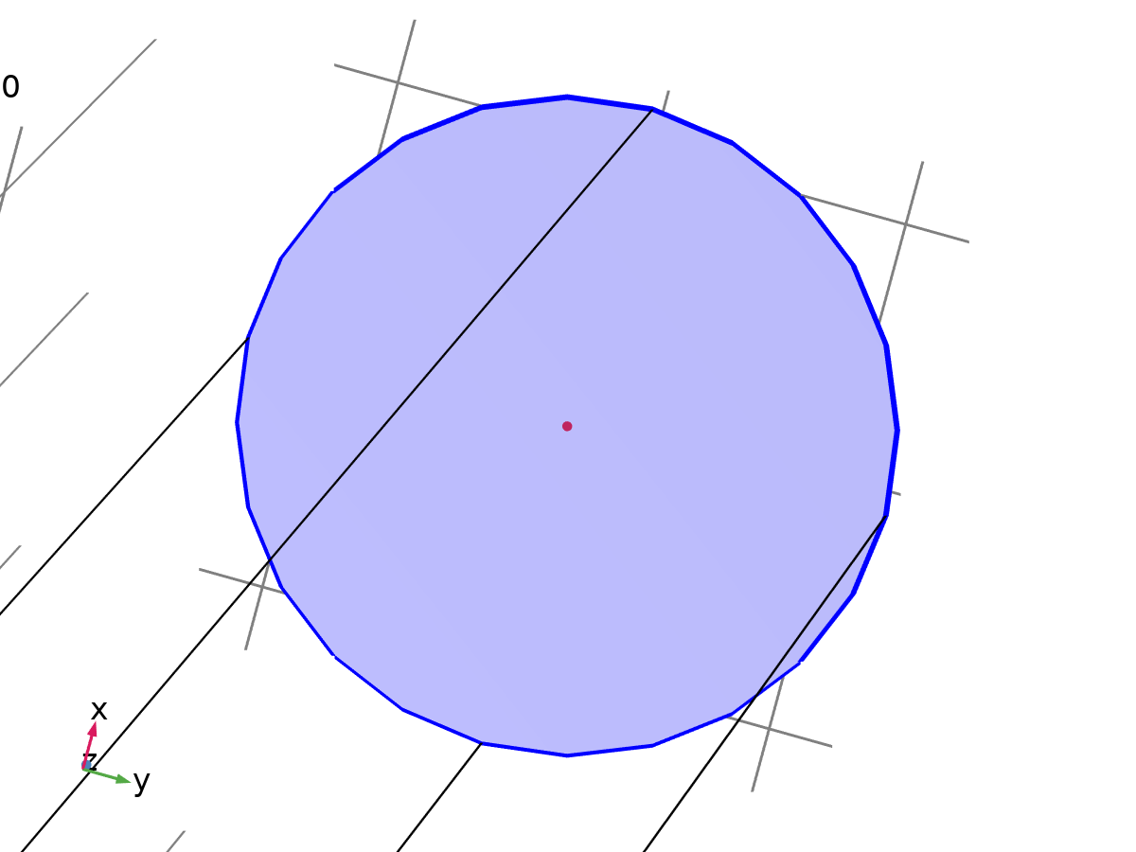
Port 2
Selection
Geometric entity level | Boundary
Selection | Geometry geom1: Dimension 2: Boundary 4

Equations

Port Properties
Settings
Description | Value
Port name | 2
Type of port | Numeric
Wave excitation at this port | Off
Activate slit condition on interior port | Off
Analyze as a TEM field | Off

Port Mode Settings
Settings
Description | Value | Unit
Mode phase | 0 | rad

De-Embedding Port
Settings
Description | Value | Unit
Port offset | 0 | m

Variables
Name | Expression | Unit | Description | Selection | Details
emw.PortConstrx | nojac(emw.tEmodex_2)*if(abs(emw.beta_2)>1.0E-7*emw.intport2(emw.k)/emw.Area_2&&(abs(arg(emw.beta_2))<=0.25*pi||abs(arg(emw.beta_2))>=0.75*pi),emw.S2x,0) | V/m | Port constraint, x-component | Boundary 4 | + operation
emw.PortConstry | nojac(emw.tEmodey_2)*if(abs(emw.beta_2)>1.0E-7*emw.intport2(emw.k)/emw.Area_2&&(abs(arg(emw.beta_2))<=0.25*pi||abs(arg(emw.beta_2))>=0.75*pi),emw.S2x,0) | V/m | Port constraint, y-component | Boundary 4 | + operation
emw.PortConstrz | nojac(emw.tEmodez_2)*if(abs(emw.beta_2)>1.0E-7*emw.intport2(emw.k)/emw.Area_2&&(abs(arg(emw.beta_2))<=0.25*pi||abs(arg(emw.beta_2))>=0.75*pi),emw.S2x,0) | V/m | Port constraint, z-component | Boundary 4 | + operation
emw.Area_2 | emw.intport2(1) | m² | Area | Global
emw.beta_2 | emw.intport2(-emw.alphaport_2*j)/emw.Area_2 | rad/m | Propagation constant | Global
emw.Pmode_2 | emw.intport2(if(imag(emw.alphaport_2)==0,1,real(0.5*(emw.nx*(conj(emw.tH0modez_2)*emw.tE0modey_2-conj(emw.tH0modey_2)*emw.tE0modez_2)+emw.ny*(-conj(emw.tH0modez_2)*emw.tE0modex_2+conj(emw.tH0modex_2)*emw.tE0modez_2)+emw.nz*(conj(emw.tH0modey_2)*emw.tE0modex_2-conj(emw.tH0modex_2)*emw.tE0modey_2))))) | W | Port mode power | Global
emw.tEmodex_2 | emw.tE0modex_2*sqrt(abs(try_catch(emw.port2.Pin,1)/emw.Pmode_2)) | V/m | Port tangential electric mode field, x-component | Boundary 4
emw.tEmodey_2 | emw.tE0modey_2*sqrt(abs(try_catch(emw.port2.Pin,1)/emw.Pmode_2)) | V/m | Port tangential electric mode field, y-component | Boundary 4
emw.tEmodez_2 | emw.tE0modez_2*sqrt(abs(try_catch(emw.port2.Pin,1)/emw.Pmode_2)) | V/m | Port tangential electric mode field, z-component | Boundary 4
emw.normtEmode_2 | sqrt(realdot(emw.tEmodex_2,emw.tEmodex_2)+realdot(emw.tEmodey_2,emw.tEmodey_2)+realdot(emw.tEmodez_2,emw.tEmodez_2)) | V/m | Port tangential electric mode field norm | Boundary 4
emw.tHmodex_2 | emw.tH0modex_2*sqrt(abs(try_catch(emw.port2.Pin,1)/emw.Pmode_2)) | A/m | Port tangential magnetic mode field, x-component | Boundary 4
emw.tHmodey_2 | emw.tH0modey_2*sqrt(abs(try_catch(emw.port2.Pin,1)/emw.Pmode_2)) | A/m | Port tangential magnetic mode field, y-component | Boundary 4
emw.tHmodez_2 | emw.tH0modez_2*sqrt(abs(try_catch(emw.port2.Pin,1)/emw.Pmode_2)) | A/m | Port tangential magnetic mode field, z-component | Boundary 4
emw.normtHmode_2 | sqrt(realdot(emw.tHmodex_2,emw.tHmodex_2)+realdot(emw.tHmodey_2,emw.tHmodey_2)+realdot(emw.tHmodez_2,emw.tHmodez_2)) | A/m | Port tangential magnetic mode field norm | Boundary 4
emw.tE0modex_2 | emw.tEbm2x | V/m | Port tangential electric mode field, x-component | Boundary 4
emw.tE0modey_2 | emw.tEbm2y | V/m | Port tangential electric mode field, y-component | Boundary 4
emw.tE0modez_2 | emw.tEbm2z | V/m | Port tangential electric mode field, z-component | Boundary 4
emw.normEbm_2 | sqrt(realdot(emw.tEbm2x,emw.tEbm2x)+realdot(emw.tEbm2y,emw.tEbm2y)+realdot(emw.tEbm2z,emw.tEbm2z)) | V/m | Tangential boundary mode electric field norm | Boundary 4
emw.dHdtx_2 | (-emw.murinvxx*(root.comp1.emw.tcurlEbm2x-emw.alphaport_2*(emw.tEbm2z*emw.ny-emw.tEbm2y*emw.nz)+emw.nebm2Tz*emw.ny-emw.nebm2Ty*emw.nz)-emw.murinvxy*(root.comp1.emw.tcurlEbm2y-emw.alphaport_2*(-emw.tEbm2z*emw.nx+emw.tEbm2x*emw.nz)-emw.nebm2Tz*emw.nx+emw.nebm2Tx*emw.nz)-emw.murinvxz*(root.comp1.emw.tcurlEbm2z-emw.alphaport_2*(emw.tEbm2y*emw.nx-emw.tEbm2x*emw.ny)+emw.nebm2Ty*emw.nx-emw.nebm2Tx*emw.ny))/mu0_const | A/(m·s) | Magnetic field, time derivative, x-component | Boundary 4
emw.dHdty_2 | (-emw.murinvyx*(root.comp1.emw.tcurlEbm2x-emw.alphaport_2*(emw.tEbm2z*emw.ny-emw.tEbm2y*emw.nz)+emw.nebm2Tz*emw.ny-emw.nebm2Ty*emw.nz)-emw.murinvyy*(root.comp1.emw.tcurlEbm2y-emw.alphaport_2*(-emw.tEbm2z*emw.nx+emw.tEbm2x*emw.nz)-emw.nebm2Tz*emw.nx+emw.nebm2Tx*emw.nz)-emw.murinvyz*(root.comp1.emw.tcurlEbm2z-emw.alphaport_2*(emw.tEbm2y*emw.nx-emw.tEbm2x*emw.ny)+emw.nebm2Ty*emw.nx-emw.nebm2Tx*emw.ny))/mu0_const | A/(m·s) | Magnetic field, time derivative, y-component | Boundary 4
emw.dHdtz_2 | (-emw.murinvzx*(root.comp1.emw.tcurlEbm2x-emw.alphaport_2*(emw.tEbm2z*emw.ny-emw.tEbm2y*emw.nz)+emw.nebm2Tz*emw.ny-emw.nebm2Ty*emw.nz)-emw.murinvzy*(root.comp1.emw.tcurlEbm2y-emw.alphaport_2*(-emw.tEbm2z*emw.nx+emw.tEbm2x*emw.nz)-emw.nebm2Tz*emw.nx+emw.nebm2Tx*emw.nz)-emw.murinvzz*(root.comp1.emw.tcurlEbm2z-emw.alphaport_2*(emw.tEbm2y*emw.nx-emw.tEbm2x*emw.ny)+emw.nebm2Ty*emw.nx-emw.nebm2Tx*emw.ny))/mu0_const | A/(m·s) | Magnetic field, time derivative, z-component | Boundary 4
emw.tH0modex_2 | ((emw.ny*emw.dHdtx_2-emw.nx*emw.dHdty_2)*emw.ny+(emw.nz*emw.dHdtx_2-emw.nx*emw.dHdtz_2)*emw.nz)/emw.iomega | A/m | Port tangential magnetic mode field, x-component | Boundary 4
emw.tH0modey_2 | ((-emw.ny*emw.dHdtx_2+emw.nx*emw.dHdty_2)*emw.nx+(emw.nz*emw.dHdty_2-emw.ny*emw.dHdtz_2)*emw.nz)/emw.iomega | A/m | Port tangential magnetic mode field, y-component | Boundary 4
emw.tH0modez_2 | ((-emw.nz*emw.dHdtx_2+emw.nx*emw.dHdtz_2)*emw.nx+(-emw.nz*emw.dHdty_2+emw.ny*emw.dHdtz_2)*emw.ny)/emw.iomega | A/m | Port tangential magnetic mode field, z-component | Boundary 4
emw.alphaport_2 | if(real(74.54801866117718*i)*imag(74.54801866117718*i)<0,-1,1)*sqrt((74.54801866117718*i)^2+emw.k^2*if(abs(emw.freq-5[GHz])<1.0E-14*abs(5[GHz]),0,-1+(5[GHz]/emw.freq)^2)) | rad/m | Complex propagation constant | Global
emw.neff_2 | emw.beta_2/emw.k0 | 1 | Effective mode index | Global

Shape functions
Name | Shape function | Unit | Description | Shape frame | Selection
emw.tEbm2x | Curl (Quadratic) | V/m | Boundary mode electric field, x-component | Spatial | Boundary 4
emw.tEbm2y | Curl (Quadratic) | V/m | Boundary mode electric field, y-component | Spatial | Boundary 4
emw.tEbm2z | Curl (Quadratic) | V/m | Boundary mode electric field, z-component | Spatial | Boundary 4
emw.nebm2 | Lagrange (Quadratic) | V | Normal boundary mode electric field, scaled | Spatial | Boundary 4

Mesh 1
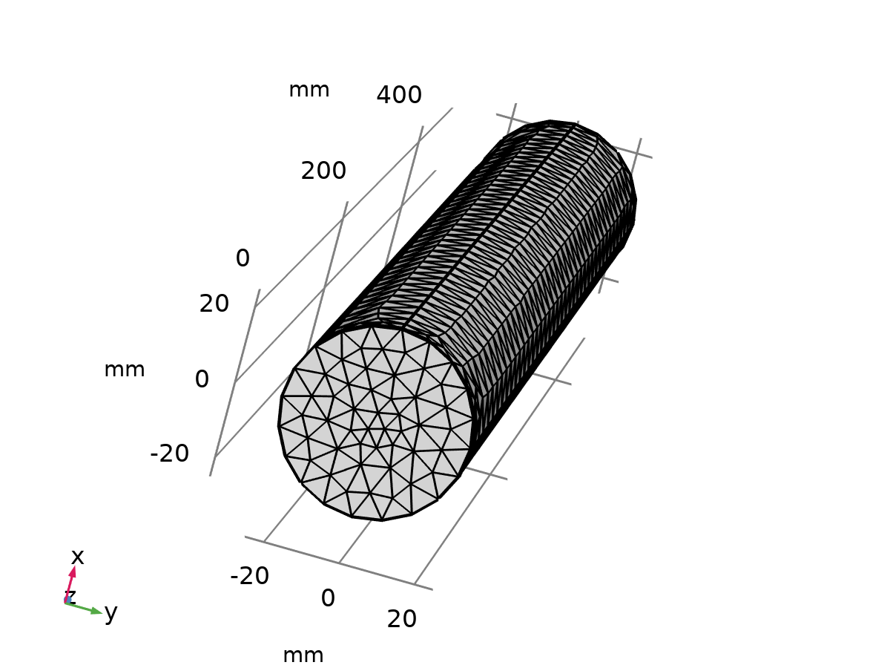
Mesh 1
Mesh statistics
Description | Value
Status | Complete mesh
Mesh vertices | 1541
Tetrahedra | 6572
Triangles | 1582
Edge elements | 204
Vertex elements | 8
Number of elements | 6572
Minimum element quality | 0.2552
Average element quality | 0.6738
Element volume ratio | 0.016672
Mesh volume | 9.573E5 mm³

Size (size)
Settings
Description | Value
Maximum element size | 15.37
Minimum element size | 1.148
Curvature factor | 0.5
Resolution of narrow regions | 0.6
Maximum element growth rate | 1.45
Predefined size | Fine
Custom element size | Custom

Size 1 (size1)
Selection
Geometric entity level | Boundary
Selection | Geometry geom1: Dimension 2: Boundaries 1–2, 5–6

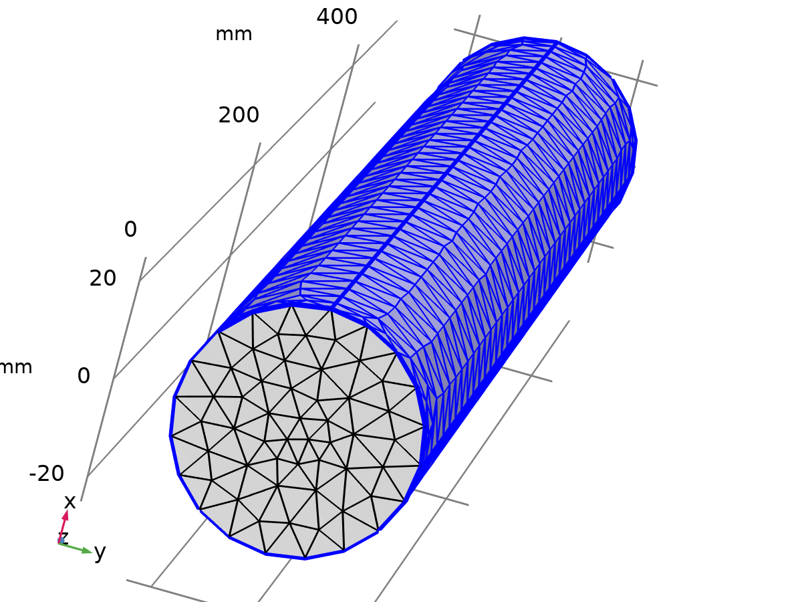
Size 1
Settings
Description | Value
Maximum element size | 13.26
Minimum element size | 0.3977
Curvature factor | 0.5
Curvature factor | Off
Resolution of narrow regions | 0.6
Resolution of narrow regions | Off
Maximum element growth rate | 1.45
Maximum element growth rate | Off
Predefined size | Fine
Custom element size | Custom

Size 2 (size2)
Selection
Geometric entity level | Boundary
Selection | Geometry geom1: Dimension 2: Boundaries 3–4

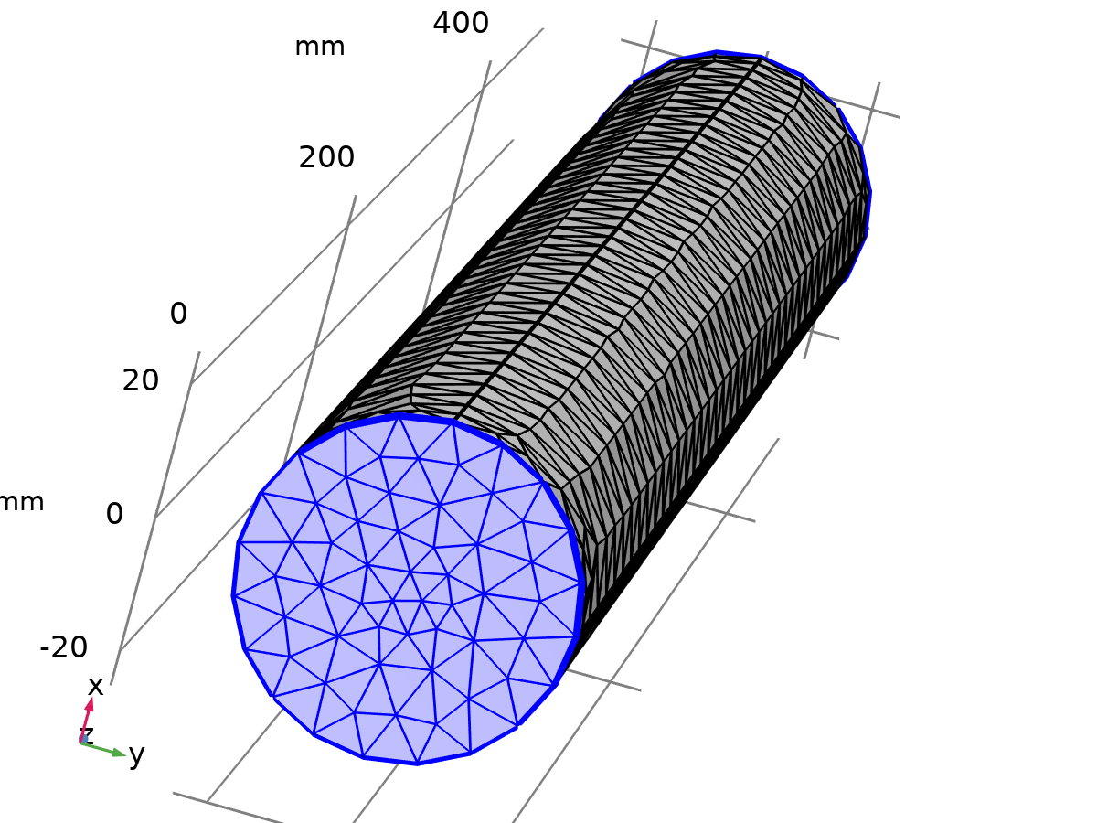
Size 2
Settings
Description | Value
Maximum element size | 7.687
Minimum element size | 0.2306
Curvature factor | 0.5
Curvature factor | Off
Resolution of narrow regions | 0.6
Resolution of narrow regions | Off
Maximum element growth rate | 1.45
Maximum element growth rate | Off
Predefined size | Fine
Custom element size | Custom

Free Tetrahedral 1 (ftet1)
Selection
Geometric entity level | Domain
Selection | Remaining

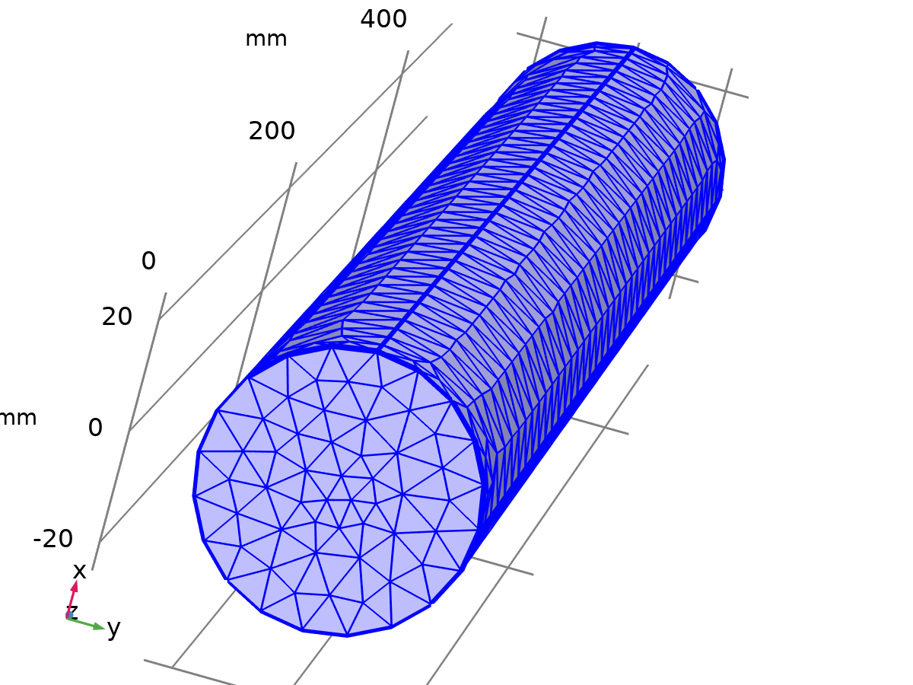
Free Tetrahedral 1
Settings
Description | Value
Avoid inverted curved elements | On

Information
Description | Value
Last build time | < 1 second
Built with | COMSOL 6.3.0.290 (win64), Oct 21, 2026, 11:13:26 PM

Size 1 (size1)
Selection
Geometric entity level | Boundary
Selection | Geometry geom1: Dimension 2: Boundaries 1–2, 5–6

Size 1
Settings
Description | Value
Maximum element size | 13.26
Minimum element size | 0.3977
Curvature factor | 0.5
Curvature factor | Off
Resolution of narrow regions | 0.6
Resolution of narrow regions | Off
Maximum element growth rate | 1.45
Maximum element growth rate | Off
Predefined size | Fine
Custom element size | Custom

Size 2 (size2)
Selection
Geometric entity level | Boundary
Selection | Geometry geom1: Dimension 2: Boundaries 3–4

Size 2
Settings
Description | Value
Maximum element size | 7.687
Minimum element size | 0.2306
Curvature factor | 0.5
Curvature factor | Off
Resolution of narrow regions | 0.6
Resolution of narrow regions | Off
Maximum element growth rate | 1.45
Maximum element growth rate | Off
Predefined size | Fine
Custom element size | Custom

Free Tetrahedral 1 (ftet1)
Selection
Geometric entity level | Domain
Selection | Remaining

Free Tetrahedral 1
Settings
Description | Value
Avoid inverted curved elements | On

Information
Description | Value
Last build time | < 1 second
Built with | COMSOL 6.3.0.290 (win64), Oct 21, 2026, 11:13:26 PM

Size 1 (size1)
Selection
Geometric entity level | Boundary
Selection | Geometry geom1: Dimension 2: Boundaries 1–2, 5–6

Size 1
Settings
Description | Value
Maximum element size | 13.26
Minimum element size | 0.3977
Curvature factor | 0.5
Curvature factor | Off
Resolution of narrow regions | 0.6
Resolution of narrow regions | Off
Maximum element growth rate | 1.45
Maximum element growth rate | Off
Predefined size | Fine
Custom element size | Custom

Size 2 (size2)
Selection
Geometric entity level | Boundary
Selection | Geometry geom1: Dimension 2: Boundaries 3–4

Size 2
Settings
Description | Value
Maximum element size | 7.687
Minimum element size | 0.2306
Curvature factor | 0.5
Curvature factor | Off
Resolution of narrow regions | 0.6
Resolution of narrow regions | Off
Maximum element growth rate | 1.45
Maximum element growth rate | Off
Predefined size | Fine
Custom element size | Custom

Free Tetrahedral 1 (ftet1)
Selection
Geometric entity level | Domain
Selection | Remaining

Free Tetrahedral 1
Settings
Description | Value
Avoid inverted curved elements | On

Information
Description | Value
Last build time | < 1 second
Built with | COMSOL 6.3.0.290 (win64), Oct 21, 2026, 11:13:26 PM

Study 1
Computation information
Computation time | 11 s

Boundary Mode Analysis
Study settings
Description | Value
Include geometric nonlinearity | Off

Study settings
Description | Value
Transform | Effective mode index
Mode analysis frequency | 5[GHz]
Desired number of modes | On
Unit
Search for modes around shift | 0.711
Search for modes around shift | On

Physics and variables selection
Key | Solve for
Electromagnetic Waves, Frequency Domain (emw) | On

Store in output
Interface | Output | Selection
Electromagnetic Waves, Frequency Domain (emw) | Physics controlled

Mesh selection
Component | Mesh
Component 1 | Mesh 1

Boundary Mode Analysis 1
Study settings
Description | Value
Include geometric nonlinearity | Off

Study settings
Description | Value
Transform | Effective mode index
Port name | 2
Mode analysis frequency | 5[GHz]
Desired number of modes | On
Unit
Search for modes around shift | 0.711
Search for modes around shift | On

Physics and variables selection
Key | Solve for
Electromagnetic Waves, Frequency Domain (emw) | On

Store in output
Interface | Output | Selection
Electromagnetic Waves, Frequency Domain (emw) | Physics controlled

Mesh selection
Component | Mesh
Component 1 | Mesh 1

Frequency Domain
Frequencies (GHz)
5[GHz]

Study settings
Description | Value
Include geometric nonlinearity | Off

Settings
Description | Value
Frequencies | 5

Physics and variables selection
Key | Solve for
Electromagnetic Waves, Frequency Domain (emw) | On

Store in output
Interface | Output | Selection
Electromagnetic Waves, Frequency Domain (emw) | Physics controlled

Mesh selection
Component | Mesh
Component 1 | Mesh 1

Solver Configurations

Solution 1

Compile Equations: Boundary Mode Analysis (st1)
Study and step
Description | Value
Use study | Study 1
Use study step | Boundary Mode Analysis

Log
<---- Compile Equations: Boundary Mode Analysis in Study 1/Solution 1 (sol1) ---
Started at Oct 21, 2026, 8:01:21 PM.
Geometry shape function: Quadratic Lagrange
Running on Intel64 Family 6 Model 126 Stepping 5, GenuineIntel.
Using 1 socket with 4 cores in total on DESKTOP-FJDOSRN.
Available memory: 16.15 GB.
Time: 2 s.
Physical memory: 1.49 GB
Virtual memory: 1.75 GB
Ended at Oct 21, 2026, 8:01:22 PM.
----- Compile Equations: Boundary Mode Analysis in Study 1/Solution 1 (sol1) -->

Dependent Variables 1 (v1)
General
Description | Value
Defined by study step | Step 1: Boundary Mode Analysis

Log
<---- Dependent Variables 1 in Study 1/Solution 1 (sol1) -----------------------
Started at Oct 21, 2026, 8:01:22 PM.
Solution time: 0 s.
Physical memory: 1.5 GB
Virtual memory: 1.76 GB
Ended at Oct 21, 2026, 8:01:22 PM.
----- Dependent Variables 1 in Study 1/Solution 1 (sol1) ---------------------->

Electric Field (comp1.E) (comp1_E)
General
Description | Value
Field components | {comp1.Ex, comp1.Ey, comp1.Ez}
Solve for this field | Off

Boundary Mode Electric Field (comp1.emw.Ebm1) (comp1_emw_Ebm1)
General
Description | Value
Field components | {comp1.emw.tEbm1x, comp1.emw.tEbm1y, comp1.emw.tEbm1z}

Boundary Mode Electric Field (comp1.emw.Ebm2) (comp1_emw_Ebm2)
General
Description | Value
Field components | {comp1.emw.tEbm2x, comp1.emw.tEbm2y, comp1.emw.tEbm2z}
Solve for this field | Off

Normal Boundary Mode Electric Field, Scaled (comp1.emw.nebm1) (comp1_emw_nebm1)
General
Description | Value
Field components | comp1.emw.nebm1

Normal Boundary Mode Electric Field, Scaled (comp1.emw.nebm2) (comp1_emw_nebm2)
General
Description | Value
Field components | comp1.emw.nebm2
Solve for this field | Off

S-parameter (comp1.Sparam1) (comp1_Sparam1)
General
Description | Value
State components | comp1.emw.S1x
Solve for this state | Off

S-parameter (comp1.Sparam2) (comp1_Sparam2)
General
Description | Value
State components | comp1.emw.S2x
Solve for this state | Off

Eigenvalue Solver 1 (e1)
General
Description | Value
Defined by study step | Step 1: Boundary Mode Analysis
Eigenvalue transformation | Effective mode index
Reference wave number | comp1.emw.k0
Desired number of eigenvalues | 1
Compute and store left eigenvectors | Off
Search for eigenfrequencies around shift | 0.711
Value of eigenvalue linearization point | 0.711

Log
<---- Eigenvalue Solver 1 in Study 1/Solution 1 (sol1) -------------------------
Started at Oct 21, 2026, 8:01:22 PM.
Eigenvalue solver
Number of degrees of freedom solved for: 1177.
Nonsymmetric matrix found.
Scales for dependent variables:
Boundary Mode Electric Field (comp1.emw.Ebm1): 1.1
Normal Boundary Mode Electric Field, Scaled (comp1.emw.nebm1): 1
Orthonormal null-space function used.
Nonsymmetric eigenvalue solver
Iter ErrEst Nconv
1 0 1
20 linear system solutions.
20 matrix multiplications.
19 re-orthogonalizations.
Solution time: 1 s.
Physical memory: 1.51 GB
Virtual memory: 1.76 GB
Ended at Oct 21, 2026, 8:01:23 PM.
----- Eigenvalue Solver 1 in Study 1/Solution 1 (sol1) ------------------------>

Solution Store 1 (su1)
General
Description | Value
Solution | Solution Store 1 (sol2)

Compile Equations: Boundary Mode Analysis 1 (st2)
Study and step
Description | Value
Use study | Study 1
Use study step | Boundary Mode Analysis 1

Log
<---- Compile Equations: Boundary Mode Analysis 1 in Study 1/Solution 1 (sol1) -
Started at Oct 21, 2026, 8:01:23 PM.
Geometry shape function: Quadratic Lagrange
Time: 1 s.
Physical memory: 1.51 GB
Virtual memory: 1.77 GB
Ended at Oct 21, 2026, 8:01:25 PM.
----- Compile Equations: Boundary Mode Analysis 1 in Study 1/Solution 1 (sol1) >

Dependent Variables 2 (v2)
General
Description | Value
Defined by study step | Step 2: Boundary Mode Analysis 1

Initial values of variables solved for
Description | Value
Method | Solution
Solution | Solution 1 (sol1)

Values of variables not solved for
Description | Value
Method | Solution
Solution | Solution 1 (sol1)

Log
<---- Dependent Variables 2 in Study 1/Solution 1 (sol1) -----------------------
Started at Oct 21, 2026, 8:01:25 PM.
Initial values of variables solved for: Solution 1 (sol1), lambda=0.71139 [Automatic (single solution)].
Values of variables not solved for: Solution 1 (sol1), lambda=0.71139 [Automatic (single solution)].
Solution time: 0 s.
Physical memory: 1.51 GB
Virtual memory: 1.77 GB
Ended at Oct 21, 2026, 8:01:25 PM.
----- Dependent Variables 2 in Study 1/Solution 1 (sol1) ---------------------->

Electric Field (comp1.E) (comp1_E)
General
Description | Value
Field components | {comp1.Ex, comp1.Ey, comp1.Ez}
Solve for this field | Off

Boundary Mode Electric Field (comp1.emw.Ebm1) (comp1_emw_Ebm1)
General
Description | Value
Field components | {comp1.emw.tEbm1x, comp1.emw.tEbm1y, comp1.emw.tEbm1z}
Solve for this field | Off

Boundary Mode Electric Field (comp1.emw.Ebm2) (comp1_emw_Ebm2)
General
Description | Value
Field components | {comp1.emw.tEbm2x, comp1.emw.tEbm2y, comp1.emw.tEbm2z}

Normal Boundary Mode Electric Field, Scaled (comp1.emw.nebm1) (comp1_emw_nebm1)
General
Description | Value
Field components | comp1.emw.nebm1
Solve for this field | Off

Normal Boundary Mode Electric Field, Scaled (comp1.emw.nebm2) (comp1_emw_nebm2)
General
Description | Value
Field components | comp1.emw.nebm2

S-parameter (comp1.Sparam1) (comp1_Sparam1)
General
Description | Value
State components | comp1.emw.S1x
Solve for this state | Off

S-parameter (comp1.Sparam2) (comp1_Sparam2)
General
Description | Value
State components | comp1.emw.S2x
Solve for this state | Off

Eigenvalue Solver 2 (e2)
General
Description | Value
Defined by study step | Step 2: Boundary Mode Analysis 1
Eigenvalue transformation | Effective mode index
Reference wave number | comp1.emw.k0
Desired number of eigenvalues | 1
Compute and store left eigenvectors | Off
Search for eigenfrequencies around shift | 0.711
Value of eigenvalue linearization point | 0.711

Values of linearization point
Description | Value
Prescribed by | Solution
Solution | Solution 1 (sol1)

Log
<---- Eigenvalue Solver 2 in Study 1/Solution 1 (sol1) -------------------------
Started at Oct 21, 2026, 8:01:25 PM.
Values of linearization point: Solution 1 (sol1), lambda=-74.548i [Automatic (single solution)].
Eigenvalue solver
Number of degrees of freedom solved for: 1177.
Nonsymmetric matrix found.
Scales for dependent variables:
Boundary Mode Electric Field (comp1.emw.Ebm2): 1.1
Normal Boundary Mode Electric Field, Scaled (comp1.emw.nebm2): 1
Orthonormal null-space function used.
Nonsymmetric eigenvalue solver
Iter ErrEst Nconv
1 0 1
20 linear system solutions.
20 matrix multiplications.
19 re-orthogonalizations.
Solution time: 1 s.
Physical memory: 1.51 GB
Virtual memory: 1.77 GB
Ended at Oct 21, 2026, 8:01:25 PM.
----- Eigenvalue Solver 2 in Study 1/Solution 1 (sol1) ------------------------>

Solution Store 2 (su2)
General
Description | Value
Solution | Solution Store 2 (sol3)

Compile Equations: Frequency Domain (st3)
Study and step
Description | Value
Use study | Study 1
Use study step | Frequency Domain

Log
<---- Compile Equations: Frequency Domain in Study 1/Solution 1 (sol1) ---------
Started at Oct 21, 2026, 8:01:25 PM.
Geometry shape function: Quadratic Lagrange
Time: 1 s.
Physical memory: 1.51 GB
Virtual memory: 1.77 GB
Ended at Oct 21, 2026, 8:01:27 PM.
----- Compile Equations: Frequency Domain in Study 1/Solution 1 (sol1) -------->

Dependent Variables 3 (v3)
General
Description | Value
Defined by study step | Step 3: Frequency Domain

Initial values of variables solved for
Description | Value
Method | Solution
Solution | Solution 1 (sol1)

Values of variables not solved for
Description | Value
Method | Solution
Solution | Solution 1 (sol1)

Initial value calculation constants
Constant name | Initial-value source
freq | 5[GHz]

Log
<---- Dependent Variables 3 in Study 1/Solution 1 (sol1) -----------------------
Started at Oct 21, 2026, 8:01:27 PM.
Initial values of variables solved for: Solution 1 (sol1), lambda=0.71139 [Automatic (single solution)].
Values of variables not solved for: Solution 1 (sol1), lambda=0.71139 [Automatic (single solution)].
Solution time: 0 s.
Physical memory: 1.49 GB
Virtual memory: 1.75 GB
Ended at Oct 21, 2026, 8:01:27 PM.
----- Dependent Variables 3 in Study 1/Solution 1 (sol1) ---------------------->

Electric Field (comp1.E) (comp1_E)
General
Description | Value
Field components | {comp1.Ex, comp1.Ey, comp1.Ez}

Boundary Mode Electric Field (comp1.emw.Ebm1) (comp1_emw_Ebm1)
General
Description | Value
Field components | {comp1.emw.tEbm1x, comp1.emw.tEbm1y, comp1.emw.tEbm1z}
Solve for this field | Off

Boundary Mode Electric Field (comp1.emw.Ebm2) (comp1_emw_Ebm2)
General
Description | Value
Field components | {comp1.emw.tEbm2x, comp1.emw.tEbm2y, comp1.emw.tEbm2z}
Solve for this field | Off

Normal Boundary Mode Electric Field, Scaled (comp1.emw.nebm1) (comp1_emw_nebm1)
General
Description | Value
Field components | comp1.emw.nebm1
Solve for this field | Off

Normal Boundary Mode Electric Field, Scaled (comp1.emw.nebm2) (comp1_emw_nebm2)
General
Description | Value
Field components | comp1.emw.nebm2
Solve for this field | Off

S-parameter (comp1.Sparam1) (comp1_Sparam1)
General
Description | Value
State components | comp1.emw.S1x

S-parameter (comp1.Sparam2) (comp1_Sparam2)
General
Description | Value
State components | comp1.emw.S2x

Stationary Solver 1 (s1)
General
Description | Value
Defined by study step | Step 3: Frequency Domain
Relative tolerance | 0.01

Results while solving
Description | Value
Probes | None

Log
<---- Stationary Solver 1 in Study 1/Solution 1 (sol1) -------------------------
Started at Oct 21, 2026, 8:01:27 PM.
Orthonormal null-space function used.
Linear solver
Number of degrees of freedom solved for: 71792.
Symmetric matrices found.
Scales for dependent variables:
Electric Field (comp1.E): 80
S-parameter (comp1.Sparam1): 0.0056
S-parameter (comp1.Sparam2): 0.0057
Iter SolEst Damping Stepsize #Res #Jac #Sol LinIt LinErr LinRes
1 0.97 1.0000000 0.97 1 1 1 9 0.0026 6.6e-06
Solution time: 5 s.
Physical memory: 1.66 GB
Virtual memory: 1.99 GB
Ended at Oct 21, 2026, 8:01:32 PM.
----- Stationary Solver 1 in Study 1/Solution 1 (sol1) ------------------------>

Advanced (aDef)
Assembly settings
Description | Value
Allow complex-valued output from functions with real input | On

Parametric 1 (p1)
General
Description | Value
Defined by study step | Step 3: Frequency Domain
Run continuation for | No parameter

Parameters
Parameter name | Parameter value list | Parameter unit
freq | 5[GHz] | GHz

Results while solving
Description | Value
Plot | On
Plot group | Electric Field (emw)

Fully Coupled 1 (fc1)
General
Description | Value
Linear solver | Suggested Iterative Solver (emw)

Suggested Iterative Solver (emw) (i1)
General
Description | Value
Number of iterations before restart | 300
Preconditioning | Right

Multigrid 1 (mg1)
General
Description | Value
Number of iterations | 1
Use hierarchy in geometries | Geometry 1

Presmoother (pr)

SOR Vector 1 (sv1)
Main
Description | Value
Variables | Electric Field (comp1.E)

Postsmoother (po)

SOR Vector 1 (sv1)
Main
Description | Value
Variables | Electric Field (comp1.E)

Coarse Solver (cs)

Direct 1 (d1)
General
Description | Value
Solver | PARDISO

Results

Datasets

Study 1/Solution 1
Solution
Description | Value
Solution | Solution 1 (sol1)
Component | Component 1 (comp1)

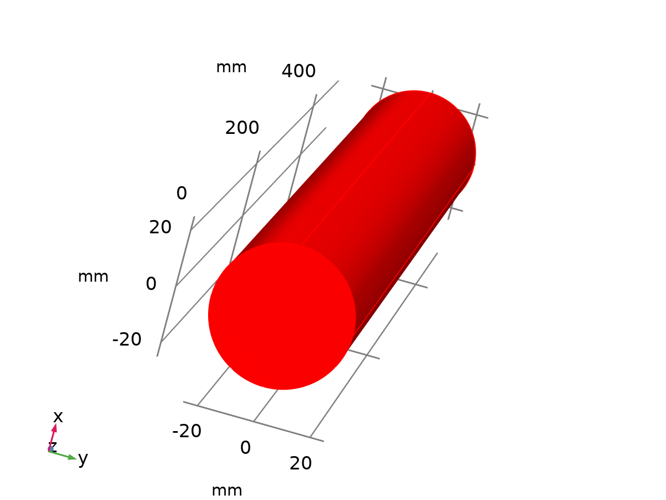
Dataset: Study 1/Solution 1

Study 1/Solution Store 1
Solution
Description | Value
Solution | Solution Store 1 (sol2)
Component | Component 1 (comp1)

Dataset: Study 1/Solution Store 1

Study 1/Solution Store 2
Solution
Description | Value
Solution | Solution Store 2 (sol3)
Component | Component 1 (comp1)

Dataset: Study 1/Solution Store 2

Cut Line 3D 1
Data
Description | Value
Dataset | Study 1/Solution 1 (sol1)

Line data
Description | Value
Line entry method | Two points
Points | {{0, 0, 0}, {1, 0, 400}}

Advanced
Description | Value
Space variable | cln1x
Tangent variables | {cln1tx, cln1ty, cln1tz}

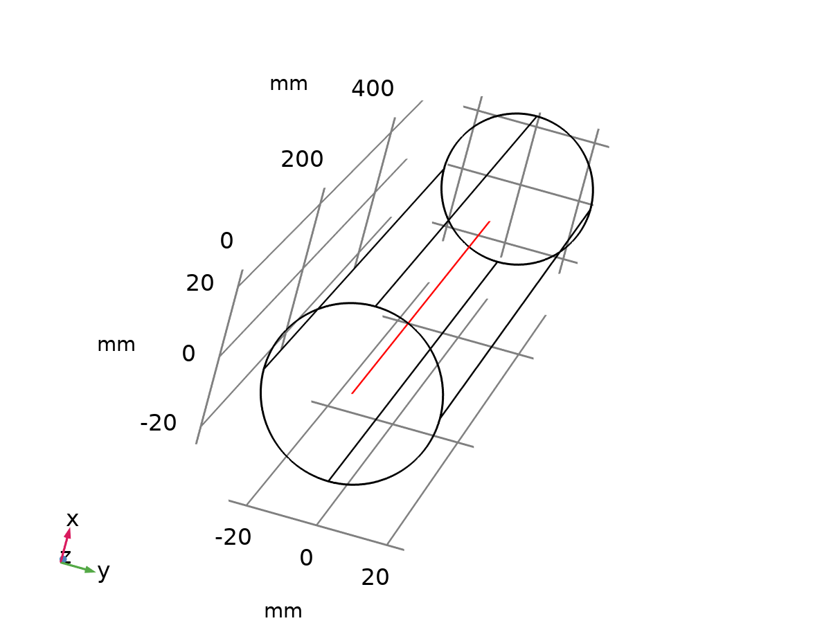
Dataset: Cut Line 3D 1

Cut Line 3D 2
Data
Description | Value
Dataset | Study 1/Solution 1 (sol1)

Line data
Description | Value
Line entry method | Two points
Points | {{0, 0, -2.4074E-32}, {0, 0, 500}}

Advanced
Description | Value
Space variable | cln2x
Tangent variables | {cln2tx, cln2ty, cln2tz}

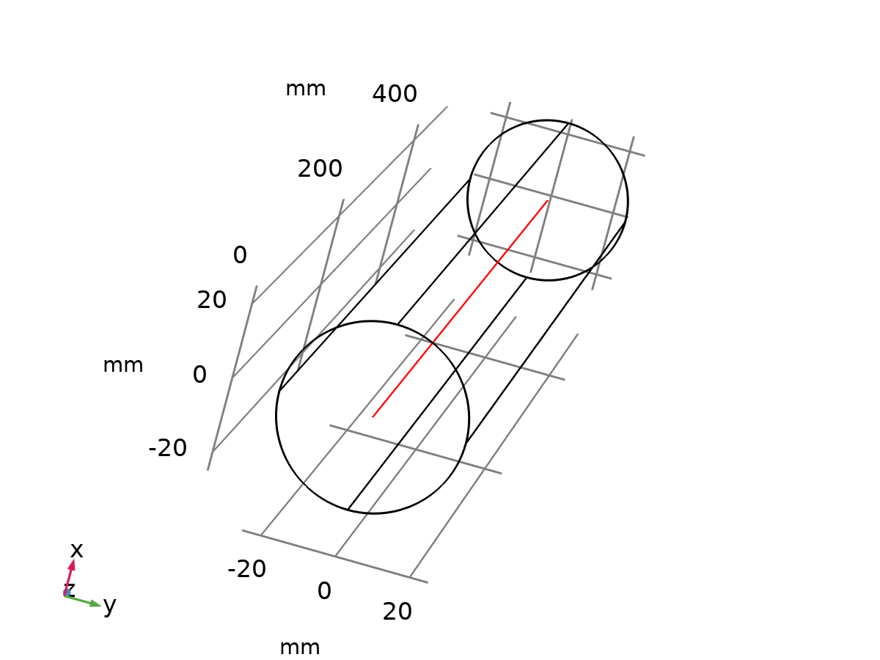
Dataset: Cut Line 3D 2

Derived Values

S-parameter (emw)
Output
Evaluated in | Table 5

Data
Description | Value
Dataset | Study 1/Solution 1 (sol1)

Expressions
Expression | Unit | Description
emw.S11dB | 1 | S11
emw.S21dB | 1 | S21

S-parameter (emw) 1
Output
Evaluated in | Table 6

Data
Description | Value
Dataset | Study 1/Solution 1 (sol1)

Expressions
Expression | Unit | Description
emw.S11dB | 1 | S11
emw.S21dB | 1 | S21

Phase Velocity
Output
Evaluated in | Table 7

Data
Description | Value
Dataset | Study 1/Solution 1 (sol1)

Expressions
Expression | Unit | Description
c_const / emw.neff_1 | m/s | Phase Velocity

Wave Impedance
Output
Evaluated in | Table 8

Data
Description | Value
Dataset | Study 1/Solution 1 (sol1)

Expressions
Expression | Unit | Description
Z0_const / emw.neff_1 | Ω | Wave Impedance

Emax
Output
Evaluated in | Table 9

Data
Description | Value
Dataset | Study 1/Solution 1 (sol1)

Expressions
Expression | Unit | Description
emw.normE | V/m | Electric field norm

Power Max
Output
Evaluated in | Table 10

Data
Description | Value
Dataset | Study 1/Solution 1 (sol1)

Expressions
Expression | Unit | Description
(3e6 /1126.2)^2 * 1[W] | MW

Tables

Table 1
Global Evaluation 1
freq (GHz) | power Max (MW)
5 | 7.3046

Table 2
Volume Maximum 1
freq (GHz) | Electric field norm (V/m) | Electric field norm (V/m) | Impedance (Ω)
5 | 1110 | 1110 | 541.15

Table 3
Eigenvalue | S11 (1) | S21 (1)
-74.548i | -Inf | -Inf

Table 4
Eigenvalue | S11 (1) | S21 (1)
-74.548i | -Inf | -Inf

Table 5

Table 6
freq (GHz) | S11 (1) | S21 (1)
5 | -87.446 | -1.7066E-6

Evaluation 3D
Interactive 3D values
x | y | z | Value
3.6262 | 1.3326E-17 | 53.089 | 0

Table 7
Phase Velocity
freq (GHz) | Phase Velocity (m/s)
5 | 4.2142E8

Table 8
Global Evaluation 4
freq (GHz) | Wave Impedance (Ω)
5 | 529.57

Table 9
Volume Maximum 1
freq (GHz) | Electric field norm (V/m)
5 | 1126.3

Table 10
Power Max
freq (GHz) | (3e6 /1126.3)^2 * 1[W] (W)
5 | 7.096E6

Plot Groups

Electric Field (emw)
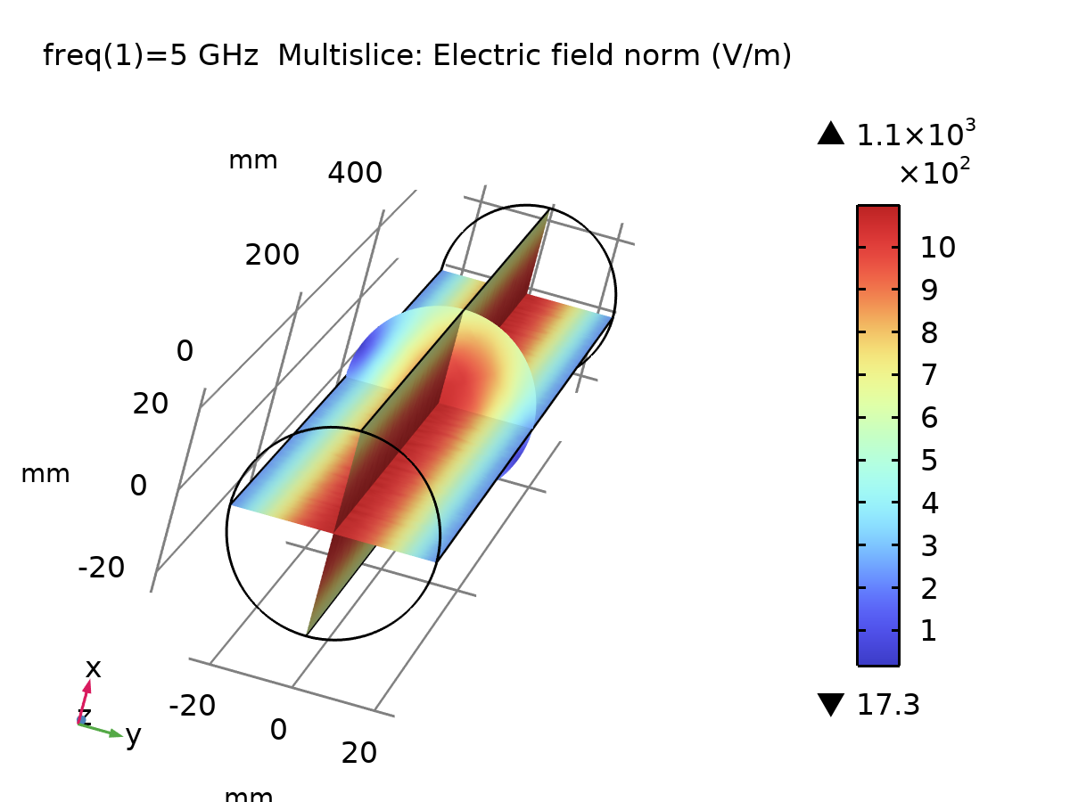
Multislice: Electric field norm (V/m)

Electric Field, Logarithmic (emw)
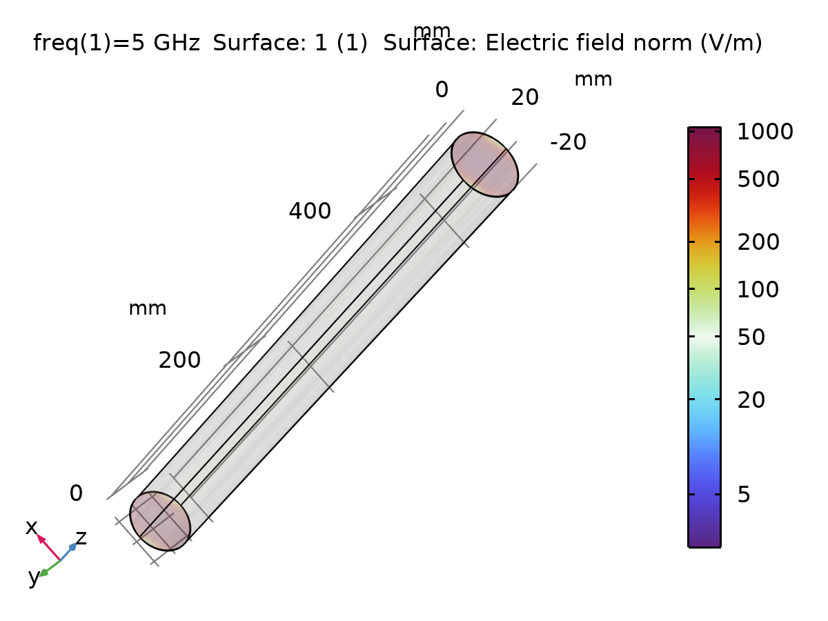
Surface: 1 (1) Surface: Electric field norm (V/m)

Electric Mode Field, Port 1 (emw)
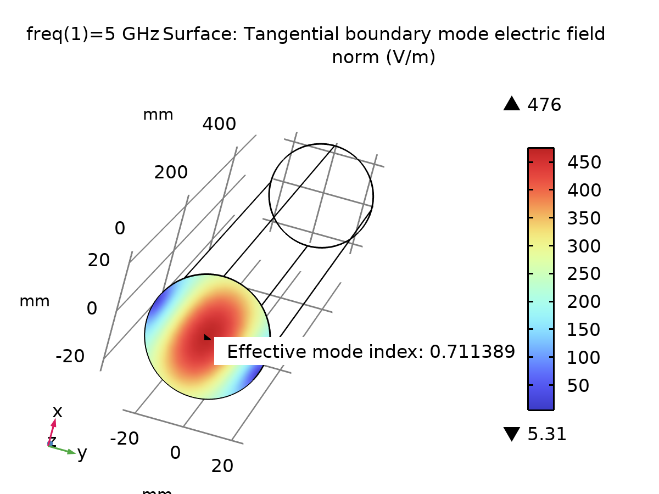
Surface: Tangential boundary mode electric field norm (V/m)

Electric Mode Field, Port 2 (emw)
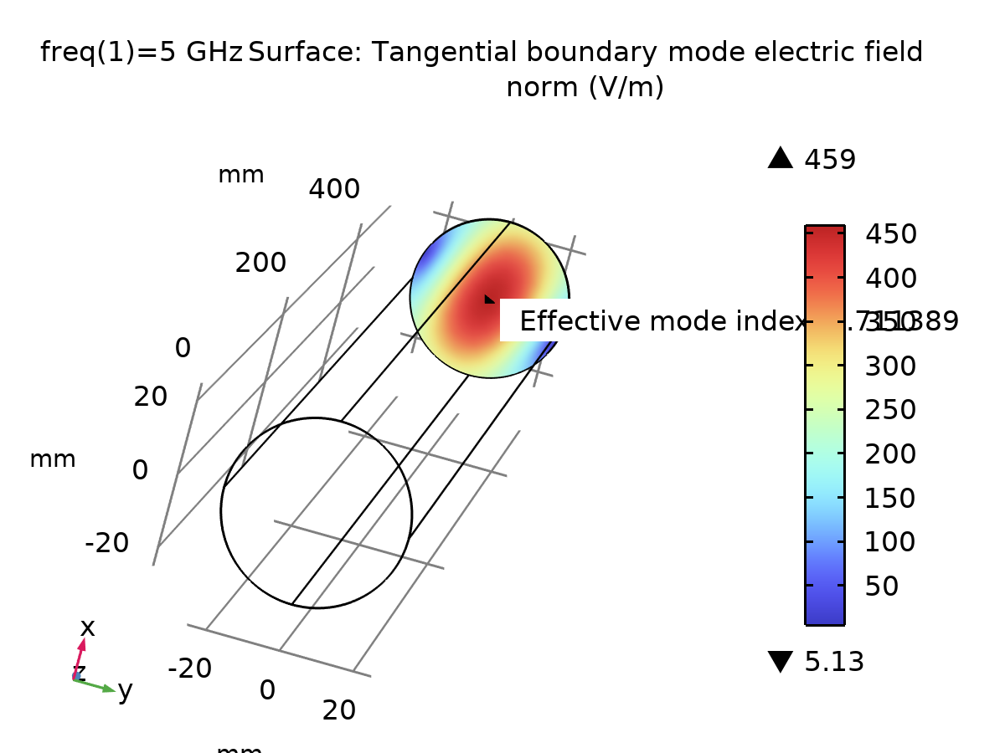
Surface: Tangential boundary mode electric field norm (V/m)

Electric Field (emw) 1
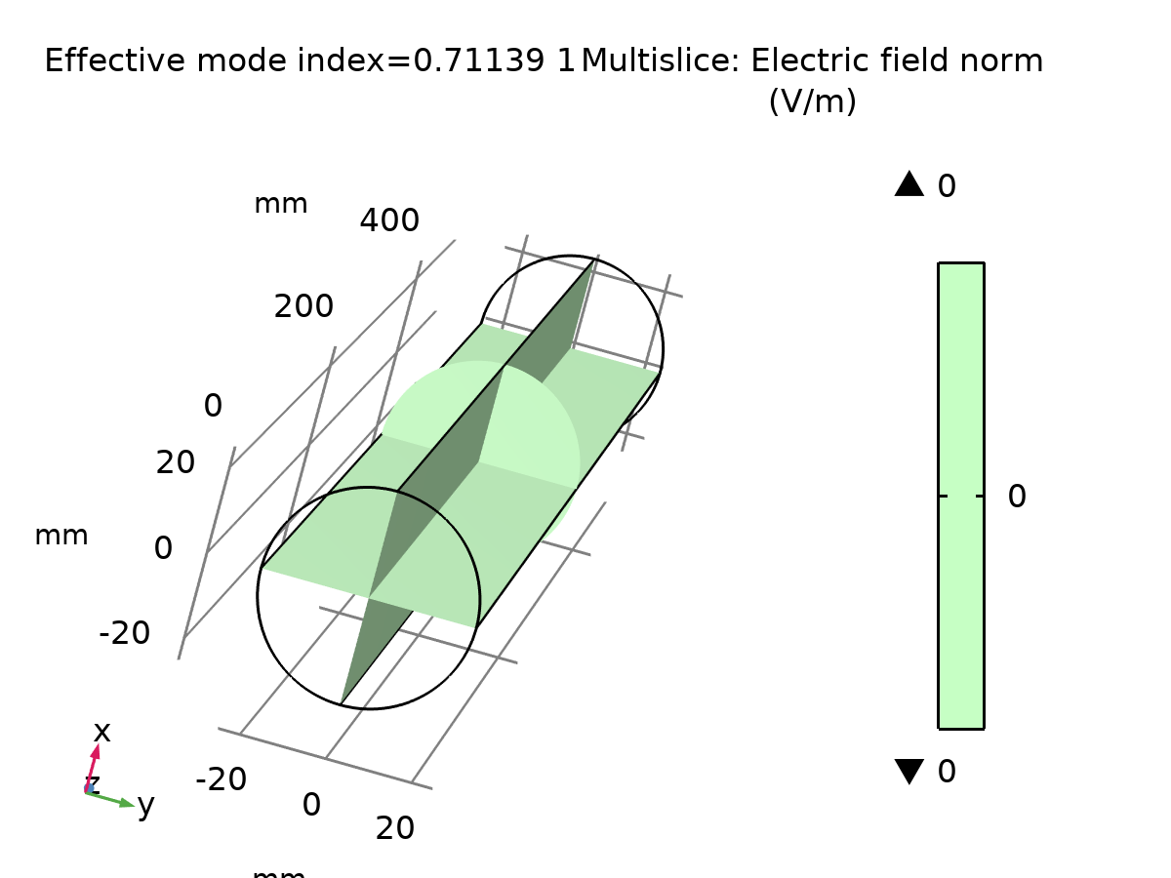
Multislice: Electric field norm (V/m)

Electric Mode Field, Port 1 (emw) 1
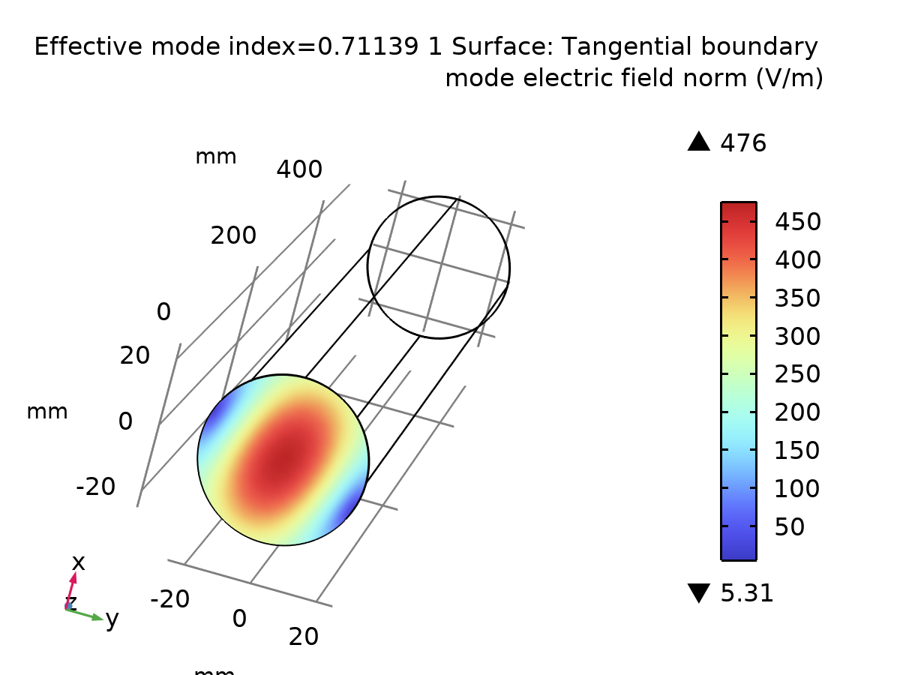
Surface: Tangential boundary mode electric field norm (V/m)

Electric Mode Field, Port 2 (emw) 1
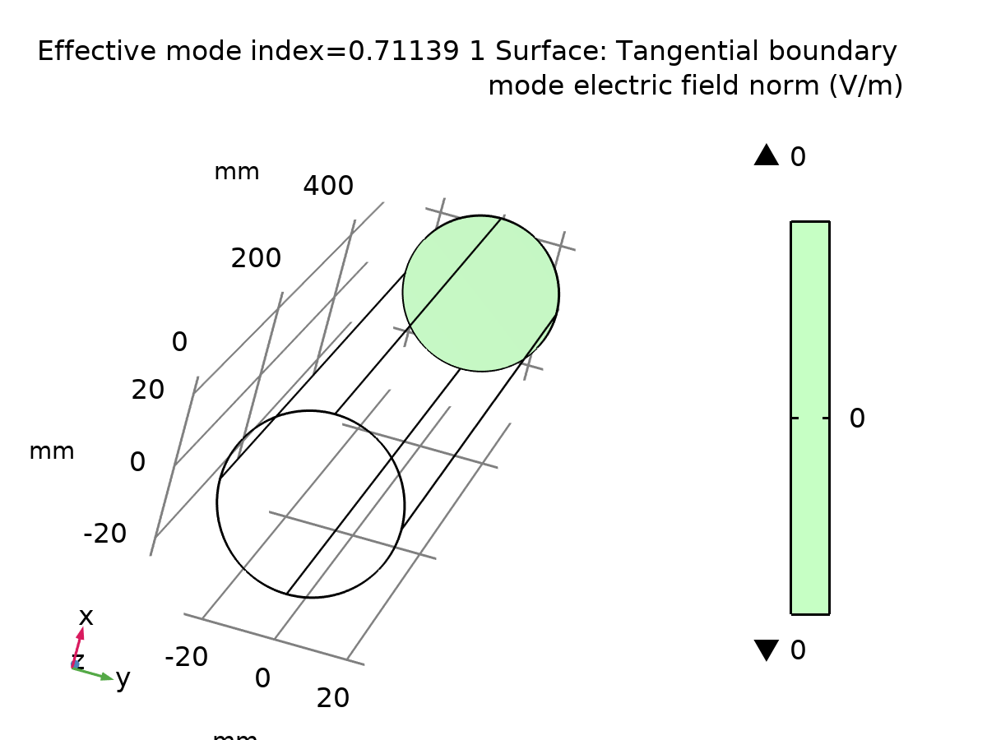
Surface: Tangential boundary mode electric field norm (V/m)

Electric Field (emw) 2
Multislice: Electric field norm (V/m)

Electric Mode Field, Port 1 (emw) 2
Surface: Tangential boundary mode electric field norm (V/m)

Electric Mode Field, Port 2 (emw) 2
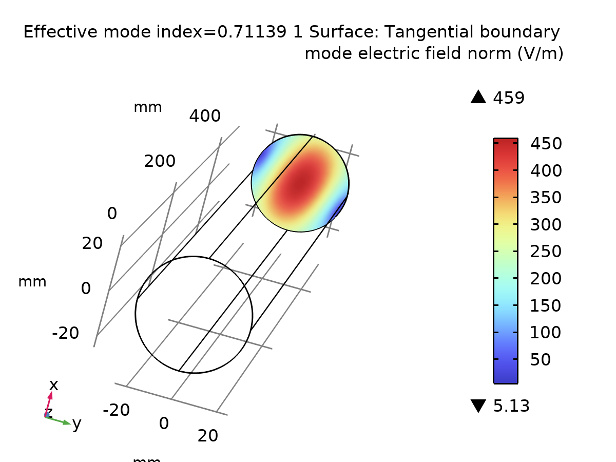
Surface: Tangential boundary mode electric field norm (V/m)

1D Plot Group 11
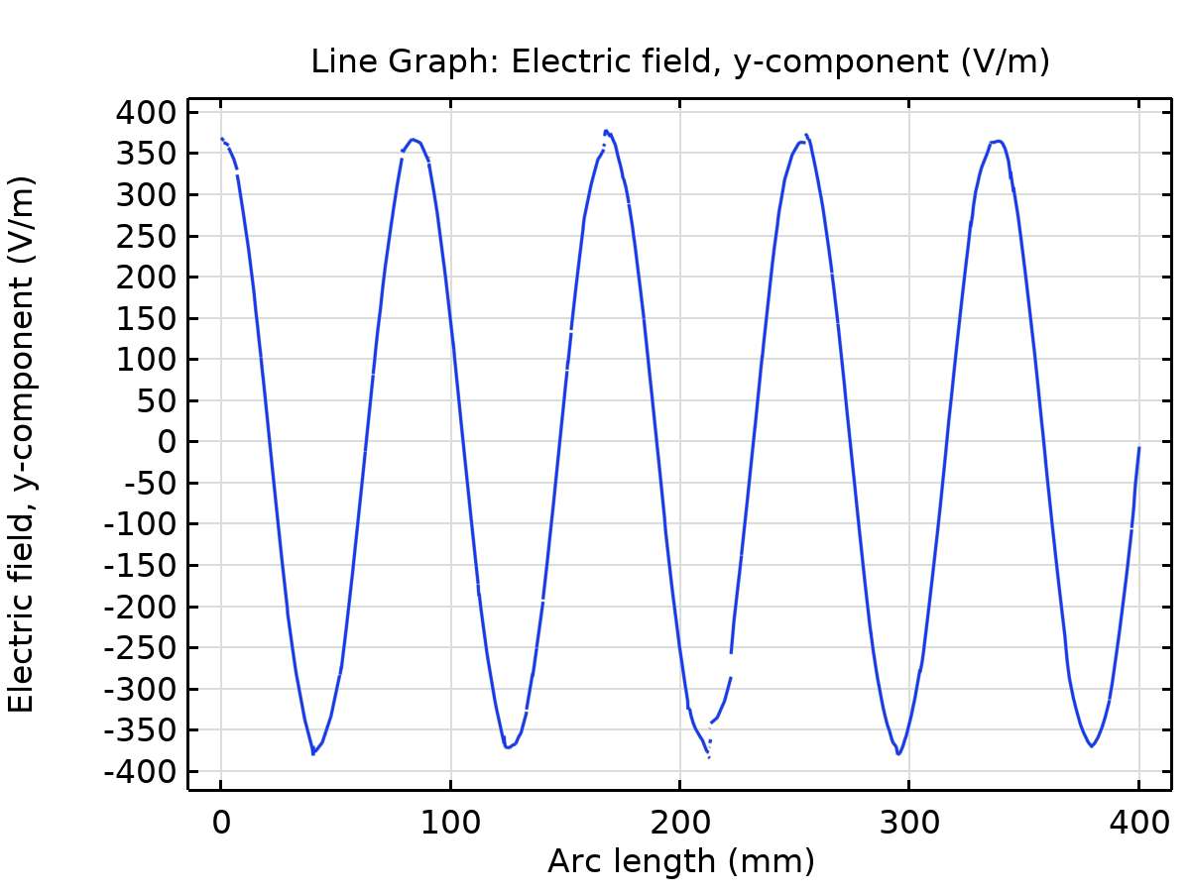
Line Graph: Electric field, y-component (V/m)

