LLM-As-A-Judge
Use Case: Assist in reducing the manual review of the complaints summarizer by adding LLM to judge to grade the manual review cases.
Automated ingestion of the cases into human in the loop workflow.
Standalone component to be added to the complaints AI application.
Reusable architecture to assist in other complaints model as well as other domains.
Copilot Prompt:
I have certain complaints and I have to implement an application and architecture that summarizes these complaints using LLM as a judge that will assist in reducing the manual review by adding LLM to judge to grade the manual review cases. Automated ingestion cases into the human in the loop workflow. Need a reusable architecture to assist in other complaints model or domains.
A reusable pattern for complaint workflows with LLM-as-a-judge + human-in-the-loop.
LLM as Judge is a framework for implementing a pattern where Large Language Models (LLMs) act as judges to evaluate content, responses, or code based on defined criteria.
LLM as a judge refers to the use of Large Language Models (LLMs) to evaluate content, responses, or code based on defined criteria. This approach leverages the general language capabilities of advanced models to serve as automated judges, offering benefits such as cost-effectiveness, scalability, and the ability to handle complex tasks.
Key aspects include:
- Evaluation Framework: LLM-as-a-Judge employs LLMs to assess the quality of outputs, allowing for structured evaluations that can capture nuances beyond simple metrics.
- Challenges: Despite their advantages, LLM-as-a-Judge systems face challenges like bias, interpretability, and the need for reliable design.
- Applications: This method is widely used in various domains, including chatbots, code generators, and more, to ensure quality and safety in AI-driven products.
Sources:
GitHub - microsoft/llm-as-judge: A repository that uses LLMs to evaluate other LLMs in a structured way · GitHub
LLM-as-a-Judge: A Practical Guide | Towards Data Science
Features:
- Judge Orchestration: Create and manage multiple judges with different evaluation criteria
- Assembly System: Group judges into assemblies for comprehensive evaluations
- FastAPI Backend: RESTful API for managing judges and performing evaluations
- Azure Integration: Built-in support for Azure Cognitive Services, Cosmos DB, and Container Apps
- Statistical Analysis: Includes plugins for statistical analysis and data operations
- Infrastructure as Code: Terraform support for easy deployment to Azure
Architecture:
The system consists of:
- Judges: Individual LLM instances configured with specific evaluation criteria
- Assemblies: Collections of judges that work together to provide comprehensive evaluations
- API Layer: FastAPI application for managing judges and assemblies, and processing evaluation requests
- Storage Layer: Azure Cosmos DB for storing judge configurations and evaluation results
- Plugins: Extensions for statistical analysis, data processing, and other functions

Here's the architecture of the Banking Complaints LLM Pipeline.
Key components:
API Layer (FastAPI)
- 5 endpoints: submit complaint, get complaint, root info, review UI (GET/POST)
LLM Pipeline (3 steps, triggered on POST /complaints)
- Summarizer LLM — calls gpt-4o-mini to produce a structured summary: text, key entities, sentiment
- Judge LLM — calls gpt-4o-mini again to score the summary (faithfulness/coverage/consistency 0–5), assign risk level, and decide specialist routing
- Auto-Process Decision — applies policy rules from config to decide auto_processed vs pending_review
Config (config.json)
- Drives taxonomy, risk thresholds, keyword filters, auto-process policy, and LLM prompt settings — loaded at startup
Storage
- In-memory COMPLAINTS_DB (dict) and REVIEW_QUEUE (list) — demo-only, no persistence
Human-in-the-Loop UI (GET/POST /review)
- Browser form served via Jinja2 template; reviewers can correct summaries, override risk level, and add notes — moves status to reviewed

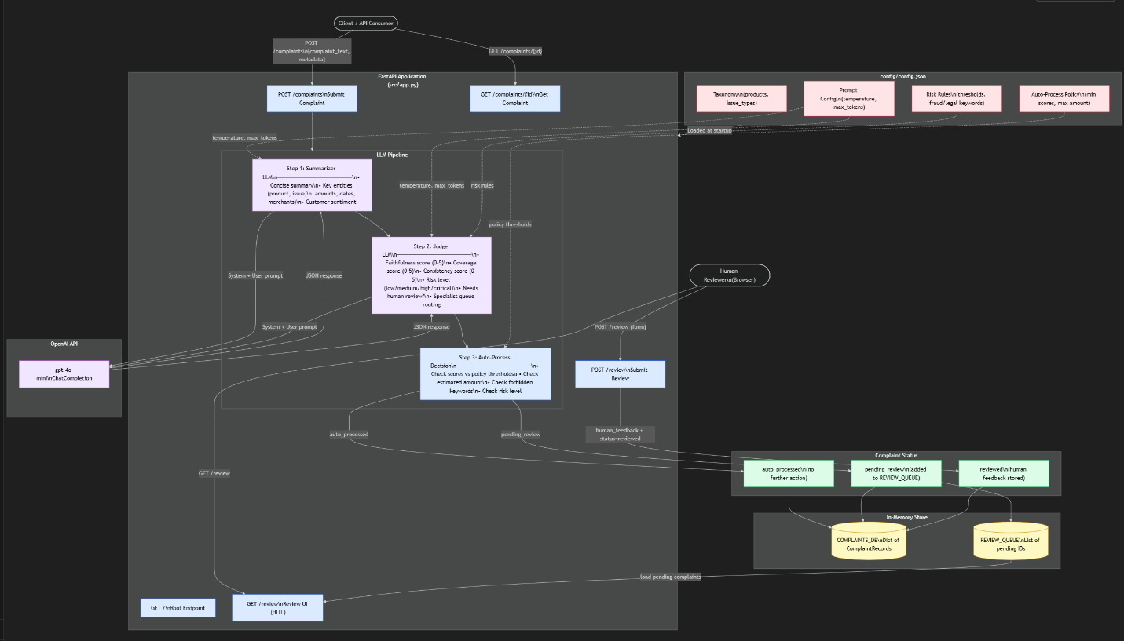
:> uvicorn app:app --reload

