**Teledermatology App:**

Teledermatology or distance dermatology app is designed to predict Healthy and unhealthy skin. If the app finds the skin to be unhealthy, it further specifies the type of disease the user might be suffering from.

Acne, Rosacea, Pigmentation are the abnormalities detected by the app. It further recommends products to cure them along with a list of best doctors available nearby to cure the same.

**Implementation Flow:**

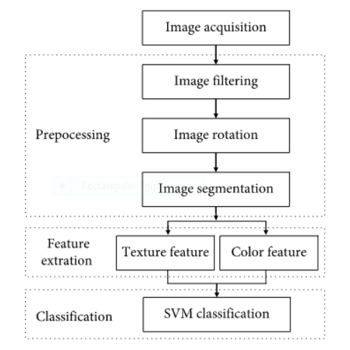

**How does it work?**

1)Teledermatology app has been made to provide accurate results at people’s ease and to reduce the expense involved while consulting a dermatologist.

2)Users can hover the camera over an area in order to see the probability of a disease they might be suffering from.

3)This app also provides a map for users to get information about nearby dermatologists.

4)Given the probability of a disease, the app also recommends products to cure the same.

**Charts:**

Accuracy (Y - axis) vs Epoch (X -axis)

Training set, Validation set

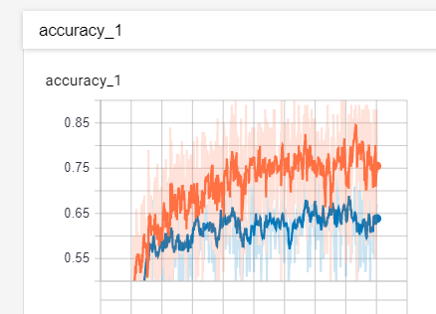

Loss(Y - axis) vs Epoch (X -axis)

Training set, Validation

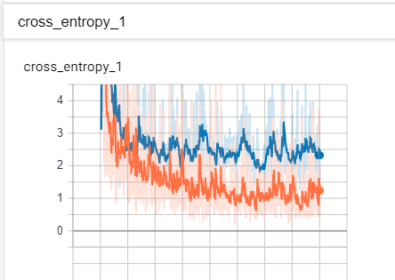

**Accuracy on 5000th Epoch**

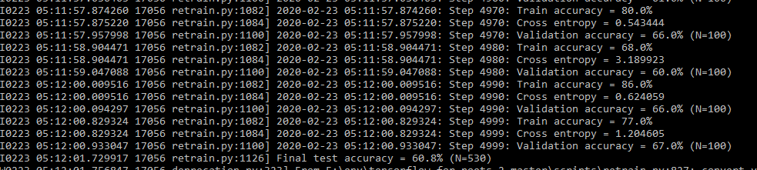

**Dataset Overview**

**Acne Healthy Pigmentation Rosacea**

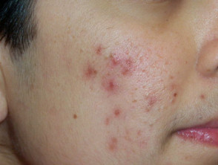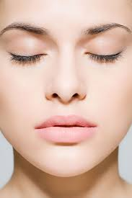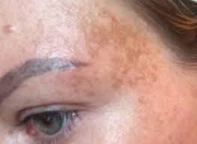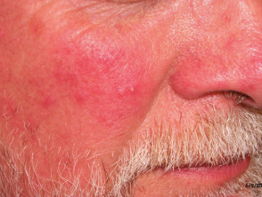

**App View**

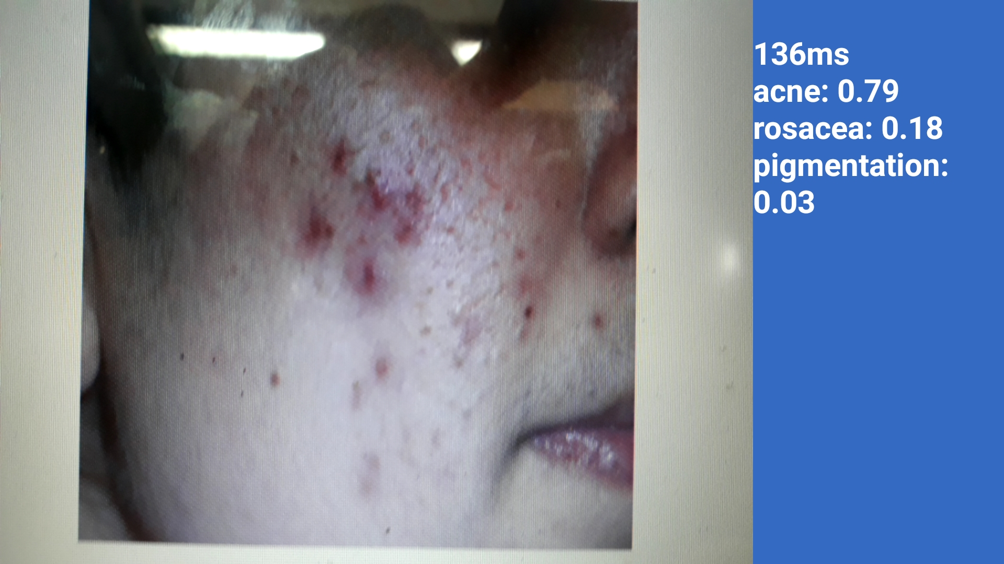

**Built with**

1)Android Studio( Platform used to deploy the model on Android devices).

2)Tensorflow.

3)Google Images(For dataset).

**To Do:**

1)Feature Engineering( To increase the accuracy).

2)Chatbot implementation(To give prompt assistance to users).

3)Increase the number of diseases classified.

**Instructions to set up the project:**

1. Run Command Prompt on the location where evn is saved
2. Pip install -r requirement
3. Run Command- activate (to activate scripts)
4. Come out of Scripts and run the following three commands:

* python -m scripts.retrain --bottleneck_dir=tf_files/bottlenecks --how_many_training_steps=500 --model_dir=tf_files/models/ --summaries_dir=tf_files/training_summaries/"mobilenet_0.50_224" --output_graph=tf_files/retrained_graph.pb --output_labels=tf_files/retrained_labels.txt --architecture="mobilenet_0.50_224" --image_dir=tf_files/flower_photos
* python -m scripts.label_image --graph=tf_files/retrained_graph.pb --image=tf_files/flower_photos/acne/acne123.jpg
* tflite_convert --graph_def_file=tf_files/retrained_graph.pb --output_file=tf_files/optimized_graph.lite --input_format=TENSORFLOW_GRAPHDEF --output_format=TFLITE --input_shape=1,224,224,3 --input_array=input --output_array=final_result --inference_type=FLOAT --input_data_type=FLOAT

**TEAM - Bytes**

Members:

Aparna Iyer

Shraddha Iyer